- PART 1

>

The above matrix resembles the resistors in a circuit. 3 out 4 resistors have a known value while one is unknown (R)
The value of the current is to be found using linear algebra with known values of voltage as follows:

The values of the current was found interm of the the unknown value of the resistance R
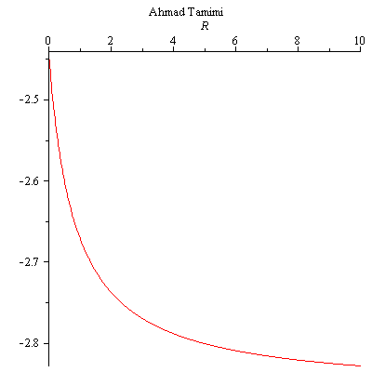
at R=7
This is the same value that was obtained using MATLAB

at R=5
These are the same values of the current obtained using MATLAB
PART 2

where T= 23.2 so

Solve for A:
At t=0, f(0) = 23.2 + A, where f(0) =27.5 so,
This means that the robot was shut down 5.12 minutes before entrance to the room;

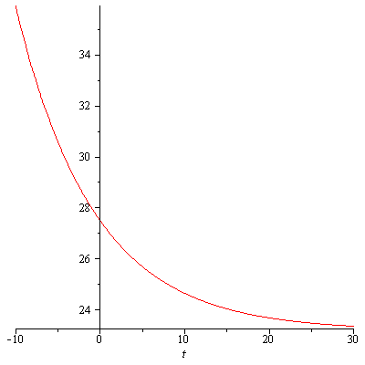
> This means that when a large amount of time passes, the robot will cool down to room temperature.

* PART 3
>


