Geog 1020

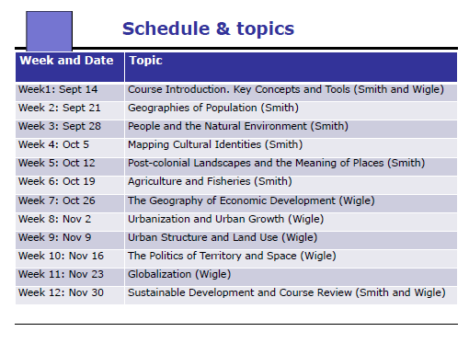

Course Description: This course introduces and explores significant geographical concepts, issues and processes that influence the dynamic connections among people, places and environments at a variety of spatial scales.
The course covers a wide range of themes related to the study of human geography and environmental studies: population dynamics; culture and identity; uneven development; agriculture and food production; cities and urbanization; globalization; geopolitics and the challenges of sustainable development.
The course critically examines the different methods and tools used by geographers to better understand the complexity of social and environmental change
in a variety of places.
Marking Scheme:
Assignments: 48 % (4 x 12 %)
Exam: 52 %

Week 1- Key Concepts and Tools

What is Human Geography?
The study of the spatial organization of human activity and of people’s relationships with their environments

What is environmental studies?
The study of interrelationships/interconnections and an approach that seeks to create, innovate and transcend barriers to change.

What is Geomatics?
The acquisition, management, analysis and display of geographic information

Spatial Organization
- Place
- Location
- Distance
- Space
- Scale

Place
“A concept with 2 levels of meaning”
1- an objective location that has both uniqueness and interdependence with other places
2 a subjective social and cultural construct

Why do places matter?
-Structure the daily routines of people economic and social life
-provide opportunities and constraints related to social well being
- Provide a context in which everyday common sense knowledge and experience are gathered
-Provide a setting for socialization processes
-Provide an arena for social norms

Spatial patterns and processes:
- Location
-Nominal(the Glebe)
-Absolute(Coordinates)
-Relative(situation)

- Distance
-Absolute(35 km)
-Relative (Time, effort or cost)
-Cognitive
- Distributions
  - Where are different things located and Why? What are implications of spatial patterns?
    - Car accidents, grocery stores, High birth rates
- Connectivity and Movement
  - How do things move across space?
- Scale

Scale
-The general concept that there are various scales of analysis.(Local, regional, national ,global) and that they are linked and that processes operating at one scale can have significance at other scales

The interdependence of places
-Places are tied to wider processes of change
-Interdependence between places and between geographical scales
-Connections are increasing through globalization

What is a map?
A representation, usually on a planar surface, of a particular portion of the earth’s surface, or geographical area.
- Basic Elements of a map:
  - Title, Map scale bar or ratio, projection/coordinate system, north arrow, symbology/legend

Map Scale: There are two main types:
- a graphic or bar scale
- Ratio or representative fraction

Coordinate systems:
- Latitude and Longitude, parallels and meridians
Projections:
“A method of portrating any portion of the curved surface of Earth on a flat map.”
This representation causes distortion in distance, area and direction

Geographies of Populations

Global Population, September 22,2010 ~6,870,200,000
- Current Increase ~83 million a year

Aspects of demography of interest to geographers
- How many people where and why
- Population structure
- Differences between and within countries
- The consequences of population patterns
- Change over time

Geographies of population:
“The why of where: why do particular aspects of population growth and change occur where they do and what are the implications of these factors for the future places?”(pg. 90)

Sources of information:
- A census
  - number of people
  - characteristics of populations (Incomes, Age etc.)
- Vital Records
  - Churches, Doctors records

How accurate are censuses?
-Bias
-Undercounting
-Merely a “snapshot”(very specific to that day)

What can you do with census data?
-Disaggregate data
-Cross-tabulate information(eg. Gender by region)
-Comparisons among cities or over time(longitudinal) or both
-Different scales (national, Local)

Population Distributions:
Factors that affect population:
-Proximity to national resources
-Climate
-Soil Fertility
- Historical Factors (e.g. War, Migrations, Tirade)
-Topography
--Political boundaries/migration policies
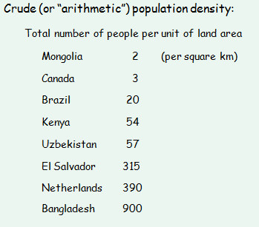
Another way of measuring population density:
Measure the number of people per unit area of arable land.
-In many cases a better indicator of a country’s ability to support its population
-However, today many nations do not rely on their own agricultural production

Population Structure:
Evaluated using population pyramids
-break population into subgroups according to age and sex cohorts(usually five years)
-Males on left, youngest at bottom
-Helps predict changes over time
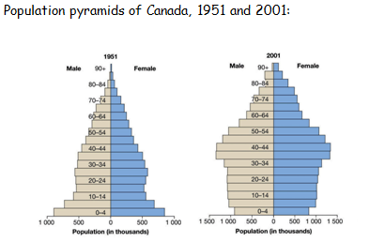

Dependency Ratio: The measure of the economic impact of the young and the old on the more economically productive members of the population. (pg.97)
3 Cohorts:
-Youth Cohort (0-15 yrs)
-Middle-age Cohort(16-64 yrs)
- Old-age cohort (65 yrs+)

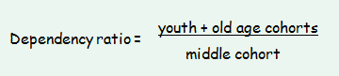

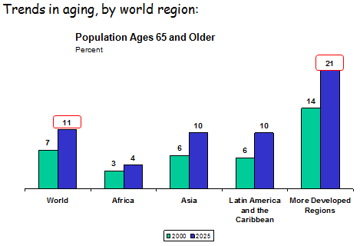

Population Dynamics-Some key demographic variables:
-Crude birth rate
-Crude death rate
-Rate of natural increase (or decrease)
-immigration and emigration

Total fertility rate: Number of births each woman will have, on average, during her lifetime (based on current rates.)
-current global TFR is 2.6
-In more developed countries its .7
-In least developed countries it is 4.6
-Canada is 1.4

Replacement rate
-The TFR that results in a stable population
-Varies from ~2.1-2.5 depending on mortality rates

Fertility and gender:
Fertility rates tend to be lower among women with:
-high levels of education
-Socio-economic security
-Work opportunities
-A more advanced age at the time of marriage
-Access to family planning methods

Some factors affecting Crude Death Rate:
-Levels of economic development
-Demographic structure
-Access to health care
-Social class
-Place of residence
Infant mortality rate: The annual number of deaths of infants under 1 year of age compared with the total number of live births for that same year (pg. 103)
-World IMR (2005) 54
-Canada 5.4
-Sierra Leone 165
-Sensitive to social and economic conditions

Life Expectancy: The number of years a person is expected to live, on average, when they are born
World average Men- 65
Women-69
Doubling time: The number of years needed for the population to double in size with a given rate of natural increase.
For example:
-At 1 %, 70 years , At 3%, 23 years
=70/% natural increase
HIV and Aids: Increases mortality in places where treatment and drugs are not available

Change over time- The demographic of transition model:
A model of population change based on the experiences of industrialized nations that describes the stages that have led to low birth and death rates

- Phase 1- In preindustrial societies, high birth rates and high death rates result in a relatively stable population

- Phase 2- A transitional stage with declining death rates associated with economic development and advanced in medical care. (While birth rates remain high)

- Phase 3- Low mortality rates, falling birth r ates associated with urbanization and changes in gender roles

- Phase 4- Low birth rates and low death rates, return to stable population

29/09/2010

Populations

Possible elements of government population policies:
-Financial incentives to have more children
-Provisions of free family planning methods
-Establish minimum age for marriage
-Pension programs
-Compulsory policies (e.g 1 child policy in China)
-Increase educational opportunities for girls and women

Canada’s Population:
-Population currently around 34 million (April 2010)
- Current annual growth rate ~1 %
+About two thirds attributable to immigration
+About one third attributable to natural increase

Major challenge is the aging population of Canada.

International Migration:

Migration facts and figures:
-214 million is the estimated number of international immigrants worldwide
-$414 billion estimated remittances sent by migrants in 2009
-27.1 million internally displaced persons in the world in 2009

Why do people move?
-Economic factors
-Family
-Political or religious persecution
-War, famine, environmental degradation
+push and pull factors often operate simultaneously”
There is also a “filter “factor> immigration policies

Types of Migrants:
- Legal versus illegal immigrants
- family unification immigrants
- guest workers
- refugees
- internally displaced persons
- forced versus voluntary migrants

Types of immigrants to Canada (2008, Total= 247,243)
-Missed

Refugees:
-People forced to relocate, usually because of armed conflict or political persecution
-Most move to an adjacent country
-Developing countries were host to four-fifths of the world’s refugees
-Pakistan was host to the largest number of refugees worldwide (1.7 million)

What are some of the main impacts of emigration for developing countries?
-Remittances
-Financial resources are sent back home
- Doctors and engineers (Countries have the resources to invest and train them)

Immigration to Canada:
-Policy favouring Europeans and US citizens ended in 1967
-Immigration Act, 1967
+Point system with 9 criteria for economic immigrants
-about 20,000 farm workers/year under special program
-Majority of immigration settlement occur in city zones rather than rural areas
Most important source countries today:
-China, India, Pakistan, Philippines, Iran

SWAP: Seasonal Agricultural Workers Program
- About 20,000 farm workers/year under this special program who work 6-8 weeeks to 8 months, leaving families behind
- Canada Benefits from cheap labour, and workers make relatively higher salaries as compared to back home

People and the natural environment
- Different perspectives of nature
- Human impacts on the environment
+ Our relationship with nature, rising concerns
+Some historical context
+Ecological footprint
Two Cases:
-Energy
-Changes in land use

The study of People and the Natural Environment:
- Complexity, Uncertainty
- Change
- Interconnections
+Many environmental factors occur on a global magnitude rather than previously being limited to local factors
- Scale
- Important Quote page 140. (Our Ability to detect the magnitude of these changes...will ultimately affect the future.”)

Serious Environmental problems:
- Pollution
- Loss and degradation of natural habitats
- Loss of biodiversity
- Soil erosion
- Climate change
The majority of the above factors are related.

What is Nature?

Nature is “Both a physical realm, and a social creation... understanding of nature are the product of different times and different needs”. (pg. 140-142)

“Social nature”
- The invention and reinvention of nature as a socially constructed concept, and the way different interpretations are shaped by different world views.

Religious Perspectives on nature:
“The fundamental worldview of religions shape beliefs about the natural world and its importance and the proper relationships between humans and the environment”

- Religious beliefs and cultural values also affect how resources are used

Other perspectives or philosophies:
  - conservation
  - preservation
  - environmental ethics
> “a philosophical perspective on nature that prescribes moral principles as guidance for our treatment of it” (p. 149)

Western views of nature:
  - A nurturning mother providing humans with their needs
  - Wilderness that needs to be tamed
  - Encourage using earths resources and manipulating them

Ecofeminism:
- Belief that patriarchial ideology is the primary cause of environmental problems
The unifying objecticve in all of ecofeminism is to dismantle the patriarchal biases in Western culture and replace them with a perspective that values both cultural and biological diversity

IPAT:
Human impact = Population x Affluence x Technology factor

Some broad historical context:
- the emergence of agriculture
- the “Columbian exchange”
Christopher Columbus’ founding of the “New World”(North America)
- the industrial revolution
+Industrialization, resulting in urbanization has had the most revolutionary impact on human life, and brought far-reaching ecological change.

10-05-2010

People and the Natural Environment- Continued
- Kyoto Protocol, 1997
-Agreement that major Countries meet specific goal-setting standards for their environmental impact
Ecological Footprint:
“A measurement of the biologically productive land area needed to support a country [or city, building, university, etc] by providing for its needs and absorbing wastes”

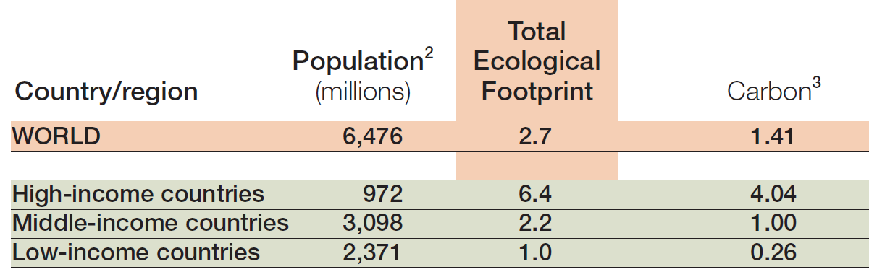

Ecological Footprints (2005)

World Biocapacity:
The use of natural resources in which resources are sustainable; usage of productive land resulting in usage of “1 earth”.
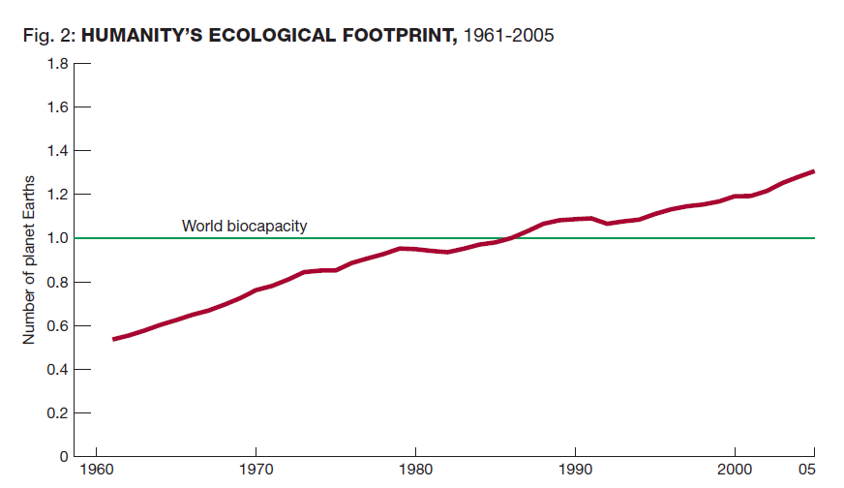
The Global overshoot is growing, and as a consequence, ecosystems are being run down and waste is accumulating in the air, land, and water.

Energy and the environment:
- Impacts include atmospheric and water pollution, deforestation, and climate change
- Caused by extraction, processing, transportation, and use

Energy Consumption, 2008:
Fossil Fuels:
-Oil 34%, Coal 26%, Natural Gas 21% (Oil is closer to the surface, making it easier to extract)
Other Sources:
-Nuclear 6%, Hydroelectricity 2%, Other renewable (Wind, Solar, Geothermal) 11 %

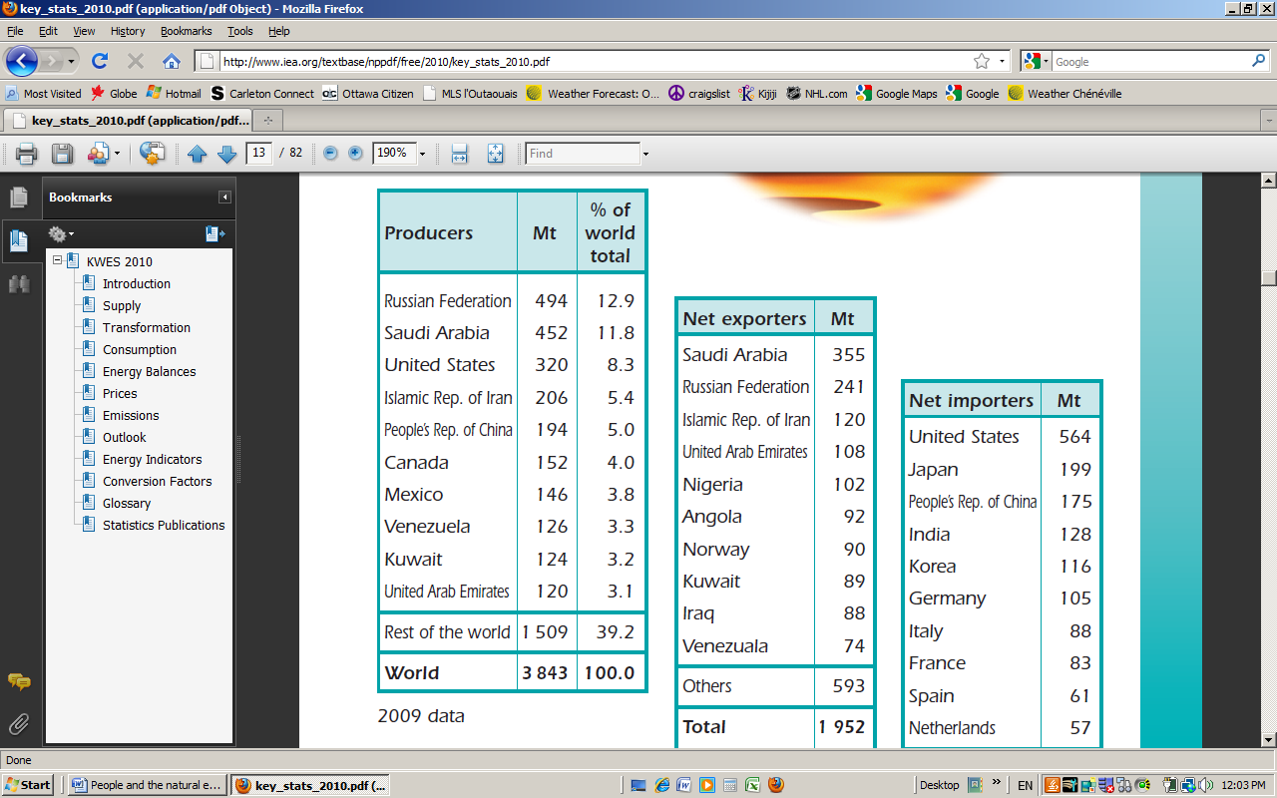 - Crude Oil producers

Changes in Land use:
Five Broad categories of land use
- Forest, cultivated land, grassland, wetland, and human settlement
One of the most dramatic changes > Loss of forest cover
- Approx. 8 million square km since the 17th century
- Deforestation rates highest in rain forest regions (~0.5 ha/sec)
Desertification a problem in semi-arid areas
- Overgrazing, drought
Conversion of Wetlands

Mapping Cultural Identities

Main Topics
- Culture
- Cultural landscapes
- Cultural regions
- Geography of Language
- Identity

Culture

Cultural Geography:
“The study of the ways in which space, place, and landscape shape culture at the same time that culture shapes space, place, and landscape”[pg. 200]

How do geographers study Culture?
- Cultural Landscapes
- Cultural Regions
- The geography of identity
- Postcolonial landscapes
- The meaning of politics of places

What is Culture?
Culture encompasses a way of life, values, beliefs, customs, behaviours and other traits passed down from generation to generation.

The term “culture” is also used in other ways:
For Example:
- Corporate Culture, Youth Culture, Counterculture, Popular Culture, High Culture
- Cultural Wars: : “Those battles, rooted in ideology, religion, class difference, the social construction of racial, ethnic and gender difference, and so on that mark contemporary society

What is a Cultural Trait?
A feature that has a regular occurrence within a culture
- Material and/or non-material
Important Traits:
- Religion, Language, Food, Dress
Religion: “A belief system and a set of practices that recognizes the existence of a power higher than humans”

Cultural Landscapes
“A characteristic and tangible outcome of the complex interactions between a human group and a natural environment”

Carl Sauer’s cultural Landscape
“Culture is the agent, the natural area is the medium, the cultural landscape in the result, with the introduction of a different-that is an alien- culture, a rejuvenation of the cultural landscape sets in”
(possibly more on the slide)

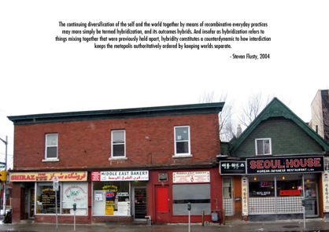

10/12/2010

Language
- Along with religion, a core element of cultural identity
- A unifying force, facilitating communication and group identity
- Distributions highlight cultural regions, past and present
- Key Terms; Dialect, Mother Tongue, Official Language, Pidgin, Creole, Lingua Franca, Language Family
- # Of languages= 4,200-5,600
  - 30 spoken by over 20 million people as a mother tongue
  - 50 percent of people speak one of 12 lanuages
Language in the Landscape- Toponyms:
- Geographic communcaiton
- Evidence about cultural history
- A window onto how people conceptualize space
- Symbolic Meaning
- A way to assert authority onto the landscape
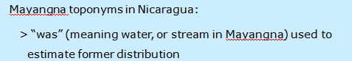

Geography of Language
Language Families- Indo-European is the most popular family language as many languages derive from it including English, Russian, and even Hindi
- Indo-European language is widely used, but not the largest family
- 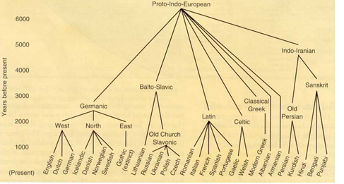
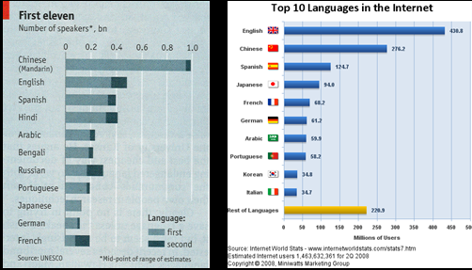

Use of Canada’s official languages (2006):
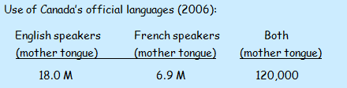
- French in Quebec: 5.8 M, Outside Quebec: 970,000, Allophones: 6.3 Million
- Top home languages other than English or French 1971: Italian, German Ukranian| 2006: Chinese, Punjabi,

Aboriginal population in 2006: 1.2 million
- 3.8 % of population
- Up from 800,000 in 1996
- Only 25% speak aboriginal as mother tongue, Which are Cree, Ojibway, and Inuktitut

Toponyms

Topynyms are used to map cultures on a geographical aspect. It is also useful to view the physical geography through a different perspective rather than a European scope. An example of this is instead of viewing snowy areas, Inuits describe snow with hundreds of variations.

Case Study-Participatory Mapping With indigenous peoples in Latin America:
- Recognizes value of local geographic knowledge
- Indigenous toponyms help document historic land rights, absent from government maps
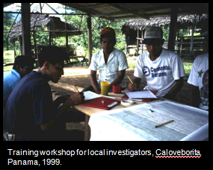

Cultural Regions
An “Area where certain cultural practices, beliefs, or values are more or less practiced by the majority of the inhabitants.”pg 204
- Definition and delimination varies according to the criteria used, time period, and spatial scale

What are some examples of cultural regions?
- Cajun Region of Louisiana, Chinatown, and Europe (Europe can be “Defined” based on 12 criteri
Europe
- Does not meet traditional definition of a continent, as it is not a separate land mass
- It can be “defined”based on 12 criteria including,
- Majority speaking Indo-European language, Majority Christian, Government is elected with free elections, Per capita income at least $7,500, At least 70 % of population in urban areas,
Challenges and limitations of defining cultural regions:
- Cultural diversity within regions
- Geographic overlap of different cultural groups
- Contested definitions
- Mapping diasporas
  - “ A spatial dispersion of a previously homogenous group”

Identity
How do people identify themselves?
-Culture, Language
-Gender
-Ethnicity
-Race
-Nationality/ Citizenship
-Sexual orientation
-Class
-Age
-Political affiliation

The importance of Place/ Location
“Spatial location is important, not only in generating shared experiences and customs that form identities but also in providing a “position “from which resistance can be made against power, inequality and other forms of perceived oppression

Gender
- a major objective of feminism was to distinguish between (i) biological differences and (ii) gender, as something that is not “natural” but rather something that is culturally defined and that is historically contingent
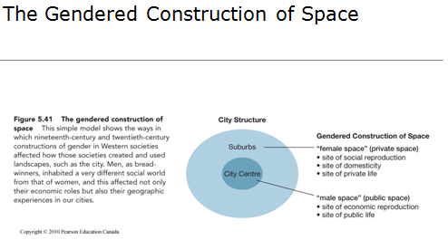
Monk, Janice (1992), “Gender in the landscape”
Two examples of gendered geographies:
  - the commemorative landscape
> e.g., military heroes versus abstract symbols
  - patriarchal divisions of urban space
> central public spheres of male employment versus domestic landscapes of unpaid, isolated housework

Race- Illusion or Reality?
“A problematic classification of human beings based on skin colour and other physical characteristics”
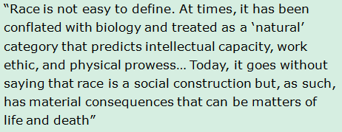

Geography and Colonialism
Postcolonial Landscapes and the Meaning of Politics of Place
- Colonialism and the emergence of the world-system
- Postcolonialism
- Places and Landscapes
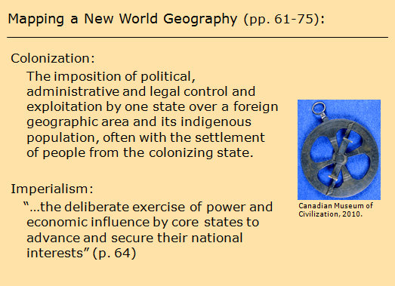
- “Geographical knowledge was crucial to the expansion of Europoean political and economic power in the sixteenth century, information about regions and places was a first step to control and influence, and this, in turn was important step to wealth and power”

People, Places andEnvironments
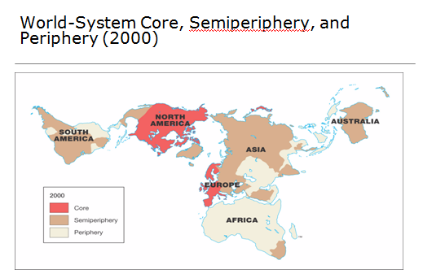

“The periphery was brought to be almost entirely dependent on European and North American capital, shipping, managerial expertise, financial services, and news and communications. Consequently, it also became dependent on European cultural products: language, education, science, religion, architecture, and planning. All of these influences were etched into the landscapes of the periphery in a variety of ways as new places were created, old places were remade, and regions were reorganized” (p. 74)

Postcolonialism:
“A broad set of artistic, political, and research approaches that examine the consequences of the end of European colonialism”

Central themes / characteristics of postcolonialism:
  - an anti-colonial stance
> impacts of colonialism past and present
> examination of the causes of persisting inequalities
  - dismantling of ethnocentric assumptions
  - uncover stories and knowledge beyond “the west”

The meaning and politics of places and Landscapes:
“Places… become powerful emotional and cultural symbols… And for many people, ordinary places have special meaning: a childhood neighbourhood, a university campus, a hockey arena, or a family vacation spot. This layering of meanings reflects the way that places are socially constructed

Sense of Place:
“Feelings evoked among people as a result of the experiences and memories that they associate with a place and the symbolism they attach to it”
Examples of places with layers of meaning: Parliament Hill, Montreal Forum

The politics of places:
- the role of power to shape the structure and meaning of places
- being “in place” or “out of place”
- Eg. Ground Zero

Landscape as Text:
“…geographers think of landscape as a comprehensive product of human action such that every landscape is a complex repository of society… many layers of meaning are embodied in the landscape, meanings that can be expressed and understood differently by different social groups”

Agriculture and Fisheries

Main themes:
  - types of agriculture
  - increases in production
  - agricultural alternatives
  - fisheries in crisis
  - environmental impacts
What is agriculture?
- “A science, an art, and a business directed at the cultivation of crops and the raising of livestock for sustenance and profit” (p. 353)
- An activity of critical importance that represents complex relationships between people and the land.
- An activity that varies considerably from place to place, conditioned by both human and environmental factors operating at a variety of scales.
Some key facts / issues:
  - about half of the world’s labour force is employed in agriculture
  - we rely on only about 20 crops for almost all of our food
  - Over 900 million people suffer from malnutrition

Environmental Factors that condition Agriculture?
    - climate
    - soil characteristics
    - Topography
Human factors that condition agriculture:
    - cultural traditions and preferences
    - technology
    - distance from markets
    - land tenure
    - government policies
Subsistence Farming:
    - main goals is to grow enough food to eat, as well as some surplus for the market
    - fewer chemical inputs
    - labour intensive
    - numerous crops
    - smaller farms
Shifting cultivation:
  - practised mainly in tropical forest regions
  - a form of rotational agriculture
  - intertillage (polyculture)
  - fruit tress often planted in fallows
  - supports relatively low population densities

Intensive subsistence cultivation:
  - labour intensive
  - raised fields or terraces common
  - can support larger populations
  - often two or more harvests per year are possible
Pastoralism:
    - practised in cold and dry climates
    - most practice transhumance
    - traditional movements of nomadic pastoralists increasingly restricted

Commercial agriculture:
    - production for the market
    - heavy reliance on agrochemicals
    - monoculture, high-yielding varieties
    - highly mechanized
    - larger farms
    - dominated by agribusiness whereby inputs, production, processing, and distribution to consumers occurs through an integrated chain of activities
The Industrialization of Agriculture:
“...the process whereby the farm has moved from being the centrepiece of agricultural production to becoming but one part of an integrated multilevel (or vertically organized industrial process, including production, storage, processing, distribution, and marketing and retailing”

The “third agricultural revolution”:
  - mechanization
  - chemical farming
> synthetic fertilizers
> synthetic pesticides
  - new processing, transportation
and storage methods

The “green revolution”:
  - an effort to increase yields in developing countries
  - gradually developed into a package of hybrid crop varieties and other inputs

Hybrid crop varieties
> mature faster
> produce more food per plant
> respond better to fertilizers
> reduce vulnerability to pests

Irrigation:
  - increases yields, opens up new areas, and can allow more harvests per year

Will it be possible to keep producing more and more food for our growing population?
    - irrigation efficiency could be improved
    - much food still lost to pests
    - room for continued expansion limited
    - much land continues to be lost to urban sprawl
    - increased production will likely increase environmental impacts
Environmental impacts:
    - soil erosion
    - pollution
    - deforestation and loss of biodiversity
    - “…as agriculture has industrialized, the impacts of agriculture on the environment have multiplied and, in some parts of the globe have reached the crisis stage” (p. 382)
Agricultural Alternatives:
    - genetically modified (transgenic) crops
    - organic farming
    - local food

Organic farming:
    - no synthetic pesticides or fertilizers
    - no growth hormones or antibiotics in livestock feed
    - no genetically modified crops
Agriculture in Canada:
    - physical environment, government policy and international trade are primary factors affecting this sector
    - agriculture and “the agri-food system” represents 8% of GDP and 13% of employment (2005)
    - over 60% of exports to United States
    - average farm size about 275 hectares, and increasing

26/10/2010

The Geography of Economic Development (Main Themes)
- Economic Development:
- World System theory and economic structure
- Processes of change

- Uneven Development:
- Human development Index
- Millennium development goalds
- Gender empowerment index

Economic Development:
“Proccesses of change involving the nature and composition of the economy of a particular region, as well as to increases in the overall prosperity of a region
- Uneven process and impacts
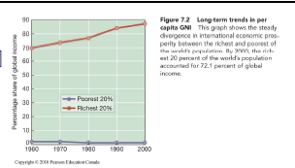
- Globalization and world cities

What are these processes of change?
-Changes in economic structure
- Changes in forms of economic organization
- Changes in availability and use of technology
-Changes in environment

World System Theory
-Places and regions are connected to broad processes of social change
-Globalization is a dynamic and highly uneven process

World system:
An interdependent system of countries linked by economic and political competition.

Competition for what?
- Power
- Resources
- Markets
- “External”areas

A world system?
- Places and regions are part of the world system:
- Regions and places have been influenced by a sequence of major changes in world geography
- Core, semi-periphery and periphery (Three Tiers)

Regions of the world system
Core:
- Dominate trade, control most of the advanced technology, and have high levels of productivity within diversified economies
- High Gross national incomes per capita incomes
- Exploitation of other regions through colonialism

Semi-periphery:
- Able to exploit peripheral regions but care themselves are exploited and dominated by core regions
- Most countries that were once peripheral
- Some fluidity in world-system
- Spatial variations within countries

Peripheral:
- Regions with undeveloped or narrowly specialized economies with low levels of productivity
- Dependent and disadvantageous trading relationships, lower levels of technology

Importance of The world System:
- Way to the think about political and economic stratification of countries
- Different pathways of development:
-Internal and external considerations
-Resources, social structures, role of state
- Broader contextual considerations
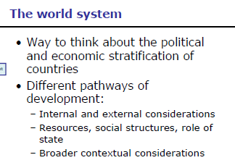

Economic Structure
“The relative share of primary, secondary, tertiary, and quaternary activities “in a given country, region or city

- Uneven impacts of globalization
- Urban economic change
- Shifting work/producting patterns
- Dispersal and concentration of economic activities
- Emergence of world/global cities

World cities:
“Cities in which a disproportionate part of the world’s most important business-economic, political, and cultural- is conducted.”

What are primary activities?
- Economic activities that are concerned directly with natural resources of any kind
- Agriculture, Fishing, Mining forestry

What are secondary activities?
- Economic activities that process, transform, fabricate or assemble the raw materials derived from primary activities, or that reassemble, refinish, or repackage manufactured goods
- Food processing, furniture making, automobile assembly

What are tertiary activities?
- Economic activities involving the sale and exchange of goods and services (pg.315)
- Retail stores, personal services, commercial services

What are quaternary activities?
- Economic activities that deal with the handling and processing of knowledge and information
- Data processing, education, research
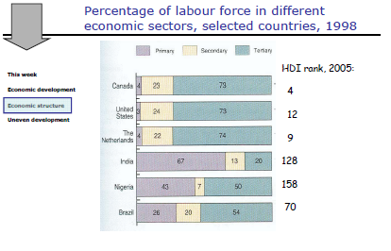

Income Inequality
Housing affordability problems:
- Supply of affordable housing insufficient
- Paying an increasing proportion of their income to maintain housing

Uneven Development
- Regional disparities and world system theory
- “Natural”Endowments
- Cultivable land, Energy sources, Minerals etc.
- Role of state and public policy in generating and redistributing resources

Conventional Measurements:
- Measurement
  - GDP
    - An estimate of the total value of all materials, foodstuffs, goods, and services produced by a country
  - GDP per capita
    - GDP/Total population
  - GDP(PPP) per capita
    - For comparative purposes
  - PPP
    - Purchasing Power Parity

GDP (PPP) per Capita:
- Weaknesses as an indicator of development (Masks social and quality of life)
- Various Factors
- Shows a national snapshot

Other Indicators:
- Social Indicators:
  - LE, IMR, Literacy rate etc
- Human Development index
- Millennium development goals
- Gender empowerment index
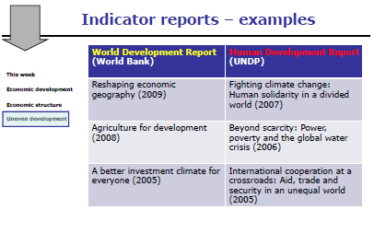

What are indicators?
“A set of rules for gathering and organizing data so they can be assigned a meaning”
- Baseline to assess change
- Various Uses:
- Moniter progress (HDI)
- Monitor performance on set targets (Millennium Development Goals)

World Development Report [WDR] (2009)
- Human Geography
- Reshaping economic geograpy
Emphasis on “3 D’s”:
- Distance
  - Shorter, as firms and workers migrate to economic oppurtunuties
- Density
  - Higher, as seen in the growth of cities
- Division
  - Fewer, as countries “thin” their economic borders to enter world markets
    - (World bank, WDR 2009)

Human Development Index
- A measure of social development:
- Assigns countries scores ranging from 0-1 based
- Composite index:
Income: Per capita GDP(PPP)

Health: Life Expectancy
Education: Literacy Rates and school enrollment rates

Gender Disparities
- Gender inequalitiy cuts across all spatial scales and regions
- In some countries, women are better off than others, but in no country are women better off than men
- Gender empowerment measure or index

Millenium Development Goals:
- Established in 2000:
  - 8 Goals
  - Multiple dimension of poverty
  - Action-oriented, not just inadequacies
  - Tracked every year and reported on
  - Indicators measure progress

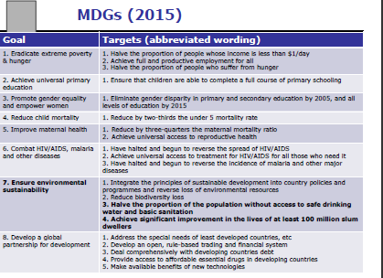
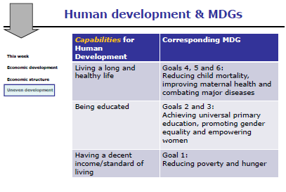
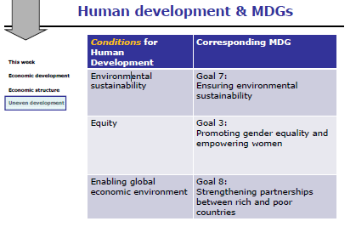

11/02/2010

Urbanization and Urban Growth
What is an urban area?
Complex term, which differentiates between countries:
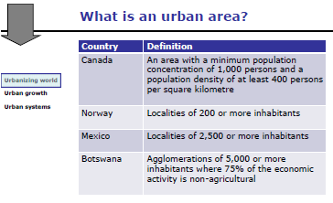

Urbanizing World
Challenges of studying urban issues:
- Lack of uniform definition of urban
- Census data
- Changing definitions overtime

What is an urbanizing world?
- An increasing proportion of world’s population live in urban areas:
-1800 – Less than 5 %
- 1950 – 30 %
- 2007- 50 %<-- Historic moment, in which the first time the world has people living in urban areas rather than rural areas
-First Urban Century
-Regional variations
-Implications for sustainability

“Urbanization is nto simply a process of the demographic growth of towns and cities. It also involved many other changes, both quantitative and qualitative”

- Urban growth rates are highest in sub-saharan Africa, india, and mostly in latin America
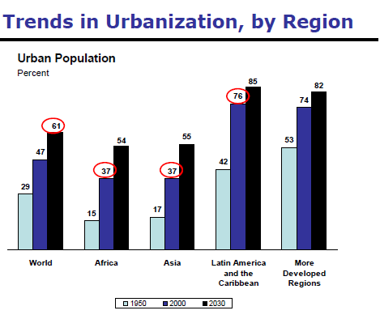

Largest cities:
1950- New York, London, and Tokyo
1980- Tokyo, New York, Mexico City
2010- Tokyo, Mumbai, Mexico City
Changing Urban Lexicon:

Mega city- 10 million plus
- Very Large cities characterized by high centrality within their national economy
Hyper city- 20 million plus

Challenges for an urbanizing world:
- Urbanization in poor regions
- Largest cities
- Fastest growing cities
- Informal settlements fastest growing parts of these cities
- Fewer state resources
- Informal Economies
- Social and environmental issues: Access to water and Sanitation, etc.

Urban Growth
How do cities grow?
- In-Migration
-National Mobility, and growth from international immigrants coming in
- Natural Increase
-Fertility rates and new household formation among existing population
- Annexation/Change in municipal Boundaries

Urban Form
- The physical structure and organization of cities (p. 439)
- Land use, layout and built and environment
  - Streets, sidewalks and block patterns
  - Locations and density of jobs
  - Housing
  - Land use mix

Why is urban form an important environmental issue?
- Density and lande use mix are key determinants of the viability of transit-use
- Compact urban Form:
  - Reduces land-consumptive
  - Reduces energy use
  - Enables protection of agricultural land and habitat

Transit-Supportive urban form:
- Land use planning- City-Scale
- Grid block pattern and continous road network
- Street oriented uses along major roads
- Urban Design- Neighbourhoold scale
-Mixed-use transit nodes
-safe, well-lit stops
- Other- Cross-cutting policy issues
-Full cost pricing for car use
-Full-cost pricing for suburban development
- Adequate funding for public transit services (gas tax)

Way to increase Transit-Supportive urban Form:
- Design of shared public facilities
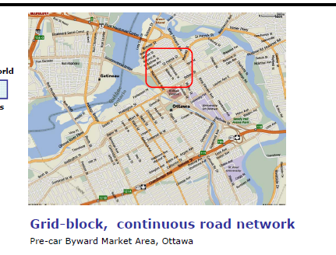
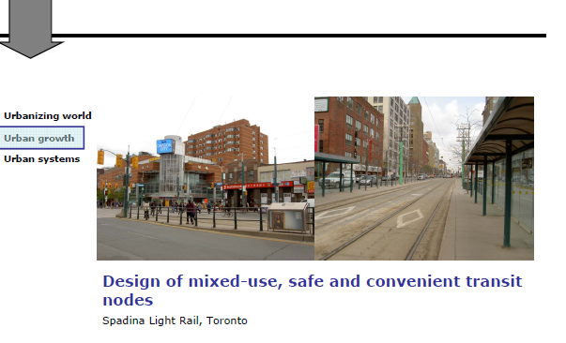

Ottawa 20/20
- Growth management plan for city of Ottawa
- Sustainable development is a strategy that requires the integration of economic growth, social equity, and environmental management. It is about ensuring a better quality of life for everyone, now and for generations to come.
- Started in the year 2000, vision is one a more compact, affordable, efficient, environmentally healthy city

Official Plan:
- City’s physical development:
- Promotes walking, cycling, transit
- Increase residential and employment densities along transit corridors and main roads
* Consistent with transit supportive urban form
*Transporation master plan
”Retrofiting” the Suburbs:
- Create mixed use and higher residential and employment densities at transit nodes and along major roads
- Housing and commercial developments “face the street “and have parking at back

Urban Form
Reflection of:
- History and colonial development
- Planning and architecture traditions
- Industrial development
- Public policy and private investments

Urban form in other contexts
Urban Geography:
- How does urban form differ among urban areas?
- How does it differ in areas with informal settlement and housing?
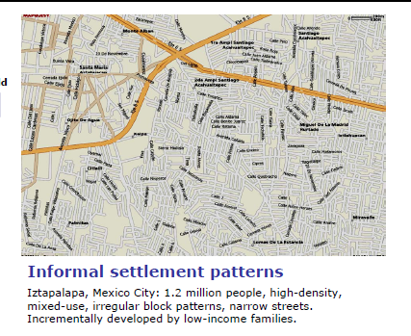

Urban form complications
- Toronto/Ottawa
- Pre Car/Post car periods
- Central city/ Inner and Outer Suburbs
- Time/Places/ Scale of greenbelts, etc.

- Mexico City/Mumbai
- All of the above complications, plus more
- Rapid Urbanization
- Planned and unplanned elements
Urban Growth Processes:
- Deindustrialization
- Decentralization
- Counterurbanization
- “Unintended Metropolis”

The “Unintended Metropolis”:
- Urbanization not necessarily connected with industrialization or economic growth
- Informal Urbanization/ Settlement
- Push Factor: Poor living conditions and prospects in rural areas
- Pull Factor: Access to schools and services, jobs and higher wages in urban areas
- Critique of term “unintended”

Not all informal settlements are slums…
- Shantytowns or informal settlement: Initial settlement lacks official planning permissions, access to urban services, occupied by poor, housing is self built
- Slums: Defined by lack of access to urban services and poor housing conditions

Agents of Change:
5 Freedoms necessary for the improvement of cities and communities
- Economic Facilities
- Megacities are driven by individuals wanting economic opportunity
- Provide economic oppurunities to increase conditions
- Social opportunity
- People participation to gather and increase conditions
- Transparency Guarantees
- Ability to negotiate and value authority figures
- Protective security
- Ability to work in the face of natural disaster
- Political freedom
- Ability of women to be in a position of power
- Freedom of the press

Urban Systems
- “An interdependent set of urban settlements within a specified region”
- Classify urban areas as part of a larger system
  - Size, function, importance

Primacy:
- A condition in which the population of the largest city in an urban city is disproportionately large In relation to the second and third largest cities in that system
- Primate cities: Mexico City, but not New York, Mumbai

Centrality:
- The functional dominance of cities within an urban system
- High share of economic, political and cultural activities, not just size
- Often primate cities, but not always
- Dhaka: 9 % of total population, 50 % of manufacturing employment

Canada’s Urban System:
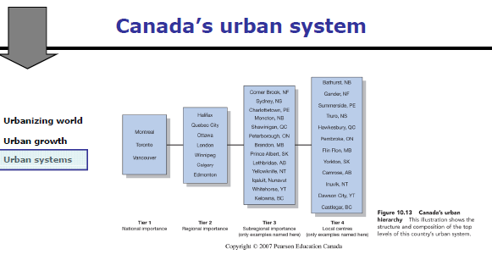

Canada’s 5 Largest city: (No primate city)
- Toronto
- Montreal
- Vancouver
- Ottawa
- Calgary

Global Urban system:
- World or Global Cities:
- Cities in whiiich a disproportionate part of the worlds most important business is conducted
- Largest, but also “the command and control” centers of the world economy
- Advanced producer services
- Concentration and dispersal of economic activities part of unevenness of globalization
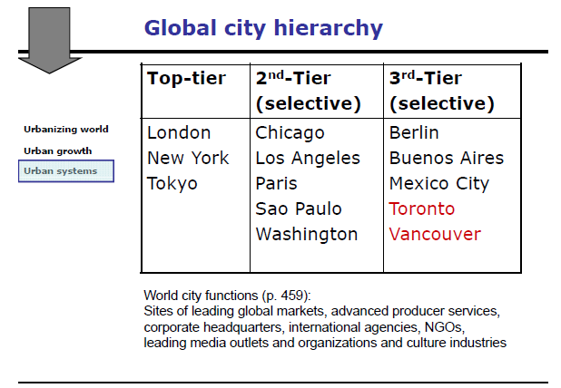

11/09/10

Urban Structure
- Internal structure of cities, land use distribution and functional sub-areas
- Land Use:
  - Commercial, Industrial, Retail, Residential
- Zoning by-laws:
  - Municipal zoning codes
  - Lot density, set-backs, heights, etc
  - “Exclusionary zoning”

- Urbanization tends to lead to industrialization

3 basic Elements: Traditional Concentric Model
- Central Business District (CBD) (Mainly downtown)
  - Central Nucleus”
  - Major Institutions, transportation hub
  - Highly concentrated land usage, Triple A office space etc
- Zone in transition
  - Area of mixed commercial and residential land use surrounding CBD
- Residential zone

Different Types of Cities:

Polycentric Cities:
- Complexity makes models difficult
- Within City:
  - Secondary business districts (“Suburban Downtowns”)
  - Commercial Strips, industrial districts
  - Mixed-use central neighborhoods
- Metropolitan Zone:
  - Sub-Centers
  - Outer suburbs
  - Big box retail
- Outside:
  - Edge cities, urban-rural interface

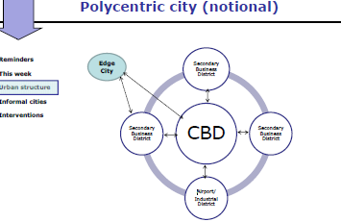
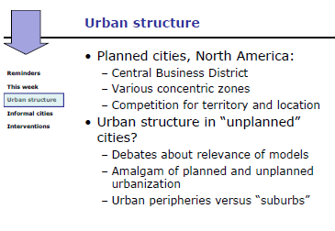
The above factors are for planned cities, what about urban structure in ‘unplanned cities”?
- More common to speak of urban peripheries rather than suburbs
- Different ways that households are built

The different city models vary in core regions or the global north, in comparison to the global south, where the models are more complex.

Canadian Cities:
- Difference with US cities:
  - More compact
  - Higher population densities
  - Lower-Levels of poverty and inner city areas of decline
  - Greater levels of public transit provisions and use
  - Dispersed diversities
- Public healthcare system

Urban structure can vary within a city, an example of this is ‘three cities in Toronto”
- The centre (pre-1930)
  - High densities, public transit use, mixed use, corridors
  - “Ethnic”villages, pockets of poverty
(Find definition of gentrification)
- Inner Suburbs (1950-1960)
  - Lower densities, mix of ownership housing and rental apartments
  - Higher dependency on cars, but still some dependence on transit
  - Loss of manufacturing jobs
- Outersuburbs (post 1970’s)
  - Outside of city, lowest densities, mainly ownership of household
  - Higher car dependency, minimal transit use
  - Fastest growing areas, higher income than inner-suburbs
Orderring/ Re-ordering of space:
Different perspectives:
- Economic: Urban structure shaped by competition for territory and location
  - Banks may pay for more affluent sectors of land, which other lower-cost businesses may not pay for
- History/Public policy: Influence of transportation systems and investments
- Socio-Cultural perspective: Congregation and segregation
  - Segregation: the spatial separation of specific population subgroups within a wider population”
    - By social class, race, cultural groups
    - Voluntary, through discrimination, exclusionary urban planning, or market driven urban development
  - Forms of segregation
    - Enclave (Ex. Little Italy)
    - Ghetto (Ex. African-American sectors of US cities)
    - Citadel

  - Congregation: The territorial and residential clustering of specific groups or subgroups of people
    - Why congregrate?
      - Inexpensive housing
      - Etc

Informal Cities
The “unintended metropolis” ( MENTIONED AGAIN FOR SOME REASON)
- Different urban growth processes in peripheral regions:
  - Push/pull factors
  - Urbanization disconnected with industrialization or economic growth
  - Informal settlements
  - Informal sector employment
- Differences in urban structure

Three common elements: (In most cities of the global south)
- Central concentration of commerce
- Separate zones of elite residential
- Informal settlements
  - Cities are often shaped by their informal settlements

Informal economy:
- Informal, but highly organized
- Significant and growing source of employment
- Extremely varied
  - Can include: Different stalls, mechanical work, food stalls etc.

Informal Housing:
- Housing in north America and Europe:
  - As product and object of consumption
- Housing in most of the world:
  - As process and productive resource for livelihoods
- Different housing trajectories and condition

Different Housing Trajectories:
Housing as product:
- Planning
- Installment of urban services
- Housing construction
- Buy finished housing product on serviced lot
Housing as a process:
- Buy or occupy un-serviced lot
- Start building house
- Struggle for urban services
- Planning

Informal Settlements: Key aspects
- At time of settlement
  - No access to urban services
  - Housing is self-built
  - Irregular or illegal access to land
  - Inhabited by urban power
- Over time, a process of consolidation
  - Access to urban services
  - Housing improvements
  - Land tenure security
  - Up-filtering or social diversity

Land, Housing, Poverty:
- Land accessible to urban poor: (These conditions make land more affordable)
  - Peripheral, remote
  - Exposed to industrial and natural risks
  - Unserviced
  - Illegally sold or occupied
- Social vulnerability, human security and exposure to “natural “disasters
  - An example is of living under a hydro electricity strip of land near a mountain

Housing as patrimony:
- Individuals who build these informal settlements form sentimental value towards these houses, and become a social and economic asset

Key Terms:
- Squatter: Without permission of landowner
- Shantytowns or informal settlement: Initial settlement lacks official planning permissions, access to urban services occupied by poor
- Slums: Defined by lack of access to urban services and poor housing conditions
- Not all informal settlements are slums

Urban livelihoods:
- Beyond “Basic needs “approach
- Looks at how the urban poor manage a range of assets to secure their livelihoods:
  - –Labour (Diversify), Housing (Share, build, rent), social (networks)
- Strategies to earn income, reduce expenditure, minimize vulnerability, increase security
- Many are place based assets

Dharavi, Mumbai:
- Mumbai: 18.3 million
- Centrally-located slum
- 600,000 people
- Dharavi redevelopment:
  - Market-led slum redevelopment?
  - Developers provide new, in-situ housing for residents through sale of other housing units at market prices
  - Conflicting interests

16/11/2010

Politics of Territory and Space

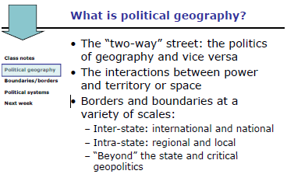
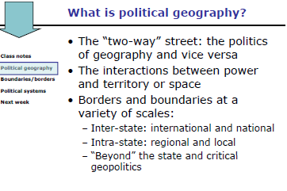

The politics of Territory and Space
The politics of Geography refers to: How the areal distribution or differentiation of people and objects ion space has a measurable impact on politics

The geography of politics refers to: How “Politics”- The tactics or operation of the state- shapes geography or is anchored in geography
  - Gerrymandering: The practice of redistricting for partisan purposes
  - Redistricting: Defining and redefining of territorial district boundaries

Political Geography
- The two way street: the politics of geography and vice versa
- The interactions between power and territory or space
- Borders and boundaries at a variety of scales

A state is: An independent political unit with recognized boundaries, even if in dispute
A nation is: “A group of people often sharing common elements of culture, such as religion or language, or a history or political identity.”p.396

Nation-State: -pg.396
Sovereignty:pg.396

The Roma(Gypsies)/ The Kurds/ The Jews Etc.
Diasporic Community
- A group made up of emigrants from a particular homeland who maintain their cultural, political and economic ties with each other, despite having been dispersed among many countries

Geopolitics:
- The state’s power to control space or territory and shape the foreign policy of individual states and internatonal political relations
  - How Space and distance influence foreign policy and international relations
  - How and why one state exerts power over another
  - Geopolitical “Tools”
    - Invasion/occupation or threats, Economic sanctions, Trade policies and agreements
    - Direct/Indirect, Formal/Informal

Critical Geopolitics:
- Beyond the limitations of the state and the national scale as the focus:
  - The World trade organization, The European Union (Supranational)
  - Cities and Citizenship ( “The rights to the city”)
    - Rights based on urban inhabitance, (Just for the fact you occupy the space)
    - Insurgent Citizenship: The right to claim everyday Space “in the city in the absence of state support. Collective mobilization to create informal housing, plumbing, urban services, jobs, etc. (Holston, Brazil)
- Transnational Networks, identities, groups and spaces:
  - Nations across state space
  - Borderlands
- Transnational Mobility/ Migration
  - South-North: Work (Mexico to US)
  - South-South ( Peru to Argentina, India to Dubai)
  - North-South: Retirement (Canada to Mexico)
- Tourism (Mostly North-South)
- “The Global Mexican Nation”: Over 13 million Mexican in the US, which send remittances(Funds back to Home Nation) back to Mexico. Although these Mexicans live in the US, they are eligible to vote in Mexico’s elections so that these beaners maintain allegiance to Mexico
- The right to the city:
- 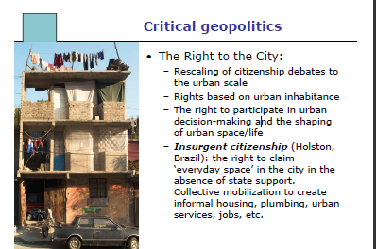

Boundaries:
- Territory
  - The delimited area over which a state exercises control and that is recognized by other states (or not)
- Boundaries
  - Inclusionary and Exclusionary (Inside and outside of a “Line”are included/excluded)
    - Eg. Healthcare for Canada, but excluding America
  - Fixed versus fluid
  - Informal and formal
    - Informal include graffiti representing gang turf, (not located on map, but exists)
    - Formal include US/Canada border
  - Recognized versus disputed
  - “Leaky”and complex

Boundary formation:
- Natural Barriers
- Colonization, Geopolitics ( Colonization of Africa lead to forming boundaries of a continent)
- Migration, Security issues (Wall being constructed between Israel and the west bank)
- Primary and Secondary Boundaries
  - External and Internal Boundaries ( Canada, Ontario)

Boundary “Re-Formation “?
- If nation and state do not conform?
  - “Alter” the space: annexation, division, etc
  - “Alter” the people: ethnic clensing,, forced migration, selective immigration, assimilation, etc.

Nationalism:
- The feeling of belonging to a nation as well as the belief that a national has a natural right to determine its own affairs
  - Cultural nationalism, identity and symbolism
  - Multiple identities and culturalism
US-Mexico Border
- Economic and Social disparities:
  - GDP per capita (41,854 vs 10,209)
- 12 million people live in 14 “sister cities “along border, 67 crossings
- Increased immigration flows since 1994

Borderlands:
- More nebulous, in-between spaces
- “Tend to historically to be zones of cultural overlap and political instability, where the national identity and loyalties of the people often become blurred

Geography and political systems
- Territorial organization:
  - A system of government formally structured by area, not by social groups
  - Political representation is tied to geographic units, or “we vote where we live”

- Confederation or a federal state
  - Powers aare divided between the federal; government and the provinces and territories
  - Municipalities are “creatures “of the province

- National Level
  - 308 seats [Most Ontario (106) and Quebec (75), Least Territories]
  - “First past-the-post “system
    - How does it work?
      - Inherited 200 years ago, a winner-takes-all approach.
    - Why is their growing support for reform, and form proportional representation?
      - Voters are getting frustrated due to disproportional results between popular vote and number of parliamentary seats. Smaller parties are unable to hold any power.
    - Advantages of first-past-the-post?
      - Governments are held more accountable for their actions, are able to act decisively in society’s interest
    - % of popular votes, and the number of parliamentary seats have little to no relationship
    - Ex, Bloq Quebecois have 10 % vote, 50 Seats, Green Party had 7 % vote, 10 seats[2008]

Exam Info

Dec 21,2010 at 19:00
- 3 hours, no aids required
- Multiple choice questions ( 60 Percent)
  - Covers all different themes, Political Geography, Urbanization, Cultural geography etc.
    - About 5 per topic (Each topic is divided by each week)
- Long answer questions (Choice of 4 of 7) ( 40 %) [Major Themes]
  - What is migration? Identify some of the key “push “and “pull “factors related to migration. Use examples
  - What is economic structure? How is it measured? What does it say about a country’s level of economic development?
  - Hints: Provide examples, relate to class material/text book, provide definition etc.
- Material presented in lectures and required readings

Be strategic:
- Assignments done, on time
- Look for overlap textbook/notes
- Posted video clips
- Slides provide guidance/hints on important themes

Sample Questions

Infant mortality rates:
- Are uniform among peripheral and semi-peripheral regions
- Do not vary within core region
- Reflect the geography of poverty

23/11/2010

Globalization

Globalization
- “A process and condition that involves the increasing interconnectedness of different parts of the world through common processes of economic, environmental, political and cultural
- Key Features: Dynamic, uneven, multi dimensional

Facilitating factors:
- New international division of labor
  - New Geographic pattern of different areas of specialization in the global economy; Companies outsourcing
- Internationalization of finance
  - Investments in different countries
- New Technology
- Consumer Markets
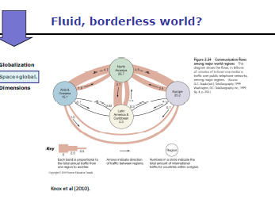

Space and Globalization
- Rapidly changing world, fluid boundaries, hyper-mobility:
  - Death of distance?
    - The transportation technology has increased dramatically
      - 1500-1840: Average speed of horse (10 mph)
      - 1960: Jet passenger aircraft (500-700 mph)
Fast World/Slow World
- Fast World:
  - “People, places and regions directly involved as producers and consumers in transnational industry, telecommunications, materialist consumption, and international news and entertainment
- Slow World
  - “People, places and regions whose participation in transnational industry. Telecommunications, materialist consumption, and international news and entertainment is limited
Digital Divide:
- “Inequality of access to telecommunications and information technology...get full

The Fourth World:
- Refers to areas of the globe without access to people, information, technology and networks required to participate in a globalizing economy
  - “The Grameen Phone and Bank”- Mohamaed Yunus created this companies which took individuals living a fourth world life-style, and got them connected and made them profits, and transformed them from a “slow world” life to a fast world.”-FIX

Dimensions of Globalization
- Economic
- Cultural
- Environmental
- Political

Economic Globalization:
- Increasing Global trade
- Increased size, number, power and prominence of TNCs
- Spatial reorganization of economic activities
  - Example: Nike Shoes
  - Ford Model, and Post-Ford Model (Current)
    - Ford Model: Manufacturing process and sale of goods takes place in a centralized location; One corporation, One Manufactuer, One Place One etc.
    - Post Ford Model: Manufacture process and companies involved span a larger area of space, for example a ford car may go back and forth between America and Canada 3 times before it rolls off the shelf
- More economic integration and a much greater interdependence of individual places and regions:
  - In-Sourcing: Import cheap labor for place-based Agriculture
  - Out-Sourcing: Export production to low-cost production areas

Export Processing Zones:
- States/ Spaces of “Exception”
- Subcontracting to where labour is cheaper
  - Going to Mexico may not be feasible, as China may have cheaper labour
- Export-led industrialization
- Impact on national and local migration, growth and settlement patterns

Transnational Corporation:
Wal-Mart
- The largest retailer in the world
- Recorded profits of over US $10 billion and sales of US $285 from 4,900 stores
- Wal-Mart Sourced US $18 billion worth of goods from China (2004)
  - 3 % off China’s Total exports

World Cities and Globalization
- “Cities in which a disproportionate part of the world’s most important business- Economic, Political and cultural-is conducted; provide a variety of place-bound, place-specific socio-economic assets that are fundamental to the production of capital mobility (pg.75)
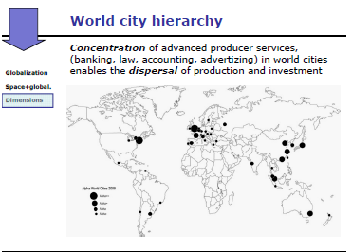
What’s so unique?
- Internationalization of world economy not new
- Globalization: Functional integration of economic activities across national boundaries
- New Geography of economic activities
- Scale of transnational migration and mobility
- Economic Remittances
  - “The global Mexican nation“
  - Facilitating transnational citizenship (Vote Abroad) and leverage remittances for “local” economic development
  - “Transnational” social subsidy and social stability- Government matches amount of remmitance

- Cultural impacts
  - Size and scope of TNCs (Transnational Corporation)
  - Global commodity chains
  - Claims of cultural homogenization?

Cultural globalization
- Increasing trade and homogenization of consumer markets
- Two competing theses:
  - Homogenization of culture
  - Hybridization of culture
- Places and regions are reconstructed rather than effaced (eg. McDonalds)
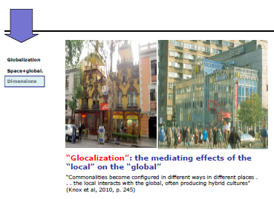

Environmental Globalizaiton
- Climate change, lost of habitat, biological diversity
- Environmental protection/justice
- Spatial Justice
  - “The fairness of distribution of society’s burdens and benefits, taking into account spatial variations in peoples needs and in their contributions to the production of wealth and social well-being”
- Natural Hazards may not be so natural, as poor are given horrible land to live on, meaning there is a social factor

Political globalization
- Increasing power of transnational corporation versus diminished importance of nation-state and citizen power
- “Corporate Globalization”
- “Globalization from below”

Globalization form below:
- NGOs- Are internationalizing themselves, creating networks of globalization form below. They are, or can be, instruments of deep democracy, rooted in local context and able to mediate globalizing forces in ways that benefit the poor”
- World Social Forum

Globalizad Agriculture:
- Globalized agriculture
  - “A system of food production increasingly dependent on an economy and a set of regulatory practices that are global in scope and organization
  - Economic, Cultural environmental and political features/impacts

Outcomes:
- Consolidation of core region as key “arenas of globalization”:
  - North America, Western Europe, Japan
- New geographies
- Increasing global social polarization, with 20 % of population in highess-income countries
  - 74 % of world income, 82 % of world export markets, 74 % if world telephone lines

Shrinking or Splintering World?
- Evolution of terms to describe changing global context:
  - From periphery and core to fast and slow world etc.
- Regions and places within regions affected differently by globalization, over time and space
- EXAM: Have a good understanding of globalization, the multi-dimensions of it, link to common process

30/11/2010

Sustainable Futures
Sustainable development
- A vision of development that seeks a balance among economic growth, environmental impacts and social equity
- Meeting the needs of the present without compromising the ability of future generations to meet their needs
- Ambiguity of the term is strong or weak depending on the context,

Examples in class:
Urban form and Sustainability
- Transit-supportive urban form
- 2020 growth management plan of Ottawa, “Sustainable development is a strategy that requires integration of economic growth, social equity, and environmental management.” (Ensuring better life for now, and generations to come)
Sustainable Fisheries
- Collapse of the cod stocks
  - Human and environmental factors:
    - Diminishing populations of fish that cod eat, overfishing and advances in technology for capturing fish
- Large companies favored over traditional inshore fish harvesters
- Key Issues: Regulations, local knowledge

9 critiical Challenges:
From the david Suzuki foundation”:
- Generating genuine Wealth
- Improving efficiency
- Shifting to clean energy
- Reducing waste and pollution
- Protecting and conserving water
- Producing healthy food(Week 6)
- Conserving, protecting, and restoring nature(Weeks 3,4,5,6)
- Building sustainable cities (Week 8 and 9)
- Promoting global sustainability (Weeks 2,3,6,10,11,12)

Review

Approach/Content:
- Case studies
- Multi-Media
  - Slum futures
- Policy application:
  - Human Development Index
  - Millennium development goals
  - Livelihoods approach and poverty reduction
  - Transit-supportive urban form
  - Ottawa 2020
  - Electoral reform in Canada

Geographies of Population
- “The why of Where: Why do particular aspects of population growth and change occur where they do and what are the implications of these factors?
  - Distributions, structure (Population Pyramids etc) , migration (Movement of people), projections (Demographic models) and polocies
    - Trends, how are things moving/changing eg. Aging populations
    - Regional Differences are good to consider
    - Eg. An infant mortality rate of 100 high? Regional differences between developed country and poor countries? Like fertility rates, and other indicators

People and the Natural Environment
- Different persectives of “nature”
- Human impacts on the environment
  - Rise of agriculture, to the Colombian shit
- Energy (Case Study)
  - Understand how we are affecting the planet

Mapping Cultural Ideeennntities
- The relationship between culture and geography
  - Cultural regions, what is useful and what is the weakness?
  - Cultural Landscape etc
- Landscapes and regions
- The geography of language
  - What is a toponym, how can they be used to better understand things?
- Identitiy

Landscapes and places
- Postcolonial themes
- Sense of place and the creating of places
- Landscapes as text
  - Landscapes have been “written “and “read”

Agriculture and fisheries
- The geography of agriculture
  - Human and Environmental Factors
- Increases in production
  - Mechanization, Irrigation, Synthetic pesticides
- Agricultural alternatives
  - What is organic agriculture and how is that different than conventional agriculture? What do people say about genetically modified foods?
- Fisheries (Did not cover in lecture)
  - 1 multiple choice question

Geography of economic development
- Production and distribution issues
- Economic structure and world systems theory
  - Core, Semi-periphery, peripheral
  - Uneveness and difference in regional and urban scale
  - Helpful to explain differences between regions of the world
  - Spatial Scale
- Uneven development
  - Indicators of economic and social development
  - GDP(PPP) Human development index, Millenium Development Goals
- People First

Urban issues (2 Weeks)
- Urbanization and Urban Gorwth:
  - An urbanizing world
    - Megacities
  - Urban growth and systems
    - Relationship to urban form (Post-car and pre-car) Patterns and shit
  - Transit supportive urban form

- Urban strucute and land use:
  - Urban structure and form
    - Internal structure which becomes complex as city grows
    - Different forms of social segregation
    - Economic factors for planning policy
  - Informal urbanization
    - Shantytowns, slums etc.
    - Informal housing, economy and livelihoods

Globalization
- Dimensions and processes of change
  - Fast World, Slow World, fourth world
- Space and Globalization
- Globalization from below
- Shrinking or splintering world?
  - It depends, and probably both
  - Importance of globalization being an uneven process

Politics of territory and Space
- Boundaires, Borders and geopolitics
  - Supranational bodies like WTO, Borderlands (US and Mexico), The urban scale (The right to the city and informal urbanization,
- Critical geopolitics
  - National scale, the global Mexican nation (Transnational focus), remmitances, The roman rights (Gypsies)
- The Right to the city
- Geography and political systems of representation
- The electoral system in Canada
  - First past the post system, reforming of this process etc.

Exam Info
- 21 december at 7 p.m, Alumni Hall
  - 3 hours, no aids required
  - Material from classes and required readings (Not material exclusive to tutorials)
  - Bring pens, a dark pencil and eraser
  - Total 100 points (52 percent of final grade)
    - 60 Multiple choice (No choice, 1 point each, 60 total)
- more questions get from slide
- Exam paper and scantron sheet
- Sign name and student number
- Fill in scantron bubbles properly
Questions focusing on:
- Terms and concepts
- Relationships, patterns, trends
- Some knowledge of particular places and regional differences

- Be thorough

- Be Strategic:
  - Some from classes only
  - Some from redings only
  - Many overlap, slides provide guidance
  - Videos posted on Webct

See tipsheeet posted on WebCT for multiple choice exams

Long-Answer tips:
- Be specific, use examples
- Write clearly and legibly
- Read the question carefully and answer all components

Geopardy

Which of the following is true?
- Infant mortality rates have decreased significantly over the past century in both developed and developing countries –TRUE

Which of the following is true?
- Roughly half of the global population is found in urban areas- TRUE
- Rates of urban growth are

In which form of government is a significant amount of administrative responsibly held by smaller political units within the state?
- a demographic state
- A federal state – TRUE
- City states
- A unitary state

Cultural Geography is:
- Is concerned with material culture
- Involves interatction among space, place and landscape with culture. –TRUE

The video, Slum futures, underlines that
- All informal settlements eventually become slums
- Slums can house a diverse an array of people- TRUE
An indicator of development is:
- A subjective opinion about quality of life
- A measurable statistic that is used to infer the status of a dimension of development

