PSYCHOPHARMACOLOGY: study of how drugs affect the nervous system.
Drugs are grouped by there behavioural effects.

- Principles of Psychopharmacology: Drugs are chemicals used to bring about a change in the body. They are used to diagnose, treat, and prevent illnesses
PSYCHOACTIVE DRUGS: substance that alter mood, thought, and behaviour and are used to manage neuropsychological disorders. Many of these drugs are taken for nonmedicinal purpose and are abused. These drugs impair user’s functioning, promotes craving, and may produce addiction
  - Drug routes: the way which a drug enters the body is called route of administration. These routes can be:
    - Orally: easy and convenient. But not all drugs can pass through the barriers of digestive tracts wall.
    - Inhalation: administered as gases or aerosol which will go through the cell linings of the respiratory tract easily and are absorbed through the membranes into the bloodstream as quickly as they are inhaled. Such drugs are nicotine, marijuana, cocaine.
    - our skin, being the largest organ in the body, has 3 layers of cells to be a protective body coat. Some small molecule (ie nicotine) penetrate the skins barrier as easy as the cell lining of respiratory tract, whereas large molecules (ie steroids) cannot.
    - Bloodstream: fastes route and few obstacles
    - Direct injection to the brain has even fewer obstacles
    - Figure 8.1
  - Absorption is affected by physical and chemical properties of drug:
    - weak acid, such as alcohol, is easily absorbed through the stomach lining
    - weak base, such as Phenobarbital which is an anaesthetic, cannot pass through the stomach lining and thus has to pass in the intestines instead (note this process may destroy a weak base)
    - after absorption by the stomach or intestine, the drug enters the bloodstream. Drug must be hydrophilic to be carried in the bloodstream because blood has high concentration of waterthe drug is diluted by the bodies 6L of water! NO HYDROPHOBIC SUBSTANCE ENTER BLOOD.
    - Next drugs goes into the extracellular, which requires the molecules to be small to pass through pores of the capillaries. Then it is diluted further by the bodies 35L of extracellular content of water!
    - With each opbstacle encountered during its route to the brain, drug dosage can be reduced by 10x! ie amphetamine needs 1000 microgram if taken orally to show effect. If inhaled you need only 100 micrograms for same effect, and only 10 microgram if injected!
  - Blood Brain Barrier (abbreviated BBB): the tight junction between the cells of the blood vessels in the brain that prevent passage of most substances.
    - Brain capillaries are composed of single layer endothelial cells. These cells are tighltly fused to form a tight junction. So most molecules cannot pass/squeeze between them. 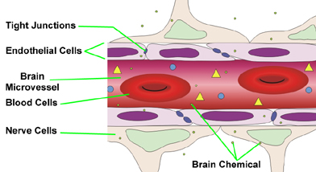
    - The figure above also shows the glial cells surrounding the blood cappuilary wall, forming 80 percent of it. The glial cells provide route for exchange of food/wastes between capillaries and the brain’s extracellular fluid. They may also play a role in maintaining the tight junction between the endothileal cells and dilate the capillaries to increase blood flow to areas in need.
    - THREE REGIONS IN BRAIN THAT LACK BBB:
      - PITUATARY GLAND: source of hormone that are secreted into the blood stream, and the release iis triggered by other hormones carried to the pituitary by the blood.
      - AREA POSTERMA: entry of toxic substances that induce vomiting.
      - PINEAL GLAND: entry of chemicals that affect the da-night cycles.
    - To carry its work, the brain needs oxugen and glucose for fuekl and amino acid building. They must reach the brain cells from the blood. Two ways this is achieve:
      - small molecules that aren’t ionized like oxygen or carbon dioxide, and are fat soluble, can pass easily through the endothileal membrain.
      - molecules of glucose, amino acids, and other food components use ACTIVE TRANSPORT SYSTEM OR PUMPS—proteins specialized for transport of particular substance.
    - One its passed through BBB, it is easily moved to the neurons and glia.
    - A drug can reach the brain only if th emocleculas are small and not ionized, or if the drug has a chemical structure trhat allows it to be carried across the membrane by an active transport system. Because few molecules are small or have the correct chemical structure, few can gain access to CNS.
    - To summarize: drugs that go from mouth to brain to be most effective: are small molecules, weak acids, wat and fat soluble, potent in small amounts, and not easily degraded.
  - How the body eliminates the drugs: after a drug has been administered the body soon begins to break it down (catabolize) and remove it
    - Catabolised throughout the body, broken down in the kidneys and liver as well as the bile in the intestines.
    - They are excreted in the urine, feces, sweat, breast milk, exhaled air.
    - Therapeutic drugs are designed to increase chance of reaching target and survival time in body.
    - The body has trouble to remove some substances – thus keeping them build up in the body to become toxic and lethal. For example, mercury a toxic substance cannot easily be removed by the body; and it causes severe neurological condition.
  - Even drugs that are eliminated can be problematic. They can remain in waste, and enter water and be reingested in food and water.
- Drug action at synapse: AGONIST AND ANTAGONISTS most drugs that have psychoactive effects influence the chemical reactions at synapses. The 7 major steps in neurotransmission are:
    - Synthesis of NT takes place in the cell body, axon, or the terminal
    - Storage:Stored into storage granules or vesicles or both until it is released.
    - Release: The amount of NT released is regulated in relation to experience
    - Receptor interaction: transmitter acts on a receptor embedded in the postsynaptic membrane
    - Inactivation & reuptake: destroyed or taken back up into the presynapse for reuse

    - Degradation: mechanism for degrading excess NT and removing unneeded byproducts.
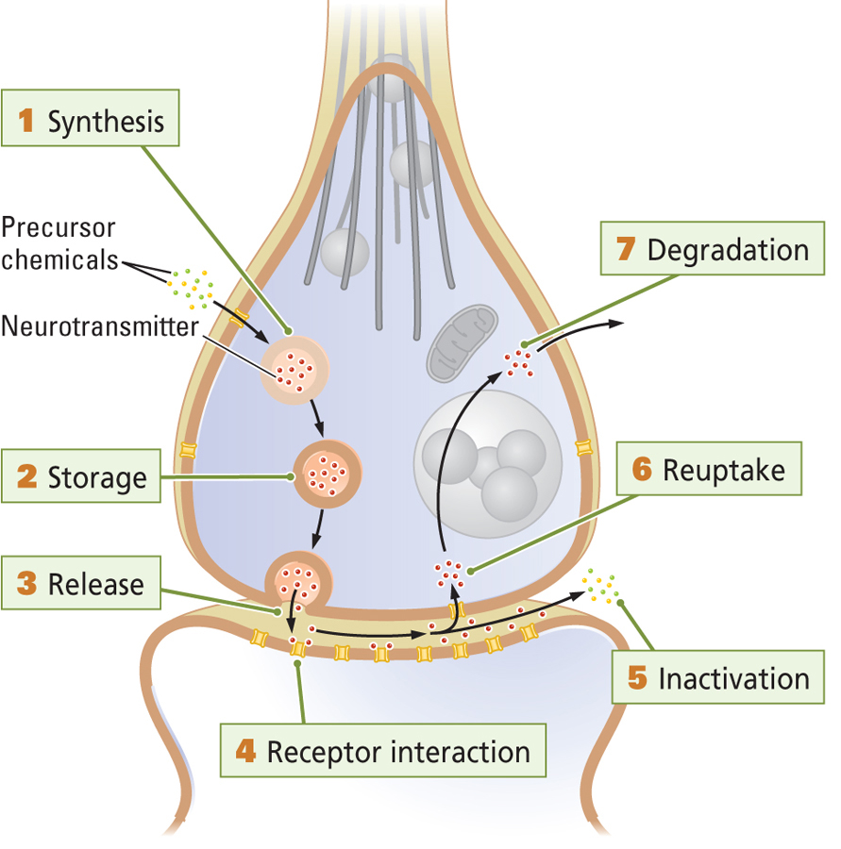
  - AGONIST: DRUGS THAT INCREASE THE EFFECTIVENESS OF NEUROTRANSMISSION
  - ANTAGONIST: DRUGS THAT DECREASE EFFECTIVENESS
- Acetylcholine (Ach) is synapse: an example
  - ACh agonists excite muscles, making them rigid; below are examples:
    - Black widow spider venom promotes release of ACh to excess. This spider contains enough toxin to paralyze an insect but not a human, though a victim may feel muscle weakness.
    - Nicotine: its molecular structure is similar to that of ACh thus it allows nicotine to fit in the receptor’s binding site. ***NICOTINE CAN READILY PASS THE BBB.***
    - Phygostigmine: drug that inhibits cholinesterase, the enzyme that breaks down acetylcholine. Therefore it acts as a agonist to increase the amount of ACh present in the synapse. Large doses can be toxic because it causes excessive excitation.
    - Organophosphates binds irreversibly to acetylcholinestarase and ca become extremely toxic/insect use glutamate as a NT at the nerve-muscle junction. But elsewhere in their nervous system, they have numerous nicotine receptors. Thus organophosphate poson insect by acting centrally, but they poison chordates by acting periphally.
  - ACh antagonists inhibit muscles rendering them flaccid (loose); below are examples:
    - Botulin: poisonus agent in tainted foods such as canned goooods. It blocks the release of ACh. Severe case could be paralysis of both movement and breathingdeath! However it has medical use. If injected in muscle it could selectively paralyse local muscle. This selective active is useful is blocking muscular twitches or contractions
    - Curare: occupies cholinergic receptors thus preventing acetylcholine from binding to them. It blocks their function. Large doses can arrest movement and breathingdeath! It is also used by south American Indians to kill small animals by covering their arrowheads with curare. The hunters dindt themselves become poisoned when eating the animal because the curare cannot pass from the gut into the body. Skeletal muscles are more sensitive than respiratory muscles to the curaretemporary palysis of muscle but not breathing!
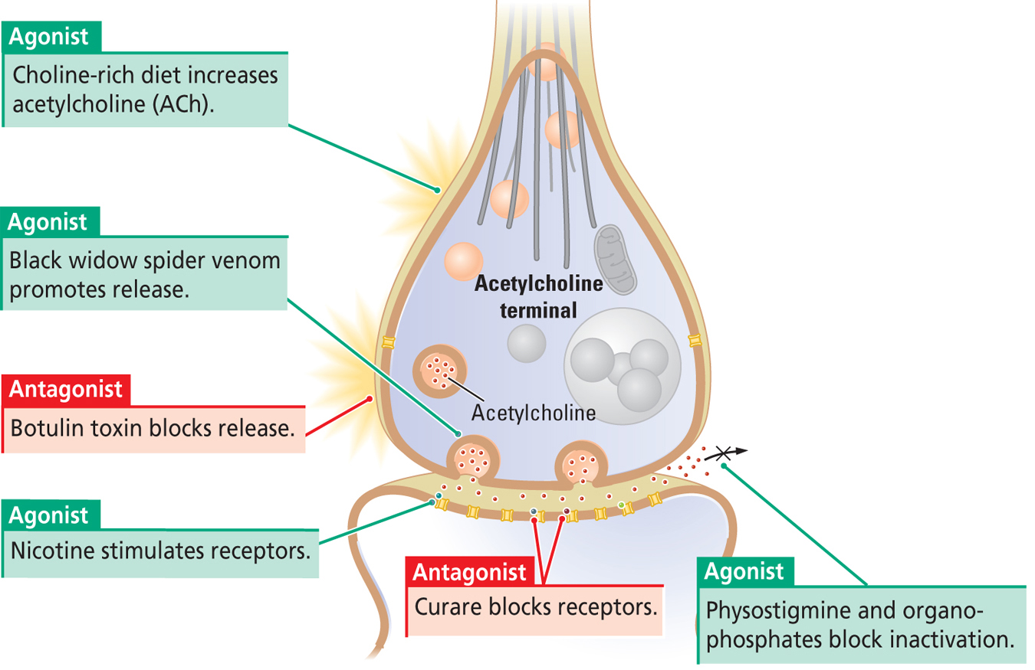
- Tolerance: decrease response to a drug with the passage of time. Harris Isbell and coworkers shows what tolerance is. The researhers gave volunteers enough alcohol daily in a 13-week period! Enough to keep them in a state of intoxication. Yet they found that the subjects did not stay drunk for the entire period!
in the beginning of the expirement, the volunteers showeed rapid intoxication. But after 3 weeks of alcohol consumption, blood alcohol levels and signs of intoxication fell to a very low—even with constant alcohol intake. Blood alcohol levels and signs of intoxication fluctuated even further with the coming days. High blood alcohol level was associated with low outward appearance of intoxication.
These results were likely the product of three kinds of tolerance:
  - Metabolic tolerance: # enzymes need to break down alcohol in the liver, brain, and blood increases result is that nay alcohol consumed is metabolized more quicklyreduced blood-alcohol level
  - Cellular tolerance: activities in the brain cells adjust to minimize effect of alcohol.
  - Learned tolerance: people learn to cope with the daily demands of living while being under the influence of alcohol.
This learning has also been shown in rats trained to walk on a narrow conveyor belt to prevent electric shock to their feet. One group of rats received alcohol after training on the before, another group received alcohol before training, and a third group received training only and a fourth group received alcohol only. A few days later, all groups received alcohol before the walking test. Only the rats group that had previous exposure to alcohol before training performed well. Apparently animals can acquire the motor skills needed to balance on a narrow belt despite alcohol intoxication.
ALL FORMS OF TOLERANCE ARE MORE LIKELY TO DEVELOP WITH REPEATED DRUG USE THAN WITH PERIODIC USE.
- Sensitization: increase responsiveness to successive equal doses.
  - to demonstrate sensitization, Robinson&Becker isolated rats in observation boxes and recorded their reactions to an injection of amphetamine. Rats typical reaction to this drugs includes sniffing, rearing, walking.
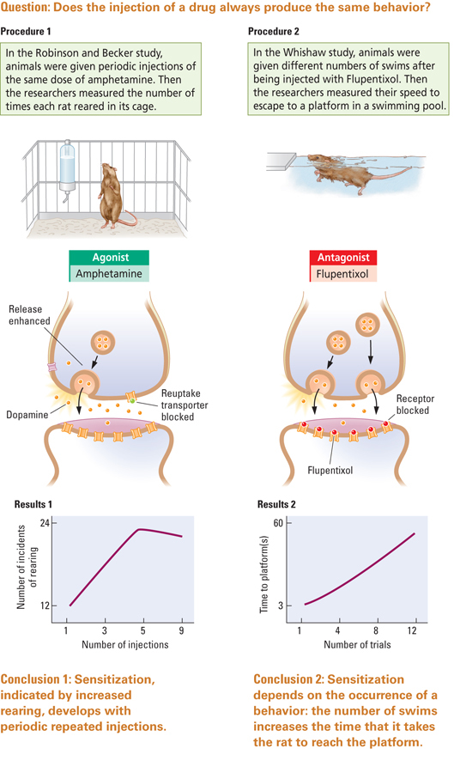every 3-4 days, rats were injected with the drug and rats behaviors was more vigorous with each successive dose. Theey showed an increase response to the drug with each dose.
  - Sensitization can also be a decrease in behaviour. This happened with administration of Flupentixol, a drug that blocks dopamine receptors displaying a decrease in swimming task. The rats displayed a decrease in swimming speed with successive trials.
  - The neural basis of sensitization occurs at the synapse by:
    - more dopamine released from presynapse in amphetamine studies
    - changes in the number of receptors in the post synaptic membrane
    - changesin the rate of metabolism in the synaptic cleft
    - changes in transmitter reuptake by presynapse
    - changes in the number and sizes of synapse
  - sensitization is show that there is a change in a learned response to the environmental cues as senzitiztion progresses.
    - Experiement: 2 groups of rats given amphetamine. One group lived in the test apparatus (out), and the other was home.
    - Home group showed no sensitization; test apparatus (out) had high sensitization
    - This home-out effect shows: rats are accustomed to a certain behaviour at home and it is difficult for them to change the behaviour that home cues. Presumably humans too show sensitization when theye periodically take it in new cues that can readily be associated with novel cognitive &physicological effects

2.Classification of psychoactive drugs
- Treating mental illnesses
- Discovered by accident.
- Pharmaceutical companies develop many forms of drugs to increase effectiveness and decrease side effects
- Drugs with similar chem structures can have different effect, and drugs with different chem structures can have similar effect.classification according to chem structures are not successful. Classifications according to receptors aren’t successful either because drugs can act on different receptors. Classification based on NT aren’t successful etiher because drugs act on differnet NT.
- The classification we will use is based on psychoactive and behavioural effect of a drug. Antianxiety Agents and Sedative Hypnotics
  - Antipsychotic Agents
  - Antidepressants
  - Mood Stabilizers
  - Opioid Analgesics
  - Psychomotor Stimulants
  - Psychedelic and Hallucinogen Stimulants
Antianxiety agents and sedative hypnotics.
        - Low doses: reduce anxiety
        - Medium doses: sedation
        - High doses: aneasthetize or induce coma.
ANTIANXIETY AGENTS aka minor tranquilizers benzodiazepines ex:valium. Used for people having major stresses like death in family, traumatic accident. Also used for presurgery as relaxing agent.

SEDATIVE HYPNOTICS include alcohol and barbiturates used sometimes as sleep meds and mainly used to induce pre-surgery anesthesia.
Alcohol and barbiturates can both induce sleep, anesthesia, and coma at doses only slightly higher than those that sedate.
Users who take the sedative hypnotics at repeated doses can develop tolerance for them. Cross-tolerance is when the tolerance for one drug is carried over to a different member of the drug group.

For both antianxiety and sedative hypnotics: target is the receptor site for the major inhibitory NT GABA. Excitation of the receptors open to influx chloride ionshyperpolarizationinhibitory effect! GABA therefore is decrease neurons rate of firing.

These receptor have three binding sites:
- Sedative hypnotic site: produce GABA-like effect
- GABA site: natural site for GABA biding
- Antianxiety site: enhances the natural action of GABA
GABA NT are reabsorbed quickly by presynapse and glia cells!
Because of their differnet actions these different drugs, antianxiety agents and sedatives should not be taken together. A sedative hypnotic acts like GABA but is not reabsorbed like GABA NTthus it enhances its effect. And combined doeses will produce coma or death!

DISSOCIATICE ANESTHETICS: group fo sedative hypnotics producing altered stae of consciousness and hallucinations. They include GHB, flunitrazepam, and ketamineDATE RAPE DRUG. They impair memories for recent events.

Antipsychotic agents

Psychosis: neurophysiological conditions such as schizophrenia characterized by hallucinations (false sensory perceptions) or delusions (false beliefs).

ANTIPSYCHOTIC DRUGS aka major tranquilizers or neuroleptics have improved functions of schizophrenia.
- They hae immediate effects in reducingmotor activityso they alleviate excessive agitation.
- -ive side effect: produce sympotoms similar to parkinsons by impairing movement.
- Can cause dyskenisia rhythmical movements of the mouth,hands, and other body parts
- Drugs that block dopamine, such as major tranquilizers, blunt reward!! lower sex drive , eating etc…
Dopamine hypothesis of schizophrenia: antipsychotic drugs block the D₂ receptor for dopamine.
- Explains that schizophrenia is excessive dopamine activity with antipsychotics control.
- Hypothesis supported also by the schizophrenia-like symptoms of actions of amphetamine. Amphetamine is a dopamine agonist releases dopamine frok the synapse and blocks its reuptake. This hypothesis is supported because if amphetamine causes like symptoms of schizophrenia, then naturally occurring schizophrenia is because of excessive dopamine.
- HOWEVER experimental studies haven’t found clear evidence of the dopamine hypothesis. Brains of schizo patients do not have more dopamine synapse, release more dopamine from presynapse or possess more D2 receptors. 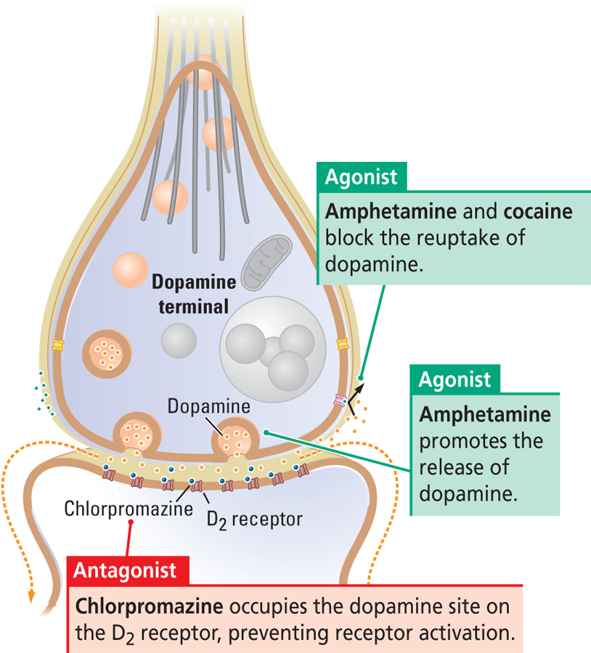

Antidepressants:

Major depression: mood disorder symptoms of prolonged feeling of worthlessness and guilt, disruption of normal eating habits, sleep disturbances, a general slowing of behavior, and frequent thoughts of suicide.
Antidepressants act by improving NT at serotonin, noradrenalin, histamine, acetylcholine synapses, and perhaps dopamine as well.
3 TYPES OF ANTIDEPRESSANT:
- MONOAMINE OXIDASE(MAO) INHIBITORS:
  - Inhibit monoamine oxidase, an enzyme that breaks down monoamines (like serotonin) within the axon terminal. In effect, this will provide mnore serotonin release
- TRICYCLIC ANTIDEPRESSANTS:
  - Block reuptake of serotonin into axon terminal – thus keeping them in synapse longer
  - Selective in blocking serotonin reuptake so they are called SSRIs – selective serotonin reuptake inhibitors.
- SECOND GENERATION ANTIDEPRESSANTS AKA atypical antidepressants (ie Prozac):
  - Block reuptake of serotonin into axon terminal – thus keeping them in synapses longer.
  - Prozac: increases production of neurons in hippocampus. The hippocampus is vulnerable to stress induced damage, and its restoration by Prozac has been proposed to underlie the drug’s antidepressant effect.
  - Prozac can also be used to treat OCD-obsessive compulsive disorder.

- Antidepressants actions take weeks to develop, even if they act on the synapse quickly.
- Side effects: increase anxiety, sexual dysfunction, sedation, dry mouth, blur vision, memory impairment.

Mood stabilizers:
Bipolar disorder: aka manic depressive illness, is mood disorder which has alternations of mood with normal periods and periods of intense excitation (mania).
This has been frequently treated with drugs called mood stabilizers.
LITHIUM increases synaptic release of serotonin, and valproate may stimulate GABA activity. Typically, mood stabilizers mute the intensity of one pole of the disorder, thus making the other pole less likely to recur.

Opioids analgesics:

Opioid analgesics is any compounds that bind to brain receptors in the brain that are sensitive to morphine. Aka narcotic analgesics. Opioid analgesics induce sleep (narcotic) and relief pain (analgesic).

Main source of opioids is OPIUM
- Extracted from the opium poppy PAPAVER SOMNIFERUM
- Used in pass for euphoria, sleep, analgesics, diarrhea relief, coughing.
- Two pure opiates(purely extracted from opium): codeine and morphine
- Codeine: cough medicine, pain relievers. It is converted into morphine by the liver.
- Morphine: powerful pain reliever!

Second source of opioids is the BRAIN:
- Number of brain peptides identified as NTs that naturally affect the receptors in brain
- The peptides I the body that have morphine-like effect are called endorphins (endogeneous morphines)
- Three classes of endorphins: endomorphins, enkephalins, dynorphins
- Three receptors: mu, kappa, delta on which the above endorphins are binded to respectively.
- Morphine mimics the endomorphins, and bind selectively to mu receptors

In addition to natural opiods, many synthetic opioids such as morphine affect the mu receptor.
- Heroin is synthesized from morphine. It is more fat soluble thus penetrates the BBB much easier. It produces fast but short relief from pain.
- Opioids used in clinical use : hydromorphones, levorphanol, oxymorphone, methadone, meperdine, oxycodone, fentanyl.
- Opioids are addictive.
- Sometimes used illegally like heroin
- People who use them for pain relief, can become addicted!
- A number of drugs act as antagonists at opioid receptors. Such as nalorphine, and naloxone. These are competitive inhibitors, they compete with opioids for receptors! Because they can quickly enter the brain the can quickly block the actions of morphine and so are useful in treating morphine overdose.
- The hypodermic needle was used in American civil was for IV injection of morphine for pain treatment.
- Morphine does not readily cross the BBB whereas heroin is more likely to produce a rush.
- If opiods are used repeatedly it can produce tolerance, that within weeks it can increase 10-fold effective dosage. Afterward the effect can no longer be realized.
- An addicted person cannot simply just stop. WITHDRAWAL can occur. Because morphine can result in both sensitization and tolerance, the morphine user is always flirting with the possibility of overdose.
- Opiods produce: pain relief including relaxation and sleep, euphoria, constipation, respiration depression, decrease blood pressure, pupil constriction, hypothermia, reduced sex drive, flush warm skin. Withdrawal shows opposite of these effects

Psychomotor stimulants

Two groups: behavioral stimulants and general stimulants.

BEHAVIORAL STIMULANTS
- Increase motor behavior as well as elevate mood and level of alertness.
- Examples: cocaine and amphetamine.
- Cocaine can be sniffed or injected. Cheaper version to smoke comes in rock forms called “crack”.
- The main use of coca (main leaf where cocaine is produced from) is to increase physical capacity for the body and hold strength to meet demands.
- Cocaine was used in coca cola to promote invigorating tonics
- Freud suggested to a friend to relief the pain from an amputation he had. But it showed that cocaine also produced euphoria and is addictive.
- Freud also showed: cocaine is valuable as a local aneathetic, and many derivatives from it such as Novocaine is used commonly today.
- Amphetamine synthetic compound to micick the NT epinephrine (aka adrenalin).
- Both amphetamine and cocaine are dopamine agonist that act by blocking the reuptake of dopamine.
- Amphetamine also stimulates the release of dopamine from presynapse.
- These are abused by students as an aid for focusing in studying for examinations
- Today its used as a weight loss aid.
- Some would be abusing it IV (intravenously) to remain wide awake and excited without eating. They would crash after a few days, and then wake up to restart this cycle.
- Amphetamine derivatives: common illegal drug is methamphetamine aka meth, speed, crystal ice is widespread.
GENERAL STIMULANTS
- Drugs that cause overall increase in metabolic activity of cells.
- Caffeine: widely used stimulant, inhibits an enzyme that ordinarily breaks down a second messenger called cAMPincrease of cAMP leads to an increase in glucose production more energy in the cells and higher rate of cellular activity

Psychedelic and hallucinogenic stimulants:

Alter sensory perception and cognitive processes and can produce hallucinations. Four major groups categorized by action on NT:

- ACh psychedelics: block or facilitate transmission at ACh synapses.
- Norepinephrine psychedelics: obtained from peyote cactus for used by Native Americans for religious/spiritual purposes.
- Serotonin psychedelics: consciousness altering by affecting serotonergic neurons. LSD and psilocybin stimulate Postsynaptic receptors of some serotonin synapses. Also block activity of other seretonergic neurons through serotonin autoreceptors. May also stimulate other transmitters
- THC : active ingredient of marijuana. Acts on endogenous THC receptors called CB1 and CB2 receptors—thought to be receptors of NT called anandamide. Anandamide plays a role in enhancing forgetting the idea is that it prevents the memory system from being overwhelmed by information that which the brain is exposed to everyday. Thus THC can have a detrimental effect on memory.
THC can be used as a therapeutic agent for a number of clinical conditions such as relieving nausea and emesis (vomiting) in patients undergoing chemotherapy. It is also useful as an appetite stimulant in AIDS patient suffering from anorexia-cachexia(wasting) syndrome. THC also help relief pain: it has helped relief pain from increase pressure in the eye (glaucoma) and for multiple sclerosis and spinal cord injuries.

