TSES 3002AV Thursday Jan 5, 2012
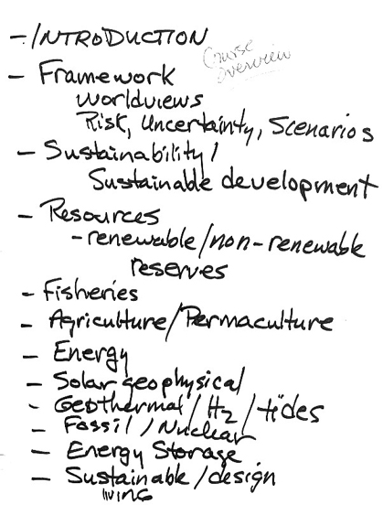

TSES 3002AV Thursday Jan 5, 2012
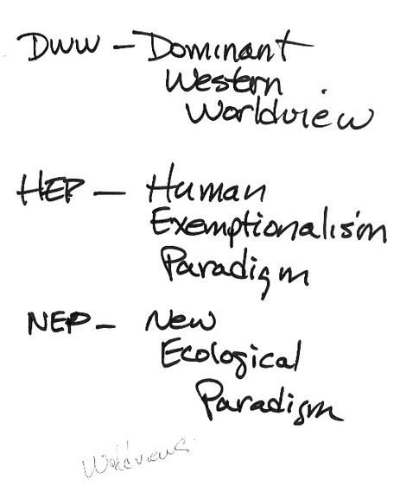

TSES 3002AV Thursday Jan 5, 2012
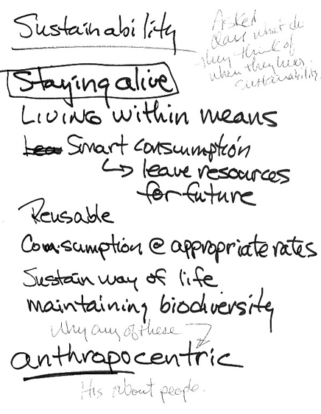
Tuesday January 10, 2012
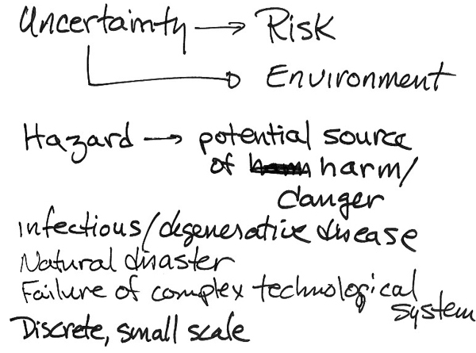
Tuesday January 10, 2012
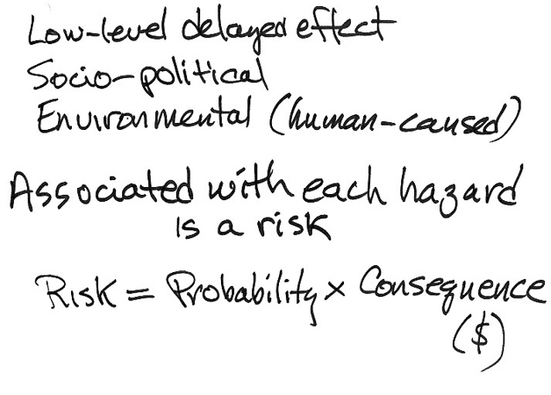
Tuesday January 10, 2012
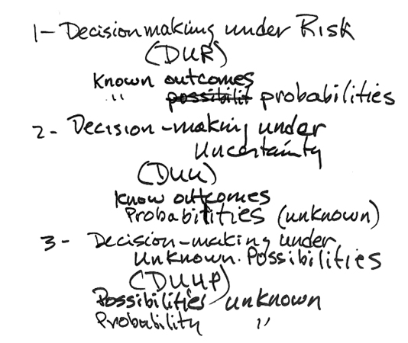
Tuesday January 10, 2012

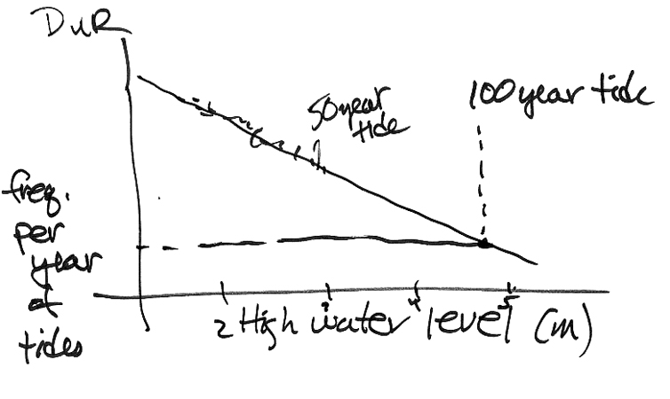

Tuesday January 10, 2012
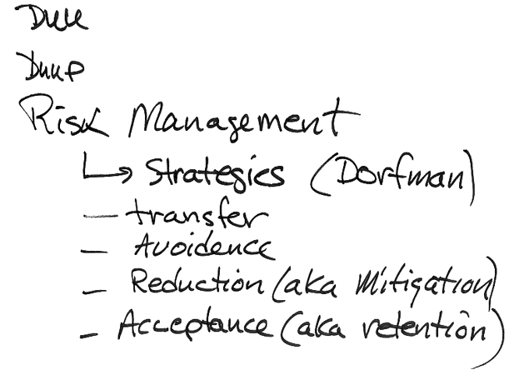
Tuesday January 10, 2012
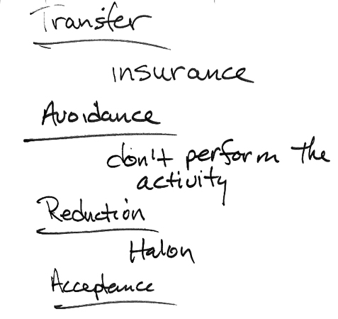
Tuesday January 10, 2012
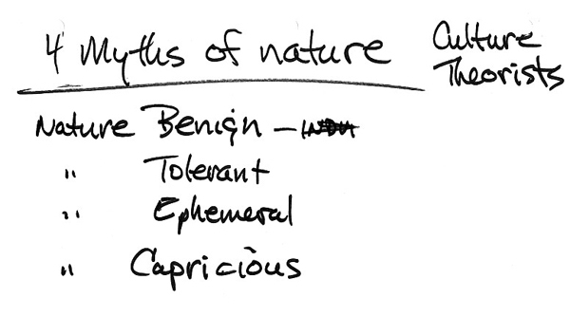
TSES 3002AV Thursday Jan 12

Rita Donovan guest lecture on scenarios and the future.
TSES 3002AV Tuesday Jan 17, 2012
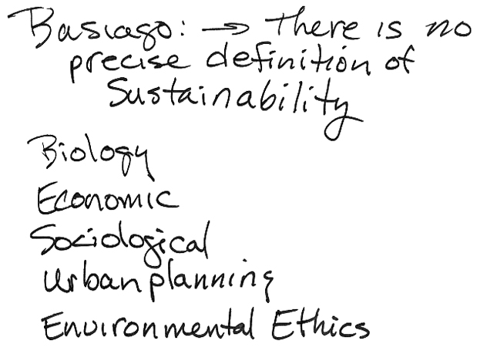
TSES 3002AV Tuesday Jan 17, 2012

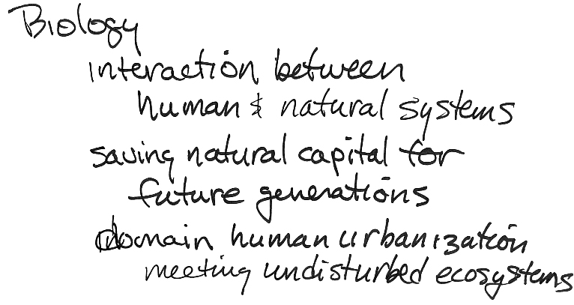

TSES 3002AV Tuesday Jan 17, 2012

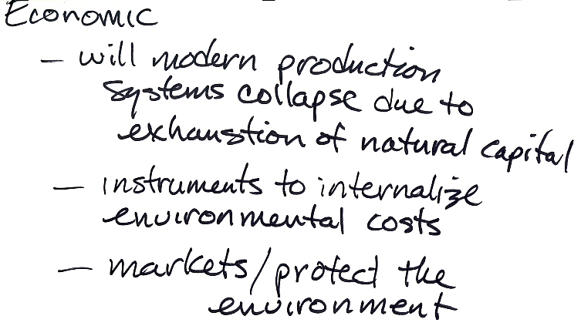

TSES 3002AV Tuesday Jan 17, 2012
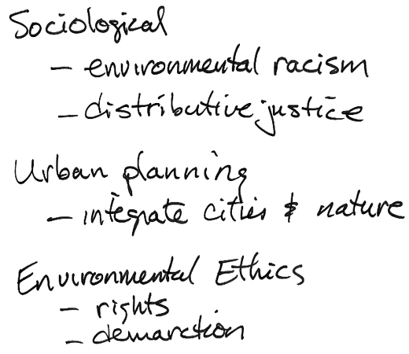
TSES 3002AV Tuesday Jan 17, 2012
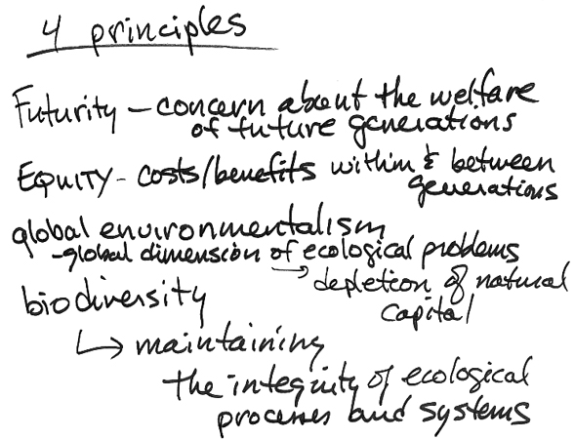
TSES 3002AV Tuesday Jan 17, 2012
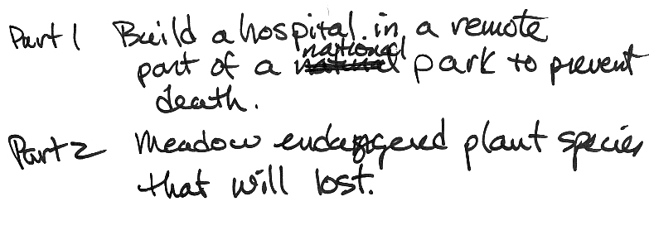

TSES 3002AV Tuesday Jan 17, 2012
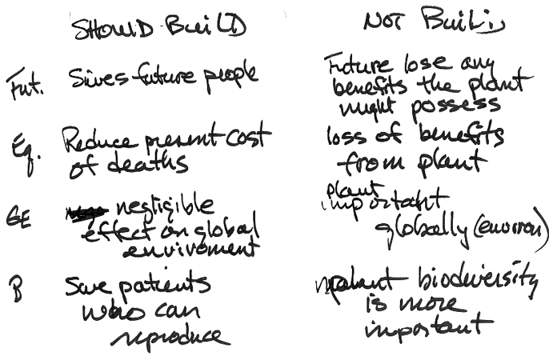
TSES 3002AV Thursday Jan 19, 2012
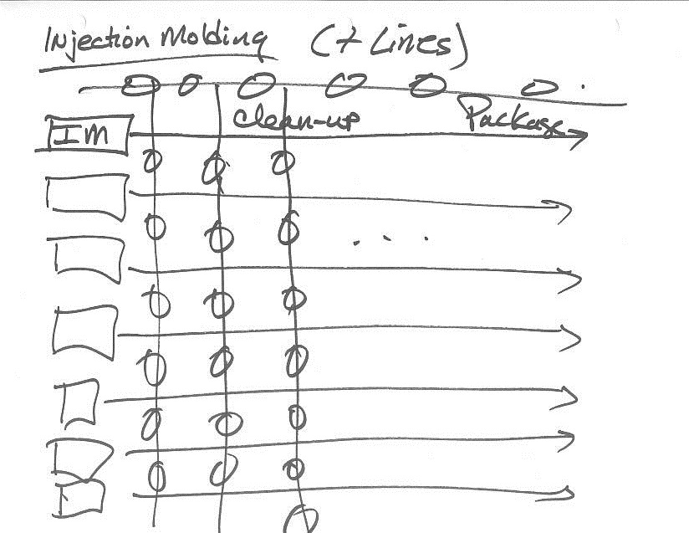
TSES 3002AV Thursday Jan 19, 2012
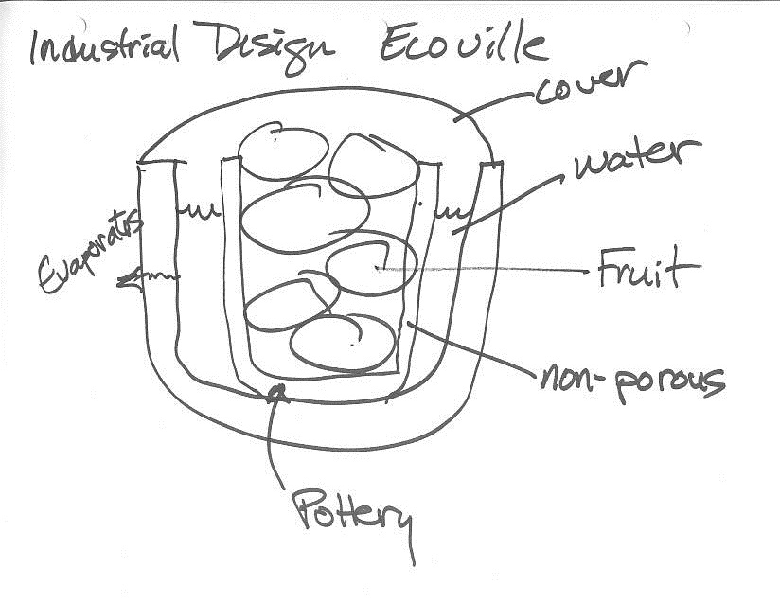
TSES 3002AV Thursday Jan 19, 2012
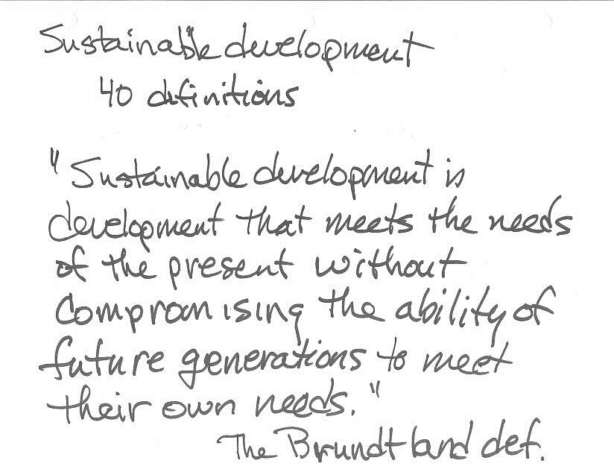
TSES 3002AV Thursday Jan 19, 2012
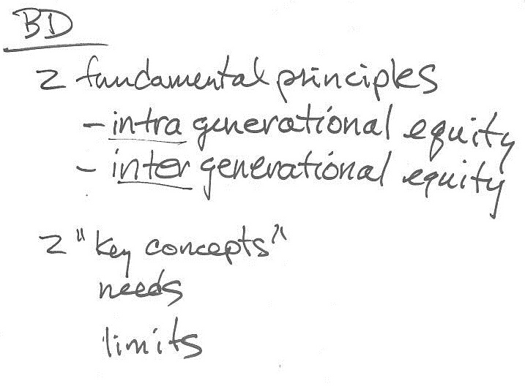
TSES 3002AV Thursday Jan 19, 2012
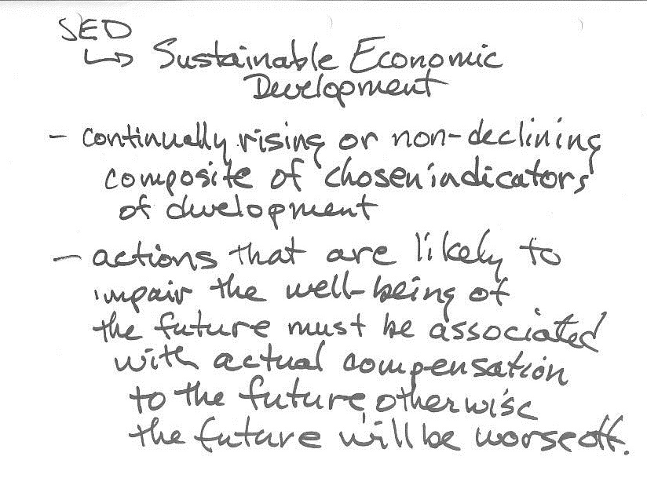
TSES 3002AV Thursday Jan 19, 2012
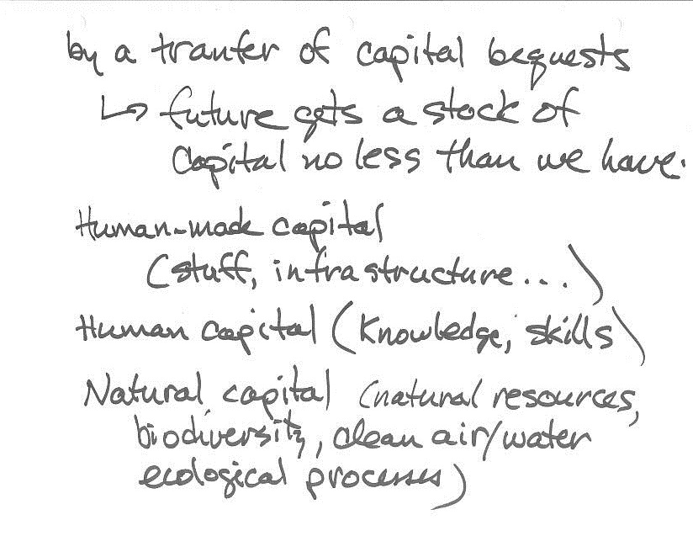
TSES 3002AV Thursday Jan 19, 2012
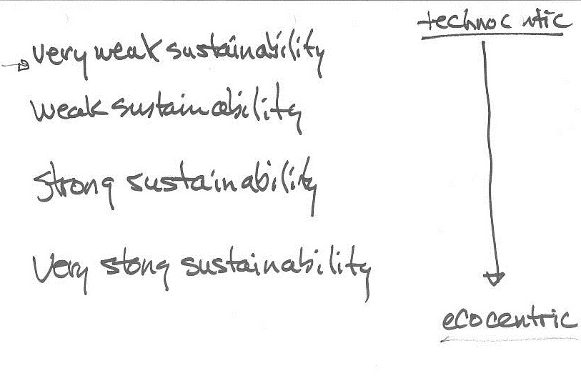
TSES 3002AV Thursday Jan 19, 2012
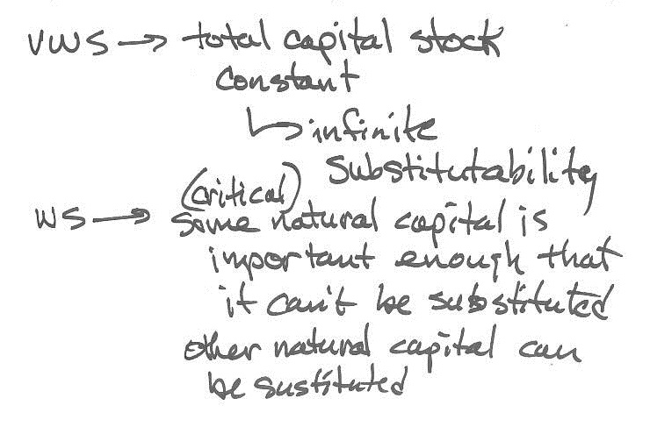
TSES 3002AV Thursday Jan 19, 2012
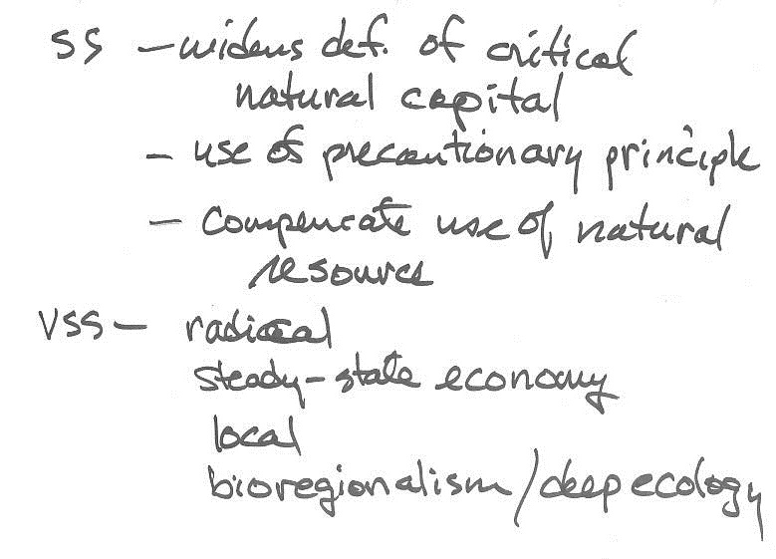
TSES 3002AV Thursday Jan 19, 2012

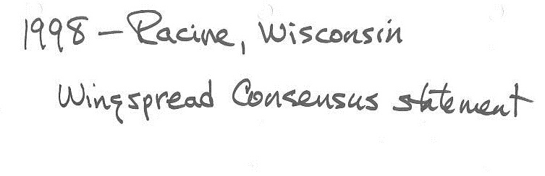

TSES 3002AV Thursday Jan 19, 2012
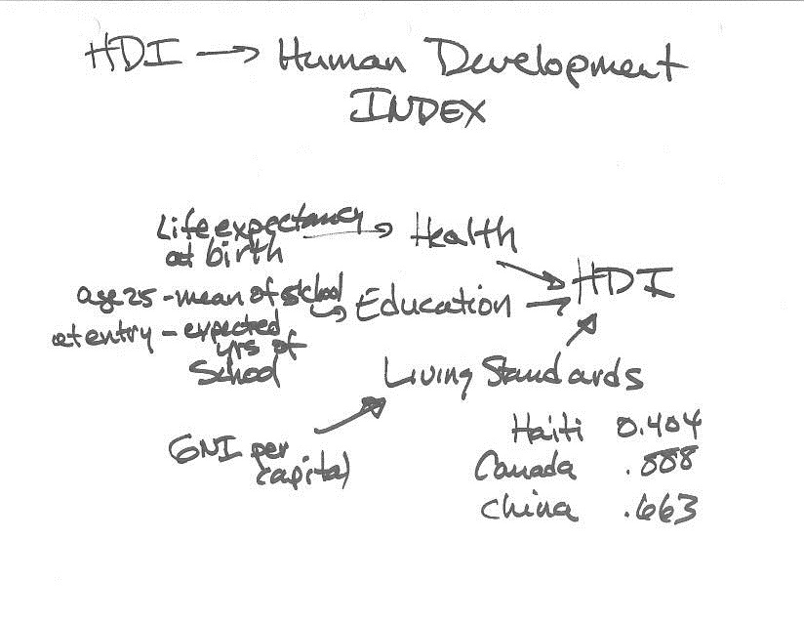
TSES 3002AV Thursday Jan 19, 2012
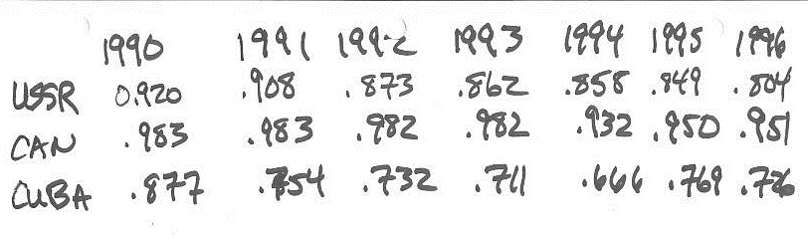
TSES 3002AV Tuesday Jan 24, 2012
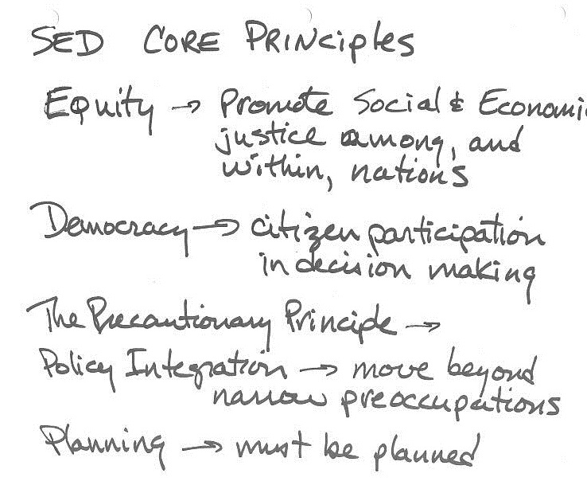
TSES 3002AV Tuesday Jan 24, 2012
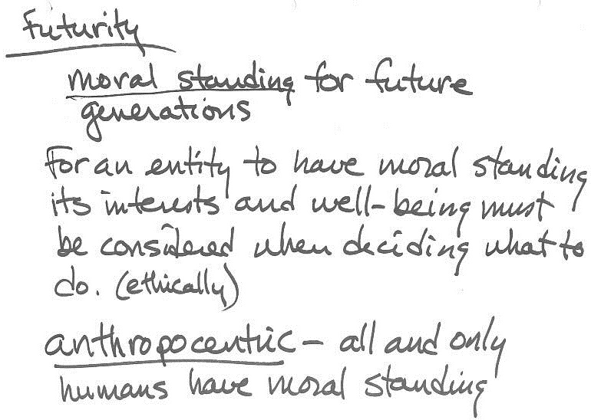
TSES 3002AV Tuesday Jan 24, 2012
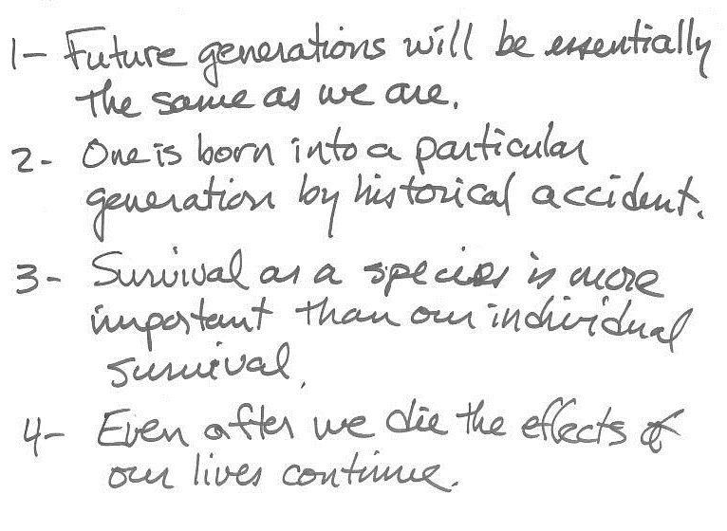
TSES 3002AV Tuesday Jan 24, 2012
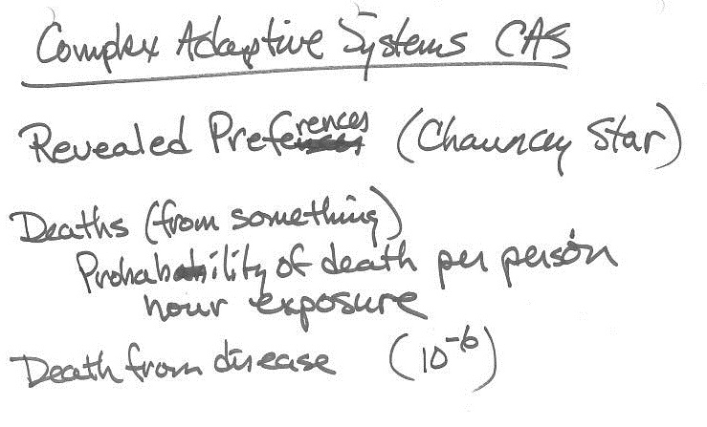

TSES 3002AV Tuesday Jan 24, 2012
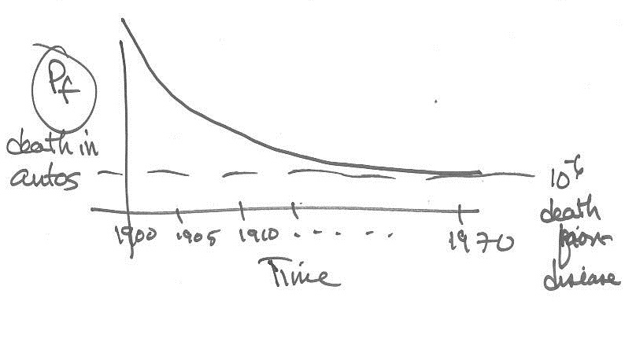

TSES 3002AV Tuesday Jan 24, 2012
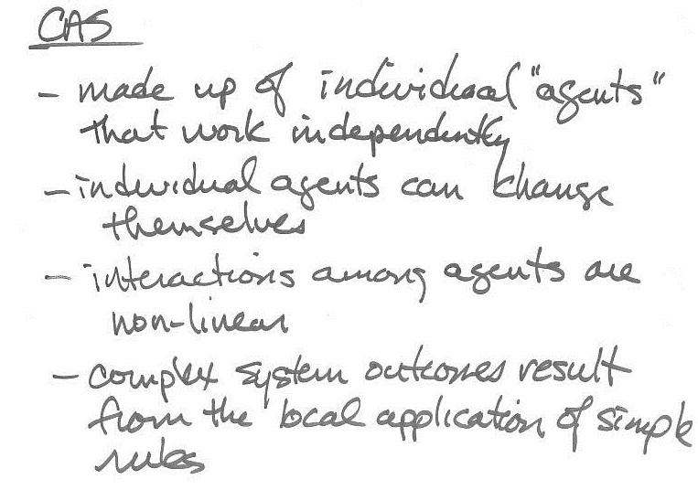
TSES 3002AV Tuesday Jan 24, 2012
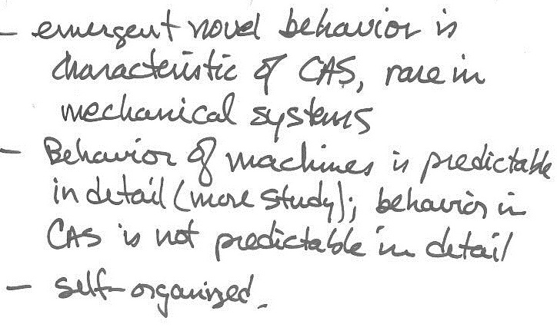

TSES 3002AV Tuesday Jan 24, 2012
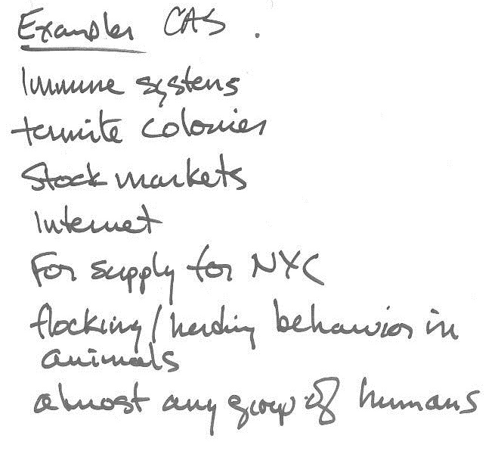
TSES 3002AV Tuesday Jan 24, 2012
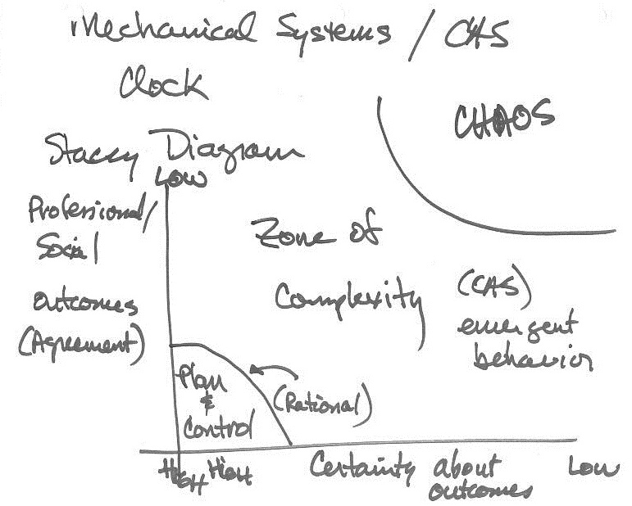
TSES 3002AV Tuesday Jan 24, 2012
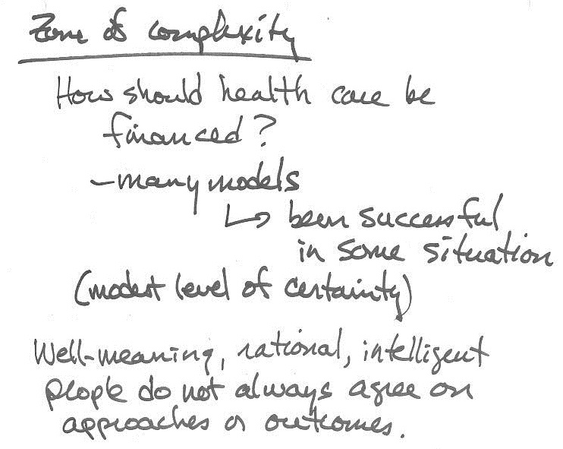
TSES 3002AV Tuesday Jan 24, 2012
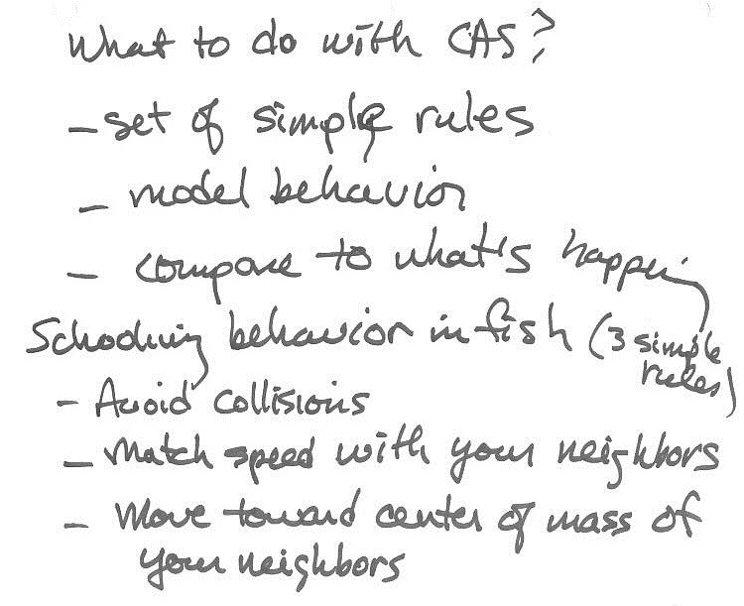
TSES 3002AV Thursday Jan 26, 2012
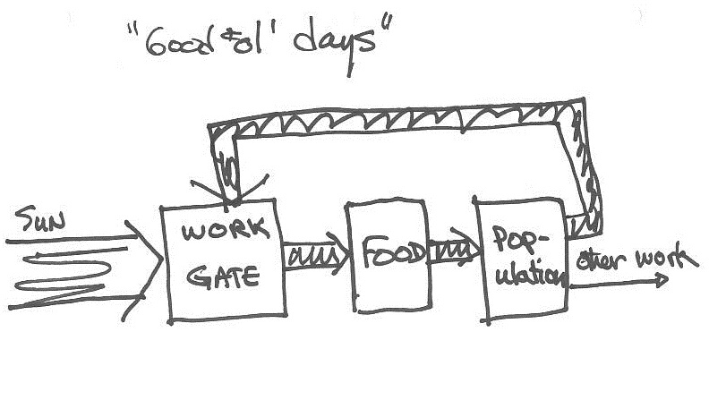

TSES 3002AV Thursday Jan 26, 2012
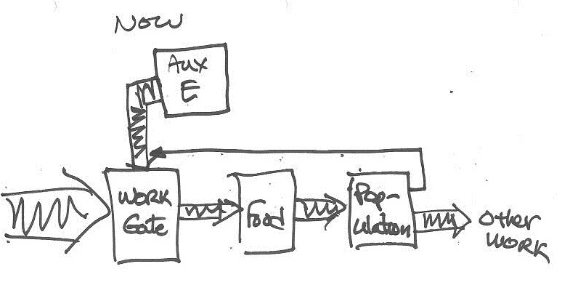

TSES 3002AV Thursday Jan 26, 2012
Chris Bisson Guest Lecture: Permaculture Project Ottawa
TSES 3002AV Tuesday Jan 31
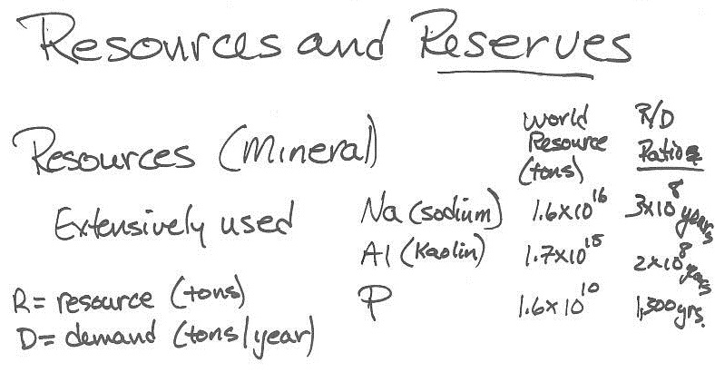

TSES 3002AV Tuesday Jan 31
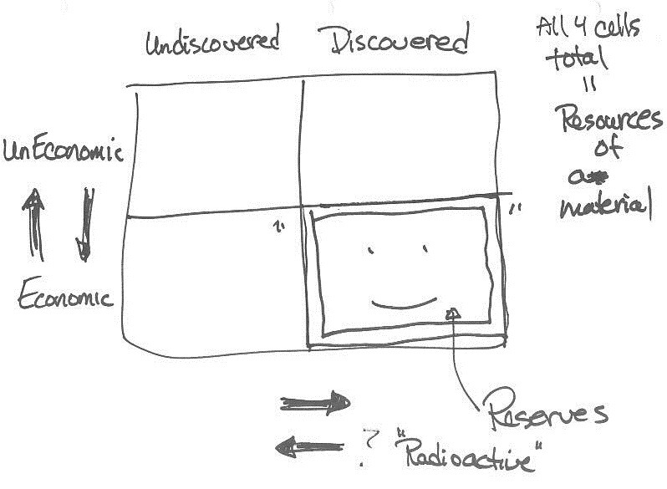
TSES 3002AV Tuesday Jan 31
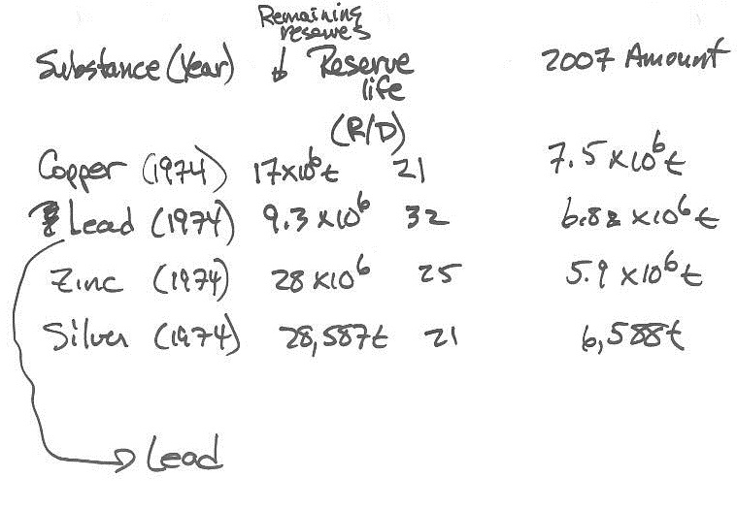
TSES 3002AV Tuesday Jan 31
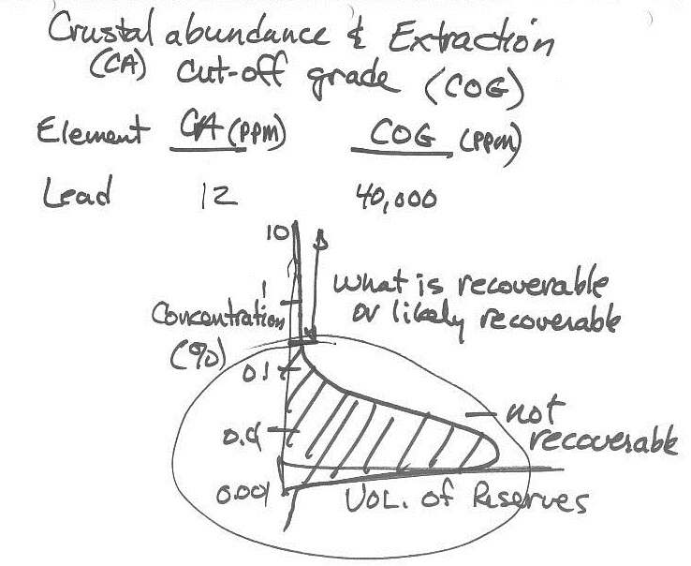
TSES 3002AV Tuesday Jan 31
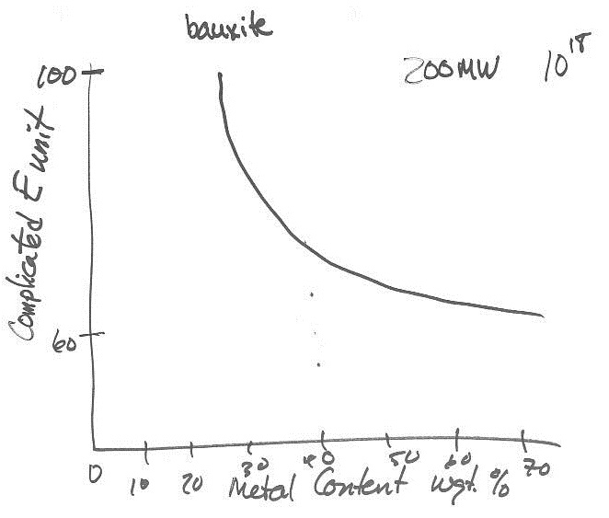
TSES 3002AV Tuesday Jan 31
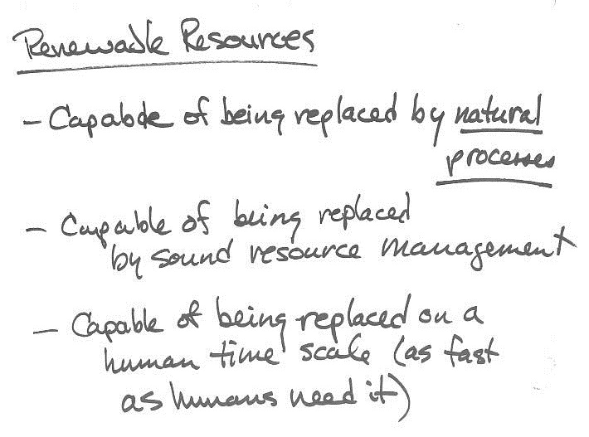
TSES 3002AV Thursday Feb 2, 2012
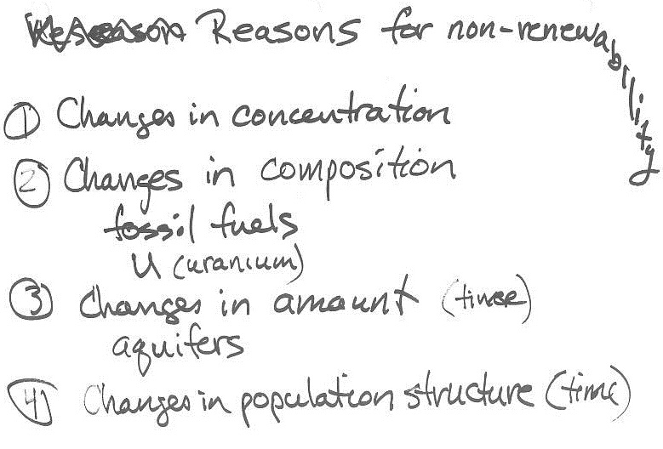
TSES 3002AV Thursday Feb 2, 2012
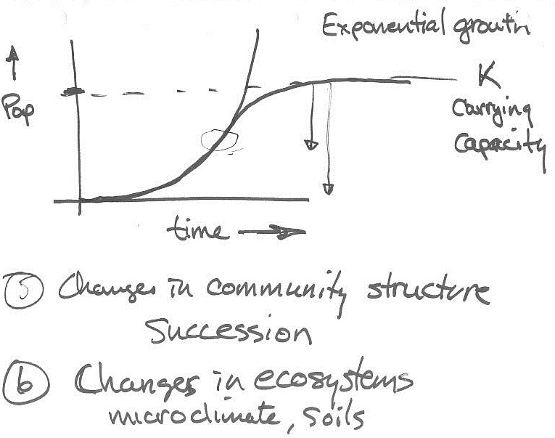
TSES 3002AV Thursday Feb 2, 2012
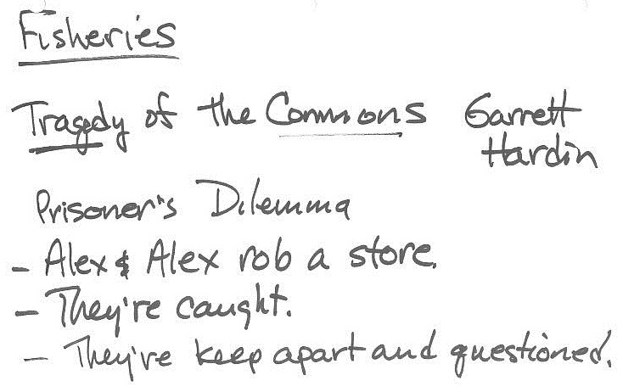

TSES 3002AV Thursday Feb 2, 2012
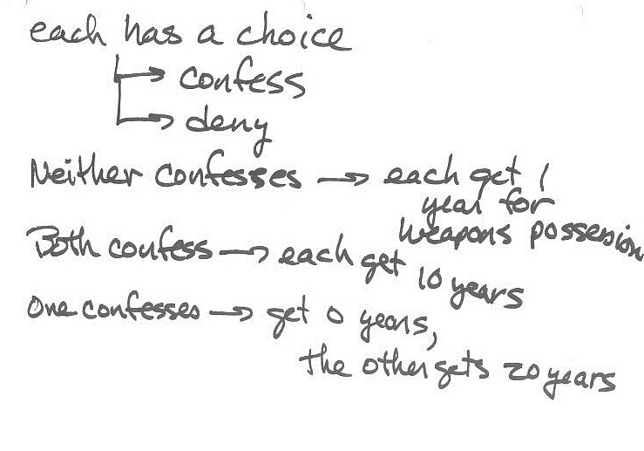
TSES 3002AV Thursday Feb 2, 2012
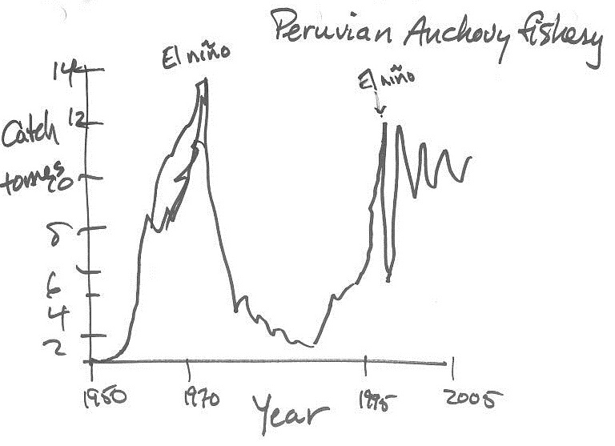

TSES 3002AV Tuesday Feb 7, 2012

Daniel Pauly Video about fishing.
TSES 3002AV Tuesday Feb 7, 2012
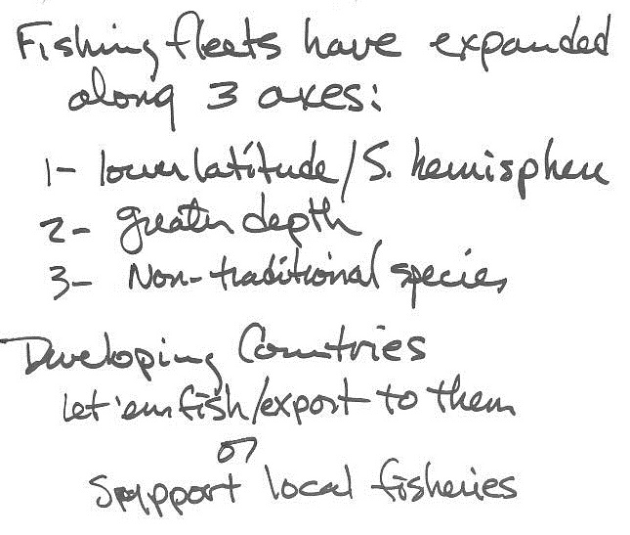
TSES 3002AV Tuesday Feb 7, 2012
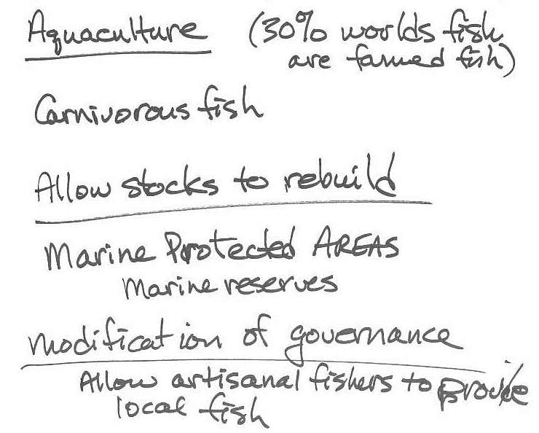
TSES 3002AV Tuesday Feb 7, 2012
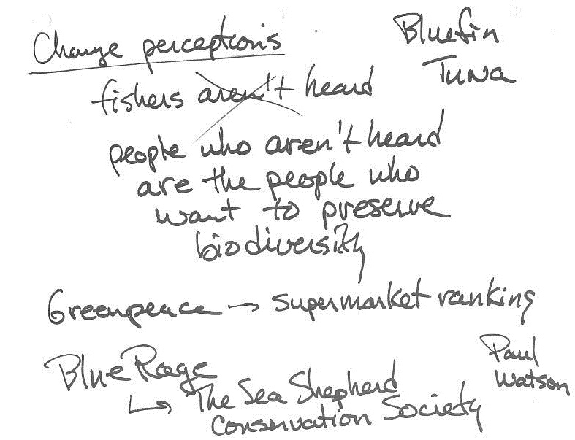
TSES 3002AV Tuesday Feb 7, 2012
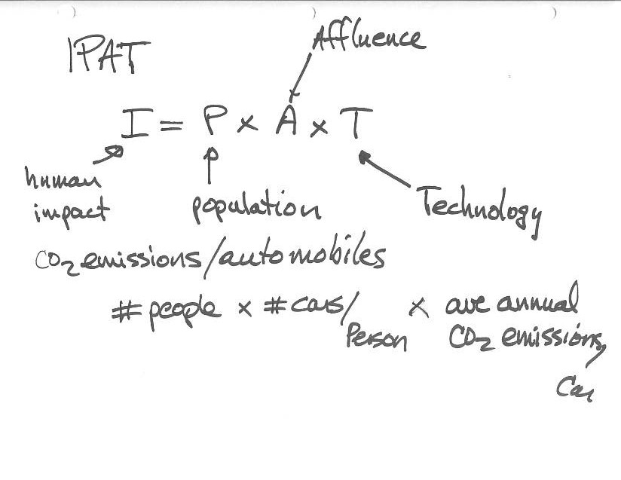
TSES 3002AV Thursday Feb 9, 2012

TSES 3002AV Thursday Feb 9, 2012

TSES 3002AV Thursday Feb 9, 2012
The Power of Community Video
TSES 3002AV Tuesday Feb 14, 2012
Sepp Holzer
Permaculture Video

TSES 3002AV Tuesday Feb 14, 2012
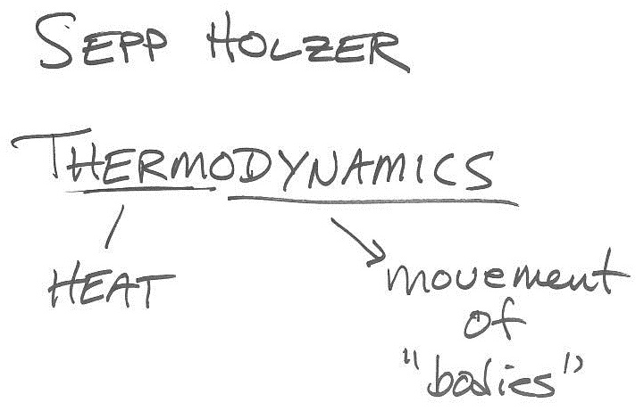
TSES 3002AV Tuesday Feb 14, 2012
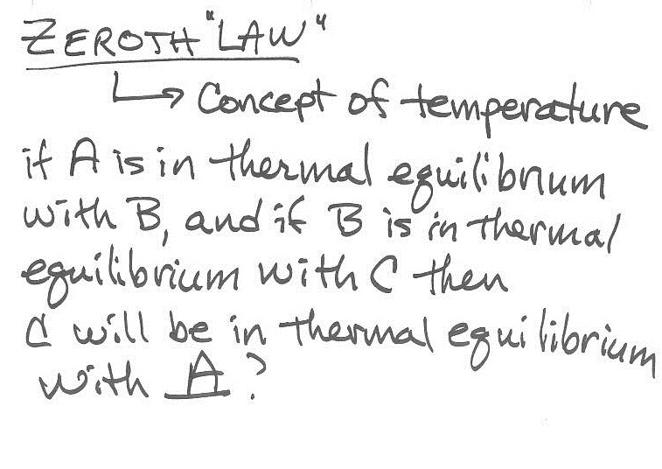
TSES 3002AV Tuesday Feb 14, 2012
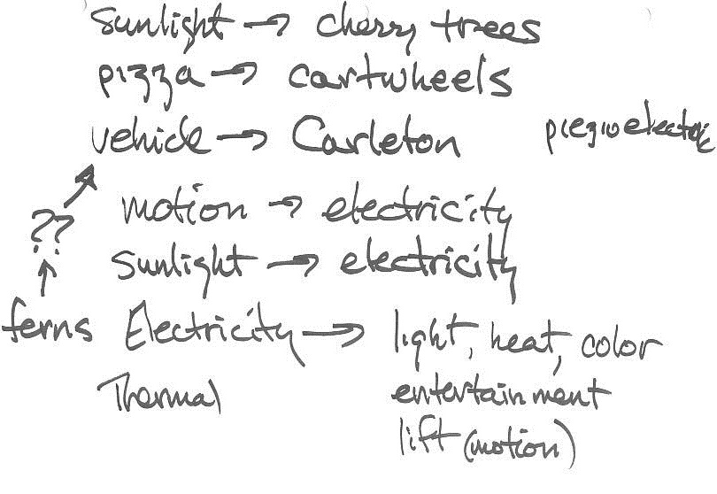
TSES 3002AV Tuesday Feb 14, 2012
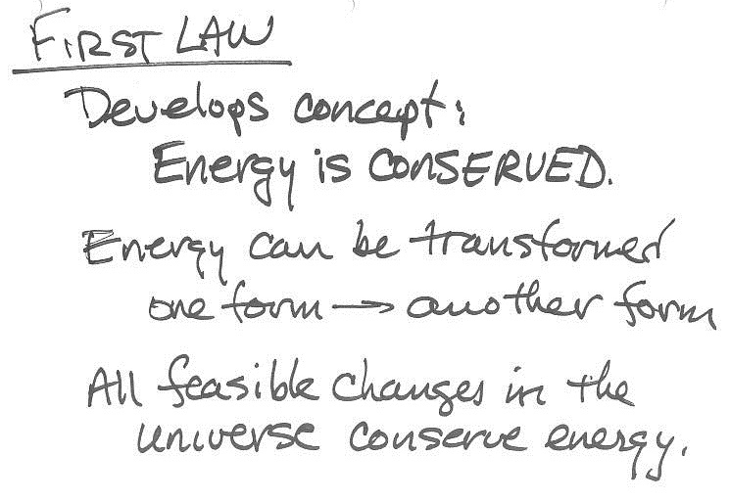
TSES 3002AV Tuesday Feb 14, 2012
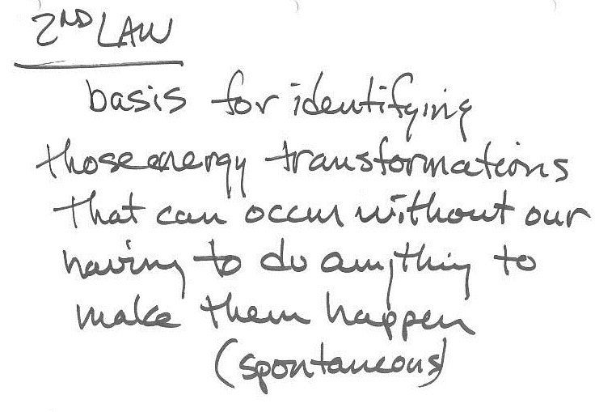
TSES 3002AV Tuesday Feb 14, 2012
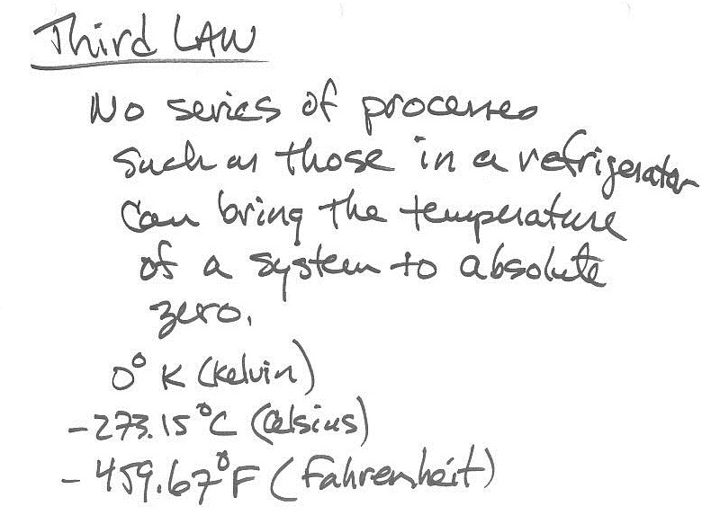
TSES 3002AV Thursday Feb 16, 2012
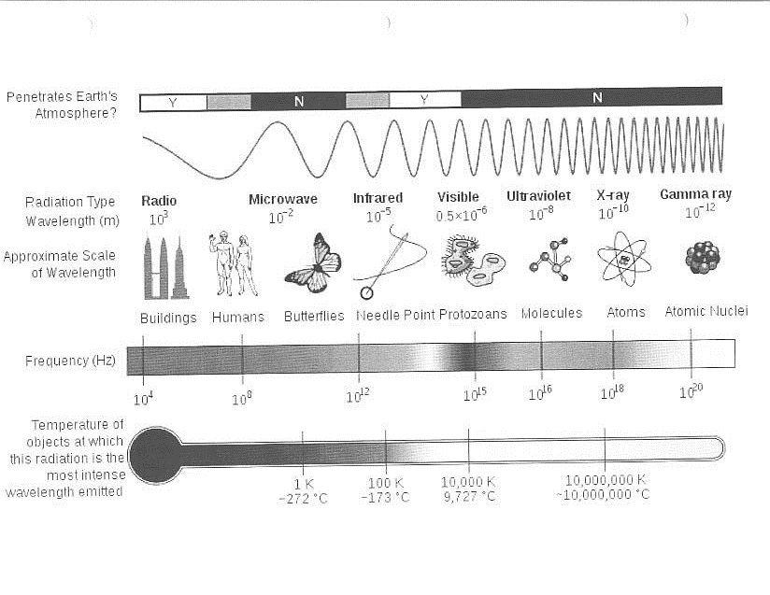

TSES 3002AV Thursday Feb 16, 2012
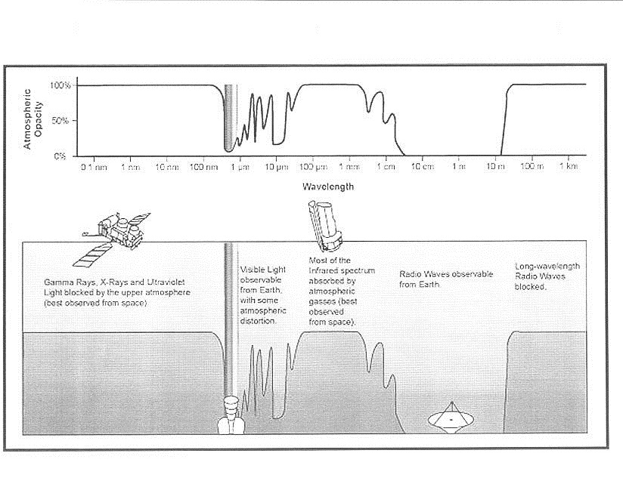
TSES 3002AV Thursday Feb 16, 2012
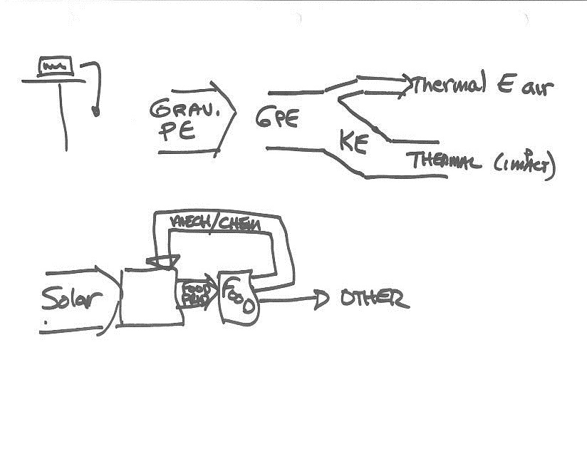
TSES 3002AV Thursday Feb 16, 2012
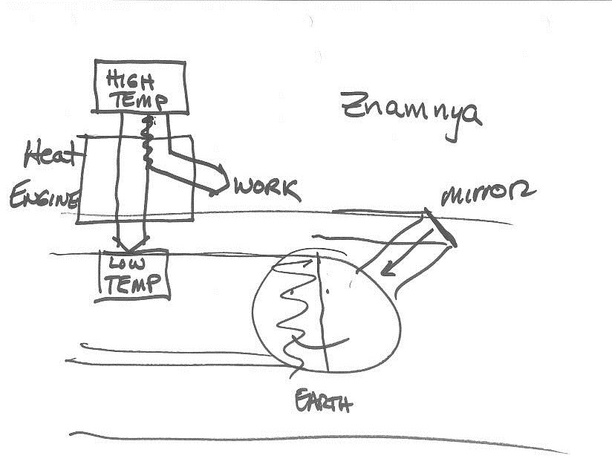
TSES 3002AV Thursday Feb 16, 2012
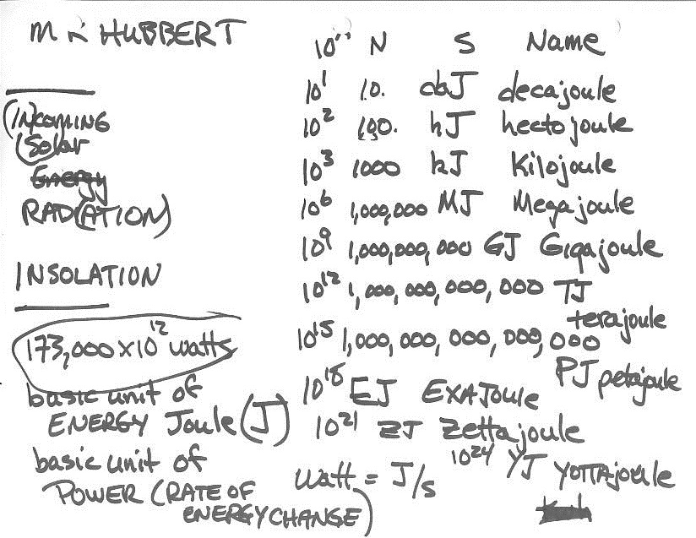
TSES 3002AV Thursday Feb 16, 2012
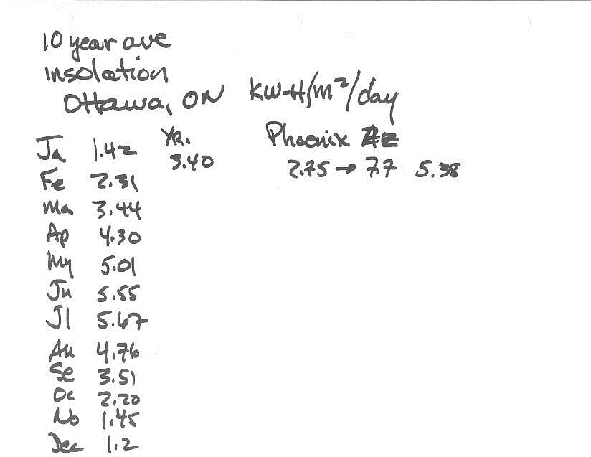
TSES 3002AV Thursday Feb 16, 2012
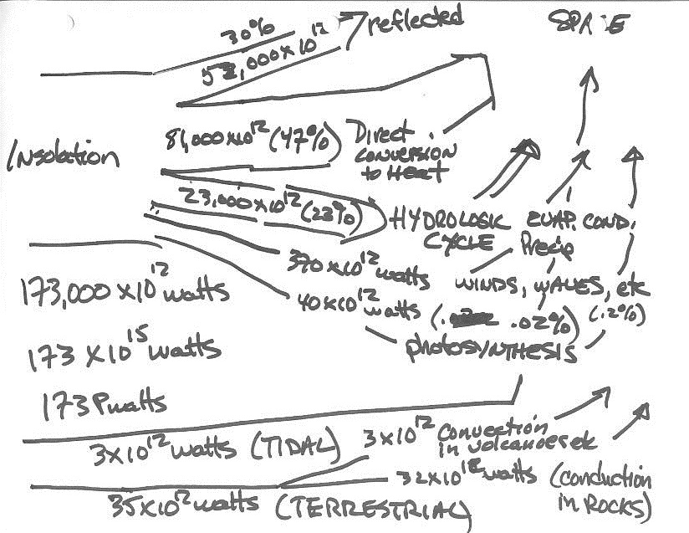
TSES 3002AV Tuesday Feb 28, 2012
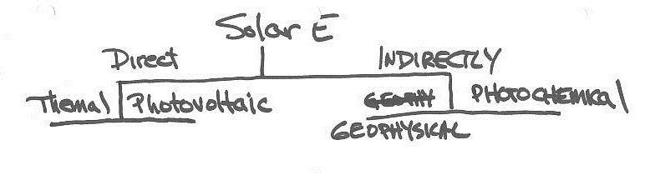

TSES 3002AV Tuesday Feb 28, 2012
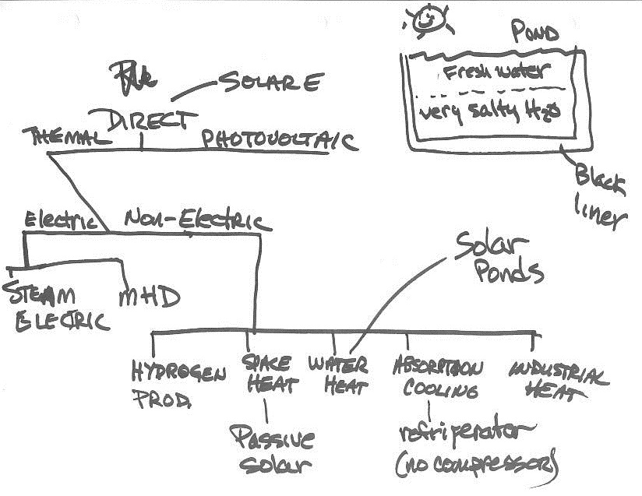
TSES 3002AV Tuesday Feb 28, 2012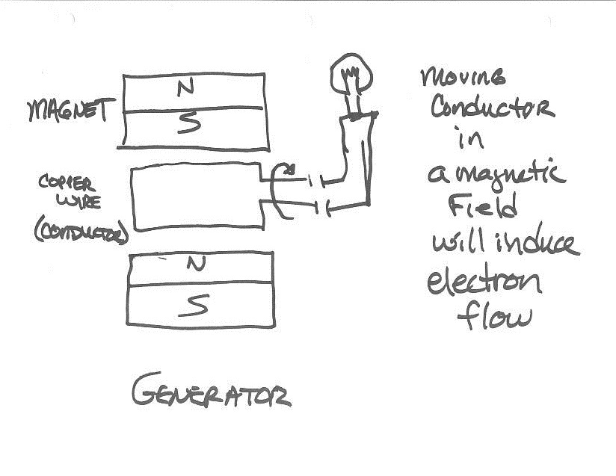

TSES 3002AV Tuesday Feb 28, 2012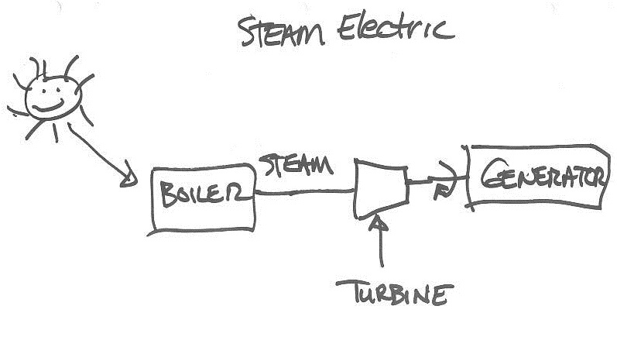

TSES 3002AV Tuesday Feb 28, 2012
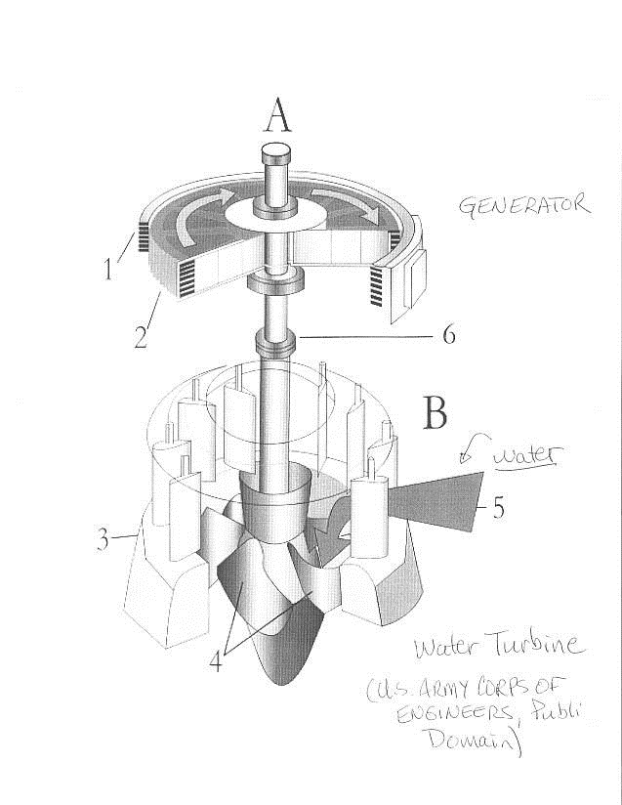
TSES 3002AV Tuesday Feb 28, 2012
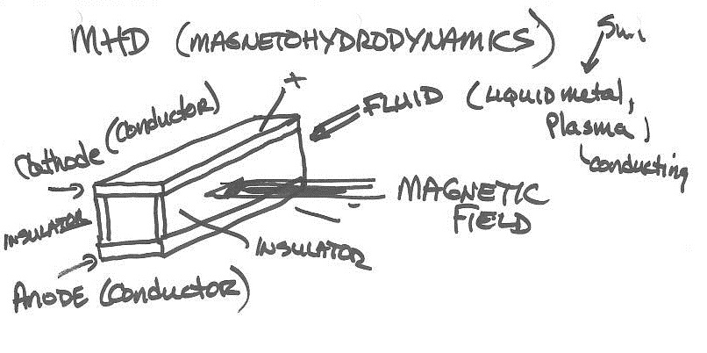
Class 7A
MHD-magnetohydrodynamics

TSES 3002AV Tuesday Feb 28, 2012
TSES 3002AV Tuesday Feb 28, 2012
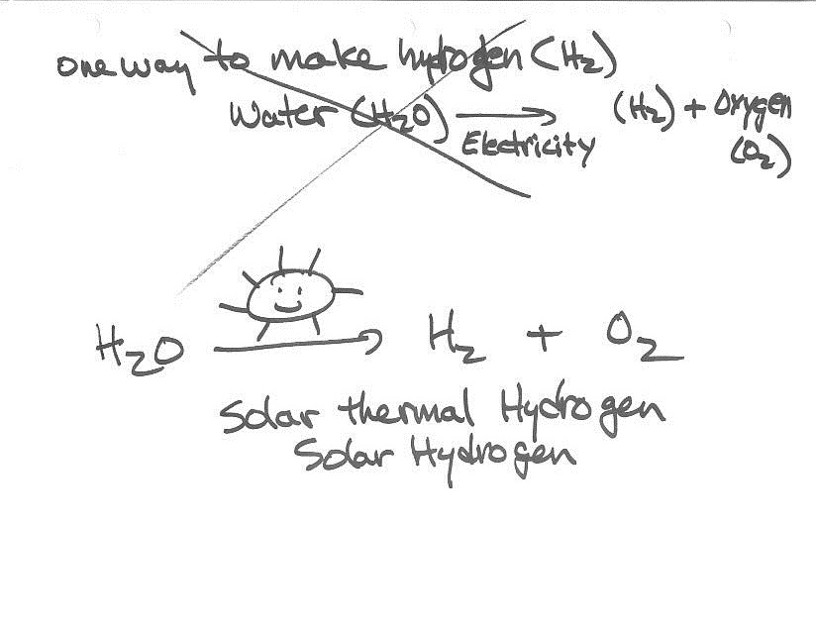
TSES 3002AV Tuesday Feb 28, 2012
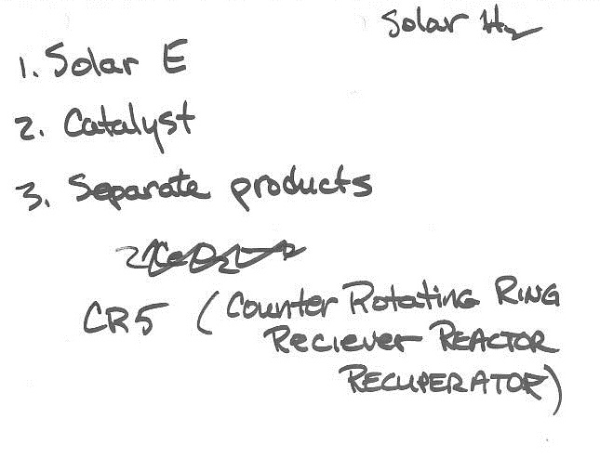
TSES 3002AV Tuesday Feb 28, 2012
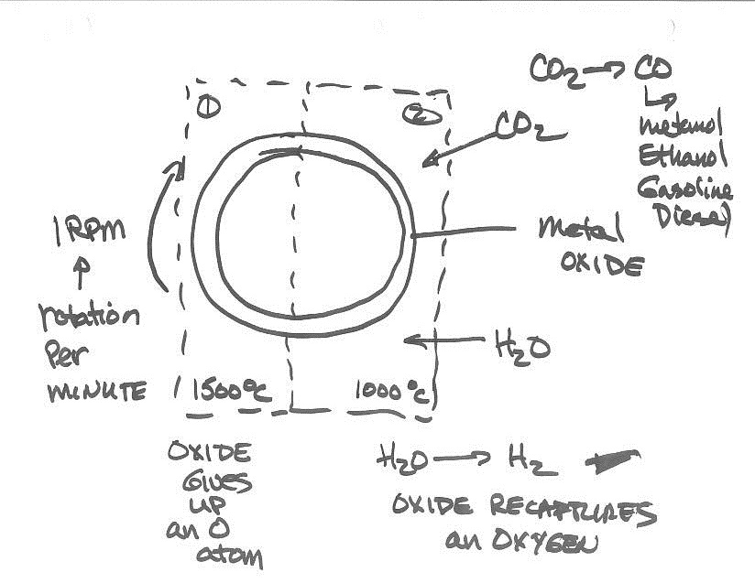
First chamber is 1500deg hot enough the oxide gives up an Oxygen atom..it hits the cooler 1000deg chamber and water is added..it turns the h2o to h2..oxide recaptures an oxygen…can put anything that has an oxygen. Multiple rings (14) opposite to the one adjacent to it.
TSES 3002AV Tuesday Feb 28, 2012
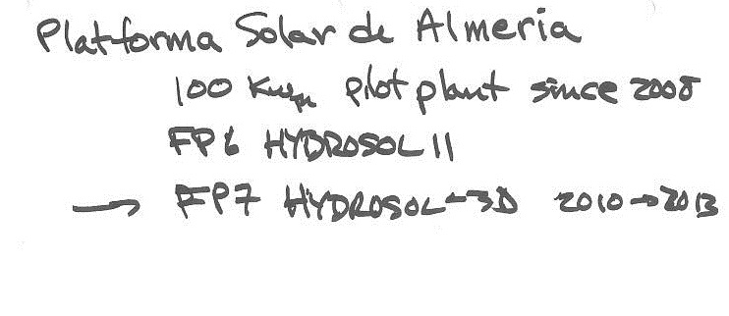

Generates hydrogen directly from the sun heliostat big field of solar reflectors all focused into one spot that hit top of a tower-> high temperatures. Use that to drive the chemical reactions

TSES 3002AV Tuesday Feb 28, 2012 class 7a
Water heat-fresh water on salty water…salt water more dense it does not flow..so salt water remains heated 80-90 deg cel. Run a pipe and transfer the heat elsewhere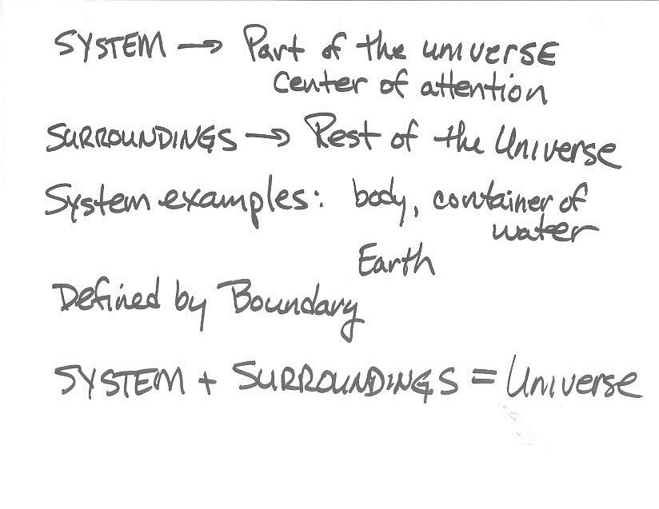
TSES 3002AV Mar 1, 2012
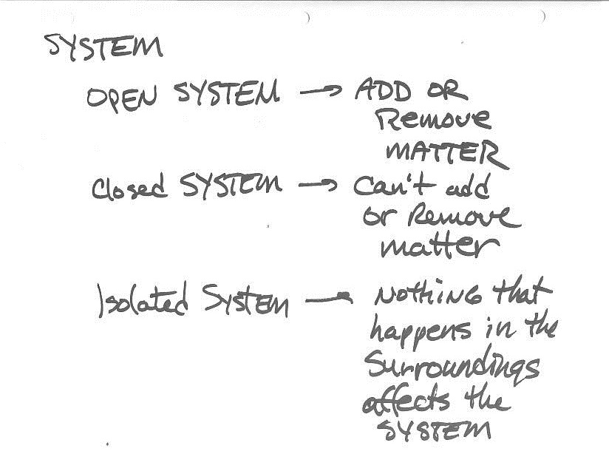
TSES 3002AV Mar 1, 2012
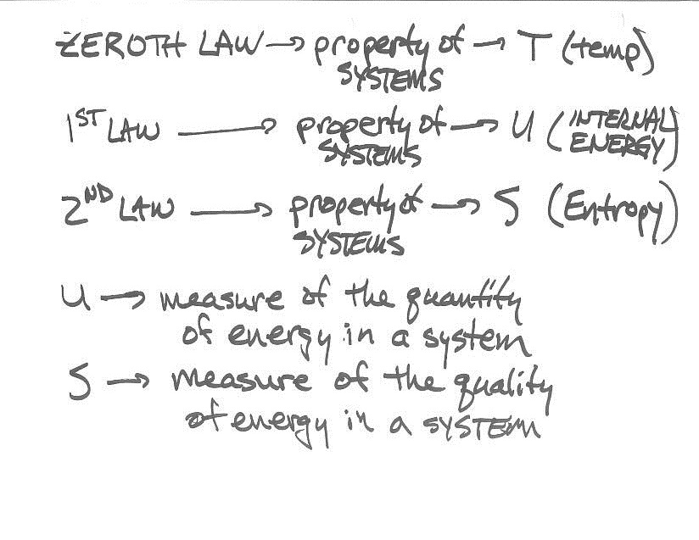
TSES 3002AV Mar 1, 2012
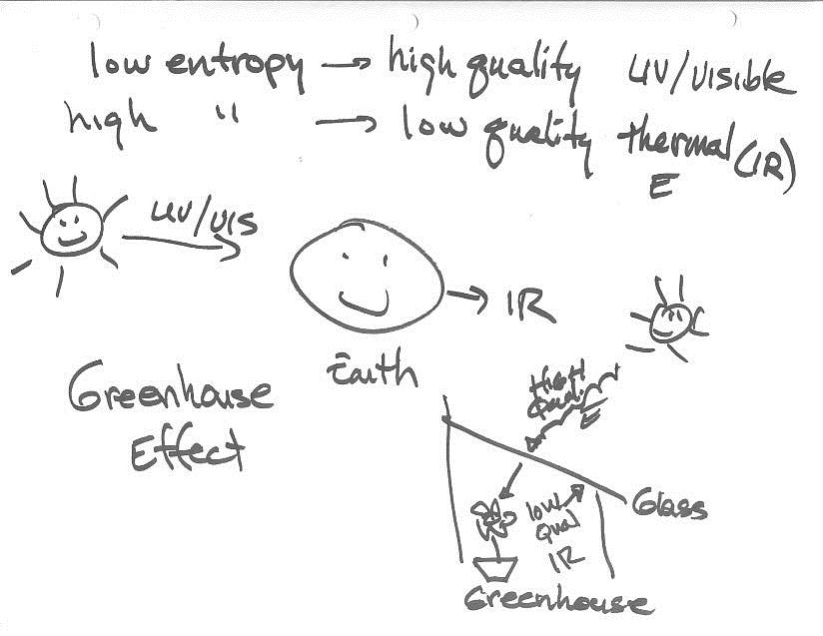
TSES 3002AV Mar 1, 2012
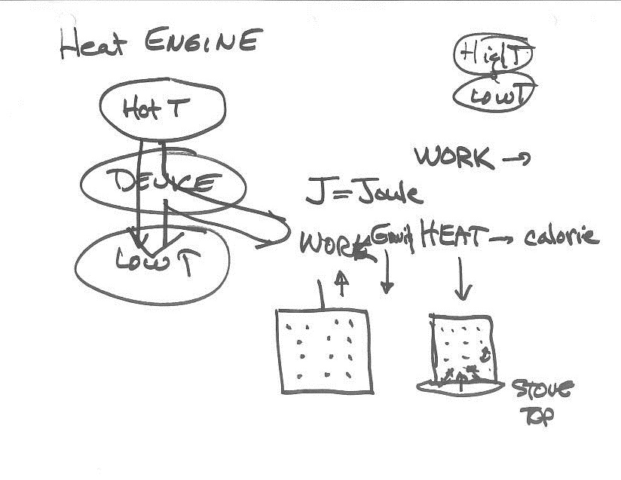
TSES 3002AV Mar 1, 2012
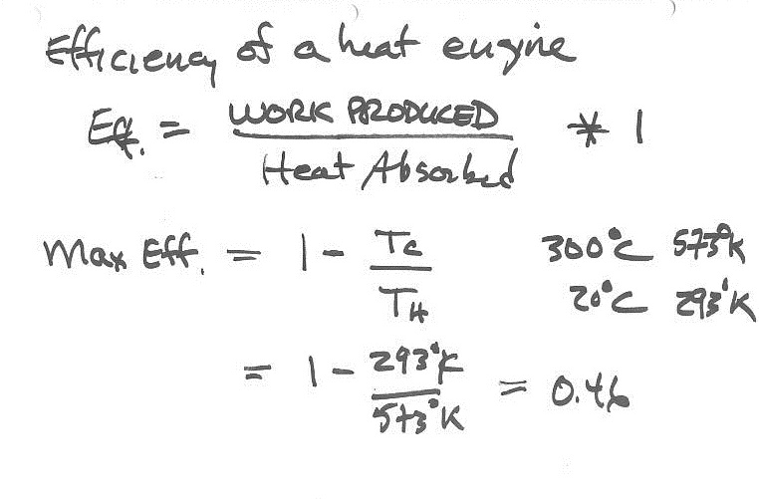
TSES 3002AV Mar 1, 2012
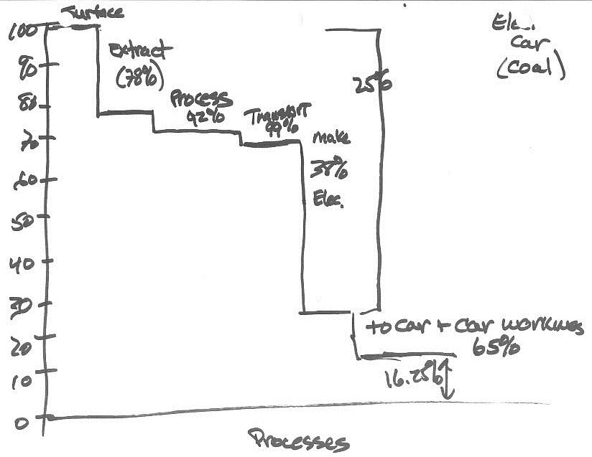
TSES 3002AV Mar 1, 2012
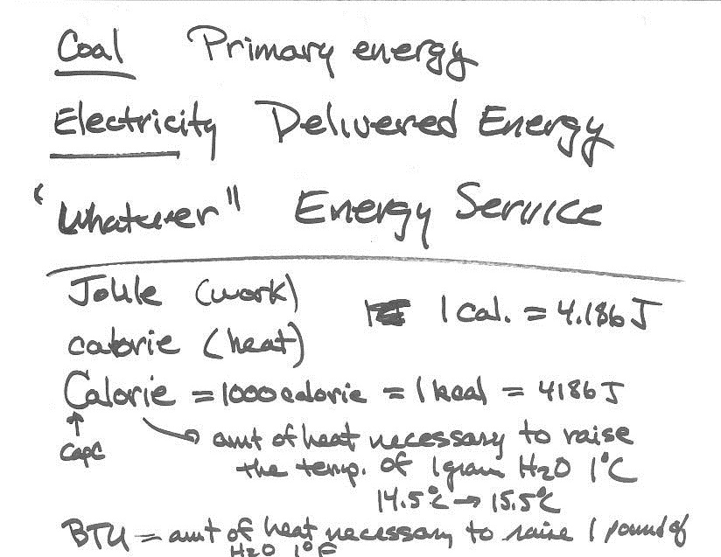
TSES 3002AV Mar 1, 2012
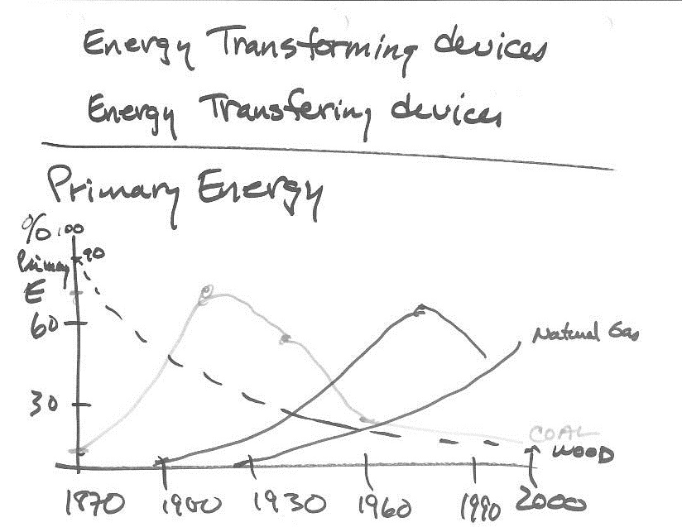
TSES 3002AV Tuesday Mar 6, 2012
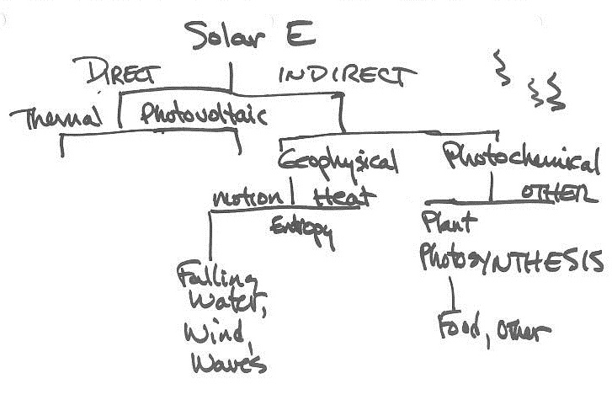

TSES 3002AV Tuesday Mar 6, 2012
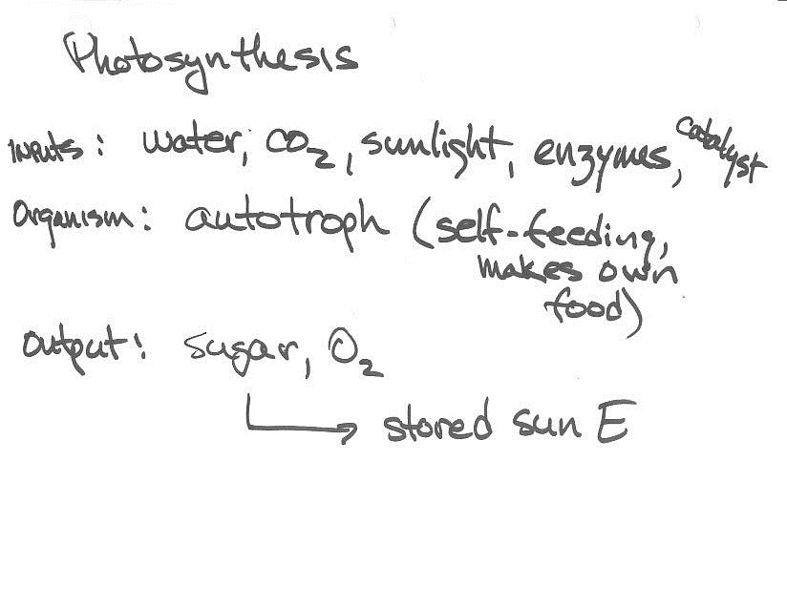
TSES 3002AV Tuesday Mar 6, 2012
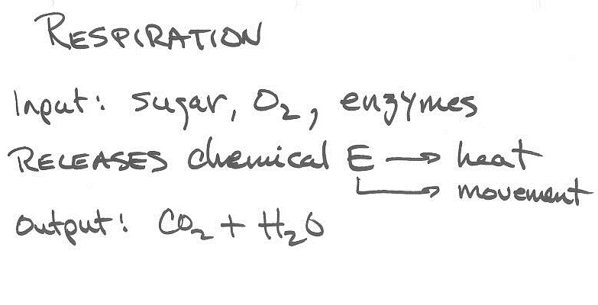

TSES 3002AV Tuesday Mar 6, 2012
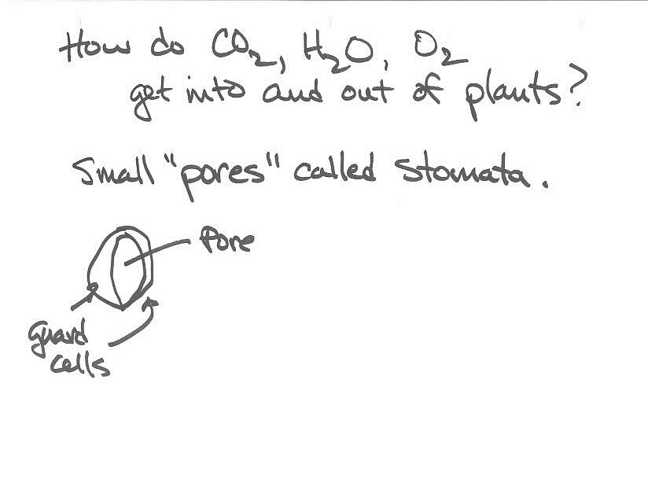
TSES 3002AV Tuesday Mar 6, 2012
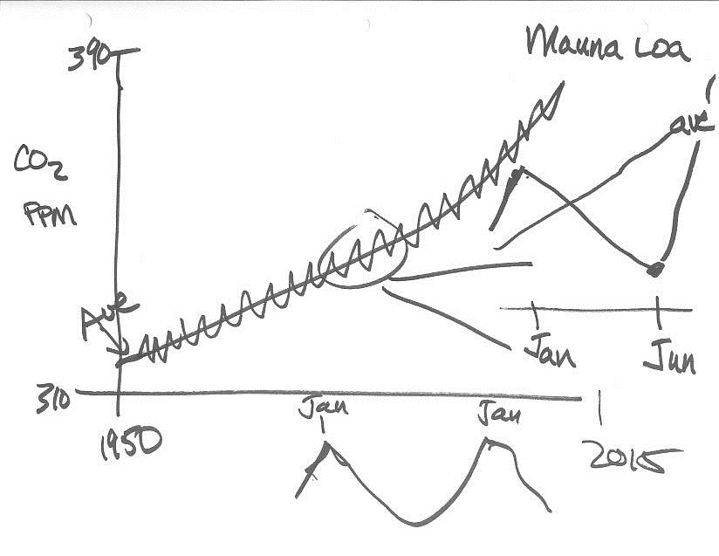
TSES 3002AV Tuesday Mar 6, 2012
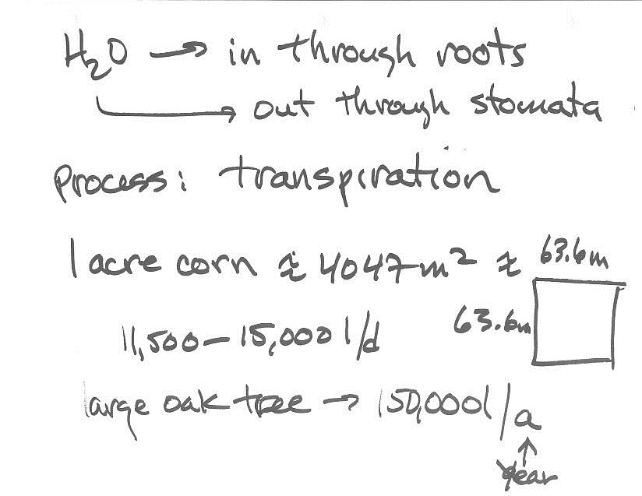
TSES 3002AV Tuesday Mar 6, 2012
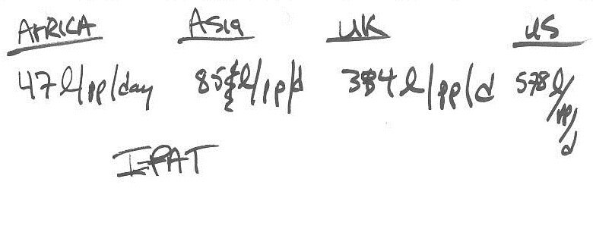

TSES 3002AV Tuesday Mar 6, 2012
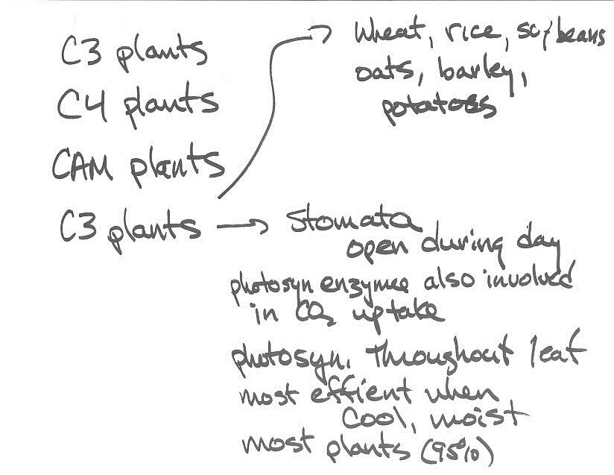
TSES 3002AV Tuesday Mar 6, 2012
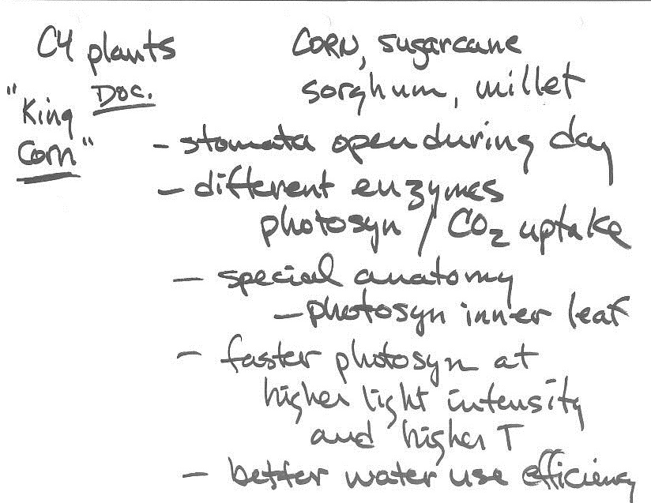
TSES 3002AV Tuesday Mar 6, 2012
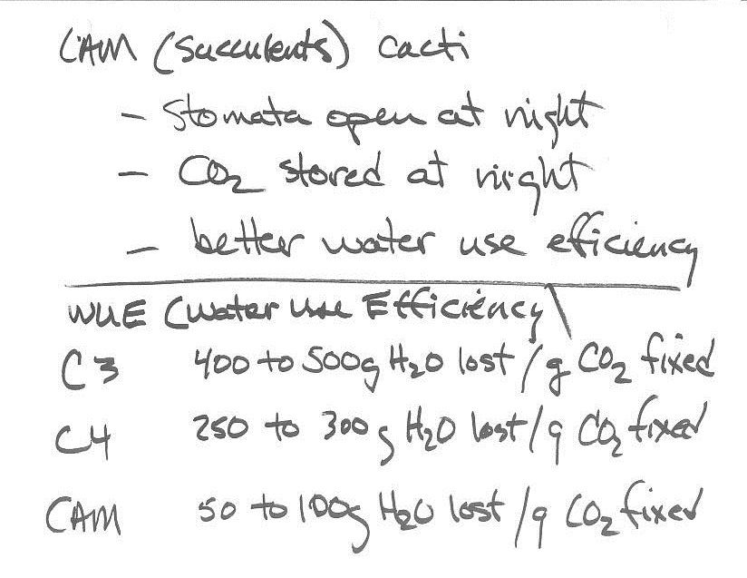
TSES 3002AV Tuesday Mar 6, 2012
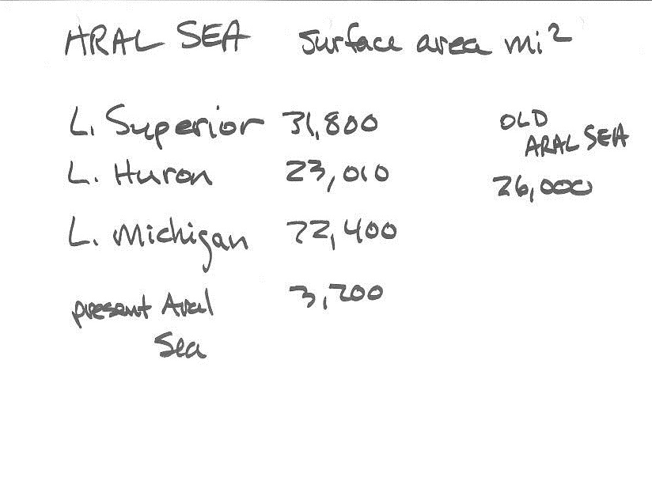
TSES 3002AV Tuesday Mar 6, 2012
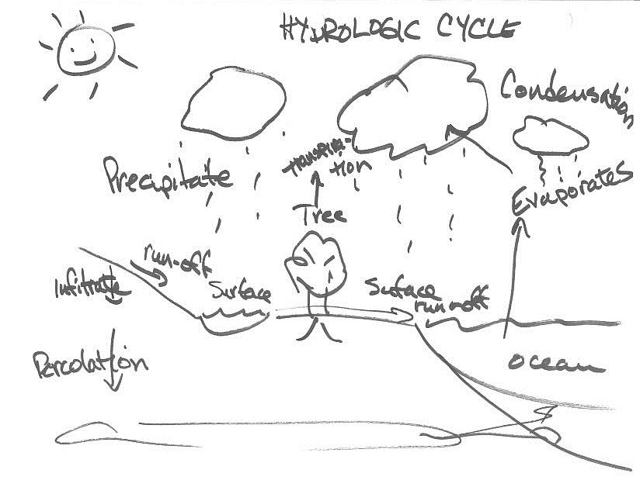
TSES 3002AV Tuesday Mar 6, 2012
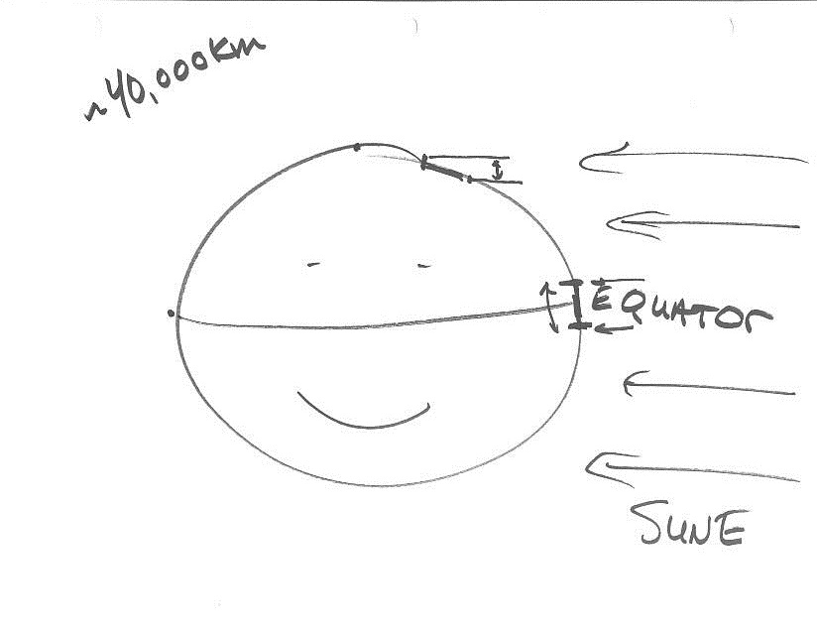
TSES 3002AV Tuesday Mar 6, 2012
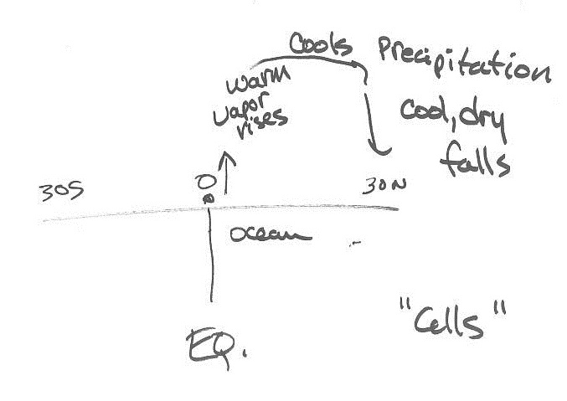
TSES 3002AV Thursday Mar 8, 2012
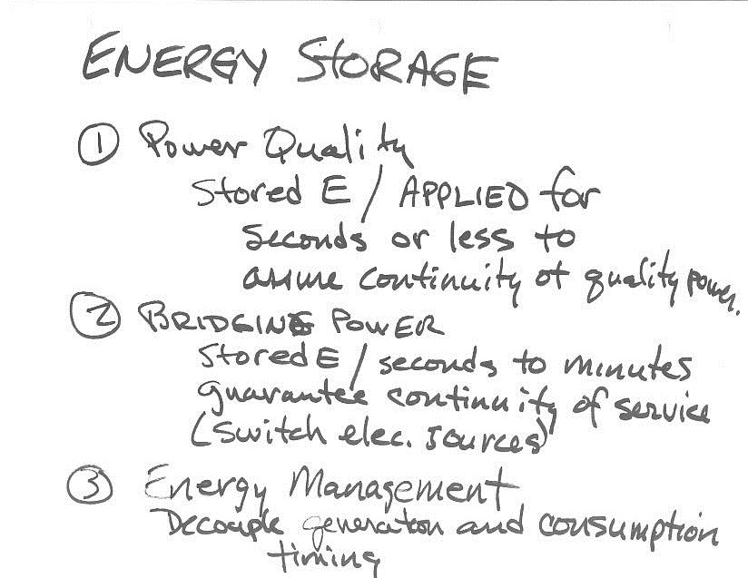

TSES 3002AV Thursday Mar 8, 2012
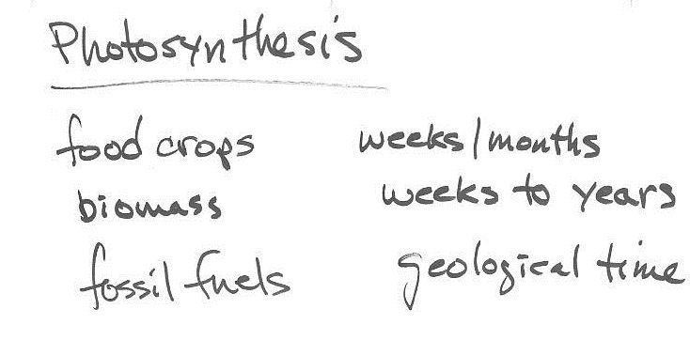

TSES 3002AV Thursday Mar 8, 2012
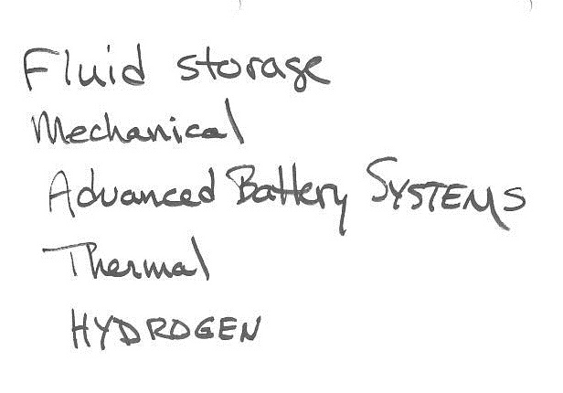

TSES 3002AV Thursday Mar 8, 2012
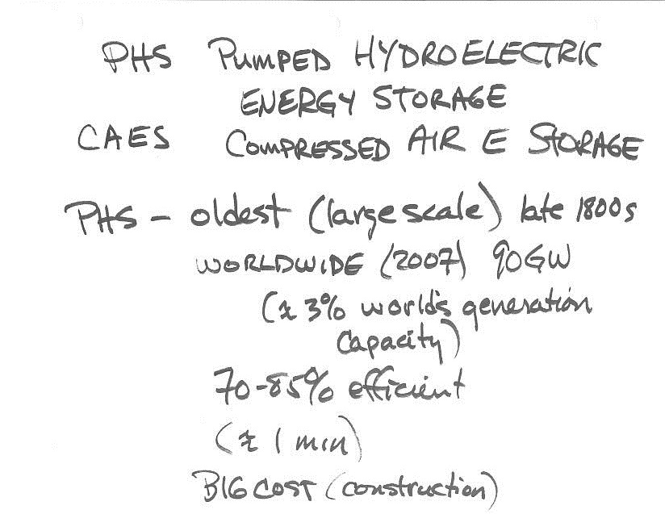
TSES 3002AV Thursday Mar 8, 2012
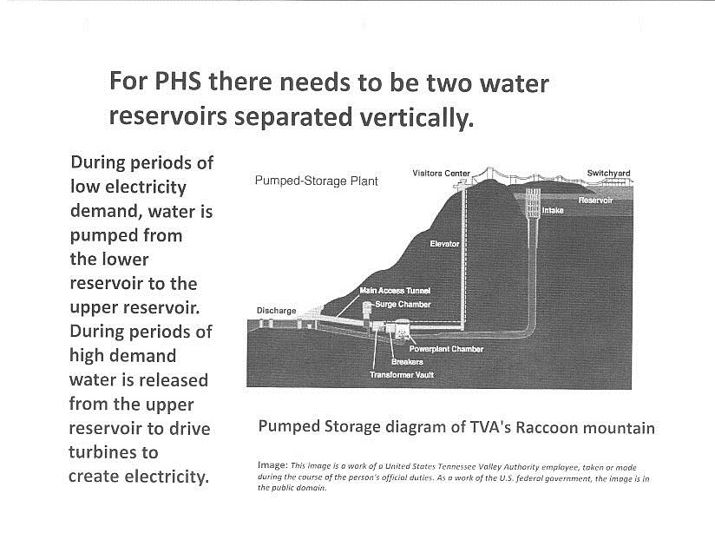
TSES 3002AV Thursday Mar 8, 2012
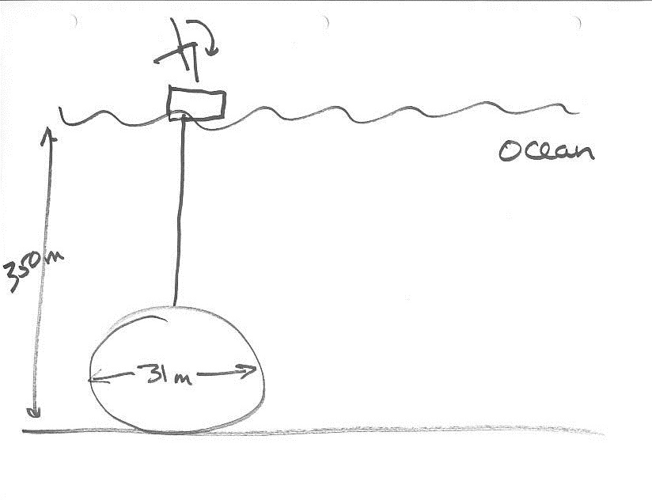
TSES 3002AV Thursday Mar 8, 2012
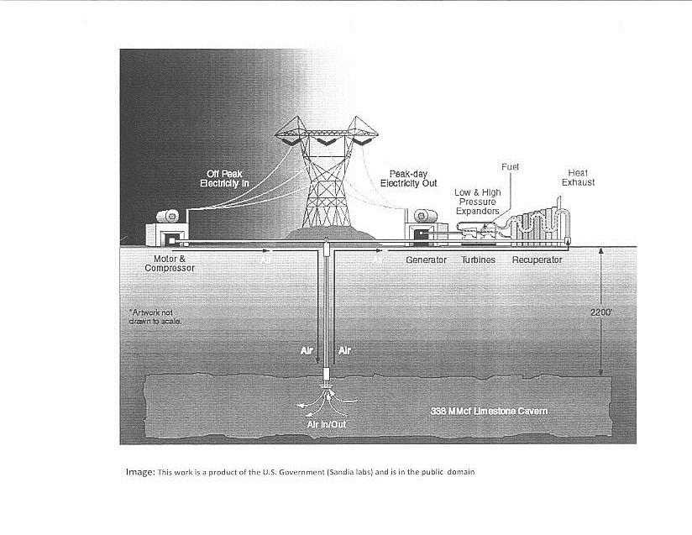
TSES 3002AV Thursday Mar 8, 2012
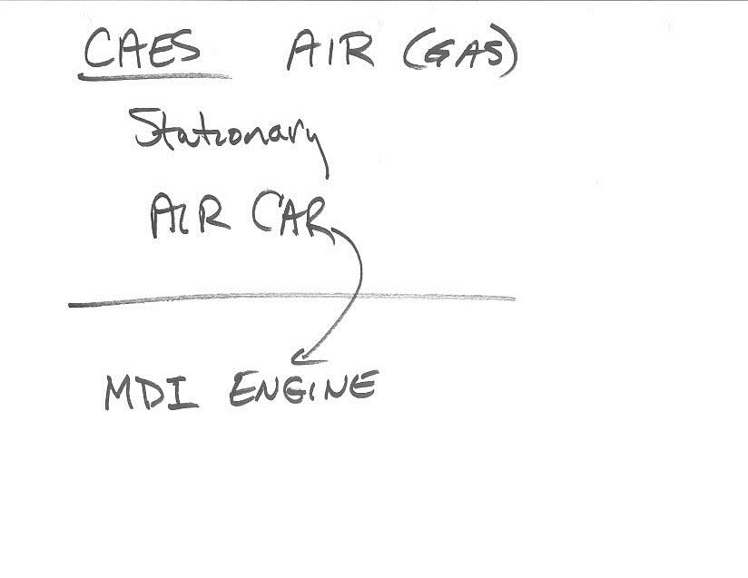
TSES 3002AV Thursday Mar 8, 2012
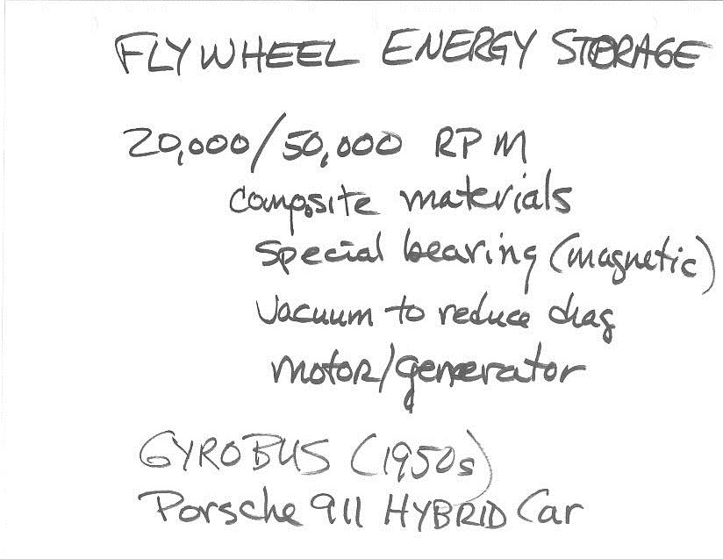
TSES 3002AV Thursday Mar 8, 2012
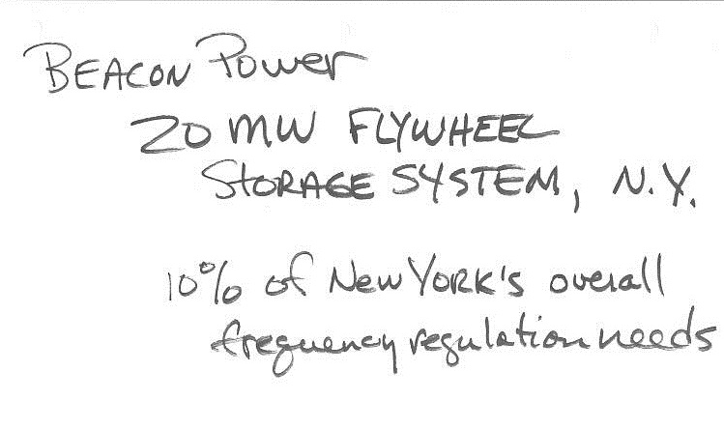

TSES 3002AV Thursday Mar 8, 2012
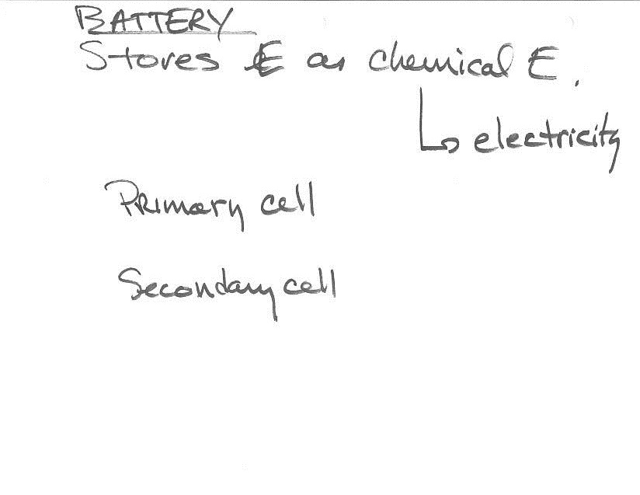
TSES 3002AV Thursday Mar 8, 2012
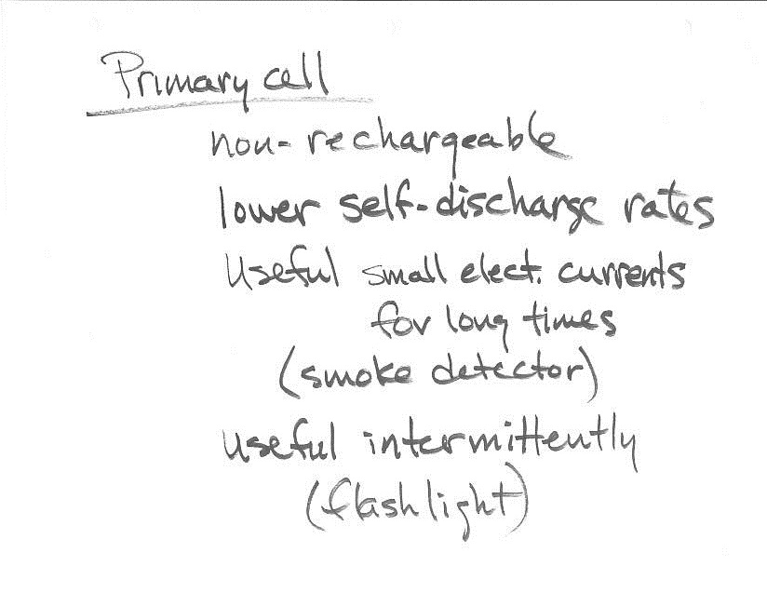
TSES 3002AV Thursday Mar 8, 2012
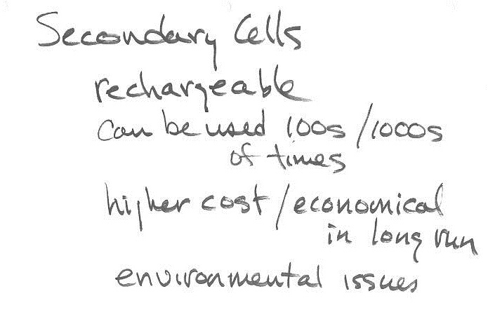
TSES 3002AV Thursday Mar 8, 2012
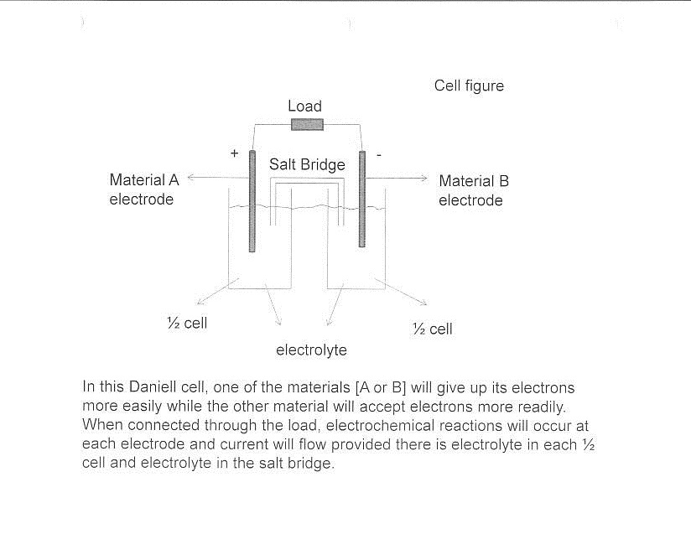
TSES 3002AV Tuesday March 13, 2012
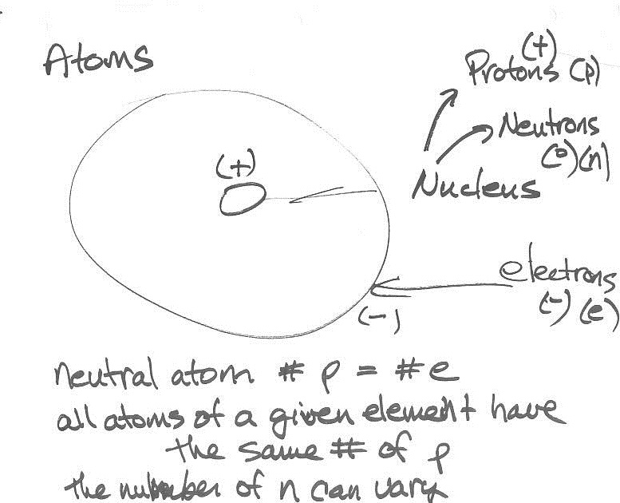

TSES 3002AV Tuesday March 13, 2012
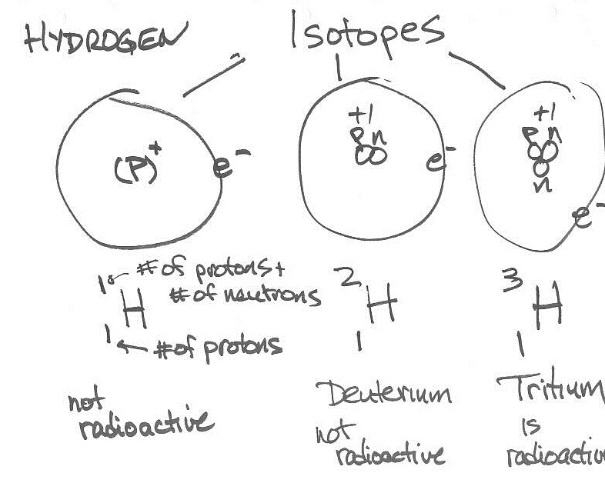
TSES 3002AV Tuesday March 13, 2012
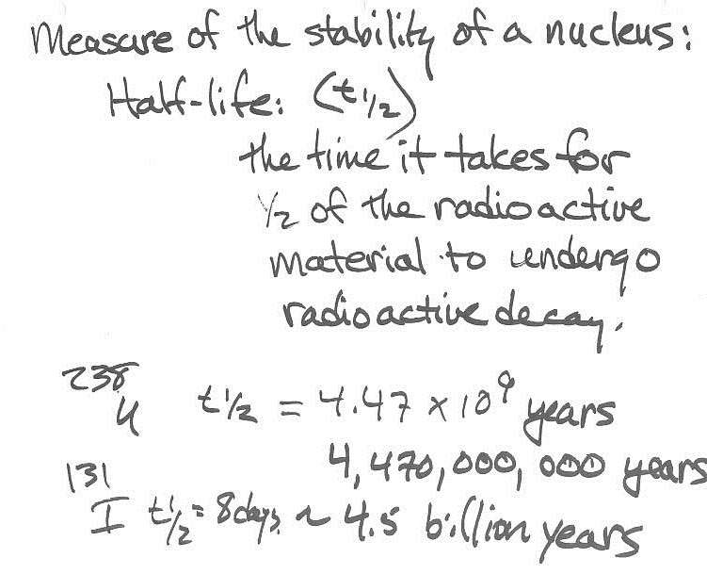
TSES 3002AV Tuesday March 13, 2012
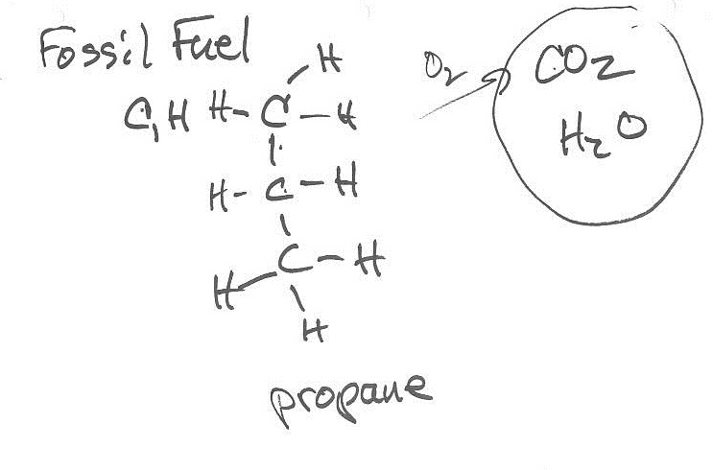
TSES 3002AV Tuesday March 13, 2012
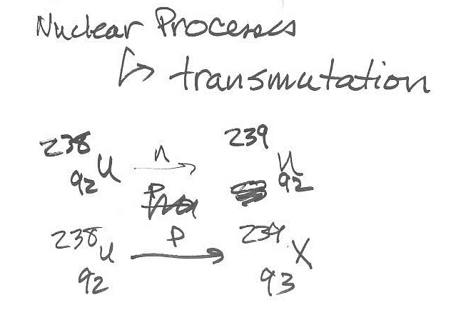
TSES 3002AV Tuesday March 13, 2012
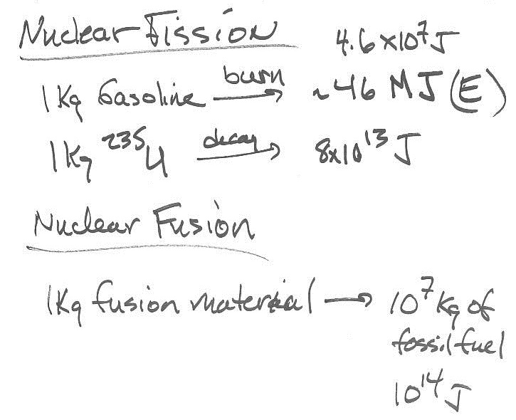
TSES 3002AV Tuesday March 13, 2012
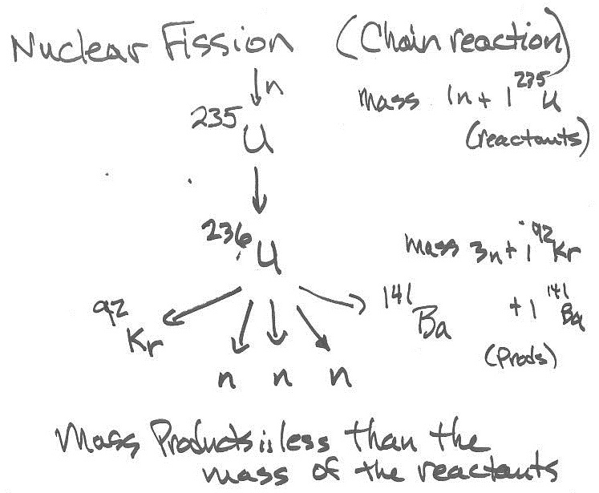
TSES 3002AV Tuesday March 13, 2012
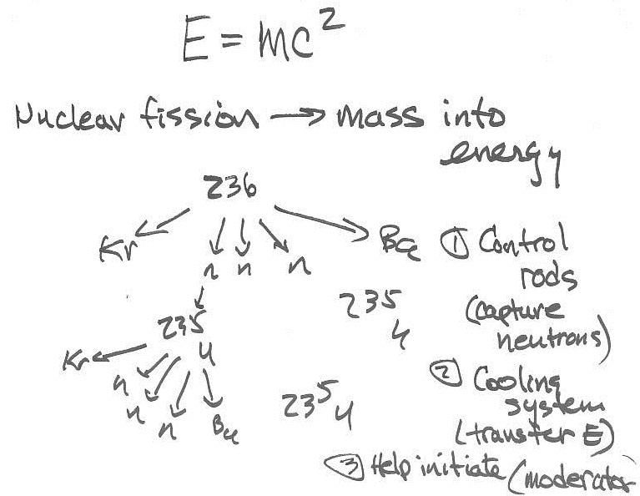
TSES 3002AV Tuesday March 13, 2012
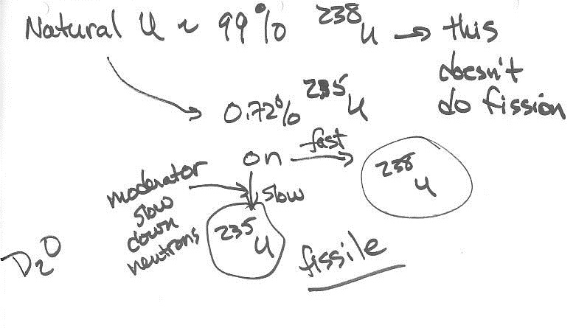

TSES 3002AV Tuesday March 13, 2012
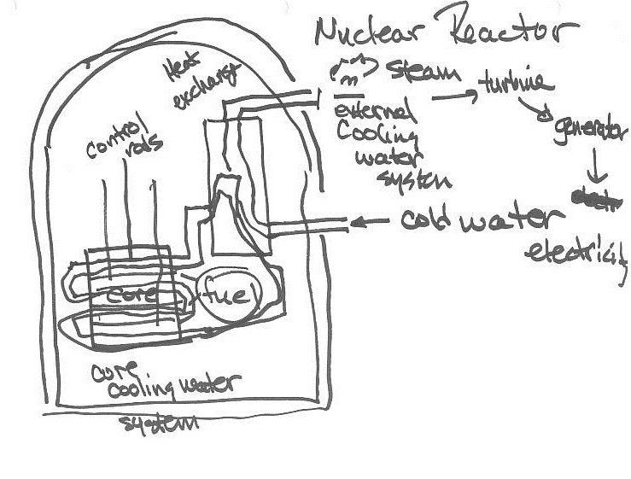
TSES 3002AV Tuesday March 13, 2012
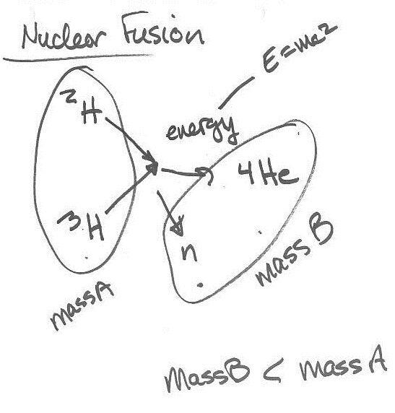
TSES 3002AV Tuesday March 13, 2012
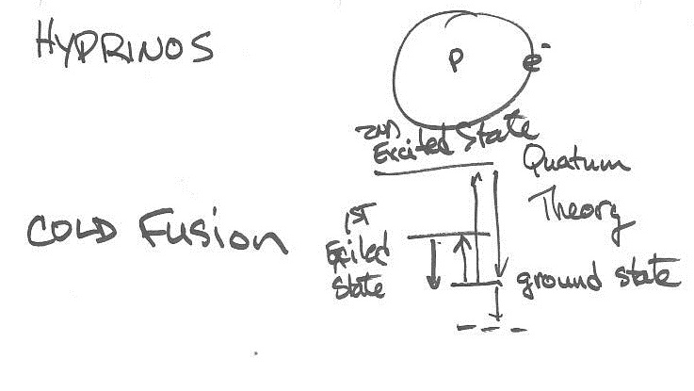
TSES 3002AV Thursday Mar 15, 2012

Video:
Ecological Design
TSES 3002AV Tuesday Mar 20, 2012
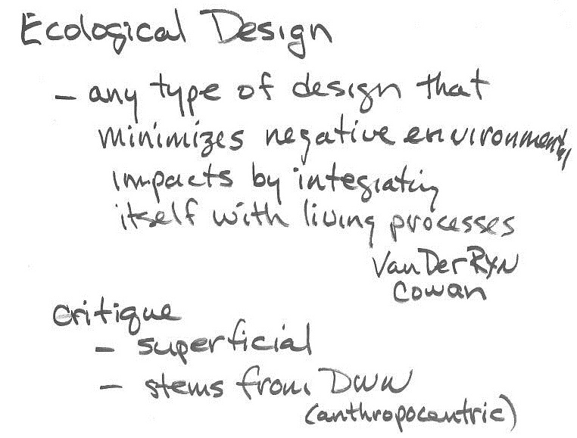
TSES 3002AV Tuesday Mar 20, 2012
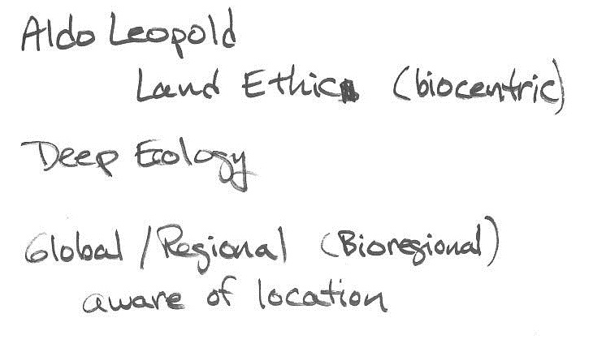

TSES 3002AV Tuesday Mar 20, 2012
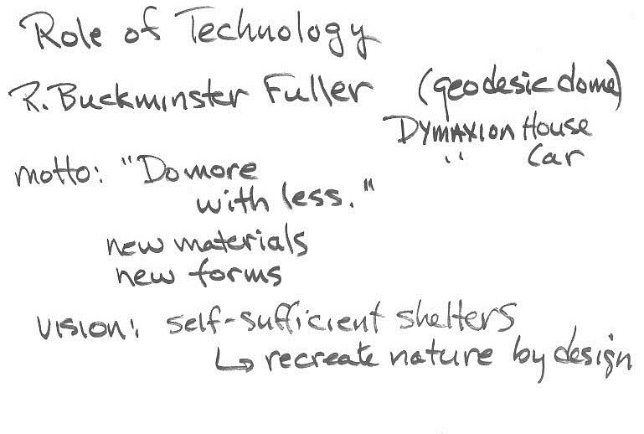
TSES 3002AV Tuesday Mar 20, 2012
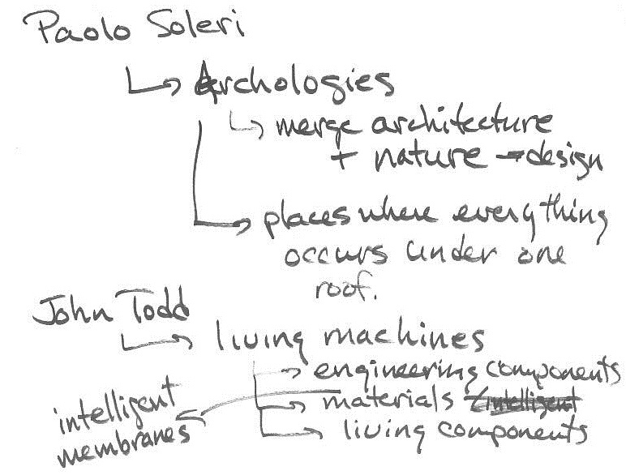
TSES 3002AV Tuesday Mar 20, 2012
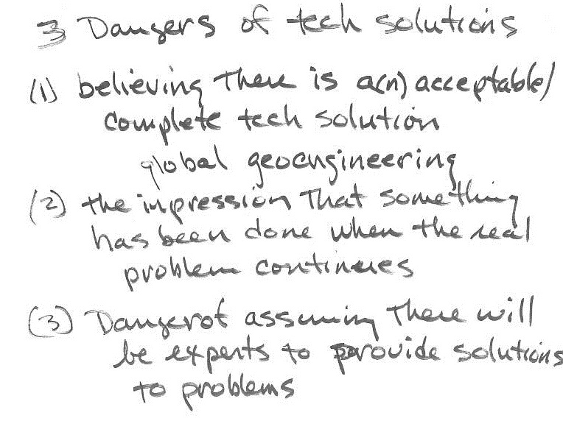
TSES 3002AV Tuesday Mar 20, 2012
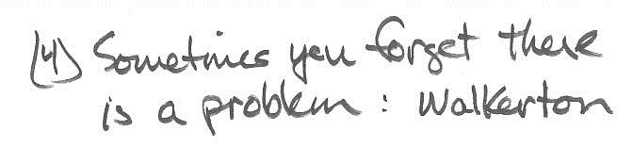

TSES 3002AV Tuesday Mar 20, 2012
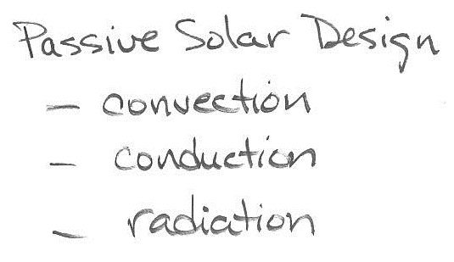

TSES 3002AV Tuesday Mar 20, 2012
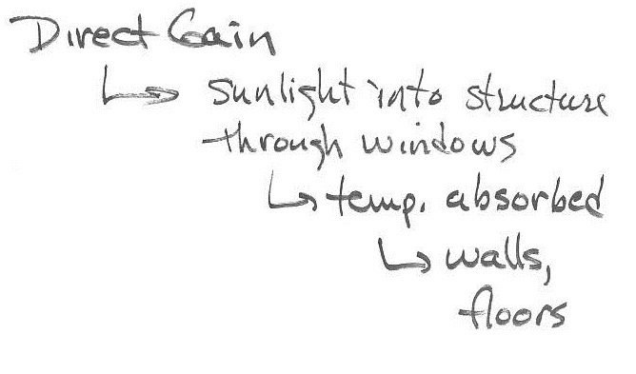

TSES 3002AV Tuesday Mar 20, 2012
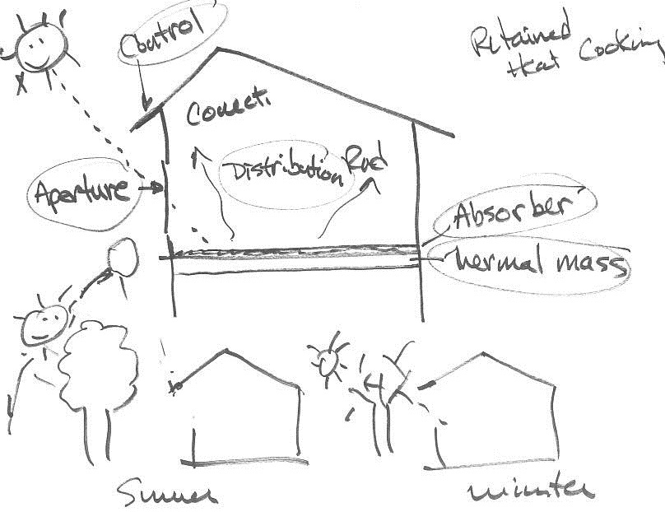
TSES 3002AV Tuesday Mar 20, 2012
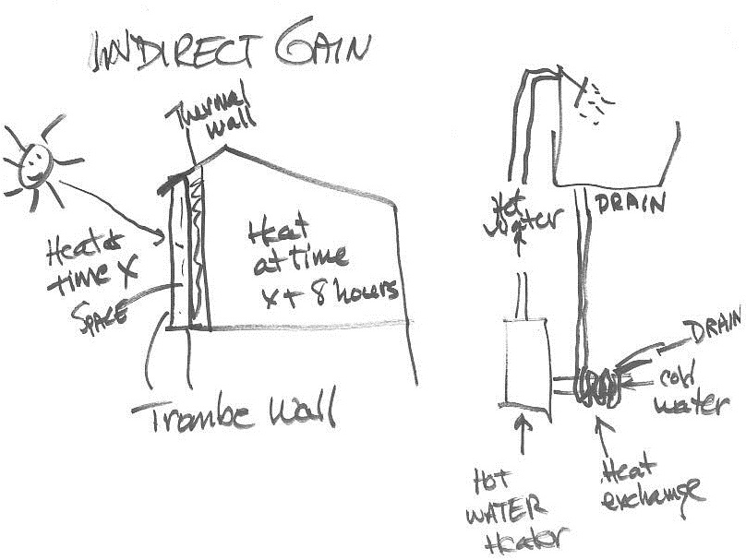
TSES 3002AV Thursday Mar 22, 2012
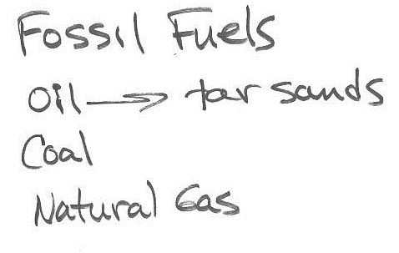

TSES 3002AV Thursday Mar 22, 2012
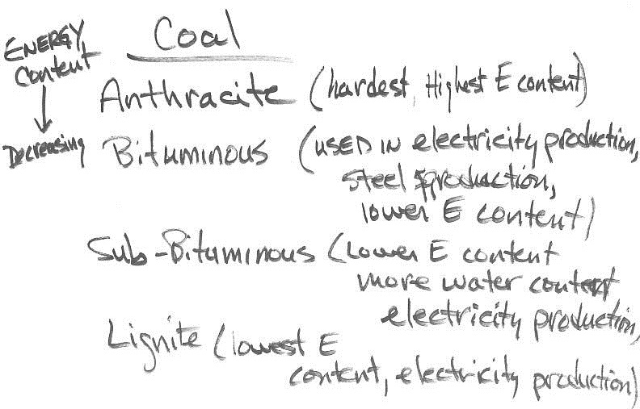

TSES 3002AV Thursday Mar 22, 2012
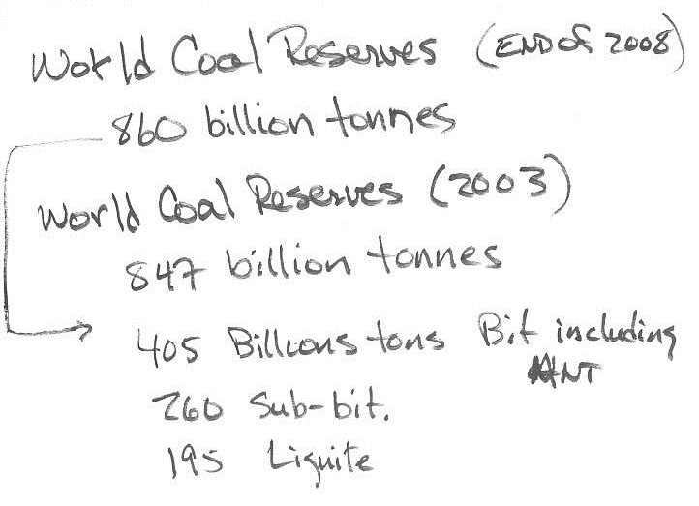
TSES 3002AV Thursday Mar 22, 2012
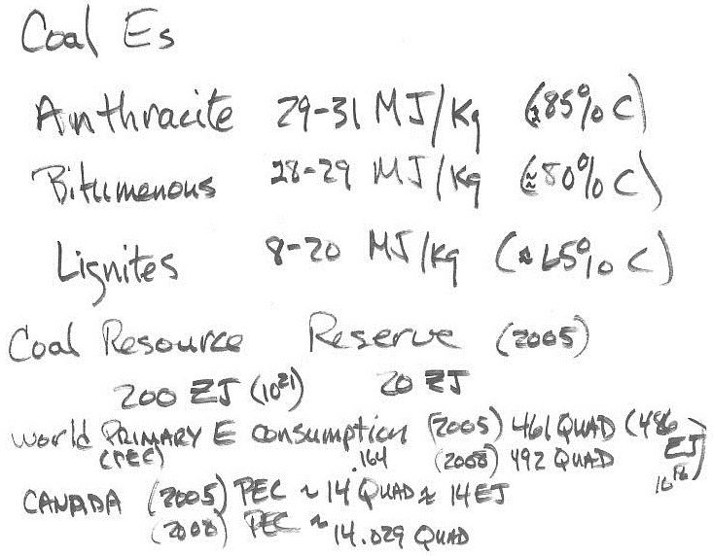
TSES 3002AV Thursday Mar 22, 2012
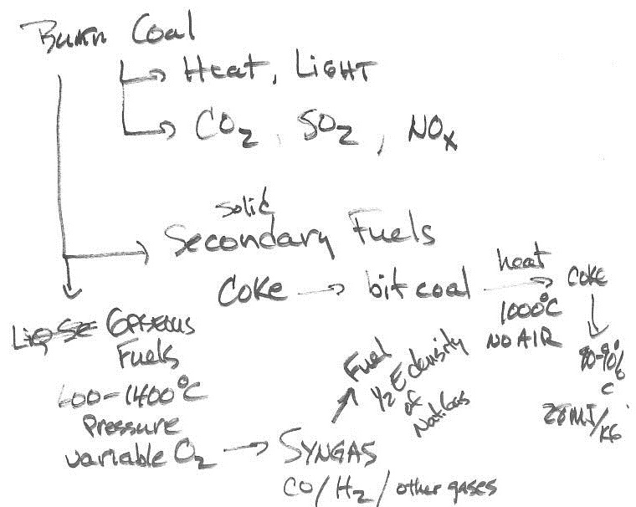
TSES 3002AV Thursday Mar 22, 2012
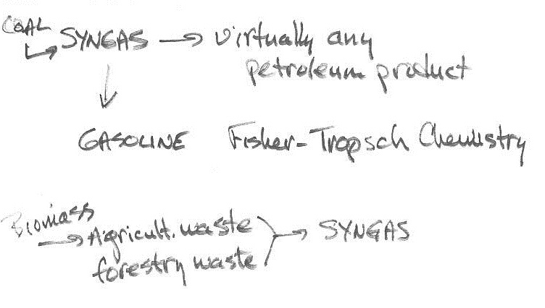

TSES 3002AV Thursday Mar 22, 2012
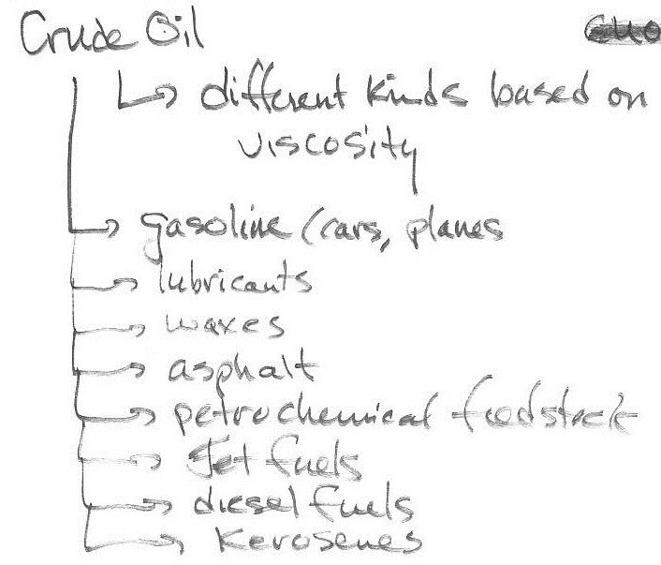
TSES 3002AV Thursday Mar 22, 2012
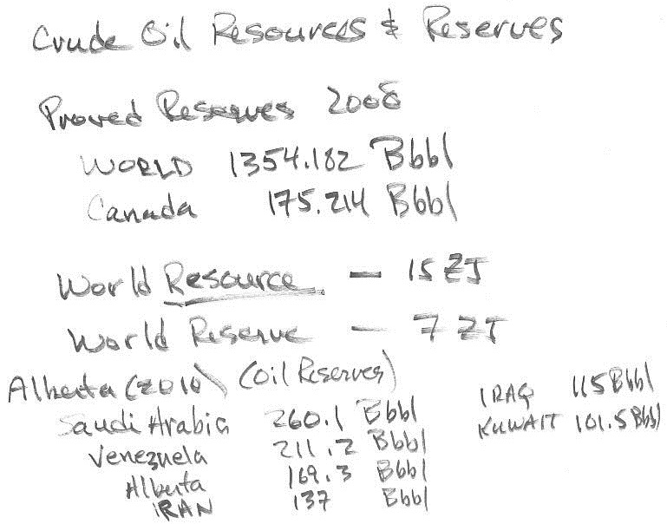
TSES 3002AV Thursday Mar 22, 2012
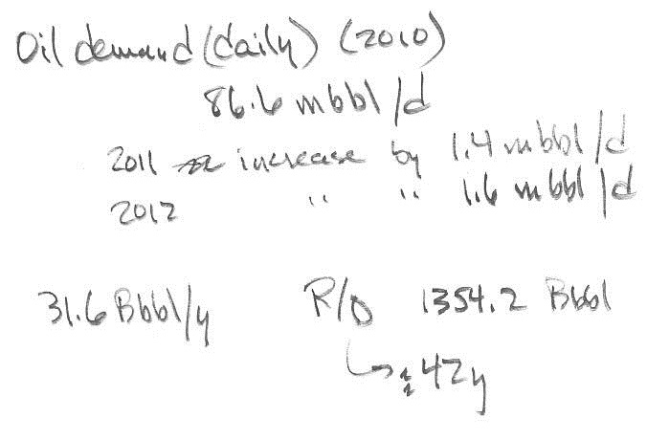
TSES 3002AV Tuesday Mar 27, 2012
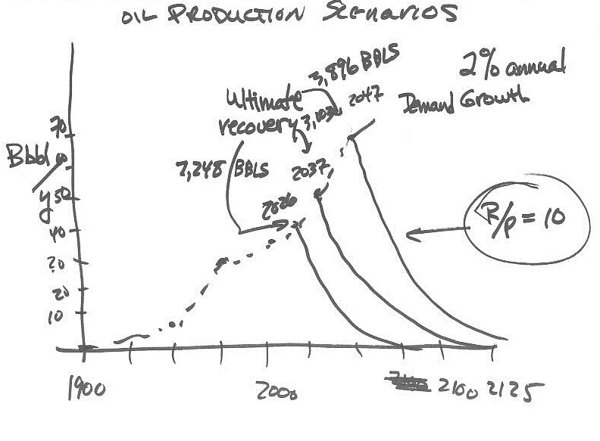
TSES 3002AV Tuesday Mar 27, 2012
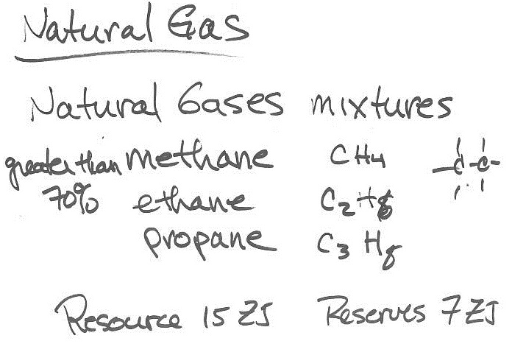
TSES 3002AV Tuesday Mar 27, 2012
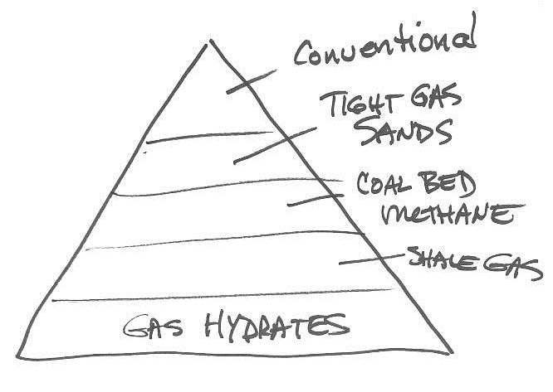
TSES 3002AV Tuesday Mar 27, 2012
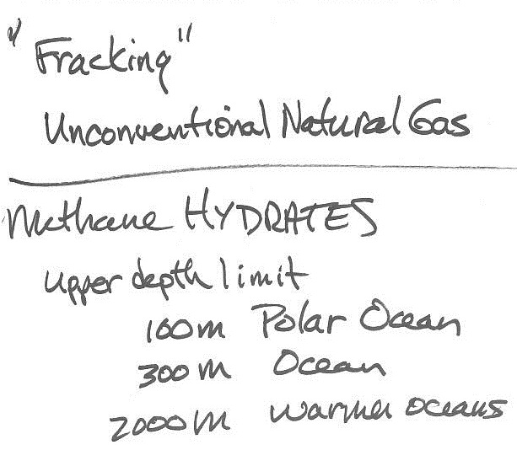
TSES 3002AV Tuesday Mar 27, 2012
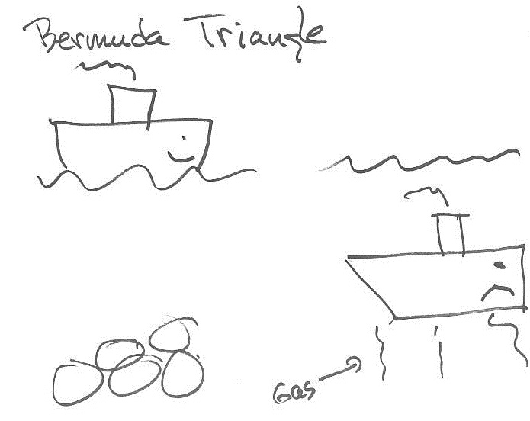
TSES 3002AV Tuesday Mar 27, 2012
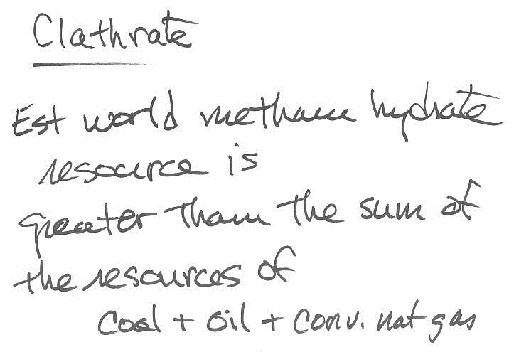
TSES 3002AV Tuesday Mar 27, 2012
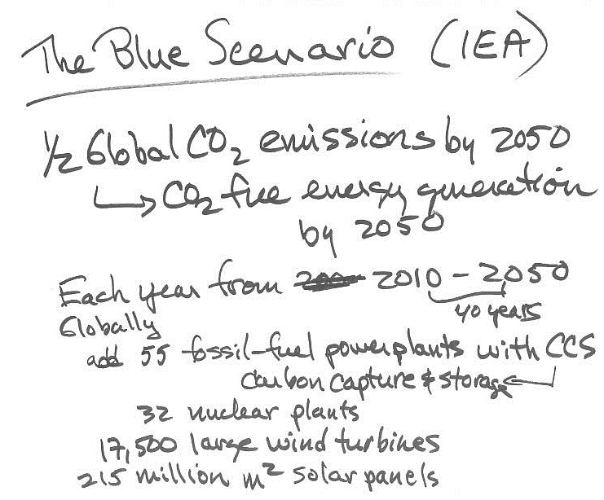
TSES 3002AV Tuesday Mar 27, 2012
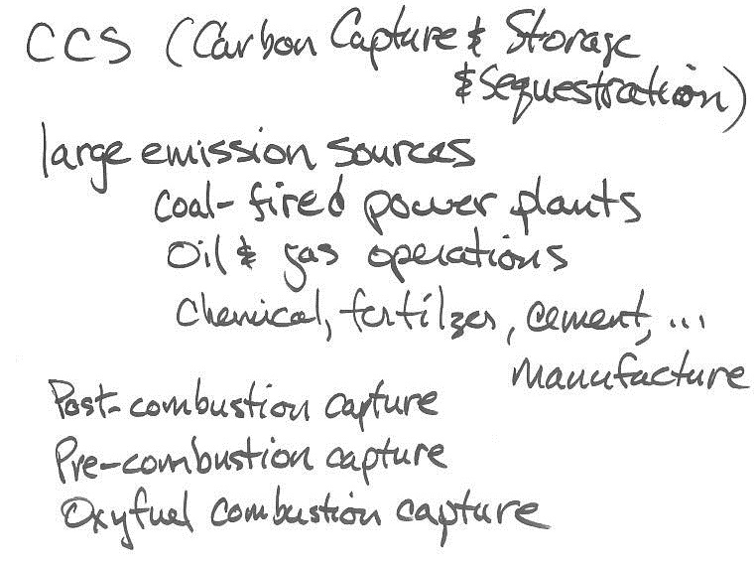
TSES 3002AV Tuesday Mar 27, 2012
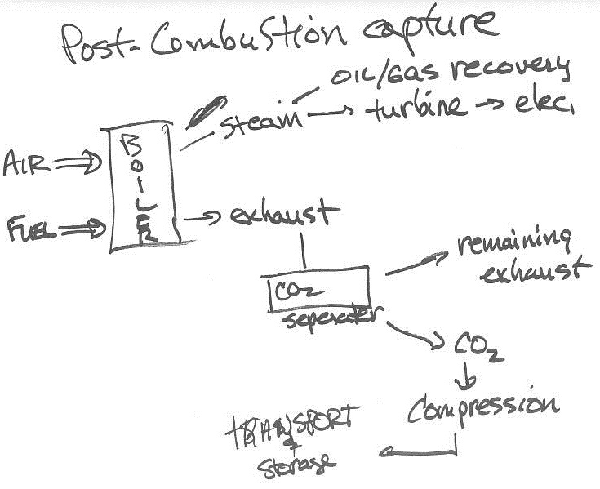
TSES 3002AV Tuesday Mar 27, 2012
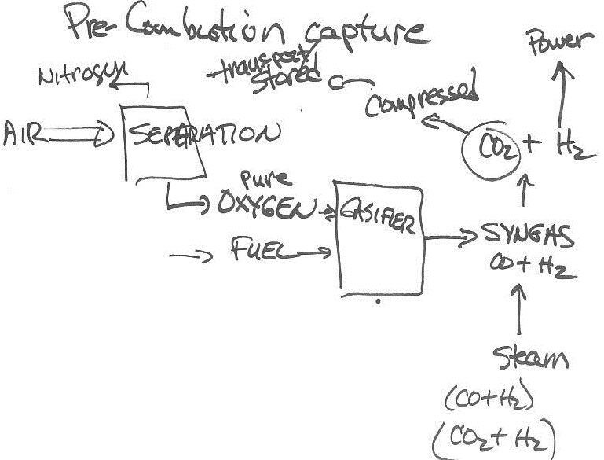
TSES 3002AV Thursday Mar 29, 2012

Video: Heather Menzies
Canada in the Global Village
Episode 11
Feminist and Ecological Perspectives
TSES 3002AV Tuesday Apr 3, 2012
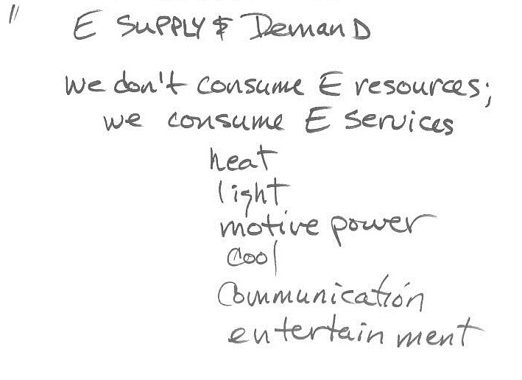
TSES 3002AV Tuesday Apr 3, 2012
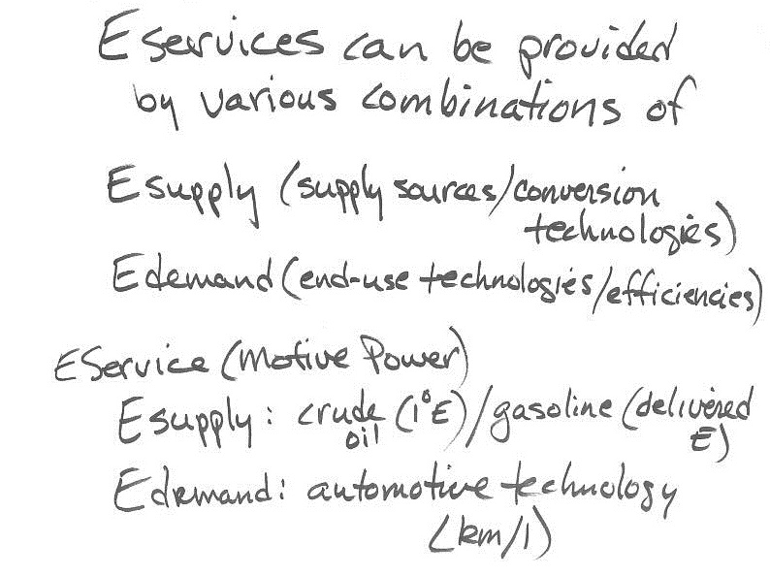
TSES 3002AV Tuesday Apr 3, 2012
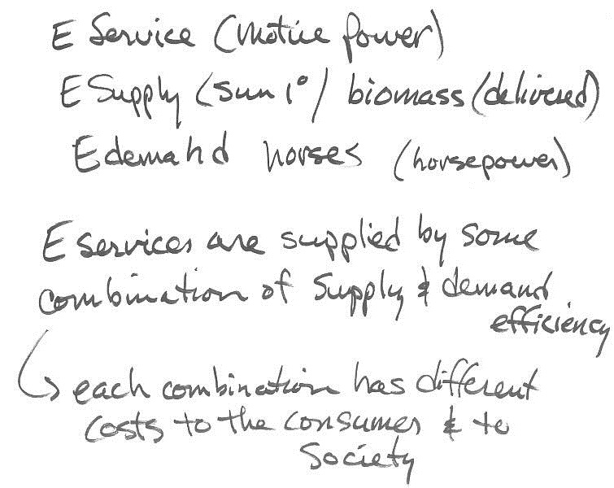
TSES 3002AV Tuesday Apr 3, 2012
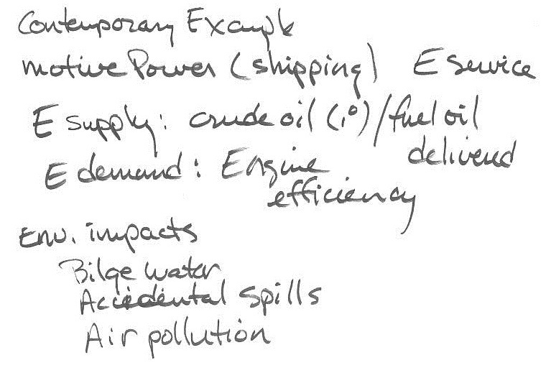
TSES 3002AV Tuesday Apr 3, 2012
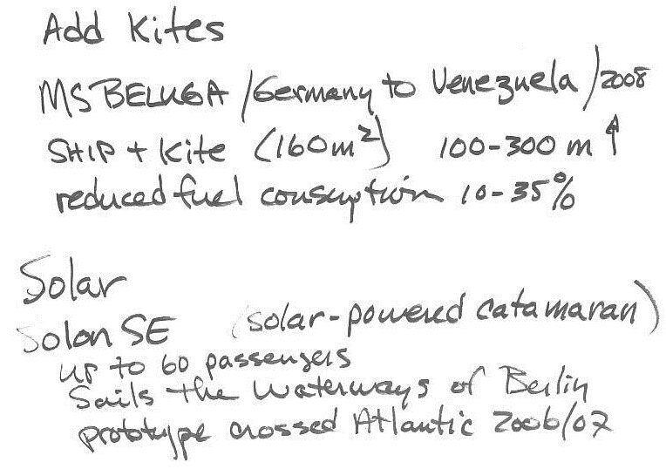
TSES 3002AV Tuesday Apr 3, 2012
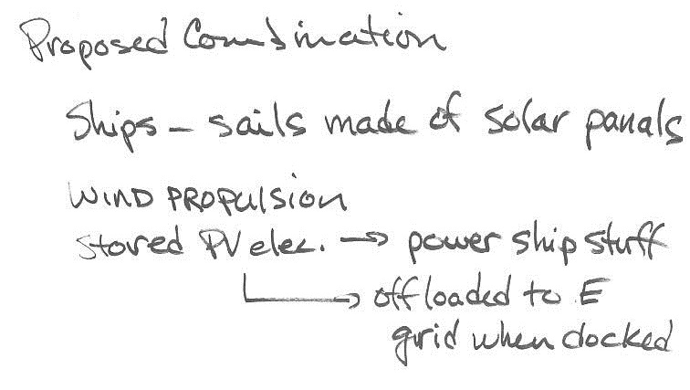

TSES 3002AV Tuesday Apr 3, 2012
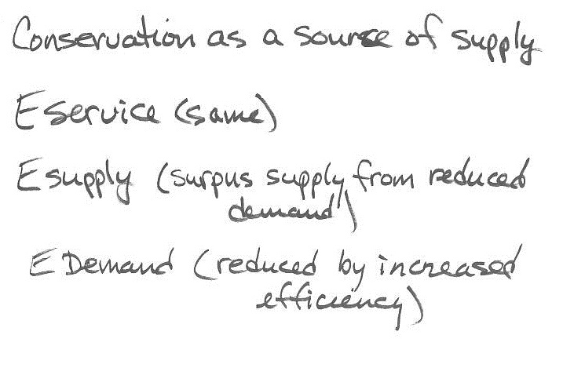
TSES 3002AV Tuesday Apr 3, 2012
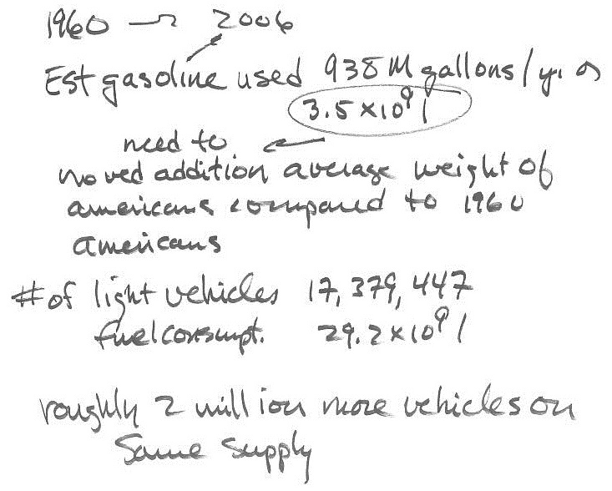
TSES 3002AV Tuesday Apr 3, 2012
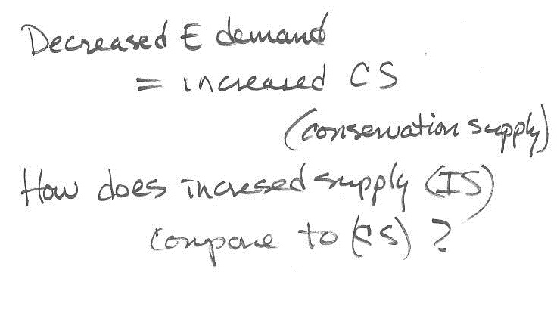

TSES 3002AV Tuesday Apr 3, 2012
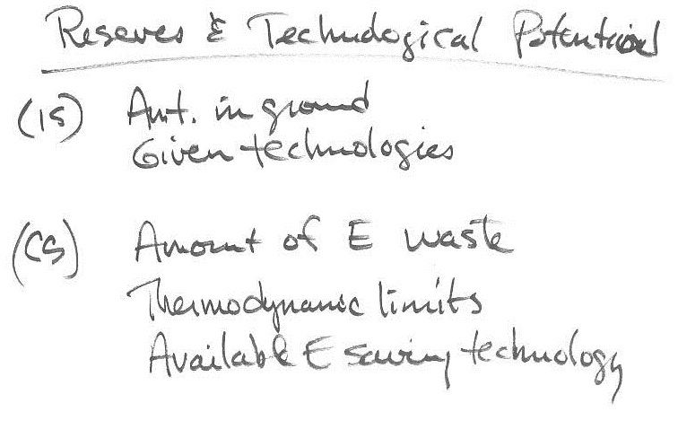
TSES 3002AV Tuesday Apr 3, 2012
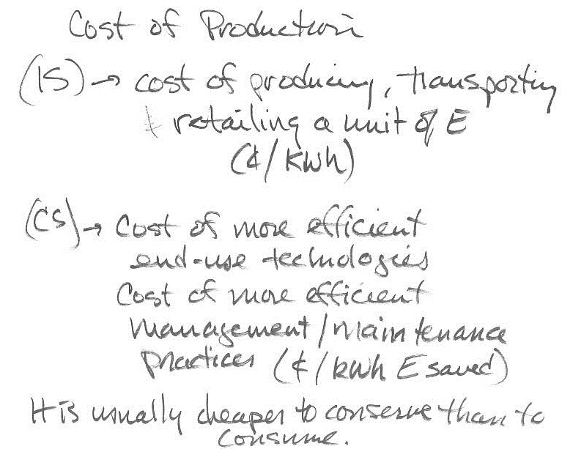
TSES 3002AV Tuesday Apr 3, 2012
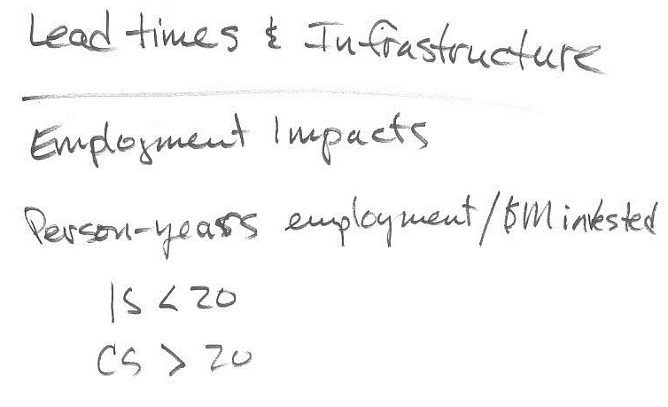

TSES 3002AV Tuesday Apr 3, 2012
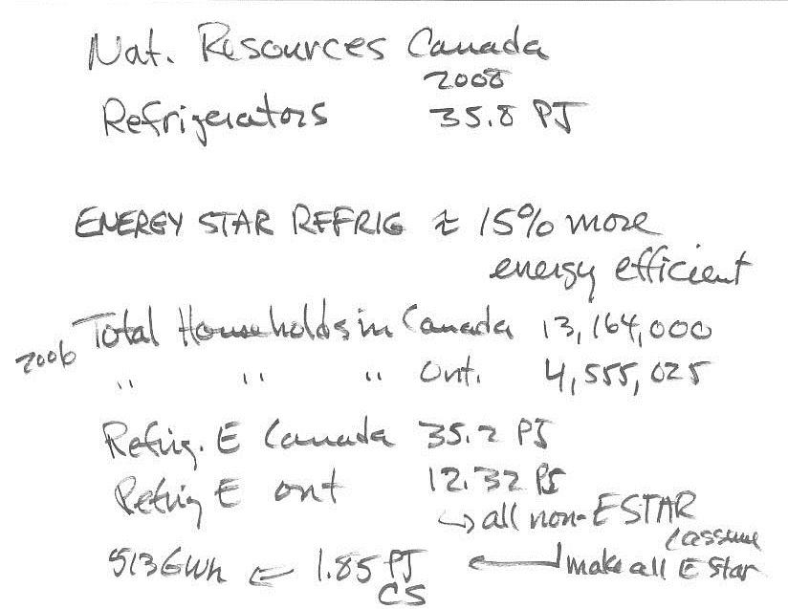
TSES 3002AV Tuesday Apr 3, 2012


TSES 3002AV Tuesday Apr 3, 2012
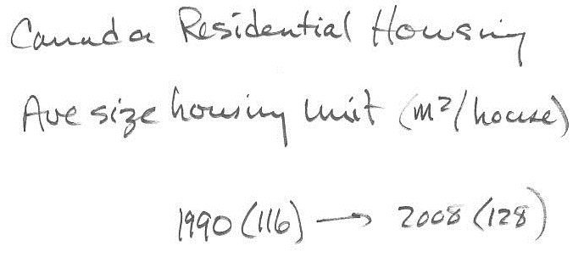

TSES 3002AV Tuesday Apr 3, 2012
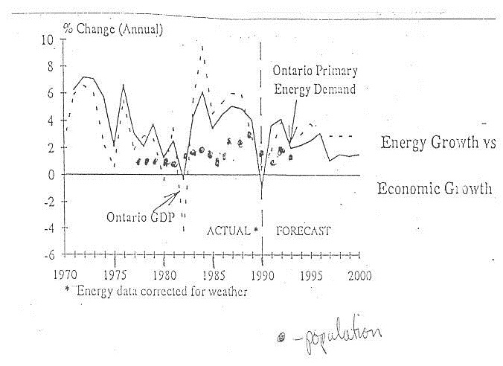
TSES 3002AV Tuesday Apr 3, 2012


