Chapter 2 MOTIVATIONAL INTERVIEWING
Introduction
- Motivational interviewing (MI) is one of the most significant innovations of the past 30 years in the way counsellors approach their clients who use substances
- MI focuses on ambivalence instead of struggling with peoples resistance and lack of motivation to change
- Client talks about changing, not the counsellor (CLIENT IN CONTROL)
- “client centered, directive method for enhancing intrinsic motivation to change by exploring and resolving ambivalence”
- MI is gentle elicitation rather than teaching or persuasion.
  - Persuasion makes client defensive, and entrenches resistance
  - Resistance is a sign that the counsellor is moving too fast and needs to change their motivational strategy
The Spirit of Motivational Interviewing
- Client centred
  - Focus on client concerns
  - Counsellor plays active role in moving the client toward change
  - Relationship is a partnership rather than authoritarian role
  - Client chooses course of action
- Motivation to change emerges from the interactions of the client and the counsellor
Steps
- Set up atmosphere so client talks about concerns and ambivalence about change
- Encourage the client to explore pros and cons of change
- By asking questions, help the client go talk about where drug use fits with his or her life goals and values
By this time the client sees the difference between the life with drugs and what he or she truly values
- Client realises they want change
- Counsellor encourages them and helps increase confidence and commitment to change

The Stages of Change Model
- In each stage the client needs to focus on specific tasks that will enable movement to next stage
- Slip or relapse is a part of the cyclical nature of changing substance use
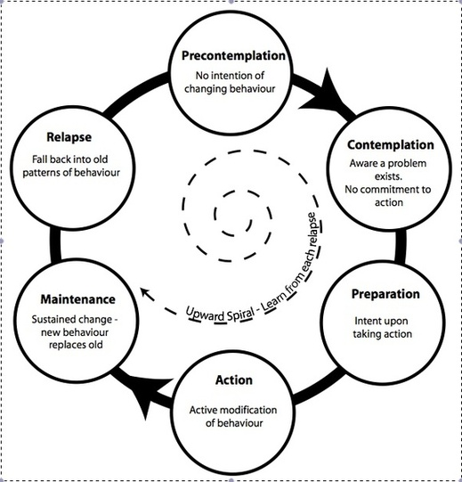
Pre-contemplation Stage:
- “no problem”
- Resist treatment
- Build relationship with client, recognize consequences, weigh pros and cons
Contemplation Stage
- Recognize problem, Need for change but not ready to do it, look at pros and cons
- Counsellor must resolve ambivalence
Preparation Stage
- Client thinks about change, getting ready to change MUST COMMIT TO CHANGE
Action
- Modifying the behaviour
Maintenance
- Adjusting to change, practising new skills and behaviours to sustain change

Principles behind Motivational Interviewing
- Express Empathy
  - Acceptance=freedom to change
  - Builds relationships
- Support Self Efficacy
  - Explore past success or relate examples of others who have succeeded
  - Maintain hope for change
- Roll With Resistance
  - Use resistance to lower resistance
    - Rather than challenge resistance through persuasion or argument the counsellor uses the energy of the resistance to further explore the clients views
- Develop Discrepancy
  - Creating cognitive dissonance
  - Client becomes aware of where they are and where they want to be
  - Allows client not counsellor to articulate reasons for change
Traps To Avoid!
- Questions And Answer Trap
  - This gives no power to client
  - No more than three questions at a time
  - Makes clients relatively passive and doesn’t encourage them to explore the deeper levels of their experience and perceptions
- Confrontation Denial Trap
  - To help with the cousellers self esteem
  - Leads to the counsellor becoming more directive and prescriptive while client becomes more entrenched and resistant
- Expert Trap
  - Simply imposes corrective measure
  - “I know best”
- Premature Focus Trap
  - Bringing up substance abuse problem before client is ready
- Labelling Trap
  - Too much stigma
  - Client rejects being labelled
  - Don’t need to accept label to change
  - MI avoids using labels
- Blaming
  - No fault policy
Interactional Techniques
- Open Ended Questions
  - Cannot be answered with a simple yes or no
- Affirmations
  - Statements by counsellor that acknowledge clients strengths
- Reflective Listening
  - Demonstrates understanding and acceptance
  - Move client toward thinking and talking about change
- Summaries
  - Show interest and build rapport
  - Eliciting change talk
  - Form of reflective listening in which the counsellor reflects back what the client has been saying over a longer period of the interaction
Practical Strategies in Motivational Interviewing
- Review Of Typical Day
  - Client relates to what happened in a typical day including their use of substances
  - Good way to build rapport without focusing on the problem
  - Gives picture of how substance fits in their life
- Looking Back
  - How things were before the drugs
  - Reflect the changes that have come about since substance use started
- Looking Forward
  - Client reflect on the impact of continuing their current behaviours
  - Client contemplates the future without using drugs
- Looking At The Food In Things And The Not So Good Things
  - Look at both sides of substance use
  - “bad things” not used as a synonym because it would create a barrier to moving forward
- Decisional Balance
  - Once you go over the pros and cons of substance use the client goes over the cost- benefit analysis
- Exploring Values
  - Focusing on the values can stimulate motivation for change and self-motivation statements
  - As inconsistencies emerge between the persons behaviour and his or her deeper sense of self and values the person may become increasingly aware that while substance abuse meets short term needs it does not fulfil higher values or lead to long term
- Discussing The Stages Of Change Model
  - Helps them understand some of the stumbling blocks they will encounter and help them realize that change may take more time and effort then they may expect
- Exploring The Importance Of Change
  - In order to make change the client must acknowledge that change is important
  - On a scale of 1 to 10??
- Exploring Confidence
  - The person must rate their confidence on a scale of one to 10, and then help them find more confidence
- Planning Change
  - Once the client wants to change, planning must be done sensitively with the client taking the lead
  - Moving too quickly may result in the client back in the stages of change
Resistance
- Not seen as a character trait but a specific behaviour in the interaction between the client and the counsellor
- Occurs when counsellor and client have different agendas
- If counsellor takes charge rather than client
- Resistance is a sign of ambivalence
- Clients who are resigned are over whelmed by the thought of change and likely have failed to change
  - With these clients you focus on building confidence using reflections and affirmations
- Clients who rationalize typically take no ownership of the problem and blame others, have all the answers and get into debates
  - Counsellor must avoid debates rather use reflections to encourage reframing
Dealing with Resistance
- Tell them you understand their resistance
  - Helps them move forward
  - Examples are on page 37
Assessment and Motivational Interviewing
- Sets the tone on what the clients will expect during treatment system
- MI brief sessions are best
- Most clients eel anxious and uncomfortable at this first point of contact
Motivation Interviewing and Concurrent Disorders
- The relationship building aspect of MI can help people with concurrent disorders develop a lasting therapeutic relationship with a counsellor
- Always be clear, concise, talk about or reflect one topic at a time, avoid compound questions, reflect frequently, give time for response, summarize frequently, use appropriate metaphors, have patience, etc. (41)
Applications of Motivational Interviewing
- Originally made for alcohol and other drug use, now this approach is used to counsel people to make health related changes
Conclusion
- MI’s non-confrontational, exploratory approach offers counsellors a more collaborative way of relating to their clients than do most other substance use therapies and provides a welcome change from more didactic and hierarchal counselling methods

