Chapter 12: Dinosaur Thermoregulation: Some Like It Hot
Physiology: temperature talk
Physiology, the study of the various integrated functions of an animal, in this chapter we discuss the aspect of physiology known as metabolism. Metabolism is the chemical reactions and pathways an organism uses to obtain energy and put it to work.
Endotherms (endo-inside, therm- heat) organisms that regulated their temperature internally
Ectotherms (ecto- outside, therm- heat) organisms that use external sources of heat to regulate their temperatures
Poikilotherms- organism in which temperature fluctuates
Homeotherms- (homeo- same) temperature remains constant
*Humans are endothermic Homeotherms
Ectothermy and Endothermy are two biochemically and biophysically different methods of obtaining heat. The terms Poikilotherm and Homeotherm, however, are endpoints in a spectrum that runs from maintaining a constant temperature to having a fluctuating temperature.

What about dinosaurs?
As we have seen, birds are dinosaurs, and modern birds are certainly endothermic. An important clue comes from insulation. All small – medium sized modern endotherms are insulated with fur or feathers. If an ectotherm depends on external sources for heat, they why develop a layer of protection (insulation) from that external source? Archaeopteryx, with its plumage, is therefore usually considered to have been endothermic.
The discovery of non-avian, feathered theropods from China gives us a clue that endothermy occurred well within Coelurosauria.
But using just this criterion makes it look like more and more animals could have been endotherms. Last chapter we saw the primitive ornithischian, Tianyulong, was likely feathered; evidence also suggests that pterosaurs were covered with a filamentous coat. On the other hand, crocodiles are not. This distribution of coats suggests that insulation could be as basal as Ornithodira.
Air sacs and unidirectional breathing in living organisms are certainly a sign of high metabolic rates, and thus endothermy. In saurischian dinosaurs they have well developed air sacs (pneumaticity) and unidirectional breathing. These features are of a highly evolved respiratory system, suggesting higher metabolic rates than commonly associated with ectotherms, as well as incipient endothermy.

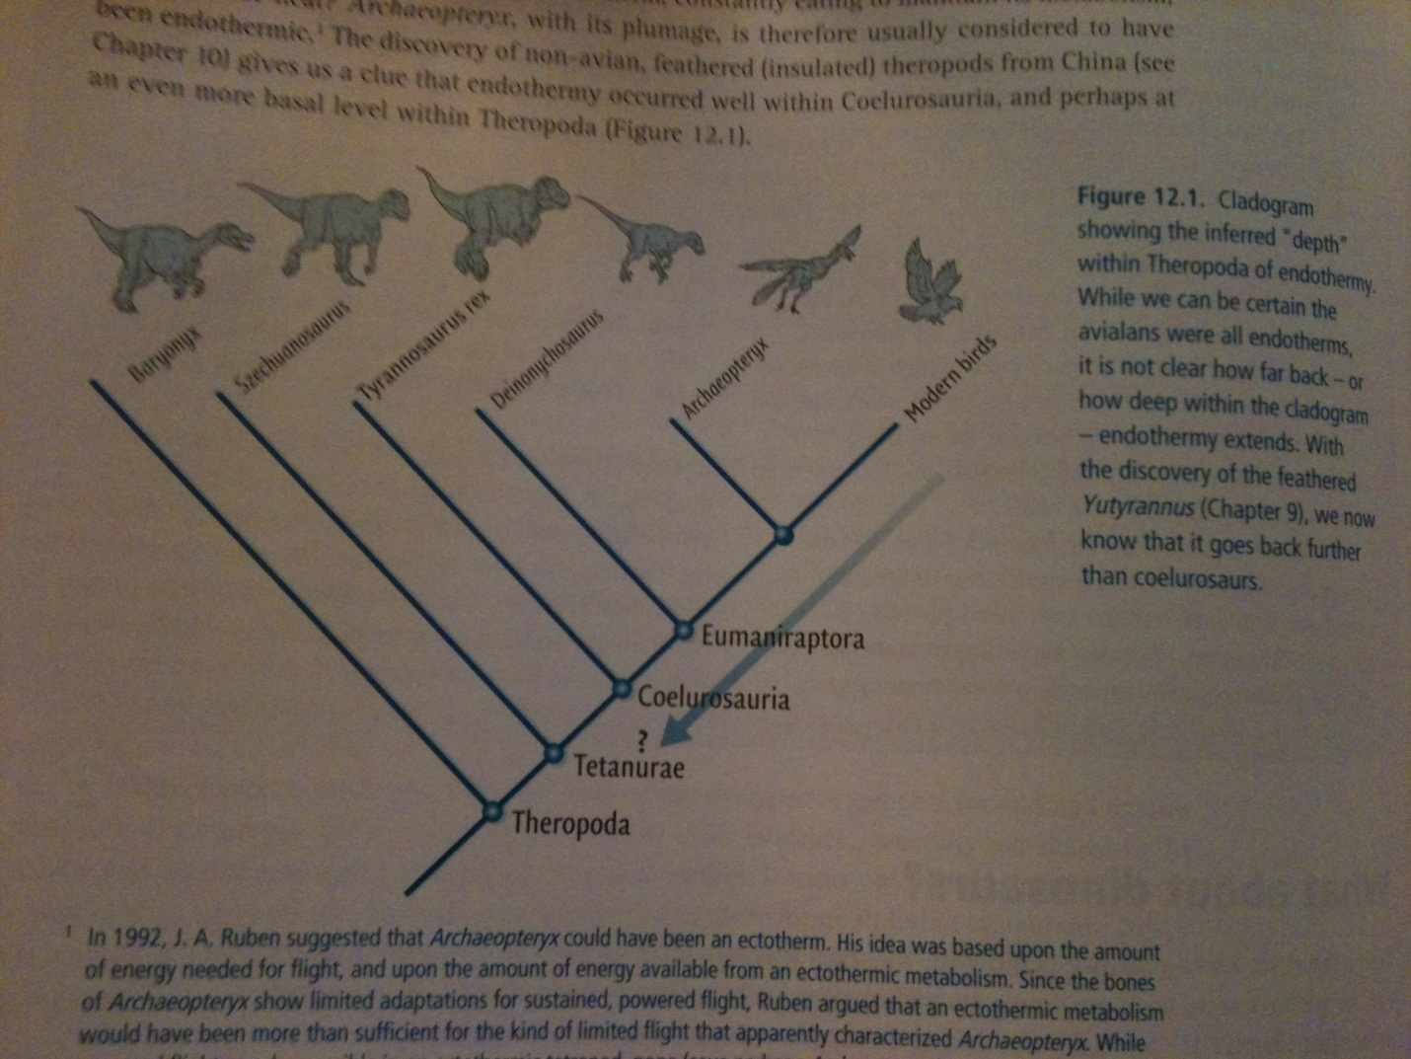
Seminal Studies
Paleontologist R.T Bakker (early evidence that dinosaurs might be endothermic) he had several theories and persuasive arguments by looking at the fossil record in an unconventional way.
1974, with paleontologist P.M Galton, proposed that, on the basis of presumably shared endothermic metabolism, a whole new class of vertebrates be recognized: Dinosauria (including birds) Bakker observed that all non-avian dinosaurs had an erect stance. This erect stance, in living vertebrates, only occurs in birds and mammals, which are endothermic. This fully erect position therefore pointed towards endothermy
There have been other correlations noted between anatomy and endothermy. Long- leggedness is a characteristic of living endotherms while living ectotherms have stubby legs. A second correlation is that among living tetrapods, the only bipeds are endotherms.
A study was then conducted to see how much energy it would take a large bipedal dinosaur vs. a small bipedal dinosaur to run or walk and they found that the large bipedal would have insufficient energy to do this, thus the authors concluded large bipedal dinosaurs must have been endotherms.
In the track of dinosaurs
Trackways are the most tangible record of loco-motor behaviour. When foot prints are arranged in a left – right- left – right pattern, they demonstrate that the dinosaur is walking fully erect. Researchers are able to determine the speed of these dinosaurs by stride length that is the distance from one planting foot to the next. When animals walk slowly they take short strides, when they are running or walking quickly they take long strides. British Biochemist R.M Alexander created a way to interpret stride length, locomotion and speed and his solution was dynamic similarity. Dynamic similarity is a conversion factor it pretends that all animals are the same size and that they are moving their limbs at the same rate. It does not matter what kind of dinosaur because all will be moving with “dynamic similarity”; only speed will vary.

Small bipedal dinosaurs (including certain theropods and ornithopods) are capable of running up to 40 km/h
Ornithomimids, the fastest of the fast, may have sprinted up to 60km/h
Large theropods and ornithopods were slow walkers averaging 20km/h
Stegosaurs and Anklyosaurs walked at 6-8km/h
Sauropods moves at 12-17km/h
Ceratopsians trotted up to 25km/h

Legs and Lungs
Endotherms produce more energy than ectotherms; it takes longer, during heavy use, for the muscles of endotherms to enter an anaerobic physiological state (lactic acid production).
There are a variety of small-medium sized bipedal dinosaurs, such as dromaeosaurid, that are characterized by gracile bones (thigh is short compared to the calf), suggesting high levels of sustained running, behaviour not characteristic of modern ectotherms.

Of predators and prey
Perhaps Bakker’s most brilliant insight was his inference of metabolism from the numbers of predators and prey found in the fossil record. He started with a simple reality of energy budgets; endothermy is much more costly than ectothermy when it comes to energy. He estimated that it costs 10-30 times as much energy to maintain an endothermic metabolism as to maintain an ectothermic metabolism, in part because so much energy is used to maintain a constant body temperature.

Hearts and Minds
All living endotherms have a four-chambered heart. Endothermy requires relatively high blood pressure in order to perfuse complex, delicate organs such as the brain with a constant supply of oxygenated blood. Such high blood pressures, however, would “blow out” the alveoli in the lungs. For this reason, mammals and birds separate their blood into two distinct circulatory systems; the blood for lungs (pulmonary circuit0 and the blood for the body (systemic circuit)
The nearest living relatives to dinosaurs have a four-chambered heart (crocodiles, and birds) so it is very likely that dinosaurs also had a four-chambered heart with a double pump system.
This idea was strongly reinforced in 2000 when a discovery of what was controversially inferred to be a four-chambered heart with an aorta. The “heart” was preserved as an iron-stone mass within the thoracic cavity of the basal ornithopod Thescelosaurus, and identified using computed tomography (CT scan).
In the late 1970’s researchers tried to determine how intelligent dinosaurs might have been based on brain endocasts (internal casts of the brain cases of dinosaurs)

The nose shows
Endothermy requires the lungs to replenish their air (ventilate) at a high rate, but high rates of ventilation lead to water loss. So what most birds and mammals have are called respiratory turbinates, (mucus covered bone in the nasal cavity), these help retain moisture.

Where the wild things are
The distribution of dinosaurs around the globe far exceeds the current distribution of modern ectothermic vertebrates, which are generally not found above or below latitude 45 north and 45 south. Large modern ectotherms rarely occur above latitude 20 north and below20 south.
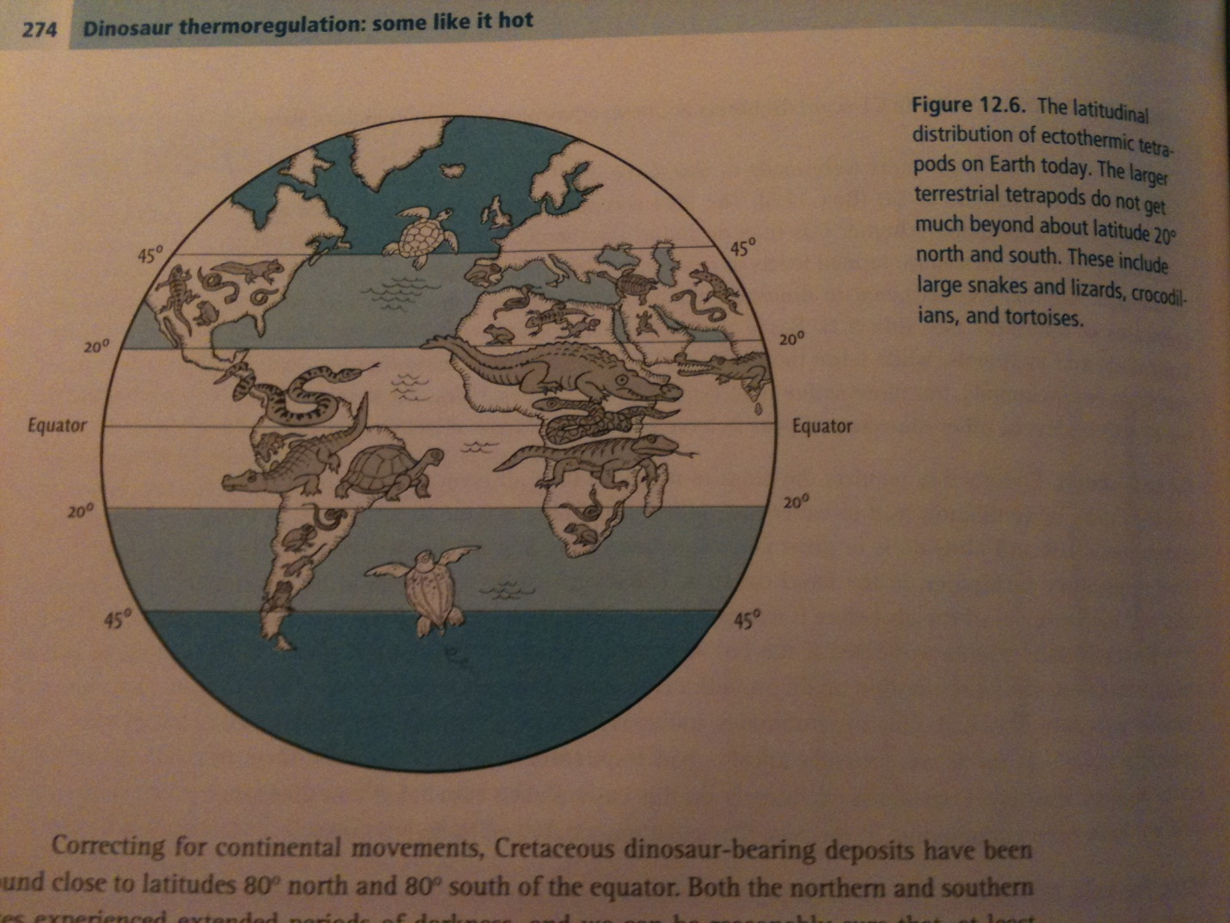

Newer Approaches

Haversian bones grow by remodeling, which involves the resorption (or dissolution) of bone first laid down- primary bone- and redeposition of a kind of bone called secondary bone. Secondary bone is deposited in the form of a series of vascular canals called Haversian Canals, and resorption and redeposition of secondary bone can occur repeatedly during remodeling. When remodeling occurs a type of Haversian bone known as dense secondary Haversian bone is formed. This bone has a distinctive look about it, visible in modern as well as fossil bone.

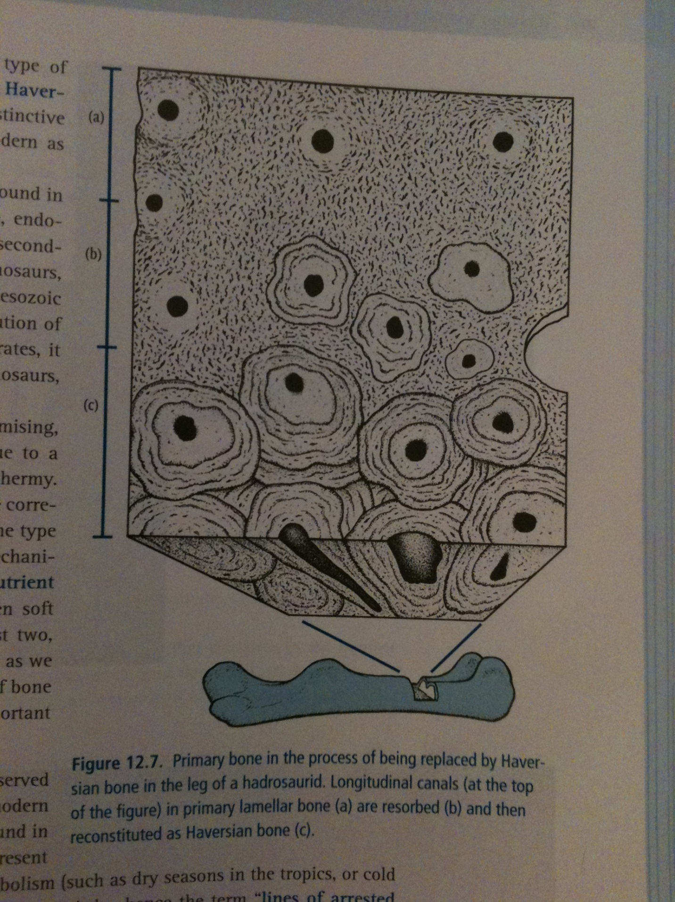

Dense secondary Haversian bone is found in many mammal and birds, all of which of course are endotherms. Among extinct vertebrates, it has been observed in dinosaurs, pterosaurs, and therapsids (including Mesozoic and Cenozoic mammals).

LAGS

Concentric growth rings have been found in the bones and teeth of dinosaurs. Among modern tetrapods, such growth rings have been found in ectotherms, where they are believed to represent seasonal cycles. During times of slowed metabolism (such as dry seasons in the tropics, or cold seasons), growth is stymied – hence the term “lines of arrested growth” or LAGS.

Most dinosaurs, with the exception of some theropods, iguanodontids, and sauropods – show well-developed LAGS, suggesting to researchers that maybe growth in dinosaurs might have been more susceptible to outer climate influences than had been predicted. In two small flyers and one large flightless enantiornithine (Patagopteryx) bird, the presence of LAGs led to the conclusion that the early birds’ metabolisms were subject to seasonal growth, even though the birds clearly bore feathers.

LAGs as time markers

Evidence suggests that LAGs are truly seasonal. There is no numerical way to date them, so evidence is circumstantial. Comparable lines known to form annually occur in a wide variety of groups and not so closely related to Dinosauria. Second, the amount of bone that forms between the lines is consistent with annual cycles. Lastly, the spacing of the lines show a steady decrease, consistent with a decrease of growth rate as the animals get older.

Growth

How does one tell the age of a dinosaur?

- Count LAGs, which yield a number presumably corresponding to the age of the dinosaur
- Measure bone thickness between each LAG, and divide thickness by the number of days/year, which should produce the amount of bone deposited per day
- Measure total bone thickness, and develop an estimate of how much time it would reasonably take to form

Two approaches can be used to learn about growth of a dinosaur. The length of the long bones – femur of tibia – can be measured as representative growth; alternatively the animal’s weight can be estimated.

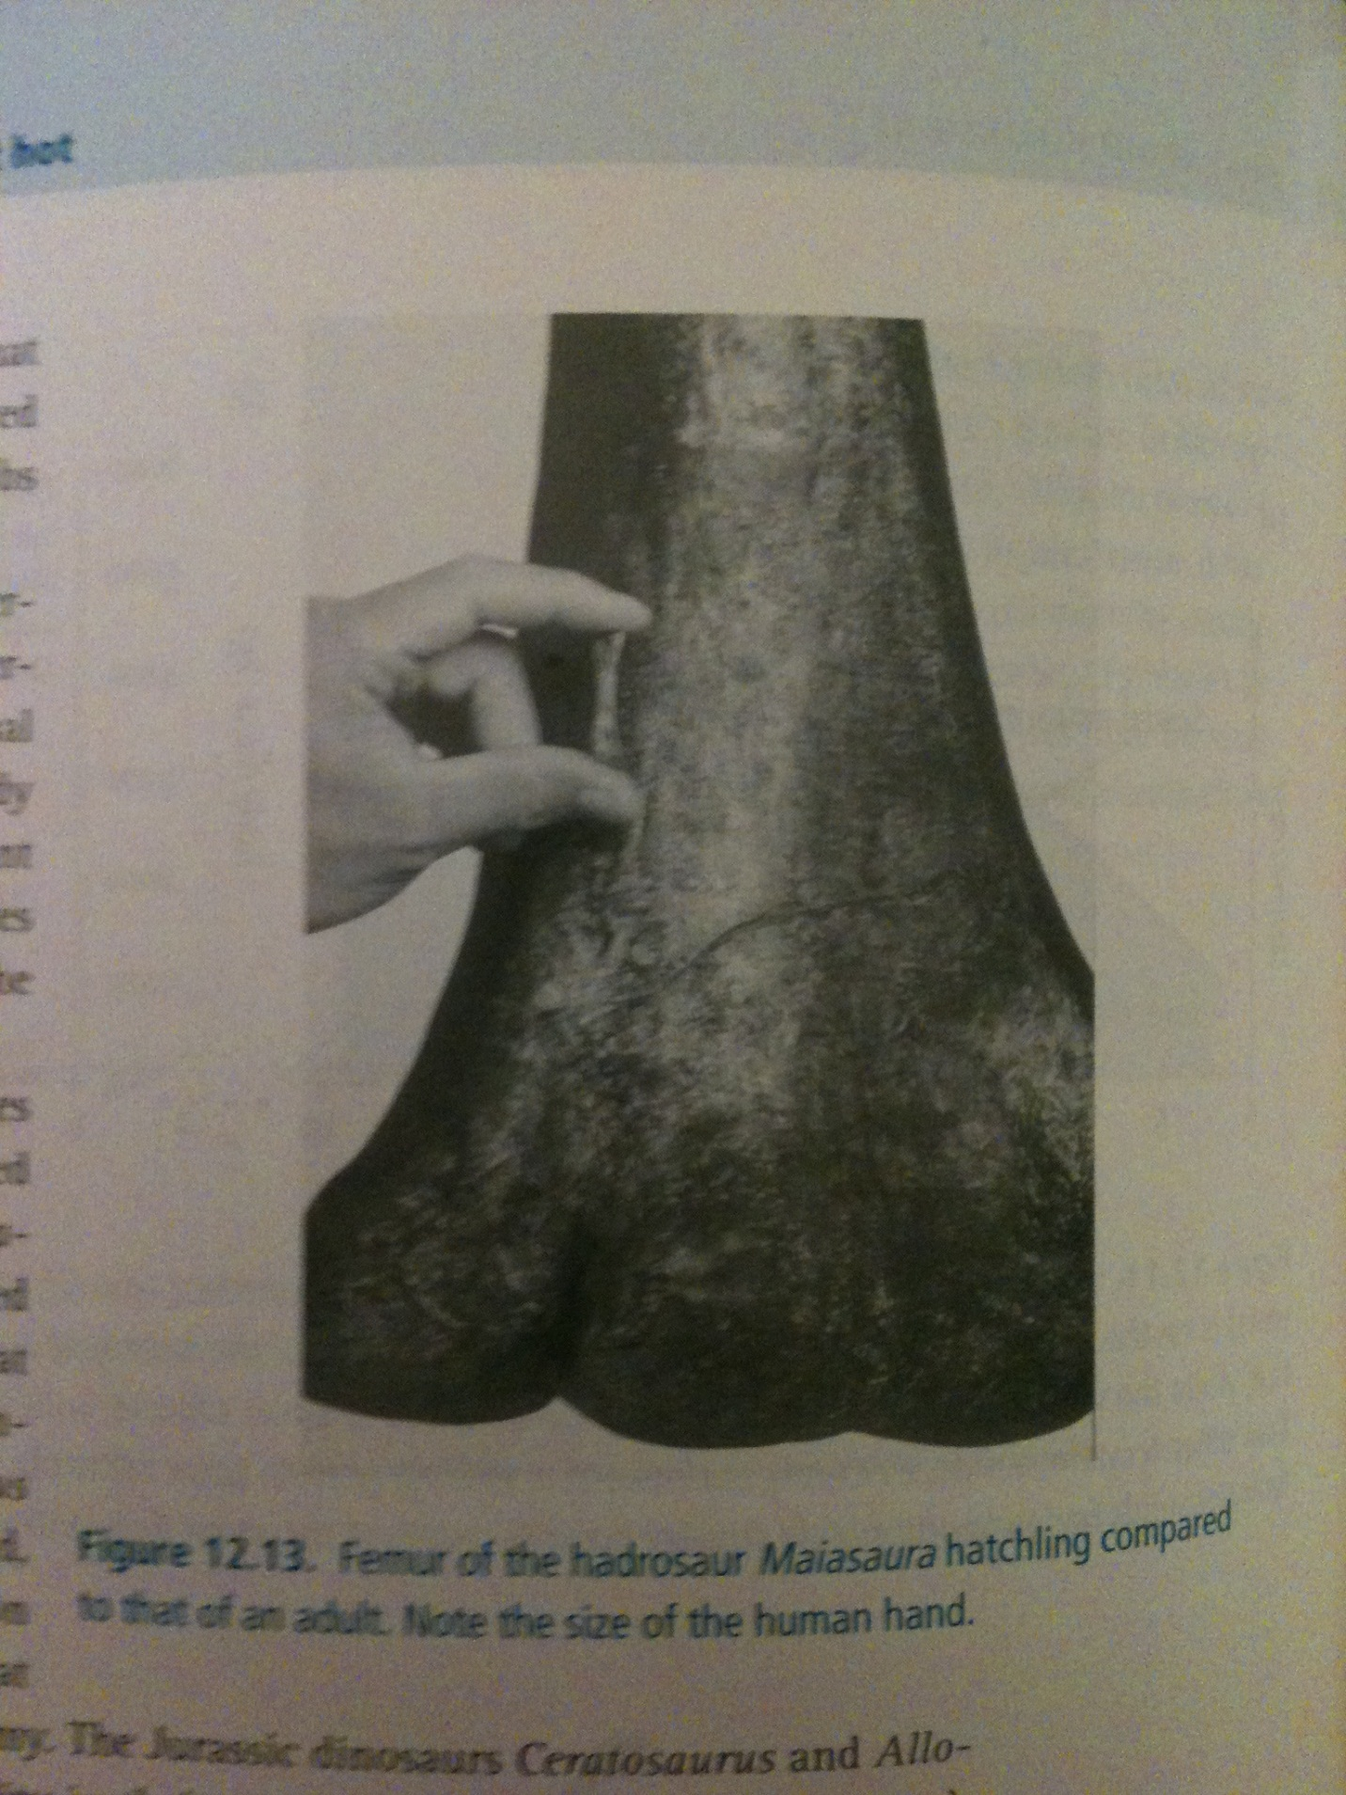

Different strokes for different folks?

Some researchers suggest that some dinosaurs- particularly large ornithopods and theropods- maintained something close to endothermic homeothermy as fast growing juveniles but may have been closer to homeothermic ectotherms as adults. Geochemists have suggested that these animals maintained a temperature different from the air that surrounded them: the hallmark of an endothermic metabolism.

Some scientists also suggest that large sauropods could have relied on a strategy called gigantothermy: small surface: volume ratios (resulting from large size) retained core heat, allowing sauropods to maintain a homeothermic metabolism without the metabolic cost of being truly endothermic.

