Chapter 10: Theropoda II: The origin of birds

Birds are dinosaurs (not necessarily related to dinosaurs but from a long lineage has evolved from something that was itself a dinosaur – think humans are mammals, birds are dinosaurs)
Diagnostic features of living birds
Feathers: all living birds have feathers, distinctive structures that consist of a hollow, central shaft that decreases in diameter toward the tip. Feathers with well-developed asymmetrical vanes (formed by barbules on the shaft of the feather), are used for flight and therefore called flight feathers. Feathers in which the barbules are not well developed tend to be puffy and are called down (used for sleeping bags, blankets etc.)
No living bird has teeth; the jaws of birds are covered with a rhamphotheca. Living birds have relatively large well-developed brains protected by a large brain case. Birds are fully bipedal, and have a fully erect stance.
The feet of all living birds are clawed and have 3 toes in front (digits 2,3,4, and a smaller toe digit 1) at the back. The three central metatarsal (foot bones that the toes are attached to) are fused together with some of the ankle bones, to form a structure called tarsometatarsus. Bird skeletons have gone through a series of bone reductions and fusions to ensure their bodies remain light.
In flying birds they have a pectoralis muscle which aids in the downward stroke when flying, the recovery stroke is carried out by the supracoracoideus.
NO LIVING BIRD HAS A LONG TAIL SKELEON, instead they have a pygostyle. ( pygo- rump, style – stake)

Lessons from History
Living birds have very unique features which they share with the Theropoda
- Hollow and/ pneumatic bones
- Pleurocoels and pneumatic foramina both present in birds; also present in other saurischians
- Bipedality (found in all theropods)
- Distinctive foot (found in all theropods)
- Furcula (a diagnostic feature of Coelurosauria)
- Large Tibia, small fibula thinning toward the ankle
- Large braincase and stereoscopic vision
- Feathers (found in non-avian avialan theropods and perhaps go back as far as Ornithischia)
Insert pigeon image

Anatomy of Archaeopteryx
The skull of an archaeopteryx is typically archosaurian, with nasal, antorbital, and eye openings. Some specimens preserve a sclerotic ring, a series of plates that supported the eyeball. Although the temporal region is poorly known, hints of lower and upper temporal fenestrae are preserved. Archaeopteryx had blade-like, unserrated, recurved teeth.
The arms and hands of an archaeopteryx were fairly long (about 70% of the length of the legs). The hands were about the size of the feet, and each hand bears three, fully moveable, separate fingers. (Each finger is tipped with a well-developed recurved claw).
The archaeopteryx has three toes in front and a fourth in the back, all have well developed claws. Its ankle is a modified mesotarsal joint. It has a small splint bone coming from the middle of the astragalus, one of two bones in the ankle, to form a tall ascending process. The bones are approximately 3 feet and unfused. The thighs are shorter than the shins and the fibula is sliver like when it gets down to the ankle.
*The Archaeopteryx has thin walled long bones with hollow spaces

The Archaeopteryx lacks many features that modern birds have today. For one, the body is relatively long and show hardly any fusion of bones that one sees in vertebrate birds. They have a gastralia( belly ribs) and the distal part of the pubis -known as the footplate- is well developed although the front part is absent. The pubis is pointed downwards. Archaeopteryx has a long tail with very little flexibility.
Archaeopteryx has well preserved, unambiguous feather impressions. The feathers impressions preserved are distinct flight feathers and are indistinguishable from those of modern birds. Unlike modern birds, however, there are feathers also lining a long bony tail. These radiate from the vertebrate, and form a tail plume.
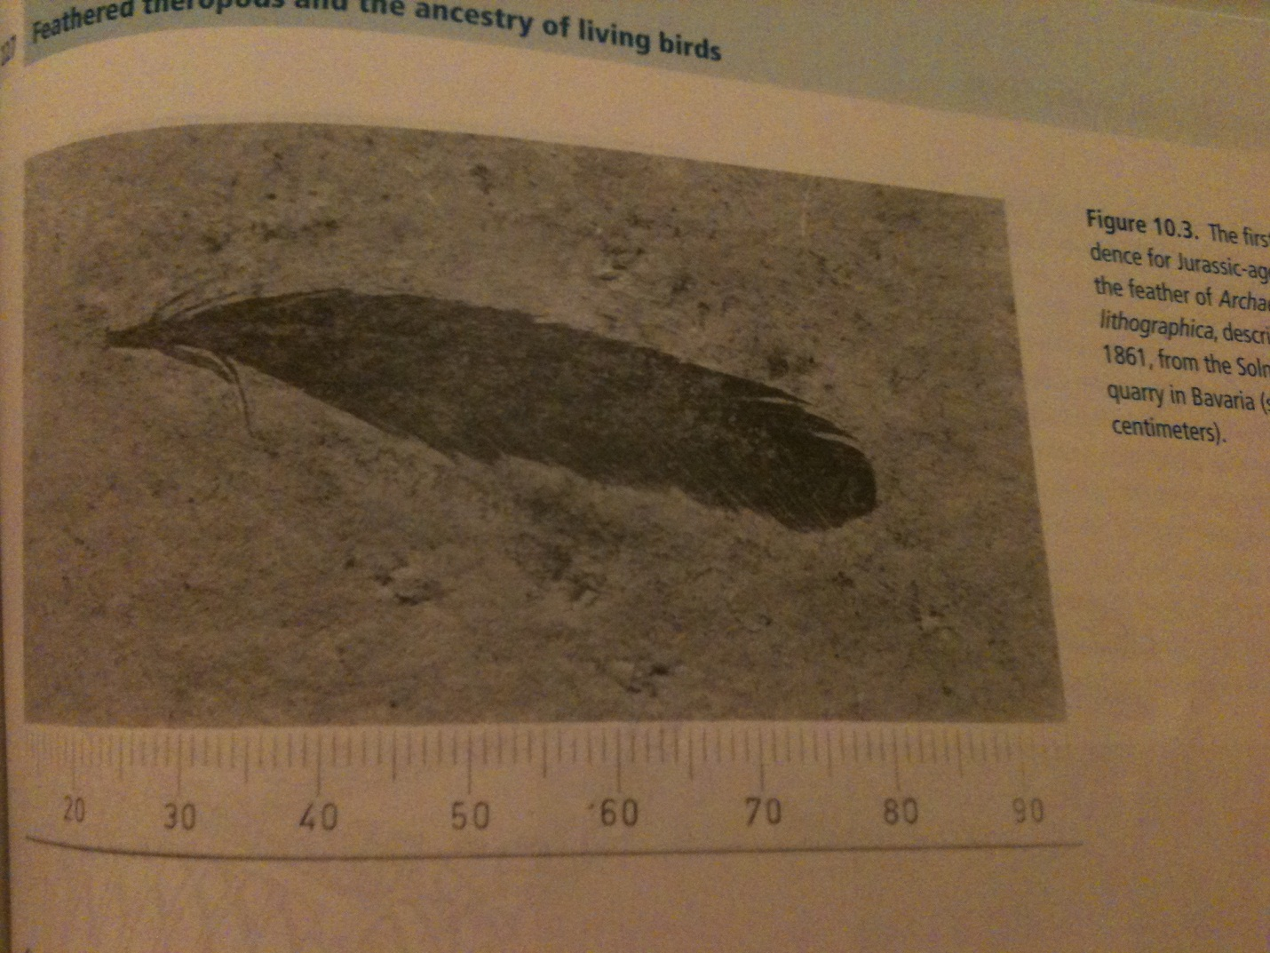
figure 10.3

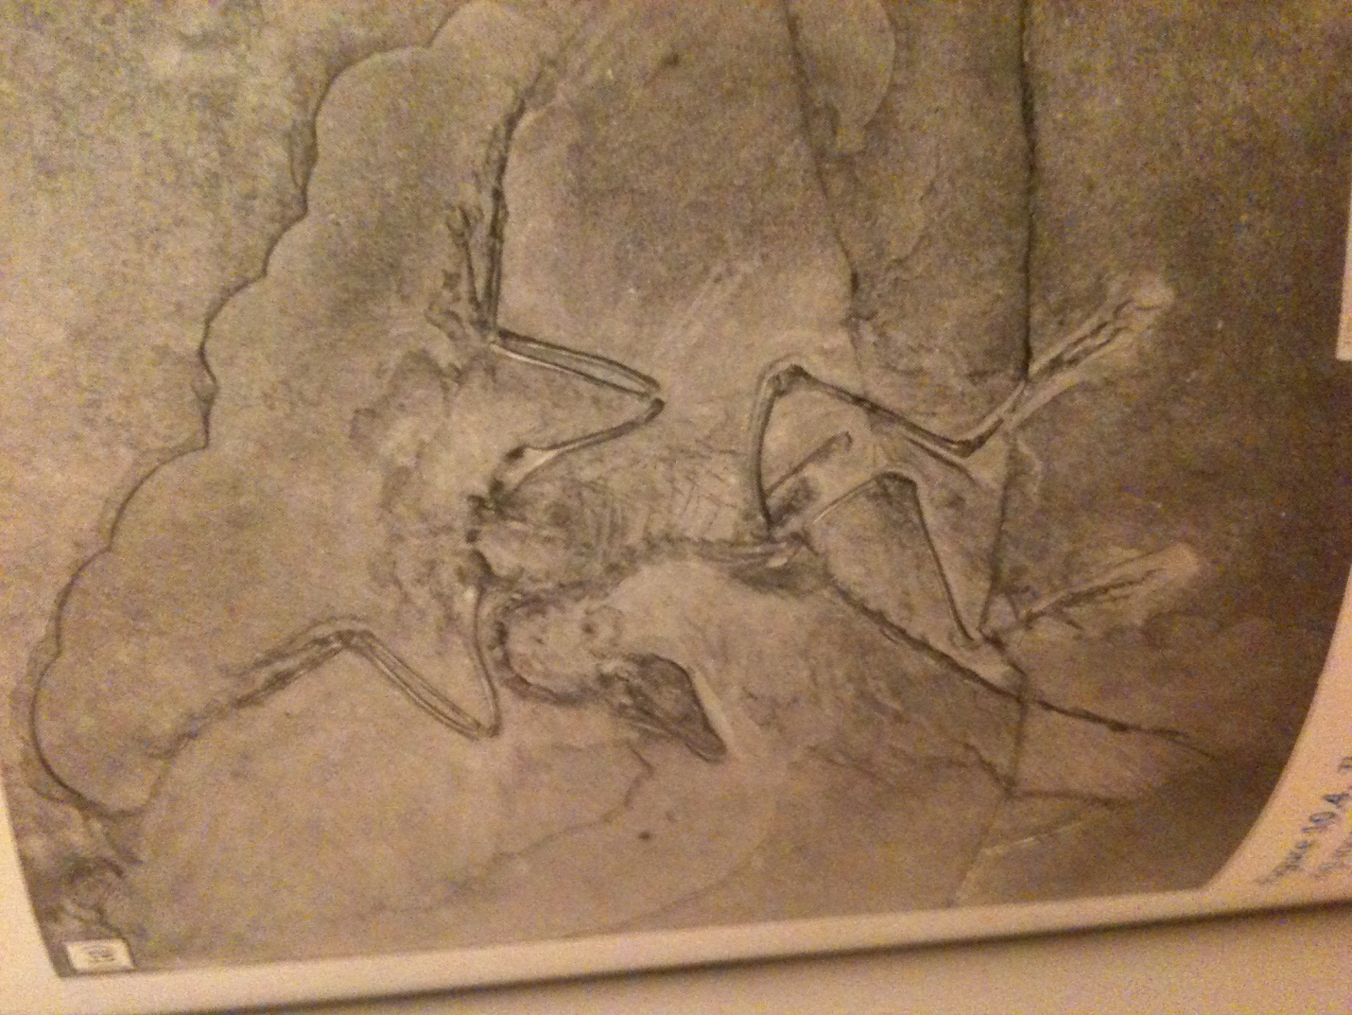
10.4
On pages 228-229 you can see a reconstruction of an archaeopteryx.
Archaeopteryx as a Bird
Once discovered, it was immediately recognized as a fossil of the most primitive bird known. The feathers had suggested it was a bird and the wings suggested flight and because the other features (particularly stance, feet, legs etc.) were remarkably bird-like, together with living birds, Archaeopteryx forms a monophyletic Avialae.
** By all theoretical accounts the archaeopteryx did not fly well. The structure of the wings could not possibly support the bird in long standing flight, thus it has been suggested that it was more of a tree dweller capable of some powered flight, but not the kind available to living birds.
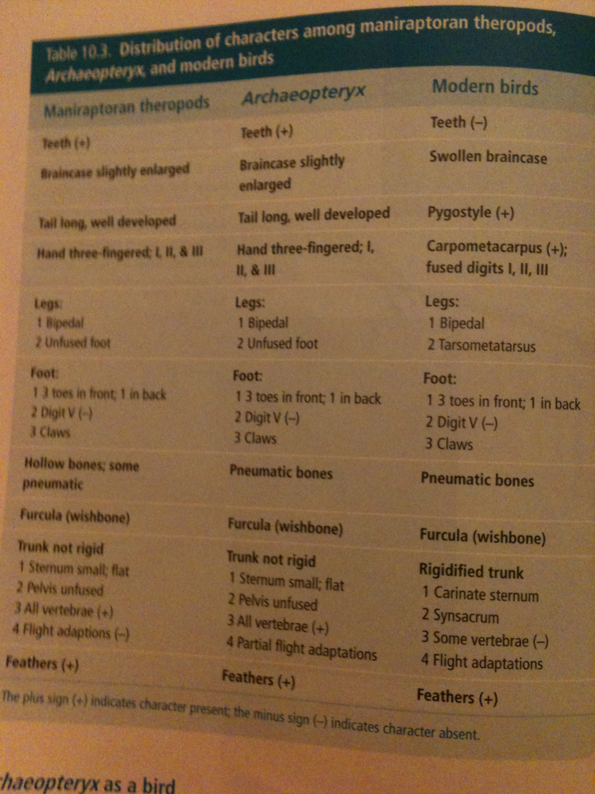

Archaeopteryx as a Dinosaur
Since it has an antorbital opening, like modern birds, it bears one diagnostic feature of an archosaur. In the hind foot it has the three digits in the front and fourth in the back, this is a diagnostic feature of ornithodirans. All living birds, as well as the Archaeopteryx have a fully erect stance, in which the shaft of the femur is at 90 degrees to the head, and the ankle of the archaeopteryx is a mesotarsal, these characters diagnose Dinosauria. Therefore Archaeopteryx is a dinosaur. Living birds are then a subset of dinosauria.
Archaeopteryx as a Theropod
Archaeopteryx have hollow bones; a diagnostic characteristic of theropoda.
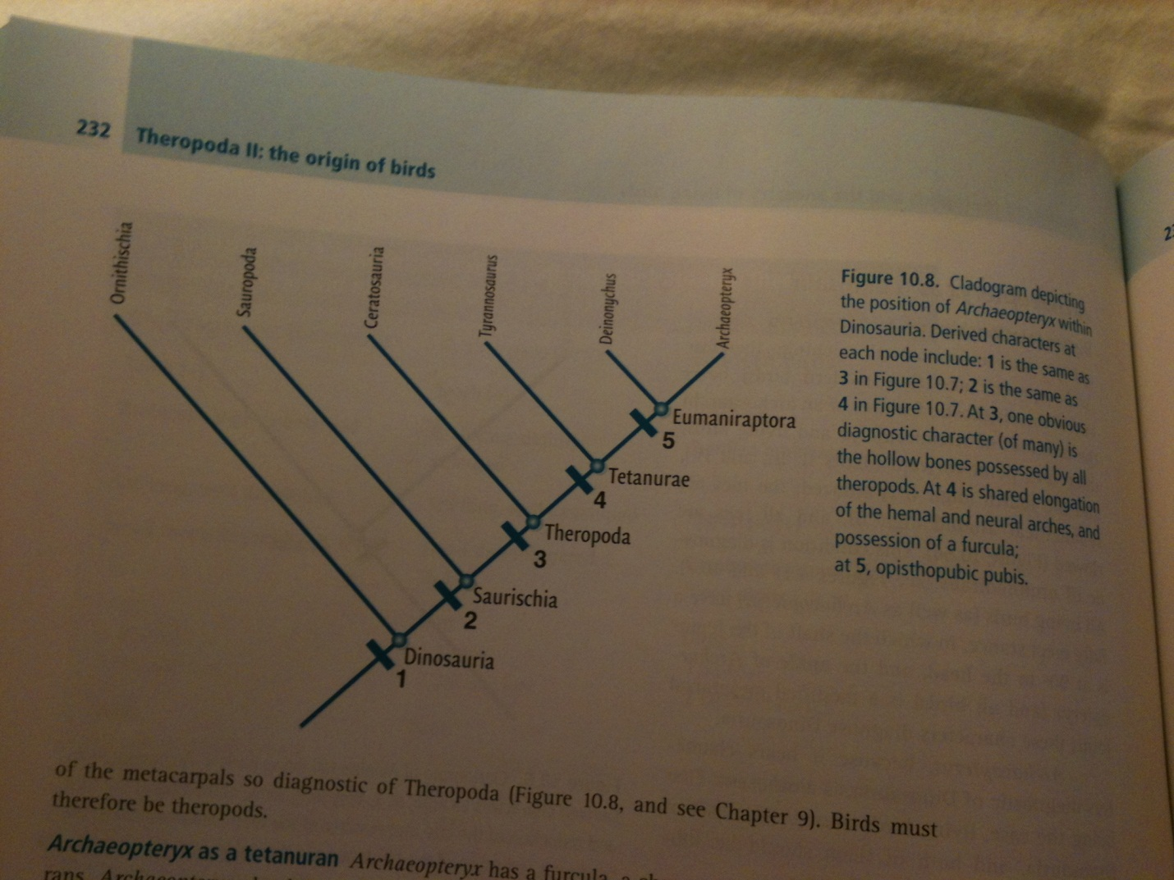
figure 10.8
The Archaeopteryx has many diagnostic features that lead them to be a part of many groups.
For instance, they have a furcula (wishbone), which is a diagnostic feature of tetanurans, but they also have an elongated zygapophyses (leading to a stiffened tail), a shortened tooth row, and an astragalar groove. With a high ascending process on its astragalus, archaeopteryx is not at the base of Tetanurae.
The Archaeopteryx has a shortened ischium (much shorter than the pubis), and a large circular orbitis. Coelurosaurs have a furcula (wish bone), as does the Archaeopteryx, therefore it is a coelurosaur.
The features that the Archaeopteryx shares with the Maniraptoran Coelurosaurs are the three digit hands, the shortened pubis which is pointed directly downwards (in which the footplate is missing), and the elongated middle finger, which the archaeopteryx has. Other maniraptoran features found in archaeopteryx include a highly flexed neck, elongated forelimbs, and a distinctive bowed ulna. Archaeopteryx is a member of Maniraptora.
Lastly, Archaeopteryx as an avialan, the tail vertebrae all show elongation of the hemal (referring to blood, in bone anatomy, hemal arch) and neural arches. Likewise, the teeth of avialans lose their serration, like the archaeopteryx.
We can then conclude that the archaeopteryx is an avialan theropod and because it is also a bird that, that birds are avialan theropods as well.

Were feathers and pneumatic bones formed for flight?
The answer is no. Hollow bones are a theropod character (reference to Coelurosauria) and pneumaticity is likely related to efficient breathing (we saw this in large sauropods, which we can safely say did not fly). Avian pneumaticity developed within avialans, long before there were things we would call birds.
Feathers without flight
Feathers in birds today are used for insulation, display (peacock), and they permit flight. (One anatomical structure; multiple uses)
Is it possible that feathers evolved for insulation and then co-opted for flight? It all depends on how far back warm-blooded creatures go. Most warm blooded creatures, especially smaller ones, require insulation. If it precedes birds and flight then it was most likely evolved for something other than flight.
The fossil record for modern-looking feathers goes back to the Jurassic; of course for the Archaeopteryx but also for other feathered theropods, such as the Chinese theropod Epidexipteryx. It makes no sense for a cold blooded animal, which needs an exterior source of heat to warm up, to be insulated. If feathers are actually an adaptation for insulating a warm-blooded creature, then fossils of non-flying theropods ought to be found with feathers, since, as we have seen, eumaniraptoran theropods were likely very active animals. When evidence finally came that showed that feathers originated for insulation, and not for flight, it came from both embryology and paleontology.
Feathers were thought to have been an outgrowth of “reptilian” scales. In the past 10 years, however, research has suggested that the development of feathers occurs by the interaction of specialized follicles and a series of specialized genes that control the onset and termination of growth.

Fossils
Archaeopteryx has flight feathers that are indistinguishable from those of living birds, and so considerable evolution had to have taken place prior to the Late Jurassic. In the early 1990’s feathered theropod dinosaurs from 124Ma in Liaoning Province, China were found. There was the first discovery in 1997 of the Sinosauropteryx, a small coelurosaur who design made it clear that it did not fly, but it was covered with barb-like filaments, a very primitive downy coat insulating a clearly non-flying theropod. Similar coverings were found in the Pedopenna and Dilong; the former is a maniraptoran theropod from the Jurassic and the latter is a distant relative of the Tyrannosaurus.
Other Dinosaurs known to have feathers:
- Caudipteryx (large and toothless)
- Protarchaeopteryx (large and toothless)
- Beipiaosaurus (very large ostrich-sized, therizinosaurid – no obvious ability to fly)
- Shuvuuia (keratin feather shaft remains were found with this)
- Sinornithosaurus ( non-flying deinonychosaur)
- Microraptor (flying deinonychosaur, covered with flight feathers on arms and legs)
- Anchiornis huxleyi (recently discovered, Jurassic aged trrodontid –DID NOT FLY- older than the archaeopteryx, with well-developed vaned plumage)
- In 2012, three nearly complete specimens of a full sized (c.9m), feathered tyrannosaur, Yutyrannus, were reported from China

This provides real insight in what the origin of feathers was really about. The prediction that feathered non-flying dinosaurs would be found was correct; feathers most likely provided the insulation that is a prerequisite for warm-bloodedness, allowing theropods to maintain high levels of activity for extended periods of time that were eventually necessary for flight.

*** Feathers were meant for INSULATION, NOT FLIGHT, at first ***

Origin of avian flight
Somewhere in eumaniraptorans, flight evolved, but how? There are two opposing theories in regards to the origin of bird flight. The first is called “Arboreal” (trees, down). The hypothesis is that bird flight originated by birds gliding down from trees. Gliding would be a precursor to flapping (powered) flight; as birds became more and more skillful gliders, they extended their range and capability by developing powered flight.
The opposing theory to the Arboreal is the Cursorial (ground up). This hypothesis states that bird flight originated by an ancestral bird running along the ground. In this scenario, perhaps as obstacles were avoided, the animal became briefly airborne. Flapping appeared early on, as the animal fought to fight off gravity. This idea requires a highly cursorial ancestor, in which feathers were already present. In this hypothesis, the legs, feet, and hands of avialans like the Archaeopteryx are viewed as an inheritance from cursorial maniraptoran ancestory.

Summary
Birds are dinosaurs, not because they evolved from them, but because they share derived characteristics of Dinosauria.
A small, Late Jurassic theropod, Archaeopteryx lithographica, shows an almost perfect intermediate mix of characters between theropods and modern birds. Archaeopteryx should not be considered as the ancestor of modern birds, but it shares many of the same characters as that ancestor.
The many discoveries of feathered, non-flying theropods from Early Cretaceous Liaoning Province in China blurs the line of bird and non-bird. Although feathers is usually a diagnostic feature of a bird in living organisms, the Liaoning fossils demonstrate that the presence of feathers does not mean one is dealing with a bird. These discoveries support the viewpoint that feathers have multiple uses, and were invented as a form of insulation, maybe even display, and only later co-opted for flight.

