Dinosaurs Lecture October 26th, 2012

Lambeosaurines
- Had a hollow crest on the top of the head that served as resonating chambers within crest (to make sounds)
- Could also be used to make themselves look bigger

Behaviour and Head Structure
Hadrosaurs: cranial features with nasal cavity , solid and hollow crests for visual and vocal display ** important in mating behaviour, also in rearing the young**

Display Features
- Good hearing and vision (could hear different frequencies and communicate different tones)
- Large eye sockets
- Preserved middle and inner ear structures
- Hearing of a wide range of frequencies
- Elaborate outer shapes of crests point towards display
- Species specific
- Dimorphic

They needed to have good alert behaviour to protect themselves from predators

Should only compare skulls between male and female, not juvenile and adult skulls (female is smaller than the males, the males crest is relatively larger than the females but it is important to make sure the age of the skull to determine if its juvenile, female or male)

Difference between species
- If species live at the same time in the same area: display features have to be different to avoid attracting the wrong mate, therefore different headdresses

Behaviour
- accentuated nasal arches and stout cranial crest possibly used for head pushing during male to male combat
- Nostrils covered by skin flaps which were blown out to impress enemy or make noise? This is present in a cobra and fox.
Lambeosaurine – 15m in length, 5 metric tons
Growth and sexual dimorphism
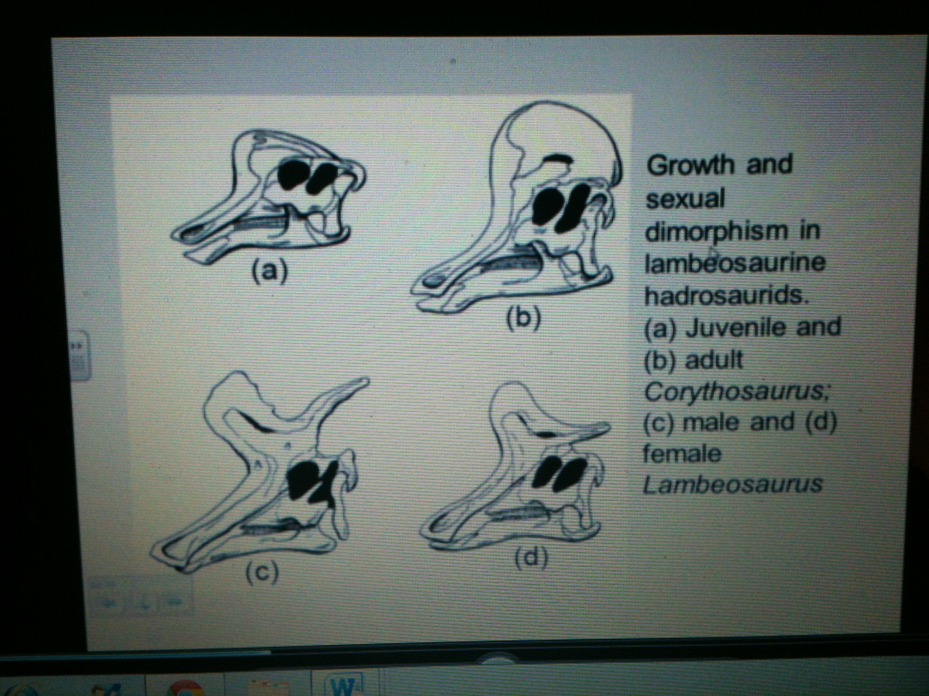

Corythosaurus – Over 20 skulls linked to one species, differences reflecting ontogenic stages and sexual dimorphism
Herd Living
- Bonebeds suggest living in herds
- Migration to feeding grounds
- Herds up to 10,000 individuals

Use of Crests
- Species recognition
- Intraspecific combat
- Ritualized display
- Courtship (animal is not solitary)
- Parent-offspring communication

Nesting behaviour
- Jack Horner ( has done a lot of research on nesting sites)
- Nesting colonies
- Nest of Orodromeus with 12 eggs, in a circle in soft mud , parental attendance possibly till hatching

Nests
8 hatched eggs in good conditions
Animals left nest soon after hatching
Otherwise shells would be trampled

Maiasaura and Hypacrosaurus
Nest up to 17 eggs
Soft sediment
Size as large as body of parent, suggesting that the parents sat on the eggs and had brooding behaviour
Shells are damaged from tramping, hatchling remained in nest, estimated nesting time : 8-9 months, quick growth

Sauropoda – THE GIANTS

Most likely walked with their necks down
In Panagonia, where the largest sauropods were found there is evidence of nesting grounds

Saurischia
8 named by H.G Seeley in 1887
The smallest and the largest
The most agile and the most ponderous

Features
- Subnarial foramen- opening beneath the nostril area
- Elongation of rearward neck vertebrae (resulting in long neck)
- Increased articulation between vertebrae
- Large thumb supported by a broad metacarpal bone, wedge shaped splint of bone on the atragalus (ankle bone) , lizard like hip
Sauropodomorpha
Saurus – Lizard, pod- foot, morpha- form
Giant among dinosaurs
Weight: 75,000kg
Length: up to 40m
Height up to 6m at the shoulder
Survival over 160 million years
Animals that big test processes such as: weight support, neural circuitry, respiration, digestion (definitely gastroliths)

