Astronomy notes

Chapter 1: Charting the Heavens

Astronomy: the study of the universe
Universe: the totality of all space, time, matter and energy
Light-year: distance that light travels in a year, at a speed of 300,000 km/sec

1.2: Scientific theory and the Scientific Method

Theory: framework of ideas and assumptions used to explain some set of observations and make predictions about the real world

Scientific Method: the process of investigating, thinking, experimenting and possibly refining a theory

Criteria of a scientific theory: must be testable, must be continually tested, must be simple, must be elegant.

1.4 Earth’s Orbital Motion

Diurnal motion: progress of the stars across the sky due to Earth’s rotation
Solar Day: 24 hours, basic social time unit, measured from one noon to the next
Sidereal day: a day measured in stars, aka Earth’s true rotation period

Difference between a solar day and sidereal day:
The reason for the difference is due to the fact that Earth moves in two ways simultaneously: it rotates on a central axis while at the same time moving a small distance along its orbit about the Sun. Earth therefore has to rotate slightly more than 360 degrees for the Sun to appear in the same location in the sky, aka at noontime. Thus, a solar day is longer than a sidereal day, by about 3.9 minutes.

Sidereal year: the true time that it takes Earth to orbit once around the Sun, relative to the Sun.

Ecliptic: the path on the celestial sphere that the motion of the Sun on the sky traces out

Summer Solstice: represents the location in Earth’s orbit where our planet’s North Pole comes closest to pointing in the direction of the Sun.
Winter Solstice: when the North Pole points in the opposite direction of the Sun

Equinoxes: when the Earth’s rotation axis is perpendicular to the line joining Earth to the Sun; on those days, day and night are of equal duration.

Precession: Earth’s axis changing direction over the course of time, caused by torques (twisting forces) from the gravitational pulls of the Moon and the Sun.

The Motion of the Moon

Lunar Phases: New moon, waxing crescent, first quarter, waxing gibbous, full moon, waning gibbous, third quarter, waning crescent
Synodic Month: the time it takes the Moon to complete a full cycle of phases, which is longer than a sidereal month for the same reason a solar day is longer than a sidereal day.

Solar Eclipse: when the Moon passes in front of the Sun, briefly turning day into night.
Total Solar Eclipse: When the alignment is perfect
Partial Solar Eclipse: The moon’s path is slightly “off-center” and only a portion of the Sun’s face is covered.

Umbra: The central region of the shadow caused by an eclipse.
Penumbra: outside of the umbra, but still within the shadow.

Annular Eclipse: even though the Moon’s and the Sun’s centers line up, unfavourable conditions makes it so that there is no region of totality. In other words, the umbra never even reaches Earth and a thin ring of sunlight can still be seen. Roughly half of all eclipses are annular.

TRIANGULATION AND PARALLAX

Triangulation: method of measuring distances by visualizing an imaginary triangle. Makes use of trig.

Parallax: the apparent displacement of a foreground object relative to the background as the observer’s location changes. The closer an object is to the observer, the larger the parallax. (Demonstrated by holding a finger and closing one eye, then the other).

Chapter 2: The Copernican Revolution

Prograde motion: the eastward motion of stars and planets across the night sky
Retrograde motion: the apparent backward (westward) loops of stars and planets

Aristotle:
- Geocentric model
- Utilized perfect circles
- uniform motion around a circle with Earth at its centre – provided fairly accurate descriptions of the orbits of the Sun and the Moon viewed from Earth, but could not account for retrograde motion or varying brightnesses in the planets
- implemented epicycles – where planets would move on their own small, circular orbit – while orbiting on a bigger orbit known as a deferent around Earth.

Ptolemy:
- most complex geocentric model ever made
- used 80 distinct circles
- to explain retrograde motion, the models had to assume that the orbits of Mercury and Venus were, for an unknown reason, tied to that of the Sun rather than the Earth.

Nicolaus Copernicus:
- showed that heliocentric models gave better explanations for observed facts
- asserted that Earth spins on its axis, and orbits the sun
- only the Moon orbits the Earth
- explains retrograde motion: if we assume Earth moves faster than Mars (since it has a smaller orbit), than every so often Earth will “overtake” Mars, making the planet appear to move backward in the sky from our line of sight.
- However, still clung to perfect circles

Galileo Galilei:
- used the telescope extensively
- discovered the Moon had valleys. Mountains and craters
- discovered the sun had dark blemishes, or sunspots. By noting the changing appearance of sunspots, he inferred that the sun rotates
- discovered Jupiter’s moons; the fact that another planet had moons provided support for the Copernican model. Clearly, Earth was not the centre of all things.
- also found that Venus varied in apparent size and showed a complete cycle of phases, such as those of our Moon (lunar phases).

Johannes Kepler:
- mentor, Tycho Brahe, maintained an extensive and accurate record of the stars, planets and other noteworthy celestial events.
- using these records, kepler developed a set of three laws that explain how planets move.

Kepler’s laws of planetary motion:
- the orbital paths of the planets are elliptical not circular.
– An imaginary line connecting the sun to any planet sweeps out equal areas in equal intervals of time. (planets move faster when it elliptical orbit brings it closer to the sun)
– The square of the planet’s orbital period is proportional to the cube of its semimajor axis

Newton’s laws:
– Every body continues to stay at rest or stay in a state of uniform motion in a straight line, unless it is compelled to change by a force acting on it.
– When a force F acts on a body of mass m, it produces in it acceleration equal to the force divided by the mass. F = ma
– To every action, there is an equal and opposite reaction.

Chapter 6: The Solar System

Comparative Planetology: comparing and contrasting the properties of the diverse worlds we encounter – to better understand the conditions under which planets form and evolve.

Extrasolar planets: planets orbit stars other than our own Sun. They are useful because they provide a whole new “proving” ground for theories to be compared to reality.

Measuring planets:
- Distance of each planet from the Sun can be measured through Kepler’s laws.
- Sidereal Orbital period can be measured from repeated records of its location on the sky as long as Earth’s own motion around the Sun is taken into account
- Radius is found by measuring the angular size through elementary geometry.
- Masses can be found by applying Newton’s laws of motion and gravity by observing the moons’ orbits around the planets.
- Masses of Mercury and Venus and the moon are found the same way, just by measuring their effect on nearby bodies in space.
- Rotation period found by watching surface features as the planet rotates
- Density is found by dividing the mass by surface area

Terrestrial vs. Jovian Planets

Differences among terrestrial planets (Mercury, Venus, Earth, Mars)
- all four have atmospheres, however, atmospheres range from vacuum to inferno
- Earth is the only one with oxygen in atmosphere and liquid water on surface
-Surface Conditions
- Rotational period
- Earth and Mars have moons
- Earth and Mercury have magnetic fields

Terrestrial vs Jovian (Jupiter, Saturn, Uranus, Neptune)

- T.W. lie close together, near the Sun - J.W. are widely spaced
- T.W. are small, dense, rocky. – J.W. are large and gaseous, containing large amounts of hydrogen and helium (lightest elements)
- T.W. have solid surfaces -J.W. have none, atmosphere eventually merges with liquid interior
- T.W. have relatively weak magnetic fields – J.W. are all strong
- J.W. have large, dense “terrestrial” cores
- J.W. have many moons each, no two of them alike, and none of them like ours
- J.W. all have rings

The job of a planetary scientist is made more complicated since a theory must accommodate the fact that terrestrial and jovian planets are so dissimilar, but still must naturally explain both.

Interplanetary Matter: cosmic debris
Interplanetary Matter, such as asteroids and comets, are composed of relatively unchanging material since the time that they were formed, along with the formation of the solar system. This provides scientists with clues on how the solar system was formed.

Solar System Properties:
1. Each planet is relatively isolated in space
2. The orbits of planets are nearly circular
3. The orbits of all planets all lie in nearly the same plane
4. the direction in which the planets orbit the Sun is the same as the direction in which the Sun rotates on its axis
5. our planetary system is highly differentiated
6. the asteroids are very old and exhibit a range of properties not characteristic of either the inner or outer planets or their moons
7. the Kuiper belt is a collection of asteroid-sized icy bodies orbiting beyond Neptune
8. the Oort cloud comets are primitive icy fragments that do not orbit in the plane of the ecliptic and reside at large distances from the Sun

Nebular Contraction:
- Rene Descartes
- large cloud of interstellar dust and gas (called nebula) a light year across
- external influence, such as collision with another nebula or explosion of a nearby star, nebula starts to contract under its own gravity
- as it contracts, becomes hotter and denser forming a star at its centre (Sun)
- Descartes suggested that while the sun was forming in the core, planets and moons were forming in the cloud’s cooler outer region…planets are by products of the process of star formation

- Laplace showed that angular momentum requires our nebula to spin faster as it contracts
- causes nebula’s shape to change as it collapses, centrifugal forces flattens into pancake shaped primitive solar system
- referred to as solar nebula
- circularity of orbits and the fact that planets move in the same direction stem from this nebular theory

Condensation Theory:
- Key new ingredient: interstellar dust
- dust helps cool warm matter by radiating its heat away in the form of infrared radiation
- as the cloud cools, its molecules move slower, allowing the nebula to collapse easier under gravity
- dust also act as condensation nuclei – platforms to which other atoms can attach, forming larger and larger balls of matter. Similar to the way raindrops form in the Earth’s atmosphere
- Planetesimals began to form through accretion of matter
- Soon protoplanets formed, causing a competing process where the strong gravitational pulls caused many collisions and fragmentations – these fragments would then be collected by other protoplanets
- evident in bodies such as the moon and mercury

How theory explains differentiation
- density and temp greatest near the centre of the nebula
- high temps caused most dust grains in the inner solar system to disappear, and left the ones in the cooler parts intact
- the smaller amount of dust grains left in the inner areas were ones composed of denser, metallic materials that could survive (thus when the nebula eventually cooled, the inner, smaller, denser planets are composed of these materials)
- Naturally, lower density and icy materials composed the larger jovian planets

Chapter 7: Earth

Overall structure:
Interior:
– two part core (inner solid surrounded by liquid), surrounded by mantle.
- relatively thin crust comprising of solid continents and the seafloor
- hydrosphere accounting for liquid oceans and 70% of surface area

Atmosphere:
- troposphere – surface winds and weather caused by convection (process through which heat is moved from one place to another by the downflow of a fluid such as air or water)
- stratosphere – lies ozone layer which absorbs income solar uv radiation
- mesosphere – meteors burn up here
- ionosphere – atmosphere kept ionized by absorption of radiation.

Atmospheric structure:
- presence of large amounts of oxygen makes our atmosphere unique
- half lies within 5 km of surface, all but 1% is found below 30 km
- atmospheric density decreases steadily with increasing altitude
- convection: the upwelling of warm air and the concurrent downward flow of cooler air to take its place – physically transfers heat from a lower to higher place. (responsible for our weather and winds)
- Ozone layer:
- absorbs incoming UV radiation from the Sun (Ozone consists of three oxygen atoms that are broken apart by UV radiation forming molecular oxygen.
- CFCs travel to the ozone layer through convection. Once there, they break down ozone into oxygen by turning into chlorine from the sun. They do not break down after use, but stay in the ozone layer, destroying the protective ozone particles.

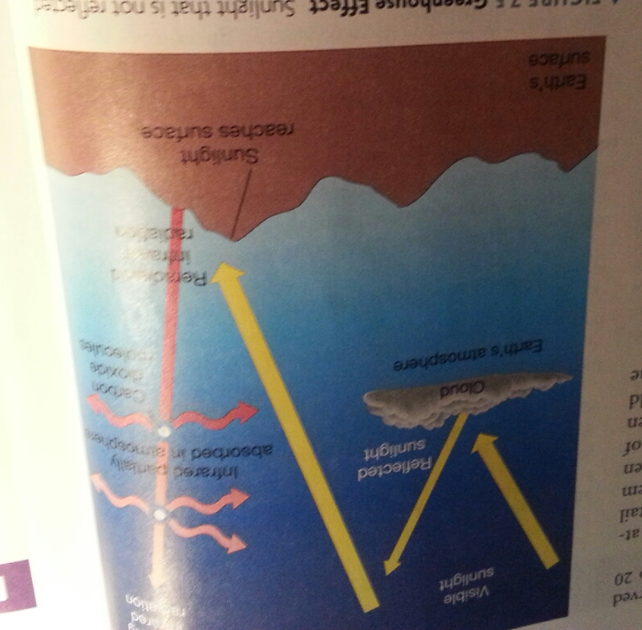
Greenhouse Effect and Origin of Earth’s Atmosphere:
- absorption and trapping of infrared radiation emitted by Earth’s surface by atmospheric gases such as carbon dioxide and water vapor.
- Earths secondary atmosphere – composed of water vapor, methane, carbon and sulfur dioxide and nitrogen – were expelled or outgassed from the planet’s interior due to volcanic activity. This replaced the original atmosphere consisting of gases such as hydrogen, helium, etc which escaped into space during Earth’s formation.
- Later on, living organisms contributed to the presence of atmospheric oxygen.

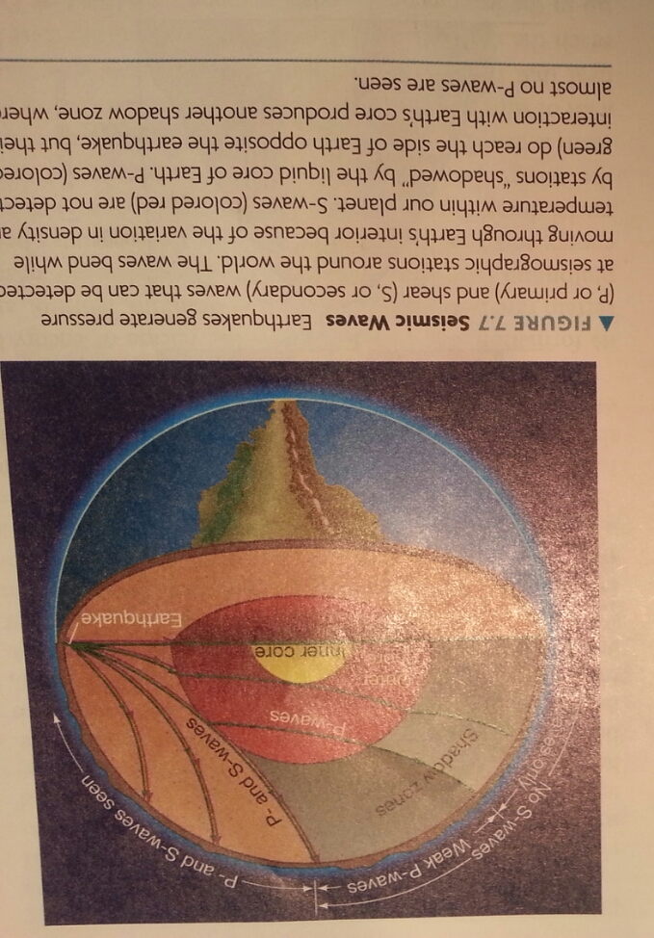
Earth’s interior:

- two types of important seismic waves: p waves (pressure waves) and s waves (shear waves)
- carry info that can be detected via seismographs
- P waves can travel through both liquid and solid.
- S waves occur after P waves and cannot travel through liquids
- the speeds of both waves depend on the density of the matter through which they are travelling
- therefore, the density can be determined through the time the waves take to move from the site of an earthquake to a monitoring station
- waves bend as they move through the interior of the earth due to the fact that wave velocity tend to increase with depth – waves that travel deeper overtake those on shallower paths
- shadow zones: areas where earths surface do not detect waves. For S – waves, this area is always opposite of the quake, P waves are refracted at the core boundary like a light is refracted by a lens while s waves are absorbed by the liquid center.
- best evidence that our core is hot enough to be liquid

- interior modeled :
- outer core surrounded by thick mantle
– mantle 3000km thick – 80% of planets volume, dense, rocky material (silicon and oxygen)
– basalt denser than granite – granite ﬂoats atop denser material below
– upper mantle – probably basalt (iron, magnesium, silicate crust 16km thick (3gm/cm3)
– density and temperature increase with depth 3gm/cm3) – 12gm/cm3); 300 K –5000K
– outer core – iron, nickel (LIQUID)
– liquid inner core solid from high pressure

Differentiation: the process through which heavy material sinks to the center of a planet and lighter material rises to the surface.

- Earth is not a homogenous ball of rock
- layered structure
- why?
- Answer appears that much of Earth was molten at some time in the past. As a result, higher density matter sunk to the core and lower density toward the surface.
- What processes were responsible for Earth being molten?

- 4.6 billion years ago: earth grew in mass by sweeping up chunks of matter in its vicinity. Gravitational field grew with area, leading to the speed of which new matter struck its surface. This process generated enough heat to lead to Earth being molten by the time it reached its present size. More gravitational energy was released as Earth began to differentiate.

- Radioactivity – release of energy by certain rare heavy elements, such as uranium.
- release energy and heat up surroundings. Earth contained lots of radioactive atoms. Rock is a poor conductor of heat so the energy would have taken a lot of time to reach surface and leak away into space. meaning that the heat built up in the Earth’s interior. Radioactive decay only works in one direction, once atoms are gone, they cannot be replenished. Earth cooled from outside in.

Surface activity:
- Earth is still geologically alive.
- Continental drift occurring – result of plate tectonics (plates that make up the Earth’s lithosphere). Suggested by Wegener
- plates colliding reshape the land and cause violent seismic activity
- subduction zones: when one plate slides another, which will then be destroyed by the mantle.
- midocean ridges: occur when new material from the mantle rises up due to movement
- convection thought to be responsible for movement
- warm matter underlying cool matter, warm rock rises just as hot air rises. Sometimes the warm rock cools and falls back down to lower levels. Large circulation patterns form, wth plates riding on top of them.
- provides natural explanation for rock cycle: process through which surface rock on our planet is redistributed and transformed from one type to another.

Earth’s Magnetosphere

Magnetosphere: region around a planet that is influenced by that planet’s magnetic field. Similar in structure to the field of gigantic bar magnet.

- field lines run from south to north, indicate the strength and direction of the field at any point in space

- the north and south magnetic poles, where the field lines intersect Earth’s surface vertically, are roughly aligned with spin axis, however, they are not fixed relative to our planet.

- Earth’s magnetosphere contains two doughnut-shaped zones of high-energy charged particles named Van allen belts.
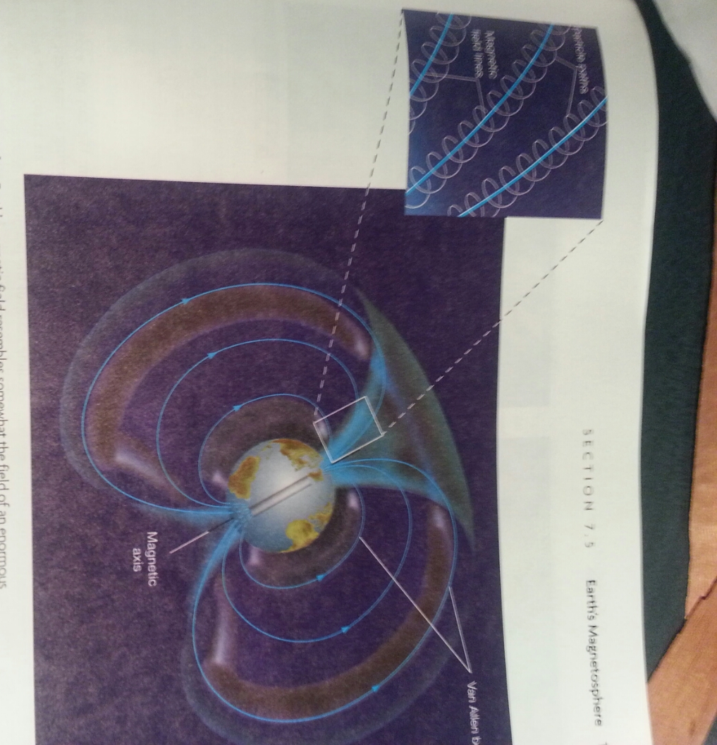
- particles in these belts originate from solar wind – steady stream of charged particles flowing from the Sun.
- neutral particles and radiation are unaffected by Earth’s magnetism, but electrically charged particles such as solar wind are influenced
- causes particle to spiral around field lines, herds them into Van allen belts.
- harmful to humans
- only thought to exist because Earth is rotating. Produced by the spinning, electrically conducting material, liquid, metal core flowing in our planet’s interior. Known as Dynamo Theory.
- we can tell a lot about other planets and their interiors via its magnetic field
- magnetosphere protects life on earth because it attracts potentially harmful particles
- charge particles can leak out of the Van Allen belts near the poles – particles interactwith the upper atmosphere Northern/Southern Lights (Aurora)

The tides:
- result of gravitational influence of the Moon and Sun on Earth
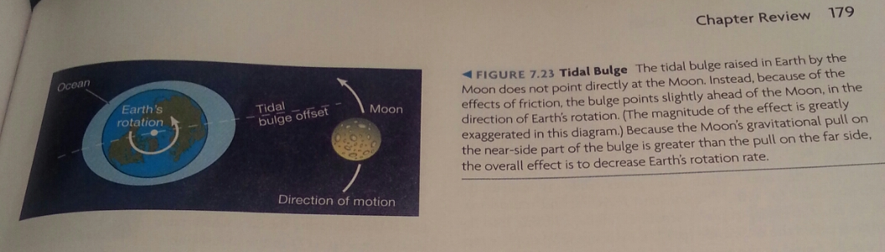
- raises tidal bulges in the hydrosphere. Tidal effect of the Moon is almost twice that of the Sun. the size of the tides depends on the orientations of the Sun and Moon relative to Earth. A differential gravitational force is always called a tidal force, even when no oceans or planets are involved. The tidal interaction between and the Moon is causing Earth’s spin to slow.

Chapter 8: The Moon and Mercury

Orbital Properties

The moon:
- parallax methods can provide us with accurate measurements of distance to moon, using Earth as baseline
- slightly elliptical orbit around Earth can be measured to the microsecond using laser ranging tech

Mercury:
- never strays far from the Sun
- visible to the naked eye only when the Sun’s light is blotted out
- not possible to follow Mercury through a full set of phases

Physical Properties

The Moon:
- Moon’s radius roughly ¼ of Earth’s (1700km)
- Mass was already well known due to study of effect on Earth’s orbit (7.3 x 10^22kg)
- Density of 3300 kg/m^3, suggests that it contains fewer heavy elements (such as iron) than Earth does
- due to size, gravitational field is significantly weaker (only about 1/6 Earth’s)
- Because of this, there is no appreciable atmosphere on Moon. The atmosphere escaped into space due to lack of pull
- no protection against harsh environment of space
- wide variation in surface temperature (400K at noon, 100K at night)

Mercury:
- 0.38 of Earth’s radius (2450km)
- Mass is about 3.3 x 10^23 kg
- Mercury’s mean density is about 5400kg/m^3, about as dense as Earth. Assuming the surface crust is about the same density, than the interior of mercury must contain a lot of high-density material. Since mercury is also a lot smaller, the interior is squeezed less by the weight of overlying material, so Mercury’s iron core must contain a larger fraction of the planet’s mass. (due to nebular theory, closer to sun, heavier interstellar dust formed planets)
- weak gravitational pull = no atmosphere
- originally, it thought mercury had traces of hydrogen and helium forming an atmosphere, however, these were just solar winds temporarily trapped by the planet’s gravity
- mercury daytime 700K due to proximity to sun, 100k at night. Largest range of temps in the whole solar system

Surface Features:

The Moon:
-dark areas that are actually extensive flat areas resulting from lava flows during Moon’s evolution called maria. About 14 maria, all roughly circular. Rock type is primarily iron and basalt.
- highlands are elevated several km above the maria, and are made up of a different type of rock. They are made up of rocks primarily rich in aluminum making them lighter in density and lighter in color than the maria.
- Highlands can be said to be the actual crust of the moon, while maria are made up of mantle material
- many craters caused by meteoric impact
- Moon rotates once on its axis in exactly the same time it takes to complete on orbit around Earth; as such “near” side is always visible to Earth and “far” side is never visible
- Far side has no major maria, which means that Moon’s surface terrain must be influenced by Earths presence and not strictly internal factors.

Mercury:
- striking similarities to our moon
- no signs of weather
- cratered surface bear strong resemblance to Moon’s highlands
- craters not as deep nor as high; due to Mercury’s stronger gravitational pull leading to less secondary collisions due to meteors bouncing off surface
- no lava flow region like lunar maria

Rotation Rates:

The Moon:
- rotation period precisely equal to its period of revolution around Earth – 27.3 days.
- Keeps the same side facing Earth at all times, to an astronaut standing on Moon’s nearside surface, Earth would appear almost stationary in the sky.
- synchronous orbit – condition in which the spin of one body is precisely equal to its revolution around another body.
- no accident, due to gravitational interaction between two bodies. Earth produces a tidal bulge in Moon about 20 times greater than vice versa due to differences in size. In the past, it was said that the distance between Earth and the Moon was 2/3 of its current value, making the tidal force 3 times greater and accounting for the Moon’s elongated shape.
- moon is tidally locked to Earth like many other moons to their parent planets.

Mercury:
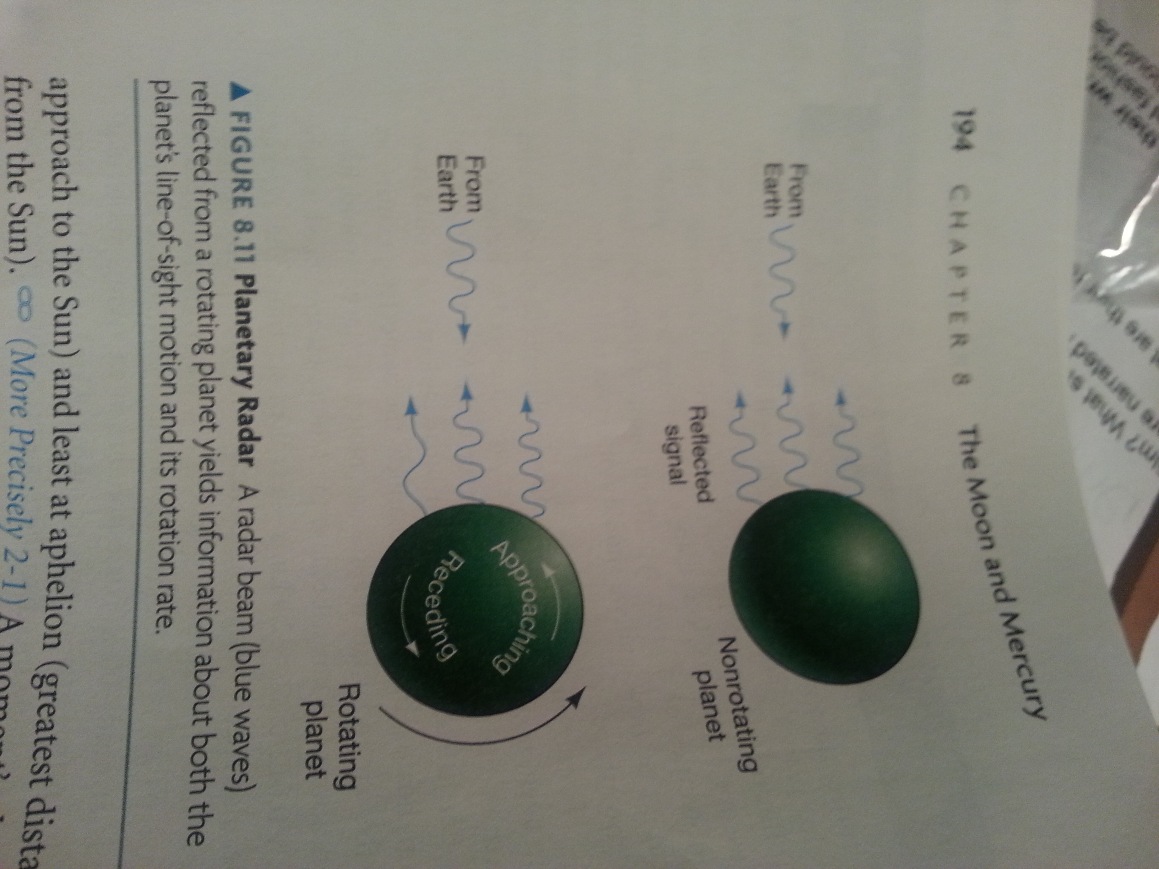
- we can measure Mercury’s spin by watching the motion of a particular, discernable region
- originally thought to be in synchronous orbit with the Sun, tidal bulge raised in Mercury has modified the planet’s rotation rate until the bulge always points directly at the Sun.
- discovered this was wrong by sending pulses of radio waves and waiting for the echoes to return
- returned signals may be redshifted or blueshifted depending on the overall radial velocity of the planet relative to Earth. As well, if the planet is rotating, the radiation reflected from the side moving toward us returns at a slightly high frequency.
- radiation reflected off planet surface
- reflected signal contains spread of frequencies that determine the planet’s rotational speed.
- found that rotation period was 59 days, not 88
- three rotations for every two revolution; 3:2 spin-orbit resonance
-resonance means two characteristic times that are related to eachother in a simple way. (synchronous orbit would be 1:1 spin orbit resonance)

Explanation
- spin still due to tidal forces, but in a subtle way
- cannot settle into 1:1 resonance due to eccentric orbit around the Sun.
- speed is greater at perihelion
- tidal forces diminish at increasing distance; forces acting during perihelion are much greater than aphelion. 3:2 resonance, Mercury would be a synchronous orbit at the perihelion, so therefore this was the rotational speed picked out by the tidal forces

Lunar Cratering and Surface Composition
- primary agent of change on lunar surface is interplanetary debris in the form of meteoroids.
- no protection from onslaught due to lack of atmosphere
- ejecta blanket: material thrown out by the explosion surrounding the crater
- meteoric bombardment roughly 4 million years ago supports condensation theory of solar system formation
- bombardment stopped 3.9 million years ago, allowing the maria to solidify later leading to its less-cratered state. Subsequent volcanic activity filled the craters with lava, making them seas of solidified molten lava.

Lunar ice
- Moon thought to be completely dead and possess no organic matter
- some regions of the moon are thought to contain water in the form of ice
- due to poles never seeing sunlight, water could have frozen in the polar craters since the early days of the solar system before it could melt or vaporize and escape into space
- water molecules were discovered in tons at both lunar poles

Lunar Volcanism
- apparently, a few craters aren’t meteoritic in origin
- there are volcanic rilles where molten lava once flowed
- craterchain patterns mark subsurface faults that the cracking or shearing of the surface once allowed molten matter to well up from below

Surface of Mercury

- Craters on Mercury are result of meteoritic bombardment
- craters are less densely packed and extensive intercrater plains cover 40% of the surface due to volcanic activity
- leading explanation for Mercury’s relative lack of craters was that older craters were filled in by volcanic activity
- absence of rilles and other obvious features suggests a different type of volcanic past
-has scarps: a cliff on the surface as a result of the planet’s interior cooling and shrinking, like the wrinkles on the skin of a shrunken apple.
- caloris basin: large impact crater that is comparable to radius of the planet. The impact sent shock waves that buckled the crust on the opposite side.

Interiors

Moon
- low density implies Moon is deficient in dense materials such as nickel and iron
- no evidence for large scale magnetic fields, consequence of slow rotation and absence of liquid core
- seismic data collected may point to inner parts of the core to be at least partially molten. However deep interior composition is limited
- crust on far side of moon is thicker than the side facing Earth due to Earth’s gravitational pull, pulling the mantle closer which makes the crust move away (heavier material sink below lighter ones in Earth’s grav pull)
- leads to more highlands and less maria on far side: lava takes path of least resistance to get to surface (thinner crust)

Mercury
-very little magnetic field
- still strong enough to deflect solar wind
- generated by dynamo action, but how this is possible with slow rotational spin and lack of a liquid metal core is unresolved
- most of interior must be dense
- lunar like, less dense mantle

Origin of the Moon

- Sister, Coformation theory: the moon formed as a separate object near Earth in much the same way as our own planet formed – a “blob” of material that became Earth gave rise to the Moon forming a double planet system revolving around a common centre of mass.
- flaw: the moon differs in density and composition

- Capture theory: Moon formed far away from Earth, and was captured by it. However, this is an extraordinarily difficult task since the Moon is unusually large compared to Earth.

- Daughter theory: Moon originated from Earth itself. But how can the Earth spin so fast it ejected the moon?

The Impact theory
- hybrid of capture and daughter theme
- a collision by a large, Mars-sized object in a glancing way rather than a direct impact. Bits and pieces of earth dislodged from our planet form earth, since these pieces could have coalesced into stable orbit
- explains similarity between moon and earth’s mantle, as well as the lack of density in the moon (dense materials were not dislodged and formed Earth’s core)

Evolutionary History of the Moon and Mercury:

- smaller objects cool faster since interior is closer to surface
-The absence of a lunar atmosphere and any lunar volcanic activity are both consequences of the moon’s small size. Gravity is too weak to retain any gases and volcanism was stifled by cooling mantle.
- mercury thick solid mantle prevents tectonic motion or volcanism
- similar evolutionary paths

Chapter 9: Venus

Orbital Properties:
- second planet from the Sun
- very circular orbit
- orbital period 245 earth days

Physical properties:
Radius, Mass, and Density
- radius very similar to Earth, approx. 6000km
- has no moon, therefore mass used to be calculated through small grav effects on orbits of other planets such as Earth
- now, flybys and spacecraft orbiting Venus, its mass is 4.9 x 10^24, again similar to Earth’s mass
- average density is 5200 kg/m3

Rotation Rate
- opaque clouds lead to indiscernible features on surface
- Venus's spin found to be retrograde, opposite to the spin of most other solar system objects and Venus's own orbital motion (north and south are inverted since convention is planets spin west to east)
- rotates extremely slowly, 5:1 resonance
- best explanation is that planet was struck by a large body in its early formation

Surface of Venus
- all radargraphs (due to opaque cloud cover)
- elevated “continents” similar to Earth
- appears to be no tectonic movement (primary agent of long term surface change is
- evidence of lava flows through rilles, solidified lava flows and lava domes - mountainous regions formed by convective motion within Venus’s mantle rather than tectonic movement
- most volcanoes are known as shield volcanoes, which are not associated with plate boundaries. Rather, they form when lava wells up through a hot spot in the crust
-indirect evidence points to ongoing volcanism: variation in sulfur dioxide in Venus’s clouds and bursts of radio energy, similar to lightning discharges that occur in erupting volcanoes on earth, from the planet’s surface.
- not all craters on Venus are volcanic, some are meteoritic although they are few due to Venus’s atmosphere
-no plate tectonics = no “release valve” for energy in the interior. Therefore, the planet’s interior tends to build up in the upper mantle and releasd through massive eruptions every hundred million years. This is the main agent of erosion.

Atmosphere of Venus
- about 90 times more massive than Earth’s
- extends to a greater height as well
- polar vortices: sable, long-lived flows of wind that circle the polar regions expected in any planet with an atmosphere
-Venus’s has unique double-lobed structure

- Carbon dioxide main component (96%)
- remaining is mostly nitrogen with trace amounts of other gases
- radically different from that of Earth despite similarities
- no oxygen due to no living organisms
- no sign of large amount of water vapor as we would expect
- infrared observations revealed that the top layer of clouds were made up of sulfuric acid, created when water and sulfur dioxide react
- sulfur dioxide excellent absorber of UV radiation

Greenhouse effect
- originally, temperature not too different from earth’s
- given composition of its atmosphere, greenhouse effect occurred
- carbon dioxide traps 99% of infrared radiation released back from Venus’s surface
- energy is spread around the whole planet via circulation of atmosphere – it is hot everywhere and at all times on Venus including night and at the polar regions
- why is there so much more carbon dioxide in Venus’s atmosphere compared to earth?
- on Earth, our secondary atmosphere, expelled from volcanic activity, sunlight split the nitrogen rich compounds releasing nitrogen into the air. Meanwhile, water condensed into oceans and carbon dioxide and sulfur dioxide dissolved into them. The remaining combined with surface rocks
- thus, the secondary atmosphere quickly became part of the surface
- due to Venus’s proximity to the Sun, the water did not condense into oceans but remained water vapor, meaning that the outgassed secondary atmosphere remained in the atmosphere
- runaway greenhouse effect came into effect – the more water vapor and carbon dioxide, the more infrared radiation was absorbed and the hotter Venus got. As Venus got hotter, more water vapor and carbon dioxide went into the atmosphere (due to the rocks and ocean’s inability to hold the carbon dioxide) making everything even hotter

Magnetic field and internal structure
-no intrinsic magnetic field of its own
-probs has similar density and overall composition (including molten core)
- result of slow rotation and consequent lack of dynamo action
- no protection against solar wind, top atmosphere constantly ionized
- surface of Venus resembles young Earth
- remained in that state without plate tectonics has not been answered. Speculated that high surface temperature has inhibited evolution by slowing planet’s cooling

Chapter 10: Mars

Orbital properties
- eccentric orbit (ave: 1.52 AU) – Mercury only more eccentric
- orbital parameters – changes sunlight received by 45%
- axis tilt similar to earth , 23.98
- sidereal day 24h 37min
- orbital parameters, axis tilt southern summer near perihelion – complicated by large eccentricity
- closest Earth-Mars separation about 0.38 AU
- largest angular size 25′′(100km across)

Physical properties
-physical properties: 3.9gm/cm3, mean surface temp, 210K, mass, 0.11 Earth 6.42 ×10^23kg, 0.53 Earth radii (3394km) 2 moons, atmosphere mostly CO2 (tin)
- moons are little more than large rocks trapped by the planet’s gravity
- assume surface rocks are similar to those on other terrestrial planets, the core must be substantially dense
- suspect it is mostly composed of iron sulfide
- surface markings allow astronomers to track rotation – rotates once on axis every 24.6 hours
- seasons as mars rotates the Sun, however seasons are eccentric as its orbit is rather eccentric

Martian Surface
-marked difference between northern and southern hemispheres
-northern hemisphere made up of rolling volcanic plains not unlike the lunar maria, lava flow features
- much larger than earth or moon, these lava plains were formed by huge eruptions
- Southern hemisphere consists of heavily cratered highlands laying some 5km above the level of the north
- smoother surface of the north suggests it is younger, perhaps 1 billion years or so
- assume southern hemisphere is the original crust of the planet
- how northern hemisphere lowered is a mystery
- no plate tectonics like Venus – upward building process similar to Venus, but smaller mass yields diﬀerent results – no recurring catastrophic resurfacing

Volcanism
-contains largest known volcanoes in the solar system
-all shield volcanoes
- no evidence for current ongoing volcanic action

- little atmosphere provides no resistance to impact craters from small meteoroids
- however, little atmosphere is the main erosion agent transporting dust from place to place
- erosion 100x slower than earth, but still far faster than Venus or the moon

Water on Mars
- strong evidence of liquid water in the past
- runoff channels – found in the southern highlands, extensive systems of interconnecting channels that merge into wider ones. Strong resemblance to river systems on Earth. Could have carried rainfall from mountains down into valleys – atmosphere was probably thicker, surface warmer, and liquid water widespread
-outflow channels – paths taken by huge volumes of water draining from the south into the northern plains
- discovered deltas, where smaller rivers once flowed into a larger body of water
- detected hydrated chemical compounds in surface rocks
- perhaps evidence of of planetwide water cycle
- confirmed that permafrost lies just few meters under the surface
- most of water that existed in past locked up in permafrost and polar caps

Martian Atmosphere
- Martian atmosphere is thin and comprised primarily of Carbon dioxide
- troposphere varies with the seasons and from place to place – arises from the variability of the Martian surface temperature
-atmospheric evolution
- superficial similarities between mars and Venus
- presumably, acquired secondary atmosphere outgassed from planet’s interior
- used to have fairly dense atmosphere and indicated by liquid water
- however, in the next billion of years, most of martian atmosphere disappeared
- may have been impacted with large bodies, and the rest leaked away because of planet’s weak gravity
- however, “reverse runaway greenhouse effect” could have occurred
- key controller of level of carbon dioxide is absorption by rocks in the crust
- in Mars, the depletion of the carbon dioxide was not sufficiently replenished by the volcanic activity. This, combined with the planet’s accelerated cooling (due to no greenhouse gases), encouraged even more depletion to a point where the atmosphere became almost non-existent.

Martian internal structure
-no planetary magnetic field
- mars rotates just as rapidly as earth, as such mars must have a nonmetallic or nonliquid core, or both
- small size indicates ineffectiveness of radioactive heating (heat would be able to reach surface easier)

Moons of Mars
- tiny compared to Mars
- orbit very close to it in prograde fashion
- both irregularly shaped and cratered
- move in circular, equatorial orbits and rotate synchronously
- tidally locked

Chapter 11: Jupiter

Physical properties
– largest planet in the solar system – very diﬀerent from the terrestial worlds
– 317 Earth masses, 11.21 Earth radius, density 1.33 gm/cm3
- composed primarily of helium and hydrogen
- enormous gravity compresses these gasses
– fastest rotation rate in solar system – 9hrs 55mins
– rotation diﬀerential – equatorial regions rotate faster than polar regions
– fast rotation leads to oblateness (equator bulges out significantly)
- would be more bulged out if not for rocky interior core
- magnetosphere can be used to find interior rotational speed as it emits radiation at particular wavelengths
– from Earth – can easily see four large moons (Galilean moons)

Atmosphere
-series of everchanging bands
- oval atmospheric blob called great red spot
- most abundant gas is hydrogen, followed by helium – strong gravity enough to hold these light gasses
- bands = bright zones and dark belts
- variations appear as a result of convective motion in atmosphere; zones are high pressure regions where warm material rises, belts are where cool material sink
- rapid rotational speed causes these systems to wrap all the way around the planet
- zones lie slightly higher than the belts in the atmosphere

Internal structure
- much of knowledge comes from theoretical modeling
- originally expected to find a temperature of about 105k, however, found 125k meaning that Jupiter emits twice as much energy as it receives from the Sun
- how? It cannot be decay of radioactive elements since the amount of energy is far too low, nor can it be nuclear fusion, since interior is not hot enough
- theorized that it is the slow escape of grav energy released during the planet’s formation. Some of the grav energy was converted into heat in the interior

- deep interior
- temperature and density increases with depth
- gasses become liquid state
- even further, the pressure makes the liquid hydrogen into metallic state
- excellent conductor of electricity -> large magnetic field
- core could be as low as 5 earth masses
-core consists of “rocky” materials (chemical composition)

Magnetosphere
- radio astronomy noticed radiation leaking from Jupiter – satellite missions established huge magnetic ﬁeld
– similar to Van Allen radiation belts, but much larger
– particles get accelerated and trapped my the magnetic ﬁeld – source of radio emission
– several thousand times more intense than eﬀects produced by Earth’s magnetic ﬁeld
– direct measurements show magnetosphere 30 million km across – long tail, 4 AU, out to Saturn
– magnetic ﬁeld deﬂects solar wind, causes Aurora
– can use the magnetic ﬁeld to understand the interior – metallic hydrogen
– can use the magnetic ﬁeld to determine the rotation rate of the planet’s interior
– magentic ﬁeld creates current sheets at the magnetic equator
– magnetic ﬁeld inverted relative to the Earth, 10 degrees relative to the rotation axis
– intrinsic strength 20,000 times greater than Earth – supports models of the interior

Moons
– four large moons (Galilean satellites
– current number: 63
– Galilean moons, large as small planets – similar in size to Mercury and our own moon
– Galileo mission expanded our knowledge of the Galilean moons: Io, Europa, Ganymede, and Callisto
– move in nearly circular, prograde orbits
– Galilean moons: parallels the formation of the solar system
– Io has many active volcanoes, Voyager 1 photographed eruptions
– geological activity results from tidal stressing from Jupiter and the other moons (gravitational pull from Europa and Jupiter)
– volcanoes emit sulfur compounds and lava – superhot lava
– heavy ions from the volcanic activity interact with the Jupiter’s magnetic ﬁeld, creating the Io plasma toru
– plasma torus, doughnut-shaped region of heavy ions that track Io’s orbit
– Europa diﬀerent from Io – few craters, young surface
– crisscrossing bright lines, bands and fractures
– might be covered with a liquid ocean frozen on top
– cracks arise from tidal stress or tectonic activity involving ice
– water “lava” on the surface
– magnetic ﬁeld studies suggestive salty ocean below the surface, interactions with
Jupiter’s magnetic ﬁeld
– outer moons: Ganymede and Callisto less dense than Io or Europa
– Ganymede – largest moon in th solar system, larger than Mercury
– has impact craters, history parallels Earth’s moon
– light parts, less heavily cratered – maria, like the moon
– system of grooves and ridges, unlike Earth’s moon

– perhaps crustal tectonic activity – radioactivity helped diﬀerentiate the moon
(large size)
– weak magentic ﬁeld – suggests some type of iron core, perhaps slushy water ice
under surface
– Callisto, similar to Ganymede, similar density, more cratered surface
– Callisto has a concentric ring structure (Valhalla) arising from impact in the moon’s past
– Callisto shows no signs of geological activity – undiﬀerentiated, never in a molten state
– odd that Callisto and Ganymede are so similar, but that Ganymede diﬀerentiated
and hence was molten at some point – perhaps tidal stressing in the recent past

Jupiter’s Rings

– Voyager discovered faint ring 50,000km above cloud tops
– most of the ring conﬁned to a region a few thousand km across
– dark particles, chips from meteoritic impacts from two small inner moons

Chapter 15: Formation of planetary systems

Making inner planets
- only rocky and metallic grains could survive in the inner part of the solar nebula
- scarcity of these elements -> inner planets never became as massive as jovian planets
- in addition, accretion could only begin after the temperature dropped to a point where grains appeared

Making jovian worlds
- two different views
- 1. Protoplanets in outer solar system grew quickly and becamse massive enough for their grav fields to capture large amounts of gas directly from the solar nebula – core accretion theory
- four protoplanets became cores of jovian worlds, captured gas became their atmospheres
- may have not been enough time for all of these evenets to take place
- 2. Giant planets formed through instabilities in the cool outer regions where portions of the cloud began to collapse under their own grav – modeled after collapse of interstellar cloud
- grav instability theory: planets formed directly from the nebular gas, skipping the accretion stage. Right from start, they had grav fields strong enough to scoop more gas and dust from solar nebula
- differences in theory stem from differences in rocky inner core mass – core accretion theory obviously means bigger rocky mass

Giant planet migration
- idea that jovian planets formed further away, and migrated inwards toward the sun
- due to interaction with comets and asteroids, jovian planets moved even further in.
-uranus and Neptune kicked some bodies out into Kuiper belt and deflected some inward toward Jupiter and Saturn, who then propelled them into the oort cloud
- support for this due to the fact that large fraction of Kuiper belt orbit in3:2 resonance with Neptune (orbit twice around the sun for every three orbits of Neptune)
- pluto shares this resonance

- problem with condensation theory: where did water come into the inner planets?
- arrived through bombardment of icy comets propelled by gravitational fields of jovian planets

evolutionary theory: one that describes development of solar system as a series of gradual and natural steps
catastrophic theory: accidental or unlikely celestial events to interpret observations

eg. Collision hypothesis: planets were torn from the Sun by a close encounter with a passing star.

8 irregularities:
1. Mercury’s large nickel iron core may be the result of a collision between two partially differentiated protoplanets. Cores may have merged and much of the mantle material lost.

2. two large bodies could have merged to form Venus, given its abnormally low rotation

3. earth-moon system may have formed from a collision between proto-earth and a mars-sized object

4. mars curious north-south asymmetry and ejected its non-existent atmosphere

5. tilted rotation axis of Uranus cause by a collision with large object

6. Uranus’s moon Miranda may have been almost destroyed by a collision

7. interactions between jovian planets and other bodies may account for irregular mmoons of those planets (i.e. Triton’s retrograde motion)

8. pluto Charon system formed by collisions from planetesimals ejected by interactions with jovian planets

Radial velocity measurements
Vast majority of currently known extrasolar planets were discovered by observing their parent star wobbling back and forth as the planet orbits (due to tidal forces acting between the two)

-minority discovered as they transit their parent star, passing in front of it and slightly reducing its brightness. The mass and density can be approximated based on the degree which the star is dimmed

Classifying exoplanets:
Hot – orbital distance is less than 0.1 semimajor axes
Cold- wider orbital distance

Jupiters – massive exoplanets
Neptunes- less massive, but still jovian
Super-Earths – between 2 and 10 earth masses

Selection effect: dont see many low mass planets or even more massive planets on wide orbits because they do not produce enough velocity fluctuations to be easily detectable. (more eccentric orbits can be more easily detectable too since they produce large velocities)

Weins law: wavelength at which object radiates its energy is inversely proportional to the temperature of the object
Stefan’s law: the total amount of energy radiated is proportional to the fourth power of the temperature
Dopper effect: perception of the wavelength of a beam of light can be altered by our velocity relative to the source.
Motion away from the source – redshift (shift to lower frequencies)
Motion to the source – blueshift (to higher frequencies)

