PART II – SUPPLY AND DEMAND I: HOW MARKETS WORK

CHAPTER 4 – THE MARKET FORCES OF SUPPLY AND DEMAND

Supply and demand: forces that make market economies work ; determine the quantity of each good produced and the price at which it is sold

Markets and Competition:

What Is a Market?
- Market: a group of buyers and sellers of a particular good or service

- Buyers: as a group, determine the demand of a product

- Sellers: as a group, determine the supply of a product

- Markets for agriculture commodities are organized
- meet up and have an auctioneer set prices and arrange sales

- More often, they are less organized.
  - sellers post the price and buyers decide how much they want to buy

What Is Competition?
- Competitive Market: a market in which there are many buyers and many
sellers so that each has a negligible impact on the market price

- To be perfectly competitive a marker must have two characteristics:
    - The goods offered for sale are all exactly the same
    - The buyers and sellers are so numerous that no single buyer or seller has any influence over the market price

- Price Takers: buyers/sellers that must accept the price the market
determines

- Monopoly: seller that sets the price

Demand:

The Demand Curve: The Relationship between Price and Quantity Demanded
- Quantity Demanded: the amount of good that buyers are willing and able to
purchase

- Law of Demand: the claim that, other things equal, the quantity demanded
of a good falls when the price of a good rises (and when the price falls, the quantity demanded rises)

- Demand Schedule: a table that shows the relationship between the price of
a good and the quantity demanded

*many things determine the quantity demanded

- Negatively Related Quantity Demanded: when the quantity demanded
falls as the price rises and rises and the price falls

- Demand Curve: a graph of the relationship between the price of a good and
the quantity demanded

Market Demand versus Individual Demand

- Market Demand: sum of all the individual demands for a particular good or
service
*most often worked with
*add the individual demand curves horizontally to get
the market demand curve

Shifts in the Demand Curve

- Increase in demand: any change that increases the quantity demanded at
every price (shift to the right on graph)

- Decrease in demand: any change that reduces the quantity demanded at
every price (shift to the left on graph)

- VARIABLES THAT SHIFT THE DEMAND CURVE:

  - Income:
    - Normal Good: a good for which, other things equal, an
increase in income leads to an increase in demand (and when the demand for a good falls when income falls)
Ex: Income falls, demand for ice cream falls

    - Inferior good: a good for which, other things equal, an increase in income leads to a decrease in demand
Ex: Income falls, demand for bus rides increase

  - Prices of Related Goods:
    - Substitutes: two goods for which an increase in the price of one leads to an increase in the demand for the other (fall in the price of one reduces the demand of another
Ex: buying ice cream instead of frozen yogurt because they are similar & the price of frozen yogurt went up
- Pairs of Goods: Sweaters & Sweatshirts
Movie tickets & Movie rentals
Hamburgers & Hot Dogs

    - Complements: two goods for which an increase in the price of one leads to a decrease in the demand for the other (and when a fall in the price of one good raises the demand of another)
Ex: when the price of chocolate sauce goes down, you buy more ice cream to go with it
- Pairs of Goods: Gas & Cars
Computers & Software
Peanut butter & Jelly

- Tastes:
If you like something, you buy it. Simple as that.

- Expectations:
If you’re expecting to make more money in the future, you’re more
willing to spend your savings now ; if you know the price of a good will be dropping soon, you won’t buy it today

- Number of Buyers:
If there are more people going to the market together there’s more
of a demand at every price. Therefore, the demand curve shifts right

*A curve shifts when there is a change in a relevant variable that is not measured on either axis.
Ex: if price is on the left axis and there’s a change in price there will be a movement ALONG the demand curve. If income increases (which is not a title of an axis), there will be a SHIFT of the demand curve.

Supply:

The Supply Curve: The Relationship between Price and Quantity Supplied

- Quantity Supplied: the amount of a good that sellers are willing and able to sell

- Law of Supply: the claim that, other things equal, the quantity supplied of a good rises when the price of the good rises

- Supply Schedule: a table that shows the relationship between the price of a good and the quantity supplied

- Supply Curve: a graph of the relationship between the price of a good and the quantity supplied

- Quantity Supplied is Positively Related: when quantity supplied and the price both rise or both falls

Market Supply versus Individual Supply

- Market Supplies: sum of the supplies of all sellers
*add the individual supply curves horizontally to get the
market supply curve

Shifts in the Supply Curve
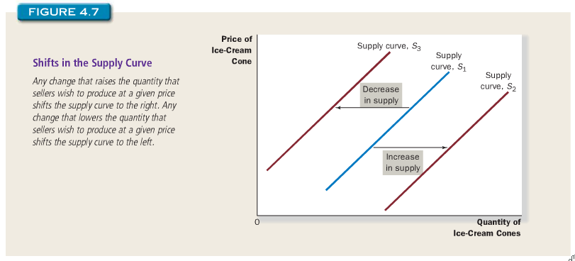

- Increase in Supply: any change that raises quantity supplied at every price (shifts
curve to the right)

- Decrease in Supply: any change that reduces the quantity supplied at every price
(shifts curve to the left)

- VARIABLES THAT SHIFT THE SUPPLY CURVE

  - Input Prices: If the price of Inputs go up (ingredients/tools needed to
make the good), then the supply goes down cause it costs more to make the good

  - Technology: more machinery = less labour. Therefore, firms don’t
have to pay for as many employees which means they have more money to spend on supplying more

  - Expectations: If firms expect the price to rise in the future, they’ll put
their good in to storage for now, which means there’s less supply for the present

  - Number of Sellers: If there are less people making the good, there’s
less supply

*The Curve shifts when there is a change in a relevant variable that is not named on the axis.
Ex: If price is on the vertical axis and there is a change in price there will be a movement ALONG the supply curve. If input prices change (which is not a title of an axis), there will be a SHIFT on the demand curve.

Supply and Demand Together:

Equilibrium

- Equilibrium: a situation in which the price has reached the level where
quantity supplied equals quantity demanded (intersection of supply and demand curves on the graph)

- Equilibrium Price: the price that balances quantity supplied and quantity
demanded (the price at the intersection of the supply and demand curve on the graph)
(aka market-clearing price) because everyone in the market (buyers&sellers) are satisfied

- Equilibrium Quantity: the quantity supplied and the quantity demanded at
the equilibrium price (the quantity at the intersection of the supply and demand curves on the graph)

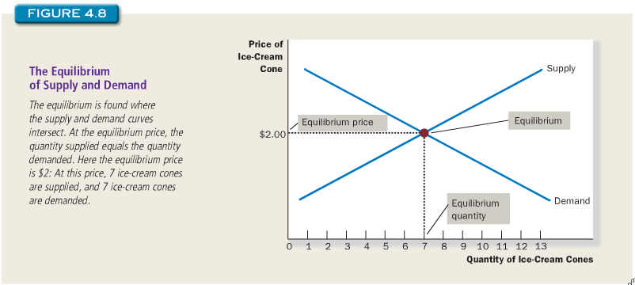

- Surplus: (aka situation of excess supply) a situation in which quantity
supplied is greater than quantity demanded

*when there is a surplus, firms decrease the prices. Falling prices increase the quantity demanded and decrease the quantity supplied. Prices continue to fall until the market meets the equilibrium.

- Shortage: (aka excess demand) a situation in which quantity demanded is
greater than quantity supplied

*when there’s a shortage, firms increase their prices. When prices rise, quantity demand falls, and supply rises in order to move towards the equilibrium again.

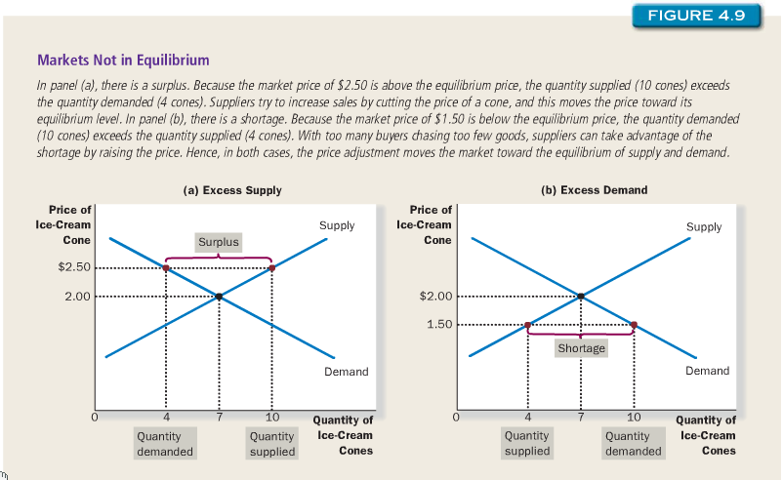

law of supply and demand: the claim that the price of any good adjusts to bring the
quantity supplied and the quantity demanded for that good into balance

Three Steps to Analyzing Changes in Equilibrium

- Comparative Statics: the analysis of when the equilibrium in the market
Changes

- Three-Step Program for Analyzing Changes in Equilibrium
- Decide whether the event shifts the supply or demand curve (or both)
- Decide in which direction the curve shifts
- Use the supply-and-demand diagram to see how the shift changes the equilibrium price and quantity
*as soon as a demand or supply curve shifts, the equilibrium changes

*when supply rises and the supply curve remains the same, this means there has been an increase in “quantity supplied” but no change in “supply”.

- Supply = supply curve
- Quantity supplied = amount suppliers wish to sell

- Change in supply: shift in the supply curve

- Change in demand: shift in the demand curve

*re-read examples on pages 18-21

BOOK SUMMARY

- Economists use the model of supply and demand to analyze competitive markets. IN a competitive market, there are many buyers and sellers, each of whom has little or no influence on the market price

- The demand curve shows how the quantity of a good demanded depends on the price. According to the law of demand, as the price of a good falls, the quantity demanded rises. Therefore, the demand curve slopes downward.

- In addition to price, other determinants of how much consumers want to buy include income, the prices of substitutes and complements, tastes, expectations, and the number of buyers. If one of these factors changes, the demand curve shifts.

- The supply curve shows how the quantity of a good supplied depends on the price. According to the law of supply, as the price of a good rises, the quantity supplied rises. Therefore, the supply curve slopes upward.

- In addition to price, other determinants of how much producers want to sell include input prices, technology, expectations, and the number of sellers. If one of these factors changes, the supply curve shifts.

- The intersection of the supply and demand curves determines the market equilibrium. At the equilibrium price, the quantity demanded equals the quantity supplied.

- The behavior of buyers and sellers naturally drives markets toward the equilibrium. When the market price is above the equilibrium price, there is a surplus of the good, which causes the market price to fall. When the market price is below the equilibrium price, there is a shortage, which causes the market price to rise.

- To analyze how any event influences a market, we use the supply-and-demand diagram to examine how the event affects the equilibrium price and quantity. To do this we follow three steps. First, we decide whether the event shifts the supply curve or the demand curve (or both). Second, we decide which direction the curve shifts. Third, we compare the new equilibrium with the initial equilibrium.

- In market economies, prices are the signals that guide economic decisions and thereby allocate scarce resources. For every good in the economy, the price ensures that supply and demand are in balance. The equilibrium price then determines how much of the good buyers choose to purchase and how much sellers choose to produce.

CHAPTER 5 – ELASTICITY AND ITS APPLICATION

The Elasticity of Demand:

Elasticity: measure of how much buyers and sellers respond to changes in market
conditions.

When do people buy more?
- Lower prices
- Higher incomes
- Prices of substitutes for the good are higher
- Prices of complements of the good are lower

The Price Elasticity of Demand Its Determinants

Price Elasticity of Demand: a measure of how much the quantity demanded of a
good responds to a change in the price of that good, (computed as the percentage change in quantity demanded divided by the percentage change in price)
*measures how willing consumers are to move away from the good as its price rises

Elastic: if the quantity demanded responds substantially to changes in the price

Inelastic: if the quantity demanded responds only slightly to changes in the price

Availability of Close Substitutes
- Goods with a close substitute have a more elastic demand
  - Ex: butter & margarine

Necessities versus Luxuries
- Necessities = inelastic demand
- Luxuries = elastic demand

Definition of the Market
- Narrowly defined market = more elastic than broadly defined markets
  - Food – broad – inelastic (can’t substitute food for anything else)
  - Ice cream – narrow – elastic (substitute ice cream for another desert)

Time Horizon
- Goods have a more elastic demand over a longer time horizon
  - Ex: Gas Prices – demand falls a bit if it’s for a short period of time
- demand falls a lot if it’s for a long period of time

Computing the Price Elasticity of Demand
Price elasticity of demand = Percentage change in quantity demanded
Percentage change in price

Ex: Price rises by 10% , demand falls by 20% :
Price elasticity of demand = 20% = 2
10%
Therefore, the change in quantity demanded is twice as large as
the change in price

The Midpoint Method: A Better Way to Calculate Percentage Changes in Elasticities

*From a graph
use the midpoint method to calculate the elasticity from 2 points on a graph
Ex: the midway point of $4 and $6 is $5. Quantity = 100. Therefore:

(6-4) x100 = 40
5
*price rises by 40% , quantity falls by 40% , elasticity demand = 1

OR

(4-6) x100 =-40
5
*price falls by 40%, quantity rises by 40%, elasticity demand = 1

Midpoint method:
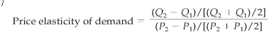
*Numerator = percentage change in quantity computed using midpoint method
Denominator = percentage change in price computed using midpoint method

The Variety of Demand Curves:

Demand is elastic when elasticity is greater than 1
- Quantity moves more than price

Demand is inelastic when elasticity is less than 1
- Quantity moves less than price

Demand is unit elasticity when elasticity is exactly 1
- Quantity moves the same amount as price

Helpful tip:
- Graph is completely vertical – Inelastic (looks like an I)
- Graph is completely horizontal – Elastic (looks like an E)

Rule of Thumb:
- The flatter the demand curve at any given point, the greater the price elasticity of demand.
- The steeper the demand curve at any given point, the smaller the price elasticity of demand

Total Revenue and the Price Elasticity of Demand

Total Revenue (in a market): the amount paid by buyers and received by sellers of
a good, computed as the price of the good times the quantity sold
R = P x Q
- Inelastic Demand – Revenue rises (the fall in Q is proportionately smaller
than the rise in P)

- Elastic Demand – Revenue falls (the fall in Q is proportionately greater than
the rise in P)

General Rule:

- When a price demand is inelastic (price elasticity less than 1), price and total revenue move in the same direction
- When a price demand is elastic (price elasticity greater than 1), price and total revenue move in the opposite directions
- When a price demand is unit elastic (price elasticity equal to 1), total revenue remains constant when the price changes

Elasticity and Total Revenue along a Linear Demand Curve

????

Other Demand Elasticites

The Income Elasticity of Demand

- Income Elasticity of Demand: measures how the quantity demanded
changes as consumer income changes
Income elasticity of demand = percentage change in quantity demanded
Percentage change in income

- Normal Goods: higher income raises quantity demanded
  - has positive income elasticities

- Income Goods: higher income lowers the quantity demanded
  - Has negative income elasticities

*Necessities (food, clothes) have small income elasticites because regardless their income, they need it.
*Luxuries (diamonds) have large income elasticities because consumers can go without if their income is low.

The Cross-Price Elasticity of Demand

The cross-price elasticity of demand: measure how the quantity demanded of one
good changes as the price of another good changes.
Cross-price elasticity demand = Percentage change in quantity demanded of good 1
Percentage change in price of good 2

*Substitutes: the price of one and the quantity of demand of the other move in the same direction. Therefore the cross-price elasticity is positive.
*Complements: the increase in price of one reduces the demand of the other. Therefore the cross-price elasticity is negative.

The Elasticity Of Supply

The Price Elasticity of Supply and Its Determinants

*The laws of supply states that higher prices raise the quantity supplied
Price Elasticity of Supply: measures how much the quantity supplied responds to
changes in the price

- Supply of a good is elastic if the quantity supplied responds substantially to changes in the price
- Supply of a good is inelastic if he quantity supplied responds only slightly to changes in the price

- Inelastic supply: when the seller can’t produce more (ex: beachfront land)
- Elastic supply: when a seller is able to produce more (ex: books, clothes…)
- Supply is more elastic in the long run because firms have more time to make supply and respond to the price changes

Computing the Price Elasticity of Supply

Price elasticity of supply = Percentage change in quantity supplied
Percentage change in price

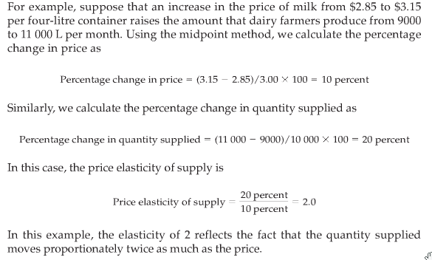

The Variety of Supply Curves

Perfectly inelastic:
- Vertical supply curve
- Quantity supplied is the same regardless the price
*as the elasticity rises, the supply curve gets flatter which shows that quantity supplied responds more to changes in the price

Perfectly elastic:
- Horizontal supply curve
- Very small changes in price lead to very large changes in quantity supplied

    - Low levels of quantity supplied = high elasticity of supply
      - Indicates that firms respond substantially to changes in price

***read “three applications of supply and demand and elasticity” at the end of the chapter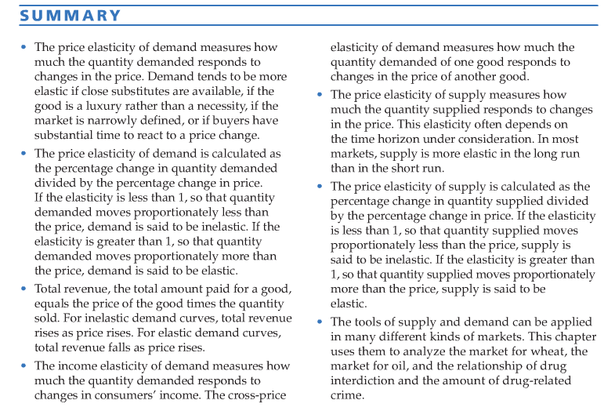

CHAPTER 6 – SUPPLY, DEMAND AND GOVERNMENT POLICIES

Policymakers use taxes to influence market outcomes and to raise revenue for public purposes.

Controls On Prices:

Price Ceiling: a legal maximum on the price at which a good can be sold
Price Floor: a legal minimum on the price at which a good can be sold

How Price Ceilings Affect Market Outcomes

- equilibrium = below the ceiling ; price ceiling is not binding
  - market forces naturally move the economy to the equilibrium
- equilibrium = above the price ceiling ; price ceiling is binding constraint
  - price moves towards equilibrium price but it can rise no further
  - Therefore, market price = price ceiling
  - Shortage in supply

- When a shortage happens because of a price ceiling, some mechanism for rationing with naturally develop.
Ex: long lines or only selling to family members/same racial group

Long lines: buyers who are willing to arrive early and wait in line get the good,
those unwilling to wait will not

When the government imposes a binding price ceiling on a competitive market, a shortage of the good arises, and sellers must ration the scarce goods among the large number of potential buyers.

People get fired for blogging because they reveal too much about their company

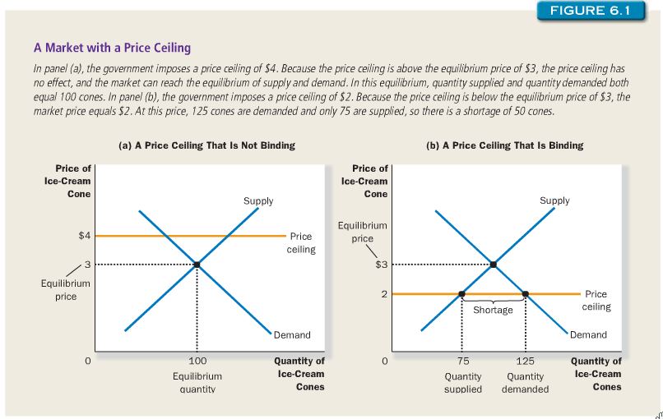

How Price Floors Affect Market Outcomes

- Equilibrium price = above floor ; the floor is not binding
- Equilibrium price = below floor ; the floor is binding constraint
  - Price moves towards equilibrium, but it can fall no further
  - Market price = price floor
  - Quantity supplied > Quantity demanded
THEREFORE, a binding price floor causes a surplus

Evaluating Price Controls

- Prices balance supply and demand therefore coordinate economic activity
- Economists don’t like price floors/ceilings because they disrupt the normal allocation of society’s resources
- Price Controls are used to assist the poor
- Price Controls also keep from making money
ex: landloards have to charge a certain price to their tenants, but really they should be asking more)

tax incidence: the manner in which the burden of a tax is shared among
participants in a market

How Taxes on Buyers Affect Market Outcomes

Steps to analyze supply and demand:
- Decide whether the law affects the supply or demand curve
- Decide which way the curve shifts
- Examine how the shifts affect the equilibrium

Lessons about taxes:
- When a good is taxed, the quantity of the good sold is smaller in the equilibrium
- In the new equilibrium, buyers pay more for the good and sellers receive less
- Taxes on buyers and sellers are equivalent

Elasticity and Tax Incidence

Elastic supply, inelastic demand – price received by sellers doesn’t fall much but the price paid by buyers rises substantially

Inelastic supply, elastic demand – price paid by buyers doesn’t rise much but price received by sellers falls substantially

***A BURDEN FALLS MORE HEAVILY ON THE SIDE OF THE MARKET THAT IS LESS ELASTIC***



