Part I - INTRODUCTION

CHAPTER 1 – TEN PRINCIPLES OF ECONOMICS

Economics: The study of how society manages its scarce resources

Economists: - determine which price goes good with what item to make the most money
- analyze forces/trends that affect the economy as a whole (growth in average income, % of people that can’t find a job, rate at which prices are rising)

Scarcity: The limited nature of society’s resources

*Principles 1-4 : how individuals make decisions

Principle #1 : People Face Tradeoffs

Decision making : “There is no such thing as a free lunch.” – to get one thing, we must give up another (to study for econ, we must give up time that we could be studying for psych)

Efficiency: The property of society getting the most it can from its scarce resources

Equity: the property of distributing economic prosperity fairly among the members of society
* efficiency = pie ; equity = how the pie is divided
*greater equity = reduced efficiency
ex: when the gov. redistributes income from rich to poor, it
reduces the award of working hard

Principle #2 : The Cost of Something Is What You Give Up to Get It

*the cost of something is what you give up to get it

Decision-making requires you to always look at your options and the outcome of them/benefits

Opportunity cost: whatever must be given up to obtain some item

Principle #3 : Ration People Think at the Margin

Rational people: people who systematically and purposefully do the best they can to achieve their objectives

Marginal changes: small incremental adjustments to a plan of action

As long as you’re getting more than you’re giving you’re good

Principle #4 : People Respond to Incentives

Incentive: something that induces a person to act
*incentives play a central role in the study of economics

Incentives allow people to consider the direct and indirect effects of their decisions.

*Principles 5-8 : How people interact with one another

Principle #5 : Trade Can Make Everyone Better Off

*”Trades between two countries can make each country better off”
Trade allows you to specialize in certain activities and gain other things by trading with others.

Principle #6 : Markets Are Usually a Good Way to Organize Economic Activity

Market economy: an economy that allocates resources through the decentralized decisions of many firms and households as they interact in markets for goods and services

Principle #7 : Governments Can sometimes Improve Market Outcomes

Property rights: the ability of an individual to own and exercise control over scarce resources

Market failure: a situation in which a market left on its own fails to allocate resources efficiently

Externality: the impact of one person’s actions on the well-being of a bystander (pollution)

Market power: the ability of a single economic actor (or small group of actors) to have a substantial influence on market prices

*possible reasons for market failure is externality and market power

Government’s role in economy: promote efficiency and equity

**Decisions and interactions make up “the economy”

Principle #8 : A Country’s Standard of Living Depends on Its Ability to Produce Goods and Services

Productivity: the quantity of goods and services produced from each hour of a worker’s time

Higher level of productivity = higher living quality
- living standards and productivity go hand in hand
  - better living standards the easier productivity is ; the more productive you are, the better your living standards are.
(ie. Better equipment)

Principle #9 : Prices Rise When the Government Prints Too Much Money

Inflation: an increase in the overall level of prices in the economy

What causes inflation?
- usually the growth in the quantity of money because the value falls

Principle #10 : Society Faces a Short-Run Tradeoff Between Inflation and Unemployment

Short-run effects of monetary injections:
- Increasing the amount of money in the economy stimulates the overall level of spending and thus the demand for goods and services
- Higher demand may, over time, cause firms to raise their prices, but in the meantime, it also encourages them to increase the quantity of goods and services they produce and to hire more workers to produce those goods and services.
- More hiring means lower unemployment.

*a short-run tradeoff between inflation and unemployment.

Business cycle: fluctuations in economic activity, such as employment and production

BOOK SUMMARY

- The fundamental lessons about individual decision making are that people face tradeoffs among alternative goals, that the cost of any action is measure in terms of forgone opportunities, that rational people make decisions by comparing marginal costs and marginal benefits, and that people change their behavior in response to the incentives they face.

- The fundamental lessons about interactions among people are that trade can be mutually beneficial, that markets are usually a good way of coordinating trade among people, and that the government can potentially improve market outcomes if there is some market failure or if the market outcome is inequitable.

- The fundamental lessons about the economy as a whole are that productivity is the ultimate source of living standards, that money growth is the ultimate source of inflation, and that society faces a short-run tradeoff between inflation and unemployment.

CHAPTER 2 – THINKING LIKE AN ECONOMIST

The Scientific Method : Observation, Theory and More Observation

Economists use History/past events in order to view economy of the past and it helps illustrate and evaluate economic theories of the present.

The Role of Assumption

International Trade is better understood when you view the world as only 2 countries and each country only produces two goods.

Short-run effects of the policy – we assume that prices don’t change a lot
Long-run effects of the policy – we assume that prices are flexible

Economic Models

Economists simplify reality in order to improve their understanding while creating/studying graphs/models/equations

Our First Model : The Circular-Flow

Circular-flow diagram: a visual model of the economy that shows how dollars flow through markets among households and firms

Factors of production: any commodities or services used to produce goods and services

Households and firms interact in two types of markets:
- Markets for goods and services : households = buyers
Firms = sellers
- Markets for the factors of production : households = sellers
Firms = buyers
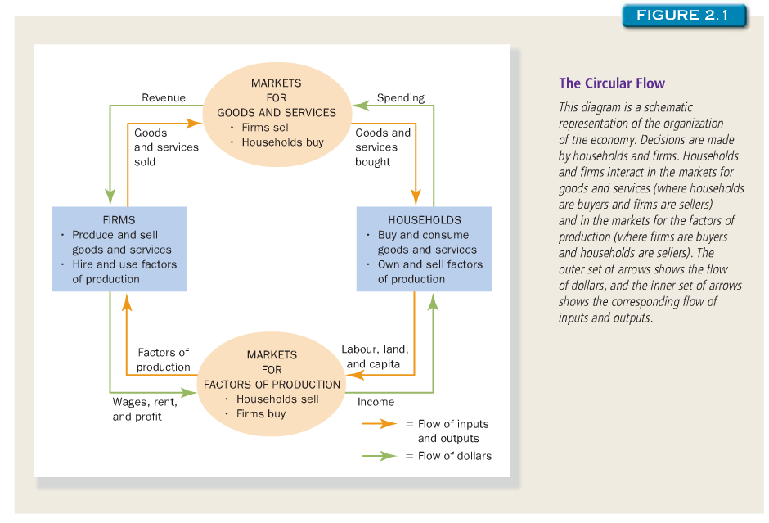

Explanation: the dollar starts in your pocket (household), and then you buy something it ends up as revenue to the firm. Then they use that dollar to pay rent/employee so it is now household once again. (and so on and so forth)

Our Second Model : The Production Possibilities Frontier

Production possibilities frontier: a graph that shows the combinations of output that the economy can possibly produce given the available factors of production and the available production technology

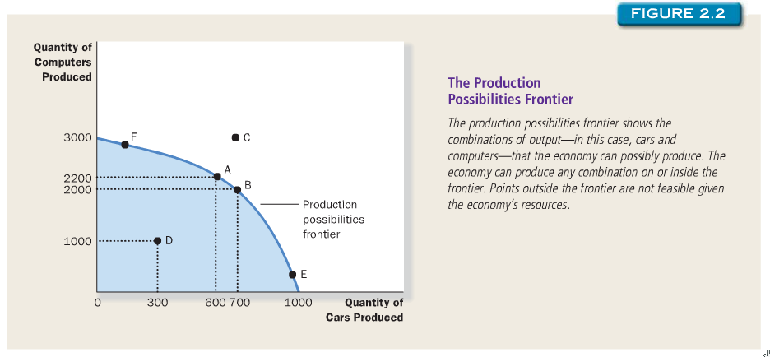

Efficient outcome – dot on the line

D – inefficient outcome

Point A is an example of “people face tradeoffs” you can’t produce more of one unless you are willing to produce less of another

Opportunity cost – the cost of one car is the cost of 2 computers

Microeconomics and Macroeconomics

Microeconomics: the study of how households and firms make decisions and how they interact in markets

Macroeconomics: the study of economy-wide phenomena, including inflation, unemployment, and economic growth

Positive versus Normative Analysis

There are two types of statements about the world:
- Positive statements : (descriptive) claims that attempt to describe the world
as it is
ex: minimum-wage laws cause unemployment
- Normative statements : (prescriptive) claims that attempt to prescribe how
the world should be
ex: the government should raise the minimum wage

*Judging a positive statement can be done with the use of data and facts. However, judging a normative statement involves not only data/facts but also views on ethics, religion and philosophy.

*Majority of economics is positive. However, economists have goals that are normative

WHY ECONOMIST DISAGREE:
- Economists may disagree about the validity of alternative positive theories about how the world works.
- Economists may have different values and, therefore, different normative views about what policy should try to accomplish.

- Differences in Scientific Judgments

Economists sometimes disagree because they have different hunches about the validity of alternative theories or about the size of important parameters.

- Differences in Values

Nobody can ever be right because we all have different values. You cannot determine who should pay more taxes than another because you do not know their background story. Should someone who has a disability pay less tax than someone who works hard for their money at a dreary job?

- Perception versus Reality

BOOK SUMMARY

- Economists try to address their subject with a scientist’s objectivity. Like all scientists, they make appropriate assumptions and build simplified models in order to understand the world around them. Two simple economic models are the circular-flow diagram and the production possibilities frontier.

- The field of economics is divided into two sub-fields: microeconomics and macroeconomics. Microeconomists study decision making by households and firms in the marketplace. Macroeconomists study the forces and trends that affect the economy as a whole.
- A positive statement is that an assertion about how the world is. A normative statement is an assertion about how the world ought to be. When economists make normative statements, they are acting more as policy advisers than scientists.

- Economists who advice policymakers offer conflicting advice either because of differences in scientific judgments or because of differences in values. At other times, economists are united in the advice they offer, but policymakers may choose to ignore it.

*slope : ratio of the vertical distance covered to the horizontal distance covered as we move along the line.
Slope = Δy
Δx

CHAPTER 3 – INTERDEPENDENCE AND THE GAINS FROM TRADE

Production Possibilities

Production Possibility Frontier: shows the various mixes of output that an economy can produce (illustrates – people face tradeoffs)

*if they are being self-sufficient and not doing trades, the Production Possibility Frontier becomes the Consumption Possibility Frontier as well.

Comparative Advantage: The Driving Force of Specialization

Comparative Advantage: The ability of an individual or group to carry out a
particular economic activity (such as making a specific product) more efficiently than another activity

Absolute Advantage

Absolute Advantage: productivity comparison between different people/companies/nation…
*the producer that requires a smaller amount of inputs to produce a good has an absolute advantage in producing that good

Opportunity Cost and Comparative Advantage

Opportunity Cost: Whatever must be given up to obtain some item

Comparative Advantage: the comparison among producers of a good according to their opportunity cost
Ex: Mike Weir should pay Forrest Gump to mow his lawn for $20 in 4 hours rather than doing it himself in 2 hours because he can make 10,000 on shooting a commercial in 2 hours.

Comparative Advantage and Trade

When everyone is producing the good that they have a comparative advantage in, the total production in the economy rises.

The Price of Trade

For both parties to gain from trade, the price at which they trade must lie between the two opportunity costs.

Imports: goods and services produces abroad and sold domestically

Exports: goods and services produced domestically and sold abroad

Principal of Comparative Advantage: states that each good should be produced by the country that has the smallest opportunity cost of producing that good

BOOK SUMMARY

- Each person consumes goods and services produced by many other people, both in our country and around the world. Interdependence and trade are desirable because they allow everyone to enjoy a greater quantity and variety of goods and services.

- There are two ways to compare the ability of two people in producing a good. The person who can produce the good with smaller quantity of inputs is said to have an absolute advantage in producing that good. The person who has the smaller opportunity cost of producing that good is said to have comparative advantage. The gains from trade are based on comparative advantage, not absolute advantage.

- Trade makes everyone better off because it allows people to specialize in those activities in which they have a comparative advantage

- The principle of comparative advantage applies to countries as well as to people. Economists use the principle of comparative advantage to advocate free trade among countries.

