Chapter 3
Domain
Kingdom
Phylum
Class
Order
Family
Genus
Species
Animal classification:
- Old style:
  - Monera (prokaryotic)
  - Protista
  - Fungi
  - Plantae
  - Animalia
- Changed to 3 domains:
  - Bacteria (pro)
  - Archaea (pro)
  - Eukarya
    - Includes 4 kingdoms above
Cell Theory:
- All organisms are made up of cells, they are uni/multicellular
- Basic structural/functional unit of life
- Arise from the division of pre-existing cells

7 Characteristics of life:
- Emergent come about from many simpler interactions
- Display order
- Harness and utilize energy
- Reproduce
- Respond to stimuli
- Exhibit homeostasis
- Growth and development
- Evolve

Chemical origins of life:
- Earth formed approx. 4.6 billion yrs ago
- Earth lies within habitable zone around the sun
  - Earth radiated away some heat, surface layer cooled and solidified, gravitational pull enough to hold atmosphere
- Oparin Haldane hypothesis (1920s)
  - Organic molecules could have emerged from primitive conditions of the earth
  - Reducing atmosphere lacked oxygen which caters to synthesis of basic building blocks of life
- Miller-Urey Equipment (1953)
  - Showed abiotic synthesis of biologically important molecules is possible, organic molecules spontaneously synthesized
  - Additions of cyanide and formaldehyde lead to all building blocks of complex biological molecues (i.e. amino acids, fatty acids, purine/pyrimidine components of nucleic acids, sugars, phospholipids)
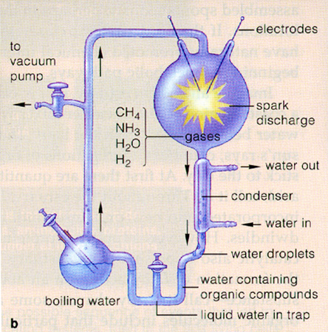

- Alternative theories:
  - Deep sea vents: high temp water, lots of reducing molecules (methane, ammonia, hydrogen sulfide)
  - Extraterrestrial: meteors containing complex biological molecules enter atmosphere and colliding with the earth
- Monomers Polymers:
  - Polymers weren’t formed in M-U experiment
  - Could’ve occurred on solid surfaces like clay
    - Clay layers of minerals separated by water hence charged allowing molecular adhesions forces to create polymers

From macromolecules to life:
- Requirements of cell:
  - Encapsulate and organize material
    - Lipid spheres create defined compartmentalized groups of abiotically produced molecules for metabolic reactions Protobiont i.e. Liposome
    - Clay also accelerates formation
  - System to organize metabolism for energy to be harnessed
    - Redox rxns e- from oxidized material directly transferred to substance being reduced
    - Multi-step processes evolved, energy from oxidation slowly released (i.e. cellular respiration)
    - ATP probably simply hydrolyzed to ADP and inorganic phosphate (energy release)
    - Eventually e- transport chain energy used to synthesize ATP from ADP and P_{i}, more efficient and versatile
  - Storage/transfer system for info that defines cell
    - RNA eventually replaced by DNA as information carrier and catalyst
      - Self-replicating and catalyzing RNA
      - RNA able to catalyze formation of short proteins
      - Production of DNA nucleotides by removal of O atom from ribose subunits of RNA nucleotides
      - DNA nucleotides paired with RNA info moecules and assembled into complementary copies of RNA sequences
    - DNA better:
      - More chemically stable, less likely to degrade
      - Thymine over uracil because conversion of cytosine to uracil= common DNA mutation
      - Double stranded hence info in complementary strand used to repair damaged strand
      - Proteins more efficient catalysts, greater diversity (they’re dominant structural/functional macromolecules)
      - DNA better repository for genetic info
      - Lead to central dogma
  - Mechanism to reproduce

Earliest life forms:
- Cells seen as:
  - Organizational unit
  - Metabolic unit
  - Storage unit
  - Informational unit
  - Reproductive unit
- Earliest evidence in fossils
  - Stromatolites layered rock formed when microorganisms bind particles of sediment together in thin sheets, 3.5 billion yrs ago
  - Some sediments dated 3.9 billion yrs ago containing less C13 than expected, possibly remains of ancient microbes
- First cell= anaerobic
  - Heterotrophs: obtain carbon from organic molecules humans, energy from sugars, proteins, fats
  - Autotrophs: obtain carbon from enviro in inorganic form (CO₂) plants,
- Oxygenic photosynthesis rise of O in atmosphere
  - O2 levels started increasing 2.5 billion yrs ago
  - Cyanobacteria used water as electron donor
    - Free O incorporated into mineral deposits, once reservoirs full accumulated in atmosphere

Eukaryotic cells and multicellularity:
- Current life forms evolved from Last Universal Common Ancestor
Extraterrestrial life:
- Panspermia hypothesis: simple forms of life in space seeded Earth soon after it cooled
  - Life formed between 4.6 and 3.9-3.5 billion years ago, earth had to cool and therefore too short of a time for life to develop solely by abiotic processes
  - Life could possibly survive for millennia in space
- All present-day org. are descended from a common ancestor
  - Cells made up of lipid molecules brought together in bilayer
  - Genetic system based on DNA
  - Info transfer DNA to RNA to protein
  - Protein assembly system from pool of AAs, translation using mRNA and tRNA + ribos
  - Proteins as structure/catalytic molecules
  - ATP as chem energy
  - Breakdown of glucose in glycolysis ATP

Euk Cells and Multicellularity

Endosymbiosis Theory:
- Multiple invaginations of PM
- Bacteria mitochondria
- ER and nuclear envelop form from PM invaginations (not endosymbiant)
- Photosynthetic bacteria become chloroplasts
  - Evidence:
    - Morphology of bacteria, mito, chloroplasts (shape)
    - Reproduction of mito/chloroplasts both divide by binary fission like bacteria/archaea, cells can’t synthesize them
    - Genetic info encoded in mito/chloro separate genes
    - Mito/chloro can transcribe/translate to produce proteins from genetic material
    - Can generate ATP through e⁻ transport
    - Chloro ribosomal RNA like cyanobac, Mito like proteobac
      - All cells with mito therefore evolved in steps, mito then chloro type bacteria absorbed
Horizontal gene transfer:
- Would’ve resulted in gradual transfer of genes from genomes of mito/chloros and nucleus
- Gradually reduced size of genomes of mito/chloros
  - Most genes that encode proteins in mitos/chloros are now found in nucleus, maintained very few in the organelles themselves

Increased complexity means more energy req.
- Bac/archaea simple, euk generate much more energy so more functions can be carried out, hence more specialization
Multicellular orgs.
- 1.2 billion yrs ago
- Cell colony or single cell divided
- Cells structurally and functionally autonomous
  - I.E. one harvests energy, one responsible for motility

Chapter 2

Prokaryotes:
- Eubacteria/archaea
- Variety of energy/carbon sources, synth almost all req. org. molecules
  - Enormous metabolic diversity
- Outnumber all other types of organisms (know little about most)
  - Only about 2% are culturable
- Live in almost all regions of earths surface (coldhot)
- Among first groups of bacteria to evolve = cyanobacteria
  - Oxidize water to produce O₂ *primitive oxygenic photosynthesis
- Gram + cell= thick peptidoglycan layer
- Gram – cell= outer membrane
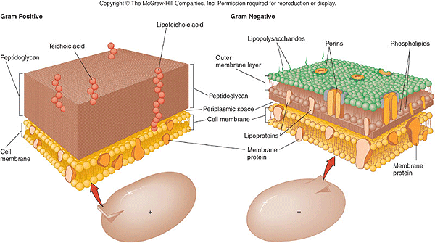

Prokaryotic Cells:
- 3 shapes:
  - Spherical
  - Rodlike
  - Spiral
- Cell wall
  - Sometimes have glycocalyx slime layer for protection/attachment
- Functions occur on PM or in cytoplasm
- Cytoskeletons keep cell shape i.e. in cell division and sometimes determining polarity
- Flagella allows for movement
  - Bacterial flagellum rotates in sock of PM
  - Pilli on flagella or PM, allow for attachment

Oxygenic Photosynthesis:
- Photosynth with H₂O as e⁻ donor
- O₂ accumulated
- Oxidizing character of atmosphere increased
- Organic molecules produced quickly broken down
      - Evolution of metabolic pathways in organisms

Cyanobacteria oxygenic photosynthetic unique for prokaryotes lead to chloroplasts

Eukaryotes:
- Animal cell diagrams= typically idealized
  - Different visualizing cells:
    - Light microscopy- illuminate specimen
    - Electron microscopy- uses e- to illuminate specimen
    - Florescence microscopy
  - Large variety of cell types
    - Neurons up to a metre long
    - Muscle cells fibrous, fusions of myoblasts

FEATURE | PROKARYOTIC CELLS | EUKARYOTIC CELLS
Genetic material | Contain naked DNA. | Contain four or more chromosomes strands of DNA associated with protein.
Location of genetic material | In cytoplasm nucleoid. | In double membrane of nucleus.
Mitochondria | No mitochondria. Surface of cell membrane + mesosome produce energy. | 100s of mitochondria.
Ribosomes | Ribosomes are smaller (70S). | Larger ribosomes (80S).
Membrane bound organelles or internal membranes | Few or none. | Several membrane bound organellesER, Golgi and lysosomes.
Size | < than 10 micrometers. | > 10 micrometers.

Cells Structure:

Endomembrane system: All interconnected. Example: Vesicles fusing b/t organelles/membranes, provides continuum b/t PM and most organelles
- Nuclear envelope
- ER
- Golgi
- Lysosomes
- PMembrane
- Vacuoles

- Ribosomes
  - very small structures (about 80S) that carry out protein synthesis
  - found floating in cytosol and attached to rough ER
  - composed of RNA and protein
  - larger in eukaryotic cells than prokaryotic cells
  - Eukaryotic ribosomes are composed of two subunits
  - Synthesize proteins, translate mRNA
- Endoplasmic reticulum
  - Network of channels that stretch from nucleus to PM
  - Transport materials through cell
  - Advantage of having ribosomes attached to ER:
    - Proteins synthesized by ribos transported by ER to be parts of cell membranes, enzymes for cell or messengers between cells. Proteins used in endomembrane system or secreted from cell
  - Smooth ER: (Metabolism)
    - Lipid metabolism
    - Carb metabolism
    - Drug/xenobiotic metabolism
  - Cells that require lots of proteins/enzymes packed with rough, synthesize lipids and break down toxic substances with smooth
- Golgi apparatus
  - Composed of many flattened sacs called cisternae which are stacked on top of each other
  - Collects, packages, modifies and distributes materials (proteins) for secretion
  - Close to ER to receive products to be transported by ER
  - Close to PM so it can discharge materials needed outside cell
  - Vesicle from ER hit cis face= release contents into cisternal, modified then transported to trans face and released
- Lysosome:
  - Single membrane bound organelles produced by Golgi apparatus
    - Contain strong hydrolytic enzymes
    - Break down biological molecule
  - Contain up to 40 different enzymes
  - Involved in breaking down materials brought into a cell via phagocytosis (including white blood cells)
  - pH is acidic (5, lower than 7.2 in cytosol)
    - Therefore leaked enzymes will be less active in cytosol because they will denature in basic environment
  - Can also break down worn out cell parts that are no longer working (autophagy)
- Nucleus
  - DNA in double membrane or nuclear envelop, fuses @ nuclear pore which helps transport in and out of nucleus (i.e. for RNA)
  - 5um in diametre
  - Double membrane allows DNA to remain separate from rest of cell and carry out its functions without interference from other parts of cell
  - Nuclei often have a nucleolus, a dark area inside nucleus where ribosomes are manufactured
  - DNA contained as chromatin then organized into chromosomes within nucleus (2m of DNA compared to 1.5 in prok cells)
  - Most cells have one nucleus. Some have multiple nuclei while others have none
  - No nuclei = cell cannot reproduce
  - Nucleoli form around genes coding for rRNA molecules of ribosomes combine to form ribosomal subunits
Evolution of the EM System
- More and more membrane being created over a long period of time
- Most functions carried out in membranes due to protein presence
- Membranes attached to exterior of cell would’ve fused around the nuclear region/genetic material

- Mitochondria
  - Very large, double membrane bound rod-shaped
  - Scattered in cytoplasm and contain their own DNA
  - Outer membrane is smooth, inner membrane is highly folded into cristae
    - Cristae increases SA of inner mitochondria for cellular respiration
  - Function: Cellular respiration converts glucose to ATP from catabolism of sugars/fats/fuels in presence of oxygen
  - Size/ability to produce energy (ATP) mitochondria have own ribosomes
  - High #s in cells with high energy needs
- Chloroplast: In plants/euk algae
  - Stroma:
    - Contains many enzymes
    - Rubisco
  - Important for the reactions of the Calvin cycle
  - Thylakoids:
    - Large SA for light absorption
    - Space within allows rapid accumulation of protons
    - Stacked in form of grana
  - Double membrane:
    - Isolate contents
    - Separate from chemically different contents of cell
  - Chlorophyll responsible for absorbing light- green pigment

- Microbodies:
  - Peroxisomes:
    - Animal cells
    - Contain enzymes to transfer H from substrates to O
    - Breakdown fatty acids them smaller products transported to mito for fuel
    - Intermediate product= H₂O₂ so catalase is produced to convert toxic H₂O2 to H₂O
    - Catalase= very fast turnover number, most catalytically enzyme to our knowledge
    - Segregate harmful chemicals so it will not harm cell
- Cytoskeleton
  - Maintains cell shape
  - Cell locomotion
  - Fills and supports cytoplasm from PM to nuclear envelope
  - Less prominent in plant cells
  - Structure= Interconnected system of protein fibres
    - Microtubules- largest elements, polar
      - a-tubulin=positive end, b-tubulin=negative end
      - a and b tubulin dimers bonded non-covalently together
        - Chromo organization/separation, anchor organelles in place, animal cell mvmnt from “motor” proteins pushing/pulling against tubules to “walk” along them
    - Intermediate filaments- only in multicellular organisms, tissue specific protein composition
      - Cytoplasmic streaming, a contractile element in muscle fibres, dividing cytoplasm
    - Microfilaments- smallest, made of actin

Microtubule | Intermediate Filament | Microfilament
a-tubulin, b-tubulin, y-tubulin | >70 different proteins, keratins | Actin
Maintenance of cell shape | Mechanical strength of cell | Maintenance of cell shape
Cell locomotion | Tissue specific roles (hard keratins in hair, nails, neurofilaments support axons) | Muscle contraction
Chromo movement in mitosis | Formation of nuclear lamina (organizing scaffold for protein entrance) | Cell division (cleavage furrow)
Organelle movement |  | Cytoplasmic streaming
 |  | Cell motility (pseudopodia)
Larger | Medium | Small

- Flagella and Cilia:
  - Elongated motile structures extended from cell surface
  - F- whip/oar-like movements propel cell thru watery medium
  - C- move fluids over cell surface
Amyloplast- colourless plastid, stores starch, in roots
Chromoplasts- red and yellow pigments, ripening fruits and fall leaves
  - Arise from centrioles
- Vacuoles:
  - Contractile Vacuoles- stores water in protists
  - Central Vacuoles
    - Occupies 90% of cell’s volume
    - Pressure w/in supports cell, growth of vacuole=cell growth
    - Tonoplast (membrane around central vac) has transport proteins
    - Storage of:
      - Macromolecules
      - Pigments
      - Waste products

- Plant Cell Walls
  - Support cell, keep shape and rigidity
  - Cellulose fibres:
    - Primary cell wall- soft/flexible
    - Secondary- addition layers cellulose+ branched carbs laid b/t primary wall and PM
  - Plasmodesmata channels allow ions and small molecules to pass thru cytosol

- Animal Cell surface
  - Cell adhesion molecules bind cells together, cell junctions seal spaces b/t and provide direct communication forms extracellular matrix
    - Adhesion mol.= glycoprotein in PM
    - Cell junctions:
      - Anchoring junctions- create flexible adherence points beneath their PM by cytoskeleton
      - Tight junctions- b/t adjacent cells, prevent ion+ molecule leaks b/t cells
      - Gap junctions- form direct channels allowing small molecule/ion flow b/t cytoplasm of adjacent cells (similar to plasmodesmata in animal cells)
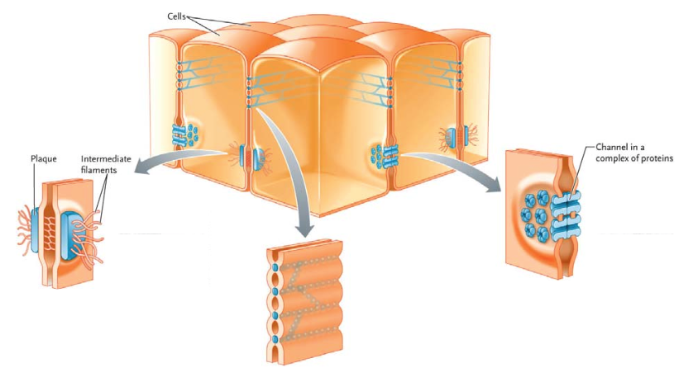
    - Extracellular matrix organizes cell exterior supports/protects cells+ provides mechanical linkages b/t tissues
      - Exterior of cell coated with proteins/polysaccharides (glycoproteins) secreted by themselves
      - Some impregnated with mineral crystals producing dense but elastic structure (i.e. bone)

Advantages of Compartmentalization:
- Separation of function:
  - Physical separation of molecules
  - Simplification of metabolism
- Isolation of potentially harmful products
- Organelles increase amount of membrane as a function of volume:
  - Surface area= d²
  - Volume= d³
  - The higher the SA: V ratio the better

Carbs:
- Monosaccharides:
  - Single unit sugar:
    - Glucose
      - Linear, a-linkage or b-linkage
    - Fructose
    - Galactose
- Disaccharides:
  - 2 monos bonded together (glycosidic bond, dehydration synthesis)
    - Maltose
      - 2 Glucose
    - Lactose
      - Galactose+ Glucose
    - Sucrose
      - Sucrose+ Fructose
- Polysaccharides:
  - Many monos:
    - Starch
      - a-(1,4) linkages of glucose
    - Glycogen
      - a-(1,4) linkages of glucose w/ (1,6) branches
        - Branches allow for easier hydrolysis for energy production
    - Cellulose
      - b-(1,4) linkages, requires specific enzymes to be broken down

Amino Acid
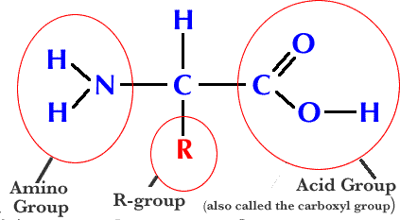

Full name of acid, 3 letter short form, 1 letter short form
- Example:
  - Aspartic acid
  - Asp
  - D
Acidic/negatively charged amino acids: Hydrophilic
- Asp
Positive/basic amino acids: Hydrophilic
Nonpolar: (10)- hydrophobic
- Ala
- Val
- Leu
- Ile
- Gly
Uncharged (but polar) 5: Hydrophilic
- Ser
- Thr
- Tyr
- Asn
- Gln
Properties of AAs determine properties of proteins

Glucose:
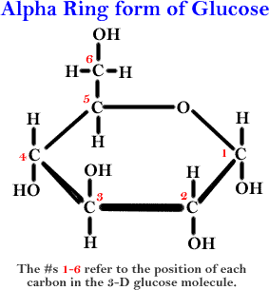

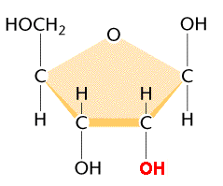
Ribose :

ADD DIAGRAMS FROM LECTURE PPT

Functions of sugars:
- Animals:
  - Glucose energy source
  - Lactose energy to newborns until weaned
  - Glycogen energy stored in muscles and liver
- Plants:
  - Fructose:
    - Sweet taste in fruits
    - Attracts animals to eat and disperse seeds
  - Sucrose energy source
  - Cellulose fibres, strengthen

Condensation:
- Joins 2 molecules together water molecule formed as result
  - Amino acids together polypeptides (amino, alpha carbon, carboxyl)
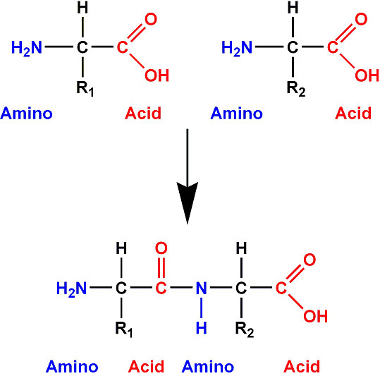

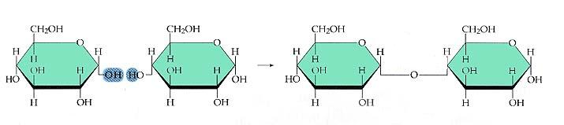
  - Monosaccharides polysaccharides

- All biological molecules formed by condensation rxns.
- Dehydration synthesis

Hydrolysis:
- Reverse of dehydration synthesis
  - Molecule of water added to break bonds

Protein structure:
- Primary:
  - Amino acid sequence
  - Peptide bonds
  - Determined by base sequence of gene that codes for protein
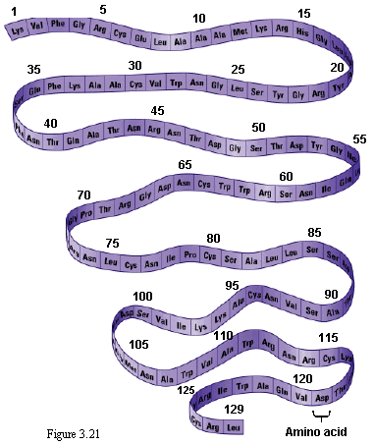

- Secondary:
  - α-helix coils and β-pleated sheets
  - Regular repeating structures
  - H-bonds between O and carboxyl group of one amino acid and H in amino group of the other

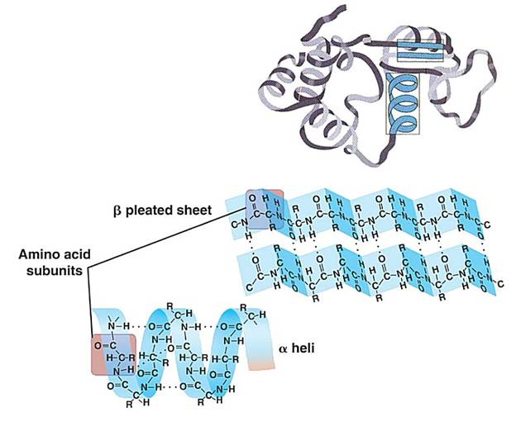

- Tertiary:
  - 3D
  - After translation
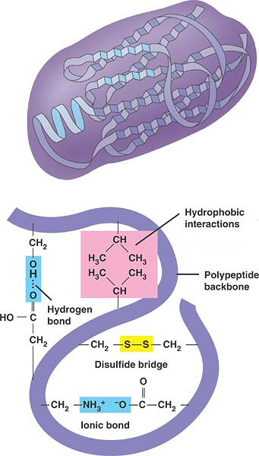
  - Polypeptide folding up, determined by interactions of R-groups, and R-groups with the enviro
  - Stabilized by intermolecular bonds b/t amino acids
    - Ionic
    - H-bond
    - Disulphide bridges
    - Van der Waals forces

- Quaternary:
  - 2+ polypeptides linked together to form single protein
    - Insulin
    - Collagen
    - Hemoglobin
      - Includes 2 b-globin polypeptide, 2 a-globin polypeptide +4 heme groups
  - All types of bonding
  - Prosthetic groups: (Cofactors)
    - Non-protein compound bound to a protein, essential to protein’s function
    - Example:
      - 4 polypeptides linked to heme group
      - Vitamins (coenzymes)/minerals
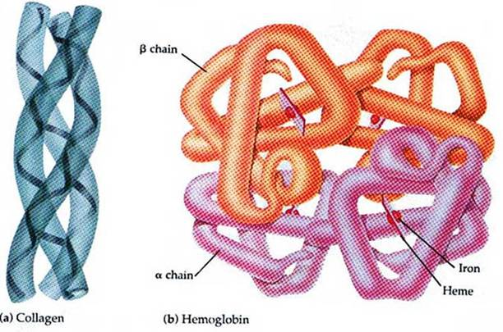
    - Conjugated proteins

Protein shape:
- Fibrous:
  - Long + narrow
  - Many polypeptide chains
  - Insoluble in water
    - Collagen Human connective tissue
    - Actin found in muscle, use in muscle contractions
- Globular:
  - Rounded 3D
  - Mostly soluble
    - Hemoglobin delivering oxygen
    - Insulin regulates blood glucose
Shapes determined by X-ray crystallography

Polynucleotides:
- DNA/RNA, polymers of nucleotides
- 3 phosphate groups + 5 carbon sugar + nitrogenous base
- Joined together by phosphodiester bonds

ADD DIAGRAM

Functions of lipids:
- Energy storage:
  - In form of oils in plants
  - Fats in animals
- Heat insulation:
  - Heat loss reduced by fat layer below skin
- Buoyancy:
  - Lipids less dense than water animals float

Glycerol fatty acids triglycerides
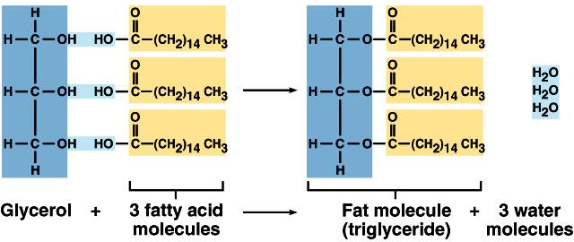

Types of fats:
- Monounsaturated: olive/canola/peanut oils, almonds, decrease LDL, increase HDL
  - 1 double bond
  - 13 degree melting point
- Polyunsaturated: corn, cottonseed, soybean, decrease LDL, increase HDL
  - > 1 double bonds
  - -17 degree melting point
- Saturated fats: animal, dairy, coconut, increase LDL, decrease HDL
  - No double bonds
  - Aggregates together 70 degree melting point
- Trans fats H present on opposite sides of C=C bond, huge LDL increases, decreases HDL
- Natural fats cis, H on same side of C=C bond,

Linoleic vs. Linolenic fatty acids:
- Omega-6 increase HDL, lower LDL: linoleic
- Omega-3 lower LDL, increase HDL: linolenic
- Importance of balance:
  - 1:1 ratio leads to:
    - Decreased inflammation
    - Decreased LDL oxidation
    - Decreased risk of coronary heart disease
    - Increased bone density in elderly

Carbs vs. Lipids:
- Energy stored in both forms
  - Carbs short term energy
    - 4 cal/g
    - Easier, more efficient digestion
    - Stored and released faster
    - Polar + soluble, transport easier
  - Lipids long term
    - 9 cal/g
      - Less dense for same amount of energy
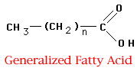
    - Non-polar (hydrophobic) do not interfere with osmosis
Fatty Acid:

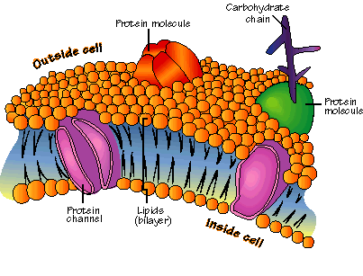
Membrane:

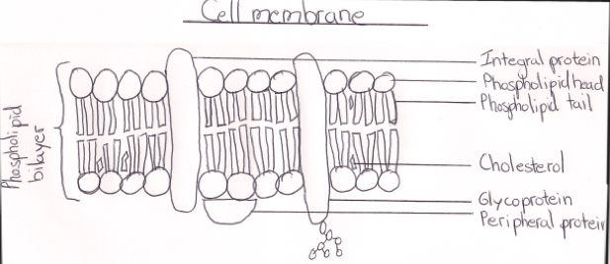

Membranes:
- Selectively permeable
- Amphipathic phospholipids not solid $∴$ semi-permeable
  - Changes shape, vesicles fuse to it.
  - Endocytosis and Exocytosis
    - Exocytosis: vesicle fuses to membrane, expels stuff, membrane returns to original state
    - Endocytosis: pulls PM inward pinches off vesicle from membrane
  - Fluidity decreases with temp
  - Unsaturated fatty acids increase fluidity at low temp by creating kinks in membrane (desaturases)
    - Regulated in gene transcription, maintain proper membrane fluidity by regulating amount of unsaturated fatty acids in membranes
  - Cholesterol:
    - Modulates fluidity of membranes
    - Increase fluidity @ low temp
    - Decrease fluidity @ high temp
- Phospholipid:
  - Phosphorylated side (head) Hydrophilic face water
  - Fatty acid chain (tail) Hydrophobic away from water
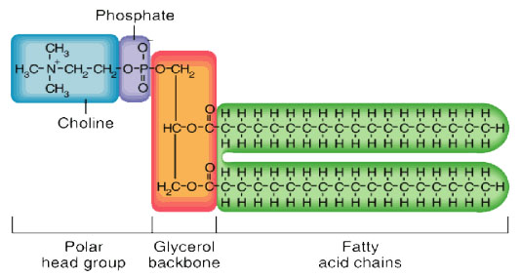
  - Makes membrane stable, but flexible
  - Fluid state change shape easily
  - Can move rapidly laterally within their layer

Steroids:
- Hydrophobic
  - Cholesterol
    - Transported around as lipoproteins
      - LDL (Bad)
      - HDL (Good)
  - Testosterone
  - Vitamin D
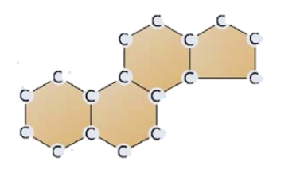

- Proteins
  - Integral
    - Penetrate lipid bilayer from one side to other
    - Control entry and exit of specific molecules from cell
    - Hydrophobic interactions with fatty acids and hydrophobic amino acids, can have hydrophilic region which helps keep them in place
  - Peripheral
    - Loosely bound to PM
    - Float in fluid phospholipid bilayer or are attached to an integral protein
    - Known as glycoproteins have a carbohydrate attached
    - Functions in immune responses and are involved in cell to cell recognition
  - Frye-Edidin Experiment shows that proteins move rapidly around in membranes
  - Slow lateral movement thru membrane
  - a-helices, 7-20 AAs

Functions of membrane proteins | Description
Hormone binding sites | Exposed on outside, one specific hormone can bind (shape based). Signal transmitted to inside cell (signal transduction).
Immobilized Enzymes | Enzymes in membranes catalyze reactions inside or outside cell, depends on location of active site. Grouped so metabolic pathway occurs.
Cell adhesion | Proteins from adjacent cells hook together permanent or temporary connections. Forms gap junctions and tight junctions.
Cell to cell communication | Involved in cell to cell communication, have attached molecule of carb provides identification label for cell (glycoproteins).
Channels for Passive Transport | Passages through center of membrane proteins. Allows specific substance to pass through from high to low [ ].
Pumps for active transport | Pumps release energy from ATP moves specific substances across PM. Energy changes shape of protein.

Membrane Asymmetry:
- Fluid mosaic means lipid composition of different sides of membrane can differ
  - Each side can be structurally and functionally different from the other

Diffusion:
- Passive movement
- Particles
- High to low [ ] region
- Result is net mvmnt of molecules in a specific direction
Osmosis:
- Passive movement
- Water molecules
- Across permeable membrane
  - Isotonic solution water passes, solute can’t, net flow = in both directions
  - Hypertonic more solute [ ] outside
  - Hypotonic—less solute [ ] outside
    - Net flow flowing from hypo to hyper (water [ ] gradient)
      - Example: liver cell = hypotonic, water flows in & expands lysis therefore work with isotonic solutions
      - Cell in Hypertonic solution, water flows out of cell, cell shrinks
      - Can also effect mass
    - Plants not as effected due to cell wall, but hypotonic pushes against wall, hypertonic= flaccid
- Low solute to high solute [ ] (along [ ] gradient of water)

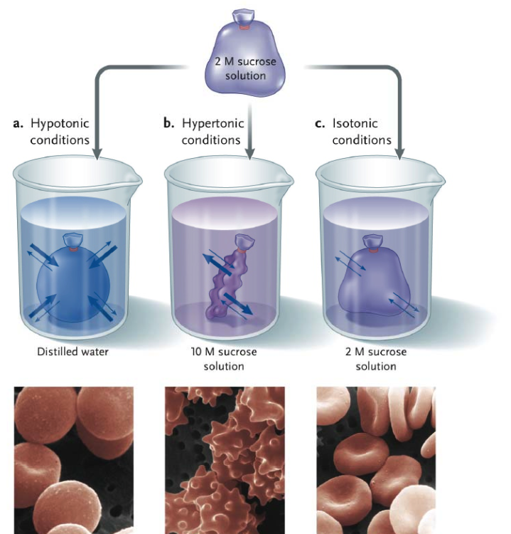

Passive transport across membrane:
- Membranes = semi-permeable.
- Passive transport = no energy used
- Simple diffusion:
  - Molecules through bilayer
  - Hydrophobic molecules
  - Water osmosis
    - If high solute [ ] in cell, water moves into cell
- Facilitated diffusion:
  - Uses protein channels
  - Larger, hydrophilic and charged molecules
  - With [ ] gradient
  - Transport protein specific to molecule being transported
    - Channel proteins
    - Carrier proteins
  - May be saturated higher concentration, higher rate of transport (blue line on graph = facilitated transport)

Active transport:
- Substances through membrane using ATP energy
- Against [ ] gradient
- Protein pumps/cotransporters
  - Transports specific substances
    - Control what enters and leave
  - Symport cotransported solute moves thru membrane channel in same direction as driving ion
  - Anti-port driving ion moves thru membrane channel in one direction providing energy for active transport for another molecule in opposite direction
- Can be saturated
          - NA K pump diagram
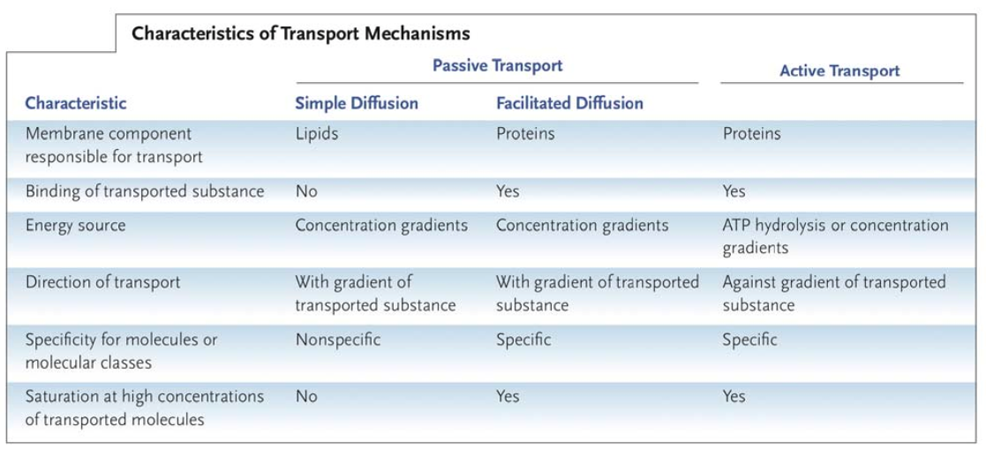
Transport of materials in cell:
- Synthesized proteins to rough ER can be modified
- Vesicles carry proteins bud off rough ER go to Golgi apparatus further modification
- Vesicles fuse with membrane expel contents outside cell

Endocytosis and Exocytosis
- Exocytosis: vesicle fuses to membrane, expels stuff, membrane returns to original state
- Endocytosis: pulls PM inward pinches off vesicle from membrane, moves through cytoplasm to destination
  - Pinocytosis (bulk phase endocytosis, nonspecific)
  - Phagocytosis (nonspecific)
  - Receptor mediated endocytosis (extremely specific)
    - LDL receptor LDL binds to receptor, triggers endocytosis, lysosomal enzymes will break down vesicle to release cholesterol, enzymes and phospholipids for their function

Cell to cell communication
- Signal transduction links signals with downstream cellular responses
  - Reception molecule binds with target cell
  - Transduction Signal reception triggers changes within cell (signalling cascade)
  - Response cell responds to signal
- Membrane surface receptors bind molecules
- Signal reception triggers response pathways in cell

Phosphorylation Cascade
- Protein kinases act in chain enzyme that transfers a phosphate group from ATP to one or more sites on particular proteins
- Catalyze series of phosphorylation rxns to pass along signal
  - ATP activated phosphorylated kinase ADP
- Ea. kinase catalyzes another in the cascade
- Last protein = target protein
- Phosphorylation of target stimulates or inhibits activity depending on protein cellular response
Balanced/reversed by enzyme protein phosphatases
- Remove phosphate groups from target proteins
- Continuously active in cells, hence quickly shut off signal transduction pathway

Amplification in signal transduction:
- Increases magnitude of each step as signal pathway proceeds
- Activated enzyme in pathway activates hundreds of proteins in next step
- More enzyme-catalyzed steps in response pathway, more amplification
- Only a few extracellular signal molecules binding to receptors can produce full internal response

Diarrhea
- Oral rehydration with solution containing both Na+ and glucose because of Na+-Glucose cotransporter
  - Na+-Glucose cotransporter transports Na+ & glucose across intestinal epithelium
    - W/out glucose, Na+ slow transport
    - W/out Na+, glucose not transported against gradient
    - Na+ driving ion drives glucose through the cell, symport active transport
  - Water flows thru brush border membrane by osmosis, facilitated diffusion and by cotransport
  - Protein SGLT1= contransports: Na+, glucose and water providing water channel
  - Tight junctions keep solutions going straight into blood

Chapter 4

Metabolism
- Totality of organism’s chemical processes
- Refers to management of cell’s molecular/energy resources
- Results from interaction of molecules
- Organized into pathways

Cell’s requirements for energy expenditure
- Many metabolic processes
- Processes such as active transport
- Mechanical work
  - Muscle contraction, chromo mvmnt
- Generation of heat
        - Macromolecules
          - Broken down
          - Built up
          - Interconversion
          - Extract energy
Catabolic pathway breakdown macromolecules to simpler forms, release potential energy stored in bonds
Anabolic build complicated molecules from simple molecules, consumes energy
Couple pathways so catabolic drives anabolic

Energy transformations:
- Takes ordered forms
- Releases less ordered molecules and energy
- Uses energy to build more organized molecules from precursors
- Do other work

Thermodynamics:
- Energy exists in different forms and states
- Energy capacity to do work
- Kinetic energy of motion
- Potential stored energy
- May be converted readily from one form to another
- Laws of thermo describe energy flow in natural systems

Isolated system no matter/energy exchange with surroundings
Closed energy exchange, no matter
Open energy and matter exchange with surroundings
Laws:
- Energy can be transformed, but not destroyed or created
- Total amount of energy in a system and its surroundings remains constant
- Total disorder of a system and its surroundings always increases energy transformations increase disorder
  - A new car gradually deteriorates, requires work hence, takes energy to maintain low entropy
- Entropy measures disorder
- Life is highly ordered, suggests against 2nd law however, not true.
  - Living things bring in energy and matter to generate order out of disorder
- Surrounding entropy also increased
  - Organisms release heat and by-products to increase disorder of surroundings
Rxn spontaneous if:
- Products have less potential energy than reactants (exothermic, releases energy)
- Products less ordered than reactants, increase in entropy (i.e. ice melting)
$$∆G=∆H-T∆S$$

If energy of A is higher than B, free energy is negative
Free energy must be negative for rxn to occur spontaneously
- No energy req. to go from G initial to G final
- $∆$G = max amount of work that the system can perform
- Exergonic
- Generally go to EQ, 95% products
$∆$G positive= not spontaneous, energy absorbed from surroundings, endergonic
$∆$G=0 at maximum stability, no work put in, @ EQ
- Living orgs, -$∆$G, only reach EQ upon death

Free energy only looks at initial and final energy states, nothing about pathway
Most cellular chemical rxns are not spontaneous quickly @ cell temperature

ATP = Energy currency:
- ATP + H₂O ADP + P_{i}
  - $∆$G= -7.3 kcal/mol
- High energy due to:
  - ADP + P_{i} carry negative charge, repulsion b/t ionic products favours hydrolysis AKA unstable, hydrolysis releases energy
  - Release of terminal phosphate= greater opp for hydration
  - Orthophosphate group has resonance forms, increase disorder of system
  - Addition of phosphate groups energizes intermediate which allows it to react to yield final products

Activation energy barrier:
- Energy invested to overcome AE barrier
- Absorb energy from enviro as thermal energy
  - Increase temp, increase rxn rate
  - BUT cell temp increase = death
  - ANSWER: ENZYMES
Enzymes:
- Proteins
- Catalyze rxn lowering AE
- Increase rxn rate 10⁶-fold
- Specific to substrate, allow control over metabolism
Enzyme: globular protein which acts as catalysts for chemical rxns.
Active site: region on surface of enzyme where substrates bind that catalyzes a chemical rxn involving substrates.
Enzyme-substrate specificity:
- Active site of enzyme is specific to its substrates
  - Precise shape
- Enzymes can only catalyze certain rxns
- Substrate must fit active site shape and be chemically attracted to it
Lock and key
- Can bring reactants together
- Expose substrate to altered chemical enviro
- Change shape of molecule to transition state
  - Brings reactants together at proper orientation for catalysis
  - Exposes reactant molecule to altered charge enviros
  - Change shape of substrate molecule that mimics transition state

Effects on enzyme activity:
- Temperature:
  - Activity increases with temperature doubles every 10 degrees
    - Molecules move faster more collisions
  - At certain point (past 37 degrees) enzymes denature and stop functioning
    - Heat causes vibrations in enzyme breaks bonds within it
- pH:
  - Optimum pH = most efficient
  - Activity decreases as it diverges
  - Acidic and basic environments denature enzymes
- Substrate [ ]
  - Activity increases with [ ]
    - More random collisions
  - Reaches max when all active sites are taken up

Denaturation: changing structure of enzyme so it can no longer carry out its function

Use of lactase:
- Lactose = sugar in milk
  - Broken down by lactase in glucose and Galactose
- Some people don’t have lactase lactose intolerance
- Milk that is lactose-free produced:
  - Adding enzyme lactase to milk breaks down lactose by hydrolysing it

Metabolic pathways consist of chains and cycles of enzyme-catalyzed rxns.
- Series of both exergonic and endergonic rxns

Induced-fit model:
- Substrate doesn’t fit perfectly into active site at first
- Binds to active site changes shape of active site to fit perfectly
- Explains why some enzymes can bind to many different substrates
  - Different but similar substrates can bind thanks to shape change
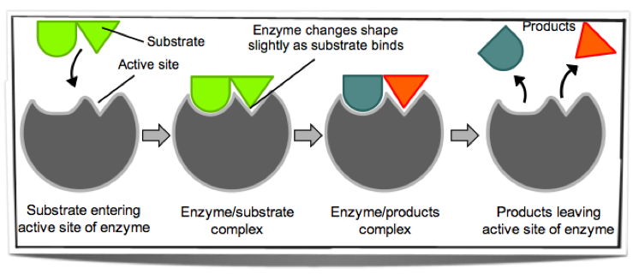

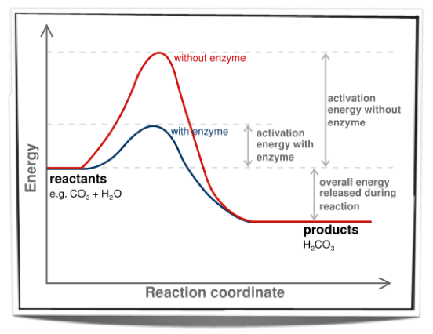

Inhibitors: inhibit enzyme activity
- Competitive:
  - Structurally similar too substrate of enzyme binds to active site
    - Prevents substrate from binding to site until inhibitor is released
  - Effects can be reduces by increasing substrate [ ] more substrate will bind to active sites than inhibitor
    - Example: malonate
      - Like succinate Krebs cycle of aerobic respiration
- Non-competitive:
  - Not similar to substrate don’t bind with active site
  - Bind with separate site that changes conformation of active site
  - Substrate may still bind, but enzyme cannot catalyze rxn as fast
    - Increasing substrate will not prevent inhibitor from binding
      - Example: ATP accumulates and binds, lowers rate of rxn less ATP produced.

Metabolic pathways:
- Many chemical rxns catalyzed by enzymes
- End-product inhibition: non competitive inhibitors
  - Last rxn in pathway inhibits enzyme that catalyzes first reaction
    - Binds to allosteric site active site changes shape
      - Unlikely for substrate to bind
    - Active site returns when inhibitor is released
- Advantage:
  - Excess end-product will shut down pathway bc it inhibits first enzyme pathway
  - Prevents formation of intermediates

Energy from exergonic electron flow allows the ETC to create a proton motive force by pumping H+ ions from the matrix to the intermembrane space

Chapter 6

Oxidation: Loses electrons, generally fuel molecules that are oxidized - C₆H₁₂O₆ 6CO₂
Reduction: Gains electrons, - 6O₂ 6H₂O
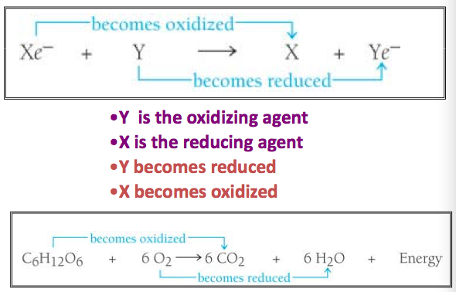
Common REDOX reactions:
- NAD+ NADH: NAD+ is reduced to NADH, using C-H bonds as reducing agents, their potential energy is transferred to NAD+
- FAD FADH: FAD is reduced to FADH2, same as above
- For the reverse reactions, O2 used as oxidizing agent, reducing NADH/FADH, releases H2O

ATP Regen:
- Substrate level phosphorylation enzyme transfers phosphate group directly from substrate to ADP
- Oxidative phosphorylation catalyzed by ATP synthase in inner mitochondrial membrane (accounts for majority of ATP production)

Proton motive force leads to ATP synthesis
- Represents potential energy, uses reducing power
- Electrochemical gradient
  - H+ gradient (pH 10-100 fold difference) Inner mitochondrial membrane higher positive charge (more acidic) than the matrix
    - H+ ions moved into intermembrane compartment from NADH/FADH2 being oxidized
    - This is powered by e- releasing energy ***Exergonic
  - Electrical gradient
    - Difference in concentration of negative charge

ATP Synthase:
- Intermembrane process, mitochondrial inner membrane
- Allows H+ ions to pass down gradient into matrix
- Uses potential energy of PMF to synthesize ATP from ADP and Pi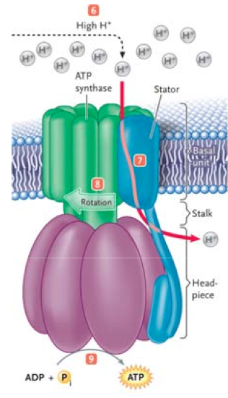

Chemical energy reducing power proton motive force ATP

Transport of e⁻ from NADH to O₂ strongly exergonic, releases energy

Catabolism of Glucose:
- Glycolysis breaks down glucose
  - Occurs in cytosol
  - Forms 2 pyruvate, 2H2O, 2 ATP net yield, 2NADH+2H⁺
- Pyruvate Oxidation:
  - Passes through outer and inner mito membranes by diffusion
  - Converted to acetyl-CoA in matrix
  - Produces CO₂ (decarboxylation), acetate (oxidation of 2-carbon group), NADH (dehydrogenation of acetate), acetyl-CoA (acetyl group+CoA)
- Krebs/Citric Acid Cycle:
  - Occurs in mitochondrial matrix
  - Yield: 2CO₂, 3NADH, 1FADH₂, 1 ATP, 3H⁺, 1 CoA
- Oxidative phosphorylation:
  - Occurs in inner mito membrane
  - Yield: approx. 36 ATP
Anaerobic cell respiration:
- In humans:
  - Pyruvates stays in cytoplasm
  - Coverted into lactate then removed from cell
- In yeast:
  - Pyruvate converted into CO₂ and ethanol no ATP produced

Aerobic cell respiration:
- Pyruvate taken into mitochondria if oxygen present
- Pyruvate broken into CO₂ and H₂O
  - Large amounts of ATP released

Oxidation: loss of e⁻ from element, usually gaining O or losing H
Reduction: gain of e⁻, losing O or gaining H

Glycolysis: First stage of cell respiration
- Phosphorylation:
  - 2 phosphate groups added to glucose from 2 ATP molecules
    - Produces fructose-6-phosphate (hexokinase and isomerization reactions involved) then fructose-1,6-biphosphate (phosphorylation)

- Lysis:
  - Fructose 1,6-biphosphate splits into 2 molecules of glyceraldehyde-3-phosphate (G3P) and dihydroxyacetone phosphate (DAP) then isomerized to G3P
- Oxidation:
  - 2 atoms H removed from each G3P
  - Energy released by oxidation used to add phosphate group to G3P
  - NAD+ = H carrier, accepts H atoms lost
  - Produces 1,2-biphosphoglycerate
- Substrate level phosphorylation:
  - 1 phosphate group removed from 1,2-biphosphoglycerate
  - Phosphate group given to ADP ATP
  - Mutase reaction, redox reaction lead to remaining phosphate group removed from phosphoenolpyruvate pyruvate produced, 2nd ATP produced
THIS HAPPENS TWO AT A TIME

Occurs in cytosol 2 ATP used, 4 produced
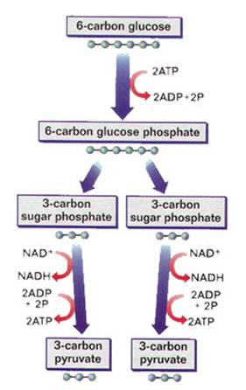
2 NAD⁺ coverted to NADH + H⁺
2 pyruvate formed

Pyruvate oxidation:
- Pyruvate diffuses through outer and inner mito membrane
  - Oxidative decarboxylation: enzymes in matrix of mitochondrion remove H and CO2 from pyruvate
    - H to NAD+
  - Results in acetyl group formation
    - Acetyl group accepted by CoA acetyl CoA
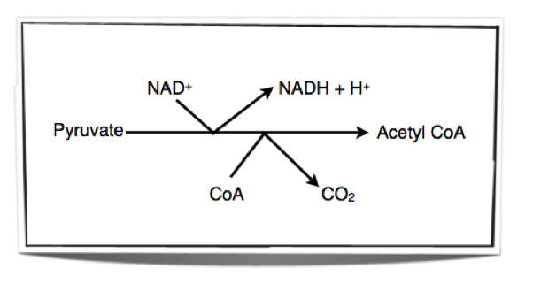
    - Catalyzed by pyruvate dehydrogenase complex,

Krebs cycle:
- Acetyl group from acetyl CoA + H2O 4 carbon compound
  - Result: 6 carbon compound (Citrate)
    - Succinyl CoA released
- 6-C compound (Citrate to Isocitrate) oxidative decarboxylation
  - Result: 5-C compound
    - CO2 released
    - NAD+ NADH + H+
- 5-C compound (a-Ketogultarate) oxidative decarboxylation
  - Result: 4-C compound (Succinyl-CoA)
    - CO2 released
    - NAD+ NADH + H
- Succinyl-CoA undergoes substrate-level phosphorylation (Succinate Fumarate + H2O Malate Oxaloacetate)
  - ADP ATP
  - Oxidation twice
    - H from Succinate accepted by FAD FADH2
    - H from Malate accepted by NAD+ NADH + H+
  - 4-C compound (Oxaloacetate) ready to accept new acetyl group
  - Cycle repeated
- CO2 removed in rxns as waste product excreted from body
- Oxidations release energy stored by carriers that accept H
- Energy used later by e- transport chain

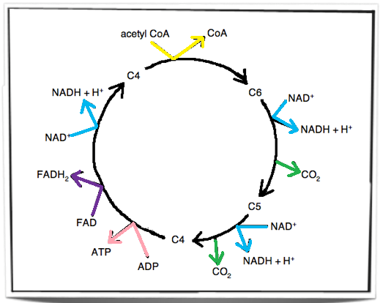

Electron transport chain: Oxidative phophorylation
- In inner membrane of mitochondria chain of e- carriers (proteins)
- NADH donates 2 e- to first carrier in chain
- e- pass along chain giving up energy as the pass from carriers
  - Redox rxns
- Enough energy released to produce ATP via ATP synthase @ 3 locations
- FADH2 donate e- at later stage than NADH
  - Only 2 stages where sufficient energy released for ATP production from FADH2 e-

Oxidative Phosphorylation and chemiosmosis:
- e- pass through chain + release energy
- Energy used to pump H+ against [ ] gradient from matrix into space between inner and outer membranes of mitochondria
  - Potential energy storage in form of built up [ ] gradient
  - Protons brought back to matrix through chemiosmotic channels in synthase molecules
- ATP synthase powered by H+ movement from high [ ] in intermembrane space to matrix (along its concentration gradient), phosphorylates ADP ATP
- Chemiosmosis necessary for oxidative Phosphorylation

38 ATP from glucose: 40% chemical energy in glucose conserved in usable form
Enough PMF from ETC, NADH= drives synthesis of 3ATP, FADH2=2ATP, NADH in cytosol=3ATPactually 2 because can’t enter mitochondria

Metabolism of other macromolecules
- Broken down into forms that can be used in Krebs cycle
- Fatty acids beta oxidation to acetyl CoA
- Proteins to amino acids, fed into glycolysis occasionally

In prokaryotes
- Bacteria metabolize energy rich substrates
- Small amount of ATP by substrate level phosphorylation
- Generate a lot of NADH/FADH₂
- e⁻ enter ETC, creates pmf across PM
  - PMF synthesize ATP, drive transportation processes and mechanical work
  - Max production of 38 ATP

Anaerobes
- No oxygen, so other substance used as final e⁻ acceptor, i.e. NO₃⁻, SO₄⁻²

Fermentation:
- ATP by glycolysis without oxygen
- Inefficient, but useful
- NAD+ all converted to NADH, therefore must be regenerated
Facultative anaerobes: capable of growth in aerobic/anaerobic conditions
- Muscle cells
Lactic acid:
- Dairy industry, exercise
- Pyruvate reduced to lactate so NADH can be oxidized to NAD+

Need to balance absolute requirement for ATP with requirement of rest of body for glucose produce ATP muscles while still maintaining adequate amounts of glucose for brain function

Several potential sources of ATP:
- Direct ATP and phosphocreatine (in muscles)
- Indirect Metabolism (stored glycogen glycolysis Krebs/Oxidative phosphorylation) OR stored triglycerides fatty acids beta oxidation Krebs/OP

Different energy sources used during exercise dependent on duration and intensity of the exercise:
- ATP used up first, Phosphocreatine used next, anaerobic metabolism kicks in, then aerobic does
- Muscle glycogen depletes so circulating blood glucose comes from:
  - Continued ingestion
  - Liver glycogen
  - Hepatic gluconeogenesis
- Blood glucose has to remain high enough to maintain brain activity body switches to using fatty acids
- End of race back to anaerobic using glycolysis depleting blood glucose and compromising brain activity hit the wall

Alcohol Fermentation:
- 2 enzymes: decarboxylase and alcohol dehydrogenase
- Pyruvate to acetaldehyde to ethyl alcohol
- Brewing/breadmaking

Hangovers:
- Dehydration
- Electrolyte imbalance
- Gastrointestinal disturbance
- Low blood sugar
- Sleep/biological rhythm disturbances
- Acetaldehyde toxicity

Most beers use barley as fermentable sugars, wheat and rye can also be used
Starch from grain hydrolysed with amylase to maltose (a-1,4 b/t 2 glucose) goes into fermenter
- Malting produces amylase
- Milling kilning (determines darkness of beer)
- Mashing
- Lauter tun
- Wort boiling
- Hop filter antimicrobial
- Wort filter
- Wort cooling
  - Fermenter (producing alcohol, using yeast)
  - 1st storage tanks
  - Carbonation
  - 2nd storage tank
    - Beer filtration
    - Filling
    - Pasteurization
    - Labeling and packing
Lagers:
- Bottom fermenting yeast
- Ferment at lower temperatures (50 degrees)
Ales:
- Top fermenting
- Ferment at higher temperatures (64-72 degrees)

Photosynthesis
- Chloroplasts found in mesophyll cells, 30-40 per cell
- O2 exits, CO2 enters leaf through stomata

ATP and H₂ derived from photolysis of water used to fix CO₂ + make organic molecules.

Rate of photosynthesis:
- Measured in many ways:
  - Production of oxygen
    - Plants release oxygen: can be collected and measured
  - Uptake of CO₂
    - More difficult to measure:
      - pH of water rises as CO₂ is absorbed
  - Increase in biomass
    - Batches of plants harvest at series of times:
      - Biomass calculated rate increase = indirect measure of rate of photosynthesis

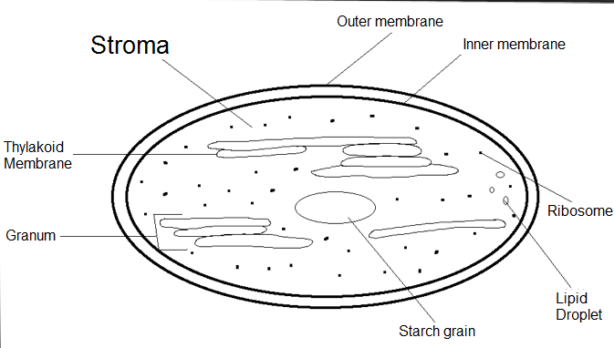

Photosynthesis consists of both light-dependent and light-independent rxns

Light-dependent rxns: converts solar energy to chemical energy
- Occurs inside chloroplasts
  - Contain chlorophyll: green pigment in thylakoid membranes
    - Pigment: chlorophyll a dominant, directly involved in light rxns
    - Chlorophyll b funnels energy towards a
    - Carotenoids also funnel energy from other wavelengths toward a
  - Chlorophyll arranged in photosystems
    - II and I
- Chlorophyll absorbs light energy raises e- to higher energy state
  - Chlorophyll = photoactivated
    - Electron accepting= redox
    - Inductive resonance, energy passed on thru chlorophyll, carotenoids to reaction centre
Non-cyclic pathway:
- Starts in Photosystem II rxn peak= 680nm
  - Excited e- passed on from one chlorophyll molecule to next until they reach reaction centre of photosystem
    - P680 excites to P680*
    - P680* transfers e- to primary e- acceptor (pheophytin) P680+ (oxidant)
  - Photolysis:
    - e- must be replaced enzyme splits H2O into 2H+ which is taken by P680+
      - O2 forms and released as waste product
      - e- transferred from pheophytin to PQ for e- transport to plastocyanin

  - Chemiosmosis:
    - Energy used to pump protons across thylakoid membrane into space in thylakoids (proton gradient)
  - Protons travel back passing through ATP synthase energy released used for non-cyclic photophosphorylation (ADP ATP)
  - END non-cyclic photophosphorylation

- e- from chain accepted by photosystem I replacing previously lost e-
- Photosystem 1 absorbs light photoactivated rxn peak= 700nm
- e- become excited again
  - P700 P700* then oxidized to P700+ (passes e- to primary e- acceptor of PSI)
  - e- from pheophytin moves thru ETC to plastocyanin producing P700 by filling e- void of P700+

- Short chain of e- carriers
  - Ferredoxin
- NADP reductase catalyses transfer of e- from ferredoxin to NADP+ in stoma
  - NADP+ accepts 2 e- and one H+ to form NADPH
Overall produces: NADPH and ATP + oxygen as a by-product intermediates used in next stage of photosynthesis

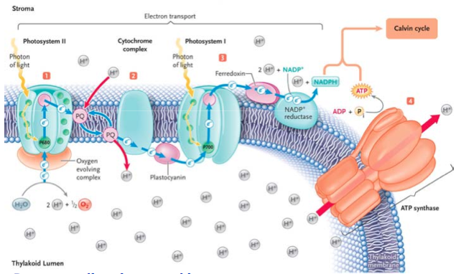

Cyclic Photophosphorylation: Photosystem 1 only, produces ATP only

Photophosphorylation and chemiosmosis:
- Chemiosmosis how phosphorylation of ADP occurs in photosynthesis
- Light energy drives chemiosmosis photophosphorylation
  - Cytochrome complex H+ pumped to inside of thylakoids during e- transport b/t photosystems
  - [ ] gradient builds, pmf created across thylakoid membrane H+ move to stroma through ATP synthase
  - Energy from H+ moving through ATP synthase produces energy to phosphorylate ADP
  - Water also split into O2 and protons

Light-independent rxns:
- Calvin cycle:
  - Carbon fixation:
    - CO2 in stroma (entered by diffusion) reacts with 5-C sugar (RuBP)
      - Result: 6-C compound
      - Catalyzed by rubisco
    - 6-C splits into 2 glycerate 3-phosphate
    - Glycerate 3-phosphate reduced to 3-C sugar (triose phosphate)
      - Energy required provided by ATP/NADPH + H+
    - Regeneration of RuBP essential:
      - 5 triose + ATP 3 RuBP
      - **Cyclic surplus ATP satisfies higher demand for ATP in Calvin cycle Net expenditure, 9 ATP, 6 NADPH for each 3-C sugar made

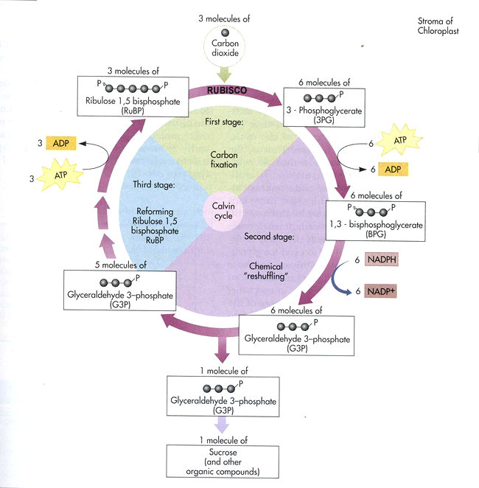

Light Dependent Reaction | Light Independent Reaction
In thylakoid | In stroma
Light energy ATP and NADPH | ATP and NADPH triose phosphate
Photolysis: splits water to provide replacement electrons + H+ also releases oxygen to the atmosphere | Returns ADP, inorganic phosphate and NADP to the light dependent reaction
Photosystems l and ll + two electron transport chains | Calvin cycle
Noncyclic e- flow Produces ATP and NADPH in roughly equal amounts
Calvin cycle Consumes more ATP than NADPH
Cyclic e- flow allows chloroplast to generate surplus ATP to satisfy Calvin cycle demand

Features of chloroplast:
- Stroma:
  - Contains many enzymes
    - Rubisco
  - Important for the reactions of the Calvin cycle.
- Thylakoids:
  - Large SA for light absorption
  - Space within allows rapid accumulation of protons
- Double membrane:
  - Isolate contents
  - Separate from chemically different contents of cell

Action spectrum:
- Shows rate of photosynthesis (for each wavelength of light)
  - Lowest rate: Green
  - Good rate: Red-orange
  - Best rate: Violet-blue
Englemann experiment: light shone through prism at Spirogyra, aerobic bacteria clustered in areas where the oxygen concentration was highest, corresponded to wavelengths that were absorbed most in photosynthesis

Absorption spectrum:
- Shows % of light absorbed by pigments in chloroplast (for each wavelength of light)
  - Least absorption: Green reflected
  - Good absorption: Red-orange
  - Best absorption: Violet-blue

Spectrums = closely related
Difference: no absorption of green-yellow, but still photosynthesis thanks to accessory pigments (like carotene)

Limiting factors in photosynthesis:
- Only one at a time furthest from optimum level at particular time
  - Example: night = light intensity, day = temp or CO2 [ ]
- Light intensity:
  - Shortage of ATP and NADPH
    - Products of light-dependent rxns light-independent rxns can’t occur bc glycerate 3-phosphate can’t be reduced
- Temperature:
  - Enzymes work slower @ low temp
  - Enzymes no longer effective @ high temp
    - Calvin cycle rate of rxn slows
- CO2 [ ]:
  - Low glycerate 3-phosphate limited

Photorespiration: O2 binds to RuBP instead of CO2 (competitive inhibition), increases with temperature produces 2-C sugar that takes ATP to convert to CO2 which is lost AKA WASTEFUL, can occur 25% of the time
- Aquatic plant solution:
  - Inorganic carbon pump
  - Aquatic systems
  - HCO3- to begin with instead of CO2
  - ATP dependent pumps create [ ] gradient of high HCO3- in cell, rapidly converted to CO2 in cytosol by carbonic anhydrase
- C4 plant solution pathway: malate pyruvate creates higher [CO2], suitable for hot, dry climates
  - CO2 combines with 3-C molecule (PEP) intermediate oxaloacetate
  - Oxaloacetate then reduced to malate by e- from NADPH
  - Transported into Calvin cycle and oxidized to pyruvate, releasing CO2
  - PEP returned from pyruvate + ATP
  - Also don’t have to keep their stomata open as long which reduces water loss
- CAM plant solution temporary separation of C4 and Calvin cycle, ie. Cactus with low SA:V, less stomata
  - Stomata only open at night
  - Release O2 and take in CO2
  - CO2 fixed to malate by C4 pathway, accumulates over night in vacuoles
  - Sun comes up, stomata close meaning less water loss and no gas exchange
  - Malate diffuses into cytosol, oxidized to pyruvate, high [CO2] released
  - Calvin cycle proceeds
  - Pyruvate produced in day accumulates then used in C4 at night

 | Photosynthesis | Cell Respiration
Where | In plants only | In both plants and animals
Reactants | CO2, H2O | O2, glucose
Products | O2, glucose | CO2, H2O
Phosphorylation | Photophosphorylation | Oxidative phosphorylation
ATP synth | Chemiosmosis | Chemiosmosis
G3P | Product of Calvin cycle, used in anabolic pathway | Intermediate in glycolysis, product of catabolic pathway

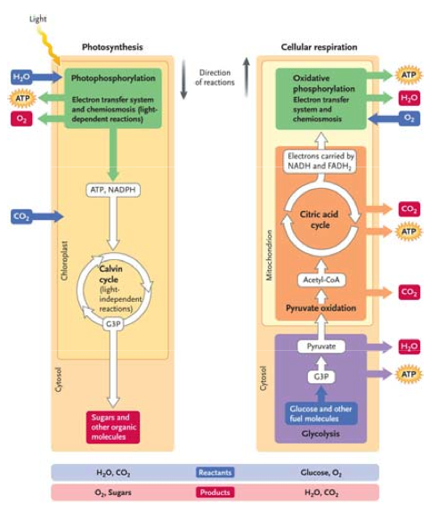
Nucleotide:
- Sugar: deoxyribose
- Base
- Phosphate group
Bases:
- Adenine
- Guanine
- Cytosine
- Thymine
Linkage of DNA nucleotides:
- Covalent bond formed between sugar of one nucleotide, phosphate group of another.
Double helix:
- 2 nucleotide strands
  - Connected by covalent bond
- 2 strands themselves connected by H-bonds between bases of strands
- A T, G C

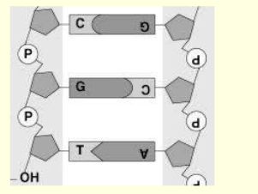

DNA Structure:
- 2 strands
  - One end: phosphate group attached to carbon atom 5 of deoxyribose (5’ terminal)
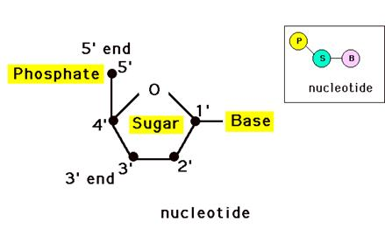
  - Other end: hydroxyl group attached to carbon atom 3 of deoxyribose (3’ terminal)

- Strands run in opposite directions
  - Antiparallel
- Adjacent nucleotides attached together via bonds between phosphate group of one and C3 of deoxyribose of other.
- Bases link with H bonds
  - A and G = purines 2 rings
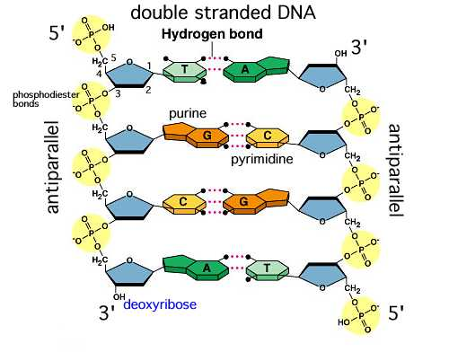
  - T and C = pyrimidines 1 ring
  - AT 2 H-bonds
  - GC 3 H-bonds

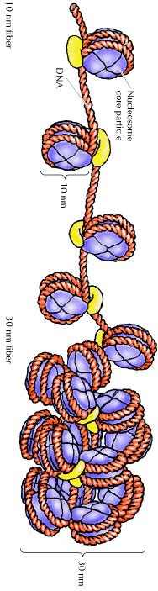
Nucleosomes:
- Forms histones to help coil up and fit inside nucleus.
- 2 molecules each, 4 different histones
  - DNA wrapped around 8 histones twice
- Negative charge DNA attracted to positive charge histones
- One DNA strand links nucleosomes
- 5th histone attached to help wrapping

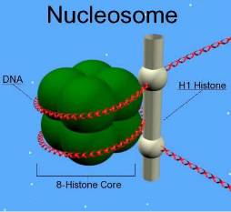

Nucleosomes help to supercoil chromosomes and regulate transcription.

Piece of DNA encodes a product mRNA (intermediate, final protein), tRNA and rRNA (final)

Not all base sequences in DNA translated:
- Genomes:
  - Highly repetitive 5-200 bases repeated up to 10 000 times
    - 5-45% of euk DNA
- Unique genes translated only small portion of euk DNA
- Regions of chromos encode RNA products with regulatory function:
  - snRNA premRNA splicing
  - snoRNA modification of other RNA (rRNA, tRNA, snRNA)
  - siRNA, miRNA, piRNA regulation of gene expression, mostly silencing
  - lncRNA regulates gene expression

Euk genes contain exons and introns
- Exons: fragments of genes coding regions
- Introns: fragments of genes non-coding regions
  - Used in transcription and translation

Replication:
- Semi-conservative both DNA molecules produced formed from an old strand and a new strand
- Unwinding of double strand breaking H-bonds between bases
  - Enzyme helicase, topoisomerase counteracts over-twisting
- Separate strands templates for new strands
- Free nucleotides form H-bonds with complimentary base pairs on template strand
  - DNA polymerase
- New DNA strands rewind into double helix
- New DNA strand identical to initial one

Complementary base pairing:
- Conservation of base sequence:
  - A T, CG ensures each new strand is complementary to template
  - Ensures 2 identical DNA molecules formed from identical parent strand

DNA replication is semi-conservative.

DNA Replication: 5’ 3’ direction
Prokaryotic DNA Polymerases 500 nucleotides/second
Euk DNA polymerases 50 nucleotides/second

DNA Replication:
- Initiated at an origin (one in proks, 100s of 1000s in euks replication forks)
- Enzyme helicase uncoils DNA double helix
  - Creates template strands
- Topoisomerase helps relieve tension ahead of replication forks caused by overtwisting ahead of DNA helicase
  - Single-stranded binding protein keeps strands from rewinding
- RNA primase adds short sequence of RNA to template strand
  - RNA acts as primer for DNA polymerase III to bind (10-15 nucleotides long)
- DNA polymerase III adds nucleotides to template strands (5’ 3’ direction)
  - Nucleotides have 3 phosphate groups deoxyribonucleoside triphosphates
  - 2 phosphate groups break off to release energy
- Antiparallel strands means only 5’ 3’ replication possible
  - Leading strand: goes with replication fork
  - Lagging strand: replicated in Okazaki fragments in opposite direction
    - RNA primer at the start of each fragment
- DNA polymerase I removes RNA primers + replaces them with DNA
- DNA ligase joins Okazaki fragments together to make continuous strand
  - Forms sugar-phosphate backbone new strand of DNA
  - Primase DNA polymerase III carries out synthesis extending from primer next fragment encountered, DNA polymerase I removes RNA primer and replaces with DNA nucleotides DNA ligase joins 2 strands by forming phosphodiester bond (seals nick)

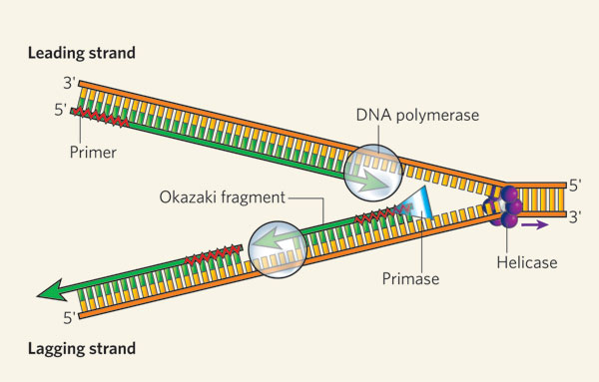

DNA replication initiated at many points in euk chromosomes.

DNA polymerase:
- Includes clamp loader, beta sliding clamp holding core polymerase
- In bacteria: DNA polymerase III
- Tus protein impedes DNA helicase (leaves 2 concatinated double helices, topoisomerase nicks and decatenates them)
- Proof-reading polymerase checks results, removing incorrect nucleotides

Euk chromos have highly repetitive noncoding DNA (telomeres) on ends, capped by a number of proteins to protect them
- Part of the buffer lost every replication because the telomere is a closed loop
- Telomerase elongates at 3’ end of top strand, carries its own template
- Primer added and new end replicated, again leaving single stranded region from primer removal
- Telomerase generally active in fast dividing cells, not in many somatic cells so the shortening of telomeres results in limited number of divisions before death
- Telomerase reactivated in cancer cells

DNA | RNA
5 carbon sugar deoxyribose | 5 carbon sugar ribose
Thymine | Uracil instead of thymine
Double helix | Single strand
1 type | 3 types: m-RNA, t-RNA, r-RNA
Can’t leave the nucleus | Leaves the nucleus
Much longer | Shorter strands

DNA Transcription:
- Formation of mRNA strand complementary to DNA strand
- Uncoiling DNA double helix
  - RNA polymerase
    - Makes RNA by joining ribonucleotide monomers together
    - 1 type in prokaryotes
    - 3 types in euks
      - I makes some rRNA
      - II makes mRNA
      - III makes tRNA and some rRNA
- Free RNA nucleotides form RNA strand using DNA template strand
  - Complementary base paring thymine replaced with uracil
- Strand elongates then separates from DNA template
- Template reforms double helix

Initiation:
- Promoter: region of DNA that includes site where RNA polymerase binds, RNA polymerase loaded onto promoter by variety of transcription factors
  - Contains initiation site, site +1
  - Recognition sequence:
    - Euk: TATA box, -25 to 30 bases upstream (left, negative direction) from initiation site
    - Prok: Pribnow box, -10 bases upstream from initiation site (often have a -35 box too)
- RNA polymerase binds and separates DNA: pops on first nucleotide that corresponds to the +1 site and continues to move along adding to the 3’ end, 30-60 nucleotides/sec. 5’ end hangs free from RNAP, duplex rewinds behind RNAP
A U, TA, CG
Termination sequence reached, signals RNAP to release RNA and dissociate from DNA
- mRNA palindrome structure (loopy things formed in mRNA at end of transcription with high G-C bonds, binds to itself rather than the DNA)
- RHO termination, RHO translocates toward 3’ end of transcript and pushes RNAP off dissociating RNA

Prok transcription/translation occur simultaneously

Euk Transcription start, pre-mRNA translated, cap and tail, splicing out introns

Exons: sequences of gene that are transcribed into RNA and encode a protein
Introns: sequences transcribed into RNA but are subsequently excised during processing
Pre-mRNA: primary transcript of euk gene, 5’ cap and 3’ polyA tail
- 5’ cap: allows export mRNA from nucleus, protects mRNA from degradation by nucleases, translation initiation
- Tail: promotes export of mRNA from nucleus, protection from degradation, influences translation efficiency
  - Polyadenylation signals termination of transcription

Introns allow a single gene to give rise to multiple different proteins through alternative splicing
- 100,000 distinct proteins are produced by genes from only 20,000 protein coding genes
- a-tropomyosin gene in humans produces different isoforms that are used in skeletal and smooth muscles
  - Skeletal: no 2 or 12
  - Smooth: no 3, 10 or 11

RNA Splicing:
- Introns removed from pre-mRNA by snRNPs, small nuclear ribonuclear proteins
- snRNA + protein

tRNA transcribed from DNA duplex (tRNA genes)
- AUGC, and some modified bases
- 80 nucleotides long

Aminoacyl-tRNA sythetase for tRNAs for each different amino acid
- Attaches correct amino acid to 3’ end of appropriate tRNA molecule, creates an activated tRNA

Codons:
- Codon = triplet bases
- Codes for particular amino acid, 64 total
  - 61 for AAs, 3 for stop
  - Genetic code degenerate, more that 1 codon per amino acid
- Amino acids link to form proteins
  - DNA/RNA regulate protein synthesis
Genetic code = codons within DNA and RNA composed of triplets of bases

tRNA:
- Different types, each recognised by tRNA-activating enzyme
- Enzyme binds specific amino acid to tRNA using ATP
- tRNA has specific structure double stranded section (base pairing H-bonds) and loops
- Anticodon loop contains anticodon + 2 other loops
- Nucleotide sequence CCA for @ 3’ end attaches to amino acid
- Each has slightly different chemical properties and 3D structure so activating enzyme can attach correct amino acid
  - 20 different enzymes 20 different amino acids
- Enzymes attach specific amino acid to tRNA with matching anticodon creating high energy bond later used to bind amino acids to polypeptide chain
  - ATP used

rRNA: also AUGC, forms complex with protein to form ribosomal particles
- Large subunit:
  - PROKS 2 different rRNA+ 31 different proteins
  - EUKS 3 different rRNA (more bases)+ 49 different proteins
- Small subunit:
  - PROKS 1 rRNA+ 21 proteins
  - EUKS 1 rRNA (more bases) + 33 proteins
- Combine during protein synthesis
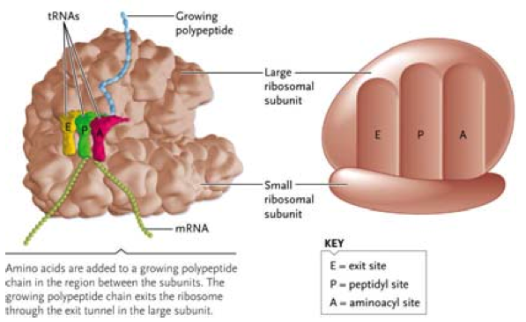

Translation consists of:
- Initiation
- Elongation
- Translocation
- Termination

Translation:
- Initiation:
  - Ribosome recognition
    - PROKS specific sequence
    - EUKS 5’ cap, then AUG start with Met-tRNA which binds to small subunit
      - GTP joins, subunit complex binds to 5’ cap, scans mRNA
      - Large unit placed on, GTP hydrolyzed, elongation begins
- Elongation:
  - tRNA enters A site,
  - Large subunit enzyme activity catalyzes peptide linkage
  - Translocation along mRNA, tRNA at P released, A moves to P
- Termination:
  - Stop codons: UAG, UGA, UAA
  - Release factor binds, stimulates peptidyl transferase
  - Peptide release rom tRNA at P site
  - Ribosome subunits separate and move away from mRNA
- Polysomes multiple ribosomes attached to one mRNA strand multiple proteins
- Free ribosomes synthesize proteins for use within cell
- Bound ribosomes synthesize proteins for secretion/lysosomes

Pairing strict for tRNA @ first 2 positions, relaxed at 3rd position (because multiple codons code for the same amino acid)
- A U
- U G or A
- C
- G U or C
- I U, C or A, I occurs from deamination of G, double bond forms
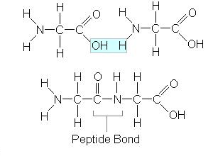

The protein that is translated includes information encoded by the primary sequence:
- Folding
- Structure
- Function
- Degradation
- Post-translational modification
  - i.e. addition of sugars to form glycoproteins
  - Cleavage i.e. initiating Met; single peptide
- Location targeted to a certain location

Protein targeting:
- Translation of all proteins initiated by free ribosomes
- If amino terminus of protein has a signal sequence (sequence of AAs bound by Signal Recognition Particle) then ribosome binds to ER
- When binds to receptor, translation starts again which means the complete polypeptide will be released into lumen of ER
- Membrane bound protein: membrane spanning domain, hydrophobic = integral membrane proteins
- Secreted cisternal proteins: packaged into vesicle and secreted

Signal sequence?
- Yes bound polyribosomes, signal sequence, protein has other targeting sequences to allow vesicular sorting to appropriate organelle
  - ER
  - Golgi
  - Lysosomes
  - PM
  - Secretion
  - Nuclear envelope
- No Free polyribosomes, protein has other sorting sequences to facilitate sorting
  - Mitochondria
  - Nucleus
  - Chloroplasts
  - Peroxisomes
  - Cytosol default location

Rubisco:
- 8 subunits of small and large polypeptide chains
- Small subunit chains encoded in nucleus, targeted to chloroplast post-translationally
- Large subunits encoded in chloroplast genome

In Prokaryotes:
- Genes contained in operons (cluster of adjacent genes with related function)
- mRNA may contains more than one peptide coding sequence (polycistronic)
- Translation can begin during transcription
Transcription/RNA processing in cytoplasm

EUKS:
- Transcription and RNA processing in nucleus, translation in cytosol
- mRNA only has info for one polypeptide monocistronic

Mutations:
- Silent mutation no change in final amino acid
- Missense mutation change in amino acid, doesn’t necessary change function of protein
- Nonsense mutation introduces premature stop codon, causes shorter protein and missing AAs @ carboxyl terminus
- Frameshift mutation insertion/deletion of base pairs, changes reading frame, all info after mutation is altered (significant alteration in protein)

Familial Hypercholesterolemia (FH)
- High blood cholesterol
- Genetic disease
- LDL receptor mutated
- Normal: 2-3.4 mmol/L
  - May be elevated due to diet/other metabolic factors
- Homozygous FH patients 12
- Hetero 5-12
- Common consequence: elevation of serum cholesterol atherosclerosis
- Clinical symptoms usually develop before age of 10 in homo,
- B/t 25 and 30 for hetero, managed with diet and drugs (statins)
  - Lipid deposits (xanthomas) with high LDL plasma levels
- LDL receptor gene: Chromo 19
  - 90% of gene is introns that are spliced out of pre-mRNA to for mRNA forms protein with 860 AAs
- Has signal sequence Synthesized on bound ribosomes
  - Inserted across membrane until membrane retention sequence is reached integral membrane protein
  - Modified by sugars during transit from ER to Golgi to secretion vesicles
  - Secretion vesicle fuses to PM, receptor remains in membrane with N-terminus extracellular and C-terminus cytoplasmic
  - LDL receptor recycled

Not having LDL receptor:
- Cholesterol not brought into cell, therefore cell synthesizes more cholesterol
- Increased LDL in extracellular fluid results in increased probability of developing atherosclerotic plaques

Cell cycle:
- Interphase: initial period of cytoplasmic growth, chromos loose and organized in nucleus
  - G1 (gap phase 1) cell grows, cells spend most of their time here
  - S synthesis, genome replicates
  - G2 more growth, separates replicated genome, each chromo has 2 sister chromatids attached at centromere condense, spindle fibres assemble from tubulin at centrosomes
- Mitosis:
  - Prophase
  - Metaphase
  - Anaphase
  - Telophase
- Cytokinesis:
  - Cytoplasm divides
  - Creation of 2 daughter cells
    - Animal: cell is pinched
    - Plant: plate formed

Tumors:
- Uncontrolled cell division
- Any organ or tissue in any living organism

Mitosis:
- Prophase
  - Supercoiling of chromos
    - Visible under microscope
  - Centrioles to opposite poles
  - Spindle fibres appear
  - Nuclear membrane disappears
- Prometaphase
  - Nuclear envelope fragments
  - Microtubules interact with kinetochores at centromere of chromos, nonkinetochore interact with each other
- Metaphase
  - Chromatids align, spindle fibres attach to centromeres (kinetochore microtubules) nonkinetochore do not attach to chromos
  - Kinetochores of sister chromatids attached to microtubules from opposite poles (so they can be separated)
- Anaphase
  - Centromeres break, sister chromatids (chromosomes) to opposite poles
  - Nonkinetochore microtubules move against each other to elongate cell
- Telophase
  - Nonkinetochore microtubules continue to elongate cell
  - Nuclear membrane + nucleolus reform
  - Chromos chromatin (less visible), decondense and genes become active (especially rRNA)
  - Spindle fibres disappear, apparatus dismantled, used to reassemble cytoskeleton
        - Cytokinesis division (cleavage furrow/cell walls)
  - Plant cells vesicles added to layer until it extends across cell, vesicles fuse together dumping contents into gradually expanding wall b/t daughter cells until the full wall is formed

Mitosis 2 genetically identical nuclei
- DNA replication chromos produces identical copies (chromatids)
- Chromatids separate copy of each chromo in each daughter cell

Growth: increase in SA and volume of cell
Tissue repair: cells divide to replace damaged/lost cells
Asexual reproduction/ embryonic development: single celled organisms reproduce via mitosis

Cyclins and cyclin-dependent kinases regulate cell division:
- Internal checkpoints stop the cell cycle if stages are incomplete
- External controls coordinate mitotic cell cycle of individual cells depending on the organism’s requirements
  - CHECKPOINT: G1s, only go thru with resources to go all the way through S phase
    - CDKS add phosphate groups to target proteins after cyclin activates it
    - Cyclin E reaches high enough [ ] to form complex with CDK2 which phosphorylates target proteins triggering S phase
    - Cyclin E then degraded and won’t rise until after mitosis occurs
  - Cyclin indicates cell is ready for S phase
  - SECOND: G2/M (rest phase)
    - M cyclin binds to CDK1

Prokaryotes:
- Most have single circular DNA molecule (bacterial chromo)
- Replication occupies most of cell cycle, starts at origin, proceeds in opposite directions, replicated origins migrate to opposite sides of cell
- Replicated chromos distributed actively to halves of cell
- Binary fission division inward growth of PM, new cell wall material assembled

Control of Gene Expression:
- All somatic cells in organism are genetically identical differentiate by gene expression
- Main control: transcribed into mRNA
- Additional controls: posttranscriptional, translational and posttranslational

PROKS expression reflects life history, bacteria respond rapidly and reversibly to their environment
- Operons: cluster of PROK genes and DNA sequences involved in regulation, promoter for entire operon, many genes transcribed as a transcription unit (polycistronic mRNA)
- Operator: regulatory protein coded by gene outside of operon
- Repressor: prevent operon genes from being expressed
- Activator: turn on expression from operon genes

Lac Operon for Lactose Metabolism:
- Operon= lacZ, lacy and lacA+ regulatory sequences
- Operator b/t promoter and lacZ
- Lactose absent:
  - Lac repressor stops operon expression
  - Encoded by lacI, synthesized in active form
  - Binds operator to prevent transcription
- Lactose present:
  - Permease molecules transport lactose into cell
  - B-galactosidase in cell convert it to inducer allolactose
  - Allolactose binds to lac repressor to inactivate it
  - RNA polymerase binds to promoter and transcription and translation of operon occur
- Positive regulatory system:
  - Operates with lactose present, but absence of glucose
  - Glucose more efficient energy source so there’s no point to use lactose
- Low glucose:
  - Lac repressor inactive
  - cAMP synthesized, binds to CAP activator
  - Activated CAP binds to CAP site in promoter
  - RNA polymerase binds efficiently
  - Genes of operon transcribed to high levels
  - Translation produces high amounts of enzymes
- High glucose:
  - Lac repressor inactive, but so is cAMP and CAP
  - RNA doesn’t bind efficiently to promoter
  - Low level transcription

trp Operon:
- Default state of operon is expression, repressor is inactive
- Tryptophan activates repressor (hence corepressor)
- trp= repressible operon like lac
lac= inducible, trp requires co-represson

In Euks:
- Problem= packaging of DNA in chromatin not all genes can be accessed, must be remodelled
- Gene organization allows regulation
  - Promoter proximal region upstream of promoter, increase transcription rate
  - Enhancer further upstream, determines max transcription rate
  - Activators bind to promoter proximal elements and increase rate
  - General transcription factors initiate transcription, bind to TATA box, recruit RNA polymerase II (like PROK)
  - Coactivators bridge enhancer and promoter, high level increase
  - Activators also bind to enhancer elements
  - General transcription factors: initiate transcription
    - Bind to TATA box area, recruit RNA polymerase II
    - Creates transcriptional initiation complex, only good for low rate
  - Repressors oppose effect of activators:
    - Transcription rate depends on activation and repression of signals
    - May bind to sites of activator or co-activator, or increase association with histones to limit the rate
  - Combinatorial Regulation:
    - Allows limited number of activators/co-activators/repressors in different combos to control an unlimited number of genes
    - For genes with related functions, will respond to one signal
- Hormones:
  - Produced in one tissue, transported to another
  - Activate all cells with specific hormone receptors
  - Receptors activate genes with related functions thru presence of similar regulatory elements upstream from gene
- DNA methylation adds –CH3 to cytosine gene silencing, makes region extremely condensed (heterochromatin), transcriptionally inactive

Gene expression can be regulated post-transcriptionally using microRNA
- miRNA genes transcribed and processed by specialized proteins
- Mature miRNA can regulate mRNA stability or translation of mRNA
  - Pre-miRNA
    - Base pairing occurring from opposite ends of same strand creating a hair pin loop
    - Hair pin loop diced by dicer leaving double strand miRNA
    - One strand lost, other interacts with mRNA
    - This complex can block translation/degrade the mRNA more quickly than it would without it

Translation regulation control rate that protein synthesis occurs and extent of translation
- mRNA with longer poly(A) will produce more proteins
- Enzymes that shorten or lengthen poly(A) tail length affect extent of translation
Many proteins degraded by large enzyme complex proteasome
- Proteins have specific sequences causing tags to be added (ubiquitin)
- Tags recognized by proteasome and broken down

Insulin synthesis controlled post-transcriptionally
- Conversion of preproinsulin to proinsulin by cleavage of signal peptide
- Converson of proinsulin to mature insulin by cleavage of C-peptide

Meiosis: sexual reproduction, haploid cells
- Fertilization 2n, meiosis n, mitosis maintain n, fertilization again

Different euk organisms have different life cycles that involve alternation of haploid and diploid phases

Genetic variation:
- PROK mutation major mech of genetic variation
- EUK small mount of genetic variation due to rare mutations, trillions of cells

Meiosis:
- Interphase:
  - G1
  - S
  - G2
- Meiosis I:
  - Prophase I:
    - Chromos coil up tightly visible
    - Chromos pair up (synapsis) homologous pairs (tetrad)
      - Crossing over @ chiasma exchange of genetic material b/t non-sister chromatids
    - Nuclear membrane breaks down
    - Centrioles/centrosomes travel to poles
    - Nuclear envelope frags/spindle fibres invade nuclear space, attach to kinetochores-chromos move to metaphase plate (prometaphase)
  - Metaphase I:
    - Homologous chromos (tetrads) align
    - Tension created by microtubules keeps homochromos at plate
  - Anaphase I:
    - Tetrads separated, pulled to opposite poles by shortening spindle fibres
    - Chromos still sister chromatids, one chromo from each pair at opposite poles
  - Telophase I:
    - Chromos uncoil slightly
    - Cytokinesis
    - May have nuclear membrane/nucleolus reformation
    - First meiotic spindles dissemble, second begin to assemble
    - May enter brief Interphase no replication
- Meiosis II:
  - Prophase II:
    - Chromos recoil
    - Centrioles move to poles
    - Nuclear membrane disintegrates
  - Metaphase II:
    - Spindle fibres attach to centromeres
    - Chromos align
  - Anaphase II:
    - Fibres shorten
    - Centromeres split
    - Chromatids to opposite poles

  - Telophase II:
    - Nuclear membrane forms around chromatids @ each pole
      - Chromatid chromosome
    - Cytokinesis
    - Chromos uncoil
    - Nucleoli form/nuclear envelope forms
- Result: 4 haploid daughter cells

Infinite Genetic Possibilities:
- Crossing over:
  - Prophase I
    - Exchange of genetic material
    - New combos of alleles
      - Recombinants different allele combo than either parent
    - Occurs @ a random point + more than one chiasma is possible
- Random orientation (independent assortment)
  - Metaphase I
    - Maternal/paternal chromos can orient toward either pole
    - 2²³ possible outcomes
- Combo of chromos during fertilization (2²³)² possibilities excluding crossing over

Phototrophs synthesize their essential macromolecules grown on minimal media
- Mutations can make them unable to survive on minimal media auxotrophs
- Some can recombine if DNA sequences are very similar
  - Transformation take up frags/plasmids of DNA
    - Plasmids can replicate autonomously in recipient
    - Frags integrated into chromosome by recombo
    - Bacteria that do this= competent
  - Conjugation
    - Transfer DNA from one bacterium to another
    - Donor cell need F factor (fertility plasmid)
    - F+ = donors, F- = recipients without
    - Sex pilus cytoplasmically connect F+ and F-
    - F- converts to F+ after receiving and synthesizing new DNA
    - Hfr cells integrate F factor into bacterial chromo thru recombo
      - Can conjugate with F-
    - Recipient becomes partial diploid, crossing over
  - Transduction
    - Bacterial phages (viruses) transfer DNA from one bacteria to another
    - Virus incorporates DNA frags from host cell
    - If homologous, bacteria partial diploids
    - Recomb
  - Special transduction when phage excises imprecisely from bacterial chromo and takes chromo bits with it, bits can recomb with bacterium
- Abilities allow bacteria to diversify and acquire beneficial characteristics (resist antibiotics)

Mendel:
- Quantitative analysis of pea pollination
  - Self pollination pollen from stamens land on carpel of same plant
  - Cross pollination pollen from plant transferred to carpel of another plant

Character detectable inheritable feature of an organism
Trait variant of an inheritable character
True breeding self fertilization, offspring/parents identical
Monohybrid cross examine inheritance of a single character (ie. Flower colour)
Locus: position of gene on homo chromos
Allele different variants of a gene
Codominant alleles: pairs that both affect phenotype in heterozygote

Conclusions:
- Different traits come from 2 forms of a gene
- Each parent contributes one factor
- 2 alleles differ, one is fully expressed and other is fully masked
  - Dominant allele: same effect on phenotype in homo/heterozygous state
  - Recessive allele: only has effect on phenotype in homozygous state
- During gamete production, 2 alleles segregate
  - True breeding gametes are the same
  - Different genes 50% chance of gamete receiving recessive allele

Genotype: alleles of an organism
Phenotype: characteristics of an organism

Homozygous: 2 identical alleles of a gene
Heterozygous: 2 different alleles of a gene

Test cross: testing for heterozygote by crossing with a know homozygous recessive
Dihybrid cross Characters segregate dependently or independently?
- Dependent: RrYy+ RrYy RRYY, RrYy, RrYy, rryy
- Independent: 9:3:3:1
- Result: random arrangement

Without Punnett Square:
- With Pp, 50% prob gamete will be P, 50% p
- Probability gamete containing an allele is independent of prob that another gamete will contain it
  - Independent events multiply their probabilities
  - If it can occur in 2+ different ways add probs

Dominance doesn’t mean:
- Subdues recessive trait
- Trait is good or bad
- Trait is common or uncommon

Incomplete dominance Red, white, pink flower colours
Codominance different alleles have equal effects in heterozygotes (ie. Blood type M and N)
Multiallelism ABO blood system
- AB antigens added stepwise, starts with fucose, adds A antigen, adds B antigen
- A/B genes code for transferase enzyme with slightly different activity
- O doesn’t encode active enzyme
- If recipient of blood doesn’t have A chain, antibodies will be formed against it
- I^{A}I^{B}= universal recipient, ii= universal donor
Rh(D) Antigen:
- RH gene on short arm chromo 1
- Encodes membrane protein
- Dd and DD= Rh(D)+, dd=negative
- Negative exposed to positive blood, anti-D develops
- If second baby is positive and mother is negative, anti-D developed, mother’s antibodies will fight against baby’s blood

Epistasis gene at one locus alters phenotypic expression of a gene at another locus
- Coat color BB or Bb=black, bb= chocolate brown
- But these colours only expressed when second dominant gene E is active
- Homozygous recessive ee will be yellow

Polygenic inheritance when phenotypic traits influence by activity of several genes continuous variation, skin colour, height, etc.

Pleiotropy When one gene affects more that one character
- Sickle cell anemia
  - Recessive allele affects haemoglobin structure and function
  - Leads to blood vessel damage
  - Damages many tissues and organs
  - Many different symptoms result

Drosophilia (fruit fly) only 4 pairs of chromos, hundred of offspring, 2 weeks to breed
- Red vs. White eye colour gene on X chromo
  - White w, mutant, recessive
  - Red w+, wild type, dominant
  - If mutant dominant uppercase Ws
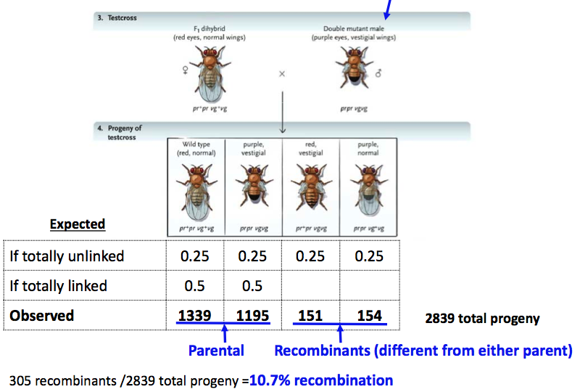
Recombination:
- Amount of recomb b/t genes reflects distance b/t them
  - Greater distance, more sites for recomb
  - Less distance, less sites for recomb
- 50% recomb is maximum, further apart means they are unlinked
- Frequency is not uniform along the chromo
- Can have multiple crossovers which require mathematical correction

Carrier: has 1 recessive allele that causes genetic disease in individuals that are homozygous for this allele
- Female carriers for X-linked recessive alleles:
  - Always heterozygous
  - Carrier will either pass dominate or recessive allele

Human Disorders:
- Autosomal Recessive Disorders gene produces malfunctioning/non-functioning protein, only aa expresses disorder
  - Albinism
  - Attached earlobes
  - Cystic fibrosis
  - Tay-Sachs
  - Sickle cell anemia
- Autosomal Dominant Hh is afflicted, HH lethal before birth, must not be lethal until after afflicted individual have chance to reproduce, otherwise not passed on
  - Free earlobes
  - Ealy balding in males
  - Huntington disease
  - Polydactyl
- Sex Linked Disorders
  - Most associated with X because there are more genes
    - Haemophilia:
      - Gene carried by X chromo
      - Female has 2 X chromos so it can be masked by other
        - Inactivated chromosome becomes Barr body
        - Random, occurs in early development
- Aneuploidy:
  - Non-disjunction
    - Anaphase I or anaphase II: chromos do not separate properly
    - Leads to gametes with too many or too few chromos
    - Usually die quite fast when missing chromo
    - With extras can survive
      - Down syndrome:
        - Trisomie 21 3 chromosome 21 instead of 2
        - 47 total chromos instead of 46
        - Leads to complications
  - Sex chromos:
    - XXY, XXX, XYY, X0
    - Not as impaired because autosomes alter more genes, but many alterations to XY chromos are lethal so they are not seen in living beings
    - Extra copies of X are inactivated
    - Main symptoms involve secondary sex characteristics, some mental and growth retardation, sterility

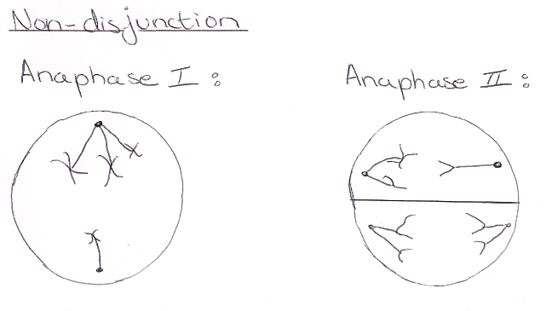

Pseudoautosomal regions: X and Y chromos pair and recombine
- 24 genes PAR1 at top
- 5 genes PAR2 at bottom
- Escape X inactivation, similar to autosomes (2X instead of 1X)

Polyploidy more tha diploid set of chromosomes
- Triploid: nondisjunction of all chromos in meiosis II 3n zygote
- Tetraploid: nondisjunction in mitosis 4n zygote
- Rare in animals, common in plants
- Doesn’t alter genetic balance, just extra copies of same genes
- Unlike aneuploidy which alters balance

Extranuclear Inheritance:
- Mitochondria/chloroplasts have some DNA/make some of their own proteins
- Most are encoded in nucleus and imported after translation to cytosol on free polyribosomes
- Traits encoded in mitochondria inherited maternally

Genomic Imprinting:
- Expression of allele determined by the parent that contributed it either the allele from the mother or father is expressed and the other is silenced due to methylation of region adjacent to gene

