BIOL 3306 Oct. 16, 2012
Lecture Topic 4

Case Study
- Apply what you’ve learned in class up until this point using precise language and terminology
- Your case study report should have your name, student number and a title
- Minimum of 900 words no more than 1500 double-spaced. Font should be Times New Roman
- Feel free to use images (won’t count towards your word limit)
- Use appropriate peer reviewed sources
- Patient X is diagnosed with Primary Progressive MS at the age of 42 after presenting with symptoms for 1.5 years. Symptoms include blurred vision, numbness of the right side of the body, trouble walking, unsteadiness, and progressive weakness in the arms.
  - Using research and what you have learned in class describe the anatomical and physiological changes in the nervous system of Patient X that would result in the above symptoms
  - How does PPMS differ from other forms of MS and what might this mean about changes occurring in the nervous system of patients?
  - What would be an appropriate course of treatment, in Canada, for Patient X and how, in general, does PPMS progress over time?
  - Of the UTMOST importance, they key to writing a successful case study is to apply what you have learned in class. Do not be tempted to use complex medical terminology or jargon that you find during your research- explain it in your own words
- Due Date: November 6th

Nervous System 2: The Spinal Cord
Chapter 12

Class Objectives
- Discuss the anatomical features of the spinal cord
- Explain the roles of white matter and gray matter in processing and relaying sensory information and motor commands
- Describe the major components of a spinal nerve and the rami associated with spinal nerves
- Relate the distribution pattern of spinal nerves to the region they innervate and their function
- Describe reflexes and neural circuits

Functional Perspective for Studying the CNS
- Gastrointestinal tract has more neurons than the spinal cord HOWEVER the importance of the neurons in the spinal cord is unparalleled

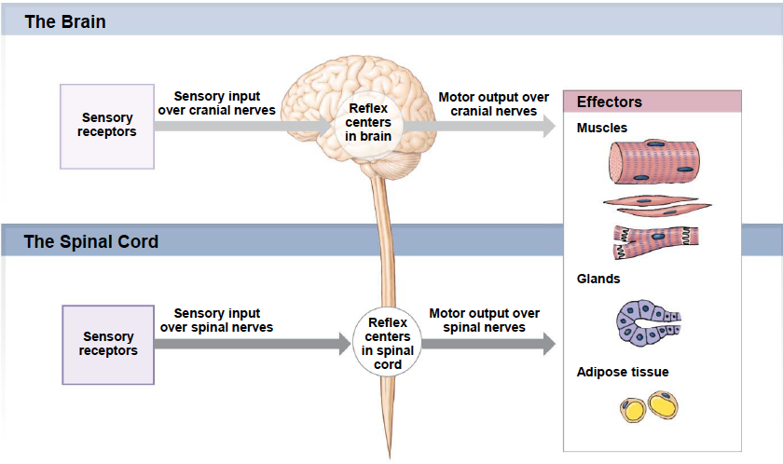
- Sensory input comes in (whether through cranial or spinal nerves) and hits reflex centers in the CNS where the information is processed, prioritized and distributed
- Vast majority of sensory input you are unconscious of
- Spinal cord much more basic simplex distribution center
  - In charge of:
    - Sending ascending signals (up to the brain- simplex reflex or for conscious perception)
    - Movement

Spinal Cord Functional Anatomy
Development
- In transverse section we see SYMMETRY if you make a sagittal cut BUT with a frontal section there is significant REGIONAL SPECIALIZATION within the spinal cord
- Germ tissues: specialize to become all tissue of the body
- Ectoderm: located at the posterior of the spinal cord
  - Generates the:
    - Epidermis
    - Neural tube
- NS is composed exclusively of ectoderm
- Endoderm (gut tube): forms the GI tract
- Mesoderm: generates muscle for the most part
- Morphogens: signaling molecules that cause cells to differentiate and become a specific type of cell that operates under CONCENTRATION
  - Bone Morphogenetic Protein (BMP)- secreted from the Ectoderm (concentration highest in exterior) which results in a difference of cell types dependent on concentration found in posterior of spinal cord
    - Causes dorsalization of the spinal cord- results in production of MOTOR neurons
  - Sonic Hedgehog (SSH)- second molecule of interest secreted by the Notocord (becomes part of ligaments within vertebrates) found at the anterior of spinal cord
    - Causes ventralization of the spinal cord- results in production of SENSORY neurons
  - Most ventral areas of neural tube are exposed to highest concentration of Sonic Hedgehog
Dimensions
- In terms of WIDTH is only ~1.5cm
- In terms of LENGTH is only ~45cm

Superficial Anatomy
  - Is WIDER at the:
- Cervical Enlargement- around C6, expanding the number of neurons here is beneficial as it serves your upper limbs
- Lumbar Enlargement- around T11, serves your pelvis and lower limbs
- Conus Medullaris- around L1, is actually the end of the spinal cord
- Coccygeal Ligaments: prevent the SUPERIOR/INFERIOR movement of the spinal chord via the:
  - Magnum Ferenum- prevents superior/inferior movement of the spine at the TOP of the spinal cord that connects to the FILUM TERMINALE
  - Filum Terminale- around S5, prevents superior/inferior movement of the spinal cord at the at the base
- Denticulate Ligaments- prevent the MEDIAL/LATERAL movement of the spinal cord and extend from pia mater through arachnoid
- Served by 3 main arteries:
  - Anterior
  - Left
  - Right

Spinal Nerves
- Spinal cord can be divided into segments, each segment is associated with a spinal nerve
- Maintained by the Dorsal and Ventral Roots
  - SENSORY information is ALWAYS DORSAL
  - MOTOR (efferent) information is ALWAYS VENTRAL
- 31 pairs of spinal nerves
- Each spinal segment is associated with a vertebral segment
  - In the CERVICAL region C1 (first spinal nerve) comes out between the skull and the first vertebrate
    - Spinal nerves are labeled by the vertebrate that the nerve is SUPERIOR to (nerve comes before vertebrae)
- When you get to T1 (the first thoracic vertebrae) the nerve that is immediately above it is still a cervical spinal nerve (C8) EVEN though we only have 7 cervical vertebrae
  - C8 is actually SUPERIOR to the first thoracic vertebrae
  - From this point on the nerve is named by the vertebrate the nerve is INFERIOR to (nerve comes after vertebrae)

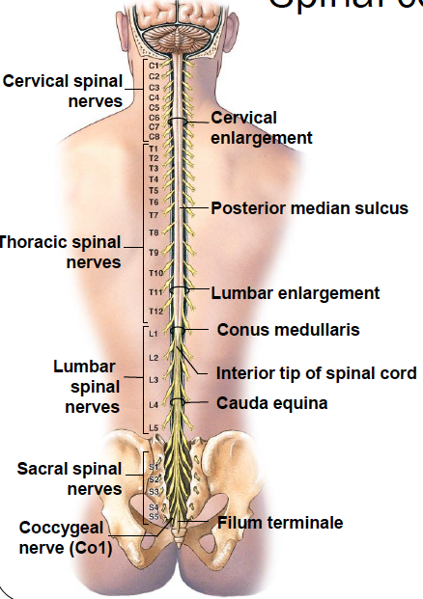

Spinal Cord Anatomy in Cross Section
- Anterior Median Fissure is more deep than the Posterior Median Sulcus
- Gray Matter is cell bodies and unmyelinated axons
- White Matter is myelinated axons
- Dorsal Root (Ganglion): cell bodies from unipolar sensory neurons held here
  - ALL sensory information COMES into the spinal cord VIA dorsal root
- Ventral Root: all motor output LEAVES the spinal cord via ventral root
- Spinal Nerve: Dorsal and ventral nerve combine to form
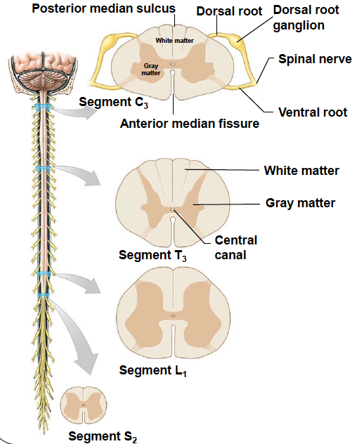

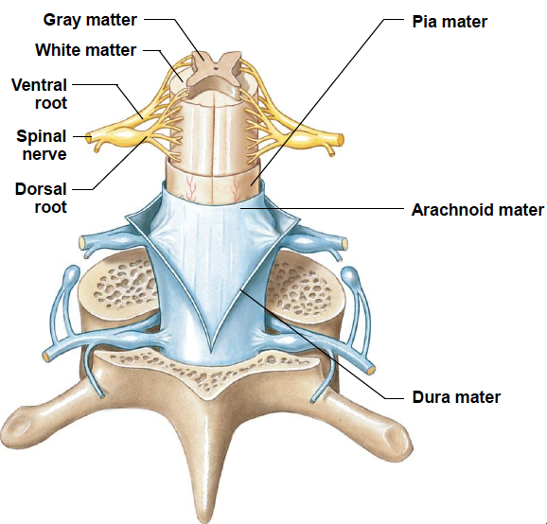

Spinal Meninges
Meninges- consistent coverings of the spinal nerves
Two main functions:
- Stability in both directions
- Shock absorption
Contact damage rubbing against bony vertebrate
Layers
- Pia Mater (pia, delicate + mater, mother)
- Inntermost meningeal layer
- Collagen and elastic
- Sticks tightly onto nervous tissue underneath
- Arachnoid Mater (arachine, spider)
- Middle meningeal layer
- Includes:
  - Simple Squamous Epithelium (arachnoid membrane)
  - Arachnoid Trabeculae: network of Collagen and Elastin Fibers connecting layer to Pia Mater
    - Responsible for circulation of CSF and blood (through the left right and anterior ventricles)
  - Subarachnoid Space- where CSF and arteries are found
- Dura Mater (dura, hard)
- Outermost covering
- Almost exclusively collagen fibers oriented in the LONGITUDINAL direction making it tough and stable
- Potential/Artificial Space (Subdural)- space between arachnoid membrane and dura mater
  - Shouldn’t actually exist would normally be filled with CSF
  - Region associated with Subdural Hematoma
- Epidural Space- space between the dura mater and the bony vertebrae
  - Filled with Areolar Tissue- most common type of nerve fiber, contains high concentration of fat (adipose cells) which gives the cushion/shock absorption in the spine
  - Epidural Tissue- made of adipose and connective tissue that prevents friction between neural tissue, responsible for most of the packing and cushion
Meningitis- swelling of the meninges membranes
- Viral or bacterial
- Body’s immune response that actually generates the issue
- Immune system recognizes bacterial membranes and kickstarts Cytokine production
- Makes Blood Brain Barrier more leaky = more fluid comes across barrier = swelling = inflammation of lining
- Lumbar Puncture best means of diagnosing
  - Come through ligamentous tissue through the fat of the epidermal space, through dura mater etc. all the way into the Trabeculae where the fluid is extracted from
  - Blood Patches are used to fix constant leaks of CSF after Lumbar Punctures

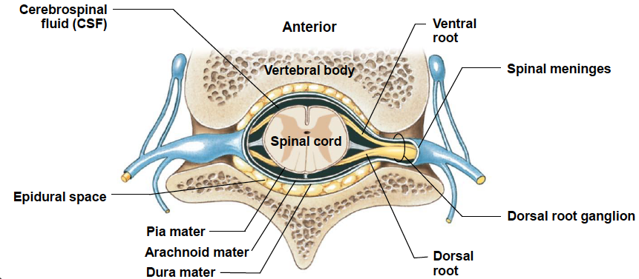

Supporting Ligaments of the Spinal Meninges
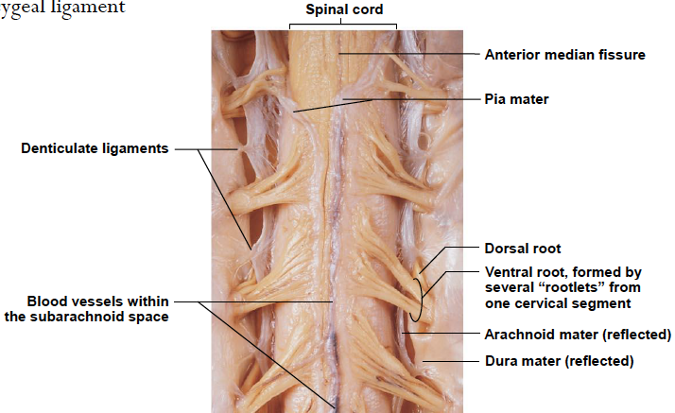

Anatomical Landmarks of the Spinal Cord
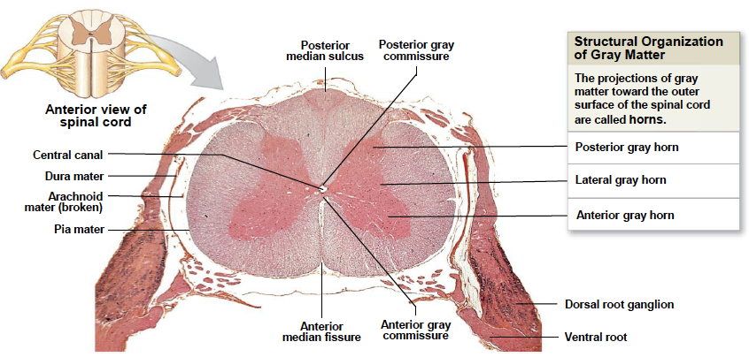
- Posterior (Dorsal) Horn: nuclei of cells that deal with SENSORY input
- Lateral Horn: the thoracic/lumbar region that deals with VISCERAL MOTOR input
  - Visceral- organs, smooth muscle, glandular
- Anterior (Ventral) Horn: nuclei of cells that deal with SOMATIC MOTOR input
  - Somatic- voluntary control (skeletal muscles), striated muscles in the skin

Organization of Gray Matter of the Spinal Cord
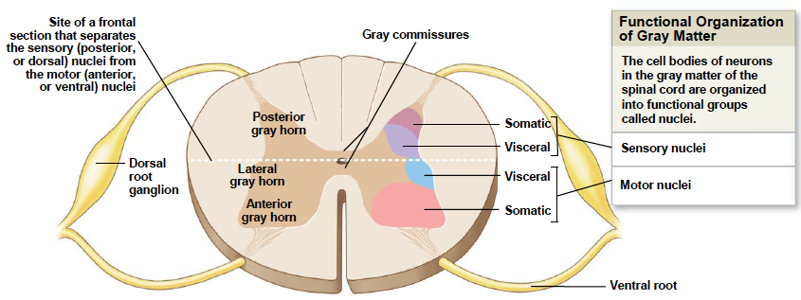
- Despite where information is coming FROM all info of the same type is regionalized to a small compact area of CELL BODIES
- Somatic region is the biggest collection of nuclei
- UPPER CERVICAL/LOWER LUMBAR region DON’T have a lateral horn because there is not a lot of visceral motor input occurring at these regions

Organization of White Matter of the Spinal Cord
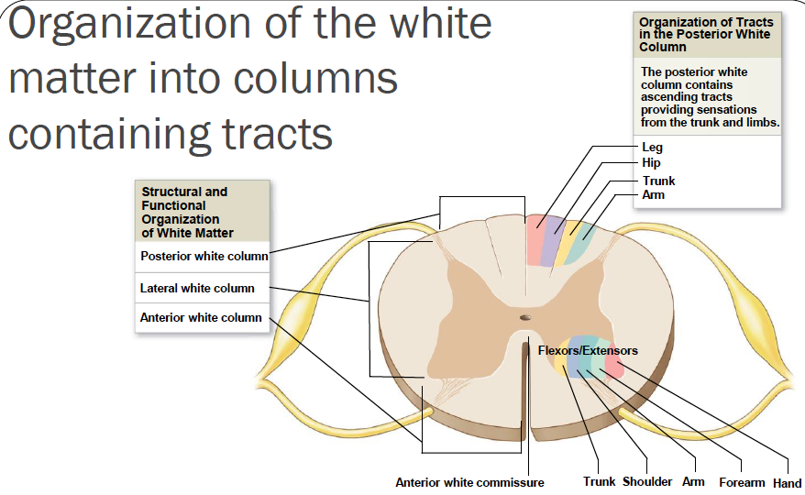
- Information is still highly compartmentalized and regionalized but in columns in AXONS NOT CELL BODIES
- Tracts: bundles of fibers/nerves that are ALL sending the SAME type of signal (ie all sensory or all motor
  - Ascending Tract: leads up TO the BRAIN via a POSTERIOR route
  - Descending Tract: leads down from the brain TO the SPINAL CORD
- Commissure: type of white matter where cross over occurs in the spinal cord (ie the cross over that occurs whereas the right side of the brain processes sensory information from the left eye)

Spinal Nerve Structure and Distribution
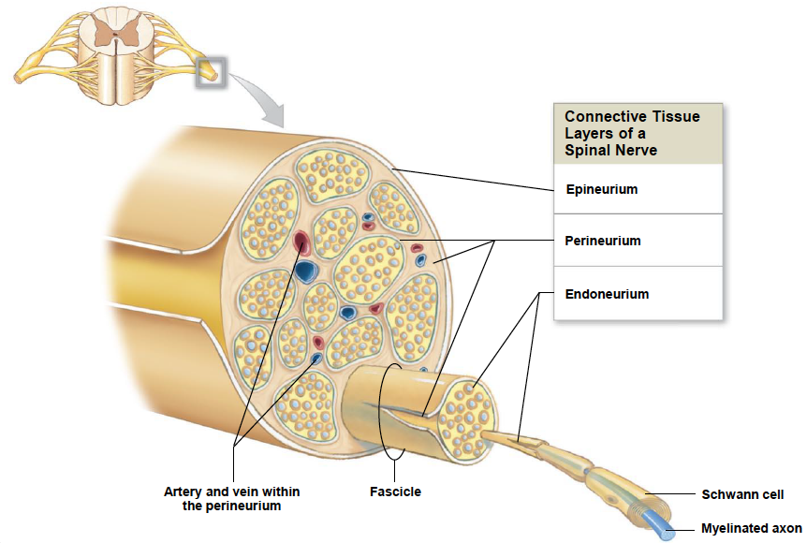
- Epineurium: the outermost layer (AKA DURAL SLEEVE) on a spinal nerve
  - Appears that this wrapping is cause by invagination and the surrounding of the dura mater and arachnoid membrane
- Perineurium: flat concentric lauer of cells around the outside of fascicles
- Endoneurium: sticks tightly to the axon and covers all of it (including the myelin and nodes of Ranvier)
  - Similar to the pia mater
  - Produces Endoneurium Fluid: similar to CSF as it bathes and nourishes
- Fascicle: bundles of nerves
  - Epineurium folds in around the fascicles and forms a durable outer coating

Spinal Nerve Branches
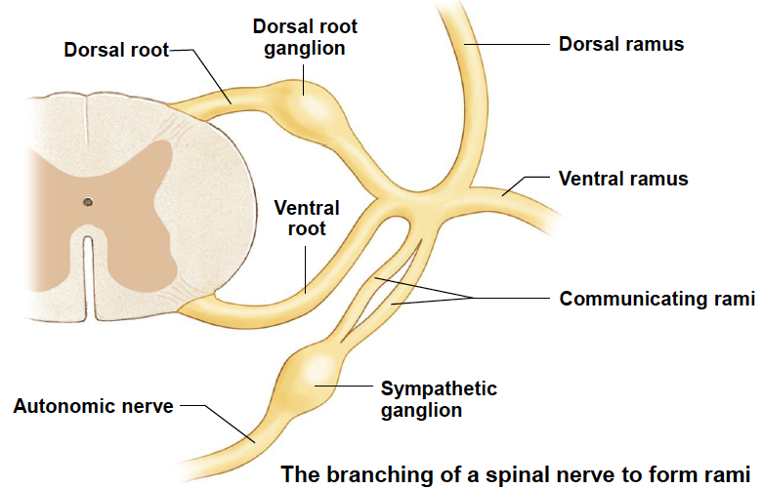
- Spinal Nerve: where the dorsal and ventral root meet
  - Then splits off into Rami (branches)
- Dorsal Ramus: contains MOTOR OUTPUT and SENSORY INPUT
- Ventral Ramus: contains MOTOR OUTPUT and SENSORY INPUT
- Communicating Rami: only in the UPPER LUMBAR and THORACIC regions
  - Sympathetic Ganglia

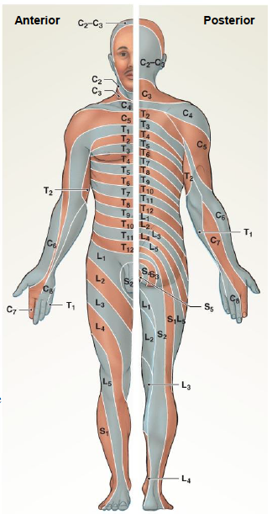
The Dermatome: specific bilateral region of skin surface monitored by a single pair of spinal nerves
- Based on premise that each spinal nerve innervates a specific region of the skin
- C1 USUALLY doesn’t have sensory input from the dermatome and when it does it covers the same region as C2 or C3
- Facial skin sensation is actually conducted via CRANIAL NERVES
- Useful because can use where skin is lacking response to determine which spinal nerve is damages
- Skin eruptions are also specific to spinal nerves
- Ex. Shingles (stems from chicken pox)- results from satellite cells in the DORSAL GANGLION
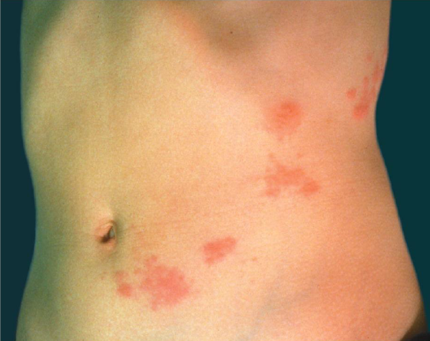
Herpetic Neuralgia: when all visible signs of shingles leave but the pain continues for the rest of the individual’s life

Motor Commands
- Ventral Root- AXONS of somatic AND visceral motor neurons
- Dorsal Ramus- somatic AND visceral motor FIBERS to skin and skeletal muscles of the back
- Ventral Ramus- somatic AND visceral motor FIBERS to ventrolateral body surface, structure of the body wall, limbs
- Rami Communicates (communicating branches)
  - White Ramus
    - Preganglionic fibers are MYELINATED (white)
    - Visceral motor fibers that project to the sympathetic ganglion
  - Grey Ramus
    - Postganglionic fibers are UNMYELINATED (grey)
    - Innervate glands and smooth muscles of body wall or limbs
- Sympathetic Nerve: preganglionic and postganglionic fibers that project to structures of the THORACIC cavity

Route of VISCERAL Motor Output
Visceral Nuclei$→$Ventral Root (joins with Dorsal Root)$→$Spinal Nerve$→$Rami Communicates$→$Abdominopelvic Cavity OR Sympathetic Ganglia$→$Thoracic Cavity OR Visceral Motor Innervation$→$Rami Communicates$→$Ventral OR Dorsal Ramus
- Visceral motor output ALWAYS goes to Ganglia FIRST (Ganglia contact the final target)

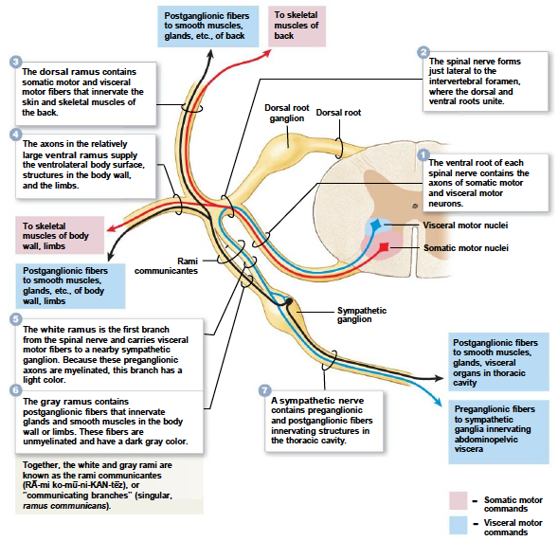
Sensory Information
- Sympathetic Nerve- sensory information from VISCERAL organs
- Ventral Ramus- sensory information from VENTROLATERAL body surface, body wall structures and limbs
- Dorsal Ramus- sensory information from skin and skeletal muscles of back
  - Dorsal Root- sensory information TO the SPINAL CORD

Three Types of sensory receptor cells:
- Interoceptors: input from visceral organs regarding hunger, movement of internal organs
- Exteroceptors: sense input from the external environment
- Proprioceptors: receive sensory information regarding limb positioning and muscles
Route of VISCERAL Sensory Input
All information from the Sympathetic Nerve OR Dorsal Ramus OR Ventral Ramus$→$Dorsal Root Ganglion$→$Visceral Sensory Nuclei OR Somatic Sensory Nuclei
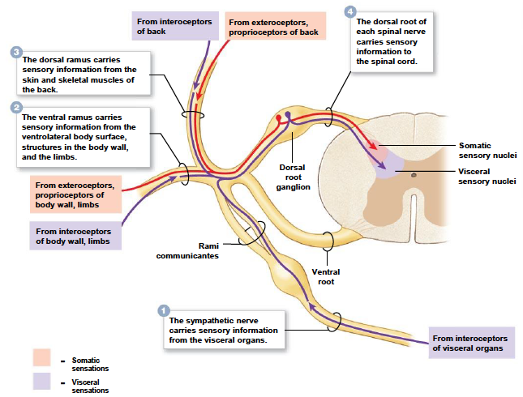

Spinal Nerve Plexuses
- Nerve Plexus: a braid-like complex interwoven network of nerves from a combination of ventral input for a given number of spinal inputs
  - Compound Muscle: the merging of individual muscle cells (which are singly innervated) by fusion to make one complex BUT is still innervated by single individual roots THEREFORE braid together into a plexus that goes to the spinal cord
  - Ventral Rami Complexes
- Cervical Plexus- smallest
- Brachial Plexus- 3 nerves that travel the entire length of the arm
  - Radial Nerve
  - Ulnar Nerve
  - Median Nerve
- Lumbar Plexus
- Sacral Plexus
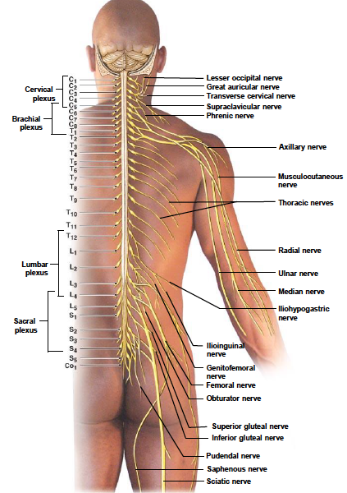
Nerve Trunk- output from MORE THAN ONE spinal nerve come together here and split off into divisions$→$Cords$→$Peripheral nerves

Brachial Plexus
- Innervates the pectoral girdle and upper limb
- Contributions from ventral rami of nerves C4-T1
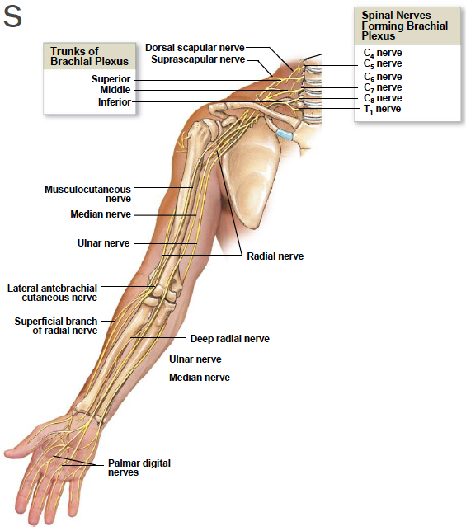
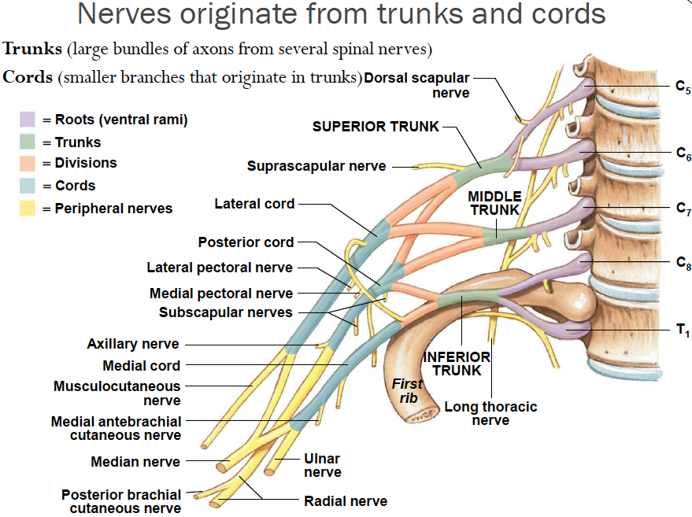

Clinical Importance of Cutaneous Nerve
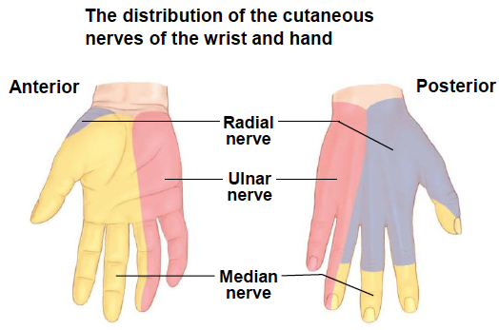
- Damage or injury can be precisely located by testing sensory function in hand

Reflexes and Neural Circuits
- Neuronal Pools: functional arrangement/groups of interconnected neurons
  - Most cases are interneurons in the CNS
    - May involve several regions of the brain
    - May involve neurons in one specific location in brain or spinal cord
  - Estimated number of pools ~100s to 1000s
  - Patterns of neuronal interactions suggest functional classification
    - Neural Circuit- the wiring diagram; different types of processing include:
      - Divergent- one neuron with two collaterals that extend onward in tree-like manner
        - Most common arrangement
        - Allows a single input to have multiple different outputs or effects
      - Parallel- special senses involve initial parallel processing whereby all component information of a single type of sensory information is all done separately in parallel (ie visual information is simultaneously processed in terms of shape, color, etc)
      - Serial- consequential information processing
      - Convergent- a series of different inputs all effecting the same output
        - Parallel information often leads here as a means of integration
      - Reverberation- the receiving cell ultimately feeds back (AKA POSITIVE FEEDBACK) on initial input and continues the propagation of the circuit unless stopped by one of two methods:
        - Synaptic Fatigue
        - Inhibitory Input
  - Simple circuits in the PNS and spinal cord control REFLEXES
- Reflex: rapid, automatic preprogrammed responses to specific stimuli
  - Show little variability
  - Preserve homeostasis by making rapid adjustments in functions of organs or organ systems
  - In neural reflexes:
    - SENSORY fibers carry information from peripheral receptors to integration centers
    - MOTOR fibers carry motor commands to peripheral effectors
- Reflex Arc: “wiring” of a single reflex from receptor to effector
  - Simple withdrawl reflex
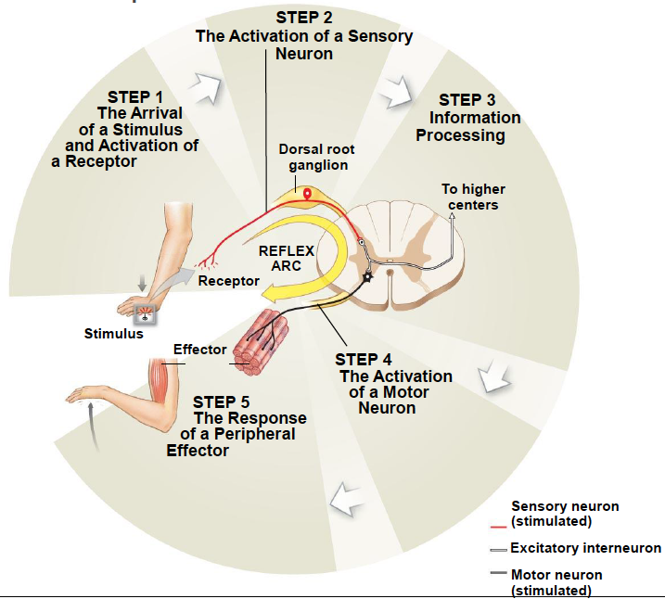
GET FROM TEXT

Reflex Classification
Reflex Categories:
- Development
- Innate Reflexes: connections formed between neurons genetically or developmentally programmed
  - Generally appear in a predictable sequence
  - Ex. simplest (withdrawal) to complex (suckling)
- Acquired Reflexes: learned rather than pre-established connections that are enhanced by repetition
  - Ex. learning to ride a bike- shifting balance
- Nature of Response
- Somatic Reflexes: involuntary control of skeletal muscles
  - Ex. withdrawal reflex (is somatic AND innate)
  - Rapid response that can later be supplemented voluntarily
- Visceral (Autonomic) Reflexes: control or adjust activities of smooth & cardiac muscle, glands and adipose tissue
  - Ex. peristalsis, papillary reflex
- Complexity of Circuit (number of synapses involved)
- Polysynaptic Reflexes: involves at least one interneuron, one sensory neuron, and one motor neuron
  - Longer delay between stimulus and response due to increased number of synapses
  - Produce more complex reflexes
- Monosynaptic Reflexes: simplest reflex arc involving one sensory and one motor neuron
  - Faster response time due to only one synapse
- Processing Site
- Spinal Reflexes- occur in the nuclei of the spinal cord; two types:
  - Single Segmental: within one spinal segment
  - Intersegmental: involve multiple segments
- Cranial Reflexes- occur in the nuclei of the brain

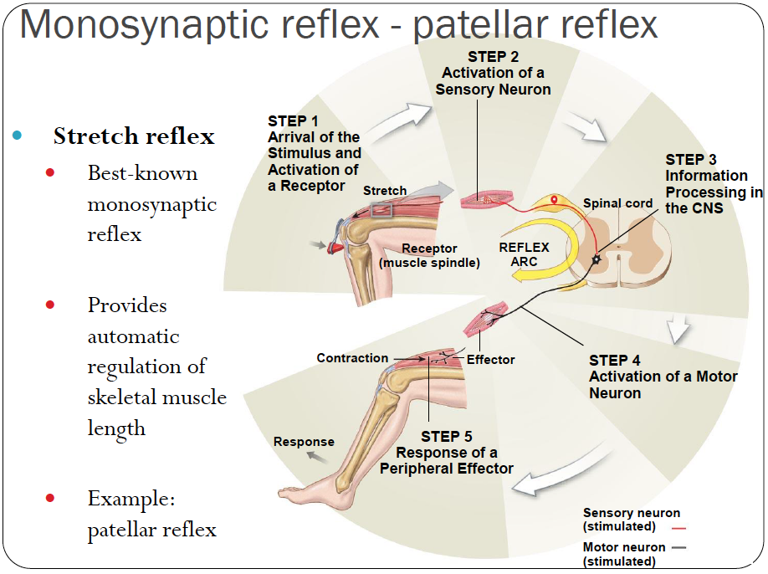
- Muscle Spindle: intrafusal fibers (specialized) bound together in the middle of the muscle that serve to prevent overstretching and rapid stretching of the muscles
  - Extensively innervated by sensory neurons

Polysynaptic Reflexes
- Responsible for automatic actions involved in complex movements ex. walking or running
- May involve sensory and motor responses on the same side of the body or opposite sides:
  - Ipsilateral Reflexes: same side
    - Ex. stretch reflex, withdrawal reflex
  - Contralateral Reflexes: opposite sides
    - Ex. crossed extensor reflex- has effects on both sides of the body
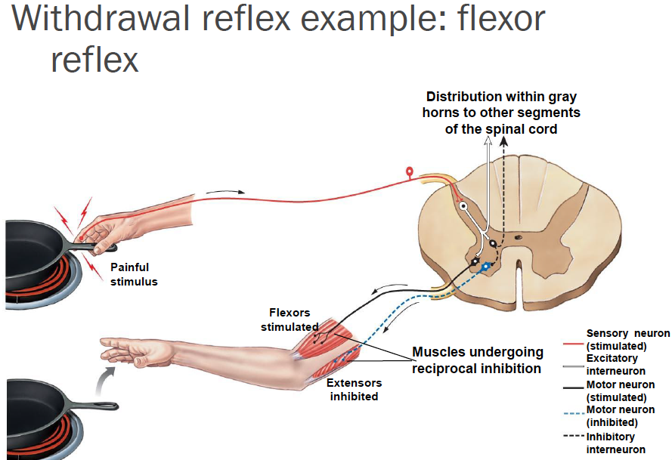
Brain Influences on Spinal Reflexes and Diagnostics using Reflexes
Brain influences on spinal reflexes:
- Can facilitate or inhibit motor neurons or interneurons involved
  - Facilitation = reinforcement
  - Ex. voluntary movement to pull apart clasped hangs can reinforce stretch reflexes and increase response (ie bigger kick after a patellar tap when clasping hands)
- Babinski Reflex
  - Positive Response- toes fan due to lack of inhibitory control of reflex response from descending motor pathways
  - Negative Response- toes curl due to development and normal reflex response (plantar reflex)
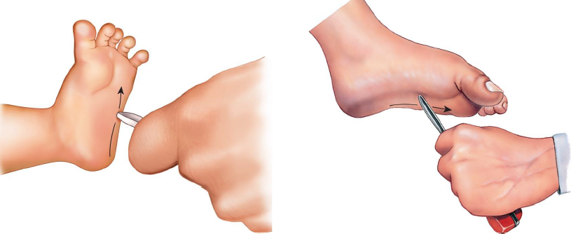
Review
- A typical spinal cord has how many pairs of spinal nerves, and where does the spinal cord end?
- Describe the composition of the gray matter of the spinal cord
- Describe the gross anatomical features of a cross section of spinal cord
- Differentiate between sensory nuclei and motor nuclei
- Identify the three layers of connective tissue of a spinal nerve and identify the major peripheral branches of a spinal nerve
- Describe a dermatome
- Define gray ramus and white ramus
- Define nerve plexus and list the major nerve plexuses
- Define a nerve plexus trunk and cord
- Describe the brachial plexus and the major nerve associated
- Define reflex and list the components of a reflex arc
- What are common characteristics and the various classifications of reflexes?
- Define stretch reflex; in the patellar reflex, identify the response observed and the effectors involved
- Identify the basic characteristics of polysynaptic reflexes; describe the flexor reflex
- Define reinforcement as it pertains to spinal reflexes

