Chapter 2
- Perception: the process by which individuals organize and interpret their impressions in order to give meaning to their environment
- Perception is influenced by the situation, the perceiver, and the target
- The perceiver’s attitudes, motives, interests, past experiences, and expectations shape the way they see an event
- The target’s novelty, motion, sounds, size, and other characteristics shape the way it is seen
- Attribution Theory: the theory that when we observe what seems like atypical behavior by an individual, we attempt to determine whether it is internally or externally caused
- In trying to determine whether behavior is internally or externally caused, we rely on three rules about the behavior:
- Distinctiveness: a behavioral rule that considers whether an individual acts similarly across a variety of situations
- Consensus: a behavioral rule that considers if everyone faced with a similar situation responds in the same way
- Consistency: a behavioral rule that considers whether the individual has been acting in the same way over time
- Fundamental Attribution Error: the tendency to underestimate the influence of external factors and over estimate the influence of internal factors when making judgments about the behavior of others
- Self-serving Bias: the tendency for individuals to attribute their own success to internal factors while putting the blame for failures on external factors
- Selective Perception: People’s selective interpretation of what they see based on their interests, background, experience, and attitudes
- Halo Effect: drawing a general impression of an individual on the basis of a single characteristic
- Contrast Effects: the concept that our reaction to one person is often influenced by other people we have recently encountered
- Projection: attributing ones own characteristics to other people
- Stereotyping: judging someone on the basis of one’s perception of the group to which that person belongs
- Heuristics: judgment shortcuts in decision making
- Prejudice: an unfounded dislike of a person or group based on their belonging to a particular stereotyped group
- Self-fulfilling Prophecy: a concept that proposes a person will behave in ways consistent with how he or she is perceived by others

Chapter 3
- Values: basic convictions that a certain mode of conduct or end-state of existence is personally or socially preferable to an opposite or converse mode of conduct or end-state of existence
- Value System: a hierarchy based on a ranking of an individual’s values in terms of their intensity
- Terminal Values: goals that individuals would like to achieve during their lifetime
- Instrumental Values: preferable ways of behaving
- Ethics: the study of moral values or principles that guide our behavior and inform us whether actions are right or wrong
- Hofstede’s Framework for Assessing Cultures: power distance, individualism vs. collectivism, masculinity vs. femininity, uncertainty avoidance, long-term vs. short-term orientation
- Power Distance: describes the extent to which a society accepts that power in institutions and organizations is distributed unequally
- Individualism: describes the degree to which people prefer to act as individuals rather than as members of groups
- Collectivism: describes a tight social framework in which people expect others in groups in which they are a part to look after them and protect them
- Masculinity: describes the extent to which the culture favours traditional masculine work roles of achievement, power, and control. Societal values are characterized by assertiveness and materialism.
- Femininity: a national culture attribute that sees little differentiation between male and female roles; women are treated as the equals of men in all respects
- Uncertainty Avoidance: describes the extent to which a society feels threatened by uncertain an ambiguous situations and tries to avoid them.
- Long-term Orientation: emphasizes the future, thrift, and persistence
- Short-term Orientation: emphasizes the past and present, respect for tradition, and fulfillment of social obligations
- Generational Differences:
- Baby Boomers (born mid-1940’s to mid-1960’s):
- Achievement and material success are very important
- Sense of accomplishment and social recognition rank high
- Believe ends justify the means
- Generation X (born mid-1960’s to late 1970’s):
- Value flexibility, life options, and achievement of job satisfaction
- Family/relationships are very important
- Less willing to make personal sacrifices for sake of employer
- Generation Y (born between 1979 and 1994):
- High expectations; seek meaning in their work
- Tend to be questioning, electronically networked, and entrepreneurial
- Socially responsible

Chapter 4
- Motivation: the intensity, direction, and persistence of effort a person shows in reaching a goal
- Theory X: the assumption that employees dislike work, will attempt to avoid it, and must be coerced, controlled, or threatened with punishment to achieve goals
- Theory Y: the assumption that employees like work, are creative, seek responsibility, and will exercise self-direction and self-control if they are committed to the objectives
- Intrinsic Motivators: a person’s internal desire to do something, due to such things as interest, challenge, and personal satisfaction
- Extrinsic Motivators: motivation that comes from outside the person and includes such things as pay, bonuses, and other tangible rewards
- Maslow’s Hierarchy of Needs Theory:
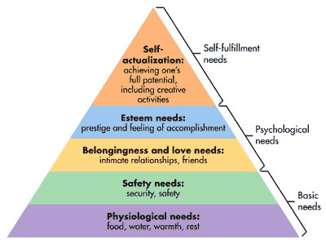
- Physiological – includes hunger, thirst, shelter, sex, and other bodily needs
- Safety – includes security and protection from physical and emotional harm
- Social – includes affection, belongingness, acceptance, and friendship
- Esteem – includes internal esteem factors such as self-respect, autonomy, and achievement; and external esteem factors such as status, recognition, and attention
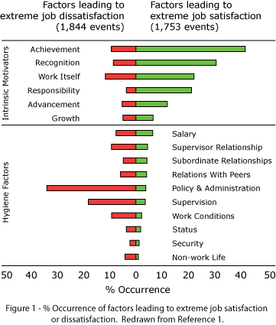
- Self-actualization – includes growth, achieving one’s potential, and self-fulfillment. This is the drive to become what one is capable of becoming.
- Lower-order Needs: needs that are satisfied externally, such as physiological and safety needs
- Higher-order Needs: needs that are satisfied internally, such as social, esteem, and self-actualization needs
- ERG Theory: a theory that posits three groups of core needs – existence, relatedness, and growth
- Needs do not have to be fulfilled in a certain order
- Motivation-hygiene Theory: a theory that relates intrinsic factors to job satisfaction and associates extrinsic factors with dissatisfaction
- Motivators: factors leading to job satisfaction
- Hygiene Factors: factors – such as company policy and administration, supervision, and salary – that, when adequate in a job, placate employees. When these factors are adequate, people will not get dissatisfied.
- McClelland’s Theory of Needs: achievement, power, and affiliation are three important needs that help explain motivation
- Need for Achievement (nAch): the drive to excel, to achieve in relation to a set of standards, to strive to succeed
- Need for Power (nPow): the need to make others behave in a way that they would not have behaved otherwise
- Need for Affiliation (nAff): the desire for friendly and close interpersonal relationships
- Expectancy Theory: the theory that individuals act based on their evaluation of whether their effort will lead to good performance, whether good performance will be followed by a given outcome, and whether that outcome is attractive
- Expectancy: the belief that effort is related to performance
- Instrumentality: the belief that performance is related to rewards
- Valence: the value or importance an individual places on a reward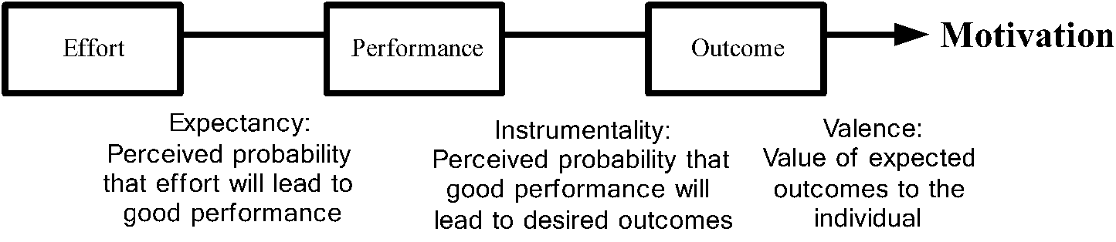
- Goal-setting Theory: a theory that says that specific and difficult goals, with feedback, lead to higher performance
- Goal: what an individual is trying to accomplish
- Management By Objectives (MBO): an approach to goal setting in which specific measurable goals are jointly set by managers and employees; progress on goals is periodically reviewed, and rewards are allocated on the basis of this progress
- Goal setting motivates in 4 ways:
- Goals direct attention
- Goals regulate effort
- Goals increase persistence
- Goals encourage the development of strategies and action plans
- In order for goals to be effective, the should be “SMART”; Specific, Measurable, Attainable, Results-oriented, Time-bound
- Self-efficacy Theory:
- Self-efficacy: an individuals belief that they are capable of preforming a task
- The higher your self-efficacy, the more confidence you have in your ability to succeed in a task
- There are four ways self-efficacy can be increased:
- Enactive mastery – gaining relevant experience with the task or job
- Vicarious modeling – becoming more confident because you see someone else doing the task
- Verbal persuasion – becoming more confident because someone convinces you that you have the skills necessary to be successful
- Arousal – an energized state, which drives a person to complete a task
- Equity Theory: a theory that says that individuals compare their job inputs and outcomes with those of others and then respond to eliminate any inequities
- There are 4 referent comparisons that an employee can use:
- Self-inside – an employee’s experiences in a different position inside their current organization
- Self-outside – an employee’s experiences in a situation or position outside their current organization
- Other-inside – another individual or group of individuals inside the employee’s organization
- Other-outside – another individual or group of individuals outside the employee’s organization
- Employees who perceive an inequity will make one of 6 choices:
- Change their inputs
- Change their outcomes
- Adjust perceptions of self
- Adjust perceptions of others
- Choose a different referent
- Leave the field
- Organizational Justice: an overall perception of what is fair in the workplace, composed of distributive, procedural, and internal justice
- Distributive Justice: the perceived fairness of the amount and allocation of rewards among individuals
- Procedural Justice: the perceived fairness of the process used to determine the distribution of rewards
- Interactional Justice: the perceived quality of the interpersonal treatment received from a manager
- Self-determination Theory: a theory of motivation that is concerned with the beneficial effects of intrinsic motivation and the harmful effects of extrinsic motivation
- Cognitive Evaluation Theory: offering extrinsic rewards for work effort that was previously rewarding intrinsically will tend to decrease the overall level of a persons motivation
- Self-concordance: the degree to which a person’s reasons for pursuing a goal is consistent with the person’s interests and core values
- 4 key rewards that increase an individual’s intrinsic motivation:
- Sense of choice – the opportunity to select what one will do and perform the way one thinks best
- Sense of competence – the feeling of accomplishment for doing a good job
- Sense of meaningfulness – the opportunity to pursue worthwhile tasks
- Sense of progress – the feeling of accomplishment that one is making progress on a task, and that it is moving forward
- 4 sets of behaviors managers use to build intrinsic rewards for their employees:
- Leading for choice – empowering employees and delegating tasks
- Leading for competence – supporting and coaching employees
- Leading for meaningfulness – inspiring employees and modeling desired behaviors
- Leading for progress – monitoring and rewarding employees
- Operant Conditioning: a type of conditioning in which desired voluntary behavior leads to a reward or prevents a punishment
- There are 4 ways to shape behavior:
- Positive reinforcement – following a response with something pleasant
- Negative reinforcement – following a response with the termination or withdrawal of something unpleasant
- Punishment – causing an unpleasant condition in an attempt to eliminate an undesired behavior
- Extinction – eliminating any reinforcement that is maintaining a behavior
- Continuous Reinforcement: a desired behavior is reinforced each and every time it is demonstrated
- Intermittent Reinforcement: a desired behavior is reinforced often enough to make the behavior worth repeating, but not every time it is demonstrated
- Fixed-interval Schedule: the reward is given at fixed time intervals
- Variable-interval Schedule: the reward is given at variable time intervals
- Fixed-ratio Schedule: the reward is given at fixed amounts of output
- Variable-ratio Schedule: the reward is given at variable amounts of output

Chapter 5
- When organizations set pay rates, they balance internal and external equity:
- Internal equity – the worth of the job to the organization
- External equity – the external competitiveness of an organization’s pay relative to pay elsewhere in its industry
- Variable-pay Programs: a reward program which is a portion of an employee’s pay is based on some individual and/or organizational measure of performance
- Piece-rate Pay Plan: An individual-based incentive plan in which employees are paid a fixed sum for each unit of production completed
- Merit-based Pay Plan: an individual-based incentive plan based on performance appraisal ratings
- Bonus: an individual-based incentive plan that rewards employees for recent performance rather than historical performance
- Skill-based Pay: an individual-based incentive plan that sets pay levels on the basis of how many skills employees have or how many jobs they can do
- Gainsharing: a group-based incentive plan in which improvements in group productivity determine the total amount of money to be shared
- Profit-sharing Plan: An organization-wide incentive plan in which the employer shares profits with employees based on a predetermined formula
- Employee Stock Ownership Plan (ESOP): a company-established benefit plan in which employees acquire stock as part of their benefits
- If an organization wants a group of individuals to function as a team, emphasis needs to be on team-based rewards
- Flexible Benefits: a benefits plan that allows each employee to put together a benefits package individually tailored to their own needs and situation
- Job Design: the way the elements in a job are organized
- Job Characteristic Model (JCM): a model that proposes that any job can be described in terms of five core job dimensions:
- Skill Variety: the degree to which the job requires a variety of different activities
- Task Identity: the degree to which the job requires completion of a whole and identifiable piece of work
- Task Significance: the degree to which the job has an impact on the lives or work of other people
- Autonomy: the degree to which the job provides substantial freedom, independence, and discretion to the individual in scheduling the work and determining the procedures to be used in carrying it out
- Feedback: the degree to which carrying out the work activities required by the job results in the individual obtaining direct and clear information about the effectiveness of their performance
- Motivating Potential Score (MPS): a predictive index suggesting the motivation potential in a job
- $MPS= \left[\frac{Skill variety+Task identity+Task significance}{3}\right]× Autonomy × Feedback$
- Jobs can be redesigned to be made more motivating through:
- Job Rotation: the periodic shifting of an employee from one task to another
- Job Enrichment: the vertical expansion of jobs, which increase the degree to which the employee controls the planning, execution, and evaluation of the work
- Flextime: an arrangement where employees work during a common core period each day but can form their total workday from a flexible set of hours outside the core
- Job Sharing: the practice of having 2 or more people split a 40-hour-a-week job
- Telework: an arrangement where employees do their work outside the office anywhere they have access to smartphones, tablets, and other mobile computing devices
- Employee Involvement: a participative process that use the input of employees and is intended to increase the employee commitment to an organization’s success
- Participative Management: a process in which subordinates share a significant degree of decision making power with their immediate superiors
- Representative Participation: a system in which employees participate in organizational decision making through a small group of representative employees

Chapter 6
- Group: two or more people with a common relationship
- Team: a small number of people who work closely together towards a common objective and are accountable to one another
- Problem-solving (or process-improvement) Team: a group of 5-12 employees from the same department who meet for a few hours each week to discuss ways of improving quality, efficiency, and the work environment
- Self-management (or self-directed) Team: a group of 5-10 employees who take on many of the responsibilities of their former managers
- Cross-functional (or project) Team: a group of employees at about the same hierarchical level, but from different work areas, who come together to accomplish a task
- Skunkworks: cross-functional teams that develop spontaneously to create new products or work on complex problems
- Virtual Team: a team that uses computer technology to tie together physically dispersed members in order to achieve a common goal
- Role: a set of expected behaviors of a person in a given position in a social unit
- Role Expectations: how others believe a person should act in a given situation
- Role Conflict: a situation in which an individual finds, that complying with one role requirement may make it more difficult to comply with another
- Role Ambiguity: a person is unclear about their role
- Role Overload: too much is expected of someone
- Role Underload: too little is expected of someone, and that person feels that they are not contributing to the group
- Norms: acceptable standards of behavior within a group that are shared by the group’s members
- Some of the most common norms have to do with issues such as performance, appearance, social arrangement, and allocation of resources
- Most norms develop in one or more of the following 4 ways:
- Explicit statements made by a group member
- Critical events in the group’s history
- Primacy – the first behavioral pattern that emerges in a group frequently sets team expectations
- Carry-over behaviors from past situations
- What makes a norm important?
- It facilitates the group’s survival
- It increases the predictability of group members’ behaviors
- It reduces embarrassing interpersonal problems for group members
- It allows members to express the central values of the group and clarify what is distinctive about the groups identity
- Conformity: adjusting ones behavior to align with the norms of the group
- 5 Stage Model of Team Development:
- Forming: the first stage in group development, characterized by much uncertainty
- Storming: the second stage in group development, characterized by intragroup conflict
- Norming: the third stage in group development, characterized by close relationships and cohesiveness
- Performing: the fourth stage in group development, when the group is fully functional
- Adjourning: the final stage in group development for temporary groups, where attention is directed toward wrapping up activities rather than task performance
- The Punctuated-Equilibrium Model: temporary groups with deadlines follow a sequence such as:
- The first meeting sets the group’s direction
- The first phase of the group activity is one of inertia
- A transition takes place at the end of the first phase, which occurs exactly when the group has used up half its allocated time
- The transition initiates major changes
- A second phase of inertia follows the transition
- The groups last meeting is characterized by markedly accelerated activity
- Characteristic of an effective team:

- Clear purpose
- Informality
- Participation
- Listening
- Civilized disagreement
- Consensus decisions
- Open communication
- Clear rules and work assignments
- Shared leadership
- External relations
- Style diversity
- Self-assessment

- Multi-team Systems: Systems in which different teams need to coordinate their efforts to produce a desired outcome
- To preform effectively, a team requires 3 different types of skills:
- It needs people with technical expertise
- It needs people with problem-solving and decision-making skills to be able to identify problems, generate alternatives, evaluate those alternatives, and make competent choices
- It needs people with good listening, feedback, conflict resolution, and other interpersonal skills
- Task-oriented Roles: roles preformed by group members to ensure that tasks of the group are accomplished
- Maintenance Roles: roles preformed by group members to maintain good relations with the group
- Group Diversity: the presence of a heterogeneous mix of individuals within a group
- Social Loafing: the tendency for individuals to expend less effort when working collectively than when working individually
- Reflexivity: a team characteristic of reflecting on and adjusting the master plan when necessary
- Cohesiveness: the degree to which team members are attracted to one another and are motivated to stay on the team
 | Cohesiveness
Performance Norms |  | High | Low
Performance Norms | High | High Productivity | Moderate Productivity
Performance Norms | Low | Low Productivity | Moderate to Low Productivity

Chapter 7
- Communication: the transfer and understanding of a message between two or more people
- Channel: the medium through which the message travels
- Formal Channels: communication channels established by an organization to transmit messages related to the personal activities of members
- Informal Channels: communication channels that are created spontaneously and that emerge as responses to individual choices
- Communication Apprehension: undue tension and anxiety about oral communication, written communication, or both.
- Channel Richness: the amount of information that can be transmitted during a communication episode
- Barriers to Effective Communication:
- Filtering: a sender’s manipulation of information so that it will be seen more favorably by the receiver
- Selective Perception: receivers in the communication process selectively see and hear based on their needs, motivations, experience, background, and other personal characteristics
- Defensiveness: when people feel they are being threatened, they tend to react in ways that reduce their ability to achieve a mutual understanding
- Emotions: the same message may be interpreted differently when angry or distraught, as opposed to when happy
- Information Overload: the state of having more information than one can process
- Language
- Silence
- Nonverbal Communication: messages conveyed through body movements, facial expressions, and physical distance between the sender and receiver
- Proxemics: the study of physical space in interpersonal relationships
- Tips for communicating under stress/encouraging less stressful communication:
- Speak clearly
- Be aware of the nonverbal part of communicating
- Think carefully about how you state things
- Downward Communication: communication that flows from one level of a group or organization to a lower level
- Upward Communication: used to provide feedback to higher-ups, inform them of progress towards goals, and relay current problems
- Lateral Communication: communication that occurs between members of the same work group, work groups at the same level, managers at the same level or any horizontally equivalent employees
- Communication Networks: channels by which information flows
- Formal Networks: task relate communications that follow the authority chain
- Informal Networks: communications that flow along social and relational lines
- Grapevine: the organizations most common informal network
- Significant limitations of email:
- Misinterpreting the message
- Communicating negative messages
- Time-consuming nature of email
- Email emotions
- Privacy concerns
- Blog (Web Log): a website where entries are written, and generally displayed in reverse chronological order, about news, events, and personal diary entries
- High-context Cultures: cultures that rely heavily on nonverbal and subtle situational cues in communication
- Low-context Cultures: cultures that rely heavily on words to convey meaning in communication

Chapter 9
- Conflict: a process that begins when one party perceives that another party has negatively affected, or is about to negatively affect, something that the first party cares about
- Functional Conflict: conflict that supports the goals of the group and improves the performance
- Dysfunctional Conflict: conflict that hinders group performance
- Cognitive Conflict: conflict that is task-oriented and related to differences in perspectives and judgments
- Affective Conflict: conflict that is emotional and aimed at a person rather than an issue
- Structural variables that can lead to conflict in the workplace:
- Size, specialization, and composition of the group
- The greater the ambiguity in precisely defining where responsibility for actions lies, the greater the potential for conflict to emerge
- Reward systems
- Leadership style
- The diversity of goals among groups
- If one group is dependent on another, or if interdependence allows one group to gain at another’s expense, opposing forces are stimulated
- Dual Concern Theory: considers how one’s degree of cooperativeness and assertiveness determine how a conflict is handled
- Forcing (win-lose): imposing one’s will on the other party
- Problem Solving (win-win): trying to reach an agreement that satisfies both one’s own and the other party’s aspirations as much as possible
- Avoiding (lose-lose): ignoring or minimizing the importance of the issue creating the conflict
- Yielding (win-lose): accepting and incorporating the will of the other party
- Compromising (lose-lose): balancing concern for oneself with concern for the other party in order to reach a solution
- Conflict Resolution Techniques:
- Problem Solving: requesting a face-to-face meeting to identify the problem and resolve it through open discussion
- Developing Overarching Goals: creating a shared goal that requires both parties to work together, and motivates them to do so
- Smoothing: playing down differences while emphasizing common interests with the other party
- Compromising: agreeing with the other party that each will give up something of value to reach an accord
- Avoidance: withdrawing from or suppressing the conflict
- Expansion of Resources: expansion of a scarce resource can create a win-win solution
- Authoritative Command: management can use its formal authority to resolve the conflict and then communicate its desires to the parties involved
- Altering the Human Variable: behavioral change techniques such as human relations training can alter attitudes and behaviors that cause conflict
- Altering the Structural Variables: the formal organization structure and the interaction patterns of conflicting parties can be changed through job redesign, transfers, creation of coordinating positions, and the like
- Mediator: a neutral third party who facilitates a negotiated solution by using reasoning, persuasion and suggestions for alternatives
- Arbitrator: a third party to a negotiation who has the authority to dictate an agreement
- Conciliator: a trusted third party who provides an informal communication link between the negotiator and the opponent
- Consultant: an impartial third party, skilled in conflict management, who attempts to facilitate creative problem solving through communication and analysis
- Three desired outcomes for conflict:
- Agreement – equitable and fair agreements are the best outcome
- Stronger relationships – when conflict is resolved positively, this can lead to better relationships and greater trust
- Learning – handling conflict successfully teaches one how to do it better next time
- Negotiation: a process in which two or more parties exchange goods or services and try to agree on the exchange rat for them
- Distributive Bargaining: negotiation that seeks to divide up a fixed amount of resources; a win-lose solution
- Fixed Pie: the belief that there is only a set amount of goods or services to be divvied up between the parties
- Integrative Bargaining: negotiation that seeks one or more settlements that can create a win-win solution
- The negotiation process is made up of 5 steps:
- Developing a strategy
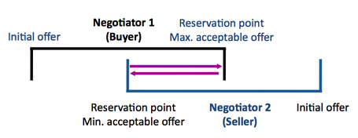
- BATNA: the best alternative to a negotiated agreement; the outcome an individual faces if negotiations fail
- Bargaining Zone: the zone between each parties resistance point, assuming that there is overlap in this range
- Defining ground rules
- Clarification and justification
- Bargaining and problem solving
- Closure and implementation
- Negotiators who are agreeable or extraverted are not very successful in distributive bargaining
- In distributive bargaining, people in position of power that show aggression negotiate better outcomes
- People in a less powerful position displaying anger get worse outcomes
- Men tend to be better negotiators
- No one likes to face an angry counterpart in negotiations, however, East Asian negotiators may respond less favorably than people from other cultures
Chapter 10
- Organizational Culture: a system of shared meaning held by members that distinguishes the organization from other organizations
- Characteristics that capture the essence of an organization’s culture
- Innovation and risk taking
- Attention to detail
- Outcome orientation
- People orientation
- Team orientation
- Aggressiveness
- Stability
- Artifacts: aspects of an organization’s culture that you see, hear, and feel
- Beliefs: the understanding of how objects and ideas relate to each other
- Values: the stable, long lasting beliefs about what is important
- Assumptions: the taken-for-granted notions of how something should be
- Cultures functions:
- It has a boundary-defining role because it creates distinction between one organization and others
- It conveys a sense of identity to organization members
- It helps create commitment to something larger than an individual’s self-interest
- It enhances stability; it is the social glue that helps hold the organization together by providing appropriate standards for what employees should say and do
- It serves as a control mechanism that guides and shapes the attitudes and behavior of employees, and helps them make sense of the organization
- Organizational Climate: the shared perceptions organizational members have about their organization and work environment
- Dominant Culture: a system of shared meaning that expresses the core values shared by a majority of the organization’s members
- Subcultures: mini-cultures within an organization, typically defined by department designations and geographical separation
- Core Values: the primary or dominant values that are accepted throughout the organization
- Strong Culture: a culture in which core values are intensely held and widely shared
- Rituals: repetitive sequences of activities that express and reinforce the key values of the organization; what goals are most important; and which people are important and which are expendable
- Material Symbols: what conveys to employees who is important, the degree of egalitarianism top management desires, and the kind of behaviors that are appropriate
- Socialization: the process that adapts new employees to an organization’s culture
- Pre-arrival Stage: the period of learning in the socialization process that occurs before a new employee joins the organization
- Encounter Stage: the stage in the socialization process in which a new employee sees what the organization is really like and confronts the possibility that expectations and reality may diverge
- Metamorphosis Stage: the stage in the socialization process in which a new employee adjusts to the values and norms of the job, work group, and organization
- Entry socialization options:
- Formal vs. Informal
- Individual vs. Collective
- Fixed vs. Variable
- Serial vs. Random
- Investiture vs. Divestiture
- Organizations can use several strategies when considering how to merge the cultures of two organizations:
- Assimilation – the entire new organization is determined to take on the culture of one of the merging organizations
- Separation – the organizations remain separate and keep their individual cultures
- Integration – a new culture is formed by merging parts of each of the organizations
- Bicultural Audit: an examination of the differences between two potential merger partners prior to a merger to determine whether the cultures will be able to work together
- Managers can create a more ethical culture by adhering to the following principles:
- Be a visible role model
- Communicate ethical expectations
- Provide ethics training
- Visibly reward ethical acts and punish unethical ones
- Provide protective mechanisms so employees can discuss ethical dilemmas and report unethical behavior without fear of reprimand
- Positive Organizational Culture: a culture that emphasizes building on employee strengths, rewards more than punishes, and emphasizes individual vitality and growth

Chapter 11
Managers | Leaders
- Press for stability  - Planning and budgeting  - Organizing and staffing  - Controlling and problem solving | - Press for change  - Establish direction  - Align people  - Motivate and inspire
- Trait Theories of Leadership: theories that consider personal qualities and characteristics that differentiate leaders from non-leaders
- Behavioral Theories of Leadership: theories that propose that specific behaviors differentiate leaders from non-leaders
- Initiating Structure: the extent to which a leader is likely to define and structure their role and the roles of employees in order to attain goals
- Consideration: the extent to which a leader is likely to have job relationships characterized by mutual trust, respect for employees’ ideas, and regard for their feelings
- Employee-oriented Leader: a leader who emphasizes interpersonal relationships
- Production-oriented Leader: a leader who emphasizes the technical aspects of the job
- Situational, or Contingency Theories: theories that propose leadership effectiveness is dependent on the situation
- Fiedler Contingency Model: a leadership theory the proposes that effective group performance depends on the proper match between the leader’s style and the degree to which the situation gives the leader control
- Three contingency dimensions that determine the situation a leader faces:
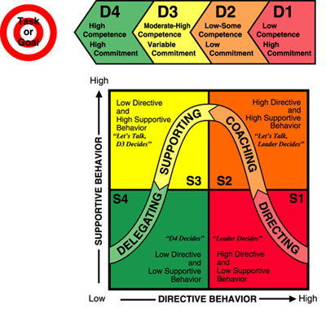
- Leader-member relations – the degree of confidence, trust, and respect members have for their leader
- Task structure – the degree to which job assignments are procedurized
- Position power – the degree of influence a leader has over power-based activities such as hiring, firing, discipline, promotions, and salary increases
- Situational Leadership (SL): a leadership theory that focuses on the readiness of followers
- Path-Goal Theory: a leadership theory that says it is the leader’s job to assist followers in attaining their goals and to provide the necessary direction and/or support to ensure that their goals are compatible with the overall objectives of the group or organization
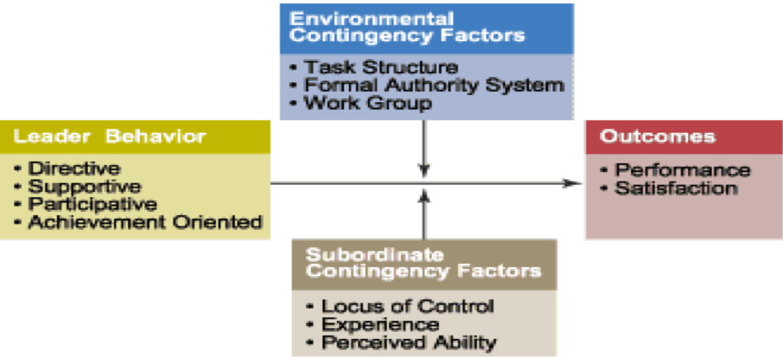
- Leaders should follow 3 guidelines to be effective:
- Determine the outcome subordinates want
- Reward individuals with their desired outcomes when they preform well
- Let individuals know what they need to do to receive rewards
- Path-goal theory identifies 4 leadership behaviors that might be used in different situations to motivate individuals:
- The directive leader – lets followers know what is expected of them, schedules work to be done, and gives specific guidance as to how to accomplish the tasks
- The supportive leader – is friendly and shows concern for the needs of followers
- The participative leader – consults with followers and uses their suggestions before making a decision
- The achievement-oriented leader – sets challenging goals and expects followers to perform at their highest level
- Charismatic Leadership Theory: a leadership theory that states that followers make attributions of heroic or extraordinary leadership abilities when they observe certain behaviors
- Charismatic leaders have 4 key characteristics:
- Vision and articulation
- Personal risk
- Sensitivity to followers’ needs
- Unconventional behavior
- Vision: a long-term strategy for attaining a goal or goals
- Vision Statement: a formal articulation of an organization’s vision or mission
- Level 5 Leaders: leaders who are fiercely ambitious and driven, but their ambition is directed toward their company rather than themselves
- They have 4 basic leadership qualities – individual capability, team skills, managerial competence, and the ability to stimulate others to high performance – plus a 5th quality, a paradoxical blend of personal humility and professional will
- Transactional Leaders: leaders who guide or motivate their followers in the direction of established goals by clarifying role and task requirements
- Contingent reward: contracts exchange of rewards for effort, promises rewards for good performance, recognizes accomplishments
- Management by exception (active): watches and searches for deviations from rules and standards, takes corrective action
- Management by exception (passive): intervenes only if standards are not met
- Laissez-faire: abdicates responsibilities, avoids making decisions
- Transformational Leaders: leaders who inspire followers to transcend their own self-interests and who are capable of having a profound and extraordinary effect on followers
- Idealized influence: provides vision and sense of mission, instills pride, gains respect and trust
- Inspirational motivation: communicates high expectations, uses symbols to focus efforts, expresses important purposes in simple ways
- Intellectual stimulation: promotes intelligence, rationality, and careful problem solving
- Individualized consideration: gives personal attention, treats each employee individually, coaches, advises

Chapter 14
- Forces for change:
- Nature of the workforce
- Technology
- Economic shocks
- Competition
- Social trends
- World politics
- Change Agents: people who act as catalysts and assume the responsibility for managing change activities
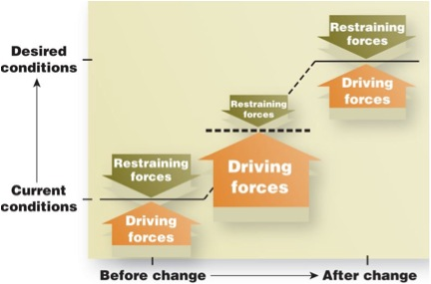
- Lewin’s Three-Step Model:
- Unfreezing: change efforts overcome the pressures of both individual resistance and group conformity
- Moving: efforts to get employees involved in the change process
- Refreezing: stabilizing a change intervention by balancing driving and restraining forces
- Driving Forces: forces that direct behavior away from the status quo
- Restraining Forces: forces that hinder movement away from the status quo
- Action Research: a change process based on the systematic collection of data and then the selection of a change action based on what the analyzed data indicate
- Appreciative Inquiry (AI): an approach to change that seeks to identify the unique qualities and special strengths of an organization, which can then be built on to improve performance
- Discovery: identify what people think are the strengths and weaknesses of the organization
- Dreaming: employees use information from the discovery phase to speculate on possible futures for the organization
- Design: based on the dream articulation, participants focus on finding a common vision of how the organization will look, and agree on its unique qualities
- Destiny: participants discuss how the organization is going to fulfill its dream, and they typically write action plans and develop implementation strategies
- Individuals may resist change for the following reasons:
- Self-interest – people worry that they will lose something of value if change happens
- Misunderstanding and lack of trust – people resist change when they don’t understand the nature of the change and fear that the costs of the change will outweigh any potential gains for them
- Different assessments – people resist change when they see it differently than their managers do and think the costs outweigh the benefits, even for the organization
- Low tolerance for change – people resist change because they worry that they do not have the skills and behavior required of the new situation
- Cynicism can be sourced from:
- Feeling uninformed about what was happening
- Lack of communication and respect for one’s manager
- Lack of communication and respect for one’s union representative
- Lack of opportunity for meaningful participation in decision making
- The 6 major sources of organizational resistance are:
- Structural inertia – organizations have built in mechanisms to produce stability
- Limited focus of change – limited changes in subsystems of an organization tend to be nullified by the larger system
- Group inertia – even if individuals want to change their behavior, group norms may act as a constraint
- Threat to expertise – changes in organizational patterns may threaten the expertise of specialized groups
- Threat to established power relationships – any redistribution of decision-making authority can threaten long-established power relationships within the organization
- Threat to established resource allocations – groups in the organization that control sizable resources often see change as a threat
- 8 tactics that can be used to overcome resistance to change:
- Education and communication
- Participation and involvement
- Building support and commitment
- Developing positive relationships
- Implementing changes fairly
- Manipulation and co-optation
- Manipulation – distorting facts to make more attractive, withholding undesirable information, and creating false rumors to get employees to accept a change
- Co-optation – seeks to “buy-off” the leaders of a resistance group by giving them a key role, seeking their advice not to find a better solution but to get their endorsement
- Selecting people who accept change
- Explicit and implicit coercion
- Innovation: a new idea applied to initiating or improving a product, process, or service

- Sources of innovation:
- Organic structures positively influence innovation
- Long tenure in management is associated with innovation
- Innovation is nurtured when there are slack resources
- Inter-unit communication is high in innovative organizations
- Idea Champions: individuals who actively and enthusiastically promote an idea, build support for it, overcome resistance to it, and ensure that the idea is implemented
- Learning Organization: an organization that has developed the continuous capacity to adapt to change
- Single-loop Learning: a process of correcting errors using past routines and present policies
- Double-loop Learning: a process of correcting errors by modifying the organization’s objectives, policies, and standard routines
- Characteristics of learning organizations:
- The organization has a shared vision that everyone agrees on
- People discard their old ways of thinking and the standard routines they use for solving problems or doing their jobs
- Members think of all organization processes, activities, functions, and interactions with the environment as part of a system of interrelationships
- People openly communicate with each other without fear of criticism or punishment
- People suppress their personal self-interest and fragmented departmental interests to work together to achieve the organizations shared vision

