- Origin of Arts

- Real creativity started in 2600 to 2800 BC. (Painted Slam, Apollo 11 caves, Namibia)
- The arts were primarily animals.

- Paleolithic (Old Stone Age) Art, ca. 30,000-9000 BCE

- In 30,000 – 28,000 BC. Cave paintings, expressed naturalism, which created perspectives. Paintings were actually more detailed even though the images were dated far back.

- In 28,000 to 25,000 BC nude woman became popular. Based on the goddess of Venus.
- Woman body parts were emphasized, because of the acknowledgement of women being the key to fertility.
- Very few men

- Cave Painting
- First cave painting in 12,000-11,000 BC. (Bison, detail of a painted ceiling in the Altarmira cave, Santander, Spain,) Each Bison was approximately 5’ long.
- People believed that the painting was based on the animals being hunted, but scientist have proven that back then the animal that was mainly hunted was dear.

- Animals were portrayed to show their whole body parts. (on the side)

- Why did they paint Bison’s then?

- 15,000- 10,000BC
- Cave painting of bulls, rhinoceros, bison, in France.

- In 30,000 – 28,000 BC. Cave paintings, expressed naturalism, which created perspectives. Paintings were actually more detailed even though the images were dated far back.

- 15,000-10,000 BC, Group of Squares

- Human minds paint what they see, which reflect the particular society.

- The values of society today radiate the expression of painting on walls, when the origin of art began on cave walls.

- Neolithic

- Greek Sculpture and Architecture are the main things to focus on in Greek Art.

- Descending from the Roman Empire.

- 1894: Guranty Building, inspired by Greek Architecture. It has a base, shaft and the capital. The windows have a vertical thrust into it, through the classical building.

  - Men were presented as athletisim, working the body.
  - Women were looked as for beauty.

- Robert Mapplethorpe – Most of his works are based o the male body(explicit), and has a value that was picked up from the Ancient Greece. Gelatin Silver Print
  - Male were dominant.

- Picasso, took histories of art and reinvented them.

- Archaic Period – c.700-480 B.C
- Marks the defeat of the Persians in the 480 B.C

- Classical Period - 480-323 B.C
- Reaches a degree of naturalism.

- Kouros, standing male figure. Something someone would aspire too, very symmetrical stance but not 100%. Very rigid, and closely chiseled and articulated. Little naturalism. They were made for some prominent display. Not meant to represent anyone specific.

- Greek culture, the male body is the default body. Naked represents bravery to go into battle with no clothes without the fear of being hurt.

- Korea from Auxerre 650-624 BC.
  - The females are clothed, because the clothes are a social control. Naked women are a distraction to men/ warriors. Women have to be clothed so there are no sexual distractions. The sculptures are very stiff.

- Kore- Korai Singular
- Kouros –Kouroi Plural

- Ca. 480 BC: Kritios Boy, from the Acropolis, Athenes, Greece.
  - The work is more natural, the posture has a weight shift in a natural way. The term for natural posture is, contrapposto.

- Ca. 470 BC: Charioteer, from a group

- Roman copies from the Greeks, such as the tree trunk was added into Roman copies in order to get a degree of balance.

- Classical Period
  - 440 B.C Riace Warriors, are identical to the postures.

- Materials Used For Sculpture:
  - Bronze is a term for the material, aka copper. The bronzes used contains about 5-10% tin. Lead helps the melting range. Zinc is used as well.

- Lost wax casting method to put the bronze in where the wax would actually be to create the sculpture.

- Search up Rodan.

- Ca. 438BC: PHIDIAS, Athena Parthenos, in the cella of the Parthenon, Acropolis, Athens, Greece.
- Model of the lost statue which was approximately 38’.
- Royal Ontario Museum, Toronto.
  - Model is made out of gold.
  - Copy was destroyed but reincarnated again through copies and old written descriptions of it.

- Sculpture placed on Architecture is called pediment. An example of this is the Parthenon.

- Ca.600-580BC:West pediment from the Temple of Artemis, Corfu, Greece. Made out of lime stone, shows a story.

- Ca. 438-432 B.C – Helios and his horses, and Dionysos ( Herakles?), from the east pediment of the Parthenon, Acropolis, Athens, Greece. Made out of marble.

- Centauromachy

- Ca. 447-438 BC : Details of the Panathenaic Festival procession freize, from the Parthenon, Acropolis, Athens, Greece.

- Ca. 450-440 BC: Polykleitos. During this time area, arts were created around mathematics, and when the math is right you can achieve the beauty.
  - Intersecting curves and angles, using geometric formula to create motion.

- Ca.350-340 BC: Ancient replica of the Aphrodite of Knidos by Praxiteles. First representation of a nude GOD.

- 340 B.C : Hermes & Dionysus Ancient replica of an original by Praxiteles.
  - The god of…..

- “Farnese Herakles.” Original by Lysippos, c320 B.C ( Roman copy by Glykon)
  - more muscular

- ca. 200-150BC: Head of Alexander the Great.
  - A lot of the sculpture were standardized, he became the prototype to show his empowerment and ruling.

- Ca. 175 BC : Reconstructed west from of the Altar of Zeus, from Pergamon, Turkey.
  - Known for the frieze of battle for the Gods and race of giants. CLASSICAL ART BECOMES MORE NATURALISTIC. Arts show the theatrical part of the art, the climax, the flapping wings, the textures etc.

- Ca 230-220 BC: EPIGONOS, made out of marbel copy after bronze. Original from Pergamon, Turkey.
  - Greeks attempt to create pity for a fallen GOD.

- Ca 190 BC: Nike of Samothrace made out of Marble.
  - Is made for a fountain, landing on a ship.
  - Create a show feeling towards the audience.

- 1513-16: The Dying Slave by Michaelangelo Buonarroti.

- Ca.100-50BC: Seated boxer made out of bronze.
  - Children are rendered with strength at a young age.

- Ca. 230-200 BC: Sleeping satyr
  - Different angles shows different perspective of diferent types of art works.

- Johann Joachim (1717-68)
- Anton Raphael Mengs ( 1728-1179)
  - These guys came to recognized the significance of Greek art.

- Thomas Bruce, the 7th Earl of Elgin –

- Ca.350 B.C – Polykleitos
  - They were placed in very dramatic settings. In natural of hill sites, the key characteristics. Again products of the mathematics.

- Naturalism vs Realism :

- Doric and Ionic

- Corinthian:
- Roman’s pick up the Corinthian columns. Was initially used as an interior space.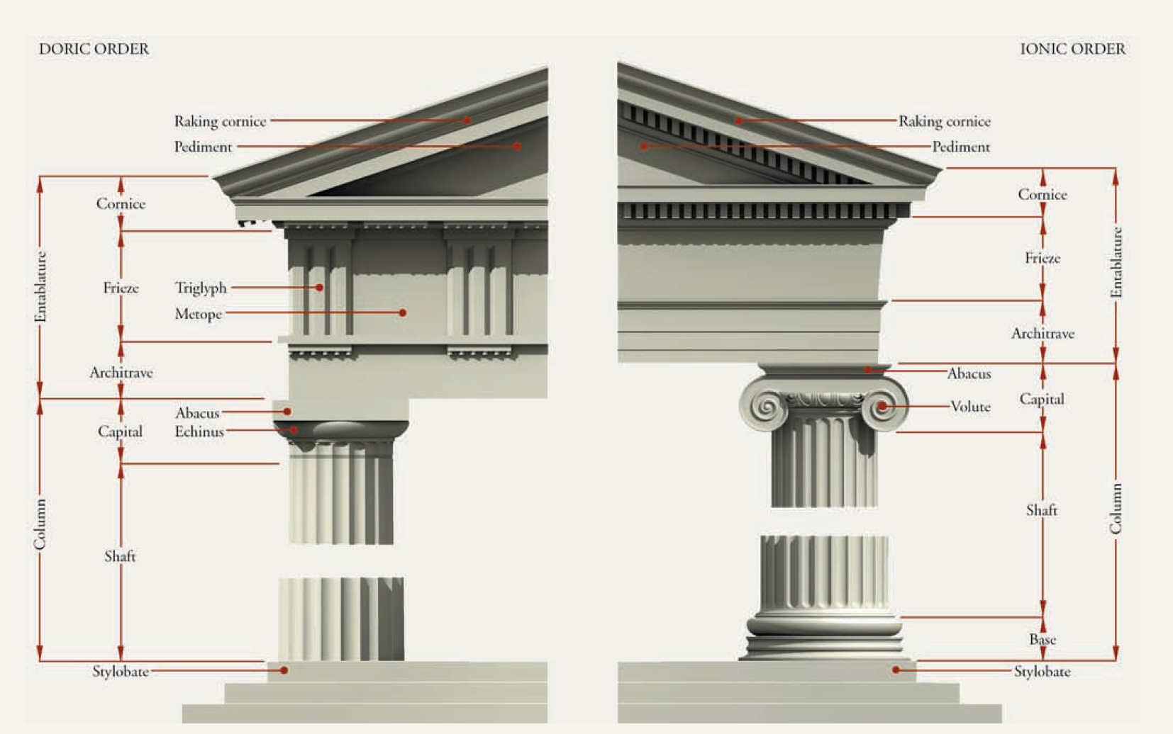
  - Pg 95

- Doric Order : is more simplistic of the three, visually. IT looks the heaviest, the column has no base. The flutting ( detail of the pillar) is created to use a visual shadow, which appeals to the eye.

- The difference between Doric and Ionic, is separated by the fillet, a flat area of the column that separates the footing.

- If were to be sexist;
  - Ionic is feminine because of small size.
  - Doric is masculine is heavier.

- Ionic Order

- The fluting is different and it has a scroll like shape that adorns the capital.
- The frieze of the ionic continues, which shows more of a story.

The Erchtheion used human statues to support the structure instead of a column. Its called a Caryatid.

The Corinthian Order was used as interiors. It became popular with the romans. It started to spread through the western world with the Roman conquest. Like the ionic predecessor has a base, The fluting is separated b the pillars.
  - It was used to favour flat roofs.

- Corinthian: Leafy but not as popular
- The third order is the Corinthian, which wasn't used much by the Greeks. It is named after the city of Corinth, where sculptor Callimachus supposedly invented it by at the end of the 5th century B.C. after he spotted a goblet surrounded by leaves. As shown in Figure 4, the Corinthian is similar to the Ionic order in its base, column, and entablature, but its capital is far more ornate, carved with two tiers of curly acanthus leaves. The oldest known Corinthian column stands inside the 5th-century temple of Apollo Epicurius at Bassae.

- Pericles, is a politician who spent the urban planning.
- Kresilas is known for the structural decoration.
- (research most about this for EXAM)

- Buildings were built at a slight slant to deal with the curve of the planet..? LOL

4:9 Ratio

Rule of Thirds = Golden Ratio
  - Tends to make a harmonic visual.
  - 4:9 Ratio

- The Arch bears weight better and is more efficient then other architecture. 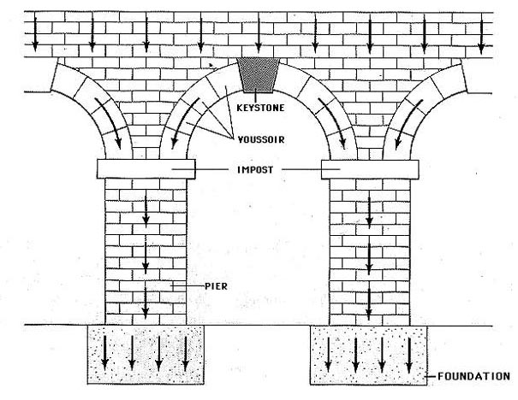If you extend the arch through space you can make a tunnel vault.(or barrel vault) A system of vaulting.

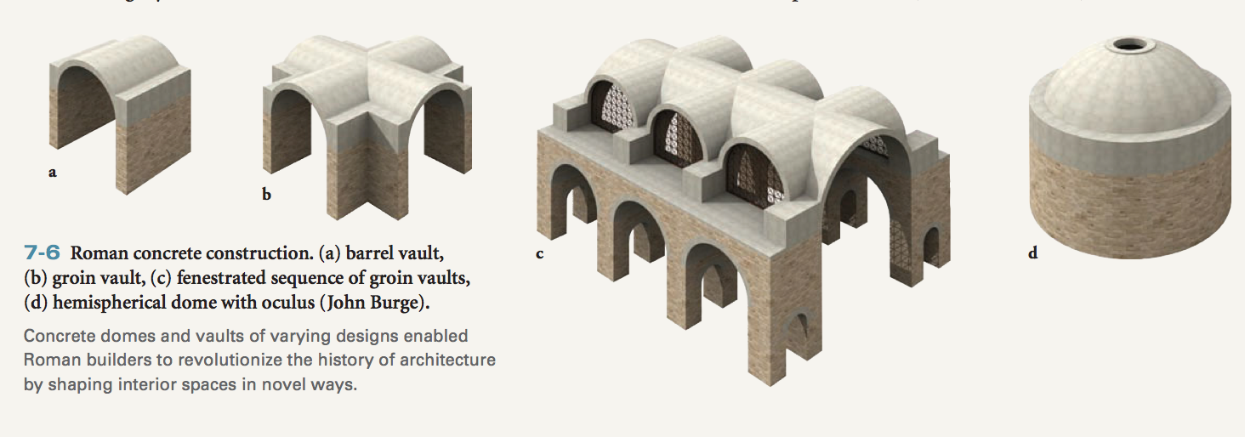
- The romans around the 3rd century, make a very strong cement. They developed concrete in the roman times, which allows them to make dynamic spacial architecture.

- Portraiture;
  - They respect the elderly by creating a lot of portraits of them because of their wisdom and knowledge.
  - Ancestor worship.
    - Statue of Roman Patrician displaying the portraits of his ancestors.
  - Realism, the statues have a real representation of the body.

- Roman History

- Monarchy 753-509 bc
- Republic 509-27bc
  - Julius Caesar 100-44bc – consul and dictator
  - Mark Anthony 83bc-30bc – consul
- Early Empire ( 27 b.c -96a.d)
- Augustus r.27bc-14ad
- Vespasian r.69-79
- Titus r.79-81

- High Empire (AD 96 – 192)
- -Trajan (Plotina) r. 98 – 117
- -Hadrian (Sabina) r. 117 – 138
- -Marcus Aurelius (Faustina the Younger) r. 161 – 180

- Late Empire (AD 192 – 476)
- -Diocletian r. 284 – 305
- -Constantine 1 r. 306 – 337
  - Augustus, became the first emperor of ROME. Absoloute ruler.
  - The public believed that Mark Anthony was corrupt by an Egyptian seduction Cleopatra.

- Augustus Statue:
- Augustus’s idealized portraits were modeled on Classical Greek statues (FIG. 5-40) and depict him as a never-aging son of a god. This portrait presents the emperor in armor in his role as general.

- Augustus claimed his lineage/ancestors went all the way to the God Venus. He believes he has association with the Gods.

- The romans manipulated the spear bearer from the greeks. ( the thing that balances the statue)

- Augustus’ altar was very decorative of floral. Under the rules of Augstae is to bring peace and prosperity.

- Roman Coliseum
- The floor was originally made out of wood and covered with sand.

- Arch of Titus;
  - Is another aspect of ancient Roman art. It honored a specific general or leader. A returning army would march through.

- 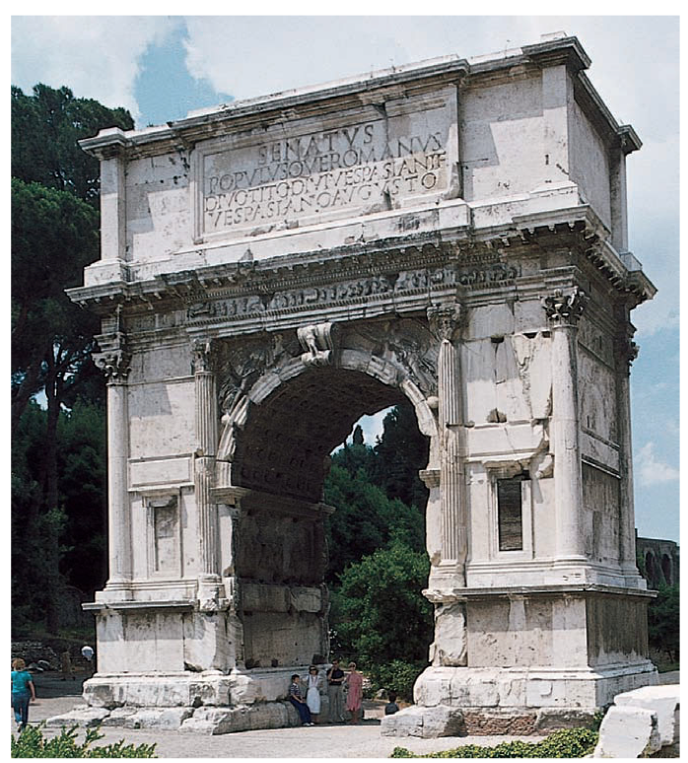

- Column of Trojan
  - 1 Roman Mile height. Matches the height of a hill that was in the place previously. Tusking Column.
  - The spiral frieze of Trajan’s column tells the story of the Dacian Wars in 150 episodes. All aspects of the campaigns were represented, from battles to sacrifices to road and fort construction.
- 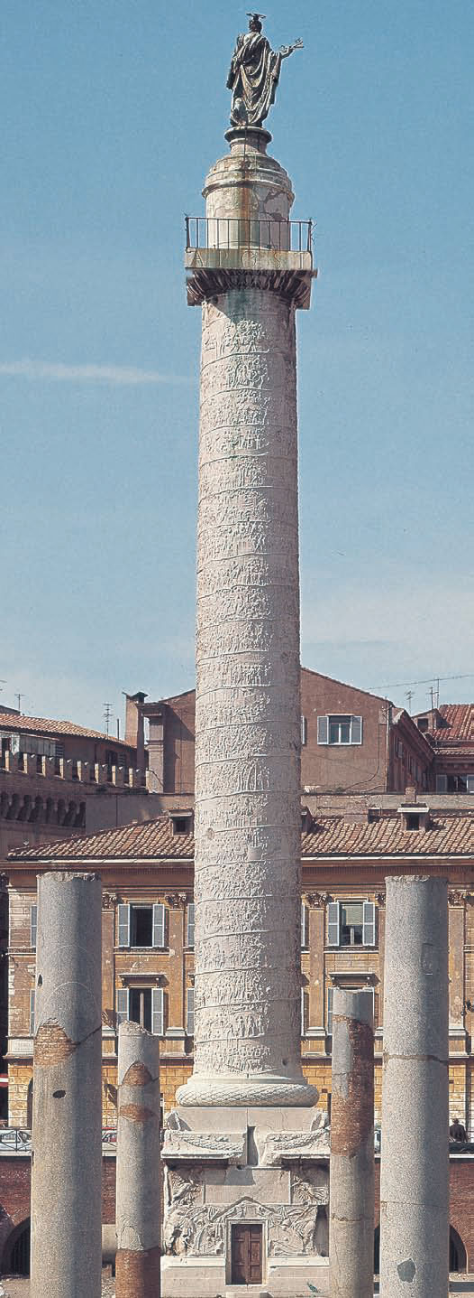

- Detail of the war against the Dacians from Trajan’s column. ATTEMPT at CINEMA. The story is narrated through the pillar and rises all the way to the top.

- Spherical structure has the same diameter and height. ( Circle)
- 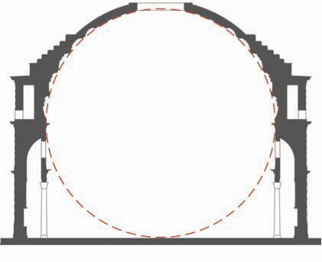
  - Perfectly articulated.
  - Architecture of mass over space.

- Marcus Aurelius,
  - believes himself to be more of a philosopher than a warrior.
- 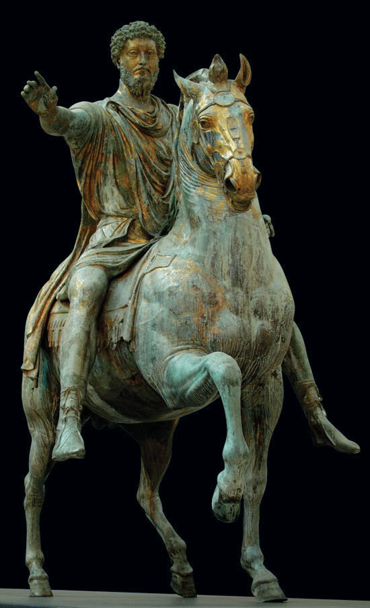
  - Man who believes in reasoning.

- Constantine
  - Legislated Christianity. Gained a victory at mobbing bridge. After this victory he had a dream of a Christian symbol.
  - The big eyes are abstract, that represents beyond realism. Something that is beyond realism, in other words heaven.

- After Constantine the west and east roman empire was split? LOL
  - Eastern portion survived
- Christian work was mainly focused on the after life which made it more abstract.

- Naturalism slowly became abandoned.
- Garmets are much more stylized. Naturalism starts to disappear after the Roman Periods.

- Catacombs were used to preserve the dead, and early Christian decorations were used inside the Catacomb.

- Most classical art was destroyed by Christians because they believed they carried demons.

- They adopted the form of Classical Art.

- Absense of a beard on Jesus in the mid 3rd century. I The Good Shepard

- JCSOGS
  - Fish became a symbol of Christ.

- Chi-Rho
  - XP represented Christ.

- Early Christian basilica
  - APSE will always be the Eastern style of the Church.
    - Half of the circle in the end. Pointed on the East side because of the horizon of the sun is in the area.

- Books were used to spread the gospel, with images.
  - Done on pigment on velum. ( plastic based film )
  - Abstract and spiritual.

- Migration Period ( from the 4th century BC)
  - Angles
  - Saxons
  - Franks
  - Lombards
  - Gothic Tribes
  - Visigoths
  - Ostrogoth
  - Vandals

Huns from Mongolia.

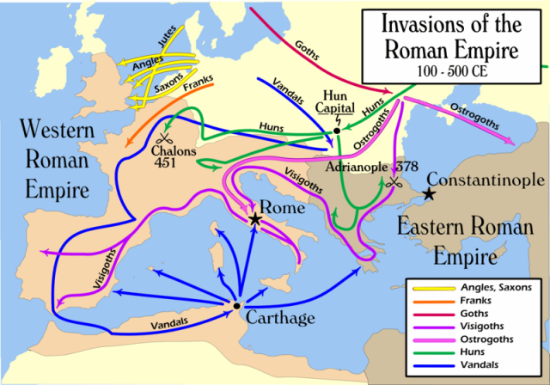

Jewelry were a prize possession of the barbarians.
  - Chalice
  - Animals are represented , sometimes abstract and realistic form.

- The Book of Kells ( late 8th century)
  - Highly elaborate in terms of the design that is articulated.
  - Just the 4 gospels of Christianity.
  - These books were more symbolic. Not designed to be read.

“ You don’t think when you’re doodling, you lose your mind and enter the spiritual world.”

Horror Vaccui – Fear of spaces.

Details in the text and illumination from the Book of Kells.
  - In the 8th century the articulation has increased.
  - Each gospel has a carpet pages, similar to the Islamic.
  - Book of Kells is incomplete.
  - Bejeweled Covers.
- Foundation of eastern orthodox from Christianity?

- Byzantine Icon
  - The idol was the prototype of the desires of the believer.
  - We represent virgin Mary because a painter illustrated her when she was alive.

- 6th or early 7th century: Virgin and Child between Saints Theodore and George, icon.

- Encaustic on wood, Monastery of Saint Catherine, Mount Sinai, Egypt.

- Christ as Savior of Souls, icon from the church of Saint Clement, Ohrid, Macedonia. Used Tempera, linen, and silver on wood.

- The Iconoclastic Controversy 726-843
  - Iconoclasm
  - It’s controversial because churches believed it went against the belief of worshipping. People worshipped the ICON. (idolism)
  - People worshiped physical objects instead of worshipping spiritually.

- Andrei Rublyev was Tempera on wood.

- Roman Mosaic
  - Mosaic uses small pieces of glasses.
  - The flickering of Mosaic, hypnotizes you because from a far it glitters which attract the human eye.

- Eduardo Paolozzi attempts to use Mosaic with tiles.

- 526 – 547: San Vitale, Ravenna, Italy
- -Ravenna used to be the Capital City
- -Choir and apse of San Vitale with mosaic of Christ between two angels
- -Ca. 547: Justinian, Bishop Maximianus, and attendants
- oMosaic from the north wall of the apse

- Romanesque
- -ca. 1060: Interior of Saint Philibert, Tournus, France
- -Cluny Abbey, founded in 910
- oCa. 1115: The Tones of Music
- oCa. 1115: The Rivers of Paradise
- -C. Mid 12th Century: The Prophet Isaiah, Souillac, France
- -Early 13th Century – The Ashmole Bestiary
- oOn Whales
- -Basilica de Santiago de Compostella
- oC. 1168 – 88: Portico de la Gloria

- Reliquary Chest
- -c. 1175: Arm Reliquary of St Lawrence
- -Late 10th – Early 11th Century: Reliquary Statue of Saint Foy

- Saint – Lazare, Autun
- -c. 1130: Portal & Tympanum with the Last Judgment
- oJesus is in the Center
- -c. 1120 – 1135: GISLEBERTUS, Last Judgment
- -c. 1125 – 30: The Dream of the Three Magi
- -c. 1130: Eve
- -c. 1130: Angel chasing a demon

- Gothic Architecture

- French Cathedrals
- -Cathedral of St. Denis
- oAmbulatory
- -1194: Chartres Cathedral
- oOld Testament Figures
- oIsaiah, Jeremiah, Simeon, John the Baptist & Peter
- oThe North Rose Window – Quality of the Color of the Glass itself
- oApothecaries and Haberdashers – The Donors’ Window
- oThe Jesse Window
- oThe Zodiac Sign Window
- oThe Blue Virgin Window
- -Amiens Cathedral, France, c.1220
- -Reims Cathedral
- -Limoges Cathedral

- Church has 3 Component Parts
- -Clerestory
- -Triforium
- -Arcade

- Abbot Suger – “The dull mind rises to truth through that which is material”

- Judgment day
  - C.1130: Portal and Tympanum with the Last Judgment

- GiesalBertev

- Roman Architecture is heavier than Gothic architecture.

Roman vs Gothic
  - Does it feel heavier?
  - Roman’s tend to be higher.

- Cluny Abbey, founded 910.
  - French revolution tried to dominant Christianity. Cluny was destroyed during the French revolution.
  - The Rivers of Paradise, Capital from the Ambulatory at Cluny.

Bestiary; animals that had symbolic values, they dominated in the medieval values. Originated from the Greeks first.

Relics were important.

Bascilica de Santiago de Compostella
  - Original church that was built here was a roman cathedral.
  - C.1168-88: Portico de la Gloria, Santiago de Compostella Master Mateo.
    - The food is worned down because people during the pilgrimage( many people touch them over the years)

- Reliquary Chest
  - Significant relics were found.
  - Things that could be found; the borns of someone or parts of clothing.

- Linear Perspective

- Artists are genius that have an idea. Imaging not working without someone giving your permission. People would only do work if they got paid or commission. The churches were the ones who would support these donners.

- “I am what you are, I am what you will become.” Death metaphor.

- Gothic Architecture

- Abbot Suger
  - “ The dull mind rises to truth through that which is material”
    - Physical representation of God is easier to belief than words.

- Ambulatory marks the gothic style. ( Cathedral of St.Denis) 1137
- Romans had blocks on top of blocks. Gothic structure is lighter and more structural. The gothic churches created a nice aesthetic of the stain glass that perpetuates the interior.
  - They were trying to emphasize the heavens with the soaring heights.
  - Buttress helps support the walls.
  - Flying Buttress help support the buildings to go higher and higher.

- Three Principle Areas of a Gothic Cathedrals
  - Clerestory
  - Triforium
    - Allows light to shine on.
    - Imitation of a walkway but isn’t really a walkway, called a Blind Triforium.
  - Arcade
- MUST VISIT PLACE: Chartres, France

- Nave Chartres Cathedral
  - A maze must be travelled through before entering the church fully.

- The gothic period has a gradual rediscovery of weight.

- The North Rose Window (Chartres Cathedral 1194-1260)
  - Stained Glass
  - Each of Chartres windows has a significant story.
    - Good Samaritan was a story about a man who was attacked by robbers and was left for dead.
    - Details on the glass is painted and fragmented.

- Amiens Cathedral
  - Built through train and error

- Flamboyant tracery at Limoges Cathedral.
  - Flame like tracery.

- The most dominant art form are illuminated manuscripts. Comes literally from the appearance. These were religious books.
  - Illumination comes from the shiny gold.
    - IF you read these books it made you spiritually illuminated.

Naturalism is not dominant and more abstract in the human figures.

- Jesus’ age varies, and the way he’s formed in the representation.

- Cimabue, has a naturalistic representation of the spcace. THE CURVES AND ANGLES don’t make sense if you compare them to reality.
  - You don’t notice the physical space.

- Giotto Di Bondone ca.1310 ; Madonna Enthroned
  - 3 artist (angelo last) Predecessor building up to Michael Angelo.
    - Cimabue > Giotto > Michael Angelo.
  - The weight feels like a real person and that gravity has a play.
  - Transforming a masterpiece and making it your own.

- Capella Scrovegni
  - Interior of the Arena Chapel. Padua, Italy.

- Giotto (1267-1337)
  - 1304-06: Meeting at the Golden Gate
  - The illustration shows the gravity. The people actually look like they’re on the ground instead of floating.
  - His arts have great expressions/emotions and gestures that look authentic. Created untold story/mystery.
  - Leonardo Da Vinci, thought he was amazing the way he painted.
    - Ian would fail Leonardo Da Vinci. He did very little work and effort. Michael Angelo is better.

- Giotto – The Kiss of Judas (1304-06)
  - You can see the stages of the details of the painting of how it works.
  - The right hand side the figure that points at Jesus (the GESTURES) guides the eye to the main point of the story line. The eye is leaded to Jesus.

- Giotto – The Flight into Egypt (1304-06)
  - He does fabulous donkies.

- The Raising of Lazarus
  - Leads the eye to the story.

Lamentation (1305)
  - You could see the different layers which shows the different parts of stages which show when the parts of the painting was finished.
  - You can see Jesus’ favorite disciple which is grieving the most.

- Nicola Pisano – Adoration of the Magi
  - You can see real gravity in the sculptural figures.

- Christianity has become so solidified.

- Early Renaissance 1400s/High 1500-1525

- Humanism and Neo-Platonism
- Lusting after someone to more spiritual interaction. Can be higly intellectual.

- C.1477/78: La Primavera by Sandro Botticelli

- Renaissance is the rebirth of classical paintings

- Michael Angelo said that the doors of Lorenzo Ghibert’s gate of paradise.

- Flippo Bruneschilli’s work had linear perspective. Which allowed 3-D art become in an articular way.
  - You cannot see it in a multiple angle which perspective only works on ONE person.
  - Almost all art that is figuratively realistic is mathematicalized use of real perspective.
  - Had genius methodology to complete the structure of the Florence Cathedral.
  - Structures inspired by the Romans.

- Linear Perspective

- Artists are genius that have an idea. Imaging not working without someone giving your permission. People would only do work if they got paid or commission. The churches were the ones who would support these donners.

- “I am what you are, I am what you will become.” Death metaphor.

- Giatto, Masaccio , Angelo.

- Masaccio,

- Linear Perspective
  - Vanishingpoint of Masaccio (Tribute Money, Branccai)
    - Jesus is the vanishing point. Most important person. Gravitational pull towards him.
    - “How do I make someone look in a perspective without them knowing”
    - More then one situation in the piece. (continuous narrative)
      - “Jesus told Peter to go fishing, when you go fishing you will find gold in the mouth of the fish.”
      - Jesus in the middle
      - Someone paying taxes on the right.
      - IF JESUS PAYS FOR TAXES YOU SHOULD TOO.

- Atmospheric Perspective: Diminishing of the clarity of the forms as they are moving further in the background.

- Giatto creates human gestures.

- Masaccio [Tommaso di Ser Giovanni Di Mone Cassai]
  - Created halos in a different perspective of halo’s. The halo’s instead of being a ring its filled flat.

- Do not try to cheat God. You may fool man but not the wisdom of God.

- Donatello- Took the trip to Rome, built perspectives into his own work.
- 1415-17: St.George, takes us to a mythical figure into a Christian contexts. Cross instead of sword shows Christian warrior.

- David, late 1420s – late1450s.
  - First prestanding nude. The figure took 50 years until he painted another nude. David=King David of Israel. Who challenges Titans…?(goliath) David and Goliath is a metaphor for the big guys who get their ass kicked.

- Nishes, Orsanmichele, Florence 1337-80. Building where people do something.

- Andrea vs Danatello.
  - One wears a florent hat. Standing preparing for battle.
  - Andrea’s shows the after math after the battle.
  - “someone could be married and have kids, may have a happy homosexual life”
  - The sword creates a sensual movement up the body.

- Donatello ca.1445-1450: Gattamelta
  - Sculpture represents a man who fights wars for you. Similar statues as Marcus Aurlius.
  - Donatello’s was made infront of a public square.

- Wooden sculpture of Magdalene
  - Beyond the relms that are believeable .
  - The face has one of the great expressions.
  - Universal expression of creative desire.
  - Way ahead of the time.

- Masaccio and Donatello’s one of he greatest during that time.

- C.1140-45: Transfiguration

- Monastery was built of the public.

- Fra Angelico
  - Angel comes to let Mary know that she will be bearing the child of God.
  - The garden has a significant about the fence.
  - Wall/enclosures represent virginities.

- Paolo Uccello; Equestrain Portrait of Sir John Hawkwood
  - This work had two different perspectives.

- Paolo Uccello
  - Painting of the war, battle of San Romano in 1455.
  - Commander leading the warriors into battle. Outnumbered 2:1.
  - You can see broken lances which display mathematical perspective.

- Andrea Mantegna;
- Ca.1501: Dead Christ
  - Known for creating art at different perspective points. Birds eye views as well.

- Piero della Francesca
  - Is a classica painter. The figures are basically modeled through basic geometrical forms.
  - Consistent in the work, atmospheric lighting creates a serene feeling when watching the piece of art.
  - Landscape that’s being depicted, brings authenticity by putting it it in a location people would recognize.
    - Makes viewers feel more intimate about a piece of art.
    - Tempera uses egg yolk to bind the piece of art into the paper?

- Upon Adam’s death, he was buried with an apple seed from the tree from knowledge. The wood from the tree of knowledge was used to pin Jesus on the cross. Extends the connection with Jesus and the background history of Christianity.

- Piero Della Francesca – Ressurection
  - The resurrection was not in detail in the bible.
  - This piece is Ian’s favorite painting.
  - 4 figures represent soldiers who were sent from pilot to guard Christ.
  - Position of Jesus is very powerful. The eyes follow (AMBIGUITY) at different angles.
  - Trees on the right are fertile, the left are dead? Connects with Christs salvation and redemption.
  - Rare image that shows the power of the art over the human race.
  - Power of art raises over the brutality of war. Commander did not want to be responsible to be destroying the “greatest art piece alive”
  - Post-modern parody (good example of) Revisit something that is notable, to challenge or re-construct the meaning. We worship famous people like God’s.

- Piero Della Francesca
  - The egg symbolizes rebirth, or virgin Mary. That will be seen in churches. The egg also creates the indepth look of the oval dome.

- Sandro Botticelli
- 1470-75: The Adoration of the Magi by Sandra Botticelli.

The figure is a depictiong of Christ being born? The background has reference into classical architecture.

Figure on the right is a self portrait of Sandro Botticelli.

- C.1477/78: La Primavera by Sandro Botticelli
  - This image was painted for marriages.
  - Painting goes from right to left.
    - Brings stages in what love actually means.
  - Right hand side shows forceful lust.
  - Middle is Venus, symbol of love. Happy union.
  - On the left the wand is used in pharmacist logo.
- Love is an action not a feeling. When you see someone you have a physical reaction. We get confused by Love and Lust. People have a physical attraction and call it love. The action is not necessarily there.

- Birth of Venus (ca.1482)
  - Venus was born from the testicles of a certain God.
  - First time a female nude has been represented on the West.
  - Donatello started the nude.
  - Does not use real body proportions.
  - This painting was almost destroyed

- Venus and Mars
  - Venus seems to be controlled and Mars is more relaxed.

TONDO- circular form of painting.
- Jan Van Eyck

- 1433: Man in a Red Turban
- -Oil Painting
- -Technique of Tempera

- Ghent Altarpiece (closed), Saint Bavo Cathedral, Ghent, Belgium, completed 1432.
- -Completed with his brother
- -Center of the Altarpiece; Annunciation

- Ghent Altarpiece (open), Saint Bavo Cathedral, Ghent, Belgium, completed 1432.
- -God is all powerful
- -John the Baptist

- 1434: Giovanni Arnolfini and His Bride
- -The bride looks like she is pregnant but the comment says she is not
- -Red symbolizing passion

- 1434: Detail of Giovanni Arnolfini and His Bride
- -Highly polished piece of metal used as a mirror

- Robert Campin (Master of Flemalle)

- 1425 – 1428: Merode Altarpiece (open), The Annunciation (center panel)
- -Jesus was born to a carpenter

- Rogier Van Der Weyden

- 1435: Deposition, Notre Dame hors-les-murs, Louvain, Belgium
- -Jesus
- -The guy in red = John the Evangelist
- -Funky Cross, it doesn’t have the top part

- Hieronymus Bosch
- 1505 – 1510: Garden of Earthly Delights,
- -Creation of Eve (left wing)
- -Garden of Earthly Delights (central panel)
- -Hell (right wing)

- Leonardo da Vinci (1452 – 1519)
- 1510: Embryo in the Womb

- 1495 – 1498: Last Supper. Fresco, Refectory, Santa Maria delle Grazie, Milan

- Andrea Del Verrocchio

- ANDY WARHOL
- 1936: The Last Supper
- oAcrylic, Liquitex, Silkscreen on canvas

- LEONARDO DA VINCI
- Cartoon for Virgin and Child with Saint Anne and theInfant Saint John 1505
- 1508: Virgin and Child with St. Anne by Leonardo da Vinci
- ooil on wood
- Mona Lisa, ca 1503-1505
- oOil on wood

- Michelangelo Buonarroti
- C. 1500 Pieta
- oMarble, 68.5”, st. peter’s rome
- 175 – 150 BC: Laocoon and his sons by Hagesandros, Athenodoros and Polydoros of Rhodes

- 1501 – 1504: David
- 1504 – 05: Holy Family (Doni Tondo)
- 1545: Tomb of Julius II
- 1513 – 1516: Bound Slave
- 1513 – 1516: The Dying Slave

- 1473: Interior of the Sistine Chapel (view facing east) Vatican City, Rome, Italy
- 1506 – 09: Sistine Chapel
- 1511 – 1512: Creation of Adam, ceiling of the Sistine Chapel
- 1506 – 09: The Expulsion, Ceiling of the Sistine Chapel
- 1506 – 09: Prophets & Sibyls
- 1534 – 1541: Last Judgment, fresco on the altar wall of the Sistine Chapel.

Raphael 1511-12 : Pope Julius II.
  - One of the key great artist.
  - Michael Angelo was a great artist but was very short tempered.
  - A lot of people liked him.
  - Created a standard for art, he is the apitimy to what artist aspire to be.
  - If we went back in time, we would be learning on HOW TO BE Raphael. His legacy is very strong.
  - Contrast and colour was used in his paintings. Created most excitement paintings to viewers, through his knowledge of principles the color wheel.
  - Edawrd manay, he doesn’t paint in the style he expected to, but handled it very well.

- Marriage of the Virgin
  - Use if linear perspective, the way the structure is portrayed at the back shows a good ideal 3d perspective.

- 1505: The Small Cowpower Madonna
  - He defined the virgin Mary and Christ child.

1511: The Alba Madonna by Raphael.
  - Rise from the left as she dips down. Possession of the composition creates a great sense of unity to the land scape itself.
  - When posing in photography will benefit the composition.
  - The body structure flows with the background with the curves.
  - There is no stronger bond, between the mother and child. (strongest bond in humanity) Your mother was there the time you were born.

Raffaello Sanzio (1483-1520)
  - This painting was re produced a lot.

- Philosophy (School of Athens)
  - Sense of naturalism was can be seen in this photo.
    - Gestures pointing upwards.
    - Raphael was inspired by Michael Angelo and used him in his paintings.
    - Moves your eye to the protagonist. Unifies the piece, with a lot of movement, it keeps your eye going from conversation to conversation from individual to individual. The way he disperses the colors.

- Giorgione Da Castelfranco
  - 40 kinds of interpretations for this painting.
  - No clear meaning to what this painting is about, very popular in venice in this time frame.
  - Zeus the God of Thunder, who would come visit his peole in different shapes and forms.

  - Sleeping Venus
    - Put her in an out door context.

  - Pastoral Sympony
    - This is the representation of Arcadia. Significant painting, because Manay will return later on and redo this painting.
    - Manay in the 19th century will update this painting to the modern days.

- Titian 1516-1518
  - Painting of 3 parts.
  - Monumental painting because it has a strong presence in the Cathedral.

- Monnay tried to change peoples perspective of art. Took a while for him to be accepted. “That’s not paint, it is an impression” is what critiques said.
  - Jewelry made woman more sexy. Such as earrings.
  - Submissiveness is created with the objects in the image. Controlling the sexuality of the image.
  - Green curtain color contrasts with the red of the bed. ( high tone color )

- Pornography
  - Woman try to be sexy, with finger in mouth.

- Titiian
- 1522-23: Meeting of Bacchus and Ariadne
  - Thesis kills the minitaro.
  - Thick figure in the foreground, guy who is strangled by the sea serpant.
  - The color is very beautiful.

- Albrecht Durer
  - 1500: Self – Portrait in a Fur Coat.
    - Self portraiture creates a sense of personality. Allows you how to express your inner mentality. Evaluate yourself, so it helps you to see you in others.

- Matthias Grunewald, 1510-1515
  - Most brutal crucifixion painting of Jesus.
  - Christ tortured to the point of death, looking at the posture as he is hanging on the cross. Gruesome crusifiction, creating a sense of realism to be brutality.

- Post-Modernism challenges the certainty.

- In the 1980’s because there was a lot of tension in the cold war period because of the nuclear arsenals. Unstable period could be the fact that would lead to the types of art work.

- Raphael
  - Fire in the Bongo
    - When you look at this you can see a bizarre concept. Puzzle photographs. Asking questions, why are people trying to climb over the walls instead of just walking around.

- Jacopo Da Pontormo
- 1525-1528: Descent from the Cross
  - The organization of the painting is chaotic because of the relationship of the figures.

- Parminigianino – Self portrait on a convex mirror
  - Another significant painter
  - Fascinating self portrait because of the way he paints himself with a convex mirror.

- Madonna with the Long Neck- ca.1535.
  - Unnatural proportion with the eglongated neck. Jesus has a body of the 8 year old new born. Can’t tell if Madonna is standing or sitting.
  - Moves away from naturalism.

- Vision of St.Jerome
  - Painting has a mysterious, omnius style. John the Baptist is making an un-naturalistic gesture, physically pointing at you to look at Virgin Mary.

- Lorenzo Lotto
  - C.1533: Portrait of a Lady dressed as Lucretia
    - Lucretia was a Roman who was raped by the roman something. Not being able to live with the dishonor, she stabbed herself in the heart.
    - Proportionally awkward due to the large size of clothing that and irrelevant body proportions.

  - C.1547: Annunciation
    - “OMG IM GOING TO HAVE GODS BABY”
    - The angel, over the top being over dramatic “ BEHOLD”
    - The cat was in horror and fear. Cats have a bad rep. Iain is a cat person.
    - Cat is satan vs the dog who is more loyal.

- Martin Luther 1517: 95 Theses
- Priest were not upright, they would have children outside of the village.

- Virgin Mary does not have a huge role in the bible, but is represented just as much as Jesus.

- Church in the Dutch Republic c.1600
  - How Christian churchs looked like. Pure white washed walls because we are all about the written work of God.

- When selling work, trying to think about scale on who you sell it for because most homes are small in comparison to the art works that are in large scales.

- Jesuit Order Formed (1540)
- Counctril of Trent (1545-63)

- Art work was used to share the gospel because, people who are illiterate needed salvation if they could not read the bible.

- Volutes = scroll like things in ionic columns. ( KNOW FOR EXAM)

- Islam = 20 virgins are waiting are you after your death.

- Fra Andrea Pozzo
  - Glorofication of Saint Ignatius
  - Illuionistic painting, that creates a sense of space from the center of the church itself. Everything proceeds to that point in heaven. An illusion that opens the roof, trying to connect with the kingdom of heaven.

- If I tried to teach you art history without pictures, its trying to teach you at a high intellectual level. Visuals create an emotional connection, that is how painters attempted to spread their messages.

- BAROQUE (keys of his artwork)
  - Energy
  - Restless motion
  - Theatricality
  - Expansiveness
  - Illusion of space
  - Interest in complexitiy
  - Richness of Texture

- Gianlorenzo Bernini (BEST SCULPTURE)
  - 1621-22: The Rape of Persephone.
    - Workaholic, spending hours chizz ling. Physically demanding.
    - The works make the rocks breath.
    - If sculpting to you is naturalism and being real, no one else can sculpt as real as Bernini. Penis.
    - Rape does not necessarily mean the physical violation, back then was more about “taking away” then the sexual rape happens later.
      - Story is mother pleads for her redemption of her life and will be released 6 months later.

- 1621-22: Rape of Proserpina.
  - Very detailed image that looks like a photograph. You can see the fingers grasping the skin.

- Apollo & Daphne 1622-24
  - As Apollo grabs onto her, Daphne is transforming into a tree, saving herself because of her father.
  - Apollo looks surprised because he thought he was going to get laid.

- Gianlorenzo Bernini 1632
  - Bust portrait of his favorite patron.

- David -1623
  - Proportion creates a dramatic sculpture looking.
    - Another form of the sculpture has a natural looking position, which captures the sculpture in action.

- 1624-1633: Baldacchino, Saint Peter’s, Vatican City, Rome, Italy.
  - Artistic rivalry between Bernini, with Barini another architecture.

- Bernini was a passionate man, but could be redirected through simple things like alcohol.

- C.1636-37: Bust of Costanza Bernini
  - You can see Bernini’s passion with the woman. Who was married. She had an affair with his younger. Bernini beat up his own brother, until he broke his bones. And slashed his wife’s face.
    - Admiring someone for their, but we should not worship them as a human being because of their darkside.
  - When peole are wearing things, it can sometimes be more sexier then without butt naked clothes.

- Bernini
  - 1645-1652- Ecstasy of Saint Teresa, Cornaro Chapel, Santa Maria della Vittoria, Rome, Italy.
- Saint Teresa was a Spanish nun, who was well known for her mystic experiences. Such as levitating when she is in a religious state.
  - RELGIOUS ORGASM. Pierced in the heart with fire. The tip is pointed at not the heart. He knows people know the physical contact of sexuality. Visually turning Teresa’s experience, the orgasmic ecstasy.

- Bernini’s arthicture of the church – 1656-67
  - The shape of the church looks like arms grabbing the people bringing them coming back to the church.
  - Arms that are extending to reach back to the heart of Christianity.

- Michelangelo Caravaggio
- PENOGRISM
CANOGRISM
- PANOGRISM
- TENEBRISM/REALISM is his style of art. – KNOW FOR EXAM
- A softer light from another direction is easier to manage. Trying to replicate a window. A spot light is not essential to get a contrast of a window.

- Caravaggio c.1597: Bacchus
  - Sexualality is fundamental in our society
  - Effected be young men around him , reflects the circle Caravaggio sexuality.
  - He repainted prostitutes, and had a young boy to do house hold work.
  - If you look at the glass carefully, the win is rippling, he cannot hold the glass steady. Evidence is from the ripples.

- Michelangelo
  - Ca.1597-1601: Calling Saint Matthew
    - Christ came back to save the sinners not to the ones that are safe.
    - Figure in the foreground draws Jesus into the background.
    - Light is the force of God, that is even stronger than jesus himself, and it’s the light that points at St.Matthew? Jesus is the pointer.
    - The hand is significant because its modeled by the hand of God and the creation of Adam. Artist learned from other artist. ( God touching Adam)
    - Everyone is dressed in contemporary outfits.

- Tenerbrism : is a high contrast type of art.

- 1599-1600: The Martyrdom of Saint Matthew
  - He’s reaching for the angel that is above him.
  - Strong type of lighting that creates the theatrical scene.

- 1601: The crucifixion of St.Peter.

- c.1600-1601: Supper at Emmaus
- Hanging off a table creates tension and anxiety.
  - This element conveys realism a sense of theatre for the audience when you look at the painting.

- C.1601-02: The Incredulity of Saint Thomas

- 1606: Death of the Virgin
  - The rejected painting was a turning point in Caravaggio’s life. Made him more violent.
    - The body posture of Mary is similar to her floating into heaven.
    - When someone dies, logically it doesn’t make sense when someone griefs when they die because they’re going to heaven. But the sense of grief is the focus of the mourners over a dead body, because you miss them for the period of time that they are not here.

- Carvaggio painted without any types of sketch on the canvas, he painted straight onto the canvas from the model.

- Common practice is to start using the dark grey background and slowly building up to the dark shades.
  - Curtains symbolizes theatrical actin that takes place.
  - Picasso quotes” had a model pull the side of the curtain of the painting.” Contains several historic art references.

- C.1607-08: The decapitation of Saint John the Baptist
  - Violent painting that shows the action of the painting.
  - Imagine what it feels like to hear someone as they are getting decapitated.

- THE ATTENTION TO DETAIL, the way you execute the ideas, then the ideas themselves. and details that will win you Oscars. It’s the attention you pay to the detail.

c.1610: David with the Head of Goliath
  - Humility conquers right. Don’t show off the self confidence and be comfortable with all your creations.
  - Never seen David holding the goliath and the brutality. You ponder through what David’s thinking about. Looks a bit sad.

- -------------------------------------------------
- Artemisia Gentileschi
- Ca.1614-1620: Judith Slaying Holofernes Oil on Canvas
  - Holofernes passed out from drinks and Judith decaptivated the head. The head was mounted on parts of the city. Judith was a biblical heroin. This shows the moments of decaptivation.
  - May or may not be true that this image showed revenge.
  - Brutal gory painting, with the blood.
  - The sword or the handle makes a shape of crucifix. It’s ironic because Judith was jewish.

- Caravaggio missed the realism himself in his version of the Gentileschi’s version.

- C.1625: Judith and her Maidservant with the Head of Holoferns

- Is a time frame but could be used to describe things.
- Abosrbs the principle of something.

- Dutch republic no longer has a church to commission work.
- Religious paintings came a lot from where the money is coming from.

- Anything you want you can get from Amsterdam.

- Pieter Saenredam 1644: The Interior of the Buurkerk at Utrecht

- The birth of Genre of art is created from the profit you can make by selling it to people with different interest. Artist tries to satisfy their customers with certain genres during the time that people would like.

- Genre scenes, are day to day living of scenes for the dutch. Early genre attempts to send a message on how to live a good life.

- Jan Weenix 1682: Still-life with Dead Hare
  - Shows a lot of texture and celebrates wealth.
  - Still life starting to become really important.

- Willem Kalf 1653: Still life with the Drinking-Horn of the Saint Sebastian Archer’s Guild, with lobster, and Glasses.

Dutch still live is a good way to start learning about still life photographs.

