Week One

Adversity Quotient: the degree to which one moves forward and upward progressing in one’s lifelong mission despite all obstacles or other forms of adversity.

- Divited in 3 catagories
- Quitters: Choose to drop out, back out etc.
- They Will: Give up, blame others
- Campers: Find a comfort zone, satisfied with sufficing not striving
- They will: Let adversity wear them down, resort to blame, lose hope when things get challenging.
- Climbers: Obsticles are temporary, “energizer bunnies of the mountain.”
- They will: Focus on what they can control, believe they can influence negative/adverse sitchs.

Internal Locus of Control: The strive for autonomy, independence, and self-reliance.
Push Theory: Having been fired or passed over for promotion leads to frustration which pushes them to achieve on own terms!
Pull Theory: Get hooked on the idea of success and become fanatical in their pursuit! They enjoy the chase!
Serial Entrepreneur: The love for creating something out of nothing over and over again.
Deficit model perspective: (Oedipus, deep psychic disruptions, displaced persons, juvenile delinquents, outsiders) is the negative view, but does happen.
Self-actualization: (personal growth and development, need for achievement, creative outlet, challenge, freedom of expression) is the positive flip-side that is being nurtured more and more today!
Cognitive Blind spot: overestimate own abilities, underestimate others.
Scalability: The speed in which business grows. Increase profit exponentially while the expense line doesn’t track.

Lies an entrepreneur told me
- Being an entrepreneur is fun; No, long hours.
- Entrepreneurs succeed; Risking your life, spending your money for something that’s most likely going to fail you, proven by statistics.
- You should quit your day job and start your company now;
- You need venture capital; (venture capital: capital invested in a project in which there is a substantial element of risk, typically a new or expanding business.)
- You need specific education to be an entrepreneur

Richard Benson
Characteristics:
• Risk taker; adventurer; intuitive; determined;
flamboyant; clown prince; buccaneer
– Marketing publicity stunts
• Perseverance & Fortitude
– Surviving the British Airways dirty tricks campaign
• Captain of sports teams
– Competitive but “benevolent dictator”
• Fun to be underdog; anti-establishment; zeal; fun-loving
– Differentiation strategy; organizational culture
• Unshakable belief in self; intuitive
– Virgin Airline
-The Manor as a recording studio

Adversity he faced:
• Did the adversity lead to opportunity?
– Dyslexia – poor grades left school - magazine
– Girfriend’s abortion – walk-in clinic
• Did the adversity affect the strategic choice or did it ? reaction?
– Mail strike – record store
– British Airways dirty tricks campaign – sell record store
• Did the adversity affect the implementation?
– $1m debt in 1980 – The Manor attracted Phil Collins

Profiling an entrepreneur
Entrepreneurial Supply
- Entrepreneurs are, [to some extent, a product of genetics, family influences, peer pressure, cultural conditions, educational systems, religion, and strength of the work ethic

Entrepreneurs and Innovation
The six types of Innovation:
- Introduction of a new product or service that improves the quality or decreases the price of the existing product or service.
- Implementation of system or resource that differentiates an existing product.
- Introducing new system that increases productivity.
- Opening a new market, particularly export market in new territory.
- The conquest of a new source of supply of raw materials, half manufactured products or alternative materials or methodolofies
- Creation of a new organization.

Change Agent
New products are being created, new ways of providing services are bing implemented.

Characteristics of an entrepreneur:
- Desire to achieve: Push to conquer problems.
- Hard working: Workaholics
- Nurturing quality: Take charge and watch over until it can stand alone.
- Accepts responsibility: Morally, legally and mentally accountable for ventures.
- Reward oriented: Want to be well rewarded for efforts.
- Optimistic: live by the philosophy that this is the best of time and that anything is possible.
- Orientation to excellence: Desire to achieve something outstanding that they can be proud of, something first class.
- Organized: Bringing together all components with a take-charge attitude.

Tendencies
-Laborer: least entrepreneurial
-Invenrepreneur: Most entrepreneurial, has ability to invent and bring it to public successfully
-Bureaucrat, lender, and manager: non-entrepreneurial
-Copycat entrepreneur: copy other entrepreneurs, have strong entrepreneur tendencies but lack innovation.
-Opportunistic Entrepreneur: Strong overall tendencies towards entrepreneurial activity especially spotting and exploiting opportunity.
-Venture Capitalists: Primary sources of equity financing esp. start up & early stage expantion.

Week Two
Social Entrepreneurship: The Case for Definition

Starting with entrepreneurship
- Entrepreneurship is an ex post term, because entrepreneurial activities require a passage of time before their true impact is evident.
- Entrepreneur: "Shifts economic resources out of an area of lower and into an area of higher productivity and greater yield," - Jean-Baptiste
- Creative Destruction: Coined by Joseph Schumpeter, a state at which the new venture and all its related ventures effectively render existing products, services, and business models obsolete.
- Agent of Change: (Schumpeter) the entrepreneur’s role a paradoxical impact, both disruptive and generative.
- Entrepreneurs are believed to have an exceptional ability to see and seize upon new opportunities, the commitment and drive required to pursue them, and an unflinching willingness to bear the inherent risks.

Entrepreneurial Context
Unsatisfactory equilibrium: the inability of geographically based markets to optimize the interests of both buyers and sellers.
Suboptimal: Opportunity

Characteristics of an entrepreneur
- Entrepreneur is attracted to suboptimal equilibrium, seeing embedded in it an opportunity to provide a new solution, product, service, or process while others see it as something they have to endure.
- Personal characteristics of an entrepreneur to have in order for entrepreneurship to occur:
- Inspiration: Entrepreneurs might be motivated to do this because they are frustrated users or because they empathize with frustrated users.
- Creativity: The entrepreneur doesn't try to optimize the current system with minor adjustments, but instead finds a wholly new way of approaching the problem.
- Direct action: Instead of waiting for someone else to do it, the entrepreneur takes direct action by creating a new product or service and the venture to advance it.
- Courage, and fortitude: Entrepreneurs demonstrate courage through out the process of innovation, bearing the burden of risk and staring failure squarely if not repeatedly in the face.

Entrepreneurial Outcome
- When an entrepreneur successfully brings his or her personal characteristics to bear on a suboptimal equilibrium they create a new stable equilibrium, one that provides a meaningfully higher level of satisfaction for the participants in the system.

Shifts to social entrepreneurship
- The entrepreneur and the social entrepreneur are strongly motivated by the opportunity they identified pursuing that vision relentlessly, and deriving considerable psychic reward from the process of realizing their ideas.
- Value proposition (an innovation, service, or feature intended to make a company or product attractive to customers.):
- The entrepreneur: the value proposition anticipates and is organized to serve markets that can comfortably afford the new product or service, and is thus designed to create financial profit.
- Social Entrepreneur: Aims for value in the form of large-scale, transformational benefit that aims either to a significant segment of society or to society at large.
Final Definition: The social entrepreneur should be understood as someone who targets an unfortunate but stable equilibrium that causes the neglect, marginalZation, or suffering of a segment of humanity; who brings to bear on this situation his or her inspiration, direct action, creativity courage, and fortitude; and who aims for and ultimately affects the establishment of a new stable equilibrium that secures permanent benefit for the targeted group and society at large.

Bliss Girl Case
-Moved to NY with 300$ and no money to become a model
-Had bad acne
-Began treating it at home
-Began giving facials to friends
-Positive feedback
-Worked as PT to earn money
-Opened small salon
-Salon succeeded so she opened “BLISS”
-Bliss succeeded because:
- Old Stable, Suboptimal Equilibrium:
– Boring matronly or spiritual spas
New Equilibrium:
- Fun, inclusional, girlfriend atmosphere

The 10x Rule
10x rule: In order to gain market traction a product must be exponentially better. ie 10 x faster, 10x smaller, 10x cheaper, 10x more profitable.

The difference between an opportunity and an idea
Opportunity Defined
-An opportunity is a favorable set of circumstances that creates the need for a new product, service or business idea.
- An opportunity has four essential qualities – it is:
▪ Attractive
▪ Durable
▪ Timely
▪ Anchored in a product, service, or business that adds value for its buyer or end user.

Social forces that give rise to new opportunities
• Family and work patterns
• The aging of the population
• The increasing diversity in the workplace
• The globalization of industry
• The increasing focus on health care and fitness
• The proliferation of computers and the Internet
• The increase in the number of cell phone users
• New forms of entertainment

Factors that make people good at finding an opportunity:
- Prior industry experience
- Cognative factors “Sixth sense” for spotting opportunity
- Social Networks
Product new-ness:
• New-to-the-world products: new products that create an entirely new market
• New-to-the-firm products: products that allow a firm to compete in an established
market for the first time
• Additions to existing product line: products that supplement a company’s established product lines
• Improvements/revisions to existing products: new products that provide improved performance or greater perceived value and replace existing products
• Repositionings: existing products aimed at new markets or market segments
• Cost reductions: new products that provide similar performance at a lower cost.

Week three

Business Plan:
- Should be:
  - 20 pages max for seed stage
  - 30 pages max for early stage
  - 35 pages max for late stage
- Should contain all the information an investor needs to make a decision
- Doesn’t have to be right just reasonable
- Focus on the 7 P’s

7 P’s
- People who is behind the venture
- Pain bigger pain is better
- Product is it 10x
- Province CAGR > 25%
- go to market Plan reasonable not right
- Pitch clear / confidence / consistant
- Proposal reward worth the risk

Elevator Pitch
"The secret to the perfect elevator pitch lies in your ability to briefly and clearly articulate how your product will improve your customer's life and why they cannot live another day without it. If you can distill your message down to just a few powerful sentences, you strengthen investor confidence in your team's talent for developing a sharp vision and executing on the business plan”

Six Steps of an elevator pitch:
- Start creating your Elevator Pitch by first putting yourself in the shoes of your clients. What is it that compels them to spend money with you?
- Quantify that pain to establish credibility.
- Develop an irrefutable hook to grab their attention
- Shift your attention from the pain to the solution, aka the Value Proposition
- Focus on benefits, tagline might come in
- Put it together and test it

Must be 4 things:
  - Irrefutable (i.e. not subjective)
  - Easily understandable (i.e. anyone could get it)
  - Greed inducing (i.e. will make big $$$)
  - Succinct (i.e. under a minute!)
Examples:
People want to have sex longer than our bodies will allow. Our blue, FDA approved pill allows them to do so in a cost effective, embarrassment free, clinically proven manner. – Viagra

One person’s trash is another’s treasure. Our online global garage sale brings together buyers and sellers from around the world through our proprietary trust-based platform. – Ebay

Week Four

Who is Carly Fiorinia
- Stanford and MIT Grad
- AT&T, Lucent & HP
- HP & Compaq merger
- Most powerful woman in business
- Spy Scandal
- The difference between management and leadership
- Other thoughts she shares?

Limitations vs. Opportunities
- Leadership sees possibilities where others don’t. Then helps others to not only see, but seize, those opportunities”
- People who focus on opportunities, while others focus on limitations, achieve more
- Being a leader is a matter of choice

The Dynamics of Change and Fear
Why is it so hard?
  - Fear
    - Everyone is afraid, courage is not the absence of fear. Courage is action in the face of fear.
  - Momentum
    - Those in Power like the status quo.
    - People in power invest to keep that power.

Leadership in the 21st Century
- Capability
  - Ask Questions Hear Answers
  - Lifelong learning
  - Be Adaptive to Change
- Collaboration
  - World is Flat
  - Good decisions come from diversity
- Character
  - Judgment
  - Perspective
  - Ethics

The Influence of Values
- Organizational culture begins with company founders values
  - HP and “The Rules from the Garage”
  - Southwest Airlines “Just Plane Fun!”

Terry McBride founder, Nettwerk Music
Values
Mirror Mirror on the Wall …
– Be honest with yourself re your own core values.
Who’s in the Fairest Market of them all?
– Identify the market that aligns with your core values,
understand them and don’t manipulate them.
Adaptive Behavior:
– Hallmark of the independent (NICHE entrepreneur)
– Use the right information and use the information right.
– Take advantages of opportunities that lie outside the
mass view.
– When the mass zigs, they must zag.
– Examples of firsts: crude website, own graphics, enhanced CD, pay-for-downloading site with iTunes
Guerrilla marketing:
– Unconventional, unorthodox approach to marketing
– Lilith Fair; shopping mall free concerts (multiple hits)
Be the Last Lemming Standing
– Don’t be afraid not to follow the crowd!
Heritage Artists
– Based on belief that music was not trend-driven and disposable.
– If an artist displayed values that spoke to emotion, was
literate, had meaning, spoke to causes and influenced causes, he/she would experience longevity and become
Response-based marketing:
– bottom-up process or pull from consumer

Week Five

Top 7 Hiring Mistakes for Startups
      - Hiring someone just because you know them
      - Hiring someone to "help them out."
      - Taking someone on as a partner because you can't afford to hire him.
      - Hiring someone to do a bit of everything.
      - Top-down hiring vs. bottom-up hiring.
      - Not knowing what job you want to hire for.
      - Hiring for the job you hate.

The Talent Triangle
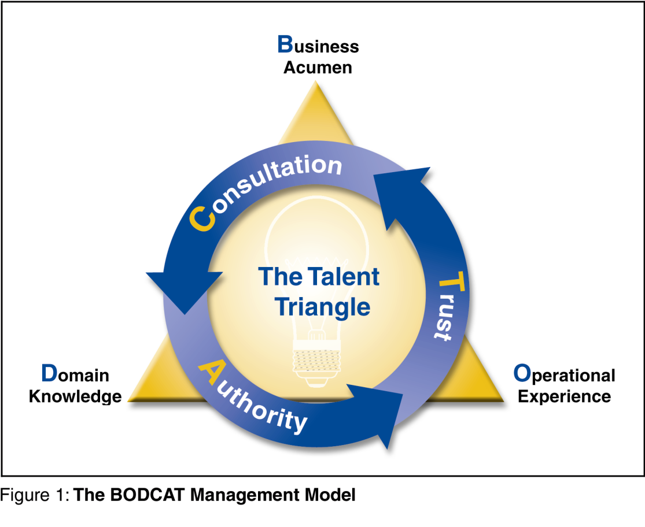
- Business Acumen: A person with Business Acumen is most often seen carrying the title CEO, President or CFO, because he or she has the skill, knowledge and experience to make key business decisions. These people are focused on HR management, investor relations and overall corporate development, which are all consistent with their expertise in venture evolution.
- Operational Experience (ops): People with ops experience are focused on infrastructure, logistics, and most importantly, product development. These founders often carry the title, COO, CTO, or VP of R&D and occupy the Operations Experience corner of the Talent Triangle. Their job is to make decisions that relate to the venture's implementation and execution of its business plan. They not only build what the startup will sell, but they are also responsible for making sure it is shipped and supported.

Domain Knowledge: The Domain Knowledge expert must have years of hands-on experience in the target industry, even if it is from a "big company" perspective. It is this person's job, to ensure that the startup's product and value proposition meet and possibly exceed the needs of end-users. In-depth knowledge of the car market, as well as an understanding of the relationships between automobile manufacturers.

Decision Making
-Decisions are made in consultation amongst all three elements and wherever possible, consensus is sought. This increases the probability that decisions will be sound, not only from a business perspective, but also from an industry standpoint. Similarly, it ensures that decisions are efficiently executed
- Authority: Each member of the Talent Triangle should not only have the responsibility for making decisions that fall within his or her own area of expertise, but should also reserve the authority to make the final call if consensus cannot be reached. Responsibility without authority will lead to frustration and substandard decisions.
- Trust: Management teams must at all times strive for internal agreement. Each member of the management team, must therefore, implicitly trust all partners, so that whenever consensus cannot be reached and a final decision is made, the other members of the team offer their energy and support for the decision. External parties such as VCs, clients, and suppliers must always believe that a venture's management team is in 100% agreement. Divide and conquer is an old investor trick. To prevent this, make sure that every member of the team is always singing from the same song sheet, even if they were originally not in agreement with the tune.

Startup Hiring Catch 22
To get Money we need a Team
To get a Team we need Money

Week Seven

Definition of Social Entrepreneurship
Social Entrepreneur: A venture that gives portion of each dollar it makes in profit to the community eg. Ben and Jerry’s – Vermont. Tom’s shoes.

”Lasting transformational benefit to society” – Martin & Osberg

Socially responsible corporation: Charitable foundations; self-regulation
Eg. Wal-Mart can still be Wal-Mart without donating.

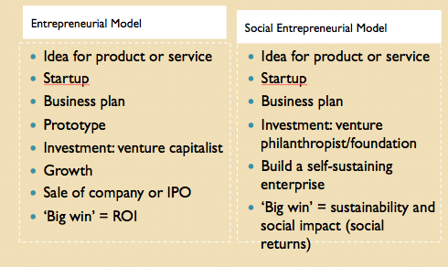

What is the Value Proposition for a Social Entrepreneur?
Social Entrepreneurship: Applying entrepreneurial principles to create ventures that address social issues and drive social change
Vs.
Entrepreneurship: Serving markets with new products and services for financial gain

Why Roger Martin thinks it is hard to define?
Social Entrepreneurship is so inclusive that it is now an immense tent into which all manner of socially beneficial activities fit.

So why is that so terrible?
If too many ‘non-entrepreneurial’ efforts are included, Social Entrepreneurship will lose its essence and fall into disrepute, attacked by cynics and skeptics.

Corp Resp vs. Soc ENT
Corporate Responsibility: Charitable foundations; self-regulation
  - Tim Horton’s, Starbucks, Wal-mart, McDonalds
Social Entrepreneurship: Businesses designed around social challenges in order to drive social change
  - Tom’s Shoes

Positive/Negative side of Social Entrepreneurship
- Positive side:
  - connotes a special innate ability to sense and act on opportunity, combining out-of-the-box thinking with a unique brand of determination to create or bring about something new to the world.
- Negative side:
  - It is an ex post term – you need a passage of time before impact is known.

Jeff Skoll case
Co-Founder of eBay, makes movies to create awareness.
Donates money
Started the Skoll Foundation

Kiva.org
Jessica Jackley is the co-founder of Kiva.org, an online community that helps individuals loan small amounts of money, called microloans, to entrepreneurs throughout the world.

Balanced feedback loop: Most of us just accept it even if it is somewhat unsatisfactory. The entrepreneur doesn’t accept it, but is attracted to the opportunity in solving this suboptimal equilibrium.

Iqbal Quadir: Founder, GrameenPhoneThey
Provide business opportunities; connect the village to the world; and generate over time a culture of entrepreneurship, which is crucial for any economic development.

What did Jeff Skoll learn from Ghandi?
“Bet on good people doing good things”

What else can the Skoll case teach us?
"Not everyone can be Gandhi, but each of us has the power to make sure our own lives count - and it's those millions of lives that will ultimately build a better world."

What did Jessica Jackley from Kiva.org teach us?
You can be a social entrepreneur without having money.
Giving money isn’t enough, go a step further and help them make use of money.
All you need is love

Larry Brillant Case

What was Gandhi's talisman? How did it help Google?
-"I will give you a talisman. Whenever you are in doubt, or when the self becomes too much with you, apply the following test. Recall the face of the poorest and the weakest man whom you may have seen, and ask yourself if the step you contemplate is going to be of any use to him. Will he gain anything by it?"

-How will our work help the poorest and weakest of the world?

Week Seven

6 Steps to Raising Capital
1. Be clear about why you want the money
2. Be prepared for external scrutiny
Bus plan>>> Exec Sum >>> Investor Pitch >>> Elevator Pitch
3. Compare, Contrast and Decide on the method of capital acquisition
4. Assemble the Best Team
Mngmt >>> Boards >>> Lawyers, Accountants, I-Bankers & IRs
5. Fine tune strategy based on chosen source
6. Relentlessly pursue Plan the Work : Work the Plan

Questions to ask yourself when preparing to raise capital
- Financing:
  - Have you raised seed capital?
  - Does management have skin in the game?
  - Why does your company need capital at this time?
- Management:
  - Are all the key management positions filled?
  - Is your team “well rounded” (remember the Talent Triangle) and experienced?
  - Are your Boards (Directors/Advisors) in place?
- Business Plan:
  - Do you have a strong well-developed plan to leverage the capital into high growth?
- Growth Potential:
  - Is there a large market potential for your venture?
  - At what stage is the market for your offerings?
  - At what stage is investor appetite for your opportunity?

The Real Questions
1) How much do I need?
2) What is the best source of funding based on:
• Cost of Capital
• Supply & Demand
• Market Conditions
• Stage of Venture
• Future Needs
• Timelines
3) Am I prepared to put in the time and resources necessary to get this done?

Company Goals
To obtain large amounts of capital for growth
To commercialize new technologies and advancements for profit
To obtain a ROI for shareholders & stakeholders
& to do it with the least pain/resources possible.

Spectrum of Financing
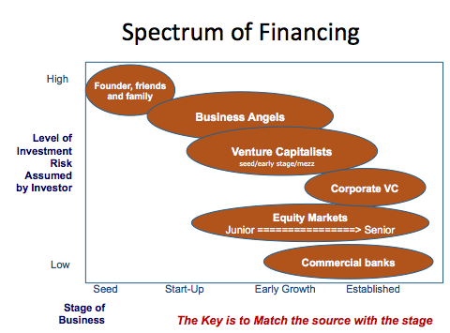

What Investors Want Back?
Friends and Family same as founders
Angels 10-20x
VCs
  - Seed 10-15x
  - Early 10x
  - Late 5x
Venture Debt 2x
x- what they originally invested

What Attracts Investors?
Team / Tech / Traction (What investors want)
OR
Management
Can these guys do it?
Do they have a “well rounded team”?
Magic
Can the tech/product work?
Is it 10x?
Can it solve the pain?
Market
Will anyone care?
Will it generate enough reward to justify risk?
(Risk Mitigation)
- Proof of concept/3rd party validation
- Solid management team
- Solid lead product with strong spin-off related products in the pipeline
- Well-protected IP
- Traction (milestones, strategic alliances, IP)
- Past start-up & seed now pushing for launch and operational excellence
- A high potential ROI to reward their risk

What Investors Look for in the Documents?
The 4 Obvious P’s
People: the management team
Product: and the Pain it addresses
Placement: industry size, status and saturation
Plan: go to market strategy
And that is what they want to learn from your Business Plan and Investor Deck

The documents: Independent data, Business Plan, Executive Summary, Investor, Presentation, Elevator Pitch, Back of the Napkin Diagram

Family and Friends
Funds 80% of seed startups
Shows Skin in the Game
Easier to overcome Management Risk
Often overpriced
Price too high will be downrounded by VC
Price too low give away too much
Always group investors as one

Questions Investors Ask
What is it that you do?
Why is such needed?
Who else agrees with you?
3rd Party Traction
Death by “No Competition”
How much capital do you need?
12-18s months of runaway
To hit next milestone
What are you going to do with my Cash?
Focus on objective targets and concrete actions
How much is it worth (i.e. valuation)?
Why you?
What are your goals?
How did you come up with this?
What stops me from taking it toChina?
How do you scale?
What's your Skin in the Game?
What happens if you hit by a car?
What stops me from doing it myself?
Who else believes?
How do we make money?

SME (small/medium enterprise) vs Startups
A small business owner
Focussed on doing it tough for a number of years and hoping they can make it as a business.

Start up
Thinks big, dream of their service being used by millions around the world and funded by VC’s and that is how they direct their business. Small business owners think about doing things slowly and building their business over time.

Good vs. Great
Companies don’t become great because they settle for good, and good is good enough.

Jim Collins: Six Timeless Fundamentals
- Be a CLOCK BUILDER not a time teller.
  - Shift from being a great product visionary to creating a great organization.
- Build your company around a CORE IDEOLOGY.
  - Create a sense of purpose beyond just making money zealously pursued; strong sense of identity
- Build a CULTLIKE CULTURE.
  - Go beyond value statements. Permeate the company with company ideology.
- HOMEGROW your management.
  - Insiders preserve core values at a gut level.
- Stimulate progress through BHAGs, experimentation & continuous improvement.
  - Big Hairy Audacious Goals
  - While core ideology provides continuity, stability, and cohesion, the drive for progress promotes change, improvement, innovation and renewal
- Embrace the GENIUS OF THE AND.
  - Clock build your company to preserve the core AND simultaneously stimulate progress.
    - Continuity AND change
    - Conservatism AND progressiveness
    - Stability AND revolution
    - Predictability AND chaos
    - Heritage AND renewal
    - Fundamentals AND craziness
The Bus
- Separate the 6’s from the 9’s.
- Take the 9’s
They’ll be able to adapt if the bus goes to a different direction.
They like being a part of something great

Perfect Storm Metaphor
- Several environmental factors can converge into a troubled challenge for a company needing extraordinary leadership - Leaders embrace challenge.
- Eg. Paul Tellier:
September 11, 2001 causes reduction in demand for flight and large lanes.
In 2004, Canadian dollar spikes and fuel prices rise dramatically.
Tellier detailed a three year restructuring plan.
Tellier changed Byzantine approach to financials by making them more informative.
You’ve got to set objectives

Seek company: Use your board to mentor your leadership. Rely on directors and mentors for support and help. Avoid isolation.
Three theories to explain how people become leaders.
- Trait Theory
  - People are born with leadership traits.
- Great Events Theory
  - Crisis brings out leadership qualities in an ordinary person.
- Transformational Leadership Theory
  - You can choose to become a leader.
  - It is the most widely accepted theory.
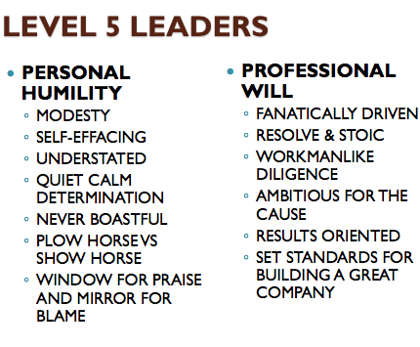
Eg Bill Gates – Donates all his money

Week 10

The Stockdale Paradox
– (From good to great) captured and put in the hunoi Hilton and tortured everyday for more than 2.5 years.
How did you survive?
Reflects what start-ups do
Found his way by knowing he would win one day by the fact that that day wasn’t here today.
Similar to adversity quotient

The Hedgehog Concept
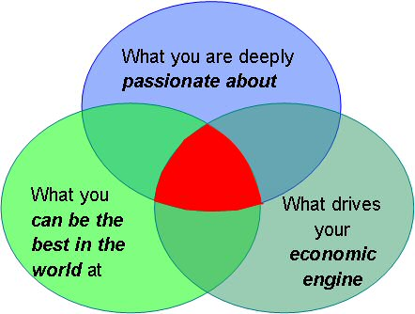
Pair -> Personal Hedgehog

Blue Ocean Strategy
- Creating uncontested market space making the competition irrelevant
- BOS is the result of a decade-long study of 150 strategic moves spanning more than 30 industries over 100 years (1880-2000).
-BOS is the simultaneous pursuit of differentiation and low cost.
- The aim of BOS is not to out-perform the competition in the existing industry, but to create new market space or a blue ocean, thereby making the competition irrelevant.
- Reorient your focus from competitors to alternatives and from customers to noncustomers of the industry.

eg. Wii
eg. Cirque du Soliel

Week 11

The S Curve
Diffusion of innovation: How, why, and at what rate new ideas and technology spread through cultures.
The four Phases of the S curve:
      - Initiation Phase
      - Planning Phase
      - Executive and Controlling
      - Closure Phase
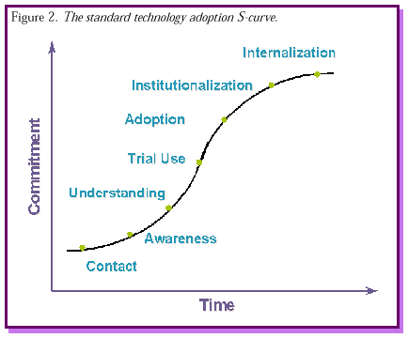

Mary Hans S Curve
- startup stage, (see “A” in Figure 1) entrepreneurs invest time and human and financial capital in the venture. The financial capital of the startup is derived from the entrepreneur’s own savings, “love funds”. provided by friends and family, or investments by venture capitalists.
- In the high growth stage (see “B” in Figure 1), the curve ascends steeply. This is where the learning curve changes significantly as the entrepreneurial venture grows either from market pull or competence push. Market pull is the result of high demand for certain products, general economic growth, or industry specific growth. Competence push relates to the core competence of the venture and entails an accumulation of experience and specific human or financial capital over time.
- The sustainability stage (see “C” in Figure 1) of the entrepreneurial process is characterized by slow growth.
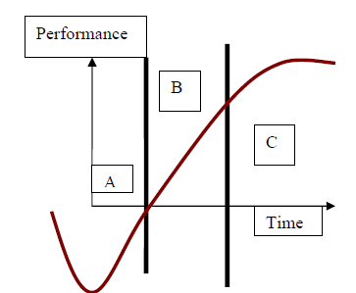
Simple rules in selecting which opportunities to pursue:
      - sell new products to established customers and established products to new customers, but avoid selling new products to new customers
      - products had to become number one or two in their market within three years, or the company would kill them
      - the company would only pursue opportunities that it could scale quickly, measured concretely by achieving $50 million in revenues within the first three years.
      - only offer products based on UTStarcom’s core platform
      - all new products had to offer unique features rather than offering me-too equipment and competing on price
Sull’s 4 Rules for Going Global
- Have a Clear Focus
  - Diversification is dangerous when a company decides to pursue a golden opportunity
- Standardize What Matters
  - To avoid the strain of rapid growth when scaling
- Manage Binding Constraints
  - Binding constraints are potential ottlenecks that could prevent a company from scaling altogether
- Hedge Against Unforeseen Problems
  - War Chest
  - Operational and financial discipline
  - Strong partners vested in your success.
  - Owners in it for the long haul.
  - Managers willing to take the plunge.

Moving an Elephant with a Mouse
Eg. GoldCorp: The Goldcorp challenge – people are challeneged to dig for gold and the person that finds the most wins a prize. The gold still belonged to GoldCorp but it made people work for free and rewarded them.

Smart money: Money that’s worth more than money – eg. ___ Invests in a industry that they know something about or network etc.
•The Halo Effect: Makes you look better. The good will (credibility) granted to the investee by smart money. – business invester.
Business Angels: High business individuals. Use their OWN money.
Venture Capitalist: An investor that manages a pool of funds on behalf of other investors. . – Invest other peoples money (OPM)
•Do large deals
Seed Investor: First money into a company from external funds.
Corporate VC: Outsourced research and development.

The theory of crowd sourcing: Where you outsource to a community. Not just looking internal but looking
Changed the rules

