SEPTEMBER
11/09/2012—Introduction
Opening Questions:
- Give 4 specific examples of how sports may be connected to religion
- Explain the “religious” meaning of fire in two different rituals
- Miscellaneous
- Note-taker
- HSS Elections
- Prandium! Wednesday, September 26th at noon:
“Fever Dreams: Febrile Disease and the Foundation of Hong Kong”
- Today:
- Photos
- Miscellaneous
- Introductions
- Study Abroad
- Course Syllabus

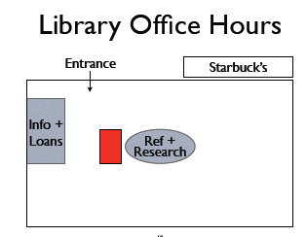
6) Philosophy:
- Religion and culture
- See first, ask questions later
- Expectations and assumptions
- Objectives:
Theories, concepts, methods
Analysis, argument, expression
5) Description
- STUDY of religion
- Complicated and important
Diverse
Questions
- Examples:
Contemporary culture
Indigenous traditions
4) More Information:
- UTM International Centre
(Davis Building 3121)
International.utm@utoronto.ca
- Ken Derry
(Dept of Historical Studies)
ken.derry@utoronto.ca
- Instructor:
- Ken Derry
- Office: North Building 152
- Office Hours:
Tuesdays 2:30-4 p.m. (in library)
Thursdays 12-1:30 p.m. (NE152)
- Phone: 905-569-4550 (email is better)
- Email: Blackboard!

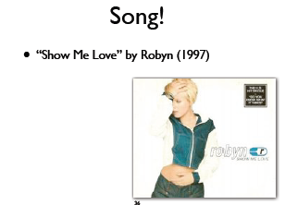

7) Grading
- Online participation (5%)
- Blackboard quizzes (10%)
- Tutorial participation (10%)
- Field research essay (15%)
- Film essay/group presentations (25%)
- Final Exam (35%)

_____________________________________________________________________________________
18/09/2012—Definitions
Opening Questions:
- What is “syncretism” and why is it a problem for the “world religions” approach?
- How might a sacred text be considered both religious and non-religious?

1) Today
- Miscellaneous
- Highlights from last week
- Finish Syllabus
- Field Research Essay
- Definitions:
Religions vs. Religion

5) Understandings Grades
- Show Up!
- Do the readings
- Pay attention
- Read instructions
3) This week’s tutorial
- Assignment:
Something about yourself
- Your own definition of “religion”
- Readings:
Nye, “Religions: Particular Traditions” (8-14)
Derry, “Change and Syncretism” (328-330)
2) Miscellaneous:
- Course texts
- Note-taker
- No laptops or phones
- Not getting emails from me..
- Discussion forums
list of TAs

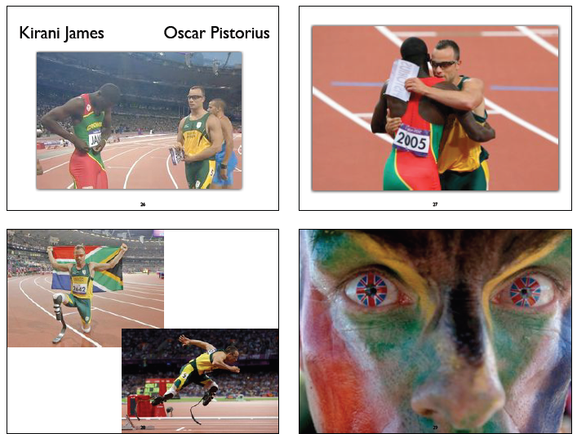

8)”Religion the Basics” –by Nye
- Religion is something that humans do
- Religion vs. Culture
- Complicated
- Social and individual
- Transcendent, abstract
- Concrete, day to day
- Problems of generalization
- Huge diversity
- Difference between AND within
- Buddhism, Christianity, Hinduism, etc…
- Study of religion does NOT = search for truth
focus on people, not gods
do they all share same “essence?”
data accessible to everyone

7) Sports
- Olympics:
faith/belief (nationalism, athletes)
Symbolism and history (circles, bibs, flags, flame)
ritual (ceremonies, face painting)
sacred space/time
mysticism and magic
- Nye (15-16)
athletes as cult heroes
worship teams
sacred space
mysticism and magic
6) Expectations:
- Respect
- Responsibilities
- Missed class
- Ask for help!
- Voice/dissent/shared knowledge

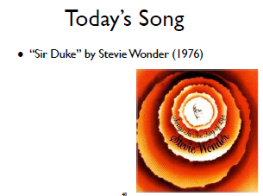

9)“Sir Duke”
• Founders:
Duke Ellington, Count Basie, Glenn Miller,
Louis Armstrong, Ella Fitzgerald
• How do you know if a song is good?
(i.e., if it has a “groove”)
➡ You FEEL it
➡ Like art or religion: you just “know”
➡ Very subjective!

11) Religion
- General/universal
- Participation in specific tradition not
- required
- Religious atheist?
- Questions of meaning, “ultimate truth”?
- Ideologies, nationalisms, film, sports, etc.?
- Ritual, community, ethics, sacred texts, etc.?
10) Religions
- Specific traditions
- “World religions” approach:
Separate, distinct
Classifications: texts, ideas, founders, histories, rituals, etc.
Useful starting point
- Simplistic
e.g., Buddhism is single tradition
No overlap/influence between traditions (syncretism)
- Exclusionary
e.g., omit Indigenous religions
global, not local

_____________________________________________________________________________________
25/09/2012—Definitions continued and Culture
Opening Questions:
- Using James Cox’s definition, explain how something can be both religious AND not religious?
- Give two examples showing how the internet may be helping to cause religious hybridity and change.
2) Today
- Tutorials
- Miscellaneous
- Finish “Definitions”
- Culture
1) The Big Bang Theory
- Thursdays @ 8pm
- Just need to watch
- This week: power

4) Definitions
- Religions = specific traditions
- Religion = general/universal
- Pros and cons
3) Tutorials this week
- Sign up! (Registrar’s office)
- Field Research Contract
- Readings:
Nye, “Cultural Hybridity and Religious Syncretism” (51-54)
Derry, “‘Primitives’ and the Problem of History” (331-333)
- Assignment: family tradition (Origin? Changes over time?)

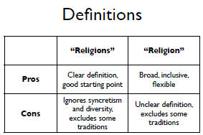

5) Is it religious?
- “Hearing of the glory of the Lord of the Universe, the mind becomes fearless.”—Guru Granth Sahib
- “ Have witnesses when you barter with one another”—The Quran
- “I fell down on my knees and thanked Heaven from an overflowing heart” –Adolf Hitler
- “The man served tea. He poured his visitor’s cup full, and then kept on pouring”—Zen Buddhism Story
- “If men get into a fight with one another; and the wife of one intervenes to rescue her husband from the grip of his opponent by reaching out and seizing his genitals, you shall cut off her hand; show no pity” –Hebrew Bible
- “No person shall threaten any other person with damage to such person’s property” –UTM Academic Calendar
- “See what large letters I make when I am writing in my own hand!”—The New Testament
- “When it was cooked, he ate and ate. But he ate too much and very soon suffered the runs”—Red Willows

6) Religion
- Religion begins with the quest for meaning and value beyond self-centeredness (Huston Smith)
- Religion is a system of beliefs and practices related to sacred things, uniting people into a community (Emile Durkheim)
- Religion is anything that involves “non-falsifiable realities” (James Cox):
God(s)
Salvation
Soul, love, evil
Morality
Meaning
- “Red Willows”:
None religious:
-eating too much bear meat is bad for you
Religious:
-Supernatural: Nanabush, talking bear
- Origins: red willows, landscape
-Morality: self vs. others

7) Summary of Religion
- What people do
- Part of culture
- Has many meanings
- Many methods, theories, disciplines
- Need to ground study in data
- Not about eternal/essential “truth”
- Dozens of definitions by scholars
- Means different things to different people
- Issue of clarity
- Problem: how to study something when you don’t know what it is
- Avoid assumptions about what IS or is NOT religious

8) Culture
- Two meanings:
1) Cultural products
2) Shared system/way of life
- Culture is never fixed/static:
hybridity/syncretism (e.g. James Clifford)
New circumstances/ideas
Diversity (e.g. “Canadian Culture??!!”
Etc.
- Religion and Culture:
each can influence the other
”influence” does not = “become the same as”
hard to understand/predict…
- Syncretism/hybridity = mix of different cultures and/or religions
- Indigenous traditions and syncretism:
Native North American religions and Christianity
African religions and Islam
Japanese Shinto and Chinese Buddhism
- Chris Brown + Christianity + YouTube = JK wedding video
- JK wedding video + Christianity + Gangnam Style + YT = San Francisco wedding video
- Issues:
Hybridity and change
Domestic violence
Definition: blasphemy vs. celebration/joy
- American Christianity + internet (blog) =38 RAOK
- 38 RAOK + American Idol + Islam + YT =22 RAOK
- “Innocence of Muslims” + riots +Newsweek + Twitter + FB =“It’s not my religion” + #MuslimRage
- Issues: hybridity and definition
- Raymond Williams
Ideal/elite: “high” culture
Popular: “low” culture
Who makes/controls definitions?
Is elite culture “better”?
- Stuart Hall:
Culture as social system (=everything!)
“What people do”
Power: popular vs. elite

- This is the "Gangnam Style" wedding video: http://vimeo.com/49218614
- And the famous video of Jill and Kevin's wedding march (seen by almost 80 million people now!): http://youtu.be/4-94JhLEiN0
- Robyn Bomer's 38 Random Acts of Kindness: http://mixmingleglow.com/blog/?p=1358
- Syed Muzamil Hasan Zaidi's 22 Random Acts of Kindness: http://lybio.net/syed-muzamil-hasan-zaidi-22-random-acts-of-kindness/nonprofits-activism/

- _______________________________________________________________________
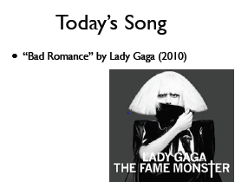
OCTOBER:
02/10/2012—Finishing Culture and Starting Power
Opening Questions:
- Explain Althusser’s ideas about “repressive state apparatus” and “interpellation” using lyrics from today’s song
- How do conflict issues in Long Island and the Big Bang Theory relate to Foucault?
2) Tutorials
- Readings:
Nye, “Althusser and Ideological Apparatus” (65-9)
Derry, “Loss of Religion” (361-2);“The Potlach” (363)
- Assignments:
Field research contract
CMS bibliography (for Nye)
1) Today
- Miscellaneous
- Finish: Culture
- Power

3) Religion
- “Non-falsifiable realities” (James Cox)
- CAN anything be “religious”?
Yes
- IS everything “religious”?
No!
- Example: wine
- “Is it religious”? (quote vs. source from last day…)
4) Culture
- Religion and change:
Has any religion NOT changed?
- Relative importance of change
Is “core” of religion the same?
Theological question! (NOT academic)
“what people do”
- Examples:
Indigenous religions: syncretism
Christianity: culture photos, internet (e.g., Gangnam Style)
Various: microphones, screens, internet, sacred texts

4) Culture Continued…
- Raymond Williams:
Ideal/elite: “high” culture
Popular: “low” culture
NOT about quality
IS about wealth/power of consumers
Definitions CHANGE (e.g., Shakespeare, Bible)
- Stuart Hall:
Popular culture: “power relations established and resisted”
Support of status quo
Critique of elite culture
- Probably not so useful essay theories:
Culture as what people do
Definitions of elite/popular culture
Religion as system of symbols (Geertz)
Each group has its own culture (Tylor)
- Possibly useful essay theories:
Change/hybridity/syncretism (various)
Power: popular vs. elite (Williams/Hall)
Sub-cultures and resistance (Hebdige)
Popular vs. orthodox religion (Sutcliffe)
Religion as “social glue” (Durkheim)
- University as “social glue”:
Ways in which UTM fosters community?
Ways in which UTM discourages community?
- Pattern: UTM and community
- Idea: “social glue” (Durkheim)

5) Power
- Power: politics, economics
- Theories: concern with social justice
- Ideology: power as natural / obvious
- Power relations are complex
Oppression AND resistance
Oppressed → oppressors
Etc.
- Power relations exist in all human communities / institution
Including religion!
(No special treatment by scholars)
Relations within specific religions AND between religions and larger society
- Religion and larger society:
Create, sustain power
Subvert, oppose power
- Marx
- Gramsci
- Althusser
- Weber
- Foucault
- Colonialism / violence

6) Marx
- Marx and Engels, On Religion
- Religion CAN be an ideology
- Economics → religion
- “opium” / “imaginary flowers”
Masks suffering
Reward after death (vs. conditions of life)
“Daydreamin’”
- “Religious suffering is, at one and the same time, the expression of real suffering and a protest against real suffering. Religion is the sigh of the oppressed creature, the heart of a heartless world, and the soul of soulless conditions. It is the opium of the people.”
- Religion: promotes the (unjust) status quo
- “Turn the other cheek”
- “Love your enemy”
- “Let every person be subject to the governing authorities; for there is no authority except from God and those authorities that exist have been instituted by God.” (Romans 13:1)

7) Gramsci (“gram-she”)
- Hegemony: power relations as natural
- Those who are ruled over feel they have a stake in powers that control/exploit them
Colonialism
High school
- Counter-hegemony


8) Althusser (“alt-sair”)
- Repressive state apparatus
Police, army, etc.
- Ideological state apparatus
Education, media, religion, etc.
- Interpellation: actively participate in own exploitation
Illusion of choice (vs. Marx: we are “drugged”)
Colonialism (e.g., religion)
Attending university?
Critique by Nye

9) Weber (“vay-ber”)
- Protestantism + capitalism
Self-discipline, hard work, thrift, material achievement
- Religion → economics (reverse Marx)
- Economics → power

11) Other “Panopticons”?
- “Reality TV” (e.g., Big Brother)
Related movies: 1984, Brazil, V for Vendetta
- Enemy of the State, Law Abiding Citizen
- Cameras (government and civilian)
- Electronic payment (debit/credit cards)
- The internet (user-generated content; ISPs)
- Secret shoppers
- Santa Claus
- God(s)!

10) Foucault (“foo-coe”)
- Power relations are complex
- Panopticon
Prison
Always being watched (but can’t see watcher)
Internalize surveillance
- Power, knowledge, discourse
God(s)
Religious authorities
Teachers
Friends / spouses / parents
Bullies

Turf Dancing in the Rain: http://youtu.be/NbkCkYWctJ8
_____________________________________________________________________________________
09/10/2012—Finish Power and Start Gender
Opening Questions:
- Give 4 examples of how specific gender stereotypes are reinforced in The Big Bang Theory.
- Explain the connection between rig, GQ, and recent problems in Bet Shemesh, Israel.
3) Tutorials
- Text:
“Essay 1 - Model Paragraphs Using CMS”
- Assignment:
Write out thesis statement for one pattern
(Likely more than one sentence!)
2) Essay
- Model paragraphs using CMS posted on BB
Pattern and analysis
Citations and bibliography
- Thesis
Data/method/conclusion
“I examine [PATTERN] using [THEORY] and conclude that…”
1) Today
- Miscellaneous
- Finish: Power
- Gender
- BBT + religion

4) Power
a) Review: theories + essay
b) Foucault + Big Bang Theory
c) Violence + colonialism: next week!
- 1. Power relations WITHIN a religion
- 2. Power relations BETWEEN religion and larger society
- Power relations are COMPLEX
- Religion:
Create, sustain power
Subvert, oppose power
- Marx: Religion CAN be an ideology (“drugs” us into accepting things as they are)
Religion: provide comfort?
Accept status quo?
- Gramsci: Hegemony (oppressed believe they have a stake in power relations)
Religion: support existing unequal power relations?

4) Power Continued…
- Althusser: Interpellation (unknowingly participate in own exploitation) and repressive / ideological state apparatus
Hard to prove people ARE “brainwashed” (=interpellation)
Attempts to “brainwash”? (=ideological apparatus)
Support for police/army/etc.? (= repressive apparatus)
- Weber: “Protestant ethic” (religious beliefs lead to/support Capitalist economic system)
Implicit or explicit economic activity?
Connection to religious ideas/teachings?
- Foucault: Panopticon (internalize surveillance and change behaviour)
G20 video (power reversal)
Are people being literally or symbolically watched?
What KIND of watching is this? (e.g., punitive or supportive)
RLG101H?
- Foucault: Power, knowledge, discourse (all three terms are interconnected)
Who talks? Who appears knowledgeable?
Who seems to be in charge (+ how can you tell)?
Note varying levels of power/knowledge/discourse (e.g., prof/TAs/students)
Contract(s)?

6) Religious “Loopholes”?
- Power relations are complex!
- Orthodox Judaism
No work on the Sabbath
Eruv (Hebrew): ritual enclosure
2011: Jewish conflict over eruv in Long Island
The Daily Show
5) Contracts
- Religion and relationships
Between people and god(s), sacred items, other people, etc.
- Agreements (“covenants”)
Form of discourse + knowledge
Power: responsibilities + consequences
- Big Bang Theory?

7) Judith Butler
- Gender as constructed by culture (+ religion)
Biology ≠ gender
Gender as performance (consider: public vs. private)
Sexual orientation
Is gender “either/or”?
Role of discourse (e.g., media!)
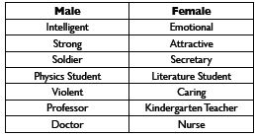

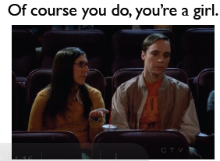
8) Gender +Media
- Commercials:
Beer
Jewelry
Cars
Cooking
Cleaning

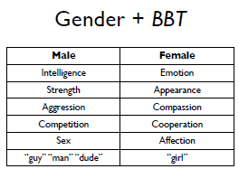

9) Gender + BBT
- Exceptions that reinforce stereotypes of “masculine” and “feminine”?
Male characters: child-like, physically weak
Sheldon: not interested in sex
Leonard: focus on relationship
Penny: likes sports, beer
Amy: scientist, clothing, interested in sex

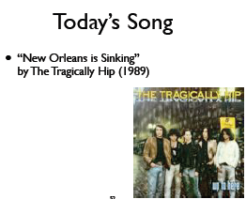
10) Gender
- Key issues:
Gender constructions (women AND men)
Patriarchy (women given less value/power than men)
- Role of religion?
- Theorists: critique and reform
- Sample test: imagine genders reversed

11) Mary Daly
- Patriarchy!
Understand gender-based power in order to challenge it
How is male power justified?
Patriarchy as ideology
Religion!
(Tends to over-generalize)

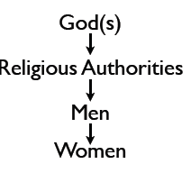

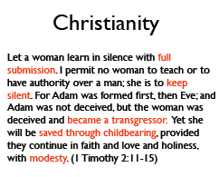
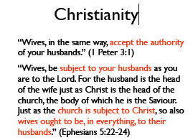

13) Luce Irigaray
- Language / “the symbolic”
Reflects gendered perspectives
What is spoken / written?
Other kinds of “language”?
12) Elizabeth Schussler Fiorenza
- Feminist hermeneutics of suspicion
Don’t take texts at face value
Consider the source/focus
Texts by and about males?
Male perspective presented as universal?

15) Islam: “Veiling”
- Complex issue
- Colonial arrogance / hypocrisy
- Western feminism
- Egypt: hijab and employment
Issues of context and agency
14) Gender Continued…
- Shukrallah: women often represent “traditional values”
What do roles suggest about the community’s values?
- Asad + Spivak: Agency
We act AND are acted upon
Importance of context

_____________________________________________________________________________________
16/10/2012—Essay Writing
Opening Questions:
- Explain the connection between religion, GQ, and recent problems in Bet Shemesh, Israel.
- What lesson can we learn about essay writing from Penny’s response to seeing Leonard and Alex together?
2) Tutorials
- Texts:
Derry, “Moko” (354)
Nye, “Religion, Gender, and Agency” (92-5)
- Assignment:
Message(s) about gender in the story of moko’s origins?
1) Today
- Miscellaneous
- Culture, power and gender
- Essay writing

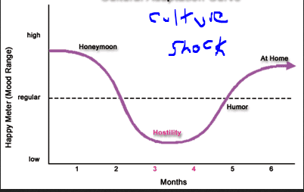
3) Culture Shock
- Make friends!
- Get oriented to your surroundings
- Comfort items
food, music, activity
- Take care of yourself
- Ask for help!

5) LGTBQ
- Religion / culture
- Heterosexuality as “normative”
- LGTBQ people viewed as “sinful” /“monsters” / “deviant”
Evil (worst) or lesser than “us” (best)
Proportional absence from popular culture (cf. “Where the Girls Aren’t”)
Power issues (e.g., denial of rights)
4) Culture, Power, Gender
- Feminist?
“man-hating” / “extreme”
- Equal rights and opportunities
- Re-define “violence” (not just physical)
- PATTERNS!?
- Religion: gods, texts, leaders, founders, experiences, scholars
All male!
- Canada: power (income / professions)
- Study of religion: “paradigm shift”
- Essay: why study religion from “outside”
- Pattern?
Women DEFINED by / as their bodies
Objectification
Distraction for religious men
- Bet Shemesh, Israel
Orthodox Judaism
- Exceptions exist re: gender, but . . .
- PATTERNS:
Absence (e.g., “Where the Girls Aren’t”
Devaluing / objectifying
Gender constructions (e.g., re: “voice”)
Power

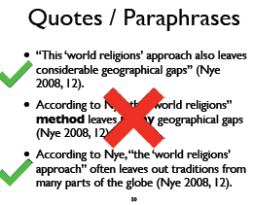

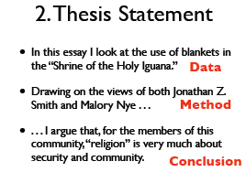
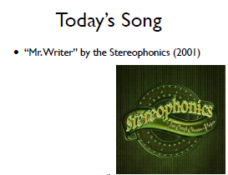

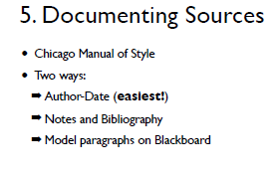
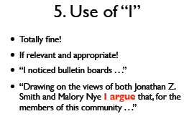

____________________________________________________________________________________
23/10/2012—Belief
Opening Questions:
- "All religions essentially believe the same thing." Discuss.
- Explain the difference between cognitive and effective beliefs, with reference to horror movies and Sheldon from BBT.
2) Tutorials
- Texts:
Derry, “The Afterlife” (336)
Nye, “Belief and Reductionism” (108-9)
- Assignment:
What story brings you comfort? Why?
1) Today
- Miscellaneous
- Field Research Essay
- Belief
- Film Essay

3) Belief
- Big Bang Theory
- World religions
- Martin Luther and the study of religion
- Reductionist views
- Non-reductionist views
- Cognitive approaches
- Belief and practice

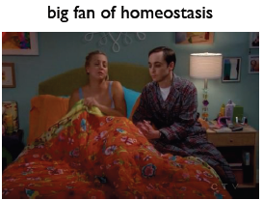
4) Belief + BBT
- Leonard and Penny: No clear religion
- Amy: Agnostic? Deist?
- Bernadette: Catholic
- Raj: Hindu
- Howard: Jewish
- Not fully observant (e.g., dietary laws)
- Sheldon:
Atheist
Science!
Fundamentalist Christian mother
Other?

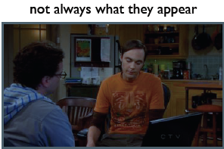

5) Awareness Test
- Seeing is believing
- Believing is also seeing! (+NOT seeing)
Tend to reinforce views we already have
hard to incorporate new data (=science!)
Essay: see what we expect, not what we don’t
Gender issues (e.g. women in orchestras)
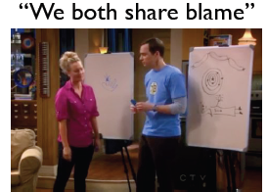

6) World Religions
- General views about religions:
1) stereotypes
2) the same beliefs?
3) peace and violence
- Stereotypes:
“Muslim terrorists”
“Christian terrorists”
“Buddhist terrorists”
Reel Bad Arabs (Shaheen): film + book
- Do all religions believe in the same basic things?
religions don’t believe anything
people believe
religion: what people do
- Same essential beliefs among all religions?
- Stephen Prothero, “God is not One”
- ProblemSolution:
Buddhism Eighfold Path
Christianity salvation through Christ
Hinduism Dharma
Islam submission to God
- Religious beliefs: peaceful or violent?
Religion: focus on people
People: peaceful and violent
texts: peaceful and violent

7) Colonialism
- “Eden” → cooperation
- “Canaan” → subjugation, genocide
- Duncan Campbell Scott (“The Onondaga Madonna”)
- “Primitive,” “no religion,” “vanishing race”
- Resistance
- Appropriation

8) World Religions Continued..
- Power of belief
- Belief and change
- Official vs. individual beliefs
- Belief ≠ lack of doubt
- “Doubt is part of all religion. All the religious thinkers were doubters.” (Isaac Bashevis Singer)

10) Reductionist
- Religion is “really” about something else (of THIS world)
- Feuerbach
God is a projection
Xenophanes: horse gods look like horses
Marx, Freud
Sheldon’s belief about himself?
9) Study of Religion
- (Over-)emphasis on belief
- Protestant Reformation (Christianity)
- Martin Luther: 95 Theses (1517)
Catholic church: institution b/t person and
- God; over-emphasis on rituals
Faith over works (Ephesians 2:8-9)
- Focus on belief: Protestant Christian bias
- Tylor: Religion is belief in spiritual beings
- Indigenous (and other) traditions: doing more
important than believing
- Stories and beliefs
Is literal meaning the only one?
- Indigenous traditions
Origin stories
Relationships vs. doctrine / theology
Importance of place
Locative vs. universal (p. 364)

11) Non-Reductionist
- Assume beliefs point to reality or “essence”
- Circular: must exist b/c people believe
- Hick: “the Real”
- Eliade: “the Sacred”
- Critiques: Wiebe, McCutcheon

12) Cognitive Approaches
- Study of the brain
- Luther Martin ≠ Martin Luther!
- Non-reductionist (Whitehouse)
- Reductionist (Guthrie, Boyer)
13) Belief and Practice
- Cognitive vs. affective (thought vs. action)
Which matters more?
Bell: emphasis still on belief (p. 125)
Interpretation: Hindu woman + spider
Horror movies
- Sheldon
- Cognitive belief: SCIENCE!
- Behaviour: ignores data (= Penny and Amy always win)
- Affective belief?
Sheldon is the smartest in the room

14) Belief: Summary
- Influence of “belief” on study of religion
- Various approaches to study of belief
- Avoid assumptions!
What people / religions “believe”
(e.g., peace and violence)
Centrality of belief to religion
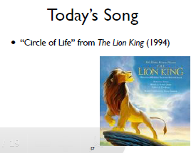

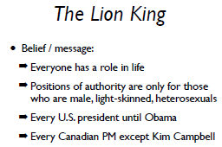

The "Awareness Test" video I showed in class tonight. Use it to amaze your friends! :-)
http://youtu.be/Ahg6qcgoay4
_____________________________________________________________________________________
30/10/2012—Ritual
Opening Questions:
- How do rituals from three traditions (Maori, Chirstian, Sikh) reinforce community and relate to sacred texts?
- Explain how three different rituals involving Simba are connected to a key belief promoted by The Lion King
2) Tutorials
- Texts:
“Sacrifice” (Derry 346-8)
“Rituals and Communication” (Nye 138-9)
- Assignment:
Family ritual: expressive/symbolic meaning?
1) Today
- Miscellaneous
- Film Essay
- Rituals:
Instrumental vs. expressive actions
Rites of passage

3) Ritual
- Definition issue again
what is ritual?
what is religious ritual?
Can any ritual be “religious? (YES)
Is every ritual “religious”? (N)
- Instrumental vs. expressive action
”literal” vs. “symbolic” meaning
- Religious ritual can have BOTH literal and
symbolic meanings
- Hair (growing or cutting)
- Receiving grades
- Wedding

4) Big Bang Theory
- Repeated actions?
comic book store
school cafeteria
apartment: laundry room, living room, walking up stairs
Sheldon!

5) Ritual Continued..
- “Meaningful action” (OR experience)
Special actions / times / places
Difference in reality / experience(e.g., “sacred” vs. “profane”)
Can reflect AND/OR create differences
(Sometimes difference is/seems minor)
NOT just about repetition

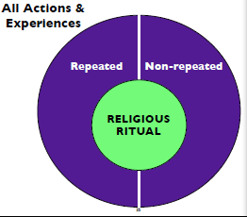
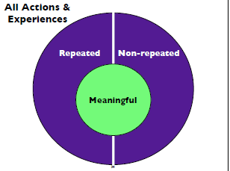

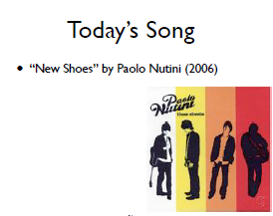

7) Arnold van Gennep
- Transformation (of space, time, social relations, etc.)
- Boundaries
- Rites of passage:
- Separation
- Liminality
- Incorporation

6) Ritual Continued..
- “Meaningful action
Order/structure in face of chaos/pain?
- Connections: people, beliefs, history, etc
Poker night
- Remember: culture, power, gender!
- Foucault + power relations
Vision quest
Wiradjuri male rite of passage
Xhosa (“thosa”) cow sacrifice
- Rituals and society
Cultural beliefs, values, etc.
Community!
Often connected to texts / stories
Examples?
- Langar (Sikhism)
Vegetarian food service in Gurdwara
Free to all
Principles of equality / no discrimination
“the light of God is in all hearts”
- Feed approx. 80,000 people / day
- Golden Temple (Amritsar)

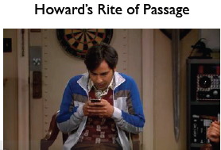

The Golden Temple Langar video:
http://www.aljazeera.com/programmes/frames/2011/01/2011113153524699670.html
Info on snake handling churches:
http://en.wikipedia.org/wiki/Snake_handling
_____________________________________________________________________________________
NOVEMBER
06/11/2012—Texts
Opening Questions:
- List 4 diff ways in which the meaning of a text is not just about the words themselves.
- What does AJ Jacobs' experience tell us about sacred texts in terms of context, cafeterias and authority.
1) Today
- Miscellaneous
- Essays
- Ritual: Finish
- “Texts”

3) Texts
- Max Müller:
Study of religion = study of sacred texts
Origins, (male) founders
“Pure” tradition vs. changes over time
Protestant Reformation (Martin Luther)
- Quotation marks? (“Texts”)
- Oral “texts”
- Non-official / non-mainstream texts
- Stories, poems, films, TV shows, lyrics, commercials, billboards, etc., etc.
Roland Barthes, Mythologies
- Meaning beyond words:
Interpretations can change over place and time
Influence on behaviour
Importance of physical text
★ e.g., Judaism, Sikhism
Understanding vs. content
- Authorship
Sensitive question re: sacred texts
Attribution of authorship is highly political
Conflict between beliefs and historical / textual evidence
Assumptions of intentionality
- Authors given authority (Nye, Foucault)
- Author is NOT authoritative (Barthes)
E.g., patriarchal texts
- Gendered readings (Nye, Fetterley, Leslie)
- Contexts of reading / importance of
- READER (Iser, Fish)
- Meaning of words not fixed (Derrida)
- Bible:
Many authors / editors / texts (“books”)
Approx. 3000-1900 years old
- Dr. Laura Schlessinger:
Radio talk show host / counsellor
Conservative, anti-homosexual

2) Ritual
- Symbolism
One way to think of “meaning”
Symbols are not universal!!
One symbol can have many meanings; and meanings can CHANGE
Often participants do not know meanings
Importance of context (time, culture, gender, etc.)
- Durkheim: ritual brings people together
Function NOT related to content
- Freud: ritual = neurosis
Brings comfort; avoids real problem(s)
- Whitehouse: ritual + memory retention
Values, beliefs, events, etc.
- Bell: ritual + relationships
Each ritual action is particular

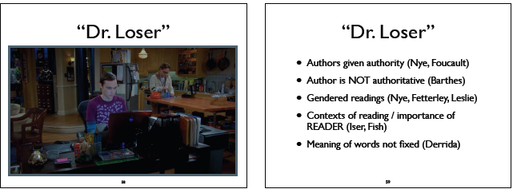

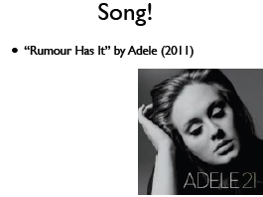

A.J. Jacobs discussing his Bible project: http://www.ted.com/talks/a_j_jacobs_year_of_living_biblically.html
_____________________________________________________________________________________
13/11/2012—Visual Culture
Opening Questions:
- Give 3 ex's of indigenous art or architecture that demonstrate the idea that "what you see is not what you get"
- Using 3 ex's, show how elements of visual culture relate to the belief promoted by The Lion King.
2) Tutorials
- Readings:
Plate, “Religious Seeing and Seeing
- Religion” (p. 10-11)
Derry, “Masks” (p. 352-353)
- Assignments:
Something visual that is meaningful to you personally (e.g., photo, tattoo, artwork, etc.)
Optional: film essay thesis statement
1) Today
- Miscellaneous
- Texts: finish
- Visual Culture

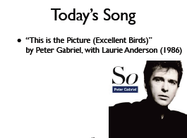
4) Indigenous Traditions
- Exclusion from study of religion
Doctrine vs. practice
- Power of images
Visual learners
Islam: Qur’an, hadiths
Judaism, Christianity: 10 commandments
3) Visual Culture
- “Field of vision”
Image itself
Relation b/t FORM and CONTENT
Creator(s)
Discourse (title, explanation, responses)
- “Field of vision”
Historical context
Identity of viewers
Cultural context (of everything!)
Institutional context
- How we see / how we live
Desire for transformation
Not just object, but also (changing) environment
Makers AND viewers
- “Religious seeing”
Visuality and construction of reality (Morgan)
Visual culture and religious practice
Context: belief, devotion, and transformation
- Exclusion from study of religion
Doctrine vs. practice
- Power of images
Visual learners
Islam: Qur’an, hadiths
Judaism, Christianity: 10 commandments

_____________________________________________________________________________________
20/11/2012—Contemporary Religion
Opening Questions:
- Explain why a decline in attendance at formal religious services may NOT indicate a decline in religion overall
- Briefly describe 4 examples of specific Indigenous religions taking on modern forms

1) Contemporary Religion
- Local AND global levels
Macro-level similarities/patterns AND micro-level differences/diversity
- Modern trends with old connections
Paganism, spirituality, etc.
- “Non-religious” cultural products
Film, literature, TV, music, art, YouTube, etc.
- What is “religion”?
Going to church / temple / mosque / etc.?
No “essence” / clear definition
Why do we look to the past? (misplaced sense of authenticity?)
Religions CHANGE
Connection to CULTURE

1) Contemporary Cultures Continued..
- Popular culture:
References to “religions”
Connections to “religion”
- The Big Bang Theory:
“Religions”: Hinduism, Christianity, Judaism
“Religion”: Rituals, beliefs, texts, relationships, meaning, etc.
- Indigenous cultures
- Reclaim identity, rights, land, traditions, etc.
- Some “return” to traditions, mix old with new
Maori: full moko on women
Yoruba: Ogun (god of war) connected to welders, car mechanics, and chauffers
Painting, literature, film

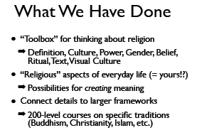
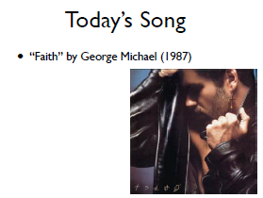

____________________________________________________________________________________
27/11/2012—Group Presentations (for those who didn’t do the Film Essay)
1st Presentation: “Bridesmaids”
- Main belief: No one can change your life except for you
“Don’t ever let anyone step all over you. Just open your heart and your mind. Is it really fair to feel this way inside?” [Chorus]
- Ritual:
Analyzing: bridal shower planning and gift giving
Beattie (135):
*instrumental actions (focus on the bride): theme, location, invitations
* expressive actions (competition between Helen and Annie)
Problem: Helen plans the bridal shower (Annie’s self-worth)
Solution: Annie has the choice to work in partnership
Connect to belief: only Annie has the power to step back and change the situation (She doesn’t have to compete with Helen)
- Text:
gift-giving (who is giving the gift)
Michael Foucault- “Authors are created within a context of social power relations…what we see as an author is what we as reader impute them to be, to allow us to give sense and meaning to a text” (171)

1st Presentation Continued…
Helen’s gift- the fact that Helen (the author) gave Lillian the trip to Paris had a negative impact on Annie in specific
If anybody else gave Lillian a strip to Paris, it would not have the same effect on Annie
relate to belief
- Visual Culture
Mary Douglas (p.66)
-separating what is “pure” from what is “dirty”
-what is “dirty” is what is “out of place” or doesn’t belong
Annie at the Bridal Shower
-appearance
-facial expression
-stance
-out of place, doesn’t belong, absurd comments
-she is literally dirty
how it relates to belief:
-resists change
-choosing to fight with Helen and be unhappy to her best friend
- Ritual:
Rituals communicate subtle and unsubtle messages (Nye, 138)
Unsubtle: “take control of your life”
-physical force
-carrot cake
Subtle: bullying –self-worth
problem: Annie’s life
solution: “take control of your life”
connection to belief: only Annie has the power to realize she is the solution to her problems
- Text-Language and Reality
Derrida’s theory of “logocentrism”—Links between language and reality are not reliable (159)
-it is language, not text which is everything
-the words that we use to speak, to describe, to communicate, to evoke…are the world in themselves
-human experience is mediated through language (159)
Megan uses swear words to get Annie’s full attention
- Text and the Power of Masculinity
Meagan’s pep-talk has a dramatic effect on Annie due to Meagan’s “maleness”
Meagan physically fights with Annie—depicting masculine behaviour
- Visual Culture
Brent Plate (p.69)
-connection between how we see and how we live
-Annie’s business fails, affects the way she lives her life
desire of transformation
- Problem and Solution = YOU! http://www.youtube.com/watch?v=zOK7ijzywgs



2nd Presentation: The Dark Knight Rises
- Message/belief: In time of chaos, each of us must make sacrifices in order to protect the ones we love
- Ritual:
Batman is willing to sacrifice himself to remove the bomb from the city relates to
Emile Durkheim’s theory that religion brings together rituals and makes them feel part of a larger cohesive whole (society) –Nye, 141
Bane is willing to sacrifice himself to allow Talia to escape relates to
Van Gennep’s threefold scheme
Talia sacrifices herself by driving the truck underground and flooding the core reactor…relates to “ritual and performance”—Following the script of a child’s role and fulfilling and protecting her father’s wish Nye argues that ritual is like a script in a performance which is simply a script until it is performed
Talia and Bruce use safety nets to protect Bane and Gotham city respectively …relates to “ritual and repetition”—Nye’s theory that rituals “often use repeated actions”—Nye, 142
Commissioner Peter sacrifices himself in his land stand to try to and destroy Bane’s army ..relates to “rituals and power”—Nye’s point about all rituals expressing power
- Visual Culture :
The bat sign burning on the bridge—components
-people trapped = hope, criminals believe = sign of resistance and batman is back = sacrificed his fear of death (Brent’s theory on Visual Culture)
The mask isn’t just to keep Bane breathing, it has a deeper meaning = symbol of love (Bane’s mask-body and mind)
the bat coptor –Brent’s theory on the field of vision (the batcoptor is the link for different views—only way to save Gotham city)
batman statue—identity of those who view image (the statue represents batman’s ultimate sacrifice for the city)
- Text:
Author vs. Interpreter –“The author is the ideological figure by which one marks the manner in which we fear the proliferation of meaning” –Foucault –Bruce in prison experience vs. Talia in prison…they both have to sacrifice their well-being to escape the prison
Selena is willing to sacrifice anything to anyone for her clean slate which becomes the world itself for her—Nye 159

3rd Presentation: The Godfather
- Message: Often circumstances drives one to make choices that might not be satisfying as these choices might not correlate with one’s ideal
- “Correlation between the internal and external space” [Plate 2002, 12]
- “Medium and the message” [Plate 2002, 5]
- “Identify of those who view the image” [Plate 2002, 5]
- “Ritual is used to describe very varied types of behaviour, helping us try to understand things that people are doing” [Nye 2008, 130]
- “Symbols are defined as the lowest unit of ritual. Rituals symbolize more than a materialistic approach” [Nye 2008, 135]
- “Ritual actions which involve transition have three important stages: separation, liminality, incorporation” [Nye 2008, 146]

4th Presentation: The Hunger Games
- Message: In order to reach a higher achievement and become the best in a lifelong battle, you have to bear the responsibility for your identity, do not follow the same path as everyone else (repression). One must stay unique to stand out from the majority.
Evidence: “I just keep wishing I could think of a way to show them that they don’t own me. If I’m gonna die, I wanna still be me” –Peeta
-Peeta is repressing his true feeling of being unique and he is reluctant to be controlled
- Ritual:
Theory—John Beattle
-instrumental acts are preformed primarily for their practical value: to achieve some goal, to get something done (Nye, 134)
-Katniss tries her best to please the judges in whichever way she can
-she’s not just trying to fulfill the requirements, she also wants to show her brave, confidence and determination to win over the judges
Theory—Malory Nye
-most ritual behaviour is done unreflectively (Nye, 132)
-the tragedy makes people want to fight for their rights so they stop following rules blindly and fight against the army
-symbols are things that represent more than their material properties (Nye 135)
-the fingers that Katniss raises symbolize to remember the dead people and the tragedy that happened
- Visual Culture:
masks
totem poles
repression: television broadcast (remind everyone the punishment they have received fr rebelling)
spirit baskets bread
- Text:
theory –Judith Fetterely (178)what Katniss says to her mother, sister and Rue
theory –the power of speech (335)lsitening to the president
theory—Jacques Derrida (159)the lullaby (reminds her so much about her sister)

5th Presentation: The Shining
- Message: Love yourself
- Jack Torrance: has low self-esteem and interferes with his ability to become a good father …should have instead worked with his flaws
- Picture at the end:
-Jack is reborn and his spirit is linked to the hotel—always comes back to kill more
theory:
-Plate-Theory of memory: visual experience is linked together with history and memory
- The hedge:
-what ends up saving them
-he’s trapped in it, the only escape is death
Theory: David Morgan—relgiious seeing (Plate, 10)
- Ritual:
-the three main characters: Danny, Jack and Wendy all look into mirrors at one point throughout the film
-through the lens of Maurice Block, “Ritual is a type of language” –Nye 139
-images seen in the mirror are different for each person
-symbolism: (Nye, 135)
-deliberate choice of music played in background as characters look in the mirror
- Instrumental vs. expressive, “the symbolist approach” (Nye 135)
- Instrumental: action with a practical intention
- Expressive: the symbolical/ideological undertones beneath an action
- Dany’s case:
Danny is asking Tony if Jack will get the job as caretaker of the Overlook Hotel
Tony answers prophetically, and Wendy gets the call confirming Jack’s position as caretaker
Tony goes on to show Danny why he doesn’t want to go to the hotel through a series of visions
Instrumental: Danny is looking into the mirror to brush his teeth, and then starts to talk to Tony. He could also be looking into the mirror, as Tony is the boy who lives inside his mouth, so he is looking at Tony while talking to him.
Expressive: This is a warning from Tony to Danny to stay away from the hotel. It is also a symbolic interpreta2on of future events, (cascade of blood from the elevator, Grady sisters)
- Jacks’ Case:
First instance…Jack looks into the mirror in his room when Wendy wakes him up for breakfast.
Instrumental: Looks at his appearance.
Expressive: On a symbolic level, ager Jack looks into the mirror, he begins to open up about the hotel and its affects on him. He loves it. Second instance…Looks into the mirrors behind the bar table, and suddenly talks to Lloyd the bartender who shows up out of nowhere.
Instrumental: Looks at his appearance.
Expressive: Jack’s desperate desire for a drink ager 5 months of going clean is represented symbolically in the sudden appearance of Lloyd the bartender.
- Wendy’s Case:
Danny writes, “REDRUM” on the door opposite to the mirror. As she is hugging Danny, Wendy looks behind him into the mirror to find the word “MURDER” reflected.
Instrumental: She just opened her eyes and there was the mirror reflec2ng “MURDER”
Expressive: Another prophetic warning about Jack’s intentions.

6th Presentation: Anchorman
- Message: the importance of masculinity in a male-dominated society
- Rituals (theories):
Emile Durkheim (Ritual and society)
-Nye 141-142
-peopleangeredgathermob
-“Nobody talks about my city that way!”
Victor Turner (Ritual and Symbols)
-“I will not eat that!”
-“You make a fool out of me, and everyone here. You will put that cat poop in your mouth!”
-Nye 135
-Cat poop: sins
-eating poop: repentance
-steak: forgiveness
teaches Ron a lesson
- Text:
-“It’s anchor MAN, not anchor LADY!”—Champ Kind
-Not reflective of the advancing culture
-lady vs. woman
- Visual Culture:
-oriented around personal and public activities
-Ron and helicopter
theory of Indigenous traditions
-Indigenous art formsIndigenous religion
-smoking and drinking symbolizes the news team how the industry looks like

