Chapter 1 Marketing: Creating and Capturing Customer Value
Marketing – is a process of (1) determining customer wants and then (2) developing a product to satisfy that need and (3) still yield a satisfactory profit. It is externally focused.
Selling – is producing a product and then trying to persuade customers to purchase it – in effect, trying to alter consumer demand. It is internally focused.
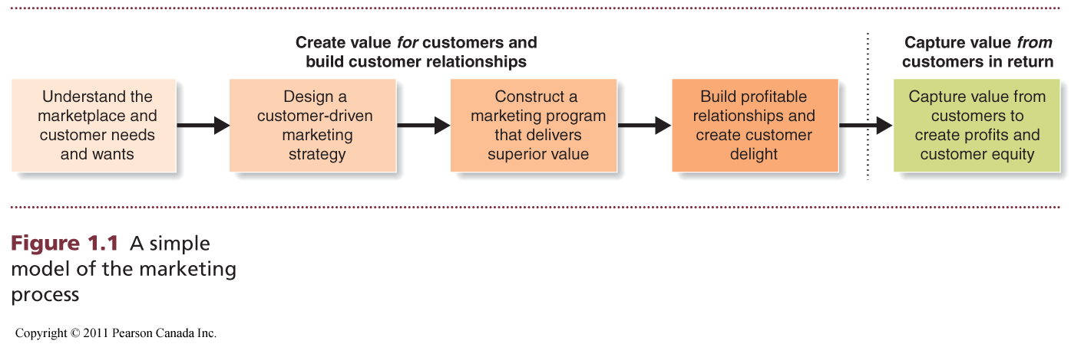

Creating VALUE for Customers and Build Customer Relationship
- Understanding the Marketplace and Customer Needs
- Customer Needs, Wants, and Demands
- Needs – a state of felt deprivation. These needs are not created by marketers.
- Most basic concept underlying marketing
- Physical needs for food, clothing, warmth, and safety
- Social needs for belonging and affection
- Individual needs for knowledge and self-expression
- Wants – the needs become wants when they are directed to specific objects that might satisfy the needs.
- Wants are shaped by:
- culture and individual personality
- one’s society as well as by marketing programs
- Demands – wants for specific products backed by an ability to pay (purchasing power). Given their wants and resources, people demand products with benefits that add up to the most value and satisfaction.
- Market Offerings – Products, Services, and Experiences
- Market Offerings – some combination of products, services, information, or experiences offered to a market to satisfy a need or want.
- Marketing myopia – the mistake of paying more attention to the specific products a company offers than to the benefits and experiences produced by these products. They are so taken with their products that they focus only on existing wants and lose sight of underlying customer needs. They forget that a product is only a tool to solve a consumer problem.
- Customer Value and Satisfaction
Customers form expectations about the value and satisfaction that various market offerings will deliver and buy accordingly. Satisfied customers buy again and tell others about their good experience.
- Customers view products as bundles of benefits
- And choose products that give them the best bundle for their money
- Dissatisfied: switch to competitors and disparage the product to others
- Too high expectation: buyers will be disappointed
- Too low expectation: satisfy buyers but fail to attract enough new buyers
- Exchanges and Relationships
- Exchange – the act of obtaining a desired object from someone by offering something in return.
- Marketing consists of actions taken to build and maintain desirable exchange relationships with target audiences involving a product, service, idea, or other object.
- Markets
- Market – the set of all actual and potential buyers of a product and service; they share same needs/wants that can be satisfied through exchange relationship
- Company purchasing agents do marketing when they track down sellers and bargain for good terms.
- Consumers do marketing when they search for products and interact with companies and obtain information and make their purchases.
A company’s success at building profitable relationships depends on only on its own actions but also on how well the entire system serves the needs of final consumers.

Marketing intermediaries

Consumers
Competitors
Company

Suppliers

Major environmental forces
- Designing a Customer-Driven Marketing Strategy
Marketing Management – the art and science of choosing target markets and building profitable relationships with them. The marketing manager’s aim is to find, attract, keep, and grow target customers by creating, delivering, and communicating superior customer value.
Demarketing: seek fewer customers and reduced demand
Marketing management = customer management and demand management

- Selecting Customers to Serve
- The company must first decide who it will serve by dividing the market into segments of customers (market segmentation) and selecting which segments it will go after (target marketing). Marketing management is customer management and demand management.
- Choosing a Value Proposition
- The company must also decide how it will serve targeted customers – how it will differentiate and position itself in the marketplace. A company’s value proposition is the set of benefits or values it promises to deliver to consumers to satisfy their needs. Such value propositions differentiate one brand from another.
- Customer value concerns the difference between the benefits a customer sees from a firm’s market offering and the costs of obtaining those benefits.
- The customer’s view of costs and benefits is not just limited to economic (or even rational) consideration – a lot price may NOT result in superior value.
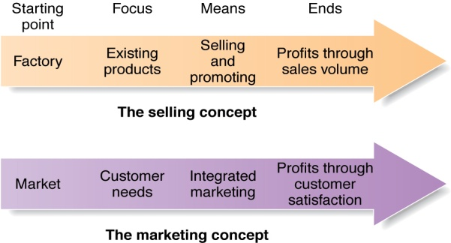
- Marketing Management Orientation
- Production Concept – the idea that consumers will favour products that are available and highly affordable. Therefore, management should focus on improving production and distribution efficiency.
- Can lead to marketing myopia. Companies adopting this orientation run a major risk of focusing too narrowly on their own operations and losing sight of the real objective – satisfying customer needs and building customer relationships.
- Product Concept – the idea that consumers will favour products that offer the most quality, performance, and features and that the organization should therefore devote its energy to making continuous product improvement.
- “make and sell’
- Can lead to marketing myopia by focusing only on company’s product.
- Selling Concept – the idea that consumers will not buy enough of the firm’s products unless it undertakes a large-scale selling and promotion effort. The selling concept is typically practised with unsought goods – those that buyers do not normally think of buying or doing (insurance, blood giving).
- Carries high risk. It focuses on creating sales transactions rather than on building long-term, profitable customer relationships. The aim often is to sell what the company makes rather than making what the market wants.
- Marketing Concept – the marketing management philosophy that achieving organizational goals depends on knowing the needs and wants of target markets and delivering the desired satisfaction better than competitor do. Under the marketing concept, customer focus and value are the paths to sales and profits.
- “ sense and response”: find the right product for your customer; a customer-centred philosophy
- Research current customers deeply to learn about their desires, gather new product and service ideas, and test proposed product improvements. Such customer-driven marketing usually works well when a clear need exists and when customers know what they want.
- In many case, customers don’t know what they want or what is even possible.
- Customer-driving marketing: understanding customer needs even better than customers themselves do; creating products and services that meet existing and potential needs, now and in the future
“lead customers where they want to go before they know where they want to go”
- Social Marketing Concept – the idea that a company’s marketing decisions should consider consumers’ requirements, consumers’ long-run interests, and society’s long-run interests. Companies should balance three considerations in setting their marketing strategies: company profits, consumer wants, and society’s interests.
  - The societal marketing concept holds that marketing strategy should deliver value to customers in a way that maintains or improves both the consumer’s and society’s well-being
- Building Customer Relationships
- Customer Relationship Management
Customer Relationship Management – the overall process of building and maintaining profitable customer relationships by delivering superior customer value and satisfaction.
- Relationship Building Blocks: Customer Value and Satisfaction
- Customer-perceived value – the customer’s evaluation of the difference between all the benefits and all the costs of a market offering relative to those of competing offers. Customers often do not judge values and costs “accurately” or “objectively”. They act on perceived value.
- Customer satisfaction – the extend to which a product’s perceived performance matches a buyer’s expectations. Higher levels of customer satisfaction lead to greater customer loyalty.
Creating VALUE from Customers
- Creating Customer Loyalty and Retention
- Companies are realizing that losing a customer means losing more than a single sale. It means losing the entire stream of purchases that the customer would make over a lifetime of patronage.
- Customer lifetime value – the value of the entire stream of purchases that a customer would make over a lifetime of patronage.
- Growing Share of Customer
- Beyond simply retaining good customers to capture customer lifetime value, good customer relationship management can help marketers to increase their share of customers.
- Share of customer – the portion of the customer’s purchasing that a company gets in its product categories.
- Building Customer Equity
- Companies want not only to create profitable customers, but to “own” them for life, earn a greater share of their purchases, and capture their customer lifetime value.
- Customer equity – the total combined customer lifetime values of all the company’s customers.
- Customer equity may be a better measure of a firm’s performance than current sales or market share. Whereas sales and market share reflect the past, customer equity suggests the future.
- Building the Right Relationships with the Right Customers
- The companies should view customers as assets that need to be managed and maximized. Not all customers, not even all loyal customers, are good investments.
- “strangers”- low potential profitability and little projected loyalty.
- “butterflies” – potentially profitable but not loyal.
- “true friends” – both profitable and loyal.
- “barnacles” – highly loyal but not very profitable.
- Different types of customers require different relationship management strategies.
- Rapid Globalization
- Many marketers are now connected globally with their customers.
- Companies are not only trying to sell more of their locally produced goods in international markets, they are also buying more supplies and components abroad.
So, what is marketing? Pulling all together. Read.

