CH 4 SENSORY AND PERCEPTION

Human Eye

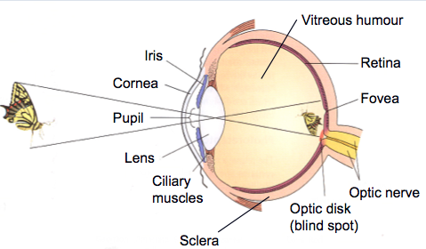
- First point of contact: Cornea. Transparent structure, protective function.
- Pupil: Adjusts to amount of light in the environment.
- Iris: A muscle regulating the pupil.
- Lens: elastic structure. Primary goal to send visual info to the receptor cells at the back of the eye. Changes for how close an object is. Ciliary muscles put pressure on the lens. Reverses image (left right, up down).
- Fovea: very back of eye. Allows you to perceive detail.
- Vitreous humour: fluid, the main area of the eye. See dead cells on your eye when it is not stimulated
- Sclera: back of eye. Helps to maintain the eye’s structure. Reflective function.
- Optic nerve: Where it leaves the eye, blind spot.
- Retina: Absorbs light, process image, sends visual info to brain

Myopia (near sighted)
- Can see what’s near. Trouble seeing farther away
- Lens is trying to send info to retina but falls short. Lens is defective or length of eye.

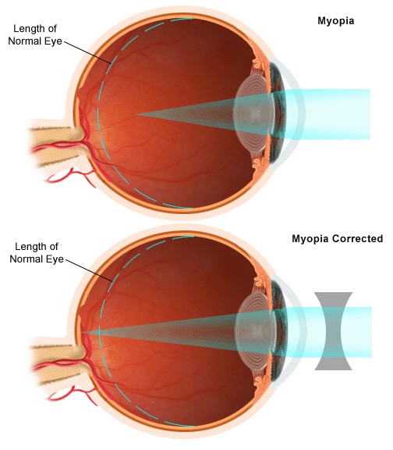
Hyperopia (farsighted)
- Sends info too far back. Misses retina.
- Eye is not long enough.
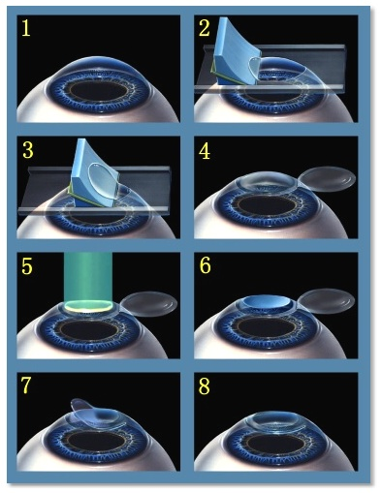

Lasik Eye Surgery
- Tries to alter curvature of cornea
- Take eye drops, and wait. Speculum used to keep the eye open.
- Slices cornea, opens as a flap
- Exemer laser adjusts cornea

Cells of Retina
- Sensory receptive cells. 20 million rods. Allow us to see B/W.
- 6 million cones. Colour vision.
- Peripherals perceived by rods and cones
- Cones: daylight & colour vision
- Rods: night & peripheral vision
- Light striking rods and cones trigger neural signal in retina
- Prefer well lit environments
- Optic disk: whole in retina where optic nerve fibres exist eye
- Transduction:
  - You want to collect light energy and convert into nerve impulse.
  - Physical (light) energy --> electrical energy
  - Rods and cones communicate with other cells. Collects info, perform other operations.
  - Ganglion cells: collect info and converge to form optic nerve. 1 million ganglion axons = optic nerve. Optic Nerve travels to thalamus, to occipital lobe.
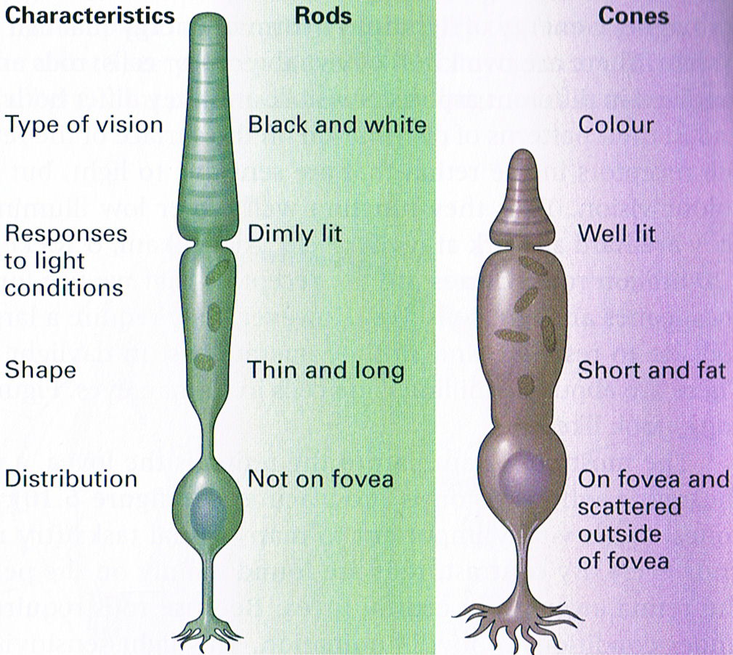
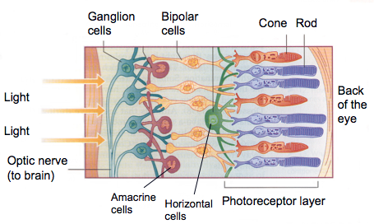

Dark Adaptation
- Rods and cones adjust in levels of low illumination
- The more time in the dark, the better it adjusts. Eyes become more sensitive.
- The process in which the eye become more sensitive to light in low illumination
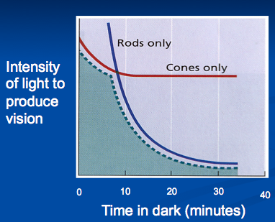
Colour Vision
- Trichromatic theory (Young & Helmholtz):
  - Red, green, blue
- Opponent process theory (Hering):
  - Red-green
  - Yellow-blue
  - White-black

Colour Blindness
- Trichromat
- Monochromat: difficulty with RGYB. They see Black, white, shades of grey. One cone type not working properly.
- Dichromat

Visual Perception
- Feature detection
- Form perception
- Depth and distance perception
- Perceptual constancies
- Perceptual illusions

Gestalt Principles
- Similarity: we tend to group together similar objects.
- Proximity: group what is close to each other
- Closure: fill in gaps in visual scenes
- Continuity: perceive lines that move in the same direction. We notice what is different.

Depth Perception
- Binocular cues: involve both eyes.
  - Primarily used to judge distance and depth. 10-15 m away or closer.
  - As the item comes closer, greater convergence.
  - Rely on one eye more than the other
  - Convergence “catch the ball”
  - Retinal disparity “the preferred eye”
- Monocular: single eye.
  - Interposition. The item blocked is behind. What is closer/farther away.
  - The smaller the object appears from the retina the farther it is.
  - Greater convergence, greater distance
  - Illumination. Judge where light is coming from. Judge how close an object is from what is illuminated.
- Monocular cues:
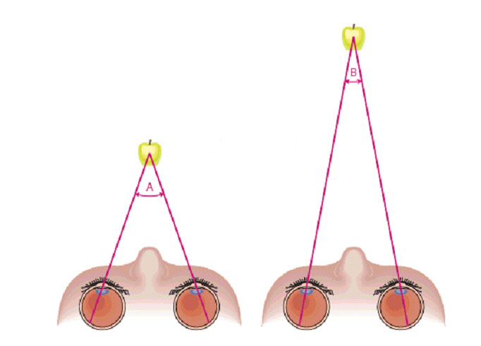
  - Relative size
  - Texture gradient
  - Aerial perspective
  - Relative clarity

Perceptual Constancies
- Size – Things appear that they are different sizes, but you know they aren’t. Some are closer and farther away.
- Tendency to experience stable perception in face of continually changing sensory input

Audition

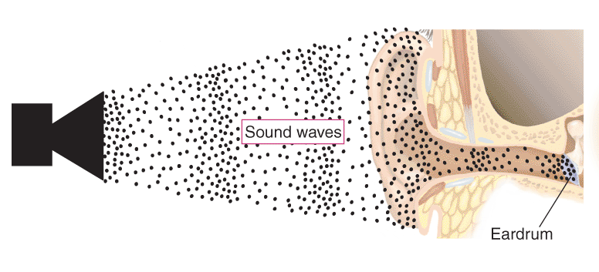
- Amplitude: Decibels (dB)
- Frequency: Hertz (Hz)
- Transduction
- 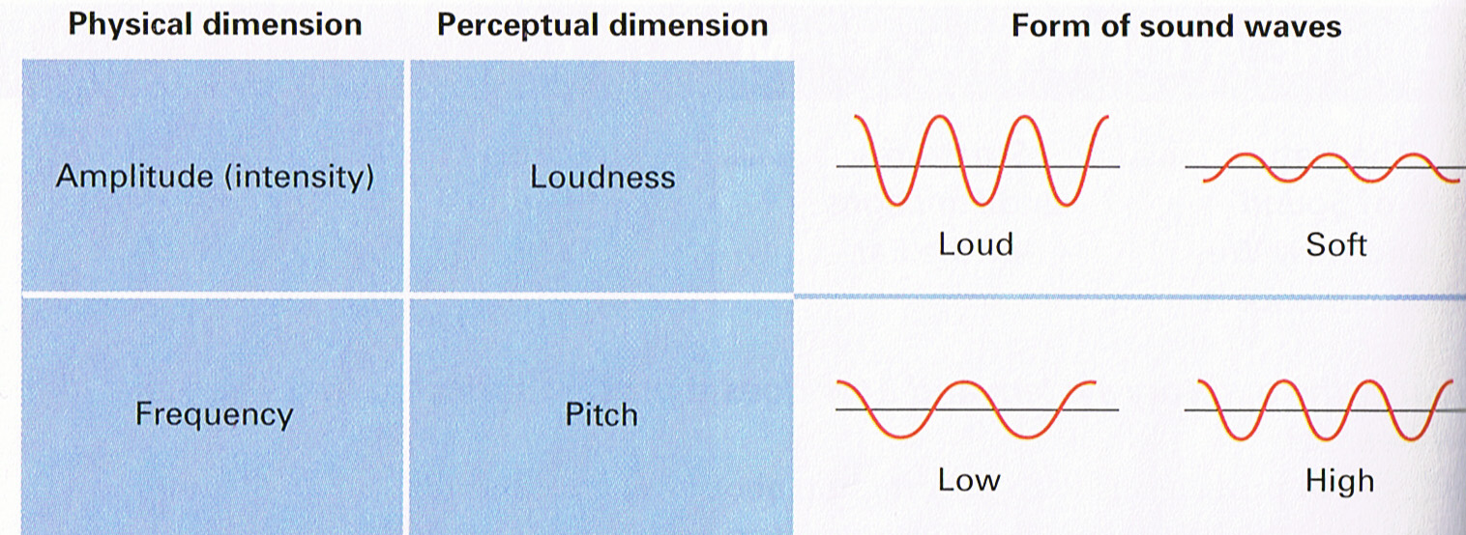

Human Ear
- Transduction
- Energy channeled down ear canal towards eardrum
- Eardrum – very sensitive, as it vibrates it picks up mechanical energy. Smallest bones in body,
- Cochlea – sensory receptor sites for hearing. 3.5 cm long. Connects to auditory nerve thalamus
- Eustachian tube – regulates pressure of internal and external environment. High and low pressure, ear pops.
- 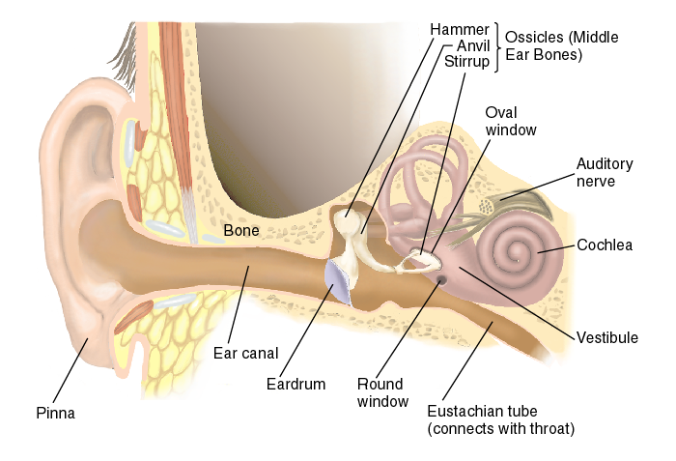

Response to Sound Waves
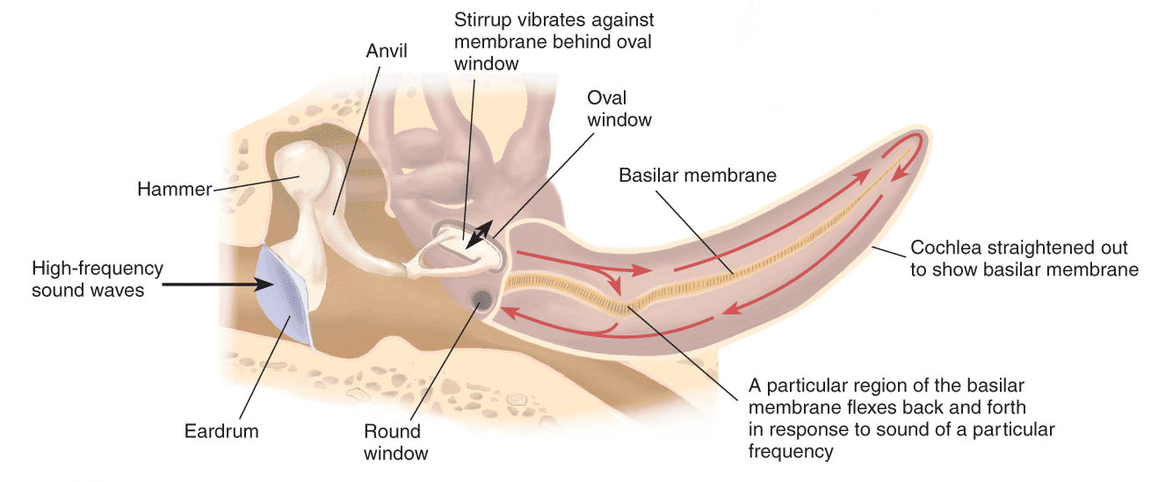

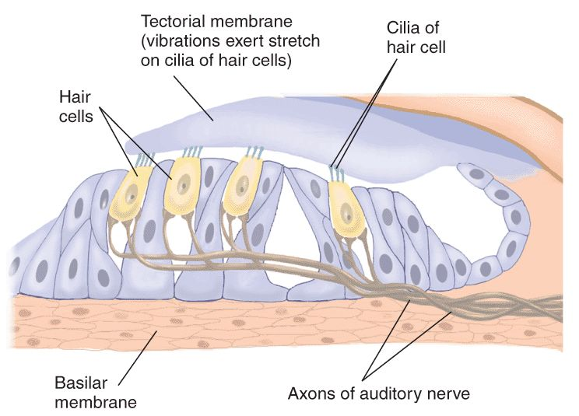

Hearing Loss
- Conduction deafness – something has happened with mechanical structures of ear canal, eardrum, small tiny bones that transmit stimulus to inner ear. Ear wax?

Nerve deafness – damage to structures of the inner ear (auditory nerve) ability to convert mechanical energy to nerve impulse is impaired.

CH 5 STATES OF CONSCIOUSNESS

Circadian Rhythms
- 24 hour biological cycle
- Suprachiasmatic nucleus- regulates melatonin levels
- Cycle experienced by humans and other animals
- Makes us want to get up in the morning/go to bed at night
- Alters blood pressure, alertness, body temperature, hormone secretion
- Genetically programed into us
- Hypothalamus contains the suprachiasmatic nucleus
- Super communicates with pineal gland. We’re loosing light, time to produce melatonin (relaxes body)
- Our body responds negatively when taken out of our regular routine

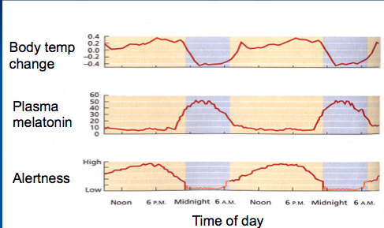

Sleep
- Determined stages of sleep based upon EEG:
  - Awake – beta waves
  - Relaxed/drowsy – alpha waves (light form of sleep, head bobbing)
  - Stage 1 – theta waves
  - Stage 2 – sleep spindle
  - Stage 3 – delta waves (deep sleep, pulse slowing down)
  - Stage 4 – delta waves (Very deep sleep, extremely difficult to wake you up)
  - REM sleep
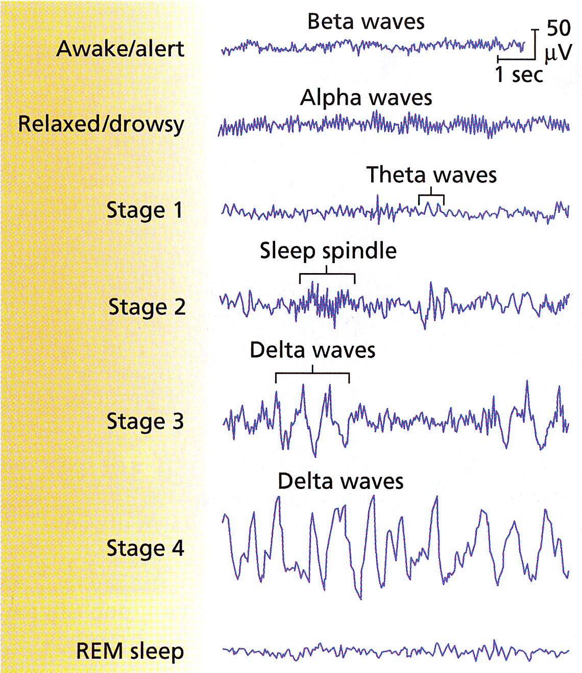

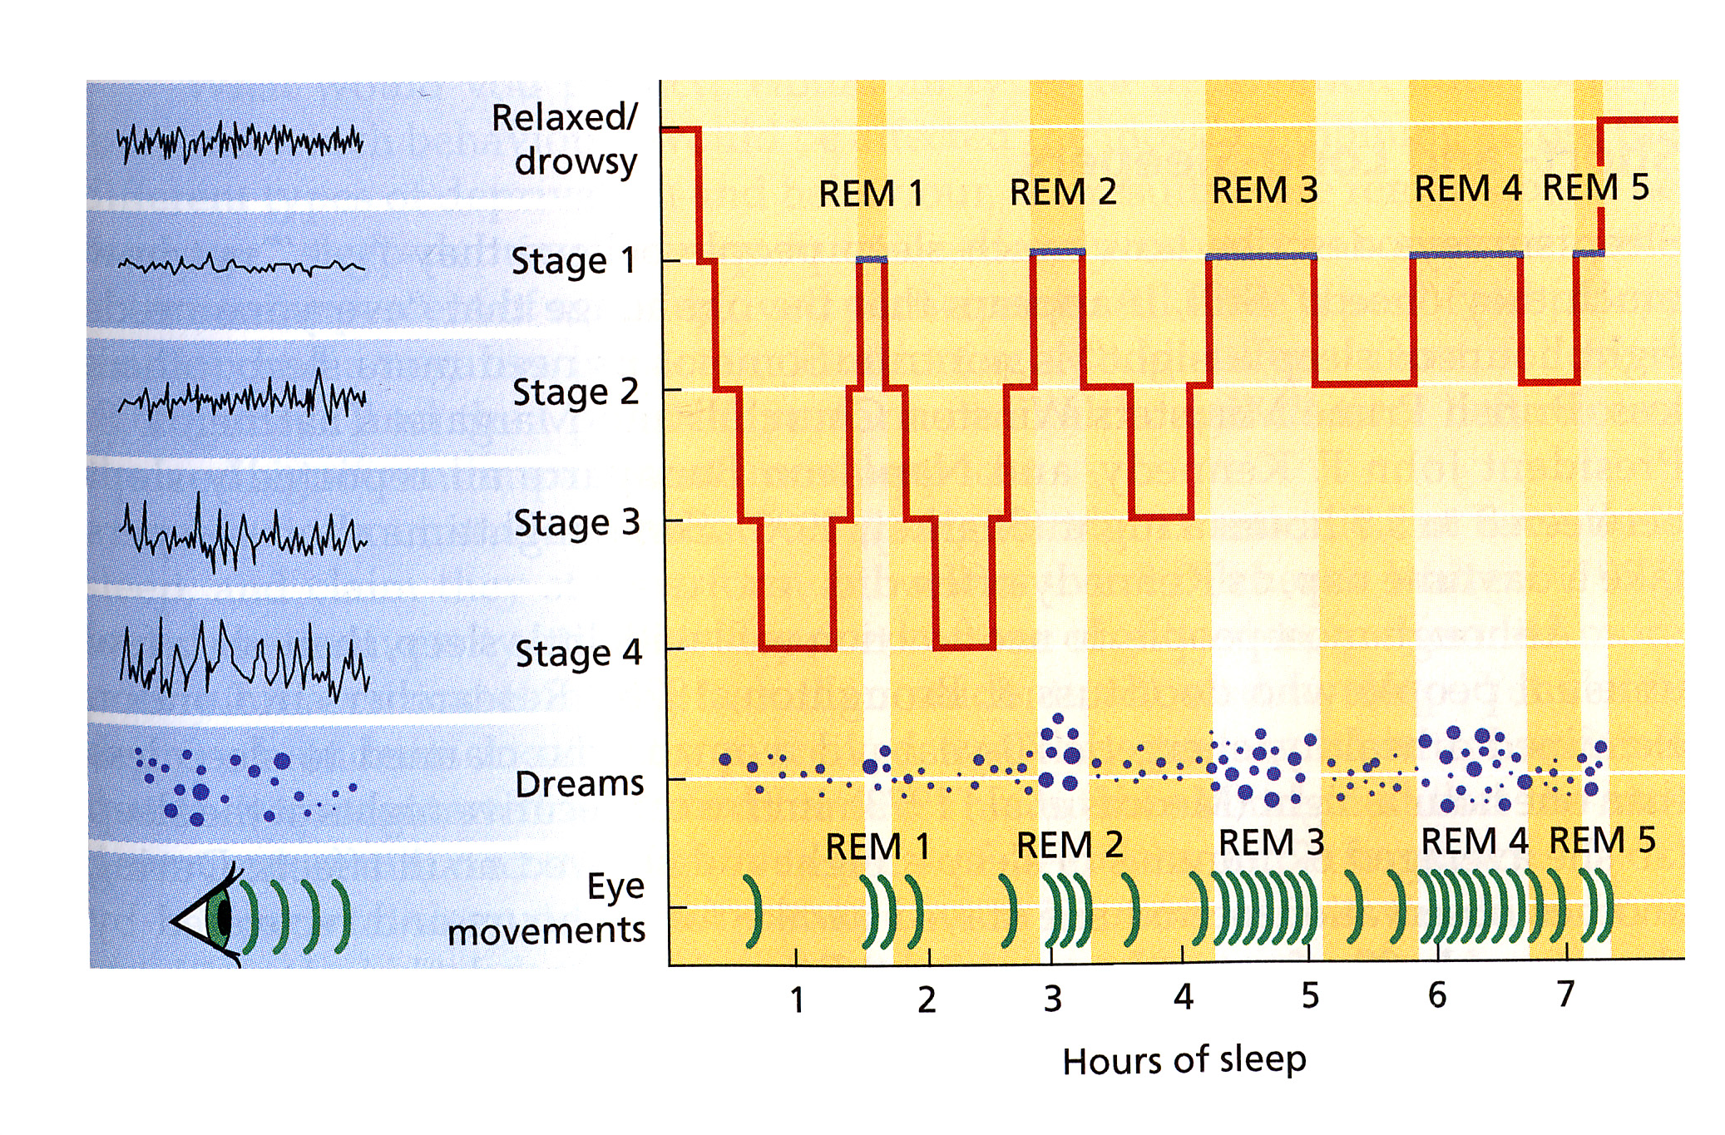

Rapid Eye Movement (REM)
- Similar brain pattern to someone awake
- Increase in breathing, blood pressure
- Face twitching, eye movement
- Can’t move
- Can’t wake up
- REM aka dream sleep
- REM rebound - when we’re deprived of REM for period time
- Most of our night is in REM sleep
- As we get through the night, closer to waking up, we experience more REM
- Release of growth hormones
- Physiological changes
- REM paralysis
- Dream issues

Our Sleep Life

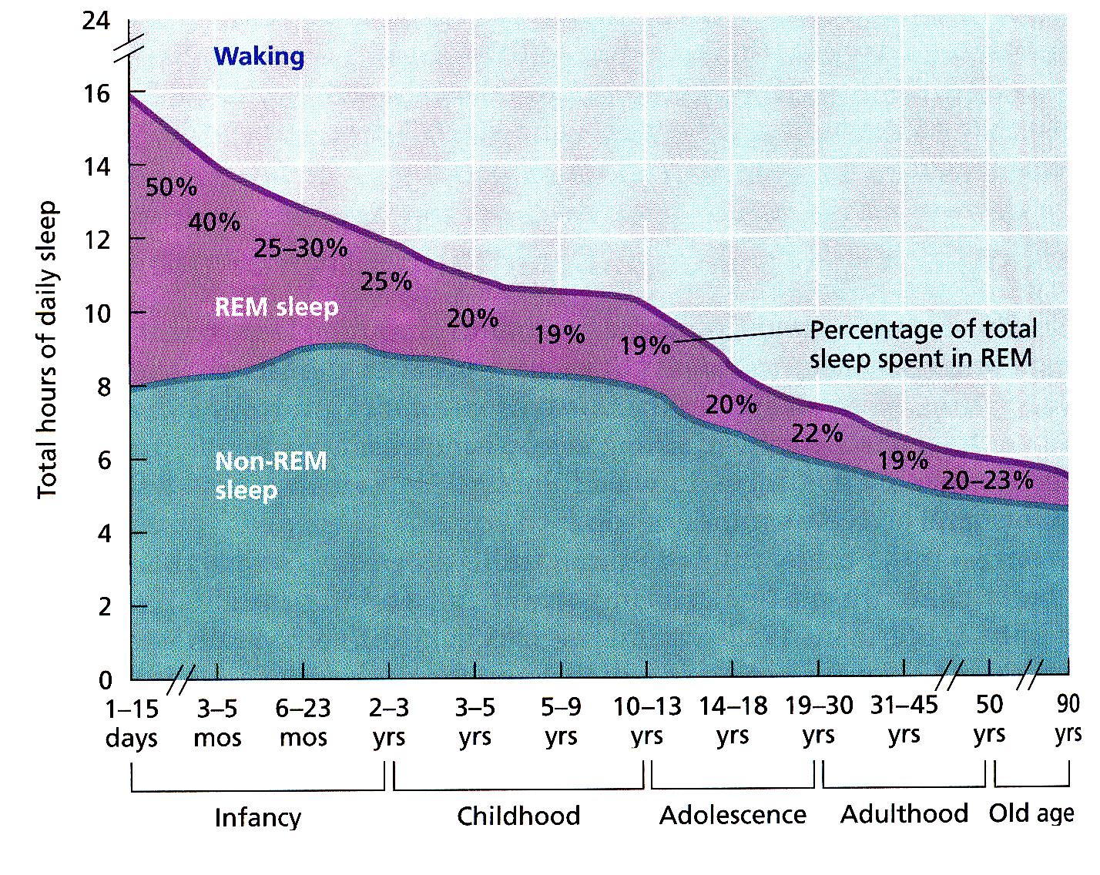

Why Do We Sleep?
- Time out period to recharge
- Evolutionary/circadian models. What promotes survival of species?
- Larger animal = more likely to be a target. Can’t afford to be asleep as long

Evolutionary Models
- Snowshoe rabbit (Doesn’t experience REM) vs cottontail rabbit (underground, can afford to experience REM sleep)

What Do Dreams Mean?
- Sigmund Freud “Royal road to the unconscious”
  - Psychoanalytic theory – theory of personality and therapy
  - Wish fulfillment
- Conscious mind - thinking
- Pre conscious - info not aware of but accessible)
- Unconscious – sex and aggression impulses stay here.
- Dreams represent “royal road to the unconscious”
- Dreams a caldron of seething expectations
- Content of our dreams are manifest (face value) or latent content (true underlying meaning
- Dream work – our mind transforms sexual and aggressive impulses into symbols within the dream.

More Dream Theories
- Problem–focused (Cartwright): We are able to solve important problems in a dream. Dreams consist of elements from waking life
- Mental housekeeping (Hobson, consolidation): physiological approach. During sleep unnecessary neural connection pruned back and the ones we’re using strengthened. Dreaming = strengthening
- Activation synthesis (Hobson & McCarley): Pons send info to cerebral cortex, activates higher brain structures to make sense of dream (synthesis). Physiological approach.

Sleeping Disorders
- What you’re experiencing is more intense than normal
- Insomnia – difficulty falling asleep (30+), difficulty staying asleep
- Pseudo insomniac – think they have insomnia but don’t
- Sleep apnea – stops breathing for 20-40 seconds at a time during the night. Waking up to gasp.
  - Peripheral: individual diagnosed as obese, extra weight exerting pressure on wind pipe, impairing air flow
  - Central: Brain stem regulation impaired
  - CPAP – continuous positive airway pressure
- Narcolepsy – opposite of insomnia. Sudden attacks of sleep. Being awake right into REM.
  - Psychomotor stimulants – keep individual awake. Anti-depressants suppresses REM.
- Nightmares – something is bothering you, appears in your dreams. More of a concern for children
- Night terrors – young children sit up in bed and scream, parents come, child immediately lie back down back to sleep. Not aware of it happening
- Sleep walking – eyes are open, still asleep.
  - Occurs during stages 3 & 4 you know you’re not in REM, because of REM paralysis.
  - You’re supposed to gently lead them back to bed.
  - Genetic
  - High fever
  - Stress & anxiety

Consciousness Altering
- Meditate
- Practice mindfulness
- Psychoactive drugs – alters biological practices involved with neurotransmission. Can become physically dependent
  - Withdraw – once tolerant, takes drugs to note feel bad not feel good
  - Psychological Dependence – overwhelming craving for drug ex. Only crave a cigarette with drinking

Depressants

Slows down certain nervous activity. Lowers anxiety. Slows down breathing, heart rate
- Increases level of GABA, slowing system down
  - Alcohol
  - Barbiturates
  - Tranquilizers
  - Opiates

Fetal Alcohol Syndrome
- Lower brain weight
- Heart trouble
- Liver trouble
- Lower life span

Barbiturates
- Tremendous addictive potential
- Used to reduce anxiety, sleep aid
- If mixed with other depressants -> toxic

Tranquilizers
- Relaxant
- Anti-anxiety
- Safer drug, addictiveness lower
- Don’t suppress REM

Opiates (Narcotics)
- Opium poppy
- Production dominated by Afghanistan, Mexico
- Makes heroin
- Mimics endorphins therefore body stops producing endorphins
- Profound relaxation, more often the first time taking it = vomit
- Withdrawn: Profound agitation, opposite of constipation

Stimulants
- Increases blood pressure, heart rate, breathing
- Initially boosts mood
- Blocks reuptake of norepinephrine and dopamine

Amphetamines (methamphetamine, crystal meth)
- Suppresses appetite
- Strongly addictive
- Reduced need for sleep
- Meth – higher levels of dopamine, euphoria, exhilaration, snort, inject
- Crystal meth – crystallization from of meth. Highly addictive & levels of relapse. Intense withdrawal (mood swings, memory problems). Destroys tissue, destruction of blood vessels, weight loss, dental problems,
- MDMA (ecstasy) – reduce inhibitions, promotes sense of social connectivness, empathy towards others. Not sleeping or hydrating. Moderately addictive.
- Cocaine – from the cocoa leaf. Chronic users: paranoia, hallucinations (cocaine bugs), bleeding of nasal membrane. Snort or vapor. Lower addiction level.
- Caffeine
- Nicotine – one puff of a cigarette = one tenth of a mg of nicotine. One cigarette = 2mg. If injected you would die.

Psychedelics/Hallucinogens
- Changes perceptions

- LSD
  - Tablet or gelatin
  - Soak paper, lick paper
  - Slows time down
  - Visual hallucinations
  - Crossing over of senses. Ex. I see smells, sound.
  - Flood of serotonin
  - Low addictive, low psychological & physical dependence
- Mescaline (magic mushrooms)
- Psilocybin
- Marijuana
  - Mild euphoria, relaxation, sedative
  - Enhance sensory perception
  - Increased appetite
  - Not a gateway drug
  - Long term risk of cancer
  - Cognitive issues, memory/attention problems
  - Low level of physical addictiveness.

CH 6 LEARNING

- Parents don’t need to teach the child to walk, they come programmed already
- The only thing they can do is mess that up
- Much of who you are came about as a result of learning
- Along the way, a series of associations are made
- If I act a certain way = this consequence
- Classical conditioning – we come to associate experiences with others (happiness of a song)
- Power of association
- Adaptation: instinct = closed program, learning = open program
- Behaviourism

Classical Conditioning

Ivan Pavolv
- Studies saliva response in dog
- Measure amount of saliva dog produces in presence of food
- Dog salivated without him producing food
- Dog associated food with the experimenter
- Can we teach the dog to salivate when we want it to?
- UCS: food in mouth = UCR: salivation
- Learning trials – teaching the dog to do something

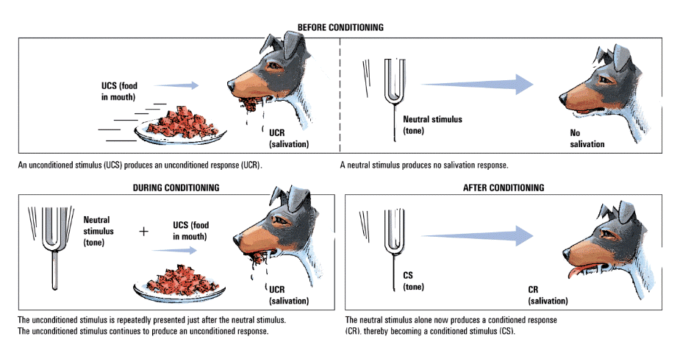

Principles of Classical Conditioning
- We don’t want the conditioned response to generalize too broadly
- Generalization
- Discrimination
- Acquisition: initial stage of learning
- Extinction: the association is no longer adaptive (present tone without food)
- Spontaneous Recovery: We’ll see the reemergence of the conditioned response. Neural pathways associated with responses still exist, but not being used.
- Stimulus generalization: when learned a response to a specific stimulus, responds the same way to similar new stimuli

Applications of Classical Conditioning

John Watson
- By pairing positive experiences with a erson, you can learn to love someone
- Anything can be conditioned to produce fear if paired with pain & embarrassment
- Ex. Baby fearing rabbits
- Learning to like arousal: this body part = arousal
- Aversion therapy: Possible to change the process. Ex. Give an alcoholic alcohol that makes them naucious
- Sauce Bearnaise effect/Garcia effect: ate bad sauce made him puke, now the thought of it makes him puke

Operant Conditioning
- B.F. Skinner
- Complex and voluntary behaviours
- Behaviours - onsequences
- We operate on our environment. Trying to control the environment with behaviours
- Heir conditioner: basically a skinner box. Placed daughter in box, confortable conditions.
- Skinner Box

Reinforcement
- Activity that increases the probability of the behavior occurring
- Positive: response strengthened b/c of reward
- Negative: taking away a consequence the person finds unsatisfying ex. Roommate nagging to do dishes, dishes = nagging stops, trying to avoid negative consequence
- Primary reinforcer: associated with biological needs/drives
- Secondary reinforce: learned reinforcer. Associated between something with a primary
- Successive approximations: trying to reinforce rat’s behavior by this. Work in the direction of the lever, taking 1 step, taking 2 steps.
- Shaping: successive approximations
- Extrinsic vs instrinsic motivation

Schedules of Reinforcement
- Continuous
- Intermittent
  - Fixed ratio: Reinforcer given after fixed # of non reinforced responses Ex. Marshall has to clean his room twice to get $5
  - Variable ratio: Given after variable # of non reinforced responses reinforce given after Reward after variable time interval. Ex. Marshall doesn’t know how many times it will take to get $5
  - Fixed interval: Reinforcer is given for first response occurring after a fixed time interval
  - Variable interval: Given for response after variable time interval
- If you want a behavior to persist and be consistent, variable schedule/interval is best

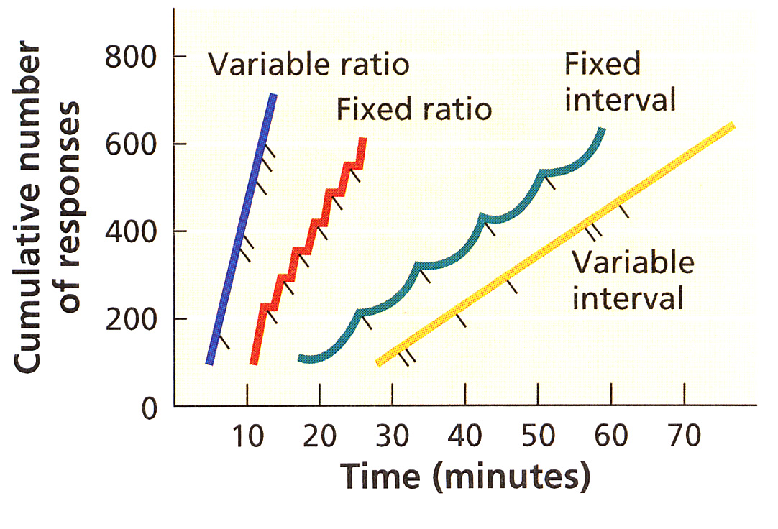

Punishment
- Positive punishment – actively applying aversive stimuli (negative consequence) Kid learns you pet the cat the wrong way, something bad will happen
- Negative punishment – removal of stimuli that the individual finds pleasant. Taking something away the person wants
  - Recipient may respond with anger, fear
  - May reinforce undesirable behaviours
  - Effects may be temporary
  - Conveys little information
- May reinforce undesirable behaviours (kid wants attention, realizes they need to do something bad to get it)
- Consequence has to happen right away after bad behavior
- Tells someone what they shouldn’t do, not what they should do

Superstitious Behaviour
- Actions lead to reinforcement by coincidence
- We look to surround environments for why something goes wrong. We make unreasonable associations
- Not always based on operant conditioning

Observational Learning

Albert Bandura
- Imitating the model
- Conducted experiment to see how young children learn “Bobo the clown”
- Child observing model interacting with inflatable clown
- Children observe some models being aggressive some not
- Children that watched aggressive behavior was more likely to act aggressive
- When there were consequences for aggressive behavior, it changed.
- Number of conditions have to be met:
  - Attention: (observe model)
  - Retention: Remember what you learned
  - Moto reproduction: Need ability to reproduce behavior
  - Reinforcement or incentive: Need to want to do it
    - Likeable
    - Power or authority
    - Competent
    - Less likely to cold people

Memory
- Our brain is kind of like a computer. We save files, try to open files.
- Retention of info over time through:
  - Encoding
  - Storage
  - Retrieval

3 Componenets of Memory

Atkinson-Shiffrin Model

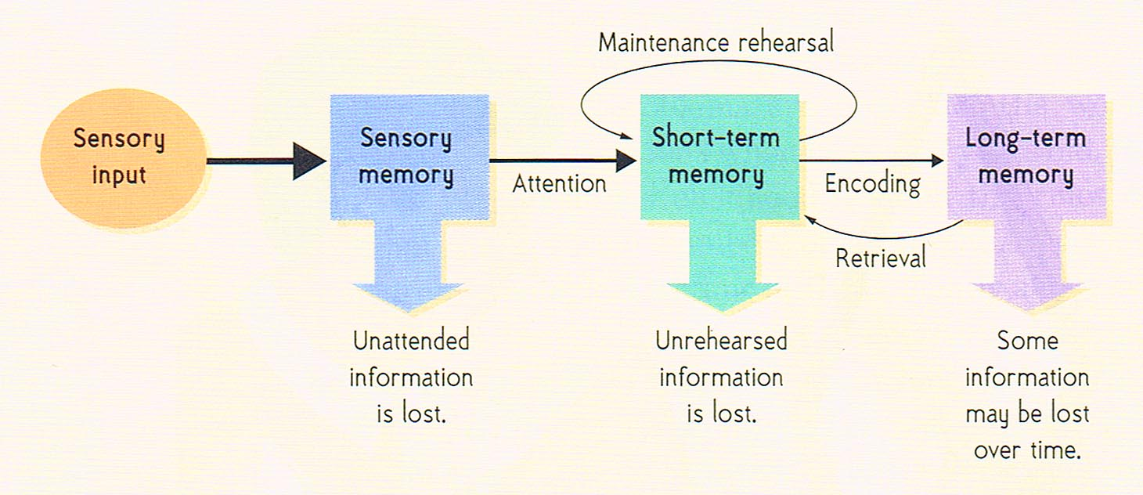

Sensory Memory
- Holding bin
- We are being bombared with sensory information, our brain decides what is worth paying attention to
- We retain what is important for a brief moment in time (half a second)
- Iconic – visual memory
- Echoic – sound memory
- Large capacity

Short Term Memory
- Transfers from sensory memory to short term
- Selective attention
- Info doesn’t last long (few seconds)
- Capacity – limited
- George Miller (CHUNKING) magic number most people can remember 7 +/- 2 digits, names, etc.
- We chunk information ex. Phone number 1 part = area code 2 part = 727 3 part = 1500
- Regarded as passive mental space, not a lot going on.
- STM as working memory, organizing, reasoning, logic, solving patterns
- Some info is related to visual, audio, special
- Auditory = phonological loop
- Visuopatial – temporarily store and manipulate images. Making a mental map when giving someone directions. Bring long term memory to short term.

STM as Working Memory

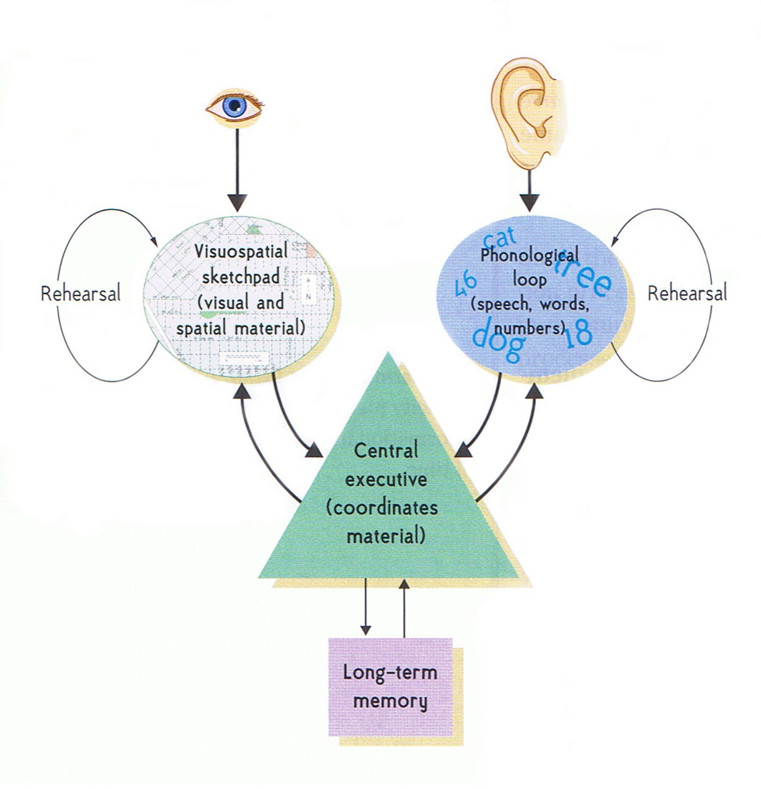

Long Term Memory
- Associated with who we are, our past, present, future, relationships
- Storage virtually unlimited
- To transfer from ST to LT, encoding
- Elaborative rehearsal – focusing on meaning of info, trying to apply it Ex. When studying, come up with own example. While studying, paying close attention.
- Maintenance rehearsal – reading notes over and over again hoping it will absorb, however only for short period of time
- Level of processing theory (Craik & Lockhart(

Encoding into LTM
- Massed practice – try to stuff as much info as you possibly can in your mind in a short period of time. Not associated with long term memory’
- Distributed practice – study throughout term

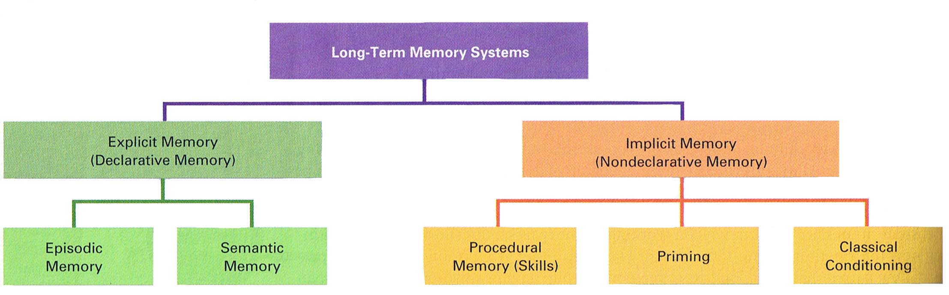

Storage of LTM
- Hierarchies
- Semantic networks
- Neural networks (connectionist or parallel distributed processing)
- Schemas

Schemas, Scripts, Expert Knowledge

Schemas – mental framework that hold expectations about stimuli of our lives (ex. Knowing the order of events at a restaurant) Deviation is disconcerting

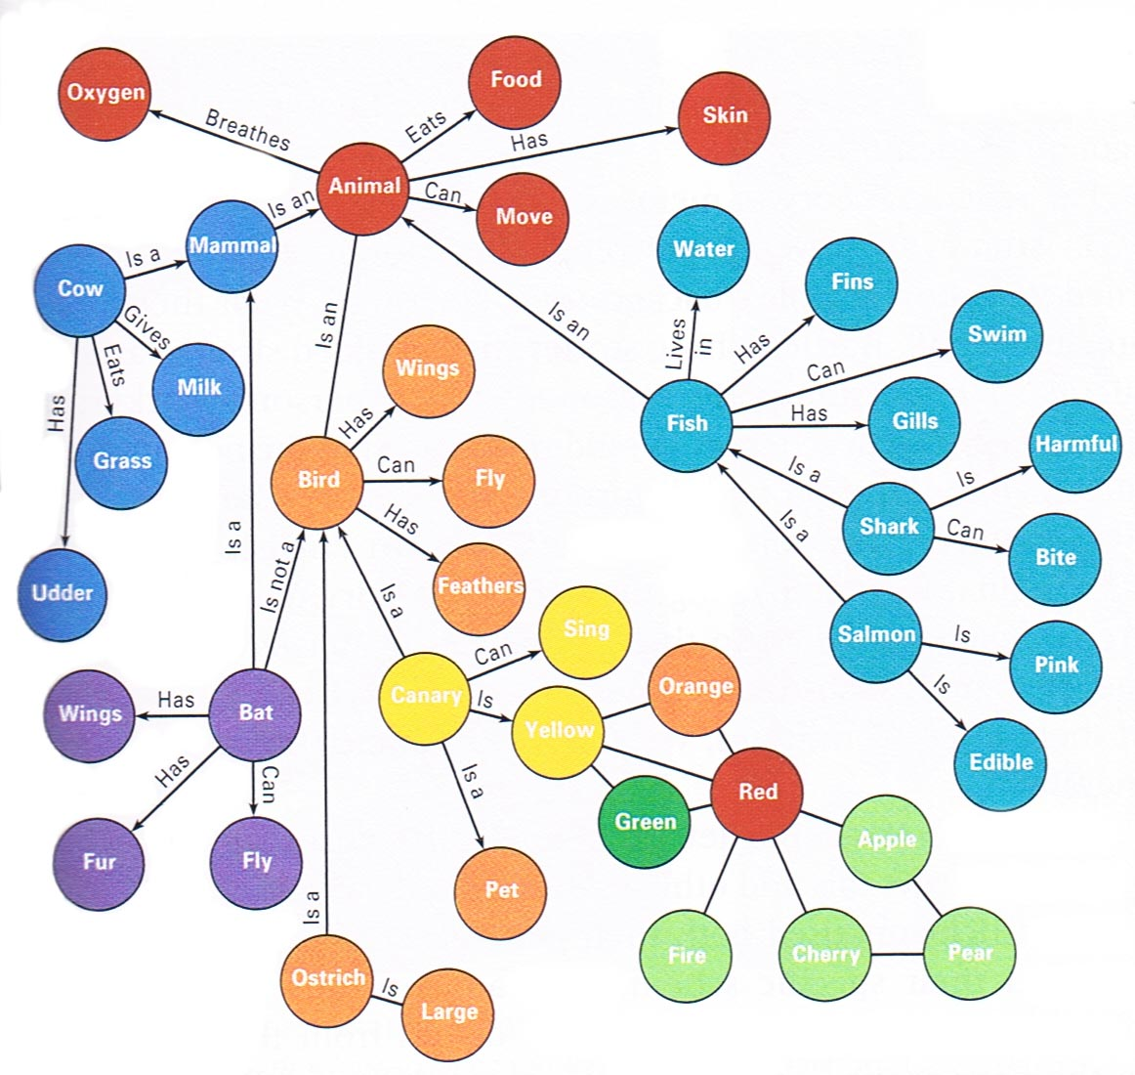
Semantic Network
- Series of ideas associated with other ideas
- Bird = feathers, trees, flying & other concepts
- The first words that come up are closest in the semantic network
- Some concepts related but farther away ex. Ostrich
- The closer it is, the easier available in long term memory
- When cramming, network isn’t as rich or deep
- Each unit of info is a node
- Closer the node, stronger the association

Neural Networks
- Neural psychology
- Memory exists in patterns of activation of neurons
- Patterns across different brain regions. Different brain regions activate at the same time = triggers memory
- Use it or lose it. Exercise your memories to strengthen, use it more
- Connectionist or parallel distributed processing
- Network activated = parallel processing occurs
- 2 neurons activated same time = connection – memory strengthened

Retrieval Cues
- Endel Tulving
- Anything that helps someone retrieve from long term memory
- MC question offers hints
- Encoding specificity principle: you want conditions to match retrieval to match conditions of learning
- Context dependent memory: Applying encoding to external cues. Easier to remember in same environment. Ex. Study in loud place, retrieving info in quiet exam room, not effective
- State-dependent memory: relating to internal environment. Info retrieval enhanced when internal state matches state during encoding Ex. Relaxing while studying, stressing during exam
- Mood-congruent recall: When in good mood, more likely to talk about positive events

Forgetting
- Encoding failure: failed to form long term memory in first place. Didn’t do anything with info while in short term.
- Storage failure: decays from lack of use, failure to exercise memory
- Retrieval failure:
  - Motivated forgetting: want to forget traumatic experience, unfortunate truths repressed.
- Interference:
  - Proactive: material learned in past interfering with present (ex. New phone #, keep thinking of old one)
  - Retroactive: new information impairing ability to get old information (ex. Studying psych then phil, ability to learn impaired by phil)

Amnesia
- Retrograde: long term memory issue, difficulty remembering past.
- Antrograde: trouble forming new memories, short term memory problem
- Infantile: Cannot remember life prior age 4 or 5. Under this age, semantic network is not sufficiently developed to make long term memory. Not much sense of self. Reacting to environment.

Memory Reconstruction
- The way you recall stories years later will change
- Flashbulb: important big moments in life. Like we are taken back to that moment, experiencing it again.
- Eyewitness testimony:
  - Misinformationeffect: distortion of memory by misleading post-event info
- Eyewitness testimony: “seeing is believing” information we acquire subsequent to event that effect recall

Enhancing memory
- Focus, pay attention, minimize distractions
- Mnemonic strategies
- Use of acronyms

