Chapter 6 – The Criminal Courts

- 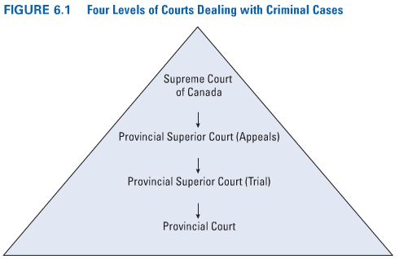
  - 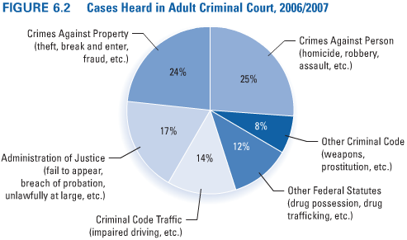
- The Provincial Court System
  - Provincial Court
    - The provincial courts are the lowest level of courts; nearly all criminal cases are begun and disposed of in them.
    - Their judges are appointed by the provinces, which also fund these courts and have jurisdiction over them.
    - Provincial courts sit without juries.
    - These courts also hear cases under the Youth Criminal Justice Act, as well as cases involving alleged offences against provincial statutes.
    - Provincial courts may also include family courts and small claims courts.
  - Community Courts
    - Vancouver’s Downtown Community Court, the first of its kind in Canada, attempts to address the needs of residents in the Downtown Eastside area of the city.
      - The community court assumes a problem-solving approach to deal with minor offenders who may have substance abuse, mental health, and/or homelessness issues.
      - Offenders are generally assigned to complete a certain number of community service hours and an attempt is made to help them access treatment services and programs.
  - Mental Health Courts
    - The attempt to address the needs of persons with mental illness who become involved in the justice system led to the creation of the first mental health court in Toronto in 1998.
      - The objectives of the court were to provide a forum to address pre-trial issues of the accused person’s fitness to stand trial and to reduce the “revolving door” syndrome of reoffending and involvement in the justice system of mentally ill persons.
    - Critics of the mental health court in London, Ontario contend that the lack of communication among the parties and of continuity in personnel assigned to the court hinder its effectiveness and limit the court to being a “Band-Aid” solution to the problems of the mentally ill in the justice system.
  - Domestic Violence Courts
    - Judicial Interim Release (Bail): Release by a judge or JP of a person who has been charged with a criminal offence pending a court appearance.
    - They are designed specifically to hear criminal law charges relating to domestic violence and to provide a mechanism for early intervention into domestic violence cases.
    - In cases where the accused is a repeat offender or inflicts serious injury, a coordinated-prosecution approach is taken.
      - This involves specialized investigations by the police to obtain evidence, and the prosecution of offenders by Crown attorneys who specialize in domestic violence cases.
  - Aboriginal Courts
    - The Gladue Court (Toronto):
      - The “Gladue Court,” an Ontario Court of Justice, meets twice a week and deals with the cases of Aboriginal people who have been charged in downtown Toronto.
      - It handles bail hearings, remands, trials, and sentencing.
      - The judge, the Crown, and the defence lawyers, court clerks, and court workers are all Aboriginal persons.
      - When the cases are processed, every attempt is made to explore all possible sentencing options and alternatives to imprisonment.
    - Tsuu T’ina Nation Peacemaker Court (Alberta)
      - This initiative on the Tsuu T’ina Nation near Calgary involves a Peacemaker working with the Crown counsel to identify cases that could appropriately be diverted to the community’s peacemaking program.
      - The cases so identified are adjourned by the court so that a Peacemaker can open a restorative justice process involving the victim, the accused, elders, and community residents.
      - A plan of action is designed, the purpose of which is to facilitate healing and address the issues associated with the harm done. Interventions include apologies, restitution payments, alcohol or drug treatment programs, and the requirement that the offender hold a traditional feast.
  - Drug Treatment Courts
    - Drug treatment courts provide an alternative forum for responding to offenders who have been convicted of drug-related offences.
    - Offenders avoid incarceration by agreeing to abide by specified conditions, including participation in a drug abuse treatment program and regular drug testing.
  - Provincial/Territorial Circuit Courts
    - In many northern and remote areas, judicial services are often provided via circuit courts.
      - Circuit court parties, composed of a judge, a court clerk, a defence lawyer, a Crown counsel, and perhaps a translator, travel to communities (generally by air) to hold court.
      - Many communities are served every month; others are visited quarterly or even less often if there are no cases to be heard or if the weather or mechanical problems with the court plane prevent a scheduled visit.
    - Circuit court judges often face a difficult decision: Should they remove the convicted person from the community and place him or her in confinement hundreds or even thousands of kilometres away?
  - Superior Court
    - The superior courts are the highest level of courts in a province and are administered by the provincial government; however, superior court judges are appointed and paid by the federal government.
    - Superior courts generally have two levels: trial and appeal. These two levels may be included in the same court, with two divisions (trial and appeal), or they may involve two separate courts.
      - In Ontario, however, the Court of Appeal is independent and separate from the Superior Court of Justice and the Ontario Court of Justice, which are the main two trial courts in the province.
      - The trial-level superior court hears cases involving serious criminal offences; the appeal-level superior court hears criminal appeals (and civil appeals as well) from the superior trial court.
      - The primary activities of appeal courts centre on reviewing decisions of the lower courts.
- The Federal Court System
  - If at least one appellate judge dissents (that is, does not agree with the majority), the unsuccessful party may pursue another appeal at the federal level.
  - The “court of last resort”—the Supreme Court of Canada—is located in Ottawa but hears cases from all provinces and territories.
  - Supreme Court Decisions: Balancing Security and the Rights of the Accused
    - While the Supreme Court receives hundreds of applications for leave to appeal, it generally grants only about 10 percent of requests.
    - Cases are heard by an odd number of judges—five, seven, or nine—to avoid ties.
    - In many cases that come before the Supreme Court, either the defendant or the Crown asks for permission, or “leave,” to appeal the decision of a lower court.
    - In some instances the federal government asks the Supreme Court for a legal opinion on an important legal question, a process referred to as a “reference.”
    - The Court has been criticized on the one hand for engaging in social activism in its decision making, and on the other hand for being too deferential to law enforcement, particularly in the area of interrogation of suspects.
- The Formal Criminal Courts Versus Restorative Justice Approaches
  - 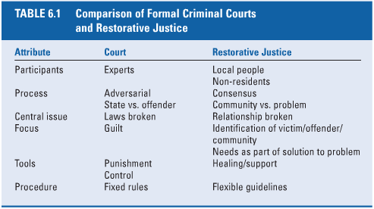
  - Mode of Trial
    - The “trier of fact” in a criminal case—usually a judge—decides whether the guilt of the accused person has been proved beyond a reasonable doubt.
    - Jury trials are virtually mandatory in some types of cases, an available option in many, and prohibited in others.
    - Jury trials are not available for summary conviction offences; nor, with a handful of exceptions, are they available in youth court.
    - Summary Trial
      - When the case involves a summary conviction offence, or when the Crown proceeds summarily, it is resolved in a provincial court.
      - Summary trials do not involve juries, and the sentences are usually less severe.
    - Indictable Offences
      - Hybrid (Or Elective) Offence: An offence that can be proceeded summarily or by indictment—a decision always made by the Crown.


