Chapter 5 – Police Strategies and Operations

- The Evolution of Police Practice
  - Traditional (Or Professional) Model of Policing: A model of police work that is reactive, incident-driven, and centred on random patrol.
    - Random patrol, rapid response, and reactive investigation.
      - The central premise of random patrol, also known as the watch system, is that the mere presence and visibility of patrol cars serves as a deterrent to crime and at the same time makes citizens feel safer.
- Community Policing
  - A philosophy, management style, and organizational strategy centred on police–community partnerships and problem solving to address problems of crime and social disorder in communities.
    - It Is An Organizational Strategy and Philosophy. Community policing is based on the idea that the police and the community have to work together as equal partners to identify, prioritize, and solve problems such as crime, drugs, fear of crime, social and physical disorder, and general neighbourhood decay, with the goal of improving the overall quality of life in the area.
    - It Requires a Department-Wide Commitment. The community policing philosophy requires that all personnel in the police service—both civilians and sworn members—balance the need to maintain an effective police response to incidents of crime with the goal of exploring new, proactive initiatives aimed at solving problems before they arise or escalate.
    - It Rests on Decentralizing and Personalizing Police Services. Decentralization offers line officers the opportunity, freedom, and mandate to focus on community building and on community-based problem solving, so that each and every neighbourhood can become a better place in which to live and work.
  - The Principles of Community Policing
    - Citizens are responsible for actively involving themselves in identifying and responding to problems in their neighbourhoods and communities.
    - The community is a source of operational information and crime control knowledge for the police.
    - Police are more directly accountable to the community.
    - Police have a proactive and preventive role in the community that goes beyond traditional law enforcement.
    - The cultural and gender mix of a police agency should reflect the community it serves.
    - The operational structure of the police agency should facilitate broad consultation on strategic and policing issues.

  - 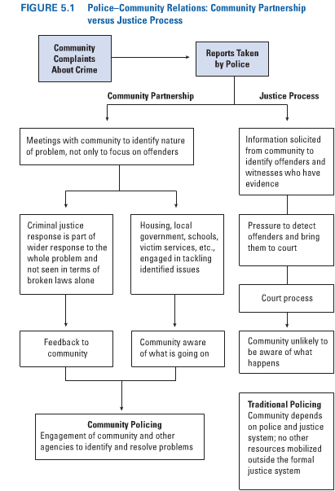
  - Peel’s Principles of Law Enforcement
    - Principle #1: The basic mission for which the police exist is to prevent crime and disorder.
    - Principle #2: The ability of the police to perform their duties is dependent upon the public approval of police actions.
    - Principle #3: Police must secure the willing co-operation of the public in voluntary observation of the law to be able to secure and maintain the respect of the public.
    - Principle #4: The degree of co-operation of the public that can be secured diminishes proportionately to the necessity of the use of physical force.
    - Principle #5: Police seek and preserve public favor not by catering to public opinion, but by constantly demonstrating absolute impartial service to the law.
    - Principle #6: Police use physical force to the extent necessary to secure observance of the law or to restore order only when the exercise of persuasion, advice, and warning is found to be insufficient.
    - Principle #7: Police, at all times, should maintain a relationship with the public that gives reality to the historic tradition that the police are the public and the public are the police; the police being only members of the public who are paid to give full-time attention to duties which are incumbent upon every citizen in the interests of community welfare and existence.
    - Principle #8: Police should always direct their action strictly towards their functions, and never appear to usurp the powers of the judiciary.
    - Principle #9: The test of police efficiency is the absence of crime and disorder, not the visible evidence of police action in dealing with it.
- The Core Elements of Community Policing
  - The organizational and tactical strategies and external relationships of a police service that employs a community policing model.
  - Organizational Elements
    - At the organizational level, the adoption of community policing philosophy is reflected in the mission statement, policies, and procedures of the police service.
    - Decision making in the police service is decentralized, as individual patrol officers are given the discretion to solve problems and make operational decisions.
    - With respect to deployment of police resources, there is fixed geographic accountability in tandem with generalist responsibilities. Most decisions about staffing, command, deployment, and tactics are geographically based. Also, personnel are assigned to fixed geographic areas for extended periods of time in order to facilitate communication and partnerships between officers and the community.
    - In traditional police services the management structure is a pyramid. In this top-down system, senior managers issue directives to be carried out by patrol officers. A one-way flow of information—from senior officers to patrol officers—ensures adherence to the goals and objectives established by senior officers.
    - Patrol officers are the cornerstones of community policing. They are given the support and authority to engage in problem-solving activities in the community and to work with community residents in identifying and responding to crime and social disorder.
    - 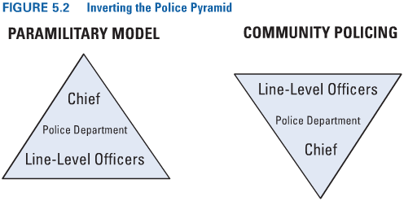
  - Intelligence-Led Policing: The collection and analysis of information by police services to provide an intelligence product designed to inform police decision making at the tactical and operational levels.
    - The strategy of intelligence-led policing is one example of how police services use technology to generate information and to deploy departmental resources more effectively.
      - Key to this approach are crime maps—computer-generated maps of specific areas that illustrate the incidence and patterns of specified types of criminal activity. This information can then be used to identify “hot spots,” to which patrol and investigative units can then be deployed.
      - A number of police observers have cautioned that although intelligence-led policing has potential, translating it from concept into actual practice involves a number of challenges, including resistance within the police organization itself and the need to develop working relationships between crime analysts and police operations personnel.
  - Tactical Elements
    - The tactical elements of community policing centre on the enforcement of laws, a proactive, crime prevention orientation, and a problem-solving approach.
    - The tactical elements of community policing focus mainly on strategies for addressing crime and other community issues. The key to success here is proactive problem-solving with community partners.
    - Zero-Tolerance Policing: An order-maintenance approach that utilizes high police visibility and presence and that focuses on disorder and minor infractions with the goal of reducing more serious criminal activity.
    - Increased police visibility is a core component of quality-of-life policing—efforts to improve conditions in an area by targeting annoying behaviours such as panhandling, public drug and alcohol use, and loitering.
    - Problem-Oriented Policing (POP): A proactive strategy centred on developing strategies to address community problems. Problem-oriented policing is a process with several clearly defined stages:
      - Scanning: Officers consider whether the issue at hand is a problem—their concern may be the result of a series of incidents, for example, break and enters in a particularly neighbourhood or business area, or a series of assaults or robberies.
      - Analysis: Information on the problem is gathered from as many sources as possible, including the police service and the community, in order to understand the nature, extent, and probable cause of the problem.
      - Response: Officers develop a plan to address and solve the problem in collaboration with other police members, community leaders, and organizations.
      - Assessment: The effectiveness of the response in addressing the problem is evaluated and, if required, adjustments to the response are made.
    - CAPRA Model: A problem-solving approach used by the RCMP.
      - The letters stand for focusing on clients, acquiring and analyzing information, developing and maintaining partnerships, generating an appropriate response, and assessing the intervention.
      - This model, taught to recruits at the Training Academy in Regina, incorporates the basic principles of community policing.
      - It emphasizes identifying and responding to problems of crime and social disorder in the community by taking a problem-solving approach.
      - It also highlights the importance of consultation and collaboration with community partners.
    - OPP PARE Model: Problem identification, analysis, strategic response, evaluation.
      - The P.A.R.E. model incorporates the same steps as problem-oriented policing (POP), and bears similarities to the CAPRA model.
      - 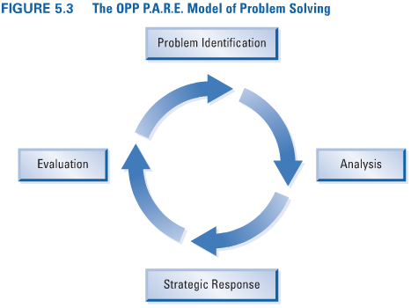
    - Crime Attack Strategies: Police patrol operations that are proactive and aimed at crime control.
    - Community Service Approaches: Police strategies designed to increase police–public contact and cooperation in addressing problems of crime and disorder in communities.
    - Crime Prevention Programs: Initiatives designed to prevent or reduce crime and the fear of crime.
      - Primary Crime Prevention Programs: These identify conditions that create opportunities for offences and alter those conditions to reduce the likelihood that a crime will be committed. The programs are most often aimed at property offences.
        - Operation Identification: Citizens and businesses mark their property with ID numbers to make the disposal of stolen goods more difficult and to assist in the recovery and return of items by the police.
        - Neighbourhood Watch: This program involves turning the “eyes and ears” of citizens in the community toward the crime prevention effort. Another goal here is to forge a sense of community among neighbourhood residents.
        - Citizen Patrols: Citizen patrols (by car and on foot) work in collaboration with police services and campus-based student patrols.
        - Crime Prevention through Environmental Design (CPTED): This program focuses on altering elements in the physical environment to discourage offenders. For example, access to areas is controlled to make victimization more difficult; architectural designs are employed that allow for surveillance.
        - Media Programs: Media programs are designed to educate the public about crime or to solicit the public’s assistance in locating known criminals. Police services have developed a myriad of “hot tip” lines and televised reenactment programs (such as Crime Stoppers). These offer cash rewards for information leading to the arrest and conviction of offenders and environments are designed to foster a sense of community.
        - Closed-Circuit Television (CCTV) Monitors: Sophisticated systems utilizing moving cameras and camera operators who maintain radio contact with police officers have been installed in many public areas in Europe, the United States, and (to a lesser extent) Canada. These systems are designed to strengthen police response to incidents and to deter and prevent crime, particularly street mugging, car theft, and property damage. The tapes can also be used to identify perpetrators.
      - Secondary Crime Prevention Programs: Secondary prevention initiatives focus on areas that produce crime and other problems; are often based on crime area analysis, including the targeting of high-crime areas; and attempt early identification and intervention with potential offenders.
      - Tertiary Crime Prevention Programs: Tertiary crime prevention initiatives use the criminal justice system to direct responses toward actual youth and adult offenders; intervene to reduce the likelihood of offenders reoffending; and deter/incapacitate/rehabilitate offenders.
    - Police Legitimacy and Crime Prevention
      - The police utilize a number of strategies within the community policing model to increase their legitimacy in the eyes of the general public. An important issue in any discussion of the effectiveness of crime prevention programs is whether specific initiatives are effective in preventing crime, or whether the specific strategy or program is being used to increase police legitimacy.
  - External Elements
    - The external elements of community policing centre on public involvement and community partnerships and partnerships with government and other agencies.
    - The strategies to achieve this include the development of police partnerships with key community stakeholders and various private-sector initiatives to address crime and social disorder.
    - A key feature of community policing is net-working with community groups and organizations, with the private sector, and with various government agencies at the municipal, provincial, and federal levels.
    - Volunteers provide a crucial link between police services and the community and are a vital component of many of the partnerships between the two.
      - Volunteers assist with charitable events, staff police storefronts, and serve as victim/witness assistance workers.
- The Framework for Community Policing in Ontario
  - Ontario’s police forces operate under one key piece of legislation, the Police Services Act, and an accompanying regulation, the Adequacy and Effectiveness of Police Services Regulation (commonly referred to as the “Adequacy Standards”). The Police Services Act contains provisions designed to ensure:
    - That community policing is integrated into all segments of policing.
    - That government can monitor the performance of police services in providing adequate and effective policing, and, if necessary, intervene to correct any perceived deficiencies in service delivery.
  - The Adequacy Standards establish uniform service standards for police services across the province in a number of areas, including crime prevention, law enforcement, victim assistance, and emergency response services.
  - The OPP has undertaken a wide range of initiatives as part of its commitment to community policing, a number of which can be considered best practices to be emulated by other police services across the country.
- Measuring the Effectiveness of Police Strategies
  - Clearance Rate: The proportion of the actual incidents known to the police that result in the identification of a suspect.
    - There are three main reasons why clearance rates should not be used as the only indicator of police effectiveness:
      - Police Officers Do Not Spend Most of Their Time Pursuing Criminals: Most of their time is spent on non-enforcement activities such as maintaining order, providing services, and preventing crime.
      - Not All Police Services and Police Officers Work in the Same Types of Communities: Police officers carry out their tasks in a variety of task environments. Some officers are assigned to remote and rural areas, while others work in suburban and urban areas. Clearance rates do not reflect variations in the levels and types of crime in these different areas. Police services in areas that experience hard-to-solve crimes may be at a disadvantage.
      - Police Officers Do Not All Engage in the Same Type of Police Work: Some officers work out of community police stations; others work in specialty units such as gang squads and auto theft task forces. Using only one measure of police effectiveness does not allow for these differences to be taken into account.

