States of Consciousness
- How do our daily cycles affect our psychology?
- What are the different stages of sleep?
- Why do we sleep?
- Why do we dream?
- What do our dreams mean?
- How do chemicals such as psychoactive drugs alter our sense of awareness?

Circadian Rhythms
24-hour biological cycle:
- Cycle that makes us want to wake up vs. go to bed @ night
- Alters blood pressure, body temp
- Genetically programmed, “baked into human organism” relation to light
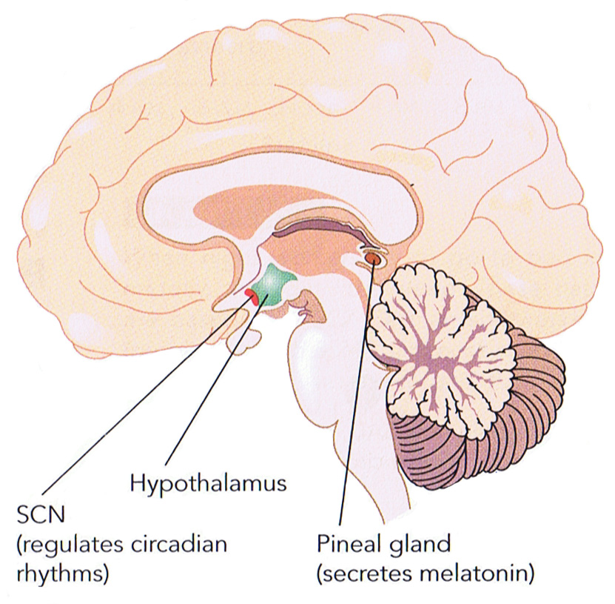

Suprachiasmatic nucleus: regulates melatonin levels
- Communicate with pineal gland, “were losing light, producing melatonin
- Body temp changes throughout the day
- Alertness increases through the day, then declines towards the end of the day
- Changes in our psychological functioning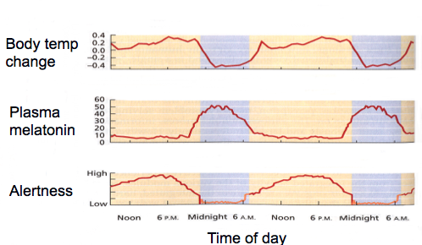
Consequences of Desynchronization
  - Air travel: Jet Lag

  - Shift work
  - Daylight savings time?
  - Illness, drugs, exercise, fatigue, etc.
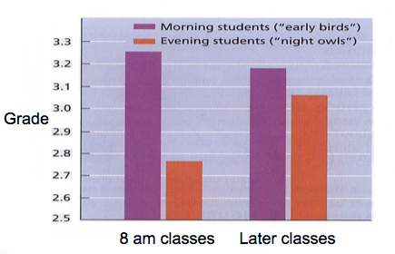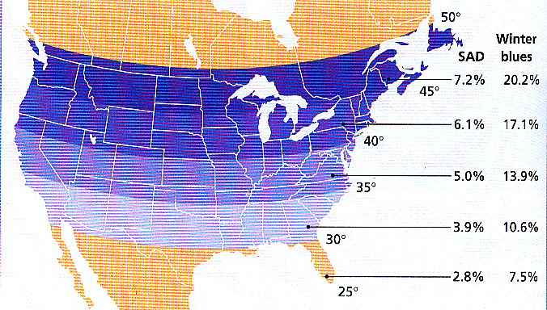
SLEEP
- Nathaniel Kleitman
- Father of modern sleep research
- First to conduct systematic investigations of sleep
- Established key methods of data gathering
- Lived to be 104

Stages of Sleep: EEG
Stage 1:
- Brain exhibits beta ways: high frequency waves
- Consistent with alpha waves
- Regular pattern
- Nod off to sleep, head is bobbing, easily aroused
- Lower frequency with brain waves, we start to see fade a ways
Stage 2:
- Not a deep sleep, but you are sleeping
- EEG is non consistent, known as sleep spindle
- Trying to shut out external stimuli
Stage 3:
- Deep sleep
- Lower frequency, hard to wake you up
- Breathing and pulse rate slows down
Stage 4:
- Majority being delta waves
- Amplitude increases
- VERY deep sleep
- Not even loud noises will wake you up
Final Stage: REM Sleep
- Known as “Rapid Eye Movement”
- Experience physiological changes
- EEG is similar to when we are awake
- Increase in heart rate/ breathing/ blood pressure
- Face starts to twitch, eyes start moving back & forth
- BUT still asleep, during all this
- Unable to move, capacitated = REM Paralysis
- Also known as Paradoxical Sleep, you seem to be awake but cannot get up
- When you wake someone from REM, they say they were just in a dream
- Stages 1-4, less likely to experience dreams
- When we are deprived of REM for a period of time, we exhibit REM rebound, when we are making up for the REM we have lost
- People become irritable without REM sleep

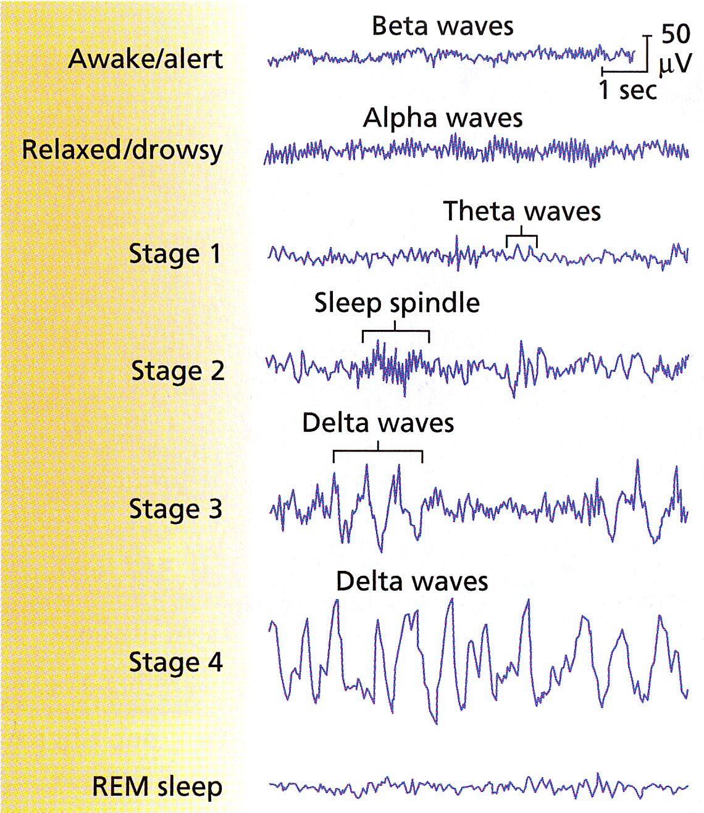

7-8 hour sleep night:
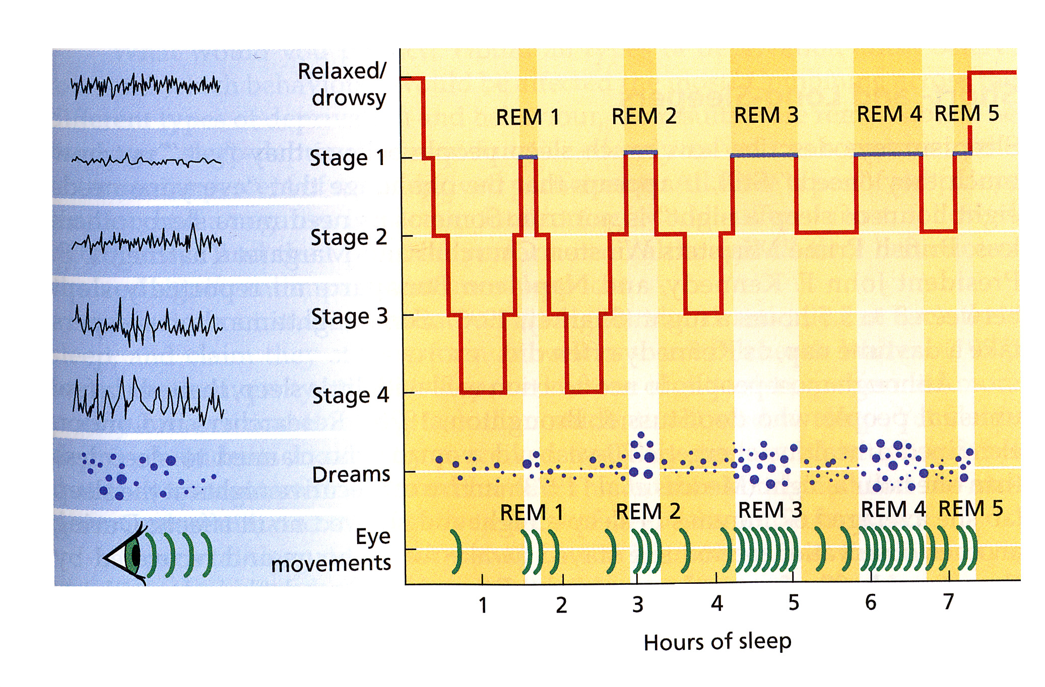
Our Sleep Life:
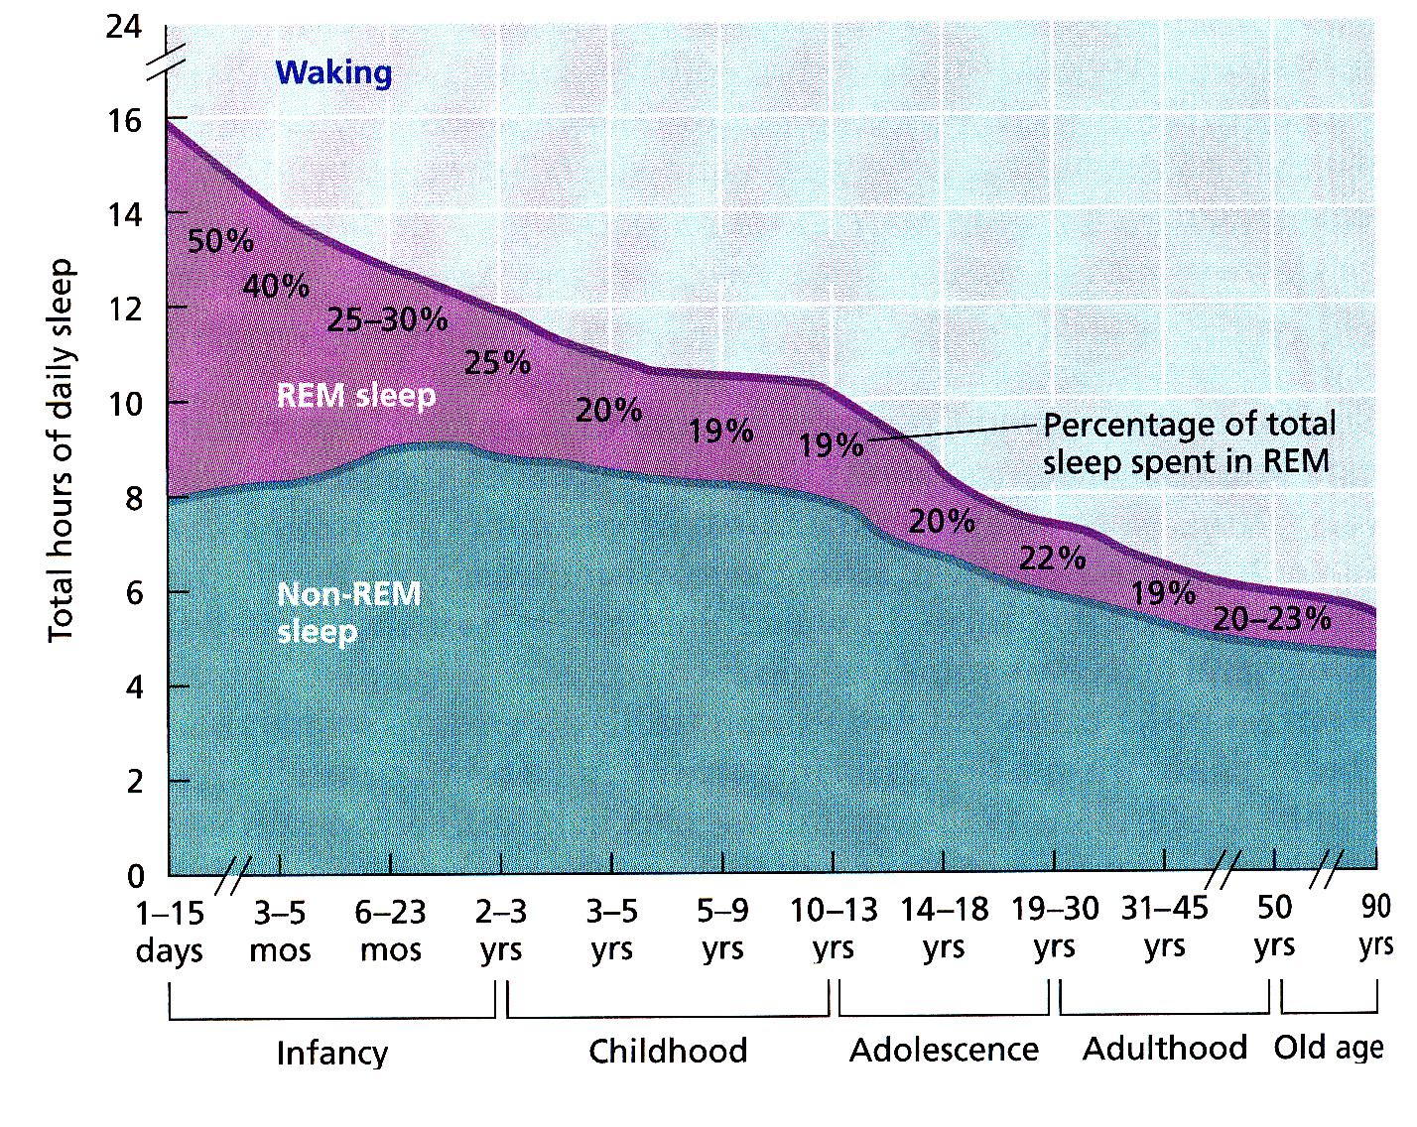
- As you get older, you don’t need to grow as much, so you don’t need as much sleep
- REM is a minority at this point in our lives
- Students are notoriously sleep deprived

WHY do we sleep?
- Christopher Evans (1984): “The behavior patterns associated with sleep are glaringly, almost insanely, at odds with common sense.”
Restoration model
- During the 1st half hour, even though your rods have had full sensitivity to light, they will not be functioning to the level of other prey.
- We require sleep to regenerate, restore, recharge and get rid of waste.
- People who are involved in physical activity, receive greater REM sleep immediately afterwards.

Evolutionary/circadian models
- Survival of the species
- Prey vs. Predator

“To Sleep, Perchance to Dream” – Sigmund Freud
- Psychoanalytic theory
- Manifest and latent content
- Dream work & interpretation
Freud’s Theory - Divided into 3 different levels:
1 - Conscious mind: your thoughts in the moment
2 - Pre conscious mind: info you’re not currently aware of, but it is readily accessible
3 - Unconscious mind: impulses we do not want to acknowledge, we want to keep it in the unconscious mind, to acknowledge them, would be too difficult (anxiety).

- According to Freud, dreams represent the royal road to the unconscious
- Dream content, sexual impulses want to bubble up, but our psyche pushes it back down. Also known as Manifest Content.
- “A cauldron of sieving expectations”
- Real meaning of the dream is, Latent Content
- Dream work, our mind converts sexual/aggressive impulses into symbols, within a dream. EX: tree trunks, ties, weapons, rockets = male errection, all things hallow = female gentilia
- Free association, say whatever comes to mind. As you’re talking about your dream you begin to unravel dream work, from Manifest to Latent Content.
- Freud was dealing with a specific population: wealthy individuals, females, and anxiety disorders.

More Dream Theories: details of daily life, that becomes represented in dream content, they are not symbols, but more trying to understand what is going on for you right now.
Problem-focused (Cartwright):
Mental housekeeping (Hobson): during sleep, unnecessary neuro connections are paired back, and unused ones are strengthened. Essentially removing old programs/ mental garbage. *Consolidation
Activation Synthesis (Hobson & McCarley): concerned with structures of the brain and how they react during a dream. Pons send messages to cerebral cortex, which become active during periods of REM. Brain wants to make sense of this info, but t is shut out from normal world. Making sense of these is the synthesis, because pre frontal cortex is under-active when you are sleeping. You’re lacking the area of the brain that gives sense to a story.
Newer models and integration: try to combine a number of different approaches, elements of our lives that are outside our immediate awareness = randomness.
Dream diary: If you happen to wake up, write down as much info as possible about the dream you had. Looking the next day, you may know or not know what the dream meant.
Sleep Disorders:
Insomnia:
- Most common
- Difficulty falling asleep (30 mins or more) younger people
- Difficulty going back to sleep once woken up (cannot STAY asleep) older ppl
- Result in cognitive issues (concentration, mood, irritable, productivity)
- Reflective of ones sleep environment
- Don’t always associate bed with sleeping (eating, reading, computer, tv)
- How to deal with it: therapy to restructure environment, sleeping pills,
Sleep apnea:
- Individual will stop breathing (20-40 seconds)
- Don’t even realize that you are waking up during the night, which causes irritability, negative affect on relationships, mood, “not at your best”
- Peripheral: obese, weight on the wind pipe, reduced air flow
- Central: reflective of some abnormality of the brain stem, ability to regulate respiration, becomes impaired
How to deal with sleep apnea: Continuous Positive Airway Pressure (Cpap) Machine: wearing a mask that forces your air flow to flow properly.

Narcolepsy:
- The opposite of insomnia, sudden attacks of sleep
- Occur during the daytime
- Almost instantly enter REM
- Stimulants or Antidepressants, suppress REM, less likely to receive an attack

Nightmares:
- Wake up concerned
- Heart racing, sweating
- Common in young children
- Nightmares decline as you age
Night terrors:
- Primarily young children
- Sit up in bed, and will scream/yell
- As quick as it started, the child lays down and are completely calm
- Not aware that they were screaming in the night
- Usually out grow them as they age
Sleepwalking (somnambulism):
- Eyes remain open
- Get up, but are still asleep (1st hour or so of sleep, stage ¾)
- Deep sleep, but not in REM
- Guide sleepwalkers back to their bed
- Stress and anxiety can be causes
- Peak around age 12 and declines with age
Consciousness-altering Drugs
- Psychoactive drugs: accomplish affects by altering our biochemistry
- Physical dependence
- Tolerance: decreased responsivity to the affects
- Withdrawal: opposite affects from a drug
- Psychological dependence: overwhelming craving for the drug

Depressants – heart rate and blood pressure lowers, breathing slows down, anxiety, lower ambitions, less sensitive to pain

Alcohol:
- Moderate, increase & availability of Gaba
- Slows your system down
- Social expectation runs quite counter to what is happening biologically
- Suppression of the Amidala
- Difficulties walking in a straight line
- During pregnancy results in the largest preventable source of developmental disability (fetal alcohol syndrome)

Barbiturates:
- Used to aid anxiety
- Sleep aid
- Tremendous addictive potential
- Combining depressants
- Suppress REM

Tranquilizers:
- Anti anxiety medications
- Physical addiction is lower
- Don’t suppress REM

Opiates:
- Derived from the Opium Poppy
- Dominated currently by Afghanistan and Mexico
- Slice edge of poppy, white liquid flows from the poppy, this liquid hardens into brown crust, and then you harvest it.
- Take raw Opium and dissolve in hot water, add fertilizer, heat and mix with ammonia, then it solidifies to make Morphine.
- To intensify the affects, creates Heroine
- Biological affect, mimic our endorphins, our body thinks that these are endorphins, which causes the body to stop producing endorphins
- Ways of doing Heroine: Smoke or Snort, or Shooting up
- Affects of Heroine: warm “glow”, profound relaxation, depression of central nervous system, constipations, want more to experience affects again
- Moving from relaxation to agitation, body is in pain, not producing endorphins (withdrawal)
Stimulants – speeds everything up, increase in blood pressure and heart rate, increase in talkativeness, heightened levels of alertness, boost your mood, can heighten levels of irritability, work on dopamine

Amphetamines:
- Originally prescribed for appetite & help keep soldiers awake at night
- Strong addictive potential
- Experience less need for sleep
- Crash withdrawals
- Dopamine levels become depleted (body runs out)
- Methamphetamines: experience euphoria, then exhilaration, can be snorted, injected or smoked in crystal form (Meth)
- Highly addictive and strong relapse (worse than Heroine)
- Individuals on meth, experience physiological consequences
- Lead to destruction of blood vessels, and cause acne, weight loss, dental problems, destroys visual tissue, mood swings, memory problems

MDMA (Ecstasy):
- Reduce inhibitions
- Promotes sense of social connectiveness, giddiness, emotionality, sense of empathy towards others
- Pill form
- Extremely tired & dehydrated and hungry when coming down from high
- Moderate addictive potential

Cocaine:
- Made from Coca leaf, pound it and mix with alcohol, shake mixture, take out liquid add sulfuric acid and add characin, forms paste which creates Cocaine
- Increased levels of activity, talkativeness, suppresses appetite
- Chronic users are visited by paranoia or experience hallucinations
- Bugs hallucination
- Bleeding of the nasal membrane (snorting)
- Inhale cocaine vapor, “freebasing” which is extremely dangerous
- Combining cocaine and heroine “speed balling”
- Heat cocaine up till it is crystalized “crack cocaine” highly addictive
- Reuptake blocker for dopamine, serotonin and norepinephrine
- Withdrawal = less physical addiction

Caffeine:
- Love it, cant live without it

Nicotine:
- Used for over 400 years
- Declining in the developing world
- Extremely addictive
- Average smoker consumes 3000 cigarettes a year
Psychedelics/Hallucinogens – change our perceptions, mind altering, and can vary from person to person.

LSD:
- Consumed in tablet or gelatin form
- Soak paper in LSD, then lick the paper
- Alter perceptions (slows time down)
- Hallucinations, cross over of senses
- Not very addictive, low levels of dependence

Marijuana:
- Exhibits properties of both
- Mild euphoria, relaxations
- Enhanced sensory awareness perception
- Alteration of ones sensory experience
- Increased appetite “munchies”
- Not a gateway drug
- Long term affects: risk of Cancer
- Cognitive issues, memory & attention problems
- Can in fact occur and are hidden through media

