Lecture 18 – Population structure, gene flow & genetic drift
People
Wright saw an important role for population structure and genetic drift in evolution
Fisher disagreed and argued that most evolution occurred in large populations by natural selection
Topics & concepts
Geographic variation
- Differentiation depending on different locations – Rat snake, Darwin’s finches
Population differentiation
Gene flow
- The movement of genes from one population to another

Models of population structure
Stochastic processes
- Unpredicted or random evolutionary forces
  - Mutation, recombination, gene flow, genetic drift
Genetic drift
- Changes in allele frequency dye to random variation in fecundity & mortality (most importantly when populations are small)
  - Population bottlenecks, founder events
  - The bigger the population the less likely it is that alleles will be lost
Genetic markers
- A gene or short sequence of DNA used to identify a chromosome or to locate other genes on a genetic map
Measuring gene flow
- Difficult to observe and measure
- Distinguish potential vs. actual
- Distinguish gamete vs. individual
- Use experimental approaches
- Use neutral genetic markers

Lecture 19 – Natural Selection & Adaptation
People
Kettlewell
- Medical doctor and moth fanatic
- Experiments involved mark and recapture of moths
- Findings thought to provide the first demonstration of the mechanisms of natural selection in the wild
Majerus
- Studied at Cambridge
- Wrote Melanism
- Was reviewed by nature saying
  - “Majerus concludes, reasonably, that all we can deduce from this story is that it is a case of rapid evolution, probably involving pollution & bird predation. I would, however, replace “probably” with “perhaps”. B. bistularia shows the footprint of natural selection, but we have not yet seen the feet.”
Hoekstra
- Conducted experiments and observations to determine whether mouse coat colour polymorphism was maintained by avian predators
Bradshaw
- Evolution of heavy metal tolerance in plants
Lenski
- Experimental Evolution with E-Coli
Topics & concepts
Fitness
- Relative genetic contribution of individuals to next generation as a result of differences in viability and fertility
Adaptation
- Any trait that contributes to fitness by making an organism better able to survive or reproduce in a given environment (noun)
- The evolutionary process that leads to the origin and maintenance of such traits (verb)
Types of selection on quantitative traits
- Stabilizing selection – favours average traits
- Directional selection – favours one extreme
- Disruptive selection – favours both extremes
Measurement and response to selection
Evolution of cyanide resistance
- Alleles are found at low frequencies in populations
- Resistance spreads through the population
- This process serves as a model for the evolution of many forms of resistance
  - e.g. antibiotics, insecticides, herbicides
Mechanisms of selection
Artificial selection
- Selected by humans
- Has a purpose or goal
Natural Selection
- All organisms
- Selection by abiotic & biotic environment
- No purpose or goal

Industrial melanism – Evolution by pollution
- Light and dark forms of the peppered moth
- White form was the more natural
- As industrial pollution increase, the black variant began to replace white in polluted areas
- Mechanism of selection though to be predation by birds and differences in camouflage depending on the backgroud of tree trunks
CRITISIZED BY NATURE (magazine)
Heavy-metal tolerance
Costs to resistance
Experimental evolution in E. coli.

Lecture 20 – Species, speciation, & hybridization
People
Jerry Coyne & Allan Orr
- Co-wrote “Speciation”
- “When we understand the origin or reproductive isolating factors, we understand the origin of species” - Coyne
Ernst Mayr (8)
- First formally defined the BSC (Biological species concept)
  - A group of interbreeding natural populations that are reproductively isolated from other such groups
Douglas Schemske
- Premating isolation in species of monkey flower: pollinator preferences & altitude
Dolph Schluter
- Observed the adaptation of 3-spined stickleback in freshwater loss of bony defensive armor
Richard Abbott
- Hybridized two species of Senecio in the UK and bred 3 new products
Topics & concepts
Species concepts (7)
Two main concepts
- Taxonomic (or morphological)
  - Based primarily on distinct morphological differences
- Biological
  - Based on inter-fertility (crossability) among individuals
Modes of speciation (9)
Two main modes
- Allopatric (often known as the theory of geographic speciation since geographical isolation is involved)
- Sympatric
Reproductive isolating mechanisms (10)
Stages when RI can occur
Finding a compatible mate
Mating & fertilization
Development of zygote
Adult growth & survival
Reproduction & fertility of offspring

Premating isolation & Post-mating isolation
Premating:
- Preventing zygote formation
  - Geographical, ecological
  - Temporal, behavioural
  - Mechanical, prevention of gamete fusion
Post-mating:
- Preventing the proper functioning of zygotes once they are formed
  - Inviability, sterility, or abnormal development of hybrids
  - F2 breakdown
    - Eg. mule (cross b/w male donkey and a female horse)
Ecological speciation
- The evolution of local adaptation as a result of divergent selection leads to reproductive isolation and speciation
Speciation genes
Adaptive radiation (25)
- The evolution of ecological and phenotypic diversity within a rapidly multiplying lineage as a result of speciation
- Single common ancestor results in an array of species that differ in traits allowing exploitation of a range of habitats and resources
Four features commonly identify an adaptive radiation
- Recent common ancestry from a single species
- Phenotype-environment correlation
- Trait utility
- Rapid selection
Causes of Adaptive Radiations (26)
1) Ecological opportunity – abundant resources and few competitors often occur on oceanic islands or their aquatic counterparts e.g. African rift lakes
2) High rates of speciation characterize the clade – can be tested by looking at mainland clade, e.g. Darwin’s finches & Hawaiian honeycreepers also radiated on mainland (although not as much), whereas Galápagos mockingbirds have not radiated on islands or continents
3) Origin of a key innovation – e.g. toepad in Anoles; floral nectar spur in Columbines (dealt with in next Lecture)
Hybridization (28)
- The exchange of genes between species as a result of occasional inter-specific mating
- Varies among different groups of organisms
  - Common in plants and fish, rare in mammals
- Can result in complex patterns of variation

Polyploidy (29)
- An organism, tissue or cell with more than two complete sets of homologous chromosomes
- Polyploid conditions range from autopolyploidy (eg. AAAA) to allopolyploidy (eg. AABB)
- Allopolyploidy arises from occasional hybridization and is the commonest type of polyploidy
Recent origin of species

Lecture 21 – Phylogenetics & Macroevolution
People
Linnaeus (4)
- The “father” of taxonomy
  - Binomial nomenclature
  - Hierarchical system of classification (kingdoms, phyla…genera, species)
Willi Hennig (9)
- Birthed the study of cladistics and the building of phylogenetic trees
  - Phylogenetic trees provide a depiction of the evolutionary relationships among groups of organisms
W&D Maddison (23)
- Designed “Tree of Life” an online database with 10, 000 webpages about biodiversity and phylogenetic relationships
Topics & concepts
Biological classification (5)
- Name is a key to the literature on an organism
- Enables interpretation of origins and evolutionary history
Taxon (6)
- A named taxonomic unit at any level
  - Kingdoms
    - Phyla
      - Classes
        - Orders
          - Families
            - Genera
              - Species
Taxonomy & Systematics (7)
Taxonomy - the theory and practice of classification
Systematics - the study of biodiversity and the evolutionary relationships among organisms
Phenetics & Cladistics
Phenetics - classifying species based solely on overall resemblance (LARGELY DEAD)
Cladistics - classifying species on the basis of their phylogenetic relationships
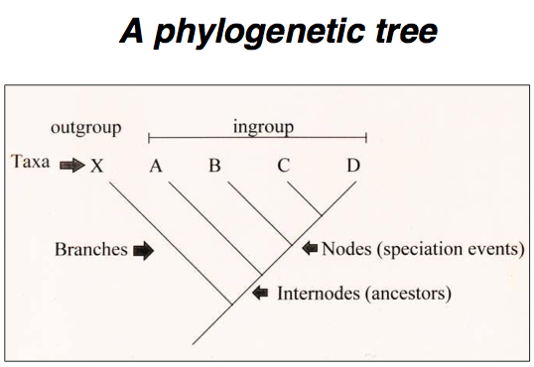
Monophyletic & Non-monophyletic (13)
Monophyletic - a single ancestor gave rise to all species in that taxon and no species in any other taxon
Non-monophyletic - A taxon whose members are derived from two or more ancestral forms not common to all members
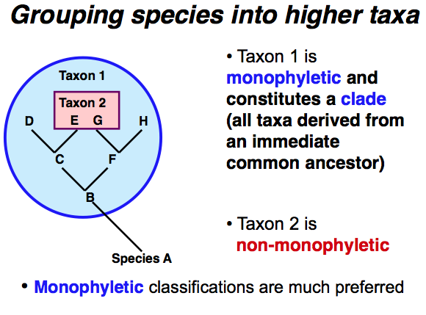

Homology & Homoplasy (16)
Homology – similarity of traits de to shared ancestry
Homoplasy – Similarity of traits as a result of convergent evolution
Convergent evolution (18 - 19)
- The evolution of structures that resemble one another and perform similar functional roles due to the shared ecology of unrelated organisms
  - E.g. cactus, spurge, and milkweed families (convergent evolution of succulence & spiny growth form in desert environments)
  - Cichlid fishes of the African Great lakes
    - Independent evolutionary radiations in two lakes
Molecular phylogenies
- The analysis of hereditary molecular differences, mainly in DNA sequences, to gain information on an organism's evolutionary relationships. The result of a molecular phylogenetic analysis is expressed in a phylogenetic tree.
Tree of life project (23)
- An online database which provides 10, 000 webpages about biodiversity and phylogenetic relationships
Key innovations (24)
- Origin of a novel trait resulting in adaptive radiation
- Carriers of the trait can exploit new resources of sets of habitats
- Usually associated with rapid evolutionary diversification (eg. adaptive radiations)
Mapping traits on phylogenies (25)
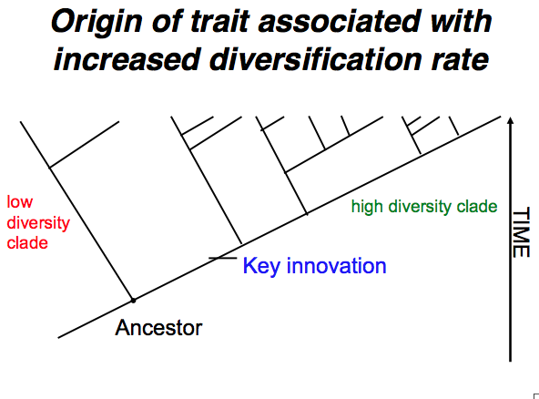
Nectar spur evolution (27-29)
- Display diverse flowers associated with different pollinators
  - Hummingbird long spurs
  - Bumblebees short spurs
  - Hawkmoth medium spurs
Sexual conflict & Arms races
- BUG RAPE!
  - Eg. Water striders
    - Females tend to resist most mating attempts by males
      - Males have evolved grasping structures to overcome resistance
      - Females also evolved behaviours to aid in resisting
- This antagonistic coevolution has the potential to escalate like an arms race

Lecture 22 – Contemporary evolution and invasive species
Topics & concepts
Native (7)
- An indigenous species that occurs wild in a given region
Alien (7)
- A species that has been introduced to a part of the world to which it is not native – introduced species
Biological invasion (6 & 8)
- The successful establishment of a species in a region not previously occupied followed by rapid range expansion
- Negative consequences
  - Disrupt ecological processes in natural plant & animal communities
  - Displace native species, leading to their extinction
  - Adverse effects on human health
  - Economic & social impacts through reduction of yields in agriculture & fisheries
Invasive species
Attributes of successful invasives (14)
- Rapid development to reproduction
- High reproductive output
- Well-developed dispersal mechanisms
- Broad ecological tolerance
- High phenotypic plasticity (the ability of a genotype to alter its phenotype in response to environmental change)
Disturbance (12-13)
- Thrive in disturbed sites: the more disturbance the more vulnerable to invasion
  - Pompas grass invasion along abandoned fire trail
Crop mimicry (15-19)
- Weeds that look more like the crop escape detection inadvertently selecting for mimicry
  - eg. Barnyard grass plants that mimic cultivated rice (SE Asia)
Herbicide resistance
Zebra mussels (21-22)
- First reported in 1988
- Single female can produce 30, 000 – 1 million eggs per season
- Extensive damage to water intake pipes and commercial & sport fisheries
- Source of avian botulism leading to death of many birds
Purple loosestrife (23-31)
- Aquatic perennial with showy purple flowers native to Europe; used as an ornamental.
- Multiple introductions to eastern North America during past century followed by invasion of wetlands.
- High phenotypic plasticity, produce millions of small, easily dispersed seeds with high viability
Common garden studies (31)
- Indicates significant genetic differentiation among populations
- Variation forms a cline (a gradual change in trait means over a geographical transect) in time to flowering with northern populations flowering faster than southern populations
- Populations farther north have adapted to shorter growing seasons
Local adaptation
- Greater fitness of individuals in their local habitats due to natural selection
Water hyacinth & Kariba weed (32-36)
- World’s worst aquatic invaders
- Native to S. America, introduced by humans to Old World tropics, free- floating, populations genetically uniform and invasiveness due to high phenotypic plasticity NOT genetic diversity
- Herbicide control causes pollution of aquatic habitats so biological control methods used
Biological control (38-40)
- The planned introduction of natural enemies (e.g. predators, parasites, pathogens) to control unwanted populations of invaders in alien range
ADVANTAGES
- Non-toxic to humans; if conducted carefully no serious environmental impacts
- If successful the effects are permanent
- Economically cheap ($1 for biological control vs. $5 for chemical control)
DANGERS
Sloppy science creates new invasion

Lecture 23 – Biodiversity, extinction & conservation biology
People
E.O. Wilson
- Early founder of biodiversity science
- “ The loss of biodiversity is the most important process of environmental change. This is because it is the only process that is wholly irreversible. Its consequences are also the least predictable, because the value of the earth’s biota is largely unstudied and unappreciated. ”
C. Keeling
N. Vavilov (35)
- Russian crop geneticist and founder of crop genetic resource conservation
Topics & concepts
Global climate change
- Increase CO2 is a result of the burning of fossil fuels
How will organisms respond to climate change?
- Migrate to more favorable environmental conditions (= ecology)
- Adapt to changing environmental conditions (= evolution)
- Go locally or globally extinct (= evolution)
Rapid evolution
- eg. field mustard in southern california
Resurrection paradigm
- Evidence for directional selection for flowering in both populations in 2002
- Earlier flowering plants set more seeds than later flowering plants
- Evolutionary response to drought involves selection for earlier flowering in both populations
Components of biodiversity
- The number and kinds of living organisms in a given area
- Two elements
  - Interspecific variation or species diversity (studied by ecologist)
  - Intraspecific variation or genetic diversity (studied by geneticists)
- Many components
  - Species diversity
  - Ecological (functional) diversity
  - Genetic diversity
  - Phylogenetic diversity

Biodiversity hotspots
- 25 hotspots that are identified and receiving special conservation efforts
Types and causes of extinction
- Background extinction – turnover of species at a low rate a natural feature of ecosystems; estimated at ~1 species per year
- Mass extinction – very large numbers of extinctions due to natural catastrophes
- Anthropogenic extinction – caused by humans now estimated at 4-6000 species per year
Causes
- Habitat destruction
- Overexploitation of species
- Introduction of pests, predators & competitors
Habitat fragmentation
SLOSS (24)
- Single Large Or Several Small debate
Keystone species
- Eg. beaver
MVP (Minimum viable population size) (28)
- The number of indiciduals necessary for a species to maintain or increase its number in a region
- The smallest population of a species that can sustain itself in the face of environmental variation
- No single number for all species; will vary
Consequences of small population size
Mating among relatives
- Loss of heterozygosity
- Inbreeding depression
- Fixation of deleterious genes
Inbreeding in zoo animals
Conservation of crop genetic resources

