CHAPTER 2 - METHODS
LECT 2

A.3 Survey:
Ex. presidential approval
- Can be part of descriptive and correlational research

Definition: survey, asking a large sample of people questions that are of interest to researchers

It is impossible to: for researchers to ask and interview everyone in the population or country.
- So researchers interview a sample
- About 1500

If the results of a survey: are to be considered scientifically accepted, the samples chosen must be considered representative.

Representative sample: your sample must closely mirror, and closely reflect the characteristics of the population
Ex. population is 50 percent black, 20 percent white, 30 percent asian
- Sample must also have these percentages
- Otherwise it's considered scientifically USELESS

Why do we need a representative sample?
- Whole goal of survey is to generalise the findings to population of interest
- We use 1500 canadians to generalise all of canada

How do you get a representative sample?
- We do random sampling

Random sampling: every single person in pop of interest, has an equal chance of being included in the survey
- Chance and only chance, will determine who ends up in the sample nothing else

Simple random sample: random sampling to extract a sample from the whole population of interest

Stratified random sample: take a pop of interest and break it down into the groups were interested in based on our goal, we call them groups or strata
- From each group were going to use random sampling to extract the subjects, we do this for every group
- From each of the groups (50% black, 20% asian, 30% white) we’re going to extract subjects from those groups thru random sampling

Advantages of a survey: they’re cheap, and easy to administer
- Can include a large amount of people
- Include people not usually included in scientific research (homebound, illiterate)
- Sometimes it's the only option, the only way to know is to ask

Disadvantages: don’t always get the truth, some people will lie
- Results can be easily affected by how you word your questions
- The person doing the interview could influence someone's answer (by their demeanour)
- White vs black person asking the question showed significant difference
- Man vs women
- Obamacare vs affordable care act (higher disagreeance)

As I have mentioned in the lecture, just because the researchers ask a question, it does not mean they are going to get the correct, accurate, or honest answer. Response bias can be a major problem in survey research. It is a general term that refers to a number of factors that could lead subjects to answer inaccurately. Here are a couple of examples:

Acquiescence bias: tendency for a subject to agree with whatever the researcher is asking. No variety in the answers. Agree or yes, dominates their answers regardless of what the question is about.
Social desirability bias: as mentioned in the lecture, sometimes subjects may not give an honest answer because they want to be perceived in a positive light. They want to be liked. As a result, they provide the politically correct and socially desirable answer and they hide their true opinion, attitude and behaviours. For example, they may be prejudiced against immigrants but in the survey they may indicate that they support policies aiming at increasing the number of immigrants accepted in the country.

Your book mentions a couple of other biases:
Volunteer bias: that would be a problem if researchers do not use random sampling and rely instead on volunteers to answer their surveys. These volunteers may not be representative of the population of interest. The mere fact that they are volunteering while others are refraining to do so is a hint to a potential difference.
Illusory superiority: (part of what is known as the self-serving bias) is the tendency for most people to perceive themselves as better than average. Most people tend to perceive themselves as sexier, smarter, kinder etc., than average. Mathematically, this is total nonsense. How could MOST be better than the average??? :)
Are you better than average? :)

A.4 Naturalistic Observation
Definition: researcher steps out of their lab and goes out into the real world to conduct their research

A fundamental rule: researchers must not interfere in any way shape or form with what they are observing, they're only there to OBSERVE

Advantages: doesn't get any more real than this, you're observing real behaviour unfold in real time in the real world
- Sometimes it's the only way to observe, pandemic (can't let a virus out into the world) so we just observe
- Researching behaviours regarding bullying, can’t let a bully go loose on people in the lab
- We may discover something we may have never discovered in the lab
  - Ex. chimps use tools, we thought only humans were that smart
  - Only elephants in the end of their pregnancy would eat this certain plant
    - This plan induces labour!

Disadvantages: researcher bias, only hears and sees what they want to hear and see
- Researchers can’t interfere, but the very presence of the researcher could affect the results
- Behaviours change when being observed
- Need to seamlessly become part of the environment
  - Observing cashiers, need to be hired as a cashier

A.5 Participant observation:

A - Correlational Research:
Purpose: it allows us to observe, describe, and make predictions
- See if there's a link or a relationship in between two or more variables
- Correlation between class attendance and grades?
- Correlation between age and death by covid?
- In this type of research we ask and answer 3 major questions

Q1. Do they co-vary?
- If one variable changes does the other one change too?
- If there is a change in class attendance is there a change in grades?

Q2. In what direction do they change?
Positive correlation: there is a systematic and reliable relationship between two variables
- The two variables change in the same direction
- If one goes up so does the other
  - If age goes up, risk of dying by covid goes up
- They change the same way

Negative correlation: two variables change in opposite directions
- If one goes up the other goes down
- Class attendance goes up, # of Ds goes down

Q3. How strong is the relationship? To what extent do they co-vary?
- Correlation coefficient: “r” (plus or minus 1)
- Plus (+) means positive correlation
- Minus (-) means negative correlation
- When “r” is zero means there's no relationship pretty much
- Closer r is to one the stronger the relationship is
- Look at the absolute value to determine strength
- 0.88 has strong relationship (close to 1)
- 0.13 has weak relationship (closer to 0)

Advantages: correlational research is an excellent first step before doing a full on experiment
- To find out of there’s actually a relationship between the two variables, them move onto the experiment if there is
- Sometimes it's the only option
  - Ex. pregnant women and alcohol affect on baby
  - Can’t pump mothers with alcohol
  - Unfortunately there are mothers who do this willingly and so we can study them through correlative research
  - It is useful in situations where it would be unethical to test in a lab
- You can make predictions! All you need to know is info about 1 variable, and you will know about the other at least a little
  - Ex. say your depressed, through correlative study you can predict that you probably also have low self-esteem and low motivation
  - Can make predictions with a decent amount of accuracy, but it's not super accurate
- Allows us to take cautions and preventative measures
  - If we know there’s a correlation between drinking while pregnant we can recommend not to do so

Disadvantages:
CAN NOT CAN NOT: infer causality!!
- Can’t say variable A caused caused variable B
- Can’t say wearing a seatbelt WILL protect you from injury (not always the case)
  - You have to do an experiment
- Shoe size and vocabulary
  - If their feet get bigger that doesn't mean they learn new words
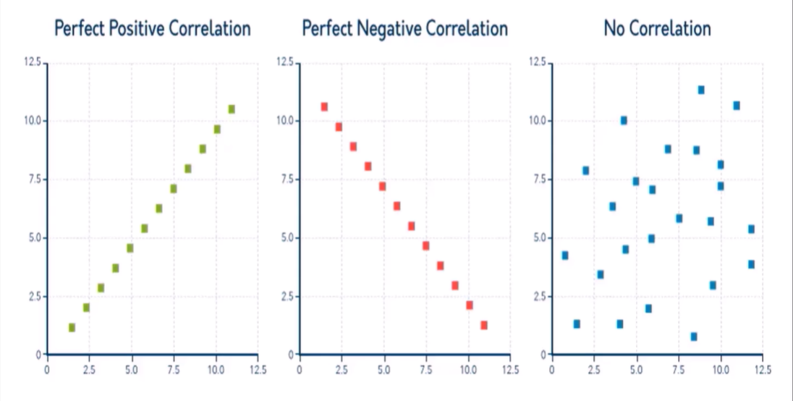
    - There's another variable at play, which is age!

