Topic 3

Types of experiments
Observational study: observes individuals and measures variables of interest but does not attempt to influence the resposes. The purpose of an observational study is to describe and compare existing groups or situations
Experiment: deliberately imposes some treatment on individuals in order to record their responses. The purpose of an experiment is to study whether the treatment causes a change in the response

Completely randomized design
- Units from the sample are each randomly assigned (ie randomized) to a treatment

Treatment – is a specific environmental condition imposed by researchers on experimental units. If more than one explanatory variable is manipulated, a treatment is a specific combination of conditions

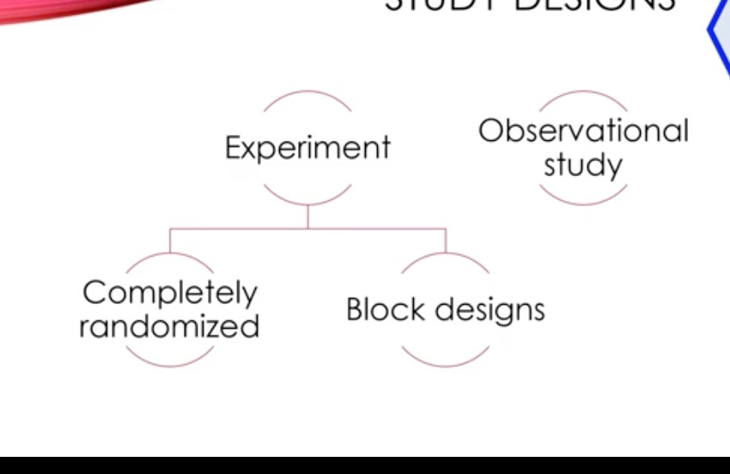

Block – is a group of individuals that are known before the experiment to be similar in some way that is expected to affect the response to the treatments
Block design – the random assignment of individuals to treatments is carroed out separately within each block
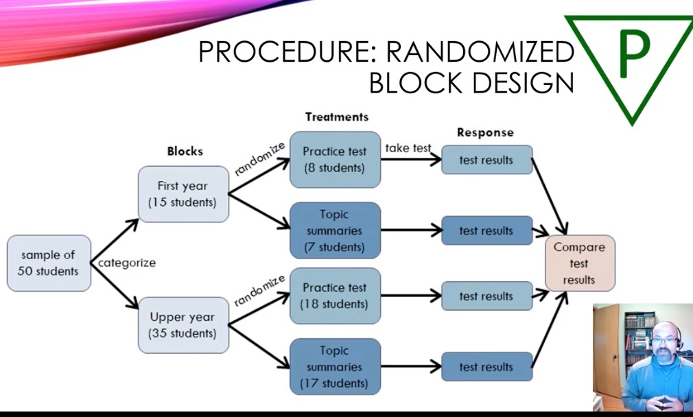

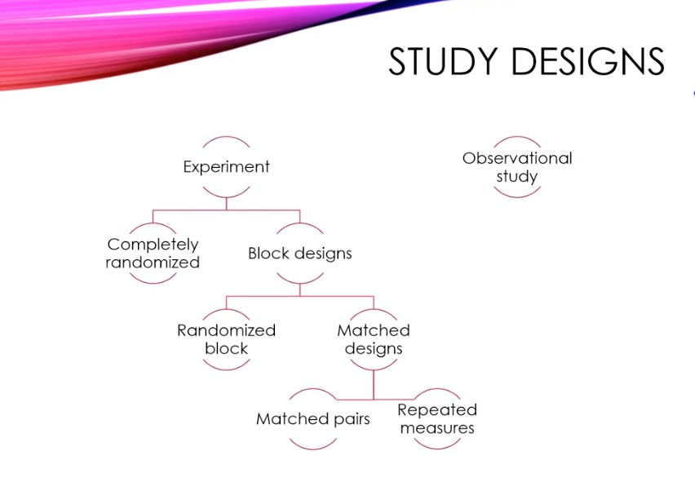

Matched Pairs Design
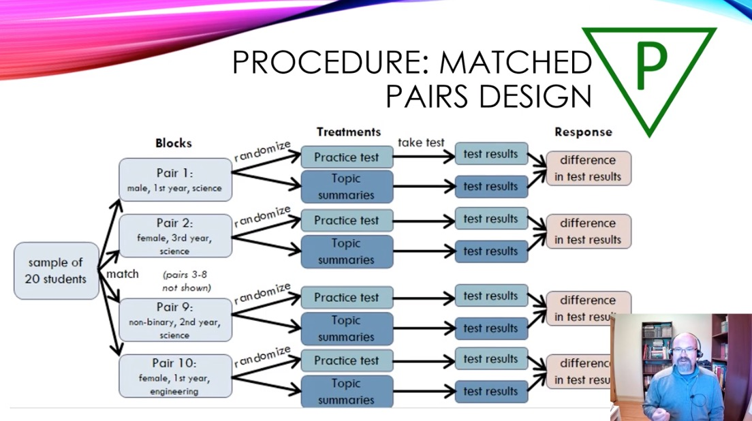

Repeated measures design
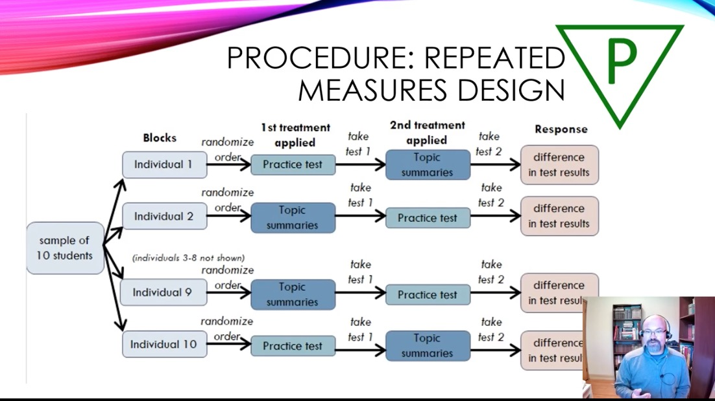

Principles of experimental design
Randomization

Response variable – measures an outcome of a study
Explanatory variable – is measured because may explain or influence changes in the reponse variable
Lurking variable – an unmeasured variable that influences changes in the response variable
Confounded – two variables (either explanatory variables or lurking variables) are confounded when their effects on a response variable cannot be distinguished from each other

Principles of experimental design
Randomize individuals among treatments
Control the effects of lurking variables and explanatory variables
Replicate within each treatment group to reduce the impact of chance variation on the results

Summary
- Randomizartion ensures an equal chance of individuals being assigned to either group. It is therefore an unbiased assignment technique
- It usually results in groups that are similar in most respects but there is some variability
- If we have knowledge of good blocking variables, a randomized block design are likely to create group that are less variable than a completely randomized design

Control and Replication

Control
- To study the effect of variation in some explanatory variables, limit the range of others
- Measure variables of secondary interest and design analysis to take them into account as cofactors
- Use blocking designs
- Use single or double blinding to guard against expectations or researcher bias

Replication
- Randomization ensures that if the study was repeated many times, on average, secondary explanatory variables would not bias the findings
- Control also limits the effect secondary explanatory variables.
- Replication reduces the role of chance in our results

Types of replication
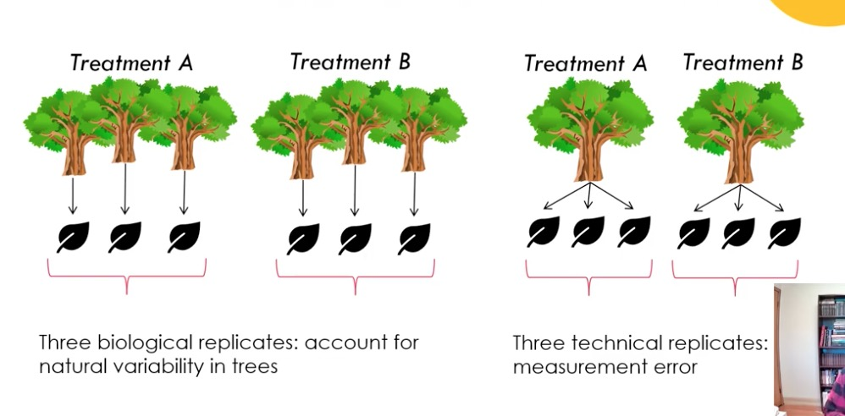

- Biological and technical replicates must be analyzed differently
- In this course we are learning the analysis fo biological replicates

Observational studies and experiments
Issues with observational studies
- Very difficult to demonstrate causation
- Confounding variables can be more problematic than in experiments

Issues with experiments
- Ethical constraints: consent
- Authenticity or “ecological validity”: will variables behave in the same way in a natural setting?
- Many variables cannot be assigned randomly or manipulated

