Carleton University

Laboratory Report

Course #: CHEM-2103 Experiment #: 4

Calorimetry- Measurement of the Heat of Reaction
Rongbin Zhang
101033409

Date Performed: 2018/09/21
Date Submitted: 2018/09/28
Lab period: A2
TA: Xun Sun (Daniel)

Data
Table 1: The volume of 0.2 M NaOH needed to neutralize the standard 0.5000 M HCl
 | 1 | 2 | 3
V_{i (mL)} | 8.9±0.2 | 2.8±0.2 | 5.0±0.2
V_{f (mL)} | 33.5±0.2 | 28.3±0.2 | 30.6±0.2
V_{(0.2M NaOH) (mL)} | 24.6± 0.3 | 25.5± 0.3 | 25.6± 0.3
V_{0.2M}（AVG） | 25.2 ± 0.5 （mL）

Table 2: The volume of 0.4 M NaOH needed to neutralize the standard 0.5000 M HCl
 | 1 | 2 | 3
V_{i (mL)} | 31.0±0.2 | 5.9±0.2 | 21.6±0.2
V_{f (mL)} | 44.7±0.2 | 20.8±0.2 | 35.4±0.2
V_{(0.4M NaOH)}  _{(mL)} | 13.7± 0.3 | 14.9± 0.3 | 13.8± 0.3
V_{0.4M}（AVG） | 14.1± 0.5（mL）

Table 3: The data sheet of 0.198 M NaOH
Node | Temperature (℃) | Potential (V) | Current (A) | ∆Time (S)
1 | 20.98±0.1 | 0.058±0.0010 | 0.035±0.0010 | 144-0=144
2 | 23.10±0.1 | 0.058±0.0010 | 0.035±0.0010 | 175-144  4=31
3 | 26.67±0.1 | 7.600±0.0010 | 1.240±0.0010 | 865-283  =582
1-2 | ∆T_{a} =2.12±0.15
2-3 | ∆T_{b}  =3.57±0.15 | 7.600-0.058  =7.542±0.0014 | 1.240-0.035  =1.205±0.0014 | 582

Table 4: The data sheet of 0.355 M NaOH
Node | Temperature (℃) | Potential (V) | Current (A) | ∆Time (S)
1 | 21.69±0.1 | 0.064±0.0010 | 0.035±0.0010 | 161-2=159
2 | 26.01 | 0.064±0.0010 | 0.035±0.0010 | 193-162=31
3 | 29.17±0.15 | 7.589±0.0010 | 1.238±0.0010 | 820-246=576
1-2 | ∆T_{a} =4.34±0.15
2-3 | ∆T_{b} =3.16±0.15 | 7.589-0.064  =7.525±0.0014 | 1.238-0.035  =1.203±0.0014 | 576

①Plots of 0.2 M NaOH:
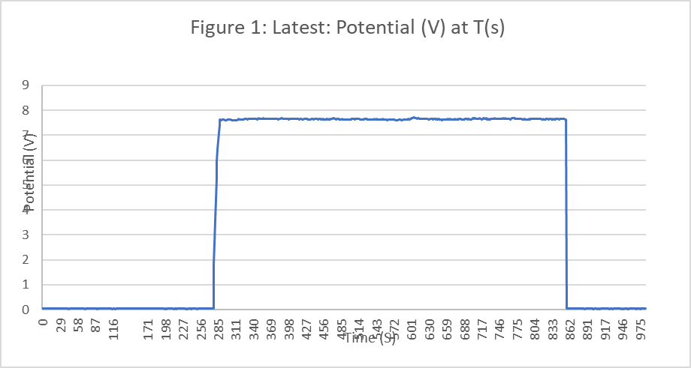

②Plots of 0.4 M NaOH:

Calculation

