Week 6
The Alternative Food System

Alternative food system: Groups of interrelated people and organizations that aim to bring structural and institutional changes to the existing mainstream practices in the food system.

- Debate on how to change the food system and to what extent do we change it.
- Fighting for space with industrial food system.

Multiheaded movement, a lot of things going on under the alternative food system, also referred to alternative food network.

- All the things happening under the alternative food system aim to challenge the industrial food system and address the negative impacts of the industrial food system
- Want to create a food system that is better for the environment
- Create better healthier food for consumption
- More meaningful, ethical, moral food system in terms of the environment and treatment of animals

Examples

- Local & organic food

- Farm gate & farmers’ markets

Farm gate refers to when farmers leave food at the end of their driveway, or have a stand set up and you purchase food from the farm directly. Happens further up north, leave corn and other vegetables, you take food and leave money in a money box.

Farmers market is pretty similar, became popular in the 1960s, farmers market their product.

- Sociologists found people who go to a farmers market goes in pairs or groups, in supermarkets people go alone leading to less social interaction
- People in farmer markets interact a lot more, more of a social gathering
- Receive feedback directly from customers, unlike grocery store.
- Consumers and farmers don’t have same motivation when going to farmers markets, farmers go for profit (financial gain) consumers go to support farmers, social interaction and the perception that the food is healthier and more fresh.
- A lot of work for farmers, want to make profit. Farmers can make more money at farmers markets than selling to a store. Farmers main motivation is money.
- One thing consumers mistake at farmers markets is the people behind the table are farmers when they usually aren’t.
- They appear farmers because they are selling produce, isn’t regulated in Canada so anyone can sell, they grab produce from farmers and can resell it for profit.
- People at farmers markets are willing to spend more on produce.
- Example Peterborough farmers market, other vendors came in selling similar produce at a much cheaper cost, they were buying from a distributor and selling it. Real farmers got kicked out.
- Certification for farmers is called my pick, are real farmers who sell their product and are certified.

- Community shared/supported agriculture (CSAs)

- Concept originated in Japan in the 60s, north America in the 70’s and 80’s.
- CSA is a concept where customers who are shareholders, gives money to a farmer in the beginning of the season and receive a basket of food each week until the end of the season.
- Depending on the size of share
- Give around March and receive a basket of food until October 22, 2020, also have Winter CSA.
- Concept is people give farmers money when they need it the most, to buy seeds etc.
- You the shareholder share the risks and rewards, if good you get more food every week, if poor you get less food, don’t get money back.
- Average of 10 items of different fruits and vegetables.

- Community gardens & school gardens

- Became popular in the 60s 70s

- Provides a great opportunity for students to have a living classroom

- Students who have access in this program tend to do better in biology and math

- Community gardens you pay to rent a plot to grow your own food, social benefits.

- Farming associations ex) Ecological Farmers Association of Ontario

- Farmers who wanted to grow farmers other than the industrial way, started this association
- Farmers support each other, and other small farmers, farmers who grow local food, in a organic way and provide resource’s.
- A lot of resources under these systems

Key characteristics of alternative food system

- Healthier diets
- Better livelihoods for farmers and farm workers
- Better environments
- Stronger social ties
- Decommodify food

- A lot of farmers are aware that people want healthier diets so they go to farmers markets.
- People who have health issues start buying directly
- Want farmers to be more profitable, as more money is being taken away from them
- In the Alternative food system we want to focus on the farmer, give them more power, a part of the decision making process.
- Farmers hire migrant workers to work on the farm.
- Alternative food system wants to address the environmental issues caused by the industrial food system. Works with the environment not against it.
- Using less synthetic fertilizer and more manure, less water, more efficient irrigation systems
- Build stronger social ties, aim to shorten the distance of not knowing where we get our food from
- Decommodify food, where food isn’t treated as just another item, want to define quality in a more extensive manor.
- Quality is defined by price and impact it has on environment also socially.

Want to bring back the notion that food is special, should be treated differently, not a piece of metal.

Local Food

Local food systems: systems of food production and distribution that remain within a locally defined area.

- Complex subject, definition varies across each country
- In Canada our food inspection agency CFIA defines it as food produced in the province or territory in which it is sold
- Local food in Ontario is all of Ontario
- Food sold across provincial borders 50km of the original province
- A lot of countries say 100km or miles, some say beyond distance
- Most people say its based on the distance, not how its grown. Not a given that local food is better for the environment.
- Canada local food can be sold at a big scale
- It all varies on countries, mostly on georgical border

Ontario has their own logo to help people support Ontario farmers.

- Economic benefits to local communities
- Priority is to support farmers
- Concept of multiplier effect, every dollar you spend on a local product that dollar will multiply within the local community
- Example you buy local carrots those dollars stay within the local community, that local farmer is more likely to buy inputs from another local business.
- Local businesses are more likely to buy from local companies

Research shows if Canadians spent $10 a week on local food we would have an additional $2.4 billion in our local economy at the end of the year creating 10,000 new jobs. Multiplier effect working economically

Criticisms

- ‘Weak’ and ‘strong’ examples
- ‘Defensive localism’ & ‘local food trap’
- Elitism
- Passive consumers
- Limited ability to feed the world
- Furthering neoliberal agenda
- Not suitable for all farmers

- Researchers have developed a category of Weak’ and ‘strong’ examples of alternative food systems
- Author Watts developed an indicator of strong and weak food systems

- Strong food systems has 4 characteristics, first is that the supply chain should be shorter, distance between farmer and eater be shorter.
- Second characteristic is flow of information, process of how food gets to your plate should be more transparent, more trust, traceable, actors within the supply chain work closer
- 3rd characteristic is that strong alternative food systems should prioritize the environment and social impacts. Challenge the negative impacts of industrial food system.
- Researchers should be working to develop a different economic system outside of capitalism, alternative economic system. No longer want to describe people as consumers but as eaters, food citizens.
- See food as something special not as a transaction
- 4th characteristic of a strong is that it provides a lot of different products and a wide range of choice for eaters.

Weak food system

- Doesn’t challenge industrial food system only mimics it
- Example using organic and local food in a supermarket, still uses that messy supply chain. Supply chain is still long
- Priorities price, most food doesn’t come from Canada, large scale farms, same methods as industrial food system, monocultures

Defensive localism’ & ‘local food trap’

- Defensive localism’ idea that people become so supportive of local food that they turn a blind eye to broader social and environmental issues.
- Leads to strong nationalism
- Local food has nothing to do with how food is grown
- Don’t question or challenge how local food is grown, referred to a local food trap

- local food trap- idea that we romanticize local food, assume its healthier for us, better for the environment. Local isn’t always better.

- Example united kingdom, compared local tomatoes to Spain, compared the environmental impacts, turns out assessing the environmental impact the UK is better to buy the Spanish is better for the environment

- Ontario peaches and California, our peach season starts august until late September. Buying Ontario peaches to support local farmers, or for freshness. If its made on environmental impact should buy California peaches.

- Environmental impact isn’t only based on transportation, it includes pesticides, water, fertilizers.

- California has better growing conditions, for peaches.

- Transportation is one of the least environmental impacts we focus on

Elitism

- Notion that local food and organic food is more expensive than its counterpart
- Not always the case
- Farmer costs about $3 for organic, grocery store is $8, but the price is changing its decreasing

You can work within the alternative food system to get cheaper food positive of alternative food system.

Bartering, exhanges compared to industrial food system.

Passive consumers

- Idea that should we be perceived as consumers, food citizens, or eaters.
- People get tricked at farmers market is because they want to support local farmers, don’t put time in to do research. Want convivence.
- People will negotiate price, want cheaper food, that’s changing as people aren’t bartering as much.

Most food is grown and produced locally in the world

Furthering neoliberal agenda

- Trying to develop an economic alternative
- Some researchers say that the alternative food system can further capitalism and the liberal agenda
- people that want are proponents of a strong alternative food system want the government to be involved and when the government is not involved In means that we're furthering the neoliberal agenda. Right.
- Shouldn’t use capitalism and liberalism together they are 2 different things
- Neoliberalism is the ideology that assumes that market forces and individual actions will contribute to a better social world.
- However were supposed to challenge
- Example farm to school programs, Allen and Guthman show that the school programs can further your liberal agenda that these programs can
- Allen and Guthman say food farm to school programs depend on private resources like donations or foundations funding, depend on volunteer labor and specific places. Makes access to local food in school a privilege.
- Food in schools should be provided by the government, it should be a right, vs a transaction between two actors.
- They see the involvement of volunteers and the private sectors is contributing to the neoliberal agenda and taking away the role and responsibilities from the government.
- Says government doesn’t have to provide food to schools, when they should

Neoliberal that we aren’t involving the government in the process when we should.

For a strong alternative food system we need the government to be involved

Not suitable for all farmers

- Large farmers wont be able to sell at farmers market just too much quantity
- They don’t like social interaction just focus on farming aspect

Quotes

I go to a farmers’ market, sit there for half a day and watch my stuff die in front of me while people pick and choose what they are doing to buy. That drives me up the wall.

- Farmers markets and CSA are not a suitable option
- This farmer sells their food to restaurants.

Farmers markets take up a lot of time, and interact with people and not everyone likes it. Put on a show.

Creates waste

One restaurant who support us for a couple of years and then stopped, kept our flayer on their wall for like 3 years afterwards
- Farmers pointed out that restaurants say they support farmers when really they don’t.
- Canada doesn’t have a monitoring system for this problem
- Many farmers are put in this situation.
- Restaurants make statement they support local farmers to make more money as people are willing to pay more.

I think this movement is bending over backwards to make it hyper convenient for consumers and to also make them feel really good about what they are doing

- Move towards buying grocery’s online
- The act comes from the alternative food movement
- Came from small business orders would pick up local food and then box it and deliver it to people
- Big companies took this from the alternative food movement
- Issue is that they prioritize the consumer.
- Have to prioritize the farmers in the alternative food system.
- Want to educate that ascetics doesn’t matter in food in terms of scratches.

I think if customers are driving the agenda, then farmers are going to get left behind. Which is what always happens with the industrial food system.

- To create a strong alternative food system, have to change the way we act.

Reading

- Given concerns over the uneven social, environmental, and economic impacts of food and agriculture, the potential for citizen engagement in food politics to transform the food system has become a significant topic of discussion among citizens and academics
- A number of scholars suggest that alternative food networks (AFNs) in Canada could transform such inequities, despite the market-based, neoliberal orientation of much of the food movement
- AFNs are ubiquitous across all components of the food system, from growing to processing, distribution, access, consumption, waste, and recycling.

- provide opportunities for producers and consumers to interact and organize in pursuit of a range of goals, including increasing the accessibility of local, organic, or fair trade food, improving community health and nutrition, revitalizing the local economy, enhancing food security, offering alternatives to the dominant market paradigm, and reducing the environmental impacts of the food system

- AFNs have formed a movement that directly resists the “dominant corporate-industrial food system” and that these networks form “one of the most important social movements of the early twenty-first century in the global north

- food politics can reproduce relations or to what extent they address institutional barriers to food system change.

- survey data from more than ten countries in Europe and North America does not support the idea that organic food consumption is class or race based (Hughner et al. 2007), a number of qualitative studies point to the fact that political participation in alternative food initiatives tends to be higher among elite social classes

While DuPuis and Goodman (2005) and Levkoe (2011) argue that reflexive localism can reduce the social inequalities associated with local food initiatives, Lockie (2013) argues that racial inequality is often “embedded in existing institutions, social practices, and geographies” and thereby reproduced, even if localism is not practised defensively

if there are race- and class-based barriers to entry into food politics, then even the practice of reflexive localism may be limited in its transformative potential. Thus, Lockie (2013) calls for further empirical examination of how and why some people are mobilized while others may be excluded from AFNs

- Jackson (1991, 200) defined cultural politics as “the domain in which meanings are constructed and negotiated, where relations of dominance and subordination are defined and contested
- A focus on cultural politics helps to explain how practices with the capacity for significant transformation may fail to fundamentally reform the food system and instead continue to foster an ever-greater number of alternative options that do not challenge the dominant social order. Guthman (2008) shows how AFNs in California are universalizing and exclusionary.

- Inadvertently, by ignoring the unique experiences that many people of colour have with food and agriculture and the food work done by minorities and other marginalized social groups, discourse and practice are narrowly focussed on the collective histories of white, middle-class actors.

- Drawing on critical environmental and political sociology, we use the cultural politics lens to situate a Canadian case study amid discussions of the transformative potential of AFNs.
- We work across disciplinary boundaries by using food as a means of studying civic engagement, drawing on a range of literature to discuss transformative social change
- the majority of critical food studies literature has been based out of the western United States while more positive accounts of local food movements are common in studies of central Canada

- few notable exceptions in Canada include Gibb and Wittman’s (2013) study of parallel AFNs among Chinese Canadians in Metro Vancouver, Lynch and Giles’s (2013) analysis of discourse in sustainable food initiatives, and McClintock’s (2014) exploration of how community gardens can be simultaneously radical and neoliberal.

Drawing on Johnston’s (2008) discursive methodological approach, we analyze the discourses and civic practices of actors in an empirical case study to explore the cultural politics of AFNs.

- Civic practices are the speech and actions that, through the production and reproduction of etiquette that defines public engagement, create opportunities to talk about politics and public life.

- Looking at discourses and civic practices in tandem aids our understanding of how systems of thought can define and limit the food and agriculture issues that dominate the public sphere.

- The driving force behind discourse and civic practices is ideology ( Johnston 2008), a system of beliefs and ideas about the social world that shapes how we speak and act

- These systems of thought are rooted in norms and values about social life.

- Ideology shapes discourses, which refers to the “broad systems of communication that link concepts together in a web of relationships

- Discourses can be laden with controversy and conflict, as actors are constantly debating the meaning of words and ideas (455).

- Examining discourses and civic practices can provide a picture of which issues are prevalent in public life and how power, ideology, and discourses are related (Fairclough 2013).

- Both ideologies and discourses shape civic practices, which together can be used to explore the cultural politics of AFNs.

- Using interviews and observation, we analyze how everyday speech and action define which food and agricultural issues dominate the public sphere.

- Ultimately, the way in which topics are defined and discussed influences the types of civic practices that emerge—ranging from practices that create transformative social change to those that reinforce current structures of power and inequality.

- We use this conceptual framework to demonstrate how ideologies, discourses, and civic practices comprise the cultural politics of AFNs.

- Our case study from Edmonton, Alberta, uses twenty-two in-depth, semi-structured interviews and six participant observation events to compare the discourses and civic practices used by actors to foster food system change.

- Edmonton was chosen for this study because of recent developments in municipal food policy as well as its proximity to farmland, which provided the opportunity to interview producers, consumers, and other food system actors.

- As in many other cities in North America, food was becoming a prominent issue in municipal politics, providing a rich opportunity for exploratory inquiry into citizen engagement.
- In the months before the interviews, a number of local organizations had worked to mobilize citizens to attend the municipal food and agriculture hearings, where Edmonton’s city council listened to input from citizens’ panels and deliberated on a new city-wide strategy for food and agriculture.
- During data collection, the members of Edmonton’s Food Council were announced

- the council appeared to be demographically homogeneous: the fourteen members were all white, aged approximately thirty to fifty-five years, and were well-educated members of the middle or upper class.
- These events shaped our approach to data collection, leading us to focus on how and why citizens promoted change to the food system, with a particular emphasis on how both environmental degradation and social equity were discussed by participants.

- after the hearings, many residents began to shift their focus to alternative food projects, such as food hubs, educational programming, and community gardens.

these projects operated primarily between civic and market spheres, without directly challenging or seeking support from the state. Further, many of these projects, whether conducted by farmers, community organizers, educators, or government employees, focussed primarily on getting consumers to buy, grow, and cook more local food.

To understand how change through individual consumption is maintained as the pre-eminent strategy for social change, we constructed a sample that extended beyond the civil society organizations typically studied in scholarship on engagement.

We recruited leaders from three sectors involved with AFNs: civil society (e.g., community organizers, educators, and volunteers), the state (e.g., federal and provincial policy makers and city planners), and the market (e.g., entrepreneurs and farmers’ market manag
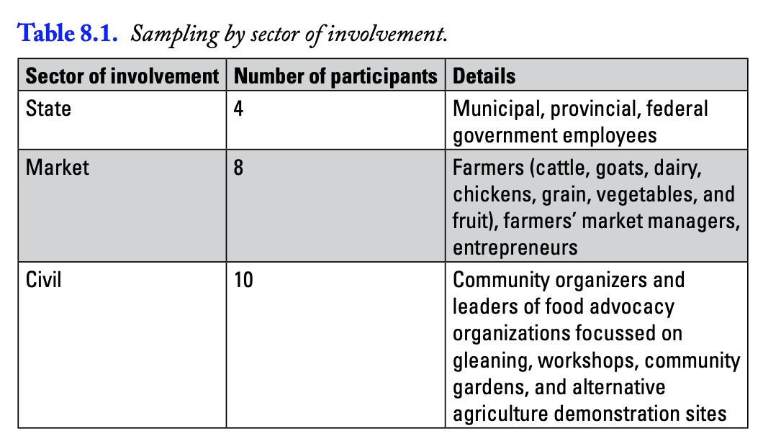

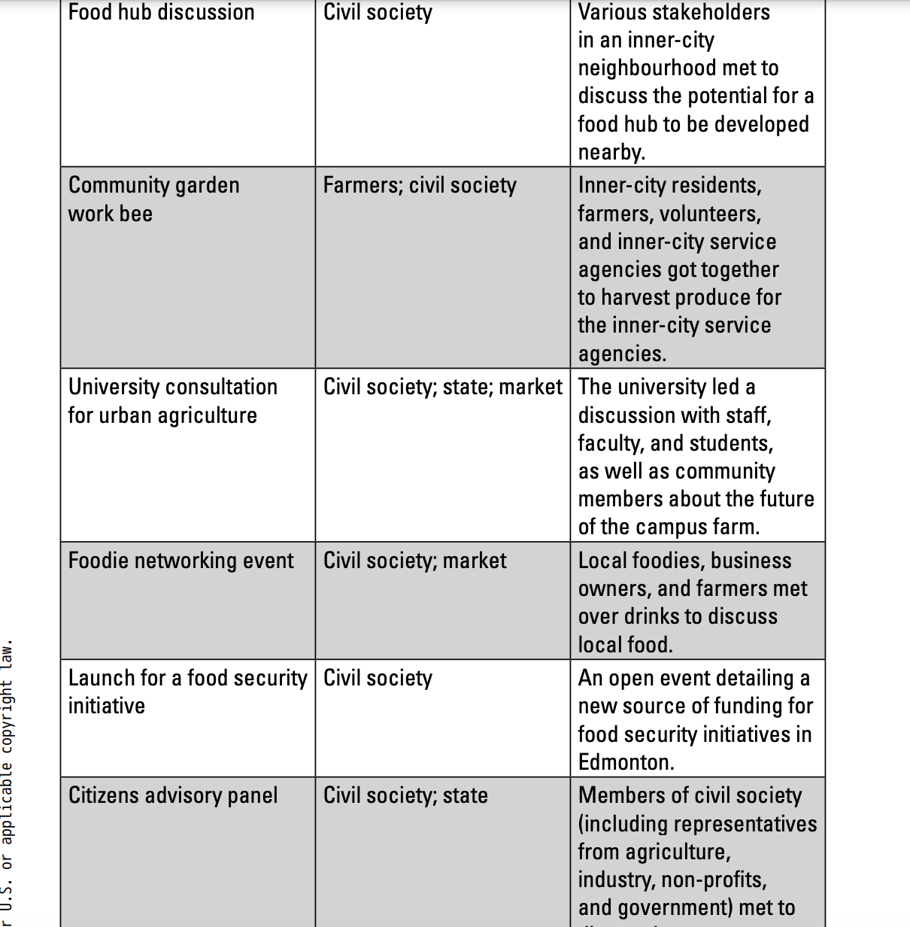

AFNs have the potential to transform the food system, they also reproduce dominant neoliberal ideologies in two key ways:

- first, through potentially universalizing discourses that fail to account for or encourage diverse participation.
- Second, through civic practices that fetishize consumer-driven change, relying on consumer-focussed initiatives such as education and awareness campaigns.

two key findings related to the environmental and social justice impacts of the food system.

- The first is that actors tend to focus on the beneficial aspects of food projects, avoiding discussions of potentially controversial issues such as equity.
- The second is that farmers discuss the environment much more frequently and with more detail than other groups.

Throughout the interviews and during participant observation, participants argued that if people were aware of where their food came from and experienced the superior taste of locally grown food, they would buy, grow, and eat more local food. This strategy assumes that education will lead to social change

- participants offered some evidence that consumers can change their eating practices as a result of education, they tended to overlook the role that power and privilege play in shaping who has access to knowledge in the first place, and who can seamlessly act on newfound knowledge to change their practices.

When we asked about how he (adam) first began to change the way he ate, he responded: “[I changed my eating habits] as soon as I went to a [conventional] farm and saw what I didn’t want to eat. It’s as simple as that. Lots of people will go to Costco and buy pork chops. If you saw how those pigs are raised, you’d never buy that product again in your life. It’s as simple as that. As long as you don’t know about that experience or you don’t have to face that reality, you’ll buy it because it’s cheap. So that was it for me, visiting farms

The danger of the attitude, behaviour, change (ABC) model, as evidenced here, is its assumption that all actors begin with the same degree of power and privilege.

The most obvious barrier to increasing local food consumption is not awareness or connection, but cost. Lack of time, access, knowledge, and support from peer groups play a role as well— material barriers that are unlikely to be overcome simply by people visiting conventional farms and being disturbed by what they see.

Cost so much because it take a long time to pick them

- The consensus among those who spoke up seemed to be that alternative food was worth the cost, and that if people knew how much work it was and how much better it tasted, they would be willing to pay more.
- many of the gardeners had not had access to garden space, transportation to a community garden, gardening knowledge, or the resources needed to grow their own food, yet these barriers were eclipsed by discourse stressing that local food was superior because of its taste and quality
- People of colour were all but absent from many of the observation events, with one notable exception: the garden where organic tomatoes were the topic of discussion. The gardeners here were much more representative of Edmonton’s demographic makeup than those at other events.
- Arguments for why alternative food was important consistently spoke to how fun, healthy, pleasurable, and economically beneficial it was rather than the barriers to broader participation, such as time, cost, and access to local food.
- At public events and meetings, we did not observe conversations about potentially controversial topics, such as diversity or inequality within the AFNs; instead, there was a clear sense that discussing such topics was taboo

The farmers we spoke with focussed their civic practices on encouraging consumers to reconnect with their food and their farmers by hosting farm tours and using community supported agriculture (CSA) models.

- farmers brought up the issue of the environment much more frequently and discussed it in much greater detail than others we interviewed or observed.

- Farmers’ discourses and civic practices do not differ widely from others in our sample, because they encourage sustainable food consumption through connection, education, and awareness.

- However, they spoke about the environment not only more frequently but also with much more precision, offering up stories about how they had seen the land change first-hand and how they had been a part of that transformation.
- Through farm visits and CSA models, the farmers we spoke with hoped to achieve the dual purpose of encouraging people to buy food from their farms and fostering a connection with the land.
- The idea of environmental stewardship was embedded in the everyday discourses and civic practices of the farmers we interviewed.

- the farmers we interviewed, the environment played a central role in their daily lives, directly impacting how they made a living. Underlying these practices was the complicated relationship between economic survival and environmental stewardship.

The Cultural Politics of Alternative Food Networks

- Based on Johnston and Baumann’s (2010, 139–40) suggestion that environmental issues tend to dominate the food discourse in North America, we expected to hear the same from actors in Edmonton’s AFNs.
- While farmers also discussed the dominant discourses of reconnection and awareness, they saw reconnection as forging a relationship between people and the land, and saw food as mediating that relationship.

Overall, actors in all of the groups focussed their civic practices on changing the food system through educating the consumer (educational civic practices); demonstrating alternative ways to grow, buy, and eat better food (demonstrative civic practices); and connecting producers, consumers, and other AFN actors (relational civic practices)

The dominant discourses and civic practices focussed on the positive aspects of alternative food, and the etiquette of these activities encouraged neither critical examination of power or equity issues nor consideration of ways in which regulation could promote broader structural changes

- Instead, reconnection and awareness displaced consideration of these more critical themes. Similar to other AFN actors, farmers centred their civic practices on educating the consumer and developing relationships with them through market-based activities, such as CSAs and farm tours.
- Lacking support or sufficient opportunity to imagine, discuss, or pursue alternative approaches to food politics, farmers within AFNs rely heavily on consumers to serve as agents of change through shopping for local food
- Building relationships, demonstrating alternatives to the current food system, and teaching people about food are vital components of food system transformation; yet, the findings of our research indicate a key limitation to the civic practices and discourses of eat local initiatives.
- With consumers positioned as the key drivers of a market-based approach to food system change, AFN actors may fail to address important environmental and social justice issues, because the dominant paradigm remains unchallenged.

actors from different sectors focussed on market-based and consumer-driven approaches to food system change rarely engaged with state or institutional actors. While farmers focussed on the environmental aspects of food and agriculture more than other actors did, overall there was not broad engagement among AFN actors in environmental or social justice issues.

Are AFNs Transforming the Food System?

- Acknowledging the potential for local food initiatives to reproduce dominant neoliberal ideology leads to the question of whether or not these initiatives can be transformative.

- Exploring the cultural politics of alternative food in California, Guthman (2008) discusses the colour-blind mentalities and universalizing narratives that shape and colour AFNs

- Evidence of similar discourses were found in Edmonton’s AFNs, yet our findings do not indicate that class and race are as polarizing as in Guthman’s (2008) observations from California. Adam’s suggestion that visiting farms is key to changing consumption patterns, Al’s discussion of reconnection, and the civic practices of farmers are all indicative of the type of affirmative discourses of awareness and reconnection that we observed.
- While traditional foods remain an important part of the diets in many Aboriginal communities (Desmarais and Wittman 2014), there are wide variations in rates of food insecurity among communities
- In 2012, almost 13 percent of Canadian households experienced some level of food insecurity (Tarasuk, Dachner, and Loopstra 2014), with Aboriginal populations experiencing levels of food insecurity three to six times higher than the average Canadian household (De Schutter 2012).
- Immigrants also experience higher rates of food insecurity (De Schutter 2012) and have specific experiences of food and agriculture.
- As Guthman (2008) reminds us, “getting your hands dirty” or “looking your farmer in the eye” demonstrate reconnection to the land for some, but to others this idea brings back no-so-distant memories of slavery and gruelling labour
- More importantly, discussions of equity, gender, race, and class were not part of the etiquette or discourse of these AFNs.
- This lack of critical public dialogue is significant, given the findings of other scholars who note that AFNs have been slow to address white privilege and class inequality (Alkon and McCullen 2011; Slocum 2007).

This exclusion of marginalized actors and viewpoints limits the transformative potential of alternative food networks. While the possibility remains that there are parallel food networks populated by visible minorities, marginalized, or non-dominant groups, such as those observed by Gibb and Wittman (2013) in British Columbia, our findings are troubling, given the potential for elites to increase their social and economic capital through participation in AFNs, potentially reproducing and perpetuating existing inequality

- Currently, AFNs are well positioned to work within the neoliberal ideologies of the marketplace, which allows them to make use of significant amounts of cultural and economic capital. In a capitalist model, focussing on the pleasures of local food supports a market-based model.
- emphasizing market and civil activities, without engaging the state or challenging institutional barriers may not bring out the kind of transformative social change that some hope to achieve
- the cultural politics of AFNs are potentially exclusionary and individualizing, in that they do not address power relations or engage a broad range of actors in promoting environmental sustainability, thereby bringing into question the effectiveness of these approaches
- The danger of these market-focussed change activities is that they can potentially limit citizen engagement in politics, because people feel as though they have adequately participated simply through their consumption

- In short, we find evidence that AFNs can discourage more radical behaviour through an etiquette that encourages participants to focus almost exclusively on the positive aspects of local food, instead of tackling the challenges.

- In particular, a tendency to emphasize awareness-based solutions seems to prevent food citizens from accounting for the numerous political, cultural, and economic barriers to localizing the food system.
- This conclusion is notable, given the findings of other scholars, who suggest that such projects can be both radical and neolibera

This market-based orientation may exacerbate the tendency to download public services to the private sphere, limiting the ability of local food movements to adequately address broader structural barriers that inhibit the transformation to an environmentally sustainable and socially just food system.

Given these limitations, we remain uncertain as to whether the current tactics of AFNs could foster a more just and sustainable food system.

This case study has important implications for both AFNs and other social movements. Environmental movements often place a strong focus on education, undertaking awareness campaigns that encourage people to take action based on their knowledge of environmental issues.

Like AFNs, climate change politics often place a strong emphasis on the role of the consumer as the agent of change.

Overall, there are many opportunities for AFNs to transform the food system. By offering a critique of AFNs, we do not intend to encourage those interested in change to abandon the project. Instead, we suggest that developing a more critical gaze with regard to how AFNs are structured and reproduced is just as important as—and indeed, germane to—promoting local food consumption and reconnection

A critical approach would foster civic practices that consider how inequality in the food system emerged in the first place, in addition to creating viable alternatives.

Tent Talk Episode 35: Tent Talk Live: The world needs LESS food

- Organic farmer Brett Preston
- Run in north Toronto
- Introduces the idea that were producing too much food
- Certified organic operation, biggest crop is cut salads
- Biggest seller are restaurants, 20 archers in production
- Big problem with human health and environmental problems,
- Bought a farm of 100 acers because they wanted to make a difference when It came to climate change.
- Came from human right democracy background
- Started off with core values, wanted It to be sustainable environmentally but also financially.
- Wanted to grow high quality food, food that would nourish people around them.
- Build a community around their farm, build connection and fight loneliness.
- 1 rule was wouldn’t work with assholes. Only work with people who share those values.

- Grew everything, grew a lot of different vegetables

- Rototilier

- Bought animals like pigs, and hens,

- Every Saturday they would pack up as much as they could and go sell in town at the farmers market.

- Help the environment, work with the community, high quality food.

- People told them what you’re doing won’t feed the world. Something saying what you’re doing isn’t going to have an impact.

- Big industrial monocrop farming way criticizes small farmers saying they can’t feed the world. Their message is we need more food.

- Realized that farmers around him were only growing 5 things, using lots of inputs like machines, fertilizer. corn, wheat, soy, canola, hay what they grew.

- Farmers growing these 5 items couldn’t eat anything they were growing they had to be fed to animals or processed.

- When companies say we need more food they mean we need more meat, sugar, and processed food because that’s what’s being grown. Whole community would generally make those things.

- Brett did some research, various sources around the globe 2600 calories for men 2000 for women. Around 2100 calories needed a day. Agriculture organization in UN in 2013 said we produce 2900 calories for everyone in the world.

- Africa 2600 available in house for everyone in the country, we have an overabundance of calories.

- Calorie intake has increased, this now has led to obesity which kills 3 times as much as malnutrition.

- Malawi giving out food who needed it, eligible to receive food. The problem was that poor farmers lost their crops and they had no money to buy food.

- Hunger and malnutrition are economic problems, not a symptom of lack of food. Increasing food supply on a global scale is going to do 0.

- We overproduce, with obesity we get spiraling healthcare cost, environmental problems, marine dead zones, agriculture is the primary driver habitat loss around the world. Which has to do with mass extinctions.

- Economic effects make food cheap, increasing the use of chemicals and pesticides and machines, makes profits thinner.

- 30% of agriculture land has be desterilized in the last 50 years

- Food waste but the primary driver of food waste is how cheap food is, we waste food because we don’t value it. It’s easy to replace.

- Biggest problem with food system is the way it climate change and environmental degradation. Eat lancent is a European based group, looks at way how we can optimize our health but help our environment.

- Food is the Single strongest lever to optimize human health environmental sustainability.

- We need less food not more food, we need better food.

- Farmed with unpaid interns, they needed to make changes and make sure they were economically viable.

- They specialized in what grew well on their farm, their microclimate that they enjoyed growing and sold well. These items were cut salads cucumbers, multicolored beats, and potatoes.

- Didn’t use a CSA, sold in the farmers market for 3 years, started selling to restauranuts their most important market, selling wholesales, home delivery company, value ad salad dressing to diversify their markets.

- Professionalized their workforce, biggest change made, hired workers from Mexico who work seasonally.

- Focused on soil, cover cropping, different mixes to improve productivity. Took 5 years to do all this and they achieved their goals.

- Year 5 they were profitable, 7 years paid off mortgage. By sticking to their values and business model it paid off.

- They made the conscious decision that they would stop growing and focus on things that made them happy and built the movement.

- This allowed them to build non-farm event space, to teach people about this kind of agriculture, has a kitchen and place for people to eat. made customers more loyal customers.

- Fight the idea that their food was elitist, so they raised money for organizations.

- Raise over 150k in one night because people care, money is used to buy food direct from organic farmers for community food centers around southern Ontario. Some money is used to buy food from their farms, most is others. Clients can pick the kind of vegetables they want.

- They planted over 10,000 trees with their land and it has helped wild life come back, their farm is buzzing with so many pollinators.

- Transforming their farm from organic to regenerate, they want to reduce tillage, use large tarps instead. So they can plant directly without any tillage.

- Create a food agriculture system that nourishes the land and regenerates our soil, feeds our communities, brings people together.

- Integrate animals into the mix, use cattle to manage the cover crop rather than mechanically.

Episode 34 of Food: A Cultural Culinary History

- Second health food movement in the 60s 70s. was a counterculture rebellion went hand in hand with hippies. Said everything about the way Americans live is wrong including their food. Political issue.
- Many cogent complaints, believed many of what the Americans ate was unhealthy, farming practices pollute the earth, believe that technologically enhanced mass produced food is bankrupt.
- Looked at simpler food, ones that didn’t exploit animals, many were vegetarians, eat local foods.
- Environmental concerns about food went mainstream with the publication of Rachel Carsons silent spring in 1962. Made people realize that a nice shiny red apple doesn’t mean it’s good for you, thanks to pesticides which disrupts our food chain.
- Carson was a legit scientist and said you shouldn’t always trust what experts say is perfectly safe. They are either wrong, or do things for profit
- Insect problem is our problem, just let nature take care of insects. Moral matter

- now.
- Progress has made us sick artificial unfree
- Natural food is grown without chemical fertilizer, pesticide, no artificial colouring, minimum processing.
- Macro-biotic diets- trendy to eating only whole foods, origin Japan
- Veganism was new, not using any animal product.
- British vegain society in 1944, American in 1960
- World vegan day November 1 since 1994
- Diet for a small planet by Frances Moore Lappe, made an argument that the population continues to grow then eating meat is an ineffiecnt way of using land as it requires 7 acers. Vegetables with that much space can produce more calories. More people can be fed on a vegetable diet.
- Looked at Asia with the introduction of Tofu, bean sprouts, Buddhims helped that
- looked at India hare Krishna.
- Health food movement looked to whole grain flower, ancient American grains.
- Health food movement introduced hummus, peta bread, yoghurt which was coined as the Mediterranean diet.
- These are all ancient traditional foods. People outside the culture became interested in it. People began shopping at these store because they were afraid of preservatives.
- Mass produced food companies began making and selling their own tofu, pita bread etc. these foods go mainstream. Products that were natural.
- Book on this called appetite for change by Warren Belasco.
- Grocery stores started selling packaged items like cereal, natural corn chips Eden foods and soil milk. Moved past fruits and vegetables. They became different. Highly processed and controlled by corporations.
- Alice waters chez panisse – most oblivious connection between hippie and foodie generation. One of the most influential chefs. Only fresh ingredients.
- Paul Bocuse, troisgos brothers, new focus on provincial recipes.

Nouvelle cuisine- used undercooked vegetables, bright citrus sauces. Didn’t use butter

Wendell berry spoke out on fast food, if you want real pleasure from food you have to eat responsible. Know where your food comes from. Encouraged people to grow their own food and cook themselves. Connected growing food with farms

- French cooking got middle class Americans interested in food.
- Julia child- mastering the art of French cooking. Taught people basic recepies from scratch.

Craig Claiborne’s James beard, graham kerr. Cooking magazines gourmet 1941, bon appetit 1946.
- Cooking and entertaining became leisure something to enjoy, renewed in eating out.
- Mobils or American automobile association.
- Increased travel encouraged Americans to try more food.
- Flood of cookbooks and tv shows hitting the market, in the 70s new interest in ethic cuisines. Americans began trying things they would never thought of trying like Indian, Moroccan.
- Required fresh ingredients with these dishes, to be authentic people were for forced to discover new fresh ingredients like plantains, coconuts.
- Frieda Caplan – be exporting exotic fruits in 1962, practically singlehandly introduced kiwi to the state, horned melon etc. Americans range of fresh food rose thanks to interest in ethnic foods.
- Tiny vegetables also was introduced.
- Microbreweries started popping up, different flavors than mass produced beer. Didn’t get sold far, was local until it gained attention.
- Cheesemaking – mass produced cheese, few dairies started experimenting with cheese like Goat cheese. Followed traditional laws. Blue cheese popped up and aged cheddars.
- U.S. has an ambiguous cheese culture.
- Artisional cheese is small and expensive.
- Doc label used in Europe first to let you know the kind of wine or cheese it is.
- Lebel tells you it’s the real thing made by locals. But not in the United States. Only label is for organic food.
- Slow food- founded in 1989 by carlo petrini , reacts to the opening of McDonalds, to get people to slow down enjoy what they are eating, keep alive regional traditions.
- The ark of taste – was founded to save endangered plants and animals, 2004 started a Terra Madre conference that brings together small scale producers from around the world in an effort to save them. Began to promote fair trade practices
- Locavorism- you can source food within a certain radius, cuts cost, and get fresh food. Includes dairy and fish.
- Farmers Markets – puts the money In the farmers pockets.

National Farmers Market Directory says there has been an increase frm 1,755 markets in 1994 to 7,175 markets in 2011. 400% increase.

Community supported agriculture, urban farming, school gardening.

Week 7

Food Labeling

- Rely on externalities such as food labels that help us make decisions when choosing food.
- GMO, humane, ethical, dolphin safe tuna, rainforest, multiple label.
- Rely on labels to make decisions on food.

Organic farming: a holistic systems designed to optimize the productivity and fitness of diverse communities within the agro-ecosystem, including soil organism, plants, livestock and people.

- The principle goal of organic production is to develop operations that are sustainable and harmonious with the environment

- Before the industrial food system all farming was organic, just didn’t use the term since we had nothing to differentiate it.

- Most of farming history, farming has been organic.

- Stepped away from organic as we wanted to grow the industrial way where we could grow more food.

- Organic farming in principle has great ideas, but organic farming in principle could be different.

Organic evolution

- 1920s - Rudolf Steiner – protesting synthetic fertilizer

- 1940– Sir Albert Howard - “An Agricultural Testament”

- 1944 – Lady Eve Balfour – “The Living Soil”

- 1960s – Hippie movement & counterculture activists

- 1970s – organic farmers began to organize

- Booker T. Whatley – regenerative farming & U-pick farms

- 1990s – organic regulations

1920s - Rudolf Steiner – protesting synthetic fertilizer

- First time we developed synthetic fertilizer

- Protests against using these fertilizer

- Rudolf Steiner from Austria, said that living things such as plants can only be nurtured by other living things. Such as composted or manure.

- First time we see s distinction being made between farming and organic farming, started in the 20s.

- Protests refer to organic 1.0, first wave of organic farming movement

1940– Sir Albert Howard - “An Agricultural Testament

- Around world war 2 there was a huge push for the industrial food system.

- A lot of protests for this system

- Two main actors are Sir Albert Howard and Lady Eve Balford from England

- Sir Albert Howard wrote a book for organic farming called the agriculture testament, inspired by farming in India. Main message is that the Health of agriculture depends on the health of the soil, linked it back to human health. Healthy soil produces healthy produce which makes people healthy.

- Lady Eve Balfour wrote a book called the living soil, similar to Alberts, founded soil and health association. Group that supports ecological farming after World war 2.

1960s – Hippie movement & counterculture activists

- Protest mainstream culture and institution.
- Women, labour movements
- More people farmed organic, informal small scaled.
- A lot of the major organic farms today started in the 60s

1970s – organic farmers began to organize

- Farmers began to organize themselves, more farming occasions
- Farmers support themselves, gather resources to help others grown organically.
- A lot of government clashing as they wanted the industrial food system to be the main food system
- Earl Butz sectary of agriculture under Nixon, said that organic farming will essentially lead to mass starvation, not capable to grow food needed to feed everyone in the world.
- Organic standards start to slowly develop
- Difficult to sell organic products, difficult to educate public on what it is as it varied from place to place.

Booker T. Whatley – regenerative farming & U-pick farms

- In the 1970s
- Huge proponent in regenerative farming, conservation approach
- Focused on soil and water quality, water cycle, biodiversity and applying these concepts to farming.
- Very influential to marketing
- Brought CSA’s and direct marketing to North America
- First came up with U- pick farm, where you pick your own fruit and pay on your way out.
- Very active in trying to develop an agrarian black middle class, black farmers.

1990s – organic regulations

- Government steps in and develops organic regulations
- Developed rules on what organic farming is, labelling products organic.
- Standards are uniform, and vary a little bit. Similar in the end.
- Result larger companies can use the term organic to differentiate the products

Global Trends 2018

- Organic market: € 97 billion
- Country with largest market: United States 47 billion
- Country with highest per capita spending: Denmark & Switzerland, 12.8 per person
- Organic agricultural land: 71.5 million hectares, only 1.5% of world farmland
- Country with most organic agricultural land: Australia, then china
- Country with highest shares of organic agricultural land: Liechtenstein
- Organic producers: 2.8 million producers, only certified, 1999 was 200,000
- Country with most organic producers: India, Uganda, Ethiopia

Euro is worth 1.5 Canadian Dollars

United States has the Largest market,

Canadian Trends 2017

- There are 5, 053 organic operations in Canada.
- 983,000 hectares are organically managed in Canada.
- Organic farmers create jobs 2 times the rate of conventional farms. This is because they can’t use synthetic fertilizer so it requires more work.
- Organic market in Canada: CAN$ 5.4 Billion
- 66% of Canadians buying organic every week.
- Most popular organic items are: Fruits & Vegetables, after are beverages, 3rd are eggs and dairy.
- Canadians buy organic food mostly at: Regular Grocery Stores
- Provinces leading in organic market share: 80%
- 67% of buyers identify as non-Caucasian.

- Organic farmers have to hire more workers, why we have to pay more for Organic as its more labor intensive

- Western Provinces lead organic purchases, prioritize organic more.

- Organic food price decreases, education can have an impact.

- Not a lot of research on why the shift occurred. Why nationalities prefer to buy organic.

- Organic doesn’t allow GMOS

- Elitism of organic is fading

Principles of Organic

- Protect the environment
- Make sure we work with nature
- Looking at water cycle and biodiversity
- Maintain long-term soil fertility
- Health of the soil is important
- Better plants, healthier humans

- Maintain biological diversity
- Want to keep many varieties of different crops
- Having diversity and growing a variety of crops help each other out
- Example corn, beans, squash grown together, Corn provides shade for the crops, beans and squash provide a lot of nutrients to the soils as corn sucks the nutrients of the soil. Growing these together keep pests away, not efficient in using machines,
- industrial perspective it’s not efficient
- efficient the organic way

- Recycle materials
- Use everything you have on the farm, not creating waste
- Food waste you use composte to put on soil to grow crops
- Attentive care towards livestock
- Keep animals happy
- Wildlife is used to manage livestock
- Example birds and wild boar, larger mammals and people. How to mimic that with chickens and pigs.
- Emphasize careful processing and handling methods
- Little contamination as possible
- Rely on renewable resources
- Use many renewable sources
- Minimize the external inputs on the farm

- Organic Philosophy

- Organic became regulated they developed standards, reached a balance between organic principles and practical at the same time.

- 1990 organic 2.0, regulation of organic became organic 2.0

- Companies could use logos on products

- U.S has been lineament over the past years,

Organic in Practice

- Land free of synthetic pesticides, synthetic fertilizer for 3 years
- Land free of GMOs, no cloned animals or their descendants
- No routine drugs, antibiotics or synthetic hormones
- No artificial food colors, flavours, sweeteners, preservatives in processed foods
- Organic feed & free range

- Someone from organic board comes and takes samples to test if land is organic

- GMO’s aren’t allowed

- No drugs antibiotics and synthetic hormones, unless animal is very sick. That animal will be taken out of production.

- Animals have to eat organic food, example Cows eat organic Corn

- Label of organic, the certification specify that the animal have to be free range.

- Free range- animals are allowed outside to roam around

- Free range and free run aren’t certified in Canada

- Free Run means animals aren’t in cages they move freely in a barn. With Chickens.

- Chickens in free range is they can only go outside during the day time and depending on the weather.

- Chickens are let outside 2 weeks after birth, slaughtered at 4-6 weeks, half of their life they are spent inside.

- Large operations minimize the amount of time animals spend outside, like with the chickens.

- When chickens live in cages, about 6% will die prematurely, when outside a cage about 12% die prematurely. More chickens die outside of the cages.

- Pecking order in chickens, end up killing other chickens to establish higher order. Free run or free range allows for this to happen. This is why farmers cut their beaks.
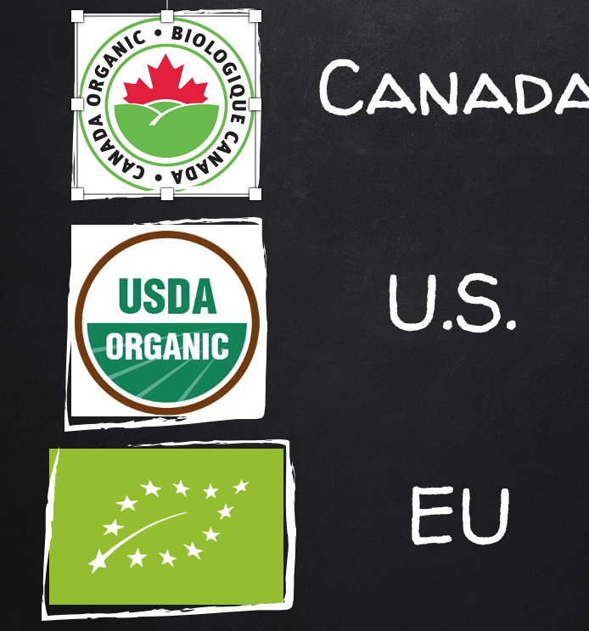

- Trading agreement were more likely to see the EU logo

- They have more organic farming.

- These logos refers that these items have been grown organically.
- These are seen on more processed foods like cereal and granola bar

- When a product uses at least 95% of organic ingredient they can put it on their product. They can use the Canada logo.

- Not 100% because certain ingredients in processed food aren’t natural. There is no natural product that can be used.

- Example baking soda is man-made synthetic. Which is used in a lot of products.

- If your logo has 70-95% as organic you can write it contains 80% organic ingredients and list the organic ingredients. You cant use the logo.

- Example are the Cliff Bars, say 70% organic ingredients

- If your product has less than 50% you cant use logo, or say the percentage of organic it is. You can only list the organic ingredients on the back. Can’t put organic on the front.

- U.S & European Union have the same agreements when it comes to the logos.

- Canada as a trading agreements accept organic standards as our own, take it as it, allow them to use their logo on our market. U.S is less strict than Canada but we still use their logo.

- Canada regulated by the Government, but it’s the third body of third party certification bodies that do the certification.

- Government came up with the rules, certification body approves it.

- Example if you want to get a product organically certified you call a certification body that has been approved by the government.

- Certification body include: Eco Cert, Pro cert which are companies that go to farms and test soil. Collect data kept by organic farmers.

- Costs depends on farm size

- Farmers who don’t want to be organically certified do this because they don’t agree the leniency of organic certification and they believe it should be more strict.

- Another main reason is because small farmers don’t need a label, people around them who they sell to trust them, you need a logo when you don’t trust or know the process of a farmer.

Big vs. Small Organic

BIG ORGANIC
- Supermarkets
- Mimics industrial food system
- Monocultures
- Long and complex supply chain
- Permitted list of substances

“Market”

SMALL ORGANIC
- Direct marketing
- Challenges industrial food system
- Large variety of crops
- Shorter supply chain
- Minimizes synthetic inputs

“Movement”

big organic is food bought in a supermarket, small organic is when you go to a farmers market or buy directly from a farmer.

- Big organic uses long complex supply chains

- Small organic is a strong alternative food system

- Big organic is a weak alternative food system as it mimics it and used the industrial food system to its advantage

- 1990s huge pressure from corporations to use synthetic substances, most governments allow synthetic inputs. Mainly big farms.

- Asterix on the government of Canada of allowed synthetic inputs companies can use and be certified organic.

- In Canada there are 20/21 , similar in the U.S.

- Small organic tries to limit the synthetic substances they use when farming.

- Small organic challenges the industrial movement.

Organic 3.0

- Result of big and small organic a solution to this situation is organic 3.0

- Organic certification has a lot of gaps, like a cow eating grass all year long outside. Which isn’t always the case.

- Horizon organic milk, dominating the organic milk industry, people believe one corporation shouldn’t have all the power.

- Horizon organic milk ultra posturizes the milk by boiling it for longer and higher temperature but it kills the nutrients in it. Goes against organic philosophy.

- Another example is beatnik that goes against organic philosophy, tv dinner isn’t healthy and creates waste.

- Under organic certification One of the biggest gaps is social justice and labor rights for organic. Organic movement was a counterculture, Driscoll is here a the largest berry producer but they have broken many human right violations. Sexual abuses, money shortages. Still continues in Mexico.

- Organic berries is good for the environment, but they treat their workers horrible.

- Rainforests are cut down to grow a lot of this organic food

- Organic 3.0 is called upon to address these gaps.

- Organic 3.0 wants to embody more of those principles and address those gaps, such as social justice and environment.

- Organic 3.0 is talked more outside of 3.0, might see a new organic system, relatively new. Being implemented.

Yet the organic label itself—like every other such label in the supermarket—is really just an imperfect substitute for direct observation of how a food is produced, a concession to the reality that most people in an industrial society haven’t the time or the inclination to follow their food back to the farm, a farm which today is apt to be, on average, fifteen hundred miles away.

- Michael Pollan an author who wrote a book, an omnivore dilemma
- Represents the organic label.
- Organic is just a label and can’t replace our relationship with the farmer.
- People assume organic means something instead of doing something.
Implications

- Greenwashing: making a product seem more environmentally friendly. Using marketing strategies
- Health washing: making a product seem more healthy. See in stores all the time, enriched with. Comes from deskilling, not knowing where food comes from.
- Confusion around labels
- Responsibility is put on the individual

- People blindly believe labels
- Fair trade labels, if you do research it’s not really fair.
- Our responsibility to make the correct food choices, choose the right products.
- Labels use neoliberalism, people are one the fault. No government to step in, its up to people to make decisions.

Bananas: a case for fair trade

Equifruit is the Canadian market leader in Fairtrade banana sales and marketing.

- Founded in 2006 and “Fair from the Start”. Mission-driven.
- Long-standing relationship with 2 producers co-ops and outstanding reputation for supplier relations: winner of “Excellence in Producer Parnerships” at the 2020 Canadian Fairtrade Awards
- Only Canadian member of the World Banana Forum

Equifruit’s challenge: disrupting an industry (and consumer mindsets) based on low price

Nothing comes free: someone is paying the costs not reflected in supermarket pricing

Industry foundations

- Concentrated supply: Four banana companies controlled supply chain for 100 years
- Business model based on paying little for land and labour, and making profits on massive volume
- Marketing strategy: price bananas cheaply to outsell apples.

Low-price legacy

- Bananas still cheapest fruit at the grocery store: retailers could change industry but worry about power of “Known-Value Items”
- Someone else pays external costs of banana production:
- Social: inadequate income (small producers) & wages (workers), poor health & safety
- Environmental: pesticide use, water exhaustion, climate change

Fair trade ensures that workers & producers in supply chains are paid fairly for their work

Fair trade (two words)= the notion of trade justice between developing & developed countries

Fairtrade (one word) = the international certification scheme, most recognized globally and considered “gold standard” at the World Banana Forum

Fairtrade dictates the terms of commercial relationships between buyers and sellers

Fairtrade-Certified Small Producer Organizations and Plantations

- Both partners must meet and maintain Fairtrade standards and be certified under Fairtrade for their product to be sold as Fairtrade in the marketplace.

A buyer expects the producer to have respected wide-ranging sustainability standards

Economic

- Fair wages, respecting at least national standards
- Signed contracts for workers
- Traceability
- Good governance

Social

- No child or forced labour
- Occupational health & safety
- Gender equity
- Freedom of association

Environmental

- Hazardous materials (pesticides) control
- Water usage / composting / plastic minimization / waste mgmt.
- Non GMO

A producer can expect to be paid a minimum price and social premium: tangible impact!

Fairtrade Minimum Price

- Floor price: like a minimum wage
- Established by Fairtrade Standards Unit in cooperation with producers
- Represents Cost of Sustainable Production, by commodity & country
- Provides long-term income stability for vulnerable producers

Fairtrade Social Premium

- Additional sum of money which goes into a communal fund for workers and farmers to use – as they see fit – to improve their social, economic and environmental conditions.
- For bananas, social premium set at 1 USD / standard case.

Equifruit can trace each of its cases back to the small producer who grew them.

- Meet Juan Calderon More. Juan is the export manager at APPBOSA

- Every time Equifruit imports a container of bananas, the packing list tells us who produced each and every case of fruit. With an average of only 1.5 hectares / producer, sometimes this is only a few cases per load.

Social premium impact is tangible and wide- reaching in producer communities
- Hired Labour uses tend to be more “basic”: housing, sanitation & transportation projects
- Typical community investment by a small producer cooperative: donation of laptops and projector for local school

So, can we get Canadians to care as much about banana workers as hens?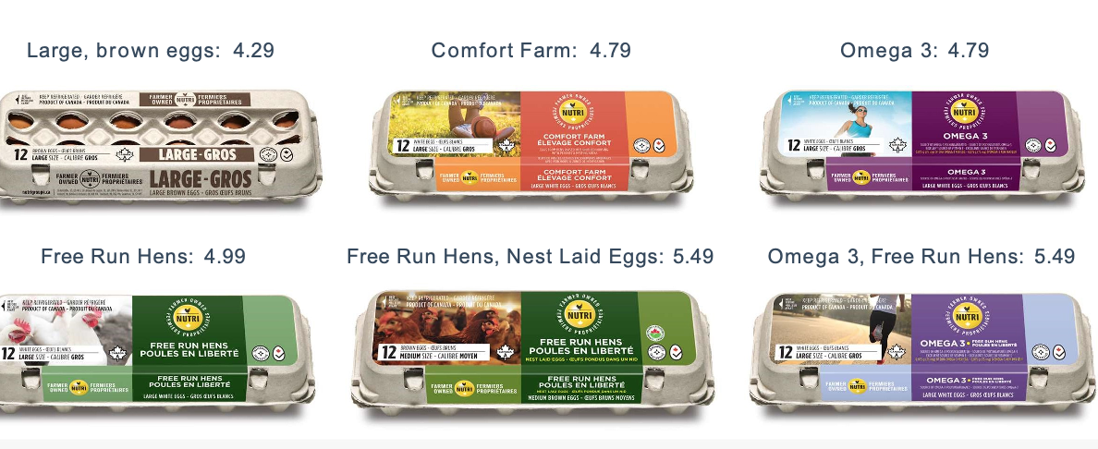

ORGANIC 3.0 for truly sustainable farming & consumption (Reading)

- The organic timeline can be measured in approximately 100 years: from the early days of imagining organic by those who saw the connections between how we live, eat, and farm, our health and the health of the planet (what we call ‘Organic 1.0’); to the forming of the movement and the codification of standards and enforced rules that have established organic in 87 countries with a market value of over $80 billion per year (what is termed ‘Organic 2.0’).

- Looking to the future, this paper is a call for change of culture and spirit, a call for institutional and strategic reforms and a call for actions to implement what the next phase of organic, ‘Organic 3.0’ can and should be.

- Organic 2.0 shaped the visions of the pioneers into a practical reality.

- Organic has inspired producers and consumers alike and has changed unsustainable habits around the globe.

- There is evidence of positive impacts on a wide range of important issues including consumer health, biodiversity, animal welfare and the improved livelihoods of producers.

The rules and regulations of Organic 2.0 have also resulted in the organic movement facing constraints on three fronts:

- First, it has excluded many producers who grow organically without organic certification: smallholder and peasant farmers - frequently women, and often in the least economically developed countries in the global south - who play a critical role in feeding much of the world’s population.

- Second, it has limited opportunities to build bridges with other sustainability initiatives that share the objectives but do not aim at full compliance with organic standards, including agroecology, fair trade, food movements, smallholder and family farmer movements, community supported agriculture, urban agriculture and many others. Third, economic pressure and economies of scale forced many producers to specialize and abandon diversity and other desirable organic practices.

- The overall goal of Organic 3.0 is to enable a widespread uptake of truly sustainable farming systems and markets based on organic principles and imbued with a culture of innovation, of progressive improvement towards best practice, of transparent integrity, of inclusive collaboration, of holistic systems, and of true value pricing.

- Organic agriculture is a lighthouse for truly sustainable agriculture and agriculture products systems.

- Organic 3.0 expands the participation options, and positions organic as a modern, innovative farming system that holistically integrates local and regional context including its ecology, economy, society, culture and accountability.

- Regeneration of resources, responsibility in production, sufficiency in consumption, and the ethical and spiritual development of human values, practices and habits are concepts that guide the building of a new organic culture that can drive societal development.

- The core of Organic 3.0 is the living relationships between consumers and producers, which includes the stories of products and production and the multiple benefits of organic agriculture.

- At its heart, Organic 3.0 is not prescriptive but descriptive: instead of enforcing a set of minimum rules to achieve a final static result, this model is outcome-based and continuously adaptable to local context.

ORGANIC 3.0: STRATEGY

The strategy for Organic 3.0 includes six main features, consistently promoting the diversity that lies at the heart of organic and recognizing there is no ‘one-size-fits -all’ approach:

- A culture of innovation, to attract greater farmer conversion and adoption of best practices.
  - Organic 3.0 proactively scouts for traditional and newly arising innovations and assesses them against impact risks and potentials.
- Continuous improvement toward best practice, for operators along the whole value chain covering all dimensions of sustainability: ecology, society, economy, culture and accountability.

- Diverse ways to ensure transparency and integrity, to broaden the uptake of organic agriculture beyond third-party certification;

- Inclusiveness of wider sustainability interests, through proactively building alliances with the many movements and organizations that have complementary approaches to truly sustainable food and farming.

  - However, it also clearly distinguishes itself from unsustainable agriculture systems and ‘greenwashing’ initiatives;

- Empowerment from the farm to the final consumer, to recognize the interdependence and real partnerships along the value chain and also on a territorial basis; It particularly acknowledges the core position of smallholding family farmers, of gender relations and of fairness in trade.

- True value and cost accounting, to internalize costs and benefits, encourage transparency for consumers and policy-makers and to empower farmers as full partners.

- It starts with internalizing Organic 3.0 strategies into all organic institutions.
- From there, it broadens outside of the traditional circle and builds bridges to other groups including the research community, operators throughout the value chain, and media, policy-makers and international bodies.

Society today is challenged by the endangered state of the planet and the possible consequences for all life upon it.

- Humanity relies on agriculture (and fishing/aquaculture) for food and other products like textiles and body care products to meet the most basic human needs.

- Agriculture, as most widely practiced, significantly contributes to issues such as loss of biodiversity or climate change – yet when practiced differently, is also a source of solutions.

- Far-reaching changes in agriculture and agricultural product systems are needed without delay if future generations are to have equal or improved preconditions for prosperity, particularly in view of a growing world population.

- The positive and multi-faceted environmental, social and economic benefits of truly sustainable agriculture can significantly reduce current problems and help us rise to the challenges.

- The principles of health, ecology, fairness and care can be used to shape any farming and ecosystem, whether they provide with food, textiles, body care products, energy, ecosystem services, leisure activities, or other products.

- They are the foundation for the proposal to implement Organic 3.0, as outlined in this document.
- Sustainable means meeting the needs of the present without compromising the ability of future generations to meet their own needs.

ORGANIC 1.0 – 2.0 – 3.0: A CONTINUING JOURNEY

- ORGANIC 1.0 Founders Visionaries

- ORGANIC 2.0 Private Standards Public Regulations Global Recognition

- ORGANIC 3.0 Widespread conversion Towards true sustainability Inclusiveness

ORGANIC 1.0 – PIONEERS FROM AROUND THE WORLD

- The organic movement was founded around 100 years ago by visionary pioneers who saw the connections between the way we live, the food we eat, the way we produce that food, our health and the health of the planet.

- The concept arose in several places around the world. ‘Organic’ was one of a number of terms the visionaries used to describe and define their diverse approaches. Looking back, one century on, we have termed this first phase of the organic movement Organic 1.0.

ORGANIC 2.0 – NORMING AND PERFORMING

- With the establishment of IFOAM - Organics International, the early 1970s saw the emergence of Organic 2.0.

- Over the following decades, production and processing standards were developed and certification schemes were introduced by organic organizations around the world.

- Official regulation was first introduced in Europe and the United States of America in the 1980s.

- By 2016, 87 countries in Africa, the Americas, Asia, Europe and Oceania had implemented organic regulations.

- Organic standards and control through inspection and certification has gained the trust of consumers and policy makers.

- There has been rapid growth in the area of certified organic land (around 81 million hectares in 172 countries worldwide by 2014), and in the consumer purchases of certified organic food, textiles and body care products ($80 billion worldwide in 2014).

- The past decades have also seen a concerted effort to enable political and administrative support, market development, and therefore access to and availability of better food, textiles, personal care, and other healthy products.

- Many technical challenges have been overcome through research and development, in institutes, universities and on farmers’ fields in participatory programs.

The Need For Organic 3.0

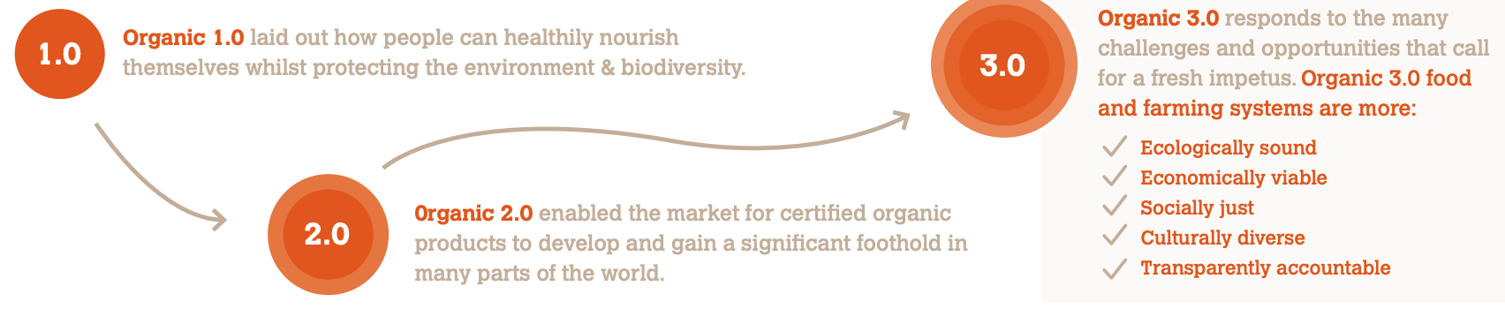

The Organic 2.0 strategy of developing a reliable certification system that is supported by government regulations has enabled continuous growth from a few farmers in many pockets of the world to a globally active sector with millions of producers and consumers.

- A holistic system view that concentrates on more than the exploitation of short term market opportunities has proved to be robust and has assured growth even in times of economic crises in many countries.

- While there is sound development and wide prosperity in the organic sector, many stakeholders also see a need for reforms, or they call for a paradigm shift in order to make production and consumption truly sustainable.

- Organic agriculture has offered many of opportunities for farmers. Many managed to escape the poverty trap and bankruptcy that can accompany being a pioneer in their communities

- However, in recent times organic farmers are often forced, due to the dominant economic paradigm, to specialize and scale up production, at the cost of biodiversity and sustainability.

THE NEED FOR ORGANIC 3.0 IS UNDERLINED
BY SOME EXEMPLARY CHALLENGES OF ORGANIC 2.0
• In many countries, organic production and consumption is too small to
have a big impact.

• There is a low rate of conversion to organic agriculture and growth
of organic agriculture land is much slower than the dynamic
market development.

• Even though some organic fields outperform conventional ones, the
average yield is lower than in comparable conventional systems,
particularly under good agriculture conditions.

• Organic standards set minimum requirements and not a high target.
In certain instances this leads to operations that meet standards,
but that neither fulfill the Organic Principles nor progress towards
true sustainability.

• Not all production techniques allowed under standards and certification
fully meet the organic principles (e.g. inputs for horticultural crops,
livestock medication, recycling of nutrients, use of synthetic inputs in
processing of food/fiber/extracts, social requirements, fairness in trade).

• Certification, third party verification, detailed standards and related
bureaucracy in Organic 2.0 have imposed an oftentimes unaffordable and
unpractical burden on farmers and the value chain.

• The certification system can`t fully avoid fraud, especially in longer chains.

• Some high priority areas such as instance social requirements or fairness
in trade aspects are not directly regulated in most organic standards
and cannot be claimed, although there are many farmer and business
initiatives delivering very well on them.

• Effective delivery of ecosystem services and other common goods are
often not rewarded.

• Organic is excellently positioned for high value and healthy products, and
trust is placed in its ecological processes and animal welfare. However,
it does not sufficiently cover other sustainability dimensions and is rarely considered by policy makers as an option for mainstream agriculture strategies.

THE ORGANIC 3.0 FRAMEWORK

OVERALL APPROACH AND THE GOAL OF ORGANIC 3.0

- The overall goal of Organic 3.0 is to enable a widespread uptake of truly sustainable farming systems and markets based on organic principles and imbued with a culture of innovation, of progressive improvement towards best practice, of transparent integrity, of inclusive collaboration, of holistic systems, and of true value pricing.
- Organic agriculture is a lighthouse for truly sustainable agriculture and agriculture products systems.

- Organic 3.0 expands the participation options and positions organic as a modern, innovative farming system that holistically integrates ecology, economy, society, culture and accountability into local and regional context.

- The core of Organic 3.0 is the living relationships between consumers and producers, which includes the stories of products and production and the multiple benefits of organic agriculture.

- While Organic 2.0 focused on clearly defined minimum requirements and organic claims on products, Organic 3.0 puts the impact of and on the farming system in the foreground.

- Organic 1.0 and Organic 2.0 approaches and achievements are not abandoned.

- Organic 3.0 retains the original bedrock concept of Organic 1.0 and expands the progress made under Organic 2.0.

- Through the new Organic 3.0 understanding and strategy, the organic movement wants to showcase its ability to have impact on issues of critical importance to billions of people – e.g. ensuring climate change mitigation, resilience and adaptation, access to capital and adequate income, availability of land, water, seeds, adequate and healthy diets, and avoidance of waste in production and consumption.

THE ORGANIC 3.0 MODEL AND ITS KEY FEATURES

- Organic 3.0 is a revised understanding and positioning towards more ambitious and common-good goals, and therefore has a strong focus on the spirit, attitudes, values and strategic plans of stakeholders inside and outside the organic movement.

- It calls on governments to create an environment conducive to empowering stakeholders by setting legal frameworks and public investments that support the Organic 3.0 concept.

- Governments should partner with and enable the participation of civil society and foster private initiatives in the sector rather than overregulate and bureaucratize operations.

- Organic 3.0 embraces a strategy of dynamic and continuous improvement.

- The organic narrative develops from its past offering of certified agricultural products into the smartest, most authentic and fully regenerative way of production and consumption of nutritious food, ecological textiles and natural body care products.
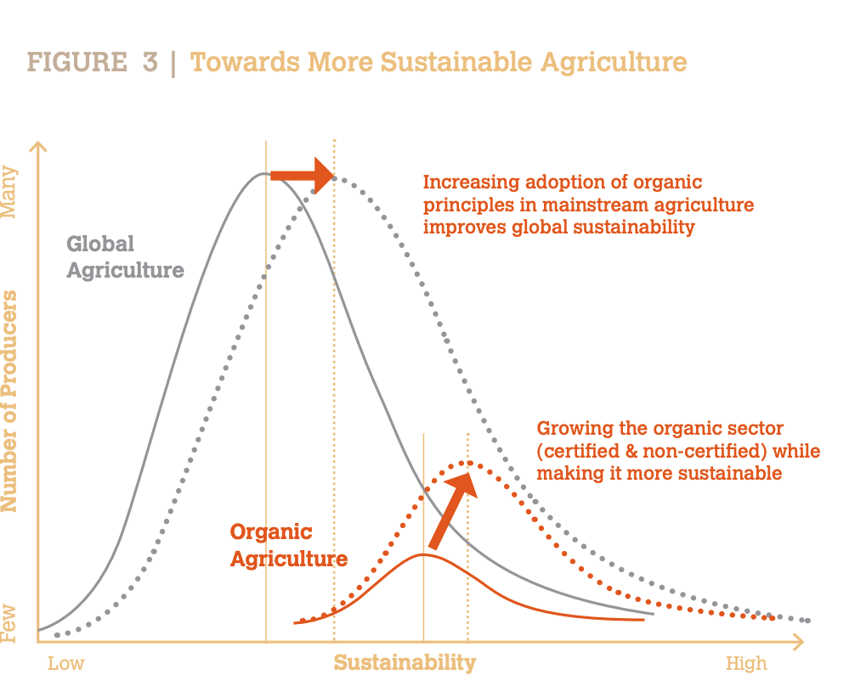

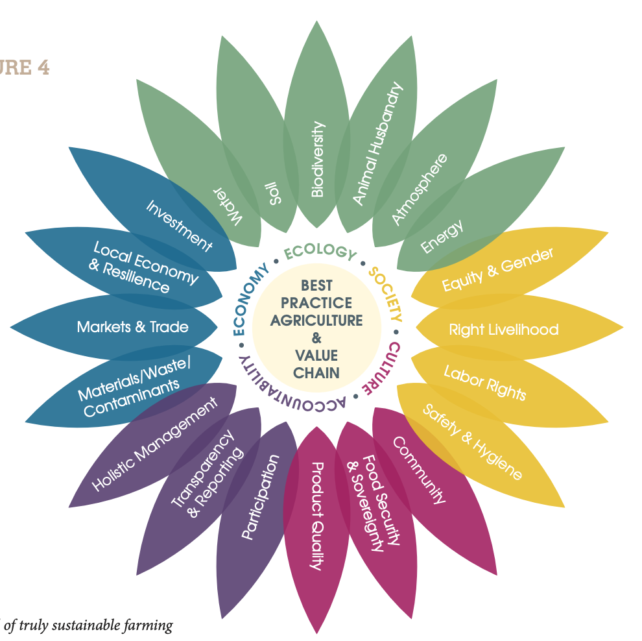

- Symbol of truly sustainable farming and value chains. It visualizes the five dimensions and 20 criteria of sustainability as described in the IFOAM Best Practice Guideline for Agriculture and Value Chains.

- With its ‘more and better’ approach it aims at increasing relevance and credibility not only for a limited organic niche, but also as an integral part of the societies of all countries (see figure 3, page 10).

- This strategy requires clearly defined minimum requirements such as the ones defined in many government regulations around the world and in the objectives of the IFOAM Standards Requirements (e.g. no applications of GMOs).

- But it also requires a culture of continuous improvement through stakeholder driven initiatives towards best practice, and adapted to local priorities as described in the IFOAM Best Practice Guidelines.

ACHIEVEMENTS OF ORGANIC
1.0 & 2.0: HIGHLIGHTED EXAMPLES
• The growth in scale from a very small recognition
in policy to a widespread uptake of a clear and
detailed legal framework.

• In some countries in Europe the area of certified
organic land accounts for up to 20% of the
agricultural land, while in some alpine regions
there is even a majority of farmers managing
their land organically.

• Organic baby food represents up to 80% of the
baby food market in many countries.

• In some countries in Latin America exports of
certified organic crops like coffee, cacao and
banana are greater than non-organic.

• The introduction of internal control systems
and group certifications has improved access
to international markets and connections with
smallholders.

• Some Himalayan states have pledged to become
100% organic.

• Many organic farming models are high yielding and provide a range of highly effective
ecosystem services.

• There is evidence that organic produce has improved health qualities.

• Proven positive effects on soil fertility and biodiversity.

• Organic is increasingly proven to be a better economic model for farmers.

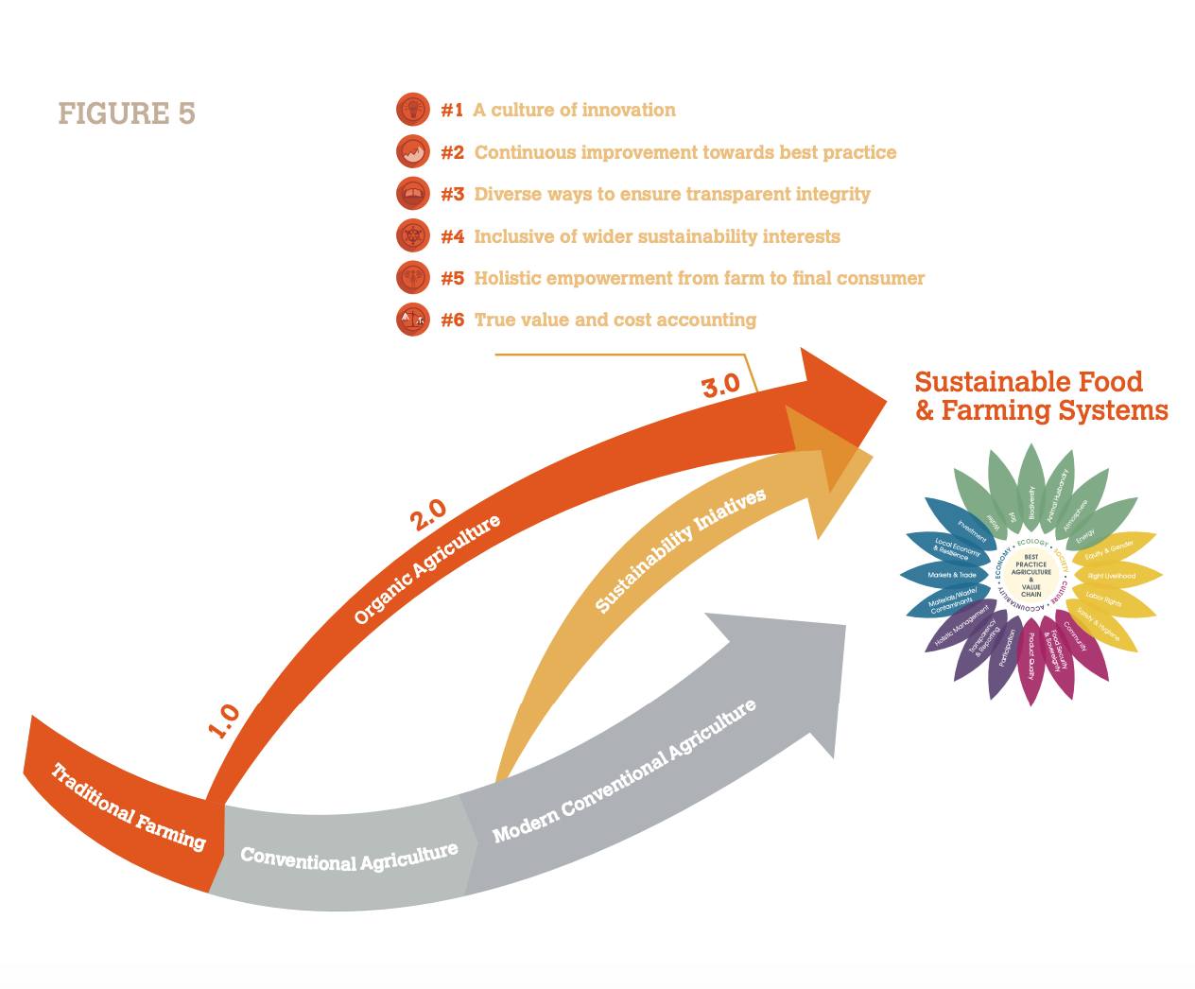

FEATURE #1: A CULTURE OF INNOVATION

- To successfully address the challenges of the 21st century, a combination of social, ecological and technological innovation is essential.

- Organic agriculture is not a farming system that is disrupted by inappropriate new technology, nor dominated by conservative thinking.

- Rather, Organic 3.0 is a disruptive force itself by enabling more people to adopt leading-edge concepts that bring substantial change to solve major social and environmental issues that the planet faces.

- Two priorities are innovations to overcome the present very low rate of farmers’ conversion, and to increase nutritional revenues from fields while maintaining ecosystem vigor.

- Certain practical tools become common practice, for example those that test to ensure correct nutrient balance, or those that enable more timely monitoring pest and disease pressure so that farmers can consistently get good yields and perform according to the concept of ecofunctional intensification. Farmers intensify biological processes rather than intensify inputs.

Some examples illustrate the way in which a culture of innovation will help:
• Systematically extract, evaluate, preserve and renew indigenous or tacit knowledge of farmers and farm communities.

• Smart technologies such as robots and precision farming, information and communication technology, or intensified crop and livestock breeding techniques that are avoiding genetically engineered varieties.

• Further development of methods that provide assurance of compliance to sustainability criteria those that enable value chains to demonstrate how key issues are addressed, quality and authenticity are assured, and impact achieved.

• Use of modern Internet technology by social networks, by food, fashion, personal care and health movements and by urban farming, community supported agriculture and collective land ownership initiatives etc., to democratize the value chain.

• Societal and economic transformation trough increased consciousness of the concept of sufficiency/ eco-sufficiency in production and consumption, and connection of society at large to the natural production base on which it depends, in order to reduce negative impacts of the use of natural resources (e.g. reduced meat consumption, promotion of organic lifestyles or fostering spiritual health).

• Foster relationship building, with innovative models and initiatives that reinforce interdependency, e.g. the economy of the common good.

- While applying the precautionary principle, innovation committees explore potentials and develop positions on the use of upcoming technologies.

- The innovation committees assure a fast uptake of potentials, but they also carefully assess the risks and act timely to exclude technologies that are not in line with organic principles.

FEATURE #2: CONTINUOUS IMPROVEMENT TOWARDS BEST PRACTICE

- Certification requirements based on private standards and government regulations – the core of Organic 2.0 – will not be the most important focus anymore.

- Standards may however become out comes based, become broader and/or address neglected dimensions of sustainability in order to underpin the holistic nature of organic agriculture. And they may evolve to play an important role in facilitating continuous improvement by integrating tools for monitoring individual progress of the operator

- Continuous improvement of operations and systems should address the ecological, social, economic, cultural and accountability dimensions.

- The Organic 3.0 framework should provide guidance for prioritizing developments that have the biggest impact.

- Meaningful criteria and credible targets will be agreed by stakeholders and used to evaluate and communicate improvements in a transparent way.

- Not everything can be accomplished at once by any given enterprise; over time more and more will be achieved.

- Farmers, processors and traders shall use an appropriate tool to benchmark their own operations, in order to demonstrate their improvements year by year.

- An attitude of continuous improvement towards best practice rather than an economic optimization on the minimum standard also supports the above-described culture of innovation.

- Operational objective related to feature #2: Organic sector operations are working towards best practice through continuous improvement.

FEATURE #3: DIVERSE WAYS TO ENSURE TRANSPARENCY AND INTEGRITY

- Organic 2.0 successfully developed standards and implemented certification systems validated in a legally enforced system of compliance verification.
- It has enabled the growth of the production base and the market for certified organic products.

- Participatory Guarantee Systems (PGS) that rely on the relationships between famers and consumer groups are engines of social development.

- Different, new verification schemes may become practiced depending on the length and complexity of value chains.

- Reputation economy and web-based communication technology offer new opportunities; the organic movement must be open to this.

- For long chains, the process-oriented paperwork might be complemented and reduced by modern authentication, tracing and tracking technologies, which will become widely used as they become more affordable.

- Third-party certification will remain important particularly for marketing in large quantities in retail chains.

- The Organic 3.0 model in this case must entail reforms to lower the burden of producers for onerous reporting requirements.

- Greater transparency across the value chain and among all associated relationships will also help ensure that potential conflicts of interest are more readily exposed.

- Organic 3.0 communications systems will enable parties to identify and address such concerns

- Operational objective related to feature #3: Transparency becomes the organizing principle of guaranteeing integrity. A diversity of appropriate methods for ensuring transparent integrity is developed and promoted.
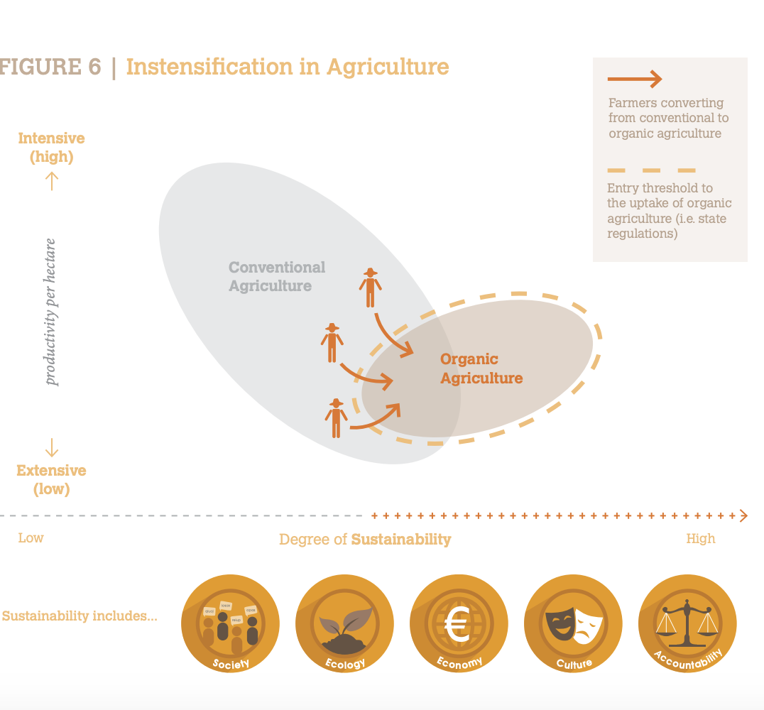

FEATURE #4: INCLUSIVE OF WIDER SUSTAINABILITY INTERESTS

- The goal to become more relevant and to increase impact implies a strategy to build alliances with the many movements and organizations with aligned goals and complimentary approaches to sustainable food and farming systems.

- The organic movement is a pioneer but not any more alone in working for a paradigm of ecological and social intensification based on natural processes and closed cycles.

- The organic movement seeks to be an active partner in the diversity of the worldwide actors that are pushing for sustainable food and farming systems.

- Potential allies include for example agroecology, fair trade, smallholder and family farmers movements, food sovereignty alliances, community supported agriculture, food movements, green fashion, natural beauty, urban agriculture and many others.

- Organic becomes a mechanism for achieving true sustainability, a shared journey with others, respecting differences and working with diversity.

- To achieve this means proving the benefits of organic practices and systems through evidence-based findings and helping others to adopt such practices into their systems.

- Beyond market success of organic labels, the organic movement must develop substantial leadership in the development of up-scalable truly sustainable farming and value chain systems.

- Such leadership could be for instance in offering best farm or best food handling practice packages and informing consumers about healthy diets.

- Another form of leadership could be the role of the organic movement as a guide and guardian of a modern, responsible and caring innovation culture.

- The organic movement must be inclusive on the journey towards true sustainability – regardless of whether they comply with minimum organic requirements – but it must also make clear and pointed positions against greenwashing, abuse of organic claims where not legally protected, and against the greed-fuelled exploitation of the planet and society

Operational objective related to feature #4: Organic is part of a wider sustainability debate and the organic movement works with like-minded movements to pursue common goals.

FEATURE #5: EMPOWERMENT FROM FARM TO THE FINAL CONSUMER

- Organic agriculture is farm-based but also engages processing and trade. It allies with consumers – the force that ultimately pulls developments.

- Organic 3.0 repositions organic from chain to system, from certified product to a way of life that addresses all sustainability dimensions.

- Such a repositioning implies real partnerships along the whole value chain.

- It demands empowerment of disadvantaged stakeholders such as smallholding family farmers in difficult ecological, economic or governance environments, of farm laborers who deserve payment of living wages or of the women who largely carry the burden of assuring decent livelihoods for their families.

The focus on empowerment of stakeholders in the whole system may imply for example:

• A shift towards designing agroecological, low input, closed loop, high yielding, resilient systems that implement the concept of ecological intensification, which will mean less costs and better production outcomes for farmers.

• Farmers are one of the lowest socioeconomic groups in many countries even though they produce most of the food on Earth. They must be empowered to be drivers of change rather than the current situation in which production systems are imposed on them through a top-down system of standards, checklists, and financial obligations. Many farmers risk losing their farm if crops fail and are often consequently forced to give up their farms to live in abject poverty on the fringes of the rapidly growing cities.

- Production costs, margins and prices along the value chain become more transparent and benefits from the sales of high value products are shared fairly including with the farmers in long chains.

- The majority of farmers and the majority of decisionmakers among consumers – two primary stakeholders in organic systems – are women. Their critical role must be acknowledged. In many countries, numerous women have no property, financial or reproductive rights, and are the object of physical violence. Even in the institutions of the organic movement, women are grossly under-represented in leadership roles. The principles of fairness and care mandate that organic 3.0 actively address gender equity

Healthy nutrition is an objective of organic 3.0. The understanding of organic broadens from production processes and products to also include consumption patterns.

Operational objective related to feature #5: The most vulnerable stakeholders – including farmers and their livelihoods, and consumers and their health - are empowered so that they become real partners in the system.

FEATURE #6: TRUE VALUE & COST ACCOUNTING

- Fair prices throughout the value chain must be an essential component of Organic 3.0 – producers should be price makers, not price takers, in all supply chains.

- key to more fairly account for the costs and benefits to the environment, biodiversity, human health, society and culture of any production system and farming method.

- This depends on developing tools for true cost accounting and pricing.

- From the consumer’s point of view, the perceived true value matters, so a premium price can easily be associated with clear benefits.

- Examples of distortions that true cost accounting would help resolve include the abolishment of fertilizer subsidies (often practiced through hidden energy subsidies), the full implementation of the ‘polluter pays principle’ via taxing (e.g. of energy, CO2, pesticides, nitrogen) and clear labeling of unsustainable practices (for example GMO, pesticide use and intensive animal rearing practices) so that consumers can make informed choices.

- In addition, public subsidies and direct payments to farmers must be coupled to farming systems that provide public goods and ecosystem services.

- Establishing a system to account for the true costs and responsibilities involved in production and consumption requires a combination of consumer awareness raising campaigns, market mechanisms, and policy mechanisms.

- These must all work concurrently under a common framework of goals, primary indicators toward those goals, and the specific practices that lead to them.

- Such a framework must be simple enough to be understandable and actionable by all stakeholders across the value chain.

- Positive practices should be incentivized and negative practices discouraged through economic instruments.

- Agreement on the qualitative or quantitative (financial or otherwise) impacts of different practices should be based on scientific assessments that are part of ongoing, transparent study and refinement.

Operational objective related to feature #6: A common, easily understood, science-based, and transparently reviewed cost assessment methodology is applied and recognized as a base for fair pricing, assigning appropriate responsibilities to all actors in the production-consumption loop.

ORGANIC 3.0 – ACHIEVING OUTCOMES & IMPACTS

- Organic 3.0 means the evolution of the present situations of stakeholders and institutions into new priorities, with reoriented strategies and with a new organic culture.

- The achievements of Organic 2.0 and of institutions do not need to be given up, but they need to be reformed and complemented with new approaches.

- The new strategy demands integration of organic into the development of the planet and societies rather than concentration on the perfection of the niche.

- The impact of the organic movement must also be measured in the increasing adoption of organic principles in mainstream agriculture in order to improve global sustainability.

- The inclusive nature of Organic 3.0 with its innovative vigor, the better adaptation to local conditions and the inclusiveness to various development stages will make the organic movement even more diverse than it is today.

EXAMPLES OF ORGANIC 3.0 OUTCOMES:

- Contribution to reversing the effects of human induced climate change (e.g. mitigation through soil carbon sequestration) and helping famers adapt to climate change;

- Preserving & stewarding biodiversity;

- Protection of genetic diversity and improve breeds of plant varieties and livestock suited to agro-ecological production;

- Reduction of dependency on non-renewable resources and close nutrient loops in production systems and in living soils;

- Improvement of productivity (nutrients and ecosystem services) of organic systems, while regenerating natural resources;

All stakeholders are invited to make the idea of Organic 3.0 a reality and be the attitude and change that is needed.

- The shift from Organic 2.0 to Organic 3.0 means a change in thinking.

- The call for action includes a call to include the Organic 3.0 features in institutional and individual strategies.

- Basic values and attitudes promoted in Organic 3.0 such as continuous improvement, a culture of innovation or the outcome-based orientation need to become part of a new self-realization.

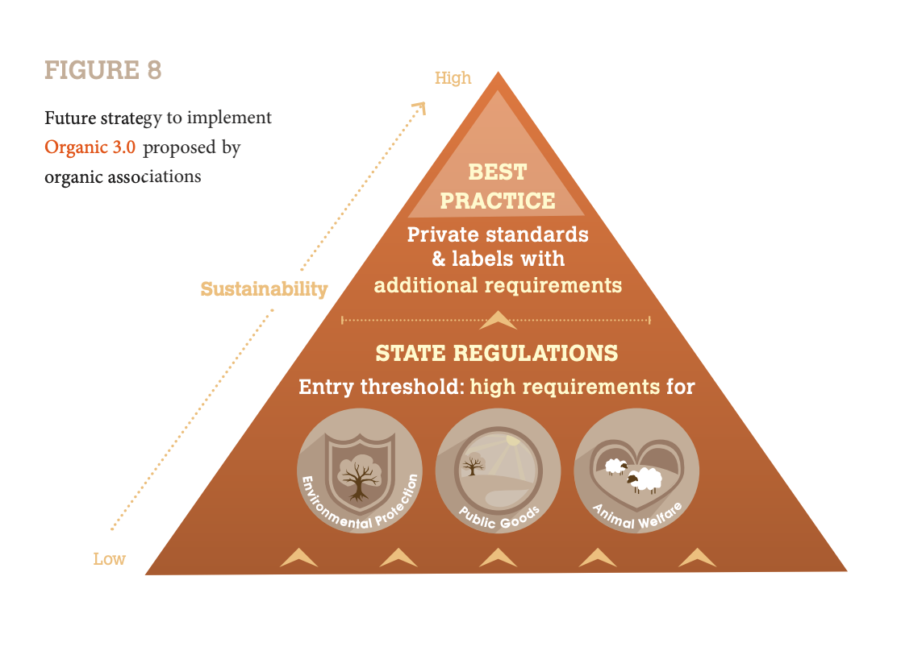

1. UMBRELLA ORGANIZATIONS

- Local, national, regional and global umbrella organizations, including IFOAM – Organics International and its self-organized structures make the transition to Organic 3.0 in their respective sphere of influence, i.e. their geographical scope or the sector they coordinate.

- They participate actively in all of the six features. They take a lead in implementing the overall Organic 3.0 concept and lead feature #4, “inclusive of wider sustainability interests” and feature #5, “holistic empowerment from farm to final product.”

The call for action includes to:

- Create awareness and showcasing willingness to transition.

- Agree with one’s own stakeholders on a transition strategy that includes one’s own system changes and advocacy for Organic 3.0 contents; Advise and facilitate stakeholders in implementation. Monitor progress and communicate achievements and barriers.

- Clarify the non-negotiable elements of organic standards that are central to delivering the required outcomes, and create systems and a culture for continuous improvement towards best practice.

- Build and host innovation committees on national and international levels of outstanding specialists that track and critically assess emerging innovations and potential conflicts.

- Recognize, critically appraise and value the objectives and achievements of like-minded organizations and movements; Be included and inclusive: create bonds, incentives and strategic alliances based on common vision and goals.

- Assure participation and empowerment of vulnerable stakeholders, respecting their rights and their power.

2. RESEARCH AND DEVELOPMENT (R&D)

R&D leads feature #1, “a culture of innovation” and supports the other features with systemic advice and innovative solutions. The call for action includes to:

- Evaluate our achievements and assess our impact honestly and openly, in the context of the scale of the global challenges that society and the planet face, and support advocacy and communication with evidence.

- Identify the key bottlenecks that hold back the scope for organic, that could be resolved through more and better research, development and practice.

- Assess opportunities for science and evidence-based innovation (including both natural and social sciences) to realize alternative approaches that are consistent with the organic principles.

- Support operators and verification bodies in their efforts for continuous improvement and the demonstration of product authenticity and transparency through the development of better benchmarking, analytical, reporting, and other tools.

- Innovate, test and scale up integrative organic approaches for smallholding family farms, that open up opportunities on household, local, national or international levels. Develop low-investment cost conversion and integration methodology to improve performance by enhanced system design.

3.OPERATORS

Operators take a lead in feature #2, “continuous improvement towards best practice” in feature #3, “ensuring diverse ways of transparent integrity” and in Feature #6, “true value and fair pricing.” They also play important roles in the features #1 and #5.

The call for action includes to:

- Build internally and externally more awareness for best practice and for the need to address all sustainability dimensions; Adopt a strategy for continuous improvement rather than optimization on the baseline standard; Use peer and own past performance as a benchmark and report about one’s own improvements.
- Reassess one’s own current scheme for organic guarantees and innovate for customer relationship building.
- Transparency and common interest should become the fundamental organizing principles of assurance systems.

- Acknowledge true costs, publish and advocate for true value and fair pricing, and expand application where possible. Empower stakeholders to negotiate true value and fair prices.

- Work with umbrella organizations for sector coordination and strategy building. Work with R&D for technical, social, and policy innovations.

- Empower partners up and down the value chain and mainstream gender equity in own operations including in high-level positions.

4. CONSUMER AND CITIZEN ORGANIZATIONS

Consumer and citizen organizations guide consumers, the force that eventually pulls organic developments.

These organizations play a crucial role in explaining the transitions and in representing the voice of consumers and citizens.

They play a role primarily in features #1, #3, #5 and #6 and lead communications about consumption patterns.

The call for action includes to:

- Be receptive to the far-reaching interests of consumer and citizen perspectives and be in a dialogue with the organic movement.

- Contribute to a culture of innovation and continuous improvement amongst all operators by understanding and welcoming the Organic 3.0 concept and by supporting it with ideas and feedback. Show openness to new ways of demonstrating transparency and integrity and engage in relationship-building with organic operators.

- Focus on holistic performance, overall impact, consumer behavior and healthy nutrition, based on agreed holistic criteria, not only on single issues, single products or single failures.

- Inform consumers about the reality of farming and thereby foster relationships with farmers and foment the creation of an understanding of the power of consumption choices.

- Build values that impact fairness of trade interactions along the value chain.

- Acknowledge the empowerment of vulnerable groups, which includes fair pricing. Make political claims for true cost accounting, polluter-pay principles and the determination of true value.
5. SERVICE PROVIDERS
Service providers support all features and take a co-lead in Feature #2, “continuous improvement towards best practice” and #3, “ensuring transparent integrity.”

The call for action includes to:

- Inspire and support all stakeholders with advice for the transition to Organic 3.0.

- Enable operators to choose appropriate assurance concepts, thus adding to the quality of assurance and integrity. Transparency and common interest should become the fundamental organizing principles of assurance systems.

- Improve information infrastructure to enable collaboration and access both regionally and globally on topics of common interest, e.g. reporting platforms registries of evaluated production materials, reviews of technologies, certification and trade data, risk assessment matrices, peer review criteria, etc.

- Develop specialized media to promote the Organic 3.0 strategy on a daily basis and help build awareness amongst stakeholders, including producers and consumers.

GOVERNMENTS AND INTERNATIONAL ORGANIZATIONS

Governmental and intergovernmental organizations set the regulatory framework and play a very important role in all the features, since policy and legal changes may be required.

The call for action includes to:

- Review agriculture policies recognize the opportunities of Organic 3.0 and adopt an updated organic strategy in consensus with the sector. Reform organic policies in line with Organic 3.0. This particularly includes innovative farming practices, the adoption of the principle of continuous improvement in organic regulations, expansion of the options of conformity assessments, expansion of scope to a holistic understanding, and the institution of true cost accounting.

- Invest in the Organic 3.0 culture of innovation with its research agenda and budget, and invest in rewarding public goods provision by farmers.

- Support the development of diverse accountability initiatives, enabling development by individual operators and of the sector as a whole.

- Mandate the purchase of organic goods in public procurement policies.

- Evaluate the impact of organic agriculture for social equity and environmental sustainability and use it in solutions toward government priorities.

- Apply financial instruments that take into account the positive and negative external effects of agriculture production. Incentivize practices in the right direction and reward common-good provisions accordingly.

Bananas: A case for fair trade by Jennie Coleman from EquiFruit

- Jennie Coleman the president of EquiFurit, founded in 2006.

- Always fair-trade produce thinks a lot about supply chain.

- EquiFurit small company, only 5 women and the only Canadian member of the world Banana forum which is a international organization based out of the FAO Food and Agriculture Organization of the UN.

- World Banana Forum regroup stakeholders across the supply chain, everything from workers unions in Latin America to a couple major companies and Europe Retailers.

- Raise awareness in the Banana industry, they want to change the industry that has worked fundamentally the same way for over 100 years and which is based essentially on the low prices.

- Low pricing for the production end in order to provide low prices in the supermarket.

- Bananas are the cheapest fruit at the grocery store, nothing comes for free, somebody else is paying for us to have these prices. That somebody are banana workers and small farmers.

- Current industry is based on a foundation of a very concentrated supply with a business model basically on free land and labor for production. To output the race against apples.

- Dole has been using political manipulation to get land and cheap labor. Only 4 suppliers you could buy from, Chiquita, Del Monte, Dole and Fyffes.

- EquiFurit main competitor are these 4 companies.

- These companies control the entire supply chain, they own the land, control the packing, have their own ships, everything to get to retailers.

- Has a impact on how people view Bananas, two people categories Consumers who have come to believe bananas should be cheap, not knowing the human and environment exploitations behind it.

- Retailers have used bananas as gauge for their price image, many grocery stores outside have bananas like Walmart, fortino’s.

- Banans are a known value item where consumers remembers from different stores what they paid for their Bananas.

- Retailers could make a switch to different bananas, but are afraid of losing business because for so long the only way they market bananas is low price. Fear sustainable priced banana will cause them to go elsewhere.

- EquiFurit believes different, that people are willing to pay got a sustainable priced banana.

- Gap means you aren’t pay for proper wages, adequate health and safety measures, using incredible amount of pesticides which has high environmental effect. Not looking at how producers will address climate change, their water usage.

- EquiFurit believes in free trade, Freetrade is about making sure there is a more equitable framework between the buyer and seller, the producer who’s traditionally been in a very poor negotiating position gets a better deal.

- Fair Trade two ways in talking about it, there’s fair trade in two words the notion of trade justice between developing and developed countries.

- EquiFurit standards are the certification they follow they are certified by Fairtrade international,

- Fairtrade is a international organization 50% owned and controlled by producers, the other half buying countries. Offices all over the world, most recognized Fairtrade label and also the most robust certification framework.

- Fairtrade gives us a framework between buyers and sellers, Fairtrade is still trade, its still business but within ethical framework.

- EquiFurit imports fruit, if not good quality they claim back to the producers, need to make sure they send quality fruit.

- Work together to make sure its Fairtrade

- EquiFurit expects producers to have respected standards on three pillars of sustainability, economic social, environmental sustainability.

- Economic end they want fair distribution of value, pay more for product but want to make sure people get their fair wages.

- Socially they want to make sure there aren’t child and forced labor, good occupational health and safety standards. Want to make sure people have good work places.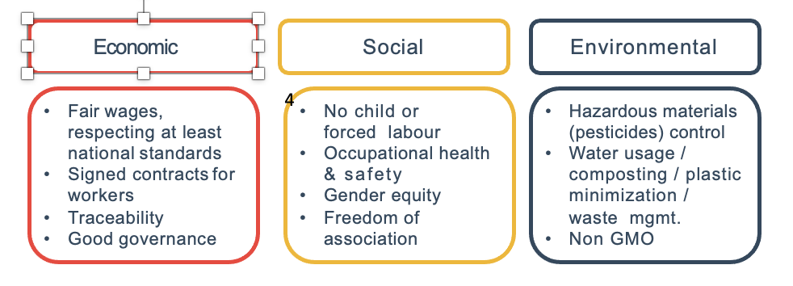

- Strict pesticides producers can use

- Like an Umbrella certification that will certify both conventional and organic production, fairtrade conventional bananas.

- Make sure workers are protected when applying them, make sure others nearby don’t get sick. Avoid environmental toxicity.

- EquiFruit needs these to be delivered in order to purchase their bananas.

- Buyers have 2 main mechanisms, first is respect for the fair trade minimum price

- Fairtrade International certification body has standards on pricing units, work with producers to look at what is the cost of sustainable production.

- Fairtrade sets the same standards for a variety of different products

- Fairtrade minimum prices are available on the websites where you can look for conventional prices.

- Floor price: like a minimum wage
- Established by Fairtrade Standards Unit in cooperation with producers
- Represents Cost of Sustainable Production, by commodity & country
- Provides long-term income stability for vulnerable producers

Price they will always pay.

- Each producer has its own farm, farm is its own business and these farms need to be profitable
- The basis of the fair trade minimum price also includes making sure that small producer has sufficient income to do more than just subsistence living.
- These people can invest in their bank do what they want with their money.

- Producers not selling under these terms they are selling to third party middleman who sell to the big banana companies.

- Spot price for bananas is very low, three times nothing.

- EquiFurit contributes fair trade social premium and it’s the additional amount to the cost of the fruit.

- They work to invest in a whole host of projects, not sexy but something very important for long term economic viability of the cooperative such as investing in infrastructure, making improvements to farms, putting climate change plans in order.

- Recently this has been used to help producers combat Covid-19 and protect themsleves

- Additional sum of money which goes into a communal fund for workers and farmers to use – as they see fit – to improve their social, economic and environmental conditions.
- For bananas, social premium set at 1 USD / standard case

- Community development projects include investments in schools, healthcare centers, portable water projects.

- Social premium is set by commodity as well, in case of bananas its $1 U.S. dollar for 140 pound case.

- Importing bananas on a container basis, several containers of bananas a week each container has 960 cases.

- Nearly 1000 cases, about 52,000 U.S Dollars which would go to cooperatives community to reinforce the strength of that cooperative, or invest in their community.

- Their partners are Asoguabo based in the south in Ecuador, about 125 small producers who are farming 5 hectors of land. Have their own packing station.

- Only pack fruit 2 days a week, mostly cutting fruit and washing them.

- Fruit is packed into the truck and it delivers to the cooperaives head office and it is packed together palatized and sent to us.

- Many producers fill their containers.

- Partners in Peru are called APPBOSA, small producers in Saman Peru.

- Here there are 400 small producers farming 600 hectors of land.

- APPBOSA has 8 or 9 packing stations they share as a co-op. they all workthegter they are packing every day 6 days a week. That’s their work week.

- Both cooperatives have commitments to fair trade, have direct access to a buyer like equifruit, don’t need to sell to big banana companies. They set the rules.

- Each container they receive, many producers contribute, small producers usually have a packing list of 2 pages. Each container the name of the small producer and the amount they have contributed.

- Every time Equifruit imports a container of bananas, the packing list tells us who produced each and every case of fruit. With an averageofonly1.5hectares/producer, sometimes this is only a few cases per load

- Each of these producers has a face, a family, a farm: a life story.

- Help improve the lifestyles of these farmers, thanks to fair trade.

- Longos, and farmboy have their produce in their store. Ask to see the case, it shows a code, you can send a note and ask who the producer is and they will tell you.

- Social premium impact is tangible and wide- reaching in producer communities.

- Hired Labour uses tend to be more “basic”: housing, sanitation & transportation projects.

- Typical community investment by a small producer cooperative: donation of laptops and projector for local school.

- Health care clinic received funding for a small birthing center.

- Social premium money for training, for new organic methods, gender issues.

- So, can we get Canadians to care as much about banana workers as hens?

- Items like eggs will buy a carton and will remember what they cost, falls into the known value items.

- Consumers want more variety, compared to the standard egg, they are organic which are differentiated on different grounds. One with Omega-3, one differentiated based on the comfort of the hen on the farm or in the laying process.

- People are thinking differently on the comfort on the hens, thinking about rebranding her bananas.

- Room for differentiated bananas, real message to send to retailers, based on Sustainability.

- Sustainability is the fair trade standards.

- Fairtrade Canada has a website called about behindthepeel.com

- No criteria that grocery stores have to meet to sell Equifruit, responsibility remains with Equifruit. They sell to the retailer and just need them as a distribution channel. Will sell to anyone.

- Equifruit feels strongly on volume, more volume they have the more impact, want to get their fruit into stores everywhere.

- Need help on educating consumers on point of sale, work with them so people know the values attached to a fair trade banana.

- In Europe retailers in their own volution make commitments to source fair trade bananas such Waitrose, Sainsburys, leidl a discount grocery store, buy 100% free trade bananas.

- A lot of pressure to make these supply chains sustainable, a lot of worry about reputation.

- Equifruit is the only Canadian member of the banana form.

- More consumer move towards fair trade bananas in Europe.

- Whole trade certification schemes are very nebulous, like marking your own homework they set their own rules.

- Equifruit follows transparent framework unlike others, because you can’t see what others see, like smoking mirrors.

- Education is the tool Equifruit uses the most to educate and make people aware.

- A lot of education at the buyer level, have to explain the costs and why its more money.

- Look at modern slavery and the affect it has had in other jurisdictions. modern slavery legislation very difficult to implement.

- Europeans are further ahead of modern slavery legislation in supply chains than we are, major groceries chains in Germany signed an agreement to have living wages in their supply chains.

- In support of modern slavery legislation, some retailers want that. Competitive pressures makes it difficult for Equifruit to get their product in stores because they don’t want to be high banana seller.

Week 8

Insights from Indigenous Food Systems

Land Acknowledgement

I want to acknowledge that today I have the priviledge of joining you from the traditional territory of the Haudensaunee (Iroquois), Ojibway/Chippewa and Anishnabek. This territory is covered by the Upper Canada Treaties.

- Donna Appavoo is a newcomer to the agriculture

- Canada is home to over 50 indigenous nations and they live in over 600 communities, history of 10,000 years in this place.

- Aboriginal peoples is used more by government

- Indigenous is increasingly replacing the term aboriginal, as Indigenous is recognized nationally.

Learning Objectives:
- Consider the contemporary implications of colonialism, facing Indigenous peoples when it comes to food and health
- Become familiar with the rationale and principles of Indigenous Food Sovereignty
- Identify examples of current programs, legislation and policy reform in Canada that relate to Indigenous food systems.

A few key terms: Colonialism, Terra nullius, nutrition transition, indigenous food sovereignty, food insecurity, regenerative food system

- Don Morrison ask us to think about this process as overcoming the monocultures of the mind

- Taking the opportunity to look at different perspectives

Northern Nutrition Program: support financially, the access to groceries and they have done that through providing subsidies to retail outlets.
Food Security

- Definition
  - FAO (1996) “Food security exists when all people at all times have physical social and economic access to sufficient, safe, and nutritious food that meets their dietary needs and food preferences for a healthy active life”
- Indigenous experience of food (in)security
  - Internationally
  - In Canada

- Metrics used to measure or assess food insecurity is the food insecurity experience scale.

- Implemented at the household level

- Asked questions have you worried about not having food in your house.

- Internationally UN data shows that Indigenous populations within countries experience higher rates of insecurity than the general population when this metric is applied.

- Canadas rates are much higher for ingenious than other countries

Rates of Food Insecurity in Canada 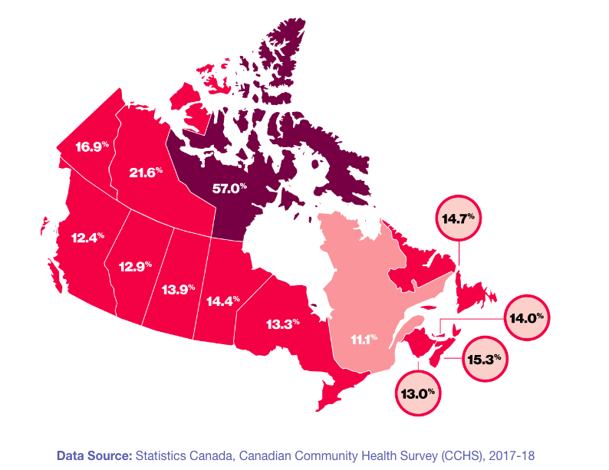
- On average 1 of 8 Canadians are impacted by food insecurity
- 4% of our population are indigenous population
- Northern regions are more impacted by food insecurity than the southern region, more indigenous people live In the north.

Rádeyįlįkóé
Fort Good Hope, “Place of Rapids

- Community has a population of 500
- 90% people have been in this region for thousands of years
- Has 1 school, nursing station, and grocery station

Common Initial Responses:

CHALLENGES:
- Cost of Food
- Retail options (mostly processed food)
- Poverty – limited employment opportunities
- Limited agricultural options

RESPONSES:
- Subsidy Programs
- Education

- Many of us these first initial responses refer to a monoculture at mind, looking at it though the lens of our own experience without thinking of what the particularity’s might be for the members of that community.

- Challenging the relevance importance is important

- Responses are choices we see presented by government, provide subsides to grocery outlets.

- Faced criticism because food insecurity exists

- Several criticisms, one is that the types of foods subsidized the decisions about what foods those would be we’re not necessarily made within the community. Example loaf of bread is subsidized, a bag of flower isn’t.

- Second criticism, one grocery store isn’t community owned it’s a retail monopoly that operates stores across the north.

- By having a monopoly it makes it difficult for Community based initiatives like food cooperatives to get up and running and to be competitive price wise. Resources they can bring into the community.

- Second challenge , not the Community that applies for the subsidy but rather the store itself.

- The concern is when the program was reviewed for years of operations we found the audit mechanisms simply weren’t in place and if they were in place they weren’t being monitored.

- Having this as a monopoly store its likely well have discrepancies in money received versus how they are passed along to community members.

- Environmental Concerns, 90% of community members have a heritage that goes back 10s of thousands of years before grocers were present.

- Fort Good Hope residents offer an important lesson, in the 1970s this community was involved in a historic consultation with one of the first nation to nation consultations between the Canadian government and the Dene people. Several Dene communities involved int this consultations.

- The consultations was known as the Birger report, topic the Mackenzie valley pipeline

- Stopped the pipeline progress.

- Community members it was a turning point that helped them find their voice and change their relationship with the Canadian Government

- Decade that followed, later their fish didn’t look right, fish showed results of pesticides and organochlorines we are much higher than researchers expected.

- Thanks to the people at Fort good hope, we greatly understand how chemicals are transported and aromatic air masses and bio accumulate in Arctic environments.

- Issue today is the migration of the caribou changing, many impacts of climate change.

CHALLENGES:
- Retail Monopolies
- Environmental Concerns – contaminants, climate change
- Ongoing Colonialism

RESPONSES:
- Nation to nation consultation
- Indigenous Guardian program

Indigenous Guardian program – we have indigenous environmental monitors that are in place in regions of particular sensitivity and where there is a history of indigenous knowledge.

- Sahtu region is new

Ongoing Colonialism

- Easily identified by students, increasing attention brought to 2015 truth and reconciliation report that highlighted intergenerational trauma wrought on the indegnious folk by the residential school system.

Truth and Reconciliation Report 2015

- One of the most consistent themes in the testimony [] was that “hunger was never absent” (Mosby and Galloway, 2017)

One survivor shared:
“I can’t cut up caribou meat; I can’t cut up moose meat; work with fish and speak my language. So I was starting to become alienated from my parents and my grandparents; everything.” –TRC 2015

- Government objective was to force a substantial cultural disruption and this captures that disruption.
- Strict policy of acculturation and assimilation students were stripped of their identity, their linguistic heritage and familiar foods.
- People who went back had to relearn their cultural kills

“Residential School Syndrome”

- Individual effects
  - Stress response
  - Nutrition insufficiency
- Intergenerational effects
  - Nutrition Transition
    - Epigenetics
    - Psychological and Cultural

- Individual effects – Stress response, cultural disruption

- Stress response was found in cultural disruption and food insufficiency

- Calorie deficient of almost 200 calories per child on average in schools, constant hunger

- insufficiency across the board students became subject of experimentation, would induce nutrient specific deficiencies and have the results of them recorded by the medical practitioners.

- Intergenerational effect- Nutrition Transition which describes a shift in dietary consumption and a consequent illnesses commonly associated with the industrial food system.

- Most prevalent illnesses are diabetes and cardiovascular disease.

- Indigenous experience requires much more attention to the colonial injustices wrought against them.

- Residential schools forceable stripped students of their dietary practices resulting in children being alienated, diets were unhealthy and inadequate.

- Responses have been to educate and teach how to make better choices as the primary solution.

- Population has uniformly under nourished, generates epigenic changes that are passed through generations leads to an increased susceptibility for those very illnesses that we are attributing to be better resolved by better education.

- Dutch Famine – cohort across generations similar to the indigenous with diabetes

- More profound underpinnings that need to be acknowledged to move toward healthier approach. For the first nation peoples.

Food sovereignty:
“The right of nations and peoples to control their own food systems, including their own markets, production modes, food cultures and environments” (La Via Campesina /"The Peasant Way”, 1996).

- The term food sovereignty was first coined by… transnational organization of small farmers and indigenous folk from around the world.

- The right of nations and people to control their own food systems, including their own markets production modes, foods, cultures, environments constitute Food sovereignty.

Four Principles of Indigenous Food Sovereignty

- Food is a Sacred Gift
- Legislation and Policy Reform
  - International Convenant on Economic Social and Cultural Rights (ICESCR 1976)
  - UN Declaration on Rights of Indigenous People (UNDRIP 2008)
  - Wildlife co-management strategies such as Indigenous Guardians
- Participation in food systems
  - Food sharing
  - Knowledge keepers
- Self-Determination
  - Environmental concerns
  - Conservation policies
  - Land Access
  - Market Access

Food is a Sacred Gift
- Gift from a land not the collective

- Dawn Morrison contrast this with the concept of Julius, the concept of Terra Nulius that used to justify the appropriation development and exploitation of aboriginal lands.

- Signaled the assumption that Aboriginal lands on occupied with no human relations prior to European settlement.

- Imposition of an ideology of land relationships that was not customary for indigenous folks

- Knowledge system is in the land is something that is a really important feature of land acknowledgements.

- Second point as one of these principles to ground food sovereignty is legislation and policy reform

- Three specific pieces of legislation:

- First the international covenant on the economic social and cultural rights of relevance, this defined the right to food as when every man, woman and child alone or in a community with others has physical and economic access at all times to adequate food and means for its procurements resonating with that undefinition gave in the beginning.

- Adequate food should not be interpreted in a narrow or restrictive sense, equating with calories or nutrients which should be broader and consider some of the cultural meaning and environmental context in which food is to be eaten.

- Second item is the United Nations Declaration on right of indigenous people again UNDRIP.

- UNDRIP a document to which the Canadian government is signatory although its not adopted within our constitution.

- Signing on to the rights of indigenous people has drawn attention from the broader international community to some of the issues of food security that are faced by indigenous people in this country.

- Third item is wildlife management strategies

- Not just international policy high level statements, but also ground initiatives within communities.

Participation in food systems
  - Food sharing
  - Knowledge keepers

  - Self determination on environmental concerns conservation polices land access and market access.

  - Imply responsibility

  - Example is from pigeon lake Ontario, Peterborough

  - Planted rice around other areas, as their culture has been attacked. Removing their rice.

  - Indigenous people are suffering from the way they have been because they haven’t had access to the healthy food resulting in illness.

  - People aren’t capable of gathering food, why he’s growing food.

  - Rice is an ecological keystone

  - Indigenous food system are an Fortune contribution to our broader knowledge on food and wrestling with these complexities wont be easy but critical.

  - Lake no longer is clear, rice hasn’t allowed the property value to go up like other parts where there aren’t rice beds.

Reading CHAPTER 2 Reflections and Realities: Expressions of Food Sovereignty in the World - Dawn Morrison

- The huge disparities in the social determinants of health reflect the systemic racism that exists in colonial laws, policies, and institutions.

- However, despite the high rates of trauma and stress associated with intergenerational impacts of forced assimilation into Indian residential schools and other institutions within the industrial military complex that was established throughout colonization, Indigenous Peoples persist in our efforts of regaining control in decision making on matters that impact our sacred trusts of land, culture, spirituality, and future generations.

- Built on the exploitation of the complex system of Indigenous biocultural heritage, the global agri-food system has enabled the political specialization necessary to build the corporate-controlled colonial empire, which, in turn, has led to the dispossession of subsistence hunting, fishing, and gathering societies.

- Indigenous Peoples offer a wealth of historical points of reference for finding solutions to the many social and ecological crises of our time.

- North American tribes are considered subsistence hunters, fishers, and gatherers, and up until 12,000 years ago.

- The socio-political and environmental injustices experienced by Indigenous Peoples and People of Colour who are migrating around the world in response to coloniality, climate change, and capitalism pose significant systemic challenges.

- These challenges call on us to dismantle structural racism and embrace the uncertainties and ambiguities of agriculture, climate change, and adaption (Whitfield, 2013) within the gaps of divergent knowledge systems where subsistence hunting, fishing, farming, and gathering have been made invisible.

BECOMING VISIBLE IN A MIRROR OF CROSS-CULTURAL NARRATIVES

- Prior to the agricultural revolution that began approximately 12,000 years ago our Indigenous ancestors enjoyed superior health over multiple millennia.

- Since the rise of agriculture, the health of humans and ecosystems has drastically declined.

- Many of the social and ecological crises of the present day were first manifested in North America between 1492 and the 1700s, when the first Europeans were arriving and the production paradigm was instituted in the Industrial Revolution.

- In contrast to the holistic health narrative and regenerative life-giving paradigm that underlie ancient Indigenous food-related knowledge, wisdom, and values, the production paradigm underlies the global agrifood system, which is valued only by increases in gross domestic product and profit for the handful of transnational corporations that already hold more assets than the governments of half the nations of the world combined.

- In what is known to settlers as British Columbia, the agricultural narrative was established relatively recently, in the early 1800s.

- Just prior to the time when the legal doctrine and cultural hierarchy on par with British morality were being imposed within provincial laws and policies regarding land and water rights, Indigenous Peoples maintained one of the most highly localized and abundant food economies; this was based on giving, sharing, and trading wild salmon and other staple foods.

- At the same time, the Indian Act (1876), Gradual Enfranchisement Act (1869), Gradual Civilization Act (1857), and BC Land Act (1874) were instituted as a means of dispossession.

- The notion of terra nullius, or land that is legally deemed to be unoccupied, persists.

- The “erasure” of Indigenous hunting, fishing, and gathering narratives under the notion of terra nullius that persists within the “monocultures of the mind” (Shiva, 1993) has fragmented the complex system of Indigenous biocultural heritage in the land and food system.

- According to the United Nations Convention on Biological Diversity, biodiversity has been disappearing at 50 to 100 times the natural rate, and over half the world’s populations live in cities disconnected from the forests, fields, and waterways that provide us with our food.
- In response to the unprecedented rate of decline of 75 percent of the world’s crop diversity over the last century (Food and Agriculture Organization of the United Nations, 2014), the Food and Agriculture Organization of the United Nations launched the Globally Important Agricultural Heritage Systems project.

- The purpose of this project is to map the complex system of biocultural heritage in traditional agricultural livelihoods.

- “Indigenous Peoples and Biodiversity” (1999), Toledo stresses the strategic importance of the link between Indigenous Peoples and conservation of the world’s biodiversity. On a global scale, Indigenous Peoples make up only 5 percent of the world’s population but inhabit 80 percent of the areas of the world with the highest biodiversity (Sobrevila, 2008).

- In addition to the significant role that Indigenous hunters, fishers, and gatherers have played in the history of humanity, the traditional agricultural strategies adapted by Indigenous Peoples have made significant contributions to the domestication of heritage varieties of corn, beans, squash, potatoes, rice, and other staple food crops of the world.

- As one of the most basic yet profound ways in which we express Indigeneity, food sovereignty is being more fully realized as a deeply meaningful strategy for remembering our original instructions encoded within our kin-centric relationships to the land, water, people, plants, and animals that provide us with our food.

- Expressions of Indigenous food sovereignty manifest outward from the tiniest scale of Indigenous micro-organisms that give life to the rich soils that nourish our food and bring balance to the microflora in our guts.

- These extend further to the higher intelligence of the contemplative traditions and rituals that enact our world at the individual, family, community, and tribal scales.

- Ancient food-related eco-social and spiritual protocols and ceremonial ways of knowing have stood the test of time and continue to be observed by Indigenous Peoples all around the world.

- Transcending the arbitrary political boundaries imposed within the fragmented system of privatized plots of agricultural land, Indigenous land and food systems are defined by a complex system of biocultural heritage areas.

FIRST PEOPLES IN FOURTH-WORLD REALITIES

- Many of the original Indigenous inhabitants continue to assert Indigenous sovereignty as distinct Nations living within the imperialistic nation-state of Canada, which asserts sovereignty of the Crown over vast geographical distances.

- The cultural hierarchy imposed at the time when agrarianism was introduced in concert with the notion of terra nullius and the Western concept of universalism fails to reflect the diversity of cultures, geographies, and socio-political realities of Indigenous Peoples.

- In addition to the 98 Nations of original Indigenous inhabitants, many Indigenous Peoples have migrated to Canada from around the world in response to coloniality, climate change, and corporate control of their traditional lands and territories.

- In Canada Indigenous inhabitants in this country experience huge socioeconomic disparities in health outcomes and social determinants of health (World Economic Forum, 2018).

- According to the World Economic Forum, Canadians enjoy the second-highest standard of living in the world, while at the same time Indigenous Peoples are overrepresented in some of the most poverty-stricken neighbourhoods in both rural and urban areas.

- Approximately 30 percent of Indigenous Peoples in Canada experience food insecurity (three times the rate among the general population; Willows, Veugelers, Raine, & Kuhle, 2011), while at the same time almost 60 percent of food grown in Canada is wasted.

- the global agri-food system is contributing as much as 30 percent of global greenhouse gas emissions, which are accelerating the impacts of climate change at an unprecedented rate.

- The Fourth-World reality is a term coined by the late Secwepemc Chief George Manuel in his holographic understanding of the ways that Indigenous sovereignty can coexist with the nation-state of Canada.

- The Fourth World refers to the diverse sociopolitical realities of Indigenous Peoples, many of whom live in Third-World conditions within a First-World nation-state such as Canada.

- Oppressive colonial land and water laws and policies established within an imperialistic legal doctrine most often rule in favour of large-scale extractive models of agriculture and “resource-based” economic activities that have had and continue to have devastating cumulative impacts on Indigenous lands and food systems.

- Many new Indigenous migrants are being exploited by Canada’s current migrant farm workers program in a way similar to when Indigenous children and families in residential schools were used as slave labour when Canada’s agricultural hot spots were being “settled.

- Indigenous Peoples are experiencing declining access to and abundance of our most important and nutritious Indigenous foods in the forests, fields, and waterways.

- Some of the most serious social injustices experienced by Indigenous Peoples in Canada are documented in the narrative accounts of the highly unethical nutrition research and biomedical experimentation that took place in Indian residential schools, during which thousands of Indigenous children experienced severe malnourishment, hunger, and illness.

- Forced assimilation into Indian residential schools and participation in the capitalist wage economy has led to the breakdown of traditional social structures and intergenerational transfer of knowledge and has disconnected families and communities from one another and the land, plants, and animals that provide us with our food.

- The result is a decreased self-reliance and a transition from traditional to store-bought foods

INDIGENOUS FOOD SOVEREIGNTY: KEY PRINCIPLES

- The values and teachings encoded within our ancestral memories and oral histories take us back to time immemorial when the transformer first placed us here in a sacred trust we would take care of one another and the land, plants and animals that provide us with our food. —Secwepmec Elder Mike Arnouse.

- Inspired in large part by the long legacy of political activism upheld by the late George and Arthur Manuel, Indigenous food sovereignty provides a framework for addressing the many underlying social and environmental injustices experienced by Indigenous Peoples in relation to colonial land, water, and social policies and planning and governance structures and processes that negatively affect our ability to respond to our own need for healthy and adequate amounts of Indigenous foods.

- Indigenous food sovereignty provides a framework for health and community development and for both reclaiming the superior health once enjoyed by our ancestors and Indigenous voice and vision in decision making on matters affecting our traditional land and food system.

- It also provides a framework for Indigenous and settler relationships as many are coming to realize themselves more fully in the narrative of social and environmental injustices that is unfolding.

- While the concept of food sovereignty was introduced to Indigenous communities in Canada and the northern hemisphere in the early 2000s, the living reality of this idea is not a new one.

INDIGENOUS FOOD SOVEREIGNTY: GUIDING PRINCIPLES

- Sacred Gift of Food

- Indigenous food sovereignty is a gift from the ultimate life force (Creator/Great Spirit), who breathes life into our ancient rituals, ceremonies, and ways of knowing about our sacred responsibilities and relationships to one another and the land, water, plants, and animals that provide us with our food.

- In the most profound and intimate way in which food connects us to the ultimate life force that makes our hearts beat, our lungs breathe, and the seeds sprout involuntarily, Indigenous food sovereignty is guided by the higher intelligence of nature, which transfers regenerative life-giving energy through the forests, fields, and waterways.

- Participatory

- Indigenous food sovereignty can only be realized more fully if we actively participate in Indigenous food-related activities on a day-to-day basis.

- Indigenous food-related activities include hunting, fishing, gathering, preparing, preserving, sharing, and trading food for ourselves, our families, and our communities.

- Self-Determination

- Self-determination is expressed at various scopes, scales, and degrees.

- In the context of the larger whole of the tribe or community, everyone must be self-determined and self-reliant in their ability to respond to their own needs for food.

- Only when individuals can take care of themselves can they be free to give to the collective health and well-being of the larger whole of the tribe or community.

- Self-determination in the context of the global food system can only be achieved in a co-operative economy that cross-fertilizes subsistence with small-scale, market-based values, where the community works together to be free from corporate control and oppressive land, water, and social policies and practices.

- Policy

- The living reality of Indigenous food sovereignty is grounded in the earth-based practices, paradigms, and protocols that underlie Indigenous cultures and worldviews.

- However, our ability to respond to our own needs for Indigenous foods in the present-day reality is being negatively affected by oppressive colonial land, water, health, economic, and environmental policies.

- Therefore, Indigenous food sovereignty requires a balanced approach to addressing underlying structural issues and inequality in privilege and power in the policy, planning, and governance of our ancestral homelands, where we hunt, fish, farm, and gather our foods

DECOLONIZING RESEARCH AND RELATIONSHIPS: CROSS-CULTURAL INTERFACE FRAMEWORK

- The Western science-based resource management system has reduced the rich complexity of Indigenous knowledge systems to narrowly defined “facts” that fail to reflect Indigenous relationships to time, space, and place.

- In contrast to the production paradigm that underlies linear outcomes-oriented mathematical models, a regenerative paradigm is more appropriately expressed through non-linear understanding of relational events in a holistic health narrative.

- There is a need to redesign institutional frameworks to facilitate the generation of democratic research that can (1) serve to increase the capacity of Indigenous Peoples to conduct food sovereignty research and education for and by ourselves, (2) educate, inform, and respond to cultural biases and assumptions made in agriculture research, action, and policy, planning, and governance proposals, and (3) influence and support the formation and implementation of adaptive laws and policies that will facilitate a much-needed transition away from production-oriented agriculture to a more holistic health narrative in regenerative food systems

- Based on the four principles of Indigenous food sovereignty, the Decolonizing Research and Relationships: Cross-Cultural Interface Framework provides conceptual tools and terminology to guide the process of assessing the key conditions for addressing underlying social and environmental injustices impacting our ability to protect, conserve, and restore Indigenous land, water, food, and culture.

- This conceptual and methodological framework provides a set of tools and terminology for entering into a journey of raising a critical consciousness of how food is the most intimate and profound way in which we express Indigeneity.

- With the intention of shifting the paradigm in food systems discourse toward regeneration, Indigeneity, and sustainability, the Decolonizing Research and Relationships: Cross-Cultural Interface Framework outlines a non-exhaustive list of key points of entry into a journey of understanding how subsistence hunting, fishing, and gathering interface with the agri-food system in either complementary or contentious ways.

- The key points provide a matrix that can serve as a measure of ability to transcend contention and paradox and identify potential that lies dormant in the gaps of knowledge where Indigenous knowledge systems have been made invisible in the techno-bureaucratic framework for AREESKT

Indigenous scholar Leroy Little Bear (2015) shares his Blackfoot philosophy of how “all humans live within a very narrow gap of ideal conditions that make possible our existence in a regenerative life-giving paradigm.

- This notion reinforces the values of humility in realizing how limited our understanding really is.

- The Fourth-World concept and holographic epistemology brings deeper meaning and understanding to the ways that diverse cultural and socio-political realities are entangled with settler society.

- The Decolonizing Research and Relationships: Cross-Cultural Interface Framework is intended to provide structure, tools, and terminology that will serve to create safer spaces for dismantling structural racism in colonial structures and processes that have eroded the health and integrity of our way of life.

- In a way similar to how our interpretations of dreams and stories progress in overlapping time and space, my offerings are an attempt to appreciate and inquire into the expressions of food sovereignty that have enabled Indigenous Peoples to persist into the present-day Fourth-World reality in some of the oldest living memories shared in ancient food-related practices, protocols, principles, and paradigms.

- One of the earliest treaties between Europeans and North American Indians was recorded by the Iroquois as the Two Row Wampum Belt. The two rows that are woven into the pattern symbolize the path of two vessels travelling on parallel paths but neither interfering with the other. It is only through mutual acknowledgement of the other’s reality that it is possible to travel on parallel courses and avoid collision. (Manuel & Posluns, 1974)

- It is not about perpetuating racism; it is about the issue of understanding the systemic barriers and acknowledging the imbalances of privilege and power that play out in Indigenous and settler relations.

THE WILD SALMON CARAVAN: TRANSFORMATION AND SOCIAL CHANGE

The recovery of the people is tied to recovery of the food, since food itself is medicine—not only for the body but also for the soul and spiritual connection to history, ancestors and the land. —Winona LaDuke, Food Is Medicine: Recovering Traditional Foods to Heal the People

- The Wild Salmon Caravan is a celebration of the spirit of wild salmon and is guided by the four principles of Indigenous food sovereignty outlined previously.

- Wild salmon are a cultural and ecological keystone species in the forests, fields, and waterways of the 27 Nations of Indigenous Peoples in British Columbia.

- They are the basis of what was one of the most abundant food economies in the region prior to contact with the first European settlers.

- As the most important Indigenous food, the migration route of wild salmon determines the cycles and seasons of other traditional hunting, fishing, farming, and gathering cycles.

- The life cycle of wild salmon provides a powerful metaphor for regeneration, healing, and working with natural systems to overcome the challenges of our time.

- Indigenous Peoples are grieving the rapidly declining numbers of wild salmon returning to the rivers, streams, and lakes where they complete their life cycles after swimming thousands of miles to the ocean and home again to spawn.

- Indigenous Peoples who rely on wild salmon as our most important source of protein are witnessing the devastating decline in their health and abundance.

- In addition to the open-net cage fish farms, wild salmon and their habitat are suffering from the cumulative impacts of large-scale agriculture, climate change, and multiple resource-extraction projects.
- Federal and provincial environmental assessment processes are failing in their ability to adequately assess risks associated with the health and well-being of Indigenous land and food systems in the broader ecological, cultural, and temporal scope and scale of watersheds that wild salmon rely on.

- large numbers of men migrating into rural communities for work on resource-extraction projects and increased violence against Indigenous women, children, and families.

- As a strategy in response to these systemic challenges, the Wild Salmon Caravan is working with the Wild Salmon Defenders Alliance and more than 100 other organizations to engage the public in community arts–based education and nurture the creative energy that can help transform the darkness surrounding the industrial storm that is killing wild salmon.

- The strategic think-tank brought together Indigenous Peoples and settler allies who are fishers, researchers, lawyers, and artists who focus on Indigenous issues and food sovereignty strategies.

- The Wild Salmon Caravan was thereby inspired by reflecting on the long legacy of political activism that took place in some key historical caravan-style actions that served to mobilize Indigenous Peoples on important issues, concerns, and strategies; these include the Canadian Constitution Express, which led to Aboriginal title and rights being encoded in Section 35(1) of the Canadian Constitution, the Indian Child Caravan of 1980, and the occupation/takeover of the Department of Indian Affairs in 1975

- In a similar spirit of inclusive consciousness that led Nelson Mandela to coin the term Rainbow Nation (people of all creeds and cultures) as a strategy to end apartheid in South Africa, the Wild Salmon Caravan calls on the Rainbow Nation to work together in a powerful, dignified model of Indigenous grassroots leadership.

- Wild salmon have inspired countless artists throughout the ages, and they challenge us to broaden our ecological, cultural, and temporal scope and scale of wild salmon research, policy, planning, and governance informed by Indigenous knowledge, values, and wisdom.

- The Wild Salmon Caravan engages communities in a visual storytelling approach of expressing Indigenous food sovereignty principles, paradigms, and protocols in colourful and lively expressions of our interdependent relationships to the wild salmon and the land, water, people, plants, and animals that rely on them for food.

- The strength of our knowledge and ability to respond to decision-making matters impacting Indigenous land and food systems ultimately lies in the extended Indigenous food system networks.

- As a measure of food sovereignty, the knowledge we mobilize within extended networks lends itself well to our individual ability to respond to our own needs for food in community and regional networks.

Fourth World: A term coined by the late Secwepemc Grand Chief George Manual in his book The Fourth World: An Indian Reality. The Fourth World describes the socio-political reality of Indigenous Peoples who live within Third-World living conditions within the First-World nation-state of Canada (Manuel & Posluns, 1974).

Indigenous biocultural heritage: A complex system of interdependent relationships between Indigenous Peoples and the environment. It includes everything from the genetic to the landscape level that enables Indigenous Peoples to adapt and maintain our traditional livelihoods. The term evolved out of the inability of colonial policies and the limited ability of intellectual property rights to protect and maintain the biological, cultural, and landscape components of Indigenous relationships to the natural world (International Institute for Environment and Development, n.d.)

Regenerative food system: A holistic, decolonizing systems approach to contextualizing the food system in a transition toward valuing health and life over economic gain/ productivity (Dahlberg, 1994).

Terra nullius: A legal doctrine used by European settlers to lay claim or ownership to newly “discovered” land—meaning “nobody’s land” or “empty land”—discounting those whom the settlers and colonial rulers found there already as mere “barbarians” or “savages,” like those they believed had been defeated on the European continent before that (National Inquiry into Missing and Murdered Indigenous Women and Girls, 2019, p. 235).

Dawn Morrison is of Secwepemc ancestry and is the founder/chair of the Working Group on Indigenous Food Sovereignty.

Video Angry Inuk

- Indigenous people hunting seal

- Indigenous people hunt and kill seal as its part of their culture

- People out there who don’t like seal hunting, protest agisnt it and call them horrible names

- Eat the food raw, different kinds of meat for men and women.

- Made the video to change the way people perceive seal hunters.

- Use every part of the animal from eating the meat, to using the seal skin to use to make products.

- Fewer places to sell seal skin products as the anti seal protesters have made it hard for inuk people to sell their products.

- Protesters argue the only way to address concerns is to totally ban trade in seal skin.

- Most seal hunters in the world are Inuk, they hunt around Canada, Alaska, Greenland and Russia.

- Animal groups make it seem seal skins come from that one spot in the south of Canada. Call it The Canadian Seal hunt or The Seal Hunt.

- Fail to acknowledge that the Inuit are an important part of the sealskin market.

- Hard for the Inuit to get their message heard because anti-sealing protests are loud and confrontational, while the Inuit anger is much quitter.

- When angry they would have a song battle until one person wasn’t upset, the moment you lose your anger you lose the battle as a loss of temper is a sign of a guilty conscious.

- Protesters say they shouldn’t kill seals just for fur, but Intuits defy that argument because they eat the meat. It also provides a warm coat which is necessary for day to day survival.

- Don’t waste meat they freeze and share extra with the community.

- Government in Nunavut arranges for a wildlife officer to buy skins from hunters throughout the year, collect the skin and sell it at international auction on their behalf.

- Allows them to continue their tradition and take part in the modern world.

- Main economy for over 100 years, 1983 that changed as Greenpeace put out intense anti-sealing campaigns thought-out the 1970-1980s and as a result the European Union banned products made from white coat harp seals pups.

- Campaigns ruined the market for seal skins and the market crashed immediate, even though they didn’t sell those kinds of skin. Was their great depression.

- As a result of the depression the Inuit people had to move away from their traditional grounds into the town. Real impact cost.

- The Inuit food and clothing

- Suicide was rare in their communities and as result of the trauma from residential school abuse, forced relocations and other destructive government policies Inuit began taking their lives in an alarming rate in the 1970’s.

- With the Ban in 83 it caused widespread hunger and hardship, within in a year the suicide rates spiked higher and have been among the worse in the world ever since.

- They are still working to undo the damage to this say, seal skins have gone back to $100 almost enough to make a living on.

- Unfortunately, anti-sealers are pushing new bans to reject all seal products, which means all skin, meat and oil.

- EU Union having hard time understanding that the Inuit are apart of the commercial market.

- Spreading misinformation about seal hunting, still using the white seal on their banners, advertisement.

- May 5th 2009, EU Parliament passed the ban by a vote of 550 against 49.

- No one asked the Inuit to be involved in the discussion of the ban.

- Could have regulated killing methods, used certification programs, quotas, daily catch limits, but chose the hardest method to crush the market.

- Launched 2 lawsuits to reverse the ban.

- Before the ban Inuit were selling about 60,000 skins a year, now they’re selling less than half that number and the price for each skin went from $100 to $10.

- Also, losses on finished product, made from seal skins like mits, boots and coats.

- People are also brining home less meat for their families, already most food insecure indigenous people in any developed country with 7 in 10 Inuit children going to school hungry.

- In all of North America their region has the highest poverty and unemployment rates and highest cost of living.

- Pay 28$ for cabbage, $18 for cheese whiz.

- With $50 they can buy little junk food for fuel to go deal hunting to feed the whole family, more nutritious and helathy than what you can buy at the store.

- Sealskin is the best way to feed the Inuit ,cash from seal skins cycle that keeps going, when the cycle is interrupted they have to look at other options which they have very few options.

- Example underwater sizing testing to explore offshore oil and gas reserves, putting extreme stress on 7 communities. Twice the size of the UK.

- Seismic testing involves underwater explosions at decibel levels, cause damage to marine levels, happens every 10 seconds for 100ks.

- This can cause whales to flee, get caught under ice, make seals deaf.

- Fighting for 45 years

- Communities main economy has been under attack, fighting to save the seals have put all artic animals and people at higher risk.

- Rebecca Aldworth, go to anti-sealing person, they have 200 million in assets.

- Went to face anti-sealers face to face

- Counter protest to fight against anti-sealers

- IFAW cancelled their protest when they planned theirs on the same day.

- They are deliberately avoiding the Intuits.

- The ban didn’t go their way, based it on moral grounds because sealing offends Europeans.

- Animal groups have millions fighting against them, these people have no money to put up the same fight.

- Spring brings the Anti-sealer fenzy, Ellen decided to donate 1.5 million dollars to the humane society of the United States.

- Sealfie, term they used to bring awareness towards their cause, brought a lot of hate messages towards them.

- Cant get any of these anti-sealer groups on camera to talk

- Found a women who brokered a deal with Canadian sealers with IFAW, they were given joint power to decide on their hunt quotas, their hunt would become full use. Everything gets used, when she took this to her bosses she was fired.

- Women said nobody wanted to talk about the fact that the Inuit were just as much if not more affected by the European ban as the sealers were.

- IFAW has known about the Inuit situation all along.

Video 2 Decolonizing the Land and Food System: Indigenous Resilience in Times of Crisis

- Center for sustainable food systems at UBC farms is a teaching center as well as a local to global food hub working towards a more sustainable food secure future.

- Mission is to innovate from field to fork to achieve resilient thriving and socially just food systems for all.

- BC Food web prortal project which aims to increase access and connection to current research, and other resource materials.

- Aims to encourage innovation between farmers and researchers for future project collobrations.

- The faculty of land and of systems is a world leader in integrated research education and service.

- UBC Faculty aims to address critical global issues around human helath and a sustainable food supply.

- Angelia Macintyre – Scottish Germany cree heritage, Salzburg island, indigenous scholar

- Called to witness in the coast Salish and interior peoples tradition.

- Role of witness is to record the message of the event in their hearts and minds and to remember and validate the occasion by carrying the message forward and sharing it everywhere.

- Tasked to do is work from the inside to breakdown some of the barriers and challenge the inherent racism in a system that has been very complicit in the reproduction of colonization, in its exclusion of indigenous knowledge.

- Try to help and confront some of the barriers that have left indigenous waiting at the door of academic institutions.

- from an indigenous way of knowing and researching ceremony is important ritual is important in intention setting is important.

- Interior Salish

- ancestors share common root words in our languages and kinship ties and traditional trade relations which we once shared one of the largest subsistence economies that existed on the planet when you look at the size of Salish territory that spans all the way from the Rocky Mountains to the Salish seas

- people and all the people who are living in the most food insecurity to find a way to respond to their own needs and to find the support they need to do that Cook's Jam to the Hamas Liam the sleigh were to attend the skirmish and their ancestors who are ultimately guiding us here today on their beautiful lands

- lives inhome the Coast Salish territory had to acknowledge that and I hope that the

- Coast Salish people watching here today will guide me in in the future and ensuring that my work is is is actually benefiting the people here.

- 

- specifically from a community scat scene is the traditional name but it's known as the miss Conliffe Indian reserve in a watershed known as hostile and aqua and our neighboring community between this got seen the talonnet qua is the squirrel acts the little schwa hidden in reserve and we are on the shores of the south of Thomson River which in our culture in our language we call Chihuahua.

- Overview of our work as the founder and curator of the research and relationships for the working group on indigenous food sovereignty my presentation and might we'll be to give you an overview of our work and our projects but also to get into some of the aspects of decolonizing the land and food system that we're doing especially in the present day.

- reality with a co-ed and climate crisis that we've been working in intersectionality’s of how indigenous food sovereignty is a framework for appreciating inquiry into the characteristics of strength and resiliency in times of crisis.

- Wild Salmon Caravan is one of their projects it's a celebration of the spirit of wild salmon and revitalize intertribal networks with the strength of indigenous fisheries knowledge lives to advocate for the conservation of wild salmon in their habitat we see our wild salmon our most important indigenous food and cultural and ecological keystone species dwindling to literally hundreds when they once traveled and migrated in the millions twos to all of the people on the Fraser basin the five major river systems

- Throughout so-called BC wild salmon is very important and we're in a very serious crisis in terms a lot of the loss of the species so we really need to mobilize and engage people through the arts and the culture in this public education campaign.

- Another project is indigenous food and freedom school, most recent one

- based on the last 15 years of mobilizing knowledge and networks and gathering the input and being entrusted with sophisticated indigenous knowledge and strategies

- is based on an emancipatory model of learning the way that we as indigenous peoples know in a transformative pedagogy and coming together in our collective right mind to appreciate all the gifts and knowledge that our cohorts

- we've got two cohorts that we've recruited one here in the east side of Vancouver
where we were awarded a residency in the Strathcona park by the Vancouver parks board whose recently accepted their vision to restore indigenous food lands in the park and is putting it into their capital planning budget for 2022 to 2026

- that park has an amazing rich history of social justice so bringing an indigenous food sovereignty lens into that neighborhood is is going to be fun as a interior Salish woman of not being Coast Salish myself our working group on indigenous food sovereignty really just sees ourselves observing the Coast Salish protocol and serving an intermediate intermediary role for the Coast Salish.

- whose land it really is so how it will be a good experience for us to facilitate the division the realization of this vision which is really in a way giving the land back to the Coast Salish and the knowledge that will be needed to restore indigenous food lands is really their their project is just showing up to figure out how to be there in that space in an emancipatory liberating way.

- we're also mapping out and/or proposing to map out and advocate for shipment food lands Conservation area in my home territory in the ship.

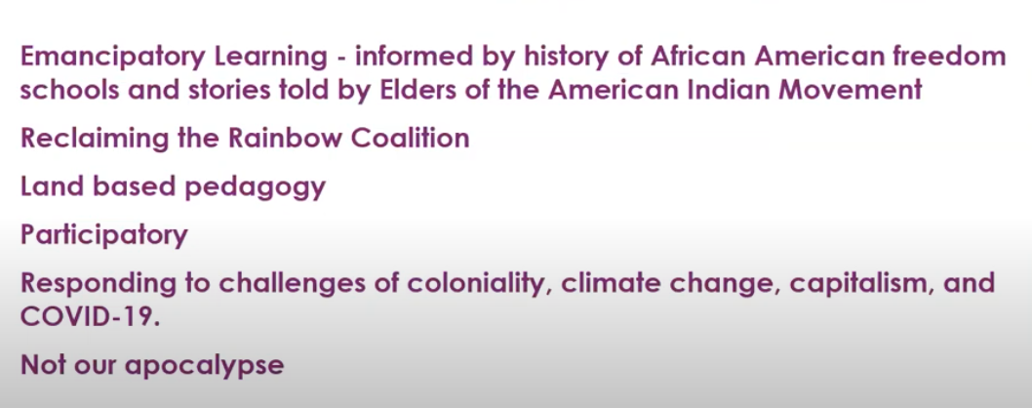

Extended networks of mutual aid and solidarity – Rainbow coalition’s

- Original inhabitants of indigenous territories
- Urban indigenous peoples
- Indigenous peoples- Global i.e. Mexico, Guatemala, Filipino etc.
- Rainbow correlations – black, brown, yellow, red, afriacn American, south Asian, Chinese
- White friends and allies working in solidarity to balance out privilege and power.

- a lot more action from within the global networks of mutual aid who are developing financial legal and technical tools to mobilize away from capitalism into a new type of economy based on solidarity mutual aid and for indigenous peoples our subsistence economy of giving sharing and trading is really the oldest living memory of what it means to live in a sustainable economy.

have indigenous peoples in the Vancouver area who really migrated from all over Canada but also all over the world and so I would we're looking forward to the opportunity to mobilize more
specifically with people of all colors which are known as the rainbow coalition's.

Colonial Realities

- 4th world realities – disparity, homelessness, substance abuse, hunger
- Security/safety – lack of restorative culturally competent community justice support

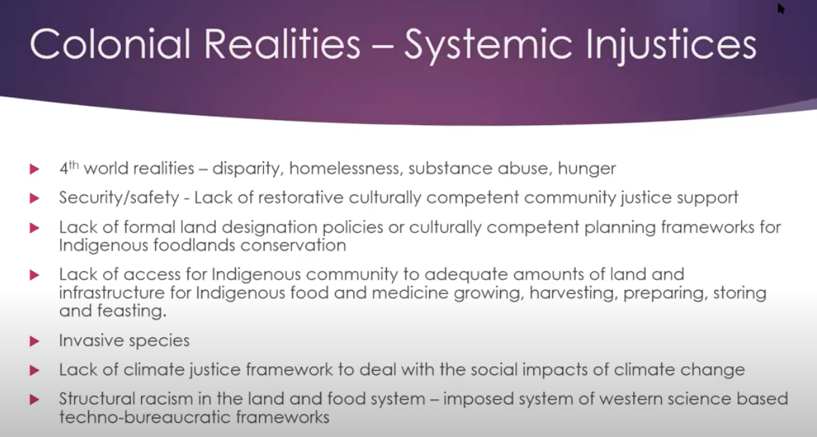

- foods solace II approach policy planning a governance approach to addressing the underlying issues of why indigenous peoples don't have enough food we live in 4th world realities meaning search third world conditions within a first world there's huge we're all food insecure poverty-stricken neighborhood bland culturally Compton and security for that matter favor is set up the what wealthiest of the.

- we're hearing a lot about structural racism in the justice system but for us the Western science based techno bureaucratic framework for accounting and for administration is really a kind of a multi-layered challenge for us to not only educate the world and be on the front line of many of the social and environmental and justices but also to navigate a bureaucratic system and a Western science methodology that is very limited in its reductionist mindset and its ability to work within the complexity of a holistic health regenerative narrative.

Coloniality, Capitalism, climate crisis- existential crisis of the 21st century

- Indigenous, black, brown and poor white people are over represented among the most vulnerable – experience huge disparity in social deterinants of health I.e. food/housing insecure, poverty.
- Small scale farmers, fisher people and indigenous people grow 70% of the worlds food
- Indigenous peoples make up 5% of population globally
- Maintain 22% of the land surface and 80% biodiversity
- Solutions are rooted indigenous ecological knowledge, and social justice
- Human beings the biggest factor impacting my health and well-being of land food water and communities.

- to say that indigenous peoples play a significant role in conserving the biodiversity and the cultural heritage of humanity we have made major contributions to the land and food systems in terms of heritage seeds in terms of land in terms of knowledge and I think that really the issues at large is the social justice issues because it's human behavior that is the biggest factor impacting health and well-being of the land and food systems so that's really a policy problem

- so in order to decolonize the land and food system we need to reconcile well I think what needs to happen is that the racist narratives and systems of Administration of accounting of research of policy planning and governance there needs to be a lot of dismantling of the structural structures and processes that perpetuate racist narratives.

- Also observed a balance or transcend the binary thinking and balance out about the imbalances in privilege and power and looking at financial technical and human tools and support to do that so next slide please so we need to just transition to a regenerative tribal economy and we can do that and I think indigenous food sovereignty offers some core principles paradigms practices and protocols.

- We need to transcend transition out of a production mind set

- developed a cross-cultural interface framework it's a transformative based on a transformative pedagogy and an indigenous way of knowing and so this is something that i would ask that it only be used if it's an indigenous person contain extra lysing it within a specific situation or issue because it's quite complex and it's not meant to be definitive it's meant to be a tool for creating structure and cultural safety in cross-cultural discourse

Cross Cultural Interface

- Gives structure and cultural safety to the process of reaching deeper cross cultural understanding
- Nonexhaustive nonlinear transformative, not based on lineary logic model.
- Process oriented, non-definitive, valuation, intra-action
- Indigenous Epistemology

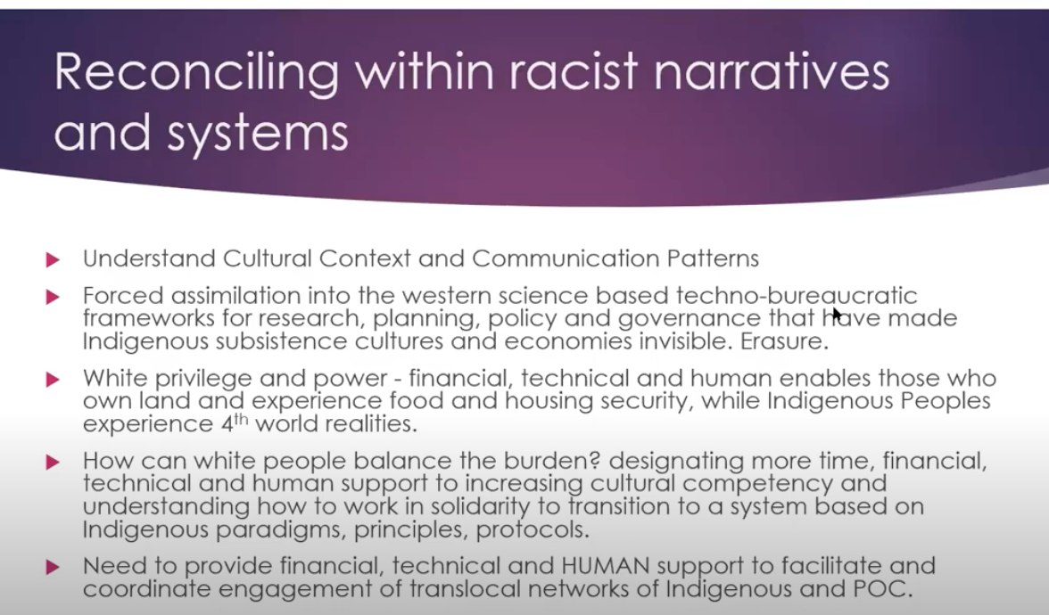

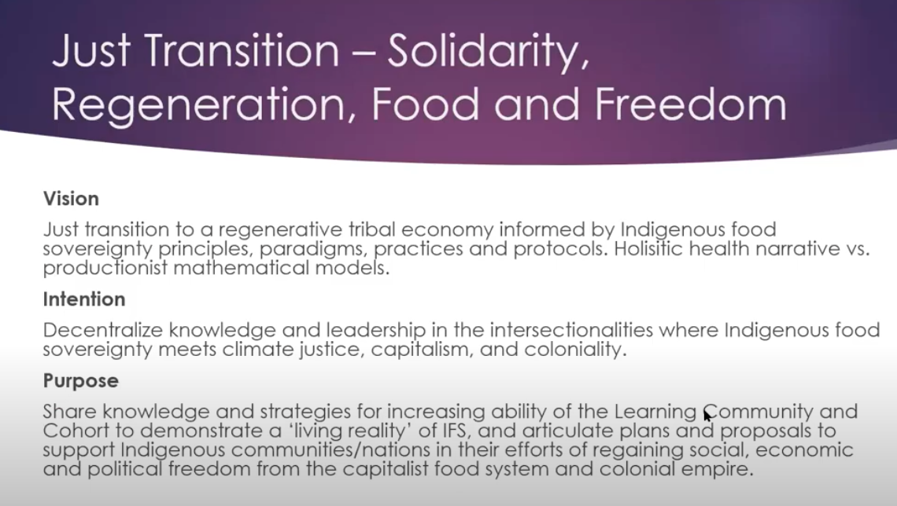

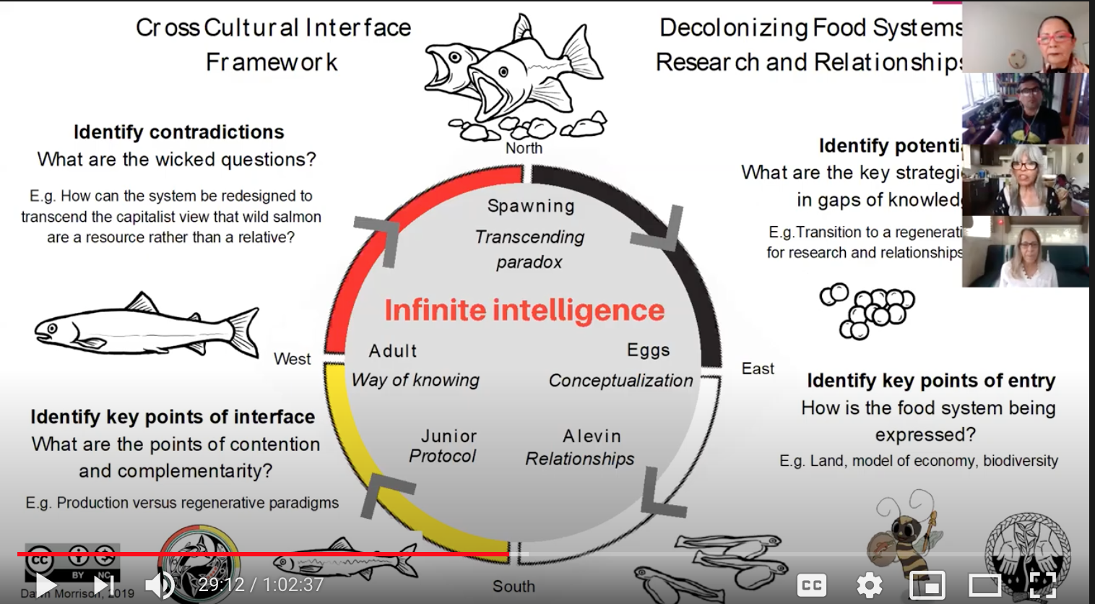

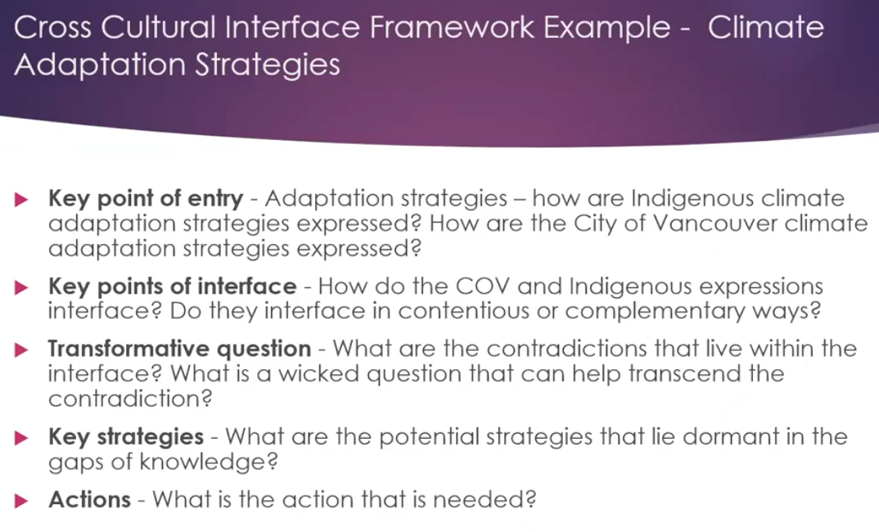

Grandmothers law
- system of governance and we need to give strengthen the voices of the women the children the grandmothers the ones with the values that are more about taking care of and feeding the people rather than mode being motivated by profit and global export for trade

Alanna

- my PhD and then from there we worked with medicine collective a group of indigenous knowledge holders and researchers with the back then it was the Institute of Aboriginal health in in the early 90s and then with dr. Eduardo hotel with the indigenous research partnerships and then looked at how do we develop these protocols together as a teaching team to demonstrate transcultural ways.

- partnerships and then looked at how do
- we develop these protocols together as a
- teaching team to demonstrate
- transcultural ways of relating to the
- land and you know working from a kind of
- intergenerational knowledge transmission
- and mobilization to connect people back
- to their earth in order to have holistic health

developed five main points that kind of looked at the Hagee's and donor toes work around maybe you can pull up that slide that look at health indicators in rural wellness

there's our garden there it's based on a spindle whorl design in collaboration with Muslim people and across different facultie

in homuth liam there's this barren and and guarantees that you know basically they're they're getting their land back so you know it's not that they want to kick people out but how do we maintain good relationship that's not going to hurt continue to hurt the economies

land-based approaches the pedagogy's that are featured in those spaces are around cultural workings with the forest or with cedar

then there's a parallel document that the indigenous Guardians kind of move also with and a short name is Gantt act but it's it was by Richardson and so looking at how do we reflect appropriately what are the processes and protocols that we need to develop there and so as a result of some of the findings it's like world gardens or food production isn't the whole thing because not only that does that only develops a certain part of the community

making space for for local interests and how that gets expressed in in lambaste settings

so sure that you know all of the salmon spawning streams there's only one left

we have to look beyond kind of the way that that food production is being looked at and talk and so based on Aundre the TRC principles which also works with the unrep what are the ways that we are making spaces welcoming to those communities and there are a number of like scarves

there and then of course the education models around massive online MOOC trainings for a reconciliation that seems like it's a really useful model for getting organizations and faculties to all be required to take things like that and social justice and to be given credit for doing that and time to do that because everybody needs to have how speaking a similar language in order to kind of move forward in a good way and it doesn't fall on indigenous peoples it becomes organizations a long term or the strategic plan

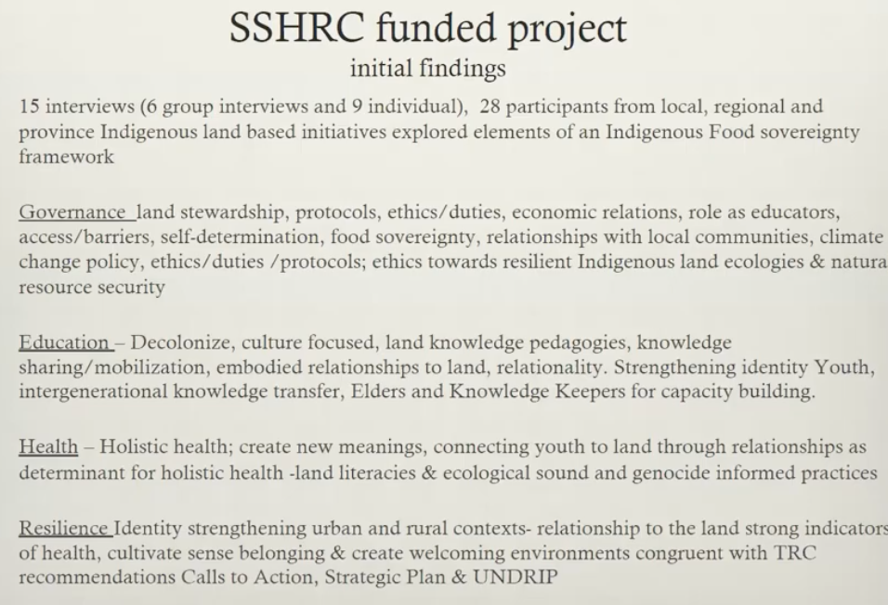

governance so we need to have last stewardship protocols all the things that Don had already mentioned and then that beautiful Donna - oh and Peggy health indicators for urban and then go Salish Education we need to have decolonized education holistic health
look at how do we do that how do we get into the schools how do we get into whatever spheres of influence that people have in order to make that change

Wilson

work with the working group of indigenous food sovereignty worked with Don and I'm the chief and media director for the working group of indigenous food sovereignty and being part of the working group for quite some time and have been you know supporter as much as I can give him that I'm also at UBC

my PhD and and leading the whatsit some garden I've been the coordinator from that space for quite some time and working with Alana here and Eduardo eval doctor I don't have air on this shirk that Alana has actually mentioned and also my PhD is a part of that work

equation here is simple land is life you know land or food comes from the land and if we don't if you access to that beautiful land you know that providers food medicine and first to keep living be with each other is not present that there is a problem

indigenous people black folks are outside of the system the food system because we are not having our voice in there so you appreciate be part of those projects following dongs leadership in here because I think that's a good example of how we can recreate and in enter this conversation of decolonize a food system that have been set up by the colonial government for a long time

look at on a global level on a like a global policy for example where framework is the unwrapped and drip as Ilona has mentioned you know and the TRC and so this I think it's like before we move into you know creating policies we have to look what we have been working on for quite some time so 2007 we've been working on the Android for so long and there's it's a it's a comprehensive but of work

comprehensive but of work that we have already framework so whether or not Canada has actually sign in you know to be part of this process of decolonization we actually haven't done Canadian government neither UBC to be honest with you have not follow up with actions you know it's actually on us so what's it some garden and the work that said the working group indigenous food sovereignty is doing it's actually addressing exactly what a lot of those articles that has been outlined on the unrep as well as the TRC

indigenous programming at the UBC farm and so while there is it I have a preliminary date of that which has been clear to me is that there say hey look you know this is not this this sort of space you know counter relevant to space it it's with elders in it with children in it is the place that we can actually hear the place that we can actually find ourselves as identity you know that we can probably move forward in terms of challenging our governments about the policy that we wanted to see in the food systems so there's a lot but I just want to highlight some of those issues you know there's another part of it

written by Mohawk scholars Steven Carty and it's about witnessing and indigenous scholars and our role in witnessing and he says indigenous scholars are being called to witness seven generations forward and to preserve the beauty and strength our ancestors wanted to protect our ancestors sacrificed a great deal and we must wipe our tears or eyes listen deeply clear our throats and raise our strong voices to bear witness to our answers so with those words I'm asking they will help me in this work of witnessing because it's a it's a really big job

presenters actually highlighted the fact that we all have a role in this job in going forward in taking this knowledge and keeping it alive no matter who we are indigenous people the world over it doesn't matter what our skin color is we all have a role in this dawn the salmon Caravan there's their celebration in
this work and the salmon Caravan is such a beautiful example of that their celebration their sorrow but their celebration it's serious work but there's also celebration and it reminds me it makes me think of the of the joy and the celebrations that people must have felt in seeing those pre-colonial that in experiencing that abundance the salmon spawns the herring runs so migrations of caribou the joy in that we need that joy back we want that joy back and I think we all hold that in our hearts we hold that in our hearts as it
as an aspiration done

you also talked about how everyone whether indigenous or otherwise whether we work with these or against these techno bureaucratic frameworks that reproduce in Justices we all have some power in
some capacity and capability to change
things regardless of where we are so
from wherever we sit we have we have
some power and we need to we need to
recognize that and use
alanna land-based health and healing I
love this subject and that that diagram
of the Donatists indicators diagram I go
back to that time and time again over
and over and over again because to me it
really it really encapsulate encapsulate
something that I call I call it the
spirit to spreadsheet dilemma how do we
how do we express how do we describe and
document and express and communicate the
processes healing processes across
across cultures because it's important
and we who work as scholars as as health
workers whatever it is that we do we
live in these two worlds and so we need
we need to become fluent in these
languages and I think what you said
about preparing us to be able to have
our voices heard and to be able to speak
on global stages that that really struck
me as incredibly important you also
talked about you mentioned unrep and the
importance of bringing bringing
reconciliation into reality and that
reminded me of something that I hear
expressed over and over again which is
that under is the floor it's not the
ceiling and from that floor we have a
lot of we have a lot of building we have
a lot of regeneration and a lot of work
to do but that's the floor not the
ceiling Wilson
land is life and this I think ties back
to the idea that without land-based
self-determination we can't do the work
that we need to do you also very
fleetingly
you use the word data and you you you
said I'm not going to talk about the
problems and I think this is a really
important point because Western science
the collection of data and statistics
reveals the
broad patterns of deficits that can only
really invite colonial solutions that
reproduce colonial violence when you
look at a continent of people even a
community from the top down without
feeling and understanding the lived
experiences of those people all you see
is patterns of deficits and all you're
capable of doing is imposing some
solutions on those people that are not
grounded in in in the aspirations and
the needs of people so data yeah
another one of my favorite subjects and
you two talked about under than the fact
that this is a this is a floor and not a
ceiling yeah I think I think those are
the most important things the things
that I think I'm gonna I'm gonna that
have really sort of come into my heart
and my mind and the things that I I
would like to carry forward from this
learning from this teaching and I want
to encourage everybody who's watching
this webinar right now to do the same
thing you you don't have to you don't
have to repeat for bait in the snow that
you don't have to reproduce it but but
feel it the parts that come into your
heart are the parts that you need to
hear things that you need to hear and
those are the messages that that that
you have the responsibility to take
forward and in doing so I hope everyone
in some way can speak with the voices of
ancestors of the thousands of years the
layers and layers of knowledge that we
all carry in our genetic memories
because we all at some point in time
were indigenous people
Wow Thank You Angela that was such a
beautiful reflection back of what we
heard today thank you for being such a
powerful witness we didn't have one
question from someone who wanted to know
who the quote was that you were talking
about just at the top about witnessing
do you have the name of that person of
your muted
you were muted there sorry I'm doing it
again okay so so the author is Steven
Carty and it's an article called
indigenous self-discovery being called
to witness and it's an it's an a journal
called first peoples child and family
review okay that was wonderful
well unfortunately we have run out of
time and I know we have some questions
that some of the participants had asked
well what we'll do is we'll try to get
to those after the webinar and we'll
share those out somehow with the group
but I just want to say a huge thank you
for those who are participating and
bearing witness and engaging with our
incredible speakers today we'd like you
to think about oh there's a there's a
poll you can take participate in and
also just think about the how your work
and your studies are benefiting the
indigenous territories where you
currently reside and what role can you
play to benefit and support indigenous
communities in your region I want to
extend a deep gratitude again to our
really great speakers and again I know I
feel like we sort of rushed you but I
think your points were made very
powerfully and yeah I have lots to think
about if take away so thank you so much
to Don Morrison and Alana young and
Wilson Mendez and then of course to our
witness
McIntire was really wonderful I also
want to thank those who worked behind
the scenes to make this webinar happen
Jessica laddus Melanie cooks Dorf Kate
Hodgson
Michael saloum who was controlling the
slides beautifully and Anisha ascends
ooh finally I just want to invite you to
join us in two weeks time for our third
episode in this webinar series and that
one will be titled a food system in
crisis climate change : 19 and
opportunities for change that will be on
June 25th at 3 p.m. and you can find out
more if you go to our website at UBC
farm dot u b c dot CA

