PSY324: Biological Psychology
Lecture 1
Wednesday, January 16, 2019

What is Biological Psychology?
A field of study that relates behavior to bodily processes, especially the central nervous system
- Goal is to understand behavior and experience in terms of their biological substrates
- Also known as behavioral neuroscience, psychobiology, physiological psychology, biopsychology

Biological Explanations of Behavior
- Four categories:
  - Physiological: relates a behavior to the activity of the brain and other organs
  - Ontogenetic: describes the development of a structure or behavior
  - Evolutionary: reconstructs evolutionary history of a behavior or structure
  - Functional: describes why a structure or behavior evolved as it did

- e.g. bird song; male adult birds sing the most.
- Physio explanation: certain area of brain larger in song birds than in others
- Ontogenetic explanation: learn from experience; if deprived, sing badly. Can learn other song from similar birds, but then can’t later learn tier own native song
- Evolutionary explanation: songs evolve differently in each species. 3 different groups of song birds, each evolved this capacity to sing separately, not from a common ancestor
- Functional explanation: male adults sing mostly during mating season, better singing=better chance of mating
Why Study the Brain?
- How the brain produces behavior is a major unanswered scientific question
- The brain is the most complex organ on Earth (86 billion neurons, trillions of connections)
- Understanding the brain can help us understand and treat/cure numerous disorders, as well as any behavior we’re interested in

Fact or Fiction?
- We only use 10% of our brains (fiction)
- Some human nerve cells are 3 feet long (fact)
- Once our brains have developed, we cannot grow new neurons (fiction-it is possible, though in certain areas, like where new memories formed)
- We can change the structure of a child’s brain by raising him/her in a more stimulating environment (fact-Romanian study, institution raised vs home raised vs later adopted after institution. Obvious structural changes in kids raised in institute, much less white matter (reflection of myelination-development changes). Kids raised 1-2 years of life, then adopted, showed white matter levels close to normal kids.)

A Brief History
- Roots of modern psychology lie in the disciplines of philosophy and physiology
Learning Objectives
- Describe the major views (3) on the relation between “mind” and “brain”
- Describe the principal contribution(s) of each historical figure we cover

Roots of Biological Psychology
Ancient Philosophers:
Aristotle (384 -322 BCE)
Mentalism: (Lasted until Descartes in the 17th century.)
- The mind (psyche) is responsible for behavior
- The mind is entirely independent of the body (brain)
- The brain exists to cool the blood
Galen (130-200 AD)
(Greek physician-Still a mentalist, still thought mind functions weren’t related to brain/body)
- The brain functions like a gland
- Nerves from the brain convey fluid to the periphery of the body
- The watery interior of the brain is the repository of the mind

Rene Descartes (1596-1650)
(17th Century French philosopher and mathematician)
- The seat of the mind is the brain, interact, but still separate
- The brain controls physical functions of body
- Dualism:
  - The non-material mind is responsible for rational (higher order rational thinking) behavior
  - The mind instructs the pineal gland (located by fluid-filled ventricles) to direct fluid through nerves and into muscles
  - The mind-body problem=???

Luigi Galvani
(18th-Century Italian Physiologist)
- He showed that he could make a frog’s leg twitch by stimulating the attached nerve with electricity, even after the nerve and muscle had been removed from the frog’s body.
- Suggests that the ability of the muscle to contract and the ability of the nerve to send a message to the muscle were characteristics of these tissues themselves.
- 1st to discover/ demonstrate: Nerves and muscles produce electricity!

Santiago Ramon y Cajal
(19th -century physiologist)
Neuron Doctrine
  - Neurons are discrete cells that communicate via spaces between them (Used Golgi’s staining technique)
  - Individual neurons are the elementary signalling elements of the nervous system
  - Compound microscope was around, not clear if brain was composed of discrete cells like the body, or one interconnected web. Using staining, showed neurons discrete cells with gaps between them, so had to be communicating somehow

Johannes Muller
(19th -century physiologist)
Doctrine of Specific Nerve Energies
  - First to show: Activity of one cell affects activity of next in predictable ways
  - Muller’s conclusion that because all nerve fibers carry the same type of message, sensory information must be specified by the particular nerve fibers that are active.
  - The difference in perception of seeing, hearing, and touch are not caused by differences in the stimuli themselves but by the different nervous structures that these stimuli excite. For example, pressing on the eye elicits sensations of flashes of light because the neurons in the retina send a signal to the occipital lobe. Despite the sensory input's being mechanical, the experience is visual.

Franz-Joseph Gall
(19th Century anatomist, physiologist, and founder of phrenology)
- All behavior emanates from the brain
- Materialism=mind and brain are not separate, signaling within brain is what causes thoughts, behaviors and emotions
Phrenology
- mental functions divided into different faculties
- Different faculties related to specific brain areas (localization)
- Greater ability relates to that area being larger; can affect development of skull over that area, so you can tell whose good at one by touching their skulls

Pierre Flourens
(19th -century physiologist)
Experimental ablation
  - The research method in which the function of a part of the brain is inferred by observing the behaviors an animal can no longer perform after that part of the brain is removed/damaged.
  - Aggregate-field view of the brain=opposite of localization; all of the brain contributes to all of the mental processes/functions (incorrect, some localization, however Gall was to extreme)
  - Brain=parallel distributor processor
Paul Broca
(19th-century surgeon)
- Applied experimental ablation to human brains via neurological disorders – found neuropsychology
- Broca (1861) first to confirm anatomically that the left frontal lobe is concerned with speech
- Lesion produces expressive aphasia; area named Broca’s Area

Localisation of Language
Darwin’s Theory of evolution
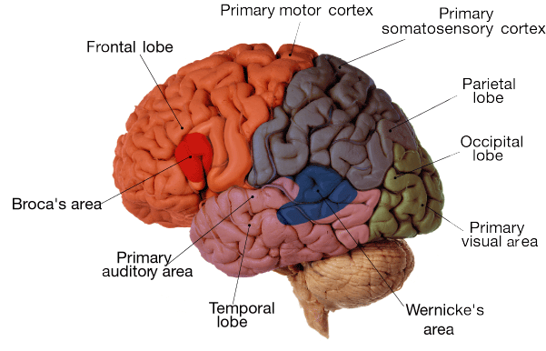
- …to explain the means by which species acquired their adaptive characteristics, and is based on the principle of natural selection.
- Materialism:
  - Rational behavior can be fully explained by the workings of the brain and the rest of the nervous system
Lecture 2:
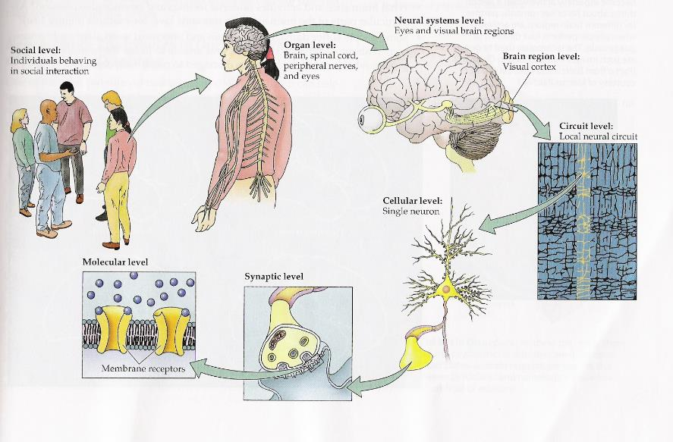
Wednesday, January 16th/23rd, 2019

- The average number of glial cells in the brain = 10-50 times the number of neurons.
- Most dramatic development of the human brain in the first two years of life. During this stage, trillions of interconnections between neurons are formed.
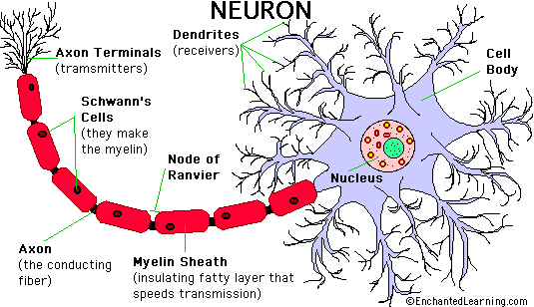
- Average number of glia depends on the area of the brain (when discussing ratio to neurons)

[Cell body (soma)]

- Axon terminals=pre-synaptic terminals
Neuron Function
Five specialist functions:
- Receive signals from neighboring neurons
- Integrate signals
- Give rise to nerve impulses
- Conduct impulses
- Transmit impulses to other neurons

Anatomy of Neurons
Cell body contains the following structures:
- Plasma Membrane
  - Like (almost) all other cells in the body, neurons contain:
    - Nucleus (need DNA to produce protein)
    - Mitochondria
    - Ribosomes
    - Endoplasmic reticulum

Dendrites: (the receiving end)
- Dendrites have branches that come off close to the cell body, unlike the axons
- Dendrites want to receive info efficiently and from multiple sources simultaneously. Have dendritic spines, boxed above, to increase SA to make even more connections to other neurons
- Axon hillock (where axon joins body): that's where signals from dendrites are integrated, all coming together, and most likely place for an action potential to be generated, because threshold is lower
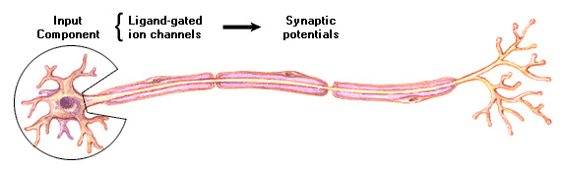
Axon vs. Dendrite
- Information flow
- Surface texture
- Structure
- Sheath or no sheath?
- Distance of branching

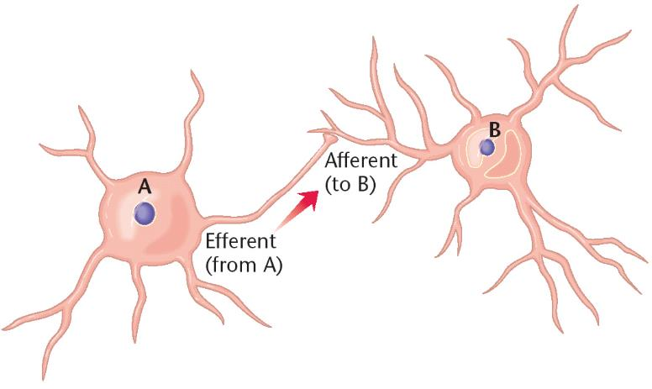
- An axon from A to B is an efferent axon from A and an afferent axon to B
Efferent = Exit
Afferent = Admit
Functional Classification
There are three general types of neurons:
Motor neuronA neuron located within the central nervous system that controls the contraction of a muscle or the secretion of a gland.
Sensory neuron (Schwann create myelin)A neuron that detects changes in the external or internal environment and sends information about these changes to the central nervous system.
InterneuronA neuron located entirely within the central nervous system
- Axon projects out, info to PNS
- Dendrites, etc. in peripheral nervous system, send info to central nervous system

- Be aware of huge variety of cell types and how structure relates to its function
GliaThe supporting cells of the central nervous system
- Do seem to be involved in communication of neurons that they are nearby to, help synchro firing of several neurons they’re connected to
Types of Glia:
- Astrocytes:
  - Help synchronize activity of several neurons to produce simultaneous firing
  - Remove waste material, including dead neurons
  - Dilate blood vessels to bring more nutrients
- Microglia:
- Remove wastes, viruses, fungi, microorganisms (immune system)
- Oligodendrocytes (CNS) and Schwann cells (PNS):
  - Produce myelin sheaths for axons
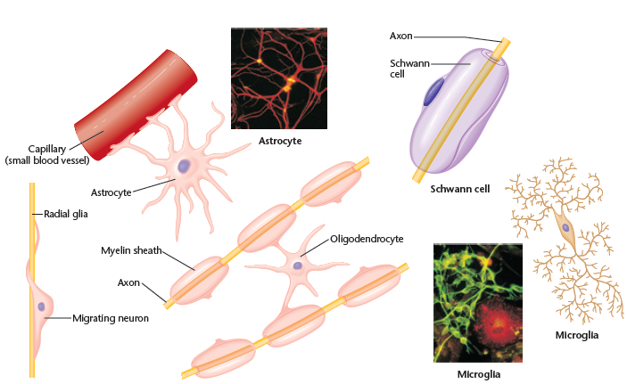

- Radial glia
- Are primarily functional during development, axons born, migrate to areas of brain, use radial glia to get to correct location. After, differentiate into neurons or other types of glia
The Nerve Impulse
  - Axons have two basic electrical states:
    - Resting Potential
    - Action Potential

Membrane Potential
- The electrical charge across a cell membrane; the difference in electrical potential inside vs. outside the cell
- Resting membrane potential:
    - The membrane potential of a neuron when it is not being altered by input from other neurons
    - Approximately -70 mV in the giant squid axon (more negative inside than outside)
Resting Potential
- How is resting potential maintained?
  - Membranes are selectively permeable: some chemicals pass more freely than others
- Sodium (Na+), potassium (K+), calcium (Ca2+), and chloride (Cl-) pass through channels in the membrane
  - Negatively charged protein molecules inside cell cannot pass membrane
- When the membrane is at rest:
  - Sodium channels are closed
  - Potassium channels are partially closed allowing slow passage of potassium
  - Resting Potential
- The sodium-potassium pump is a protein complex that continually pumps three Na+ ions out of the cells while drawing two K+ ions into the cell
  - Helps to maintain the electrical gradient, creates a negative potential
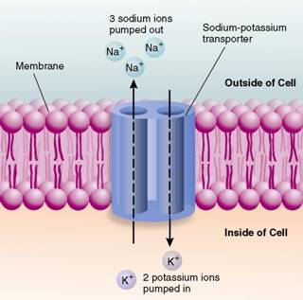
- Three sodium ions from inside the cell bind to the transport protein. Then a phosphate group (from ATP) causes the protein to change shape and release the sodium ions outside the cell. Two potassium ions from outside the cell then bind to the transport protein and as the phosphate is removed, the protein assumes its original shape and releases the potassium ions inside the cell.

Membrane Potential
- Two passive forces causing molecules to move:
  - Electrical Gradient:
    - Opposite electrical charges attract, e.g. Na+ wants to come in cell because more negative there
  - Concentration Gradient:
    - Molecules from region of high concentration to regions of low concentration
- K+ ions:
  - Electrical gradient works to pull in
  - Concentration gradient works to push out
  - K+; not many channels open at rest, concentration gradient stronger than electrical gradient at rest, so slow flow from inside to out.
- Na+ ions:
  - Electrical and concentration gradient both work to pull Na+ into cell
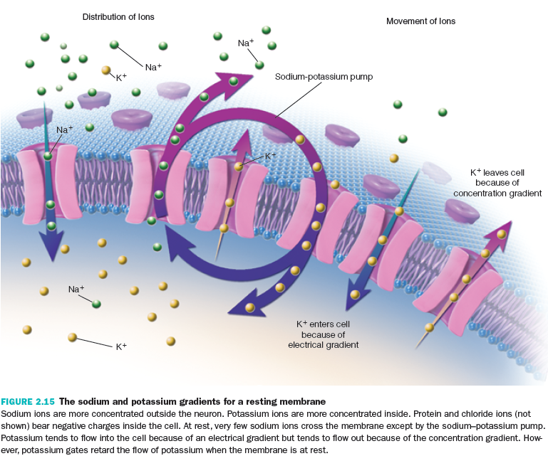
  - 10 x more sodium outside than inside cell, but at rest can’t get in, pumps closed, builds up outside cell
Check Point
- Membrane is selectively permeable:
  - At rest, K+ moves slowly across membrane (some in, some out)
  - At rest, Na+ and negatively charged protein molecules cannot cross membrane
- The sodium-potassium pump uses energy to move 3 Na+ out for every 2 K+ in
- This imbalance in voltage results in a resting membrane potential of -70 mV (inside of cell is more negative than outside)

Action potentialThe brief electrical impulse that provides the basis for conduction of information along an axon.
- Rapid depolarization of the neuron (bringing the potential of the neuron closer to 0 from the -70mV)
The Action Potential
- Neurons are at resting potential until stimulated
HyperpolarizationIncreasing the polarization or the difference between the electrical charge of two places (more –ve)
DepolarizationDecreasing the polarization towards zero
Threshold of excitationThe value of the membrane potential that must be reached to produce an action potential.
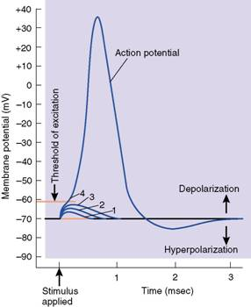
- Neuron acts out of proportion to stimulus, as long as stimulus reaches threshold of excitation, AP always same size and speed

Action Potential has two main phases:
Depolarization
- A stimulus can cause the membrane potential to change a little. The voltage-gated ion channels can detect this change, and when the potential reaches the threshold of excitation the sodium channels open. This causes sodium ions to rush in, making the inside of the cell more positive. This phase is referred to as a depolarization since the normal voltage polarity (negative inside) is reversed (becomes positive inside).
- Repolarization. At a certain point, the depolarization of the membrane causes the sodium channels to close. As a result, the potassium channels open, causing potassium ions to rush out, making the inside more negative again. Since this restores the original polarity, it is called repolarization. As the polarity becomes restored, there is a slight ‘overshoot’ in the movement of potassium ions (called hyperpolarization). The resting membrane potential is restored by the sodium-potassium pump.
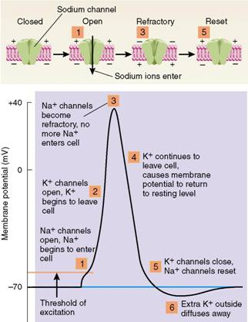
- At 6, diffuses, so returns to base line. Then sodium-potassium pump comes into play significantly here, because helps to switch out all that sodium now inside with the potassium that is outside (so re-establishes how it began)

The Action Potential (cont’d.)

Refractory periodPeriod of time following action potential during which time the neuron resists the production of another action potential;
- 2 phases:
  - Absolute refractory period not possible for neuron to produce AP no matter the stimulus, because sodium channels snapped shut at peak of AP
  - relative refractory period (inhibited, not impossible): when hyperpolarization of membrane occurs, neuron can generate another AP. so sodium channels could open in response to a stimulus, but stimulus needs to be a little stronger than normal to make up for the hyperpolarization
  - Excitotoxicity can occur if AP keeps being met too fast; sodium keeps flowing in in in, and at a certain point, the s-p pump won’t be able to keep up, and too much sodium is toxic to the cell

Communication Within A Neuron
Conduction of the Action Potential
All-or-none law:
- Once an action potential is triggered in an axon, it is propagated without decrement to the end of the fiber (the strength by which a nerve or muscle fibre responds to a stimulus is independent of the strength of the stimulus. If that stimulus exceeds the threshold potential, the nerve or muscle fibre will give a complete response; otherwise, there is no response).

Rate law:
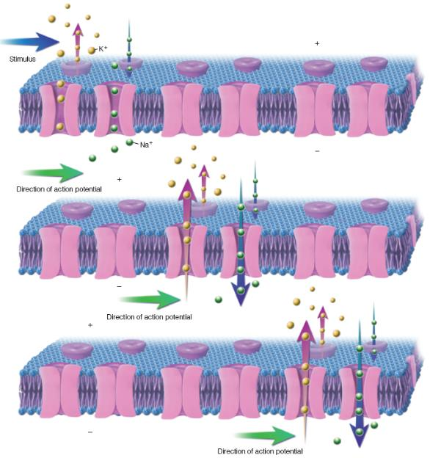
- Variations in the intensity of a stimulus or other information being transmitted in an axon are represented by variations in the rate at which that axon fires (Reflecting the strength of a stimuli by the firing rate of the nerve impulses it elicits).
The Myelin Sheath and Saltatory Conduction
- The myelin sheath of axons is interrupted by short unmyelinated sections called nodes of Ranvier
- Myelin is an insulating material composed of fats and proteins
- At each node of Ranvier, the action potential is regenerated by a chain of positively charged ion pushed along by the previous segment
- Saltatory conduction: used to describe the “jumping” of the action potential from node to node
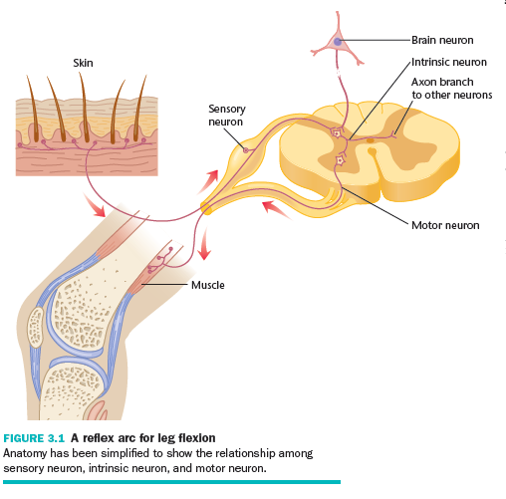
  - Provides rapid conduction of impulses
  - Conserves energy for the cell
Lecture 3:
Wednesday, January 30th, 2019
The Concept of the Synapse
- Neurons communicate by transmitting chemicals at junctions, called “synapses”
  - In the late 1800’s, Ramon y Cajal demonstrated gaps between neurons
  - In 1906, Charles Scott Sherrington coined the term synapse to describe this gap
    - Sherrington inferred the major properties of synapses through behavioural observation
- The Properties of Synapses
- Sherrington investigated how neurons communicate with each other by studying reflexes (automatic muscular responses to stimuli)
- Example: Leg flexion reflex
The Properties of Synapses
- Sherrington observed three important points about reflexes:
  - Reflexes are slower than conduction along an axon
- Difference must be accounted for by the time it takes for signal to cross gap between neurons
- Reflex took longer than it would if AP was going through one long circuit (knew approximate speed/length of AP/axons) delay at synapse
  - Several weak stimuli presented at slightly different times or slightly different locations can produce a reflex when a single stimulus can’t
- Repeated stimuli can have cumulative effect TEMPORAL SUMMATION
- Simultaneous stimuli at slightly different locations can have cumulative effect SPATIAL SUMMATION
  - As one set of muscles relaxes, another set becomes excited
- E.g. dogs: suspended off ground in harness, pinched foot, it retracts while the other extends (sensory neuroninterneuronmotor neuron); muscles work in opposition
- Stimulation can cause inhibition of certain responses (as well as excitation)
Synapse Structure
Not just a gap, composed of 3 parts:
- Presynaptic terminal:
  - The small bulbous expansion at the end of a branching axon
  - Contains synaptic vesicles, which contain neurotransmitters
- Synaptic cleft:
  - The space between the presynaptic terminal and the membrane of the postsynaptic neuron (20nm)
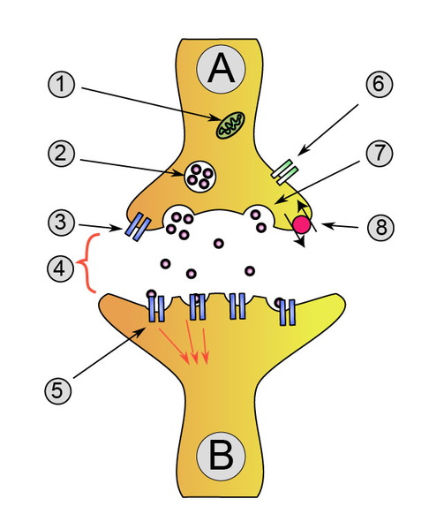
- Postsynaptic neuron:
  - Membrane of dendrite/cell body of neuron
  - Contains neurotransmitter receptors

A: Presynaptic Neuron
B: Postsynaptic Neuron
1. Mitochondria
2. Synaptic vesicle full of neurotransmitter
3. Auto receptor
4. Synaptic cleft
5. Neurotransmitter receptor
6. Calcium Channel
7. Fused vesicle releasing neurotransmitter
8. Neurotransmitter re-uptake pump

Presynaptic Events
- Neuron synthesizes neurotransmitters (NTs), stored in synaptic vesicles
- Action potential causes voltage-gated calcium channels (Ca²⁺) to open
- Ca²⁺ flows into cell (don’t need to know specifics about Ca²⁺
- Causes synaptic vesicles to bind with membrane, release contents (NTs)
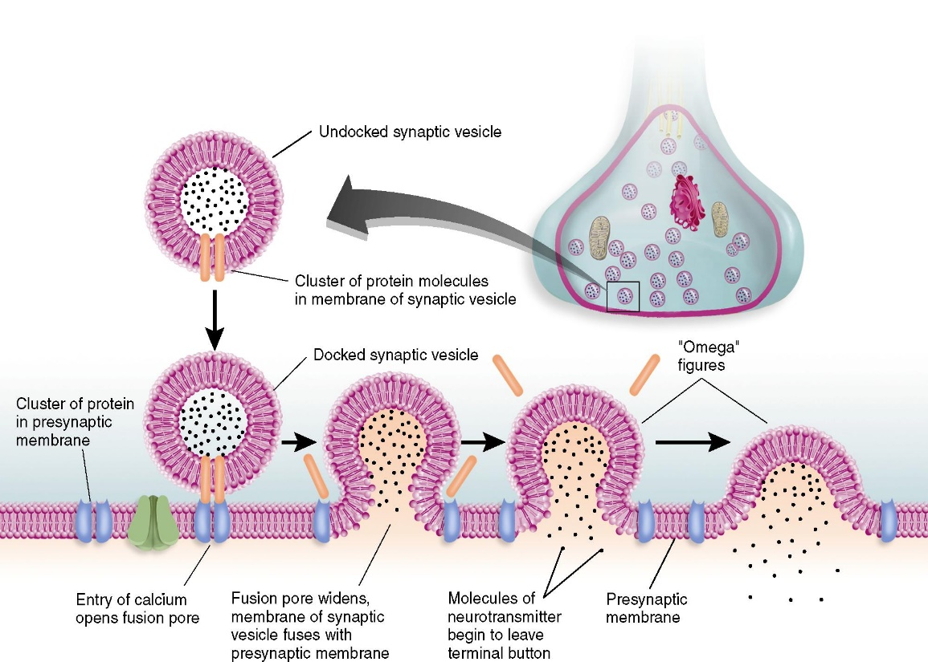

- acetylcholine 1st NT to be discovered (also involved in brain)
- Neurons in brain constantly generating AP even without AP
- Signal frequency and reaction depends on neuron/location

Postsynaptic Events
Neurotransmitters diffuse across synaptic cleft…
  - Bind to postsynaptic receptor:
  - A protein embedded in the postsynaptic membrane that contains binding site for NT
- Two main types of receptors:
  - Neurotransmitter-dependent ion channel (ionotropic):
    - An ion channel that opens when NT binds
    - Ionotropic effects are fast to begin, short-term effects
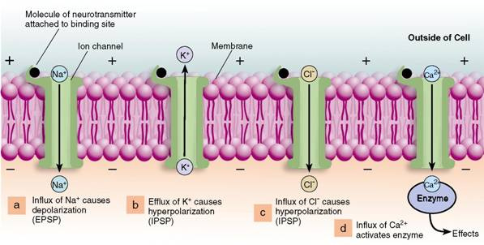

EPSPs and IPSPs

Excitatory postsynaptic potential (EPSP)An excitatory depolarization of the postsynaptic neuron caused by binding of neurotransmitter to ion channel. Graded.
Inhibitory postsynaptic potential (IPSP)An inhibitory hyperpolarization of the postsynaptic neuron caused by binding of neurotransmitter to ion channel.
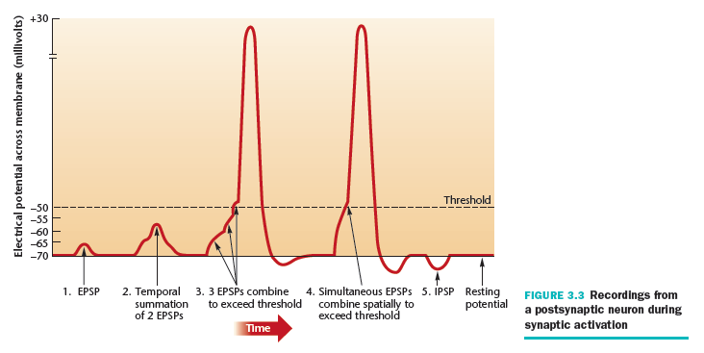
Temporal summationRepeated stimuli can have a cumulative effect
Spatial summationMultiple stimuli at slightly different locations can have a cumulative effect

Ionotropic synapses
- Glutamate:
  - Most of the brain’s excitatory ionotropic synapses use glutamate
  - Opens Na+ ion channels in postsynaptic membrane depolarization
- GABA (gamma-amino-butyric acid):
  - Most of the brain’s inhibitory ionotropic synapses use GABA
  - Opens chloride (Cl-) ion channels, Cl- flows into postsynaptic cell hyperpolarization
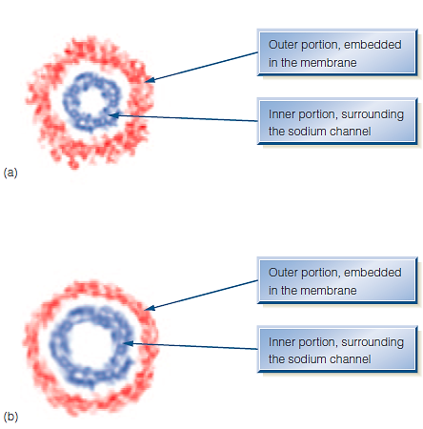
Acetylcholine
- The first transmitter to be discovered
- Has excitatory ionotropic effects
- Axons that are afferent to muscles use exclusively acetylcholine
- Involved in regulating REM sleep, learning, and memory

Spontaneous Firing Rate
- The periodic production of action potentials despite synaptic input
- EPSPs INCREASE the number of action potentials above the spontaneous firing rate
- IPSPs DECREASE the number of action potentials below the spontaneous firing rate

- Two main types of receptors:
  - Metabotropic receptors
    - How do they work?
      - G protein: A protein inside the cell coupled to metabotropic receptor
      - When NT binds to receptor, the receptor changes shape and releases G protein
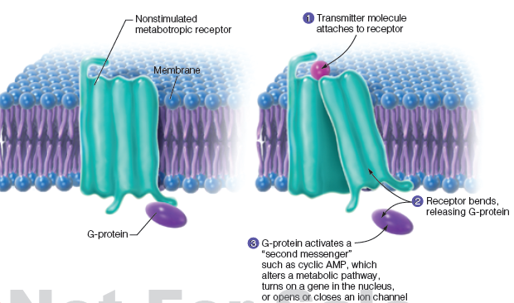
      - G protein then activates second messenger
      - Second messenger:
        - Communicates with many areas of cell
        - Opens ion channels, turns on gene, alters metabolic pathway, etc.
- Metabotropic effects are longer-lasting, but slower to start
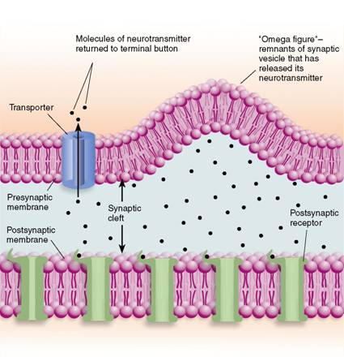
Termination of Postsynaptic Potentials
Reuptake:
- The reentry of NT into presynaptic terminal through transporter protein (Reuse!)
- Example: serotonin
Enzymatic deactivation:
- The destruction of NT by an enzyme
- Example: acetylcholine
Diffuse away:
Example: neuropeptides
- NTs cant stay bound forever; eventually released and taken away by one of the above
Regulation of NT release
- Inhibiting release of NT from presynaptic terminal:
  - Auto-receptors:
    - Receptors on presynaptic terminal that respond to released NT by inhibiting further synthesis and release
  - Postsynaptic neurons:
    - Respond to stimulation by releasing chemicals that travel back to the presynaptic terminal where they inhibit further release (e.g., nitric oxide)

How do we study the (human) brain?
- Examine effects of brain damage
- Examine effects of brain stimulation
- Record brain activity during behaviour
- Correlate brain anatomy with behavior

Effects of Brain Damage
- Ablationremoval of a brain area
- Lesiondamage to a brain area, can be naturally- or experimentally-caused
- Transcranial magnetic stimulation (TMS):
  - Apply intense magnetic field to a portion of the scalp to temporarily deactivate neurons below the magnet
  - Experimental “lesion,” but reversible

Effects of Brain Stimulation
- Stimulation of a brain area modify behavior
- Electrodes can probe the brain of someone undergoing brain surgery
Record Brain Activity
- Electroencephalography (EEG):
  - Records electrical activity produced by the brain at the scalp
  - Non-invasive; good with timing
- Magnetoencephalography (MEG):
- Similar to EEG but measures faint magnetic fields generated by brain activity instead
- Positron-emission tomography (PET):
- Detects where in the brain a radioactive form of glucose goes while the brain performs a task
- Functional magnetic resonance imaging (fMRI):
- Uses oxygen consumption in the brain to observe what areas of the brain are active while doing a task
- Good with timing and good spatial resolution (1-2 mm); low temporal resolution (slower to measure O2)

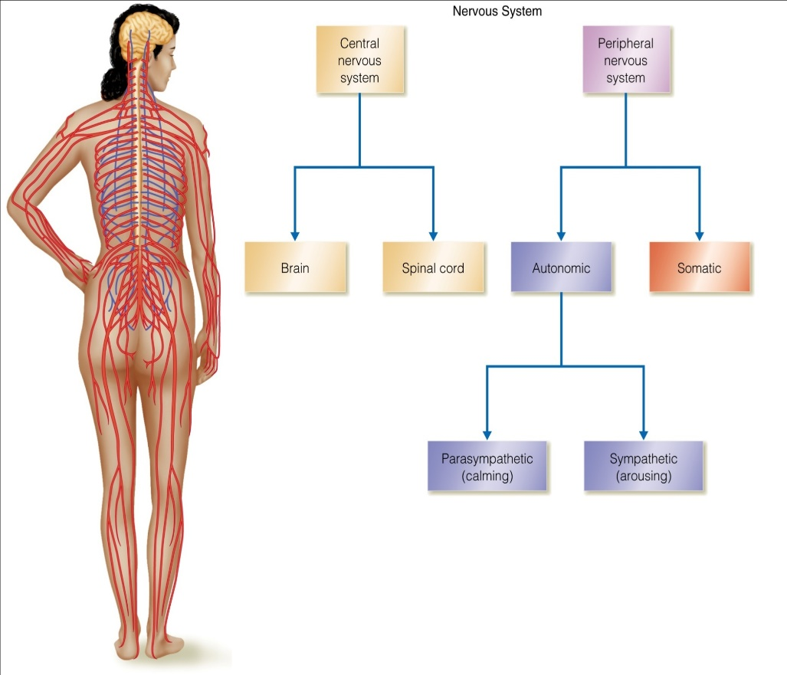
Lecture 4a: Structure & Function of the Nervous System
- Basic Organization of Nervous System
- Central Nervous System
  - Brain and spinal cord
- Peripheral Nervous System
  - Somatic
  - Autonomic

    - Sympathetic
    - Parasympathetic

The Autonomic Nervous System
- Autonomic nervous system regulates the automatic behaviors of the body
- Divided into two subsystems:
  - The sympathetic nervous system
  - The parasympathetic nervous system

Sympathetic nervous system:
  - Network of nerves that prepares the organs for rigorous activity:
    - Increases heart rate, blood pressure, respiration, etc. (“fight or flight” response)
  - Neurons release norepinephrine
  - This system expends energy

Parasympathetic nervous system:
  - Facilitates vegetative, nonemergency responses
  - Decreases functions increased by the sympathetic nervous system
  - Neurons release acetylcholine
  - This system conserves energy
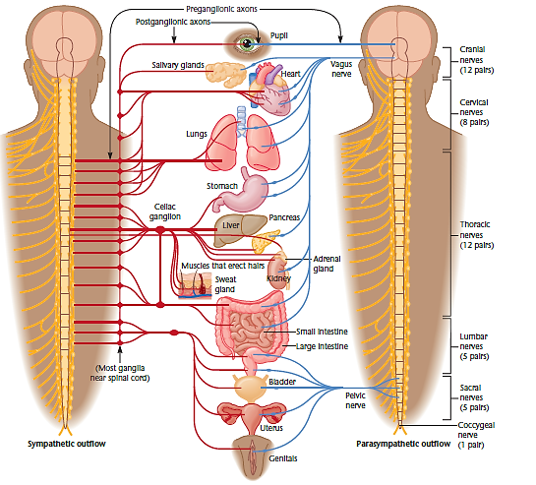

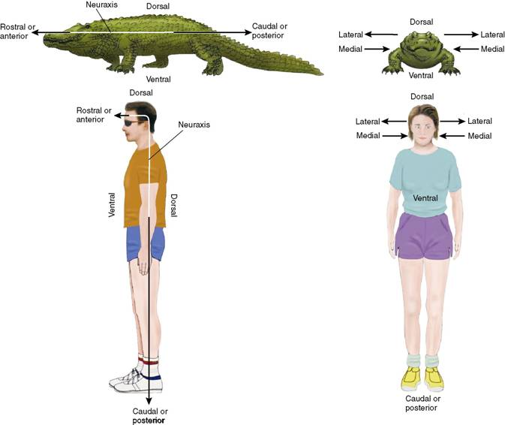
Terminology to Describe the Nervous System
- Ventral: towards the stomach
- Dorsal: towards the back
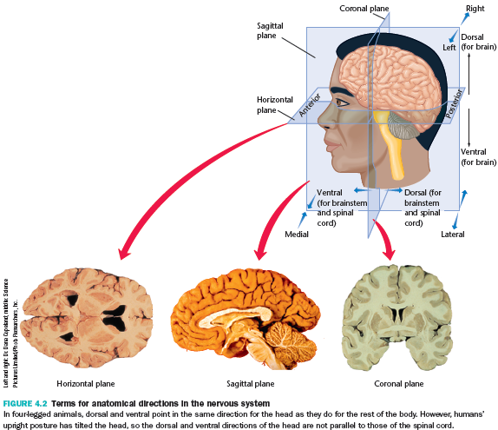
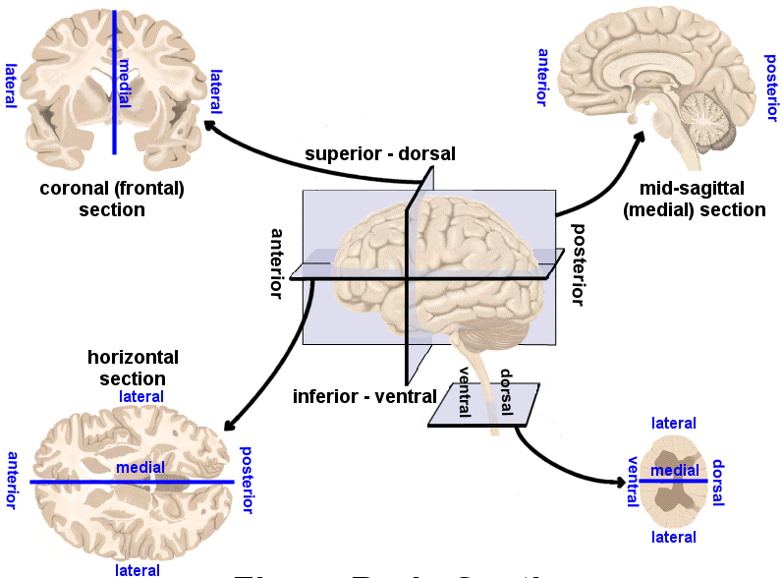

Basic Features of the Central Nervous System
The Ventricular System
- Four hollow spaces located inside the brain, plus the central canal (channel inside spinal cord)
- Each ventricle and central canal are filled with cerebrospinal fluid (CSF) – a clear fluid, similar to blood plasma.
- CSF provides cushioning for the brain, contains hormones and nutrition for brain and spinal cord

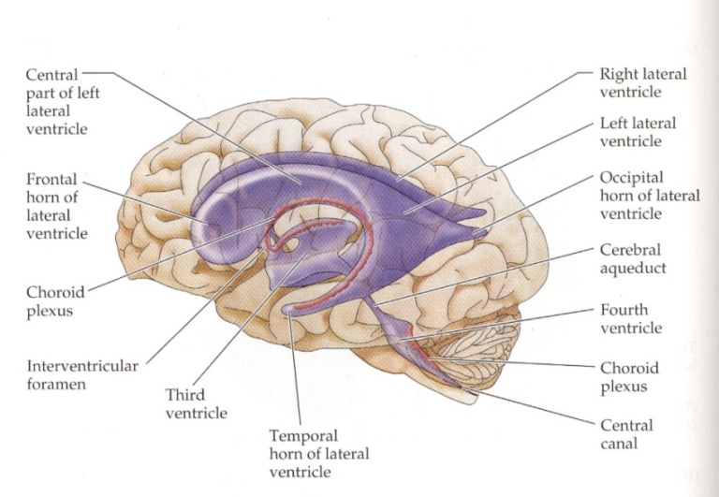
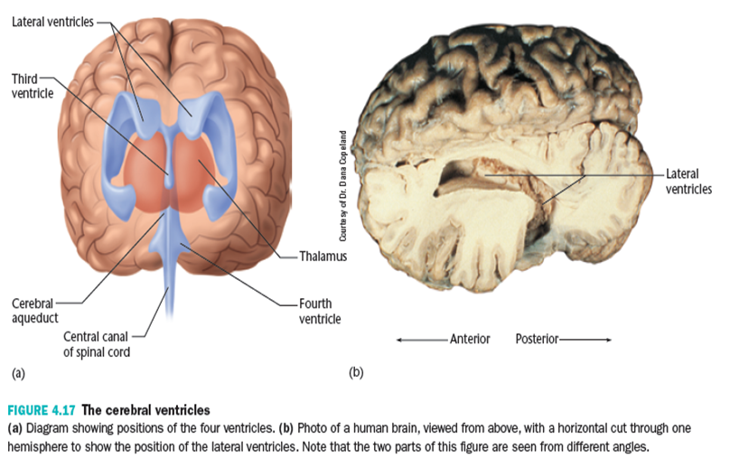
The Spinal Cord
- Communicates with the sense organs and muscles, except those of the head
  - Bell-Magendie law:
    - Entering dorsal roots carry sensory information
    - Exiting ventral roots carry motor information
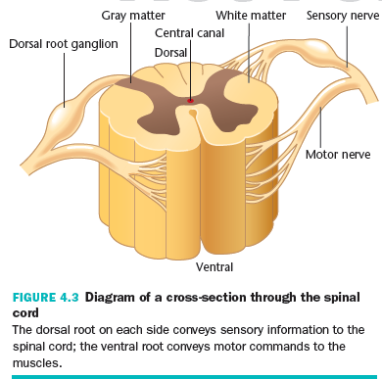
  - Cell bodies of the sensory neurons are located in clusters of neurons outside the spinal cord, called the dorsal root ganglia
The Brain
- Three major divisions of the brain include:
  - Forebrain
  - Midbrain
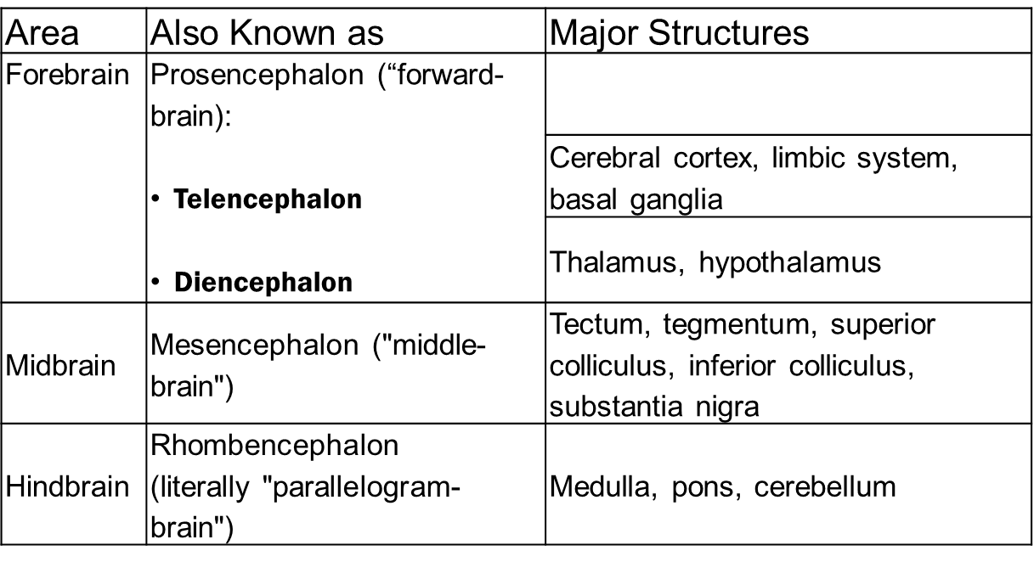
  - Hindbrain

Hindbrain
- Main function: “Life Support”
  - Substructures:
    - Medulla
    - Pons
    - Cerebellum
The Hindbrain
- Medulla:
  - Located just above the spinal cord
  - Responsible for vital reflexes such as breathing, heart rate, vomiting, salivation, coughing and sneezing
- Pons – “bridge”
  - Lies on each side of the medulla
  - Along with the medulla, contains the reticular formation and raphe system
  - Work in conjunction to increase arousal and readiness of other parts of the brain
- Reticular formation:
  - Descending portion helps to control the motor areas of the spinal cord
  - Ascending portion sends output to cerebral cortex to increase arousal and attention
- Raphe system:
  - Also sends output to cerebral cortex, modifying the brain’s readiness to respond to stimuli
- Cerebellum:
  - Structure located in the hindbrain with many deep folds
  - Helps regulate motor movement, balance, and coordination
  - Also important for shifting attention between auditory and visual stimuli
  - May play a role in language
- Midbrain
- Main function: “Relay stations”
  - Coordinates sensory information
- Substructures:
  - Tectum
    - Superior colliculus & Inferior colliculus
      - Process sensory information
  - Substantia nigra
    - gives rise to the dopamine-containing pathway facilitating readiness for movement
Forebrain
- Main function: “Higher” mental processes
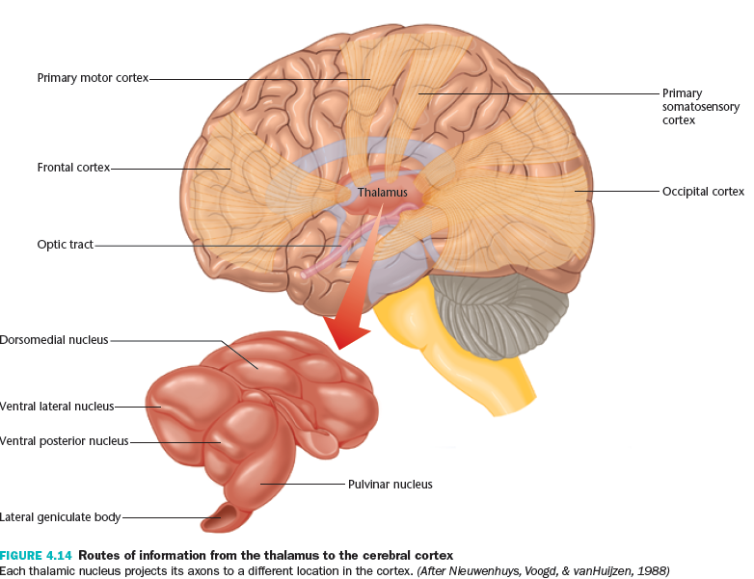
- Two hemispheres
- Substructures:
  - Cerebral cortex
  - Subcortical structures:
    - Amygdala, hippocampus, basal ganglia, thalamus, hypothalamus (among others)
Subcortical Structures
- Diencephalon:
  - Thalamus
    - relay station from the sensory organs and main source of input to the cortex
  - Hypothalamus
    - Conveys messages to the pituitary gland to alter the release of hormones
    - eating, drinking, sexual behavior and other motivated behaviors
    - Limbic system consists of a number of subcortical structures
    - Olfactory bulb, hypothalamus, hippocampus, amygdala, and cingulate gyrus of the cerebral cortex
    - Motivation, emotion, drives, and aggression
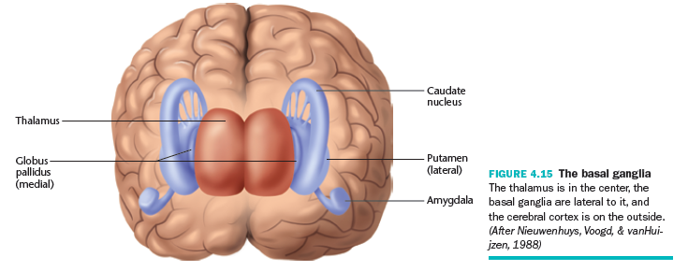
    - Memory – H.M.
- Basal ganglia:
  - Caudate nucleus, the putamen, and the globus pallidus
  - Planning motor movement, aspects of memory and emotional expression
  - Attention, language planning

The Cerebral Cortexmost prominent part of the mammalian brain
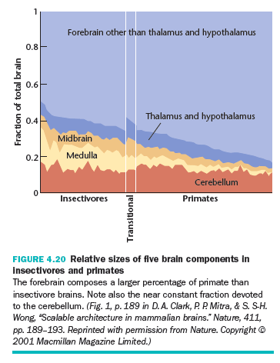
- Two hemispheres joined by two bundles of axons: the corpus callosum and the anterior commissure
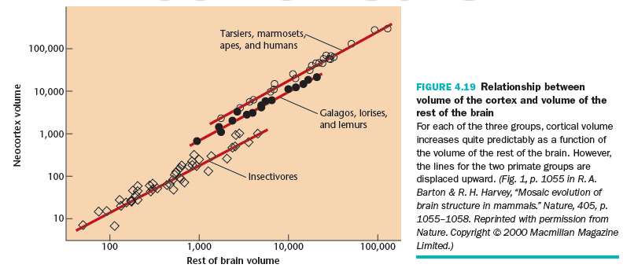
  - More highly developed in humans than other species

Organization of the Cerebral Cortex
- Contains six distinct laminae (layers) that are parallel to the surface of the cortex
- Cells of the cortex are also divided into columns that lie perpendicular to the laminae
- Divided into four lobes:
  - occipital, parietal, temporal, and frontal

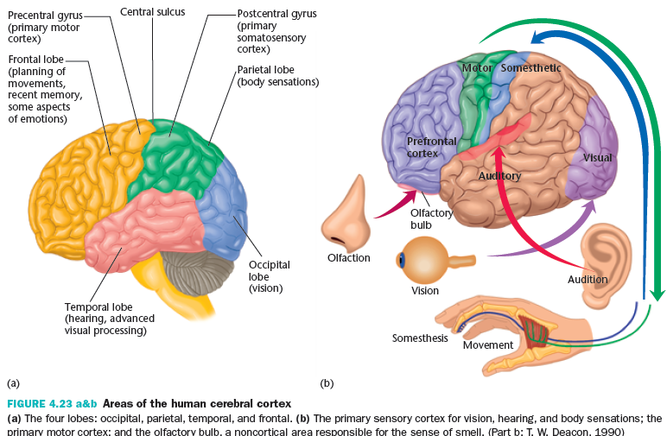
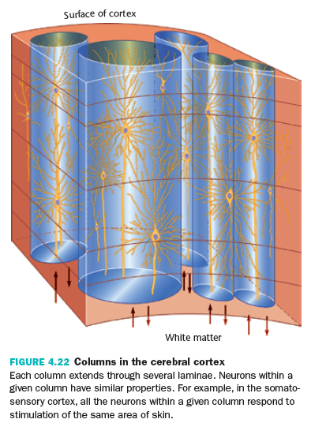
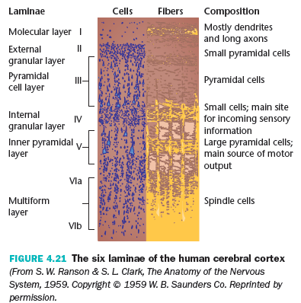
The outwardly rounded ridges of cortex are GYRI (singular GYRUS). The grooves between the gyri are SULCI (singular SULCUS)
The Occipital Lobe
- Occipital lobe:
  - Located at the posterior end of the cortex
  - Main function: Vision
The Parietal Lobe
- Parietal lobe
  - Contains the postcentral gyrus (“primary somatosensory cortex”)
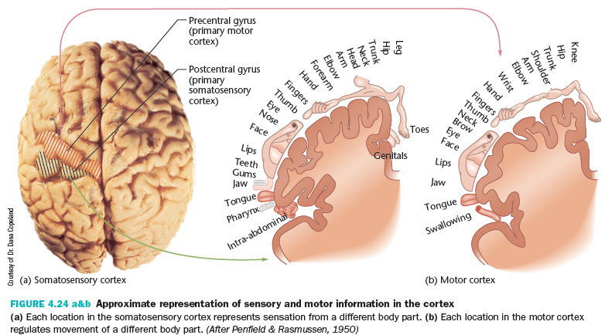
  - Also responsible for processing and integrating information about eye, head and body positions from information sent from muscles and joints

The Temporal Lobe
- Temporal lobe
  - Lateral portion of each hemisphere near the temples
  - Target for auditory information and essential for processing spoken language
  - Also responsible for complex aspects of vision, including movement
  - Some emotional and motivational behaviors

The Frontal Lobe
- Frontal lobe
  - Contains the prefrontal cortex and the precentral gyrus
  - Precentral gyrus: primary motor cortex; responsible for the control of fine motor movement
  - Prefrontal cortex: the integration center for all sensory information; higher mental functions
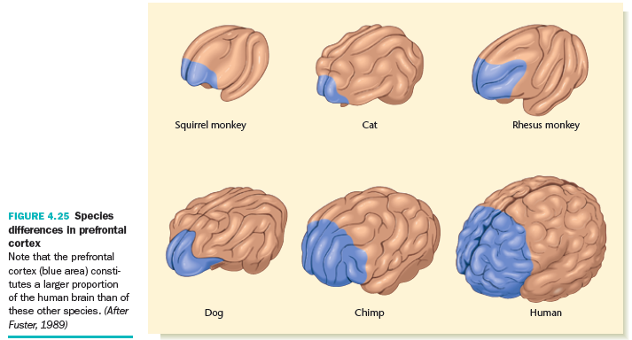
- Prefrontal cortex:
  - Higher functions like abstract thinking and planning
  - Responsible for our ability to remember recent events and information (“working memory”)

Lecture 4b: Brain Development & Plasticity

Introduction to Brain Development
- There is a general pattern of brain development that applies to all members of the species
- This pattern of brain development is largely under genetic control
- However, brain development CAN be modified by experience – we’ll discuss this today…
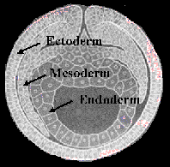
Early Embryo
- 15-18 days following conception…
  - Ectoderm:
    - Nervous system and skin, hair, fingernails
  - Mesoderm:
    - Muscles, joints, and circulatory systems
  - Endoderm:
    - Digestion and respiratory systems

Neurulation: Forming the Neural Tube
- 18th – 24th day: Nervous system begins to form
- Ectoderm thickens and forms the neural plate
- Neural plate forms a groove, then closes off to form the neural tube
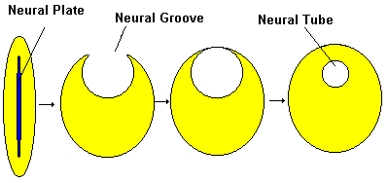
- Cells inside the tube = CNS; cells outside the tube = PNS

Errors in Neurulation
- Anencephaly (anterior portion of tube fails to close)
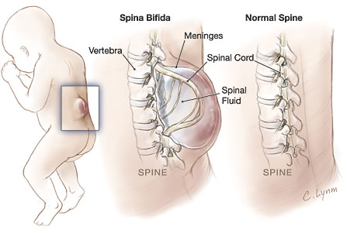
- Myelomeningocele “spina bifida” (posterior portion of tube fails to close)
- Folic acid helps reduce the risk of neural tube defects

The Development of Neurons
- The development of neurons in the brain involves the following processes:
  - Proliferation (neurogenesis)
  - Migration
  - Differentiation
  - Myelination
  - Synaptogenesis
Neurogenesis
- Precursors to neurons and glia begin to form by 6th week
- When do neurons stop being produced?
  - Postnatal neurogenesis?
Cell Migration
- Neurons continue to proliferate when migration begins
- There are 6 layers in the adult cortex, and they develop in an inside-out fashion
  - Neurons with earlier “birthdays” are in the lower layers (next to ventricles) and neurons with later “birthdays” travel over the other neurons to the outer layers
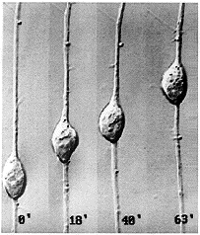
Differentiation
- Differentiation refers to:
  - outgrowth of axons and dendrites from the cell body
  - Axon grows first (during migration or once it reaches target); followed by growth of dendrites

Axon Pathfinding
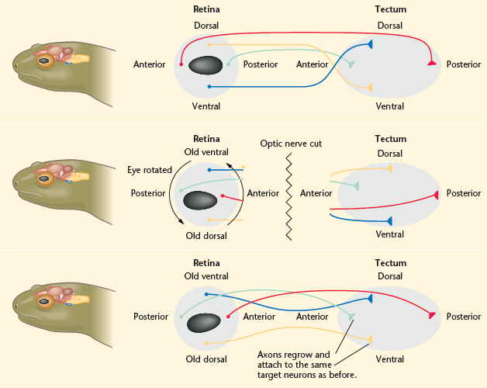
- Axons must travel great distances across the brain to form the correct connections
- How?
  - Axons follow chemical gradients – they are attracted by some chemicals and repelled by others
Axon Pathfinding
- Not perfect:
  - When axons initially reach their targets, they form synapses with many cells in the general area
- What determines what connections remain and what connections are lost?
  - Activity of the synapse!

Circuit Formation
- Many neurons die during development
  - 40 – 60% of neurons die (programmed cell death, ‘apoptosis’)
- Why?
  - Example: muscle cells release Nerve Growth Factor (NGF), protein that promotes survival of axons
Circuit Formation:
Synaptogenesis and Pruning
- Synaptogenesis:
  - Formation of connections between neurons
  - Most rapid during pre and early postnatal periods
  - Overproduction:
    - Newborn brain has many more synapses than adult brain
    - The peak number of synapses occurs at different times across different brain regions

Prefrontal Cortex
- Adolescents tend to be more impulsive than adults
  - Risk-taking behaviours
- Executive functioning:
  - Gradually improves during the teenage years
- Linked to changes in prefrontal cortex during adolescence

Synaptogenesis and Pruning
- Synapse overproduction under genetic control:
  - Enucleated monkeys
- Synapse pruning is the result of experience
  - “Use it or lose it” (Hebb)
  - When synapses are active, their connection strengthens; when synapses are inactive, their connection weakens.
- New synapses are created throughout life
Myelination
- Myelination occurs in “waves” beginning prenatally and ending as late as middle age in some regions
- This variability in timing of myelination across brain regions is related to when infants/children develop certain skills
Important Points
- The timing of brain development differs for different brain regions
- Experience affects the final product!
  - Why is experience important?
  - Why isn’t the brain just hard-wired?
Developmental Plasticity
- PLASTICITY:
  - The degree to which, and the conditions under which, the brain is open to modification by the environment.
  - Does experience work its way into the structure of the brain, and if so, how?
Examples of Plasticity
- Rats raised in an enriched environment
  - Thicker cortex
  - Increased dendritic branching
- Humans – physical activity
  - Thickness of cerebral cortex
- Genie
- Neural differences between musicians (thicker grey matter) and non-musicians
- Timing matters:
- Musicians who began before age 7 showed advantages over those who started later in life, even when duration of playing was the same
- Duration matters:
  - Grey matter volume in the posterior hippocampus of London taxi drivers was greater than in age-matched control subjects
  - The size of this increase correlates positively with time spent taxi driving

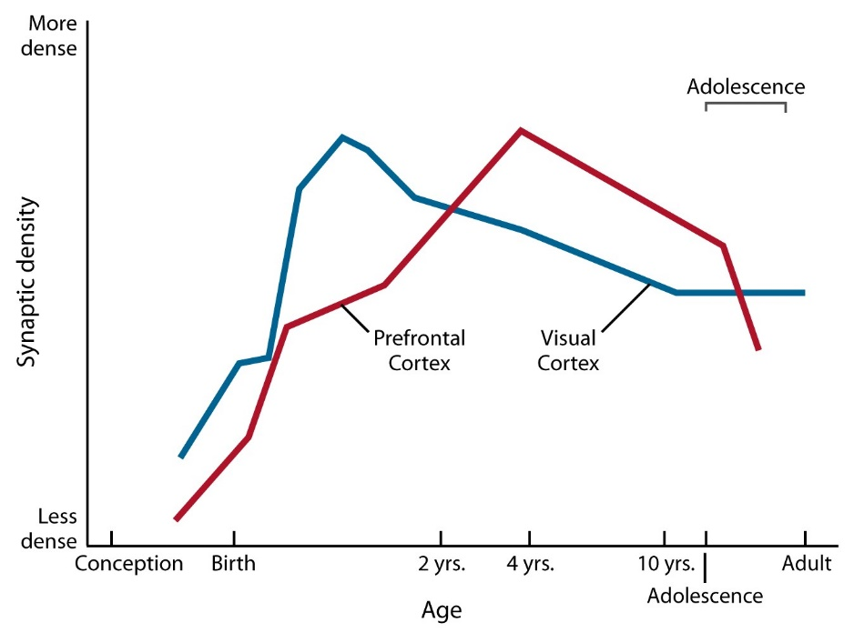
General Conclusions about Plasticity
- There are certain aspects of development that require particular experiences at particular times to proceed normally
  - If expected experiences do not occur…poor outcomes
- The effects of particular experiences depend on:
  - Timing
  - Duration
  - Dose
  - Quality of subsequent input

Plasticity After Brain Damage
- Survivors of brain damage can show subtle to significant behavioural recovery
- Mechanisms of recovery are similar to mechanisms of brain development
  - E.g., new branching of axons and dendrites
Brain Damage
- Possible causes of brain damage include:
  - Stroke
  - Closed head injuries
  - Tumors
  - Infections
  - Exposure to toxic substances
  - Degenerative diseases
- A stroke or cerebrovascular accident is temporary interruption of blood flow to a brain area
  - Common cause of brain damage in elderly
Stroke
Types of strokes:
- Ischemia:
  - 80% of strokes
  - Inadequate blood flow to brain due to occlusion of an artery
- Hemorrhage:
  - 20% of strokes
  - Results from a ruptured artery
  - Bleeding into brain, subarachnoid space, ventricles

Ischemia and hemorrhage also cause:
- Edema:
  - Accumulation of fluid in the brain increased pressure on the brain increased probability of future strokes
  - Disruption of the sodium-potassium pump accumulation of sodium ions inside neurons
  - Edema and excess sodium trigger widespread release of the excitatory neurotransmitter glutamate
  - Overstimulation of neurons sodium and other ions entering eventually lead to cell death

Treatment of Stroke
- Tissue plasminogen activator (tPA) breaks up blood clots can reduce the effects of ischemic strokes
- Save neurons from death by:
  - Blocking glutamate synapses
  - Blocking calcium entry
- Cool the brain
- Cannabinoids - anti-inflammatory effects

Brain Damage
Traumatic Brain InjuryDamage to brain tissue caused by external force

Traumatic Brain Injury Demographics
  - Brain injury is the leading cause of death for persons under 45 years of age
  - Incidence: 250-300 per 100,000; Prevalence: 175-200 per 100,000
  - Highest incidence among persons aged 15 to 24 years and those older than 75 years
  - More frequently occurs in males than females (2:1)
  - 50-80% of all TBI's are mild
  - Causes, listed in order: motor vehicle (occupant, motorcyclist, pedestrian, bicyclist), falls, assaults with firearms, and sports
  - Motor vehicle accidents account for more than half of all brain injuries

Sport Injuries
- The greatest incidence of catastrophic head injury in sports occurs in football, gymnastics, ice hockey, and wrestling
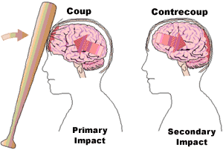
- Individuals with two or more concussions tend to perform worse than those with no concussions on attention and concentration tasks and information processing speed
Two points to remember:
  - The brain is poorly anchored within the skull resulting in movement
  - The inside of the skull is not a smooth surface throughout
Closed Head Injuries
  - No penetrating injury to the brain
  - Resting head: damage at impact site
  - Moving head: damage at impact site and “contrecoup” injury as the result of the brain bumping into that side of the skull
  - In head injury, a coup injury occurs under the site of impact with an object, and a contrecoup injury occurs on the side opposite the area that was hit. Coup and contrecoup injuries are associated with cerebral contusions, a type of traumatic brain injury in which the brain is bruised.
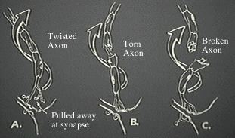
Types of Primary Damage
- Diffuse Axonal Injury:
  - Axons may be stretched or torn (shearing)
  - Axons may be intact but do not conduct electrical impulses well or at all
- Widespread diffuse axonal injury is associated with severe injury
- Mild stretch injury may be responsible for concussion (MRI evidence, i.e., Yokota et al., 1991; Lewine et al., 1999)

Secondary Damage
- Brain Distortion:
  - E.g., subdural or epidural hematomas
- Edema:
  - Swelling of the brain
  - Can cause rise in intracranial pressure, which prevents blood from entering the skull to deliver glucose and oxygen to the brain
- Hydrocephalus:
  - Collection of fluid in and around the brain
  - If blood gets into the CSF and blocks absorption, CSF will "back up" into the ventricles and enlarge them

Mechanisms of Recovery
- Following brain damage, surviving brain areas increase or reorganize their activity
- Diaschisis: decreased activity of surviving neurons after damage to other neurons
- Drugs to stimulate activity in healthy regions of the brain after a stroke
- Destroyed cell bodies cannot be replaced, but damaged axons do grow back under certain circumstances
- However…
  - Damaged axons in CNS do not regenerate or only slightly
    - Scar tissue makes a mechanical barrier to axon growth
    - Glia cells release chemicals that inhibit axon growth
- Collateral sprouts:
  - New branches formed by non-damaged axons that attach to vacant receptor sites
  - Postsynaptic cells release neurotrophins that induce axons to form collateral sprouts
- Postsynaptic cells develop increased sensitivity to neurotransmitter to compensate for decreased input

