MHR 405 TEST 1 - REVIEW NOTES

WEEK 1 - CH1

Organizational behavior (OB)

- Study of what people think, feel, and do in and around organizations
- Looks at:
- Decisions
- Perceptions
- Emotional responses
- Also studies how organizations interact with external environments

Organizations

- Groups of people who work interdependently towards the same purpose
- Members have collective sense of purpose

Why Study OB

- Helps you as an individual in workplace
- Tends to improve survival & success of organization

Organizational Effectiveness

- “Ultimate dependent variable” in OB
- Broad concept rep. by several perspectives

Open Systems

- Perspective that shows that organizations depend on the external environment for resources
- This effects that environment by their input
- Consist of internal subsystems that transform inputs into outputs

- Organization – Environment Fit
- Organizations are effective when they maintain a good “fit” with external environments
IE. by participating in positive change for environment

- Internal Subsystem Effectiveness
- How well company operates internally

4 Perspectives of Organizational Effectiveness

- Open system

- Perspective that shows that organizations depend on the external environment for resources
- This effects that environment by their input
- Consist of internal subsystems that transform inputs into outputs

- Organizational learning

- Perspective which holds that organizational effectiveness depends on the organizations capacity to
-aquire
-share
-use
-& store valuable knowledge

- High performance Work Practices

- HPWP
- A perspective which holds that effective organizations incorporate several workplace practices that leverage the potential of human capital

- Stakeholder

- Includes CSR (Corporate Social Responsibility)
- Benefit society and environment beyond immediate financial interests/legal obligations
- Triple bottom line – Economy, society, environment

4 Organizational Learning Processes

- Knowledge Acquisition
- Environment scanning
- Individual learning
- Experimentation

- Knowledge Sharing
- Communication
- Training
- I.S
- Observation

- Knowledge Use
- Knowledge awareness
- Sense making
- Autonomy
- Empowerment

- Knowledge Storage
- Human memory
- Documentation
- Databases
- Practices/habits

Absorptive Capacity

- Ability to recognize the value of new information, assimilate it and use it for added value

Intellectual Capital - Companies stock of knowledge (3 types)

- Human Capital
- Knowledge, skills and abilities among employees
- Adds value to organization

- Structural Capital
- Knowledge embedded in an organizations systems and structures

- Relationship Capital
- Value derived form an organizations relationship with customers, suppliers, and others who provide mutual value

Stakeholders
- Affect or are affect by decisions of organization

Values
- Beliefs that guide a persons preferences for outcomes or courses of action in a variety of situations

Ethics
- Study of moral principles or values that determine whether action

CSR
- CSR
- Organizational activities intended to benefit society of the environment
- Beyond firms immediate financial interest/legal obligations
Anchors of OB Knowledge

- Multidisciplinary anchor
- OB should import knowledge from many disciplines

- Systematic Research Anchor
- OB should study organizations using systematic research methods

- Contingency Agency
- OB theory should recognize that the affects of actions often vary with the situation

- Multiple levels of analysis anchor
- OB Knowledge should include 3 levels of analysis
- Individual
- Team
- Organization

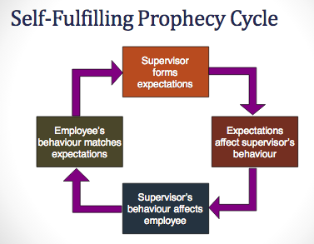

Evidence based MGT
- Practice of making decisions and taking actions based on research evidence

4 Levels of Diversity
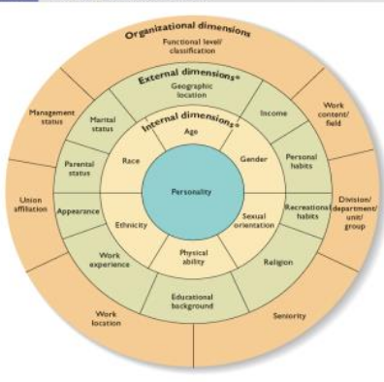

Organizational Memory
- Storage and preservation of intellectual capital
Retain intellectual capital by:
- Keeping knowledgeable employees
- Transferring knowledge to others
- Transferring human capital to structural capital
- Successful companies also unlearn

WEEK 2 – CH 3

Self Concept Dimensions
- Complexity – Many elements every person has for social identity

- Consistency – Similar personality and values across multiple shelves

- Clarity – Clearly & confidently know who you are between groups

4 Shelves of Self Concept

- Self – enhancement
- Positive re-enforcement of success
- Build self esteem

- Self – verification
- Affirming our existing self concept

- Self – evaluation
- Maintaining self-esteem

- Social – self
- Defining ourselves in terms of group membership

Self Concept – Self Evaluation

- Self esteem
- High self esteem = less influenced

- Self efficacy
- Belief in ability, motivation, role perception & situation to complete task successfully

- Locus of control
- General belief in personal control over life
- Internal vs. External Locus of Control

Selective Attention
- Selecting vs Ignoring sensory information
- Emotional markers attached to selected information
IE. - is it dangerous
- Confirmation bias
IE – Someone says something against our beliefs

Perceptual Organization/Interpretation

Categorical Thinking
- Non conscious process of organized people/things

Perceptual grouping principle
- Similarity or proximity
- Perceiving trends

Interpreting Incoming Information
- Emotional markers automatically evaluate information

Stereotyping Through:
- Categorization
- Categorize people into groups

- Homogeneous
- Assign similar traits within a group

- Differentiation Process
- Assign less favorable attributes to other groups

Stereotyping:

Problems – Overgeneralization

Solutions –

Attribution Process

Internal Attributions External Attributions

Internal – Perception that behavior is caused by person’s own ability or motivation

External – Perception that behavior is caused by fate or situation – beyond persons control

ATTRIBUTION | LOW | HIGH
Consistency | INTERNAL & EXTERNAL
Distinctiveness | INTERNAL | EXTERNAL
Consensus | INTERNAL | EXTERNAL

Attribution Errors
- Own actions attributing to internal/external
- Others actions only to internal
- Attributing failures to external factors (Not taking responsibility ever for own actions)

Perceptual Effects

- Halo effect – One trait affects perception of other traits
- False Consensus effect – Over estimate how many others have similar beliefs/traits to your own
- Primacy effect – First impression
- Recency effect – Most recent information dominates perception
- Central Tendency – Avoiding extreme evaluation

JOHARI WINDOW
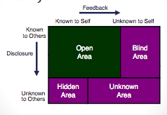

WEEK 3 – CH 2

4 Factors that Directly Influence Performance & Behavior

- Motivation – Force within a person that affects intensity and persistence of voluntary behavior
- Ability – The natural attitudes and learned capabilities requires to successfully complete task
- Role Perceptions – Extent to which people understand the job duties assigned to or expected of them
- Situational factors – Employee behavior & performance

BIG FIVE Personality Dimensions (CANOE)

- Conscientiousness
- Careful
- Dependable
- Self-Disiplined
- Agreeableness
- Courteous
- Good-natured
- Empathetic
- Caring
- Neuroticism
- Anxious
- Insecure
- Self-conscious

- Openness to Experience
- Imaginative
- Creative
- Curious
- Sensitive
- Extroversion
- Outgoing
- Talkative
- Social
- Assertive

Schwartz’s Value Model

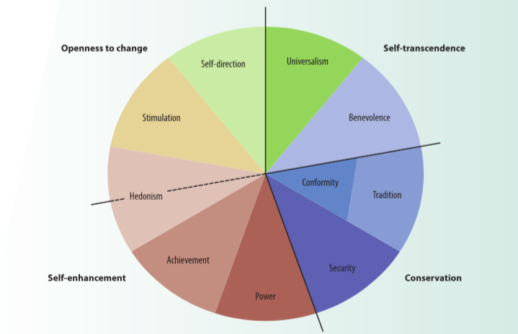
- Openness to Change – Motivation to pursue innovative ways
- Conservation – Motivation to preserve status quo
- Self–Enhancement – Motivated by self interest
- Self-transcendence – Motivation to promote welfare of others and nature

Ethical Principles

- Utilitarianism – Greatest good for greatest number of people
- Individual Rights – Fundamental entitlements in society
- Distributive Justice – People who are similar should receive similar benefits

Week 4 – CH4

Emotions
- Psychological
- Behavior
- Physiological
- Episodes that create a state of readiness
- Emotions occur without awareness
2 features
- All have some degree of activation
- All have core affect (evaluate if something is good/bad)

6 Basic Facial Expressions
- Happy
- Sad
- Fear
- Anger
- Surprise
- Disgust

Attitudes
- Belief
- Feelings
- Behavioral

3 Key Work Attitudes

- Organizational commitment
- Job involvement
- Job satisfaction

3 Forms of Organizational Commitment

- Affective commitment
- Emotional attachment & involvement with organization
- Continuance commitment
- Aware of cost with leaving or staying with organization
- Normative commitment
- Feeling of obligation to organization

5 Ways to Build Effective Commitment

- Justice/support – Humanitarian values / support employee well – being
- Shared Values – Values congruence
- Trust – Employees trust leaders & leader follows through with their word
- Organizational comprehension – Know firms past/present/future & open communication
- Employee Involvement – Employees feel part of company

Job Satisfaction

- A persons evaluation of his/her job & work context
- Feedback from leaders
- Paid fairly/benefits
- Relationship with college’s
- Stress level
- Meaningfulness/social impact

Performance
- Happy workers are somewhat more productive workers, but:
- General attitude is a poor indicator of specific behaviors
- Job satisfaction effect is lower when employees have less control over output
- Reverse explanation: Job performance affects satisfaction but only when rewarded

RESPONSES TO DISSATISFACTION: EVLN

- Exit - Quitting
- Voice – Change situation or complain
- Loyalty – wait for situation to improve
- Neglect – reduce work effort/increased absence

Emotional Labor
- Effort, planning & control needed to express organizational desired emotions during interpersonal transaction
IE – POLICE

What is stress?
- Adaptive response to situations perceived as challenging or threatening to well being
- Prepares us to adapt to hostile or noxious environmental conditions
- Eustress +
- Dis-stress -

