Unit 1: Structure and Properties of Matter
Lesson 1: Atomic Structure
Introduction to Atomic Structure
- X-rays and MRIs are both examples of medical imaging technologies.
  - However, they differ in their applications.
  - X-rays are ideal for examining dense tissue, like bone, while MRIs are best suited for examining soft tissue, like ligaments.
- X-rays and MRIs both rely on portions of the electromagnetic spectrum in order to operate.
- The energy of a particle increases inverse to its wavelength, or in other words, particles with shorter wavelengths have higher energy.

- MRI images are based on hydrogen atoms, which are plentiful in soft tissue.
  - Experimental evidence suggests that the nucleus of a hydrogen atom spins and wobbles in a cyclical fashion.
  - In other words, it “precesses” (or spins), much like a tiny rotating top.

Development of the Atomic Model
- By the turn of the twentieth century (1900), the atom was though to consist of a sphere of positive charge with negative electrons dispersed inside it, much like chocolate chips spread throughout a chocolate-chip muffin.
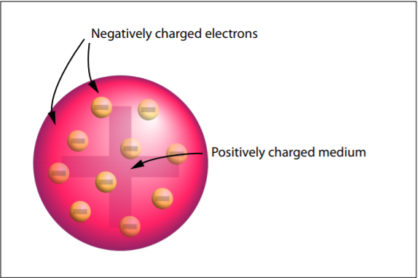

- However, this model of the atom was about to undergo a radical transformation.
  - The first major change came about as a result of one of the most famous experiments in the history of chemistry – the Rutherford gold foil experiment.
    - In thiGics experiment, Ernest Rutherford bombarded a very thin sheet of foil, made of gold, with alpha particles. (Alpha particles are positively charged particles, each containing two protons and two neutrons, and are symbolized by the Greek letter, a.
    - Rutherford’s source of alpha particles was a sample of the radioactive element, polonium.
      - Elements that are radioactive have unstable nuclei.
      - These atoms spontaneously decay (or fall apart), emitting tiny fragments of themselves.
      - One of the decayed products of polonium is an alpha particle.

- Given the understanding of the atom at the time, Rutherford expected that most of the positive alpha particles would pass straight through the atoms in the gold foil.
  - In fact, most did.
  - However, much to his surprise, a small fraction of alpha particles deflected at wide angles and fewer still rebounded back toward the source.
  - Rutherford explained these observations by inferring that these few alpha particles must have hit a small object of dense positive charge.
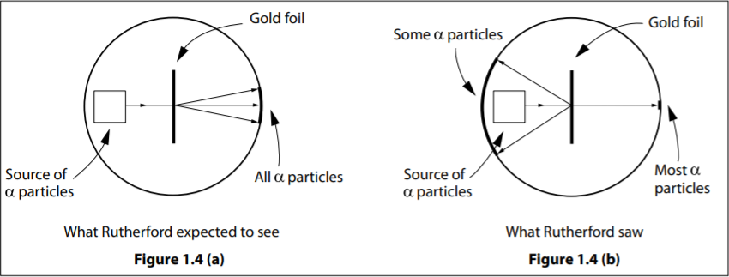

- Rutherford had discovered the nucleus!
  - Rutherford also inferred that since most alpha particles went through the foil without deflecting, most of the atom must consist of empty space.
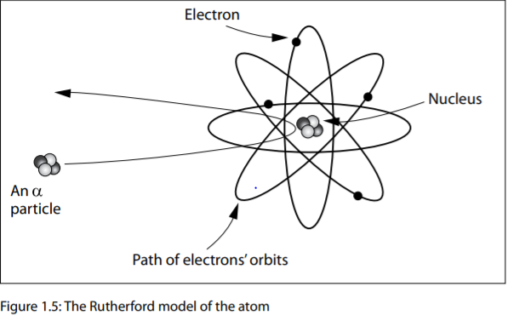
  - As a result of Rutherford’s work, the model of the atom changed to a small, dense, positive core called the nucleus, surrounded by orbiting electrons.

Support Questions
- In December 2007, the nuclear reactor at Chalk River, Ontario (near Ottawa), belonging to Atomic Energy of Canada Limited (AECL), was shut down for maintenance. This reactor produces much of North America’s supply of technetium-99m, an important radioactive chemical used in the diagnosis and treatment of many major diseases.
  - Research the properties of technetium-99m and its medical application, and then write a brief paragraph about these properties.
    - Technetium-99m is a radioactive isotope of technetium, the 43rd element on the periodic table. It is used in the diagnosis and treatment of many diseases, including cancer, heart problems, and gallbladder disorders. The nuclei of radioactive atoms spontaneously disintegrate, emitting tiny fragments. In the process, these atoms change into lighter elements. Technetium-99m doesn’t occur naturally, but it can be synthesized artificially from molybdenum in a nuclear reactor.
  - Why can’t technetium-99m be stockpiled, like other medications?
    - Once technetium-99m is produced, it only lasts for a few days before it disintegrates into lighter elements. Therefore, it cannot be stockpiled like other medications. Instead, small batches have to be made continually, using a nuclear reactor.
  - Critics argue that the Chalk River reactor is old and potentially dangerous. However, building a new nuclear reactor is very expensive. In your opinion, should Canadian tax dollars be used to replace the reactor? Explain your reasoning.
    - The Chalk River nuclear reactor is quite old and has been prone to accidents in the past. The accidental leak of radioactive materials into the environment is potentially lethal. Constructing a new reactor is very expensive, partly due to the technical complexity of the reactor, but also due to the considerable red tape involved (for example, environmental safety reviews). However, it’s impossible to put a price tag on human lives. The medical application of isotopes like technetium-99m is invaluable to the Canadian families that benefit directly from this application. Therefore, it is essential that a new reactor be built to ensure an adequate supply of these isotopes. Since Atomic Energy of Canada Limited is a federal crown corporation, it is inevitable that some tax dollars must fund the operation of the reactor. However, if the production capacity of a new reactor is increased, more medical isotopes can be sold to foreign markets. The revenue generated from the sales could offset the increased burden on the Canadian taxpayer.

Spectroscopy and the Atom
- Spectroscopy is the study of energy that is absorbed or emitted by matter.
- By the mid-nineteenth century, chemists already knew that each element of the periodic table emits its own characteristic spectrum of light when it absorbs energy from some external source.
  - For example, a sample of hydrogen gas emits purplish light when electricity is passed through it.
    - When this purplish light is passed through a prism, it is found to be made up of two violet lines of colour, a blue-green line, and a red line.
    - Regardless of the source of the hydrogen, these lines always appear in the same position, with the same light wavelengths.
    - The red wavelength is always 656.3 nanometres (abbreviated as nm), the blue-green wavelength is 486.1 nm, the blue-violet one is 434.1 nm, and the violet one is emitted at 410.2 nm.
    - This pattern of lines emitted by elements became known as a line spectrum.

X-Rays
- One method of producing X-rays also involves electron transitions.
  - Some elements will produce X-rays when electron beams pass through them.
- Inside an X-ray machine, atoms of a suitable element are first bombarded with a beam of electrons.
  - This causes some of the inner orbit electrons to be “bumped” out of the atom, forming a temporary “hole.”
  - The resulting electron hole can be filled by any electron in the atom’s intermediate or outer orbits.
  - If the electron comes from an outer orbit, flashes of high-energy X-rays are emitted.
  - The reason that these emissions have high energy is because the energy difference between the two electron orbits is large.

Support Questions
- Ernest Rutherford used the element polonium in his gold foil experiment. What property of the element polonium makes it extremely dangerous to work with?
- Ernest Rutherford used the element polonium because it is radioactive, and it emits (relatively large) alpha particles.

- Rank the following forms of electromagnetic radiation in order of increasing energy: visible light, gamma rays, radio waves, infrared waves.
- Radio waves
- Infrared waves
- Visible light
- Gamma rays
- Compare the energy of red, blue-green, blue-violet, and violet light illustrated in Figure 1.7.
- Red light has the least energy and is emitted when the electron falls from level 3 to level 2. Blu-green light has slightly higher energy and is emitted when the electron falls from level 4 to level 2. Blu-violet light has even higher energy and is emitted when the electron falls from level 5 to level 2. Violet light has the highest energy and is emitted when the electron falls from level 6 to level 2.

- Explain why atomic emission spectra are sometimes called “fingerprints” of the elements.
- Each element has a unique atomic emission spectrum similar to the way that each person has a unique fingerprint.

- There are only four lines in the visible spectrum of hydrogen. Explain why an electron transition from n=6 to n=1 would not appear in the visible spectrum shown in Figure 1.6.
- The electron transition from n = 6 to n = 1 would not appear because its energy is too high to be within the visible portion of the electromagnetic spectrum.

Quantum Mechanical Model of the Atom
- The development of the next atomic model began with the discoveries of some rather peculiar properties of the electron.
  - In other science courses, you may have heard that electrons travel as waves.
  - Yet, you have also read that the electron is a negatively charged particle.
  - Are they waves or particles?

Are Electrons Waves or Particles?
- By the 1920s, there was considerable evidence to support the idea that electrons could behave as a wave of energy as well.
  - For example, in 1927, C. J. Davidson and L. H. Germer conducted an experiment in which electrons were fired at a nickel crystal.
    - A detector was used to trace the path of the electrons after their collision with the crystal.

- The results of the experiment produced a ring pattern identical to the one produced when X-rays were fired at the crystal (Figure 1.10).
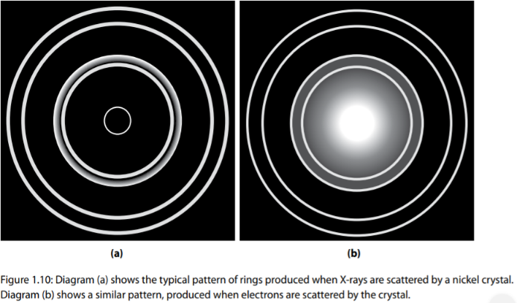
  - The production of rings like this is a characteristic property of waves, known as diffraction.
  - X-rays are waves that are part of the electromagnetic spectrum.

- The dual nature of the electron (behaving both as a particle and a wave) was one of the key ideas that led to the current model of the atom – the quantum mechanical model.
  - One of the key ideas in this model is that the exact location and speed of the electron can never be simultaneously known.
    - Consequently, it is inaccurate to describe the electron as a particle orbiting a fixed path around the nucleus, as in Bohr’s idea of an orbit.
    - Instead, quantum mechanics uses the idea of probability to describe the location of the electron.
  - According to quantum mechanics, there is a region of space around the nucleus in which the probability of finding the electron is high.
    - These high probability regions or electron clouds are called orbitals (Figure 1.11).
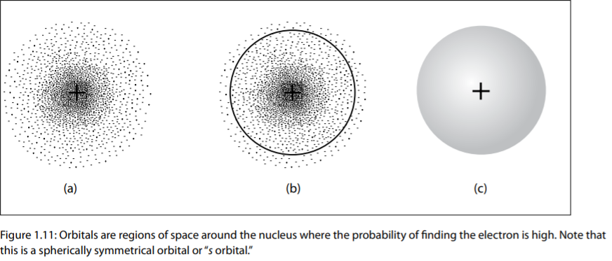

- Suppose that the plus sign in Figure 1.11 (a) is a beehive.
  - Each dot in the picture represents flowers visited by the bees of the hive.
  - The density of visits is greatest near the hive and then decreases as the distance from the hive increases.
  - Similarly, in an atomic orbital, each dot represents the location of the electron at any given moment.
  - The electron density is greatest at the centre of the orbital – the nucleus.
  - Electron density decreases as the distance from the nucleus increases.
- However, for practical purposes, each orbital has an outer boundary, as shown in Figure 1.11 (b) and (c).
  - This area within the orbital represents the region around the nucleus in which the probability of finding the electron is about 95%.

- The shape and energy of orbitals is determined by solutions to a complex mathematical equation known as the Schrodinger wave equation.
  - The results of this equation show that there are four different orbitals, which are identified by the letters s, p, d, and f.

Orbitals
- Figure 1.12 represents the four different possible orbitals.
- Each orbital represents a region of space around the nucleus where the electron can be found.
  - The s orbitals are arranged in a spherically symmetrical manner around the nucleus.
  - There is only one type of s orbital.
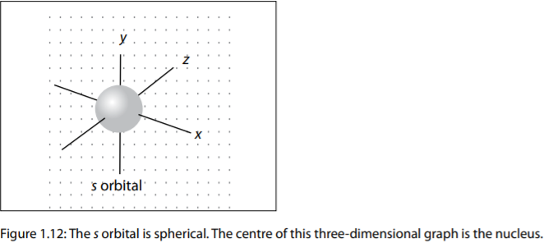
  - Each s orbital can accommodate two electrons.

- There are three different p orbitals.
  - Each looks like a dumbbell that is arranged around one of the three coordinate axes: x, y, and z.
  - The orbitals can each hold up to two electrons.
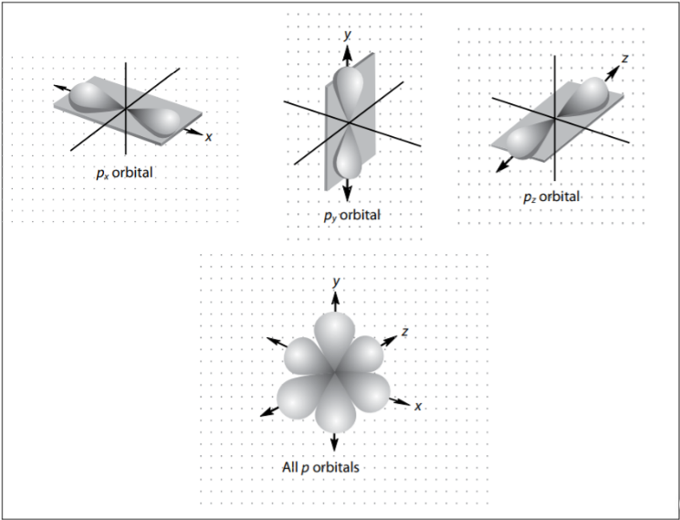
  - This means that a complete set of p orbitals can hold up to six electrons.

- There are also five d orbitals and seven f orbitals.
  - The complex, three-dimensional shape of these orbitals, which will not be illustrated, is beyond the scope of this course.
- Like s and p orbitals, each d and f orbital can hold up to two electrons.
  - Therefore, d orbitals can accommodate up to 10 electrons, while f orbitals can accommodate 14.

- Table 1.1 summarizes the four types of orbitals and the number of electrons they can accommodate.
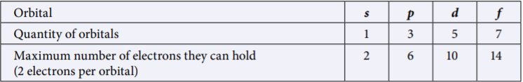

What do Atoms Look Like?
- Since, Hydrogen has an atomic number of 1, it has only one proton and one electron.
  - The single electron of hydrogen occupies an s orbital.
  - Therefore, the hydrogen atom is always shown as being spherical.
- Most atoms (other than hydrogen and helium) consist of a nucleus surrounded by a number of different orbitals blended together.
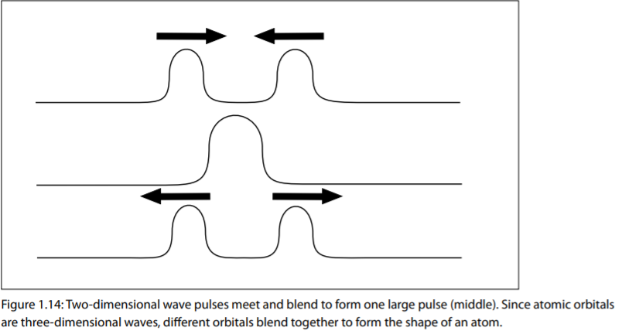
  - It looks something like this (Figure 1.14):

- An atomic orbital is like a three-dimensional wave.
  - Therefore, the shape of an atom is the result of the blending of its orbitals.
- If an atom contained s and p orbitals, these orbitals would combine and blend together like the combing wave pulses in Figure 1.15, to produce a new wave that was a blend of the two shapes.
  - The result would be an atom that was neither spherical nor shaped like a dumbbell, but rather something in between.
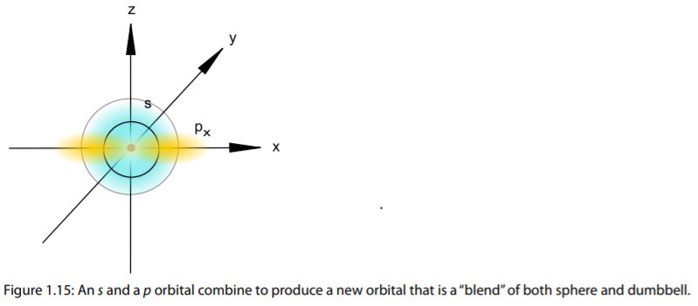

- In summary, the quantum mechanical model suggests that atoms consist of a nucleus surrounded by a combination or “blend” of orbitals containing electrons.
  - In order to explain the properties of the elements, it is necessary to know the energy of these orbitals and their electrons.

Energy-Level Diagrams
- The energy-level diagram (Figure 1.16) shows the relative energies of the orbitals in an atom under normal conditions.
  - Comparing the energies of the orbitals and the number of electrons they occupy is useful to explain and predict the properties of the elements of the periodic table.

- Each circle represents one orbital.
  - Each orbital can accommodate up to two electrons and is labelled with a number followed by a letter, such as 2s.
  - The number in the orbital label gives the energy level of the orbital.
    - For example, the first energy level (n =1) contains only one orbital – 1s.
    - This orbital has the lowest energy of all.
    - You can think of it as the orbital closest to the nucleus.
    - The s orbital is analogous to the Bohr idea of the first orbit around the atom.
- The second energy level (n = 2) contains two types of orbitals – s and p.
  - Since they are slightly different in energy, they are often referred to as sub-levels of the second energy level.

- We can use a simple mathematical formula to calculate the number of orbitals (sub-levels) associated with a given level, n.
  - This formula is $n^{2}$.
    - For example, if we are looking at n = 2, the formula, $n^{2}$, tells us that there will be $2^{2}$ sub-levels or orbitals associated with the second level in the atom.
    - So, for n = 2, we will have four orbitals associated with n = 2.
    - The first of these four would be the s orbital and the other three would be the group of three orbitals of the p type (for the second level, n = 2, we would call thar group of p orbitals, the 2p groups of orbitals).

- If we moved to the fourth level, n = 4, the formula $n^{2}$ shows us that there will be $4^{2}$ orbitals associated with the fourth level.
  - Those 16 orbitals will contain all four types of orbitals s, p, d, and f.
  - The first one will be the s orbital at the fourth level (called 4s), the next three orbitals will be the group of p orbitals (three of them called the 4p group). The next type, the d type, would have a group of five orbitals of the d type (five of them called the 4d group), and the remaining seven orbitals of the 16 would be the group of f type orbitals (seven of them called the 4f group).
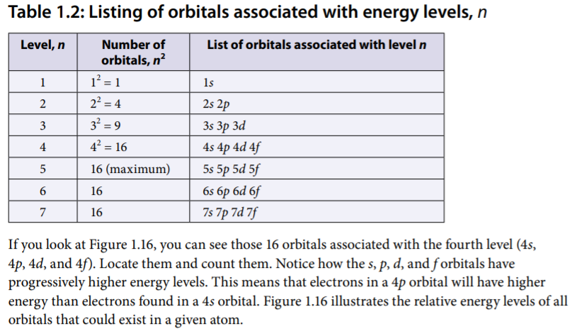
- Table 1.2 shows the orbitals that would be associated with a given level

- Note that as you proceed to higher energy levels, the space between energy levels decreases.
  - This results in some rather unusual orbital arrangements.
  - For example, Figure 1.16 indicates that the 3d orbitals are closer in energy to the 4s and 4p orbitals than they are to the 3s and 3p orbitals.

Pauli Exclusion Principle
- To have opposite spin (arrows).

Aufbau Principle
- Lowest fill first.

Hund’s Rule (“Align Spins”)
- When electrons are placed within a sub-level in which the orbitals have identical energy (p, d, or f), electron repulsion is minimized if each orbital receives one electron before pairing occurs.

Support Questions
- How do the terms “orbit” and “orbital” differ?
- The term “orbit” is used to describe the path of the electron in the Bohr model of the atom. In the model, the electron orbits the nucleus, much like a planet orbits the sun. The term “orbital” is used in the quantum mechanical model of the atom. It represents the probability region around the nucleus of the atom in which the likelihood of finding the electron is high.

- Write the electron arrangement for each element using the diagonal rule and draw the energy-level diagram for each. Indicate whether each element belongs in the s-block, p-block, d-block, or f-block of elements.
  - Aluminum, Al
  - The electron arrangement for aluminum (atomic number 13, having 13 electrons) would read as follows.

Al = ${[1s}^{2}{2s}^{2}{2p}^{6}{3s}^{2}{3p}^{1}]$ or abbreviated we see that the first part of that configuration is that of the nearest noble gas Ne so we can write the configuration this way:

Al = $[Ne,{3s}^{2},{3p}^{1}]$

Because the configuration ends $p^{1}$, this element belongs in the p-block of elements.
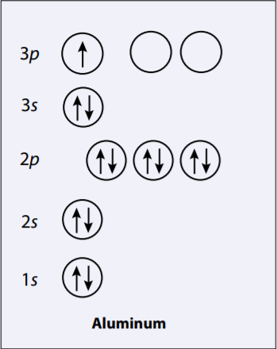

  - Chlorine, Cl
  - The electron configuration for chlorine would be:

Cl = $[{1s}^{2},{2s}^{2},{2p}^{6},{3s}^{2},{3p}^{5}]$ or abbreviated we can write Cl = $[Ne, {3s}^{2},{3p}^{5}]$

Because the configuration ends $p^{5},$ this element also belongs in the p-group of elements.
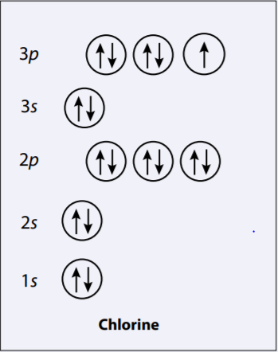

  - Scandium, Sc
The electron configuration for scandium would be:

Sc = $[{1s}^{2}{2s}^{2}{2p}^{6}{3s}^{2}{3p}^{6}{4s}^{2}{3d}^{1}]$ or abbreviated we could write:
Sc = $[Ar, {4s}^{2},{3d}^{1}]$
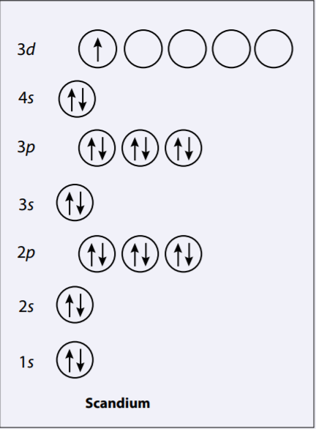

Support Questions
- Write the electronic configuration for:
  - Selenium, Se
  - ${1s}^{2},{2s}^{2},{2p}^{6},{3s}^{2},{3p}^{6},{4s}^{2},{3d}^{10},{4p}^{6}or abbreviated:Ar, {4s}^{2},{3d}^{10},{4p}^{4}$

  - Strontium, Sr
  - ${1s}^{2}, {2s}^{2},{2p}^{6},{3s}^{2},{3p}^{6},{4s}^{2},{3d}^{10},{4p}^{6},{5s}^{2} or abbreviated:Kr, {5s}^{2}$

- Based on their electronic configurations, write the chemical symbol of the icon that the elements in Support Question 9 most commonly form. Justify your prediction.
  - Selenium will most likely form the ${Se}^{2-}$ ion because it has only two electrons less than krypton, which is its nearest noble gas. Therefore, it will gain two electrons to form an ion. Strontium forms the ${Sr}^{2+}$ ion because it has two electrons more than its nearest noble gas, krypton. Therefore, strontium loses two electrons to form an ion.

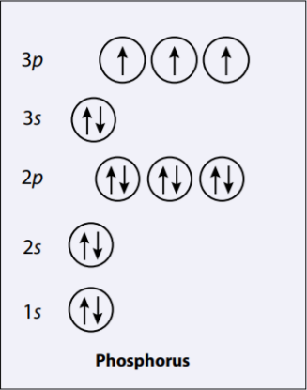
- Sketch the energy-level diagram for phosphorus.

- Use your diagram in Support Question 11 to:
  - Predict why $P^{4-}$ is not common.
  - In order to form $P^{4-},$ phosphorus would have to gain four electrons. Once it gains three electrons, however, it forms a stable phosphide ion and is not likely to gain an additional electron because it has a filled outer sub-level.

  - Explain why $P^{3-}$ is more likely to exist than $P^{5+}.$
  - $P^{3-}$ is more likely to exist than $P^{5+}$ because gaining three electrons is a more likely event than losing five electrons.

