Intro to Global Management

Global Management

Management Principles
Planning
- Performance objectives, how to achieve them
Controlling
- Measuring performance, taking action
Organizing
- Arrange tasks, people, resources to accomplish work
Leading
- Inspire hard work to achieve high performance

Key Global Trends in Business
- Use of social media to:
  - Stand engaged with customers
  - Develop awareness of company in the marketplace
  - Identify and attract NEW customers
  - Linked In – for recruiting
- Becoming more difficult to define value and customer satisfaction:
  - Do customers care more about price of product/reputation/image of the company?
- Globalization of production:
  - Electronics (e.g. iPhone)
    - Design work (Apple, U.S.)
    - Production of key components (Toshiba, Japan; Infineon, Germany; Samsung, Korea etc.)
    - All parts assembled abroad (Foxconn, China)
    - Finished equipment is re-exported to the Apple, U.S.
- Increase in the use artificial intelligence, machine learning, quantum computing, robotics:
  - E.g. robots are being used a receptionists and nursing aid (Japan), 3-D printing, driverless vehicles, Uber
- Competition in the global marketplace is getting more intense
  - Difficult to gain and maintain market share
- Businesses have to contend with environmental uncertainty (Fig. 1.6)
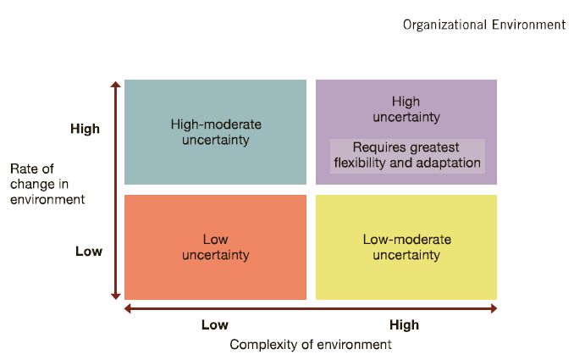
  - Low uncertainty
  - High uncertainty (e.g. technology)

Responses to Global Trends
Business executives have to:
- Revisit business model regularly (be nimble be quick)
- Know their customers very well and anticipate their demands
- Focus on the things they do best
- Focus on Flexibility and spend: IT is important but not enough
- Talented workers needed to drive innovation and support change
  - Freeminum
  - SaaS (Software as a Service)

Talent Management
- Recruit and keep employees
- Develop employee capabilities in accordance with business strategies
- Measure and manage performance
- Recognize, reward and engage employees
- Engage in succession planning to orderly replace retiring managers

Challenges Managers Face in Today’s Workplace
- Age difference can be a major challenge:
  - How do mangers integrate Generation Y workers (18-24yr olds) in a workplace domination at the top by older workers who are approaching retirement?
- Cultural differences:
  - How do managers allow people to be themselves without increasing the potential for conflict due to major difference in values and beliefs?
- Managers are expected to organize the workplace in a way that gets the most out of workers and other resources at their disposal

Value generation process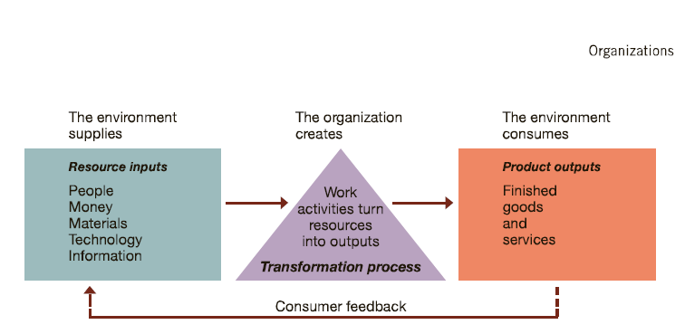

Do managers run their companies well?

Productivity and dimensions of organizational performance
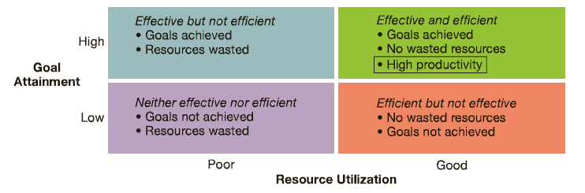

Organizations have different level of management

Management levels in typical business and non-profit organizations
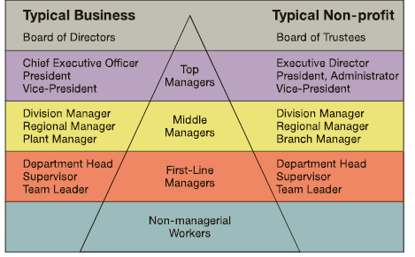

Management activities and roles

Mintzberg’s 10 Managerial Roles
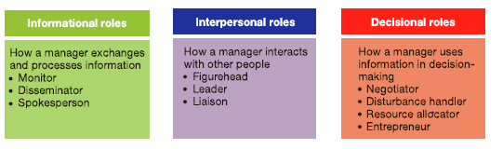

Essential Managerial Skills
- Conceptual skills
- Human skills
- Technical skills

Katz’s essential managerial skills
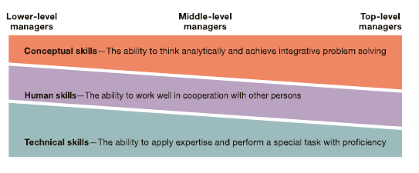

Definitions
Accountability - requirement to show performance results to a supervisor
Administrators – manager in a public/non-profit organization
Agenda setting – develops action priorities for accomplishing goals and plans
Competitive advantage – ability to do something so well that it out performs competitors
Conceptual skill – the ability to think analytically to diagnose and solve complex problems
Controlling – process of measuring performance and taking action to ensure desired results
Discrimination – occurs when someone is denied a job / job assignment for reasons not job related
Effective managers – helps other achieve high performance and satisfaction at work
Emotional intelligence – ability to understand emotions and manage relationships effectively
Environmental uncertainty – lack of complete information about the environment
Ethics – set standards of good and bad/right and wrong in one’s conduct
Functional managers – responsible for one specific area (finance, marketing, production, personnel, accounting or sales)
General environment – composed of political, economic, social/cultural, and natural environment conditions
General managers – responsible for complex, multifunctional units
Glass ceiling effect – invisible barrier limiting career advancement or women and minorities
Globalization – the worldwide interdependence of resource flows, product markets and business competition
Human skill – interpersonal skill, ability to work well in cooperation with other people
Intellectual capital – the collective brainpower/shared knowledge of a workforce
Internet censorship – deliberate blockage and denial of public access to information posted on the internet
Knowledge worker – someone whose mind is a critical asset to employers
Leading – process of encouraging enthusiasm and inspiring efforts to achieve goals
Learning – a change in behavior that results from experience
Lifelong learning – continuous learning from daily experiences
Line managers – directly contribute to producing the organization’s goods/services
Management – process of planning, organizing, leading, and controlling the use of resources to accomplish performance goals
Manger – person who supports, activates, and is responsible for the work of others
Managerial competency – a skill-based capability for high performance in a management job
Middle managers – oversee the work of large departments/divisions
Networking – process of creating positive relationships with people who can help advance agendas
Open systems – transforms resource inputs from the environment into product outputs
Organization – collection of people working together to achieve a common purpose
Organizational effectiveness – sustainable high performance in using resources to accomplish a mission
Organizing – process of assigning tasks, allocating resources, and coordinating work activities
Performance effectiveness – an output measure of task/goal accomplishment
Performance efficiency – an input measure of resource cost associated with goal accomplishment
Planning – process of setting objectives and determining what should be done to accomplish them
Portfolio worker – has up to-date skills that allow for job and career mobility
Prejudice – display of negative, irrational attitudes towards members of diverse populations
Productivity – quantity and quality of work performance, with resource utilization considered
Quality of work life (QWL) – overall quality of human experiences in the workplace
Skill – the ability to translate knowledge into action that result in desired performance
Social capital – a capacity to get things done with the support and help of others
Specific environment – task environment, includes the people and groups with whom an organization interacts
Staff managers – use special technical expertise to advise and support line workers
Stakeholders – individuals and groups directly affected by the organization and its strategic accomplishments
Strategic positioning – occurs when an organization does different things or the same things in different ways from one’s major competitors
Sustainable business – meets both the needs of customers and protects the well-being of our natural environment
Sustainable innovation – creates new products and production methods that have reduced environmental impact
Team leader – report to middle managers and supervise nonmanagerial workers
Technical skill – the ability to use expertise to perform task with proficiency
Top managers – guide the performance of the organization as a whole or of one of its major parts
Upside-down pyramid – operating workers are at the top serving cutomers while managers are at the bottom supporting them
Value creation – occurs when the result of a work task or activity makes a product or service worth more in terms of potential customer appeal than at the start
Workforce diversity - describes differences among workers in gender, race, age, ethnicity. Religion, sexual orientation, and able-bodiedness

Review questions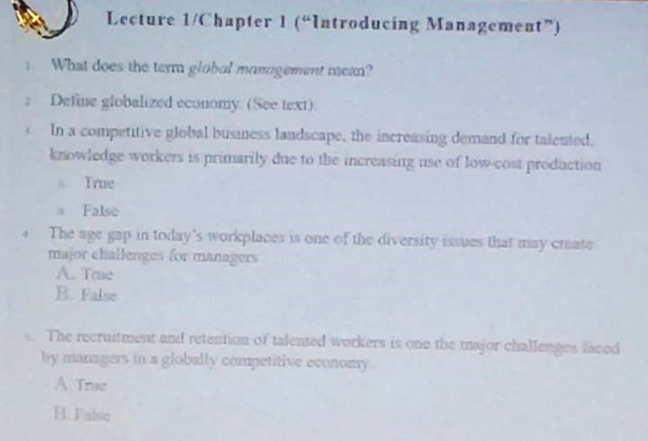

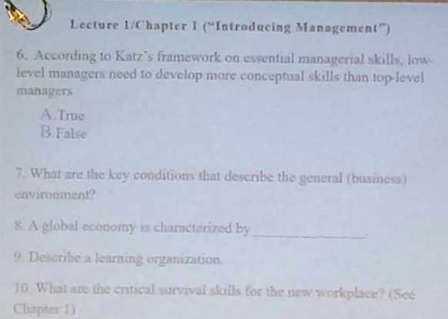

Chapter 13 Information and Decision Making
Information decision making action outcomes/consequences

5 Characteristics of Useful Information
- Timely
- Accurate
- Relevant
- Understandable
- Complete

Decisions that managers make have serious consequences…

Need to know:
- How managers make decisions, or ought to make decision
- What pitfalls managers should avoid when making decisions

Managers operate in different environments:
Environments depend on what you know
- Uncertain environment
  - You are unsure what will happen when you do something else
- Risk environment
  - In certain conditions, you know the chance of it becoming risky
- Certain environment
  - Ideal, almost non-existent, absolutely sure

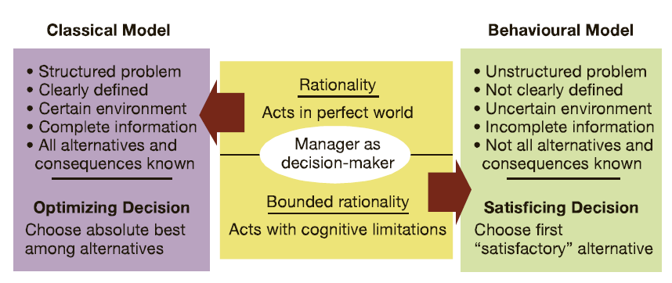
Fig. 13.9 how managers make/should make decisions (differences in the classical and behavioral models of managerial decision making)
MVP - minimum viable product

How people make decisions

Heuristics
Strategies (“quick and dirty rules”) that people use to simplify decision-making when there is limited time, information and energy
- Availability Heuristic
  - People use information readily available from memory as a basis for assessing a current event or situation
  - Ex. Buy the new iPhone do we look up the specs from scratch or just buy it
- Representativeness Heuristic
  - People asses the likelihood of something occurring based on its similarity to a stereotyped set of occurrences
  - Ex. Hiring someone based on the school they’re from, based on a stereotype, candidates don’t get a fair shot, manager doesn’t take the time to consider it further
- Anchoring & adjustment heuristic
  - Involves making decisions based on adjustment to a previously existing value or starting point
  - Ex. Anchoring someone’s salary. The raise would go up very slow because the manager is not updating their view on the employee (have matured have more experience)

Decision Errors & Traps
- Framing error
  - Framing: choosing to present a fact in a positive light or a negative light
- Escalating commitment
  - Gets negative outcomes and instead of altering the plan continues and results in negative outcomes
  - Ex. GM makes cars people didn’t like and kept selling them resulting in a loss

Steps in the decision-making process
- Find and define the problem
- Generate and evaluate alternatives
- Decide on preferred course of action
- Implement the decision
- Evaluate the results
Practice:
- What are the 5 steps of the decision-making process?
- Explain programmed or structured decisions vs. non-programmed/unstructured decisions; intuitive thinking vs. systematic thinking

Definitions
Analytics – involve systematic gathering and processing of data to make informed decisions
Bounded rationality – describes making decisions within the constraints of limited information and alternatives
Business intelligence – taps information systems to extract and report data in organized ways that are helpful to decision makers
Confirmation error – occurs when focusing only on information that confirms a decision already made
Cost-benefit analysis – involves comparing the costs and benefits of each potential course of action
Creativity – the generation of a new idea or unique approach that solves a problem of crafts and opportunity
Crisis – and unexpected problem that can lead to disaster if not resolved quickly and appropriately
Crisis management – preparation for the management of crisis that threaten an organization’s health and well being
Decision – a choice among possible alternative courses of action
Design thinking – unlocks creativity in decision-making through a process of experiencing ideation of prototyping
Information technology – helps acquire, store, and process information
Intuitive thinking – approaches problems in a flexible and spontaneous way
Lack-of-participation error – failure to involve in a decision the persons whose support is needed to implement it
Management information systems – use IT o collect, organize, and distribute data for use in decision-making
Multidimensional thinking – ability to address many problems at once
Non programmed decisions – applies a specific solution crafted for a unique problem
Optimizing decision – chooses the alternative giving the absolute best solution to a problem
Problem solving – involves identifying and taking action to resolve problems
Programmed decision – applies a solution from past experience to a routine problem
Satisficing decision – chooses the first satisfactory alternative that comes to one’s attention
Spotlight questions – test the ethics of a decision by exposing it to scrutiny through the eyes of family, community members, and ethical role models
Strategic opportunism – focuses on long term objectives while being flexible in dealing with short-term problems
Structured problems – straightforward and clear with respect to information needs
Systematic thinking – approaches problems in a rational and analytical way
Unstructured problems – have ambiguities and information deficiencies

Review questions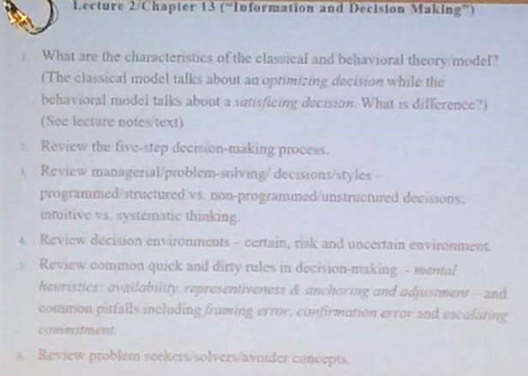

Chapter 3 – International Business

Global economy
A worldwide network of interdependent countries that share resource supplies, product markets and a competitive business environment

Globalization
Process of growing interdependence among the components of the global economy
The key channels which countries are becoming more interdependent/integrated:
- Outsource services
- Connecting with people that would have not have through social media
- International finance/trade
- Immigration

Why businesses would want to conduct business in global markets
5 reasons:
- Increase brand recognition
- Search for cheaper labor supply
- Open doors to new markets (diversity)
- Search for financial resources
- Increase sales

How companies can effectively participate in global markets
Market entry strategies…

Exporting
Direct – your products directly to foreign customers
- Advantages: establish and maintain relationship with foreign customers, control pricing of product, get a larger share of the profit, if any
- Disadvantages: have to learn about foreign markets, learn about laws
Indirect – sell your product to foreign customers through an agent of distributor abroad
- Advantages: requires limited knowledge of foreign markets, talk to agent for details, save money – can use the same staff
- Disadvantages: no opportunity to develop a relationship with foreign customers, not a personal connection with customer, have to split profit with the agent-less profit

Licensing Agreement
- Pay another company a fee for the right to make or sell a product in a particular country/region
  - Ex. Pay for right to use another company’s patent/trademark
- Disadvantage: can be costly – royalty fees > 10% of sales
- Advantage:

Franchise Agreement
- Similar to licensing agreement
  - May enter a local/foreign market by buying the right to use another company’s name and operating methods
  - A contract to duplicate a specific business

International joint ventures
- Firm may enter a foreign market by jointly owning and managing a business operation with local partners
- Two or more companies setup a separate legal entity to undertake a mutually beneficial project

Major commitment to foreign markets
Multinational corporations
- Firms owns major assets and/or undertakes production abroad through subsidiaries
Foreign direct investment (FDI)
- Parent company has ownership and control over its overseas operations
- This is most costly and risky market entry strategy

Definitions
Child labour – full-time employment of children for work otherwise done by adults
Comparative management – studies how management practices differ among countries and cultures
Corruption – involves illegal practices to further one’s business interests
Culture shock – the confusion and discomfort a person experiences when in an unfamiliar culture
Ecological fallacy – assumes that a generalized cultural value applies equally well to all members of the culture
Ethnocentric attitudes – believe the best approaches are found at home and tightly control foreign operations
Ethnocentrism – belief that one’s membership group or subculture is superior to all others
European union – a political and economic alliance of European countries
Foreign direct investment – building, buying all, or part ownership of a business in another country
Foreign subsidiary – a local operation completely owned by a foreign firm
Geocentric attitudes – high in culture intelligence and take a collaborative approach to global management practices
Global business – conducts commercial transactions across national boundaries
Global corporations – MNC, is a multinational business with extensive operations in more than one foreign country
Global management – involves managing operations in more than one country
Global manager – culturally aware and informed on international affairs
Global sourcing – materials or services are purchased around the world for local use
Global strategic alliances – a partnership in which foreign and domestic firms share resources and knowledge for mutual gains
Greenfield investments – builds an entirely new operations in a foreign country
High-context cultures – rely on non-verbal and situational cues as well as on spoken of written words in communication
Individualism-collectivism – the degree to which a society emphasizes individuals and their self-interests
Insourcing – job creation through foreign direct investment
Joint venture – operates in foreign country through co-ownership by foreign and local partners
Low-context cultures – emphasize communication via spoken or written word
Masculinity-feminity – degree to which a society values assertiveness and materialism
Monochromic culture – people tend to do one thing at a time
Most favored nation status – gives a trading partner most favorable treatment for imports and exports
NAFTA – north American free trade agreement, links Canada, the US, and Mexico in an economic alliance
Political risk – potential loss in value of a foreign investment due to instability and political changes in the host country
Political-risk analysis – tries to forecast political disruptions that can threaten the value of a foreign investment
Polycentric attitudes – respect local knowledge and allow foreign operations to run with substantial freedom
Polychromic culture – tie is used to accomplish many different things at once
Power distance – the degree to which a society accepts unequal distribution of power
Protectionism – a call for tariffs and favorable treatments to protect domestic firms from foreign competition
Proxemics – how people use space to communicate
Sustainable development – meets the needs of the present without hurting future generations
Sweatshops – employ workers at very low wages for long hours and in poor working conditions
Tariffs – taxes governed levy on imports from abroad
Transnational corporations – an MNC, that operates worldwide on a borderless basis
World 3.0 – a world where nations cooperate in the global economy while still respecting different national characters and interest
World trade organization – member nations agree to negotiate and resolve disputes about tariffs and trade restrictions

Review questions
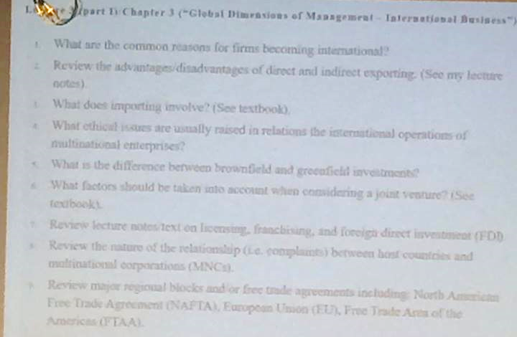

Chapter 3 Part 2 – Global Dimensions of Management
- Define a global manager
- What is the difference between a low-context and a high-context culture?
- What are Hofstede’s five cultural dimensions for comparing value differences across national cultures?

What is culture?
A shared set of beliefs, values, and patterns of behavior common to a group of people

Cultural awareness
The two building blocks of cultural awareness:
- Reasonable sensitivity
  - Put yourself in someone else’s shoes, choosing words carefully
- Self-awareness
  - Know yourself, what is comfortable, biases

3 popular dimensions of culture
- Spoken language
  - Low context culture
    - Most communication takes place via the spoken or written word
  - High context culture
    - Most communication takes place through nonverbal and situational cues in addition to the written nor spoken word
- Time-orientation
  - What is the attitude towards time
  - Polychromic culture
    - Time is used to accomplish many different things at once
  - Monochromic culture
    - People tend to do one thing at a time
- Interpersonal space
  - How comfortable you are with being in close proximity to you

Global managers
- Comfortable with cultural diversity
- Quick to find opportunities in unfamiliar settings

Cultural intelligence
- Adaptable to other cultures

Analyzing national cultures
Geert Hofstede
- Developed one of the most useful frameworks for studying differences in the cultures of employees across countries, and identifying individual countries according to their culture
  - 1967-1973: he studied the values of IBM workers with similar jobs in 40 countries
    - Scored on 4 dimensions of culture:
      - Power distance
        - High – look up to it, hope for the best for themselves In the future
        - Low - opposite
      - Uncertainty avoidance
        - High – believes in order, wisdom of the past, things shouldn’t change
        - Low - opposite
      - Individualism/collectivism
        - Individualism - Whats good for myself and the family
        - Collectivism - Whats good for the whole community
      - Femininity/masculinity
        - Feminine (Sweden) – country that values feelings, relationships, not judged on material success
      - Time-orientation (later added as a 5th dimension)
        - Short term - Wants things now
        - Long term - Willing to wait, make sacrifices, plan for the future

Summary of Hofstede’s 5 Cultural Dimensions and National Cultures
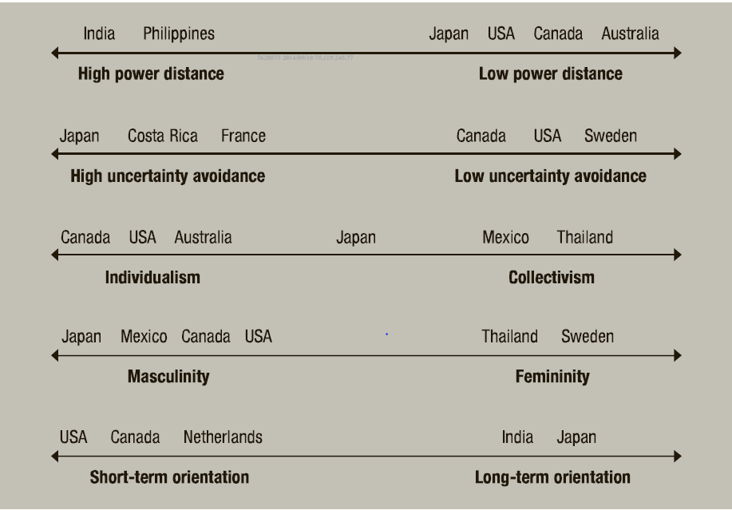
How countries compare on Hofstede’s dimensions of national culture

Review questions

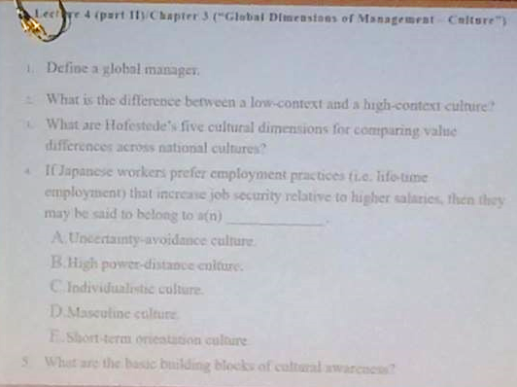

Chapter 2 - Management learning
Historical examples of management
- 5000 BC: Pyramids of Giza
- 3000 BC: Sumerian priests keeping records in Babylon
Evolution of Modern Management (1900 present)
- Management as a science and the rise of professional managers

Classical approach to management
- People will rationally consider all available opportunities and thoughtfully weight their associated benefits against their costs. They will do whatever is necessary to achieve the greatest personal economic gain
- The development of management theories was partly driven by the demand for well-trained professional managers

What drove the demand for professional managers
- EUROPE – Industrial revolution (1700-1900)
  - Large factories were built to facilitate the mass production of goods
  - Managers were needed to assign works to specific production tasks
- UNITED STATES – Railroads (1860s to 1880s)
  - Emergence of large U.S corporations in rail transportation
  - These companies were funded by many shareholders (absent owners)
  - Managers were needed to run these companies on a daily basis

- Given the rise of large factories in Europe and publicly listed rail transport companies in the US:
  - It is not surprising that European scholars like Max Weber would play a major role in the development of modern management and;
  - The American scholar Frederick Taylor would play a a pioneering role in the development of management as a science

The 3 branches of the classical approach to management
- Scientific management
- Administrative principles
- Bureaucratic organization
FREDERICK TAYLOR (1865-1915)
- Father of Modern Management
- Born to a wealthy Quaker family in Phili
- An engineer by profession
- Lectured fro, 1909 to 1914 at Harvard University
- A management consultant at the US navy
- Wrote Scientific Management in 1911
Taylor Four Principles of Scientific Management
- Job design should be based on scientific methods not guess work
- The training and development of worked should also be based on scientific methods
- Managers should help work to follow scientific approaches in carrying out their assigned duties
- Managers should plan and analyze the job while workers should focus on performing their assigned jobs
QUESTION: Suppose Protech Industries Inc installed a new computer system to clock every worker’s pace per second and determine each worker’s pay and bonus scale on the basis of her performance against a certain standard. T OR F This is an example of Taylor’s approach to scientific management
ANSWER: TRUE
General administrative Management: Henri Fayol (1941-1925)
- French executive and mining engineer

5 Duties of Management
- Foresight: plan for the future
- Organization
- Command: make sure that workers are doing their best
- Coordination:
- Control:
QUESTION: Henri Fayol’s __ closely resemble the __ that are used in contemporary businesses
ANSWER: Five duties of management; four functions of management
Mary Parker Follett (1868-1933)
- Social worker turned management scholar

Human psychology and management
- Dissatisfied with how scientific management ignored the human element of organizations
  - People are not machines to be fine tuned for top performance
- Follett emphasized that organizations should operate like communities where workers and managers strive for harmonious relations
- Mary Parker Follett believed that groups were mechanisms through which diverse individuals could combine their talents for a greater good; organizations are communities in which managers and workers should labour in harmony; the managers job is to help people in organizations cooperate with one another and achieve an integration of interests
Max Weber (1864-1920)
- Father of bureaucratic management
Weber’s principles of bureaucracy
- Organizations should be structured in terms of different layers of authority
- Employees should be give well-defined responsibilities at a particular level
- There should be a well defined reporting structure lower level employees should be accountable to others at higher levels in the organization
- People should be hired or promoted strictly based on seniority and qualifications not based on personal connections
  - Personal business should not enter the office

5 common problems
- Excessive paperwork or red tapes
- Slowness in handling problems
- Rigidity in the face of shifting needs
- Resistance to change
- Employee apathy
QUESTION: Which of the following is NOT a characteristic of bureaucratic organizations
ANSWER: Organizational members are promoted on the basis of their social status

Behavioural management approaches
- Shift from the assumption that people are rational
- Focus on the social and psychological motivations of workers
- Assumes that people at work will seek satisfying social relationship, respond to group pressures and search for personal fulfillment
Hawthorne Studies (1924-1932)
- A major series of early studies suggested that the prevailing feelings, attitudes and relationships in the workplace may affect works’ performance
Douglas McGregor
- Theory X
  - Assumes that workers dislike work; lack ambition; are irresponsible; resist change; prefer to le bed
- Theory Y
  - Assumes that workers are willing to work; capable of self control; willing to accept responsibility; imaginative and creative; capable of self direction
Argyris’s theory of adult personality
- Classical management principles and practise inhibit worker maturation and inconsistent with the mature adult personality
- Management practices should accommodate the mature personality by:
  - Increasing task responsibility
  - Increasing task variety
  - Using participative decision making
- Managers who treat people as mature and responsible adults will achieve the highest productivity

Definitions
Bureaucracy – rational and efficient form of organization founded on logic, order, and legitimate authority
Contingency thinking – tries to match management practices with situational demands
Continuous improvement – involves always searching for new ways to improve work quality and performance
Evidence-based management – involves making decisions based on hard facts about what really works
Hawthorne effect – the tendency of persons singled out for special attention to perform as expected
High-performance organization – consistently achieves excellence while creating a high-quality work environment
Human relation movement – suggested that managers using good human relations will achieve productivity
ISO certification – indicates conformity with a rigorous set of international quality standards
Knowledge management – the process of using intellectual capital for competitive advantage
Learning organization – continuously changes and improves using lessons of experience
Management science – and operations research use quantitative analysis and applied mathematics to solve problems
Motion study – the science of reducing a task to its basic physical motions
Need – an unfulfilled physiological or psychological desire
Operations management – the process of managing productive systems that transform resources into finished products
Organizational behaviour – the study of individuals and groups in organizations
Scientific management – emphasizes careful selection and training of workers and supervisory rapport
Self-fulfilling prophecy – occurs when a person acts in a way that confirm another’s expectations
Subsystems – a smaller component of a larger system
System – a collection of interrelated parts working together for a purpose
Total quality management – managing with an organization-wise commitment to continuous improvement, product quality, and customer needs

Review questions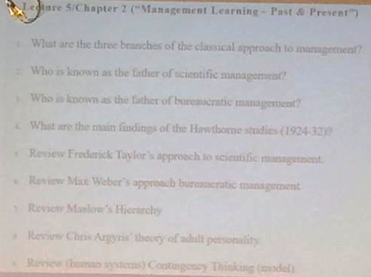

Review
Quality movement – focus on continuous improvement
Quantitative analysis – application of quantitative methods
Systems theory – helps managers understand the complex nature of the interaction between organizations and their environments
Contingency – match managerial responses to the unique problems and opportunities posed by different situations

Midterm
70 m/c
70 minutes
3. F
4. T
5. T
6. F

Chapter 6 – planning processes and techniques

Planning
The process of deciding exactly what one wants to accomplish and how to do it

5 steps of planning
- Define your objectives
- Determine where you stand relative to your objectives
- Develop premises regarding future conditions
- Analyze alternatives and make a plan
- Implement actions and evaluate results

3 key benefits of planning
- Improves focus and flexibility
- Improves action orientation
- Coordination and time management

How managers strategically determine the course of their companies in a globally competitive economy: Wal-mart

Service rules
- Sundown rule
  - Why do tomorrow when can do today?
- Ten foot rule
  - Stay attentive to customers
- Every day low prices
  - Don’t have to wait for a sale, already at lowest price

Managerial philosophies and principles
- Respect for the individual
- Service to our customers (put them first)
- Striving for excellence

Planning – providing direxction for the organization, and for Wal mart it comes from:
Basic beliefs – respect for the individual, service to our customers, striving for excellence
Customer services rules – sundown, ten foot, and every low prices rule

Planning and competition (outperform its rivals)
- Global purchasing system
- Satellite communication system
*Walmart seems to do exceptionally well in the area of planning and its well-articulated beliefs and customer service rules that encourage continuous technological innovation.

*Planning is important for both survival and success in a globally competitive business landscape

Planning can take the form of:

Scenario planning
- You identify alternative future scenarios and makes plans to deal with them

Contingent planning
- You identify alternative courses of action that can be implemented if and when circumstances change.
- If organizational procedures represent “plans that describe the actions to be taken in specific situations” what are organizational policies?

Definitions
Benchmarking – use external and internal comparisons to plan for future improvements
Best practices – things people and organizations do to lead to superior performance
Complacency trap – being carried along by the flow of events
Functional plans – indicate how different operations within the organization will help advance the overall strategy
Hierarchy of goals/objectives – lower level objectives are means to accomplishing higher level ones
Improvement of objectives – describe intentions for specific performance improvements
Management by objectives (MBO) – process of joint objective setting between a superior and a subordinate
Operational plans – identifies short term activities to implement strategic plans
Participatory planning – include the person who will be affected by plans and or will implement them
Personal development objectives – intentions for personal growth through knowledge and skills development
Plan – statement of intended means for accomplishing objectives
Policy – standing plan that communicates broad guidelines for decisions and action
Procedures/rule – precisely describes actions that are to be taken in specific situations
Tactical plans – helps to implement all or parts of strategic plan
Vision – clarifies the purpose of the organization and expresses what it hopes to be in the future
Zero-based budget – allocate resources as if each budget were brand new

Chapter 7 – Strategy and Strategic Management

Strategy in a world of globally competitive businesses
What enables some firms to achieve and sustain above average profitability while others struggle?
Do winners always have:
- more money?
- better employees?
- Better technology?
*Winners most likely have a more effective strategy, but what is strategy?

What is strategy?
To understand strategy, you have to understand the idea of competitive advantage
- Competitive advantage: when an organization has a competitive advantage: “it is operating with an attribute or combination of attributes that allows it to outperform competitors
Key courses of competitive advantage:
- Cost and quality
- Knowledge and speed
- Financial resources
- Technology

Porter’s model of five strategic forces affecting industry competition
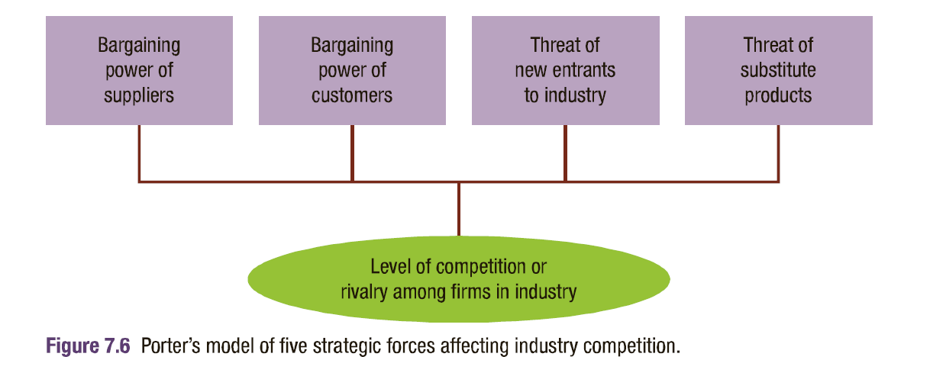

Sustainable competitive advantage
Competitive advantage will enable the company to generate above-average profits if the source of the advantage is too difficult/costly for competitors to imitate

Basics of competition
Firms compete against their rivals by either:
- Offering the same products at below average price
- Offering different products at above average prices

So strategy is…
A comprehensive plan of action that identifies the long term direction for an organization and guides resource utilization to accomplish an organizations goals with sustainable competitive advantage

Strategy at different levels
Corporate strategy:
- In what industries should we compete?
- Which competitor should we acquire?
Business strategy:
- How will we compete for customers in industry A (i.e. grocery)
- What bundle of products or services should we offer?

Strategic management process
- The major responsibilities of the strategic management process are strategy formulation and strategy implementation
- As part of the strategic management process, strategy formulation involves:
  - Identifying and analyzing the existing mission, objectives, and strategies
  - Analyzing the industry and external environment as well as organizational resources and capabilities
  - Revising the mission and objectives and selecting new strategies
- As part of the strategic management process strategy implementation involves
  - Corporate governance, management systems and practices, and strategic leadership
  - Exercising strategic control
  - Review of the strategic management process
- According to Harvard scholar Michael Porter the ultimate goal for any business should be superior profitability

Core competencies
Kaizen – organizational culture is focused on continuous improvement in all aspects of design, production, ad distribution of its products

BCG matrix approach
Managers should search for business opportunities by considering:
- Market growth rate: low or high growth rate
- Market share: small versus high market share
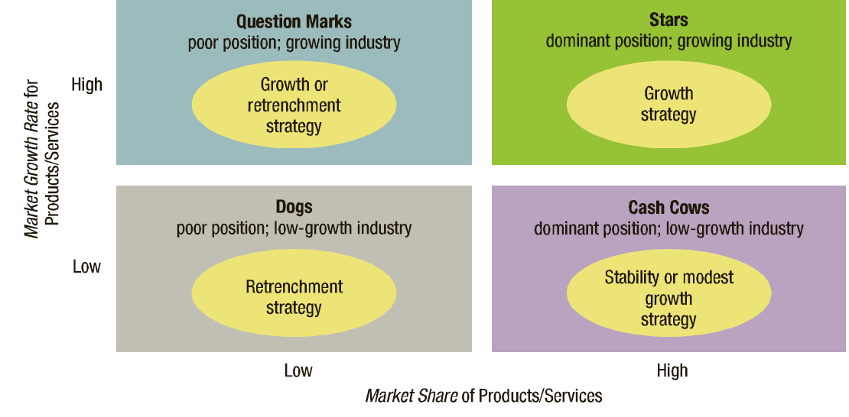

Porter’s generic strategies
The company’s strategy may be defined in terms of:
- Market scope: measures the breadth or narrowness of the target market
- Source of competitive advantage: reflects whether the advantage is sought through either low prices o product uniqueness
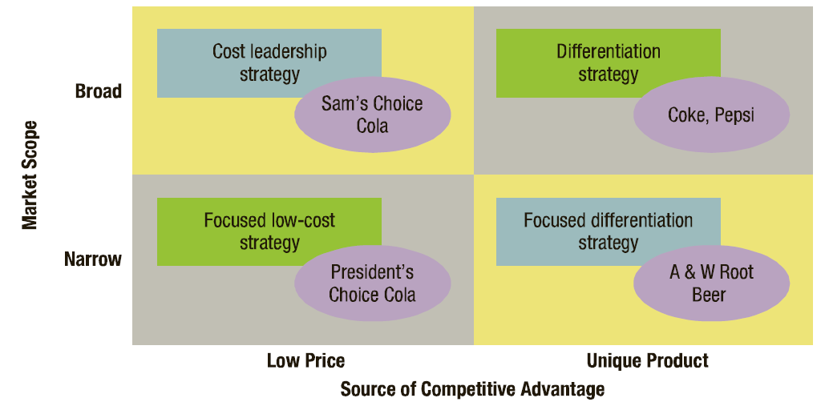

Review
- Customer relationship management, supply chain management, total quality management, organizational culture
- Strategic alliance, vertical integration, retrenchment

Definitions
B2B business strategies – uses IT and web portals to link organization vertically in supply chains
B2C business strategies – uses IT and web portals to link businesses with customers
Combination strategies – pursues growth. stability, and/or retrenchment in some combination
Concentration – growth within the same business area
Co-opetition – strategy of working with rivals on projects of mutual benefit
Core competency – special strength that gives an organization a competitive advantage
Core values – beliefs and values shared by organization members
Corporate governance – system of control and performance monitoring of top management
Cost leadership strategy – seeks to operate with low cost and benefits of each potential course of action
Divestiture – sells off parts of the organization to refocus attention on core business areas
Downsizing – decreases size of operations
Emergent strategies – unfolds over time as managers learn from and respond to experience
Focus strategies – concentrates on serving a unique market segment better than anyone else
Functional strategy – guides activities within one specific area of operations
Globalization strategy – adopts standardized products and advertising for use worldwide
Growth strategy – expansion of the organization’s current operations
Lack of participation error – failure to involve in a decision the persons whose support is needed to implement it
Liquidation – business operations cease and assets are sold to pay creditors
Mission – expresses the organization’s reasons for existence in society
Multi-domestic strategy – customizes products and advertising to best fit local needs
Operating objectives – specific results that organizations try to accomplish
Portfolio planning – seeks the best mix of investments among alternative business opportunities
Restructuring – changes the mix or reduces the scale of operations
Stability strategy – maintains current operations without substantial changes
Strategic alliance – organizations join together in partnership to pursue an area of mutual interest
Strategic analysis – process of analyzing the organization, environment, and organizations competitive position and current strategies
Strategic constituencies analysis – assess interests of stakeholders and how well the organization Is responding to them
Strategic control – makes sure strategies are well implemented and that poor strategies are scrapped or modified
Strategic incrementalism – makes modest changes in strategy as experience builds over time
Strategic intent – focuses and applies organizational energies on a unifying and compelling goal
Strategic leadership – inspires people to continuously change, refine, and improve strategies and their implementation
Strategic management – the process of formulating and implementing strategies
Transnational strategy – seeks efficiencies of global operations with attention to local markets
Turnaround – tries to fix specific performance problems
Vertical integration – growth by acquiring suppliers or distributers

Chapter 11 – Leadership and Communication

Leadership
Leadership is the process of inspiring others to work hard to accomplish important tasks

Effective leaders
Effective leaders in the world today:
- Understand the diversity of people’s gifts, talents, and skills
- Recognize the unique qualities of other people, they are less inclined to believe that they know what is best
- Are able to bring out the best in other people
Effective leaders have vision:
- A future that one hopes to create or achieve in order to improve upon the present state of affairs
Effective leaders have power:
- Power is the ability to get someone else to do something you want done or to make things happen the way you want
- Two types of power
  - Position power: determined by the person’s place in the hierarchy (or order of authority) of the company
    - 3 Types:
      - 1- Reward (positive motivation)
      - 2 – legitimate (asking to stay back, interfere with personal life)
      - 3 - coercive (if you don’t this ill fire you)
  - Personal power: determined by the unique qualities of the person
    - 2 types:
      - Expert (comes from what you know)
      - Referent (strong social network, chosen because know people)

Challenges faces by business leaders today
- Have to make major decisions in short time frames
- Have to solve complex problems
- Have to be innovative
- …

Leading and Leadership
- Leadership models or styles (i.e. democratic style, Hershey-Blanchard situational leadership model, directive leadership style, and path-goal leadership theory)
- Leadership traits
Democratic style
- Focus on both task and people. Express sensitivity and compassion.

Hersey-Blanchard situational leadership model
Provide task directions in a supportive and persuasive way
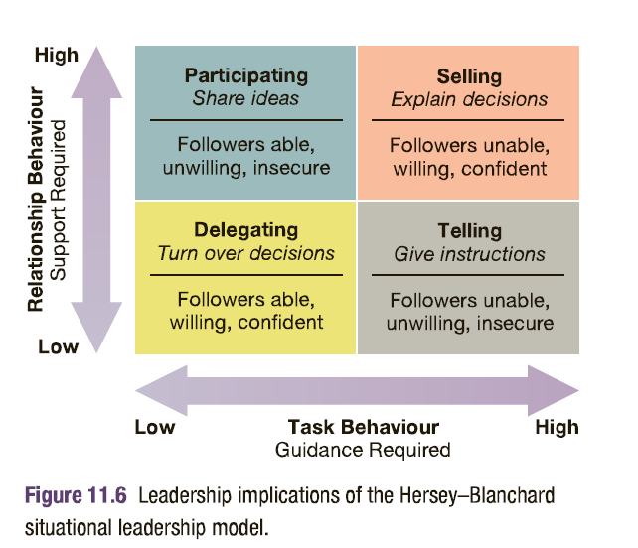

Path-Goal Leadership model
Directive leadership tyle: tell, give directions, clarified role
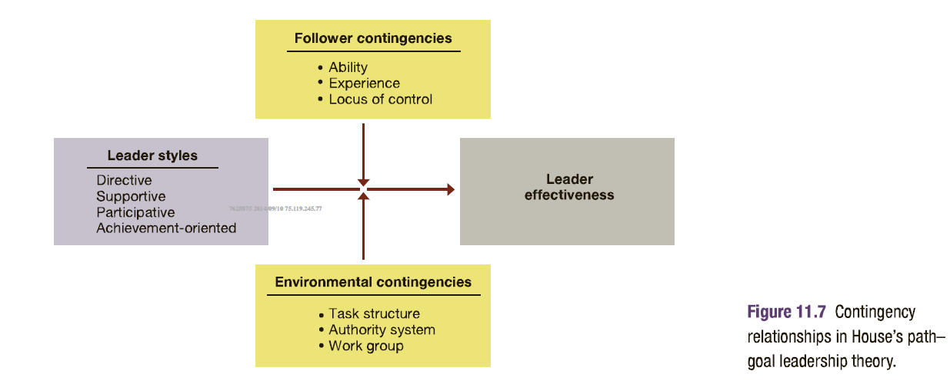

Leadership Traits
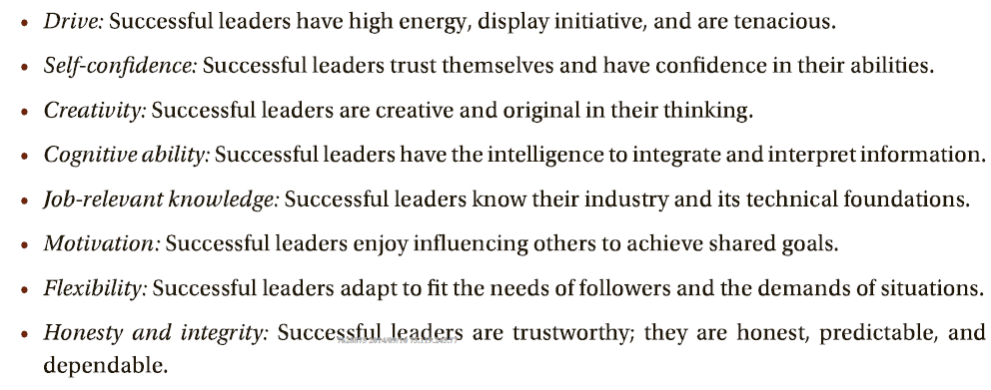
Leadership model
- Fiedlers contingency model
- Vroom-Jago leader – participation model
Other concepts:
- Emotional intelligence
- Transactional leadership
- Transformational leadership
- Visionary leader
- Charisma
- Symbolism
- Empowerment

Definitions
Authentic leadership – activates positive psychological states to achieve self awareness and positive self regulation
Authority decision – made by the leader and then communicated to the group
Autocratic style – acts in a unilateral, command and control fashion
Channel richness – capacity of a communication channel to effectively carry information
Charismic leader – develops special leader follower relationships and inspires followers in extraordinary ways
Communication – process of sending and receiving symbols with meanings attached
Communication channel – pathway through which a message moves from sender to receiver
Consultative decision – made by a leader after receiving information, advice, or opinions from other group members
Credible communication – earns trust, respect, and integrity in the eyes of others
Efficient communication – occurs at minimum cost
Electronic grapevine – use electronic media to pass messages and information among members of social networks
Ethnocentrism – belief that one’s membership group or subculture is superior to all others
Expert power – capacity to influence other because of their specialized knowledge
Filtering – intentional distortion of information to make it appear most favourable to the recipient
Gender similarities hypothesis – that males and females have similar psychological properties
Group decision – made by group members themselves
Human relations style – emphasizes people over tasks
Integrity – honesty, credibility, and consistency in putting values into action
Laissez-faire style – “do the best you can and don’t bother me” attitude
Leadership – process of inspiring others to work hard to accomplish important tasks
Leadership style – reoccurring pattern of behaviours exhibited by a leader
Least-preferred co worker scale – used in fielder’s contingency model to measure a person’s leadership style
Management by wandering around (MVWA) – managers spend time outside their offices to meet ad talk with workers of all levels
Mixed message – results when works communicate one message while actions communicates something else
Moral leadership – good and right by ethical standards
Non-verbal communication – takes place through body language
Persuasive communication – presents a message in a manner that causes the other person to support it
Proxemics – how people use space to communicate
Reward power – capacity to offer something of value as a means of influencing other people
Servant leadership – follower-centred and committed to helping others in their work
Substitutes for leadership – factors in the work setting that direct work efforts without the involvement of a leader
Transactional leadership – uses tasks, rewards, and structures to influence and direct the efforts of others
Visionary leadership – brings to the situation a clear sense of the future and an understanding of how to get there

Lecture 9
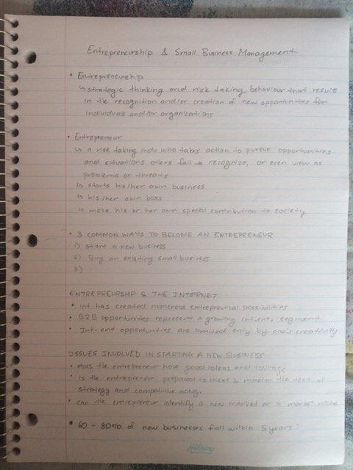
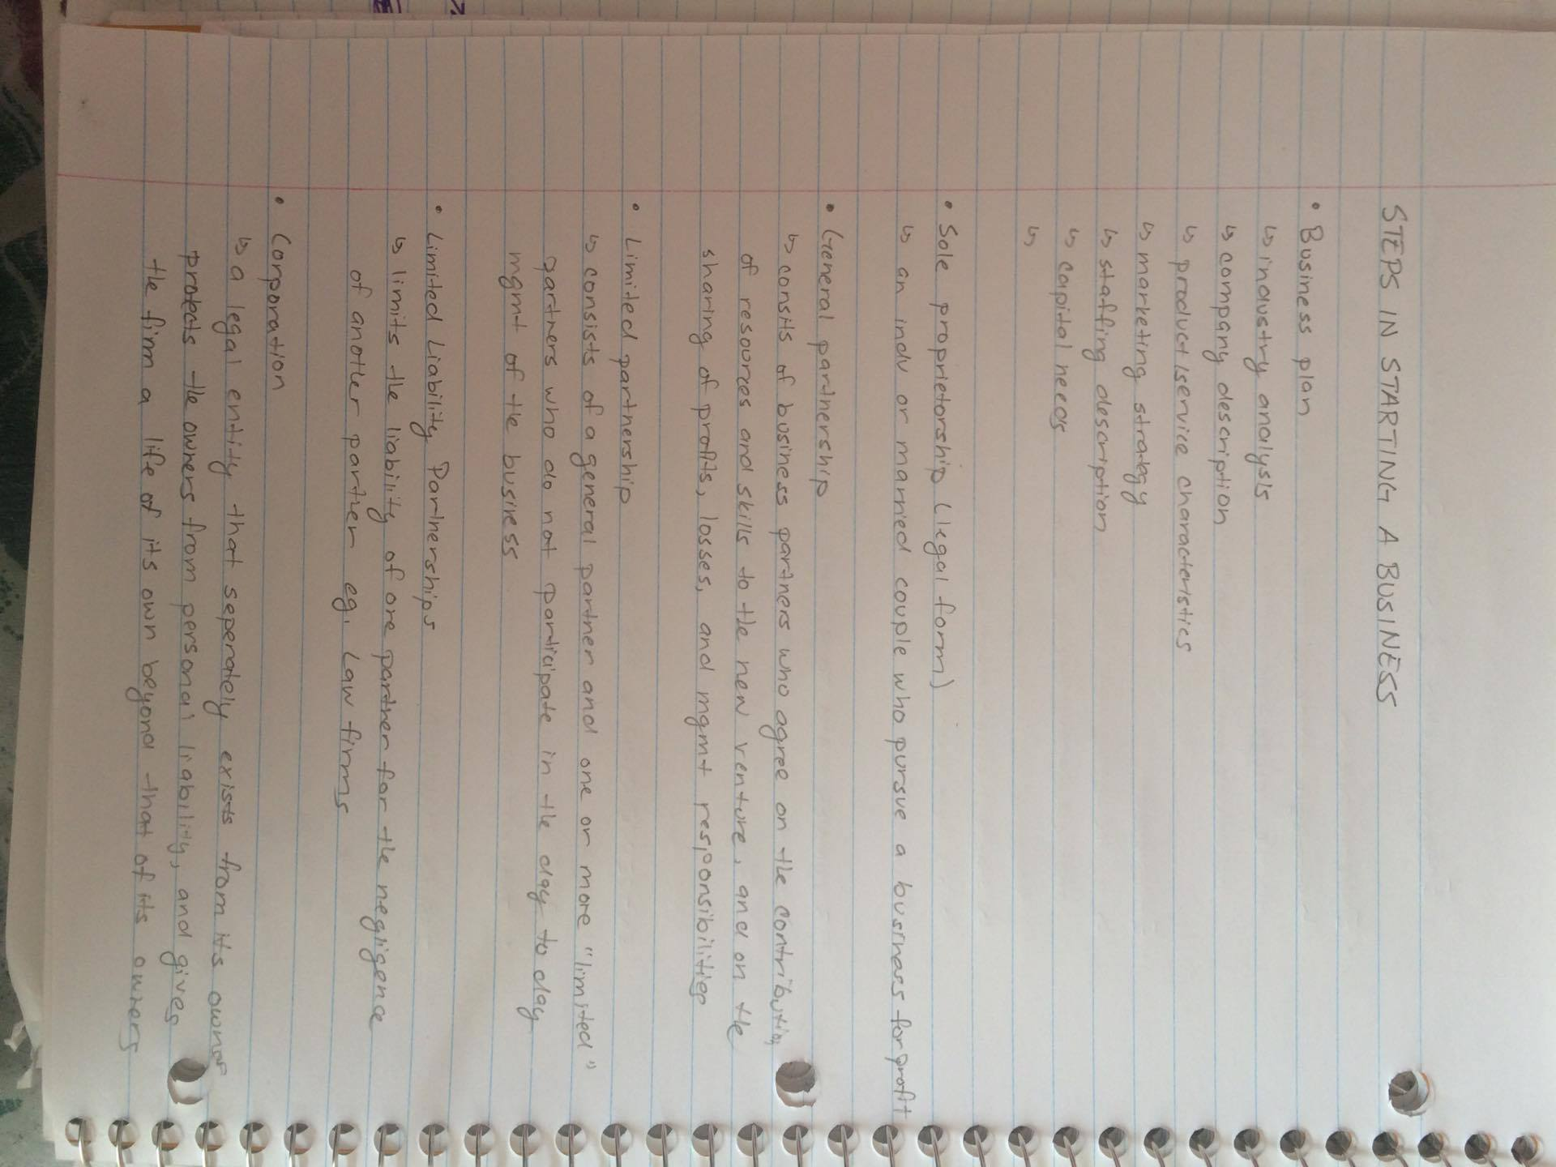
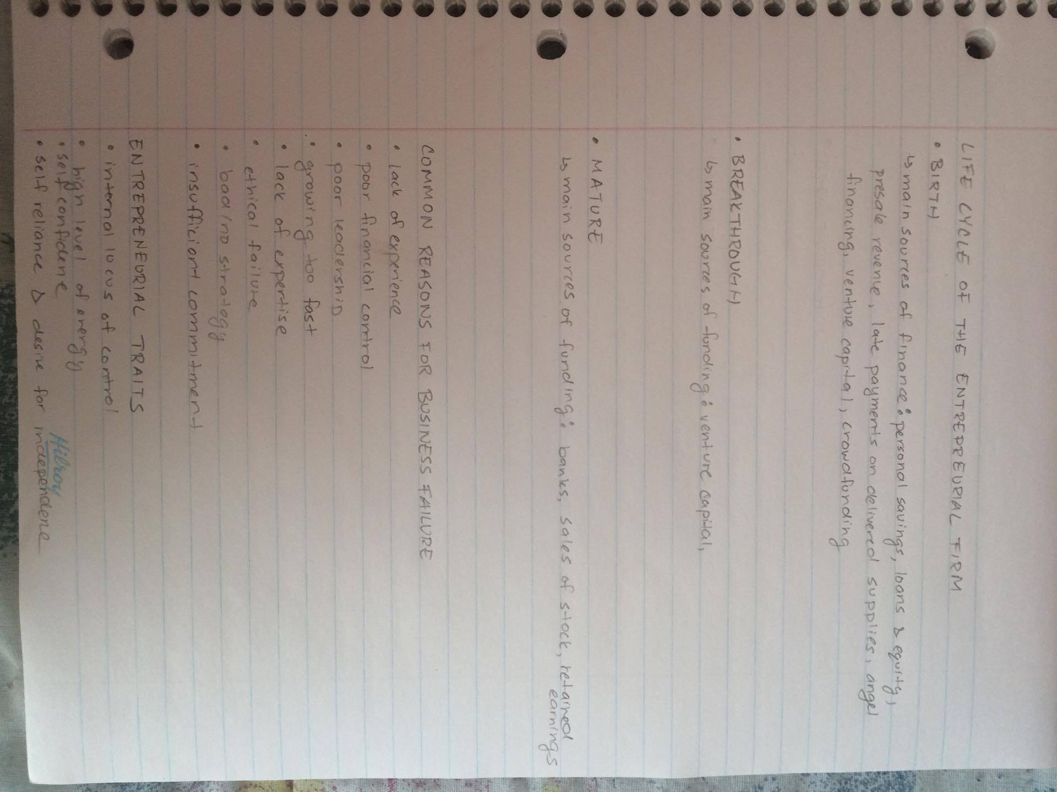

Definitions
Angel investor – a wealthy individual willing to invest in a new venture in return for equity in the venture
Business plan – describes the direction for a new business and the financing needed to operate it
Corporation – legal entity that exists separately from its owners
Debt financing – involves borrowing money that must be repaid over time with interest
Equity based crowd funding – new ventures go on-line to sell equity stakes in their businesses to crowds of investors
Equity financing – involves exchanging ownership shares for outside investment monies
Family business – owned and controlled by members of family
Family business feud – when family members have major disagreements over how the business should be run
First mover advantage – comes from being first to exploit and niche or enter a market
Franchise – form of business where one business owner sells to another the right to operate the same business in another location
Initial public offering – IPO, an initial selling of shares of stock to the public at large
Internet entrepreneurship – use of the internet to pursue an entrepreneurial venture
Limited liability corporation – a hybrid business form combining advantages of the sole proprietorship, partnership and corporation
Necessity based entrepreneurship – takes place because other employment options don’t exist
Partnership – form of business where two or more people agree to contribute resources to start and operate a business together
Small business – has fewer than 100 employees, is independently owned and operated, and dos not dominate its industry
Social enterprises – have a social mission to help make lives better for underserved populations
Social entrepreneurship – has a mission to solve pressing social problems
Sole proprietorship – form of business where an individual pursues business for a profit
Succession plan – describes how the leadership transition and related financial matters will be handled
Succession problem – the issue of who will run the business when the current head leaves
Venture capitalists – make large investments in new ventures in return for an equity stake in the business

Chapter 8 – Organization Structure and Design

What is organizing?
- The process of arranging people and other resources to work together to accomplish a goal
- It involves dividing up the work to be done and coordinating results to achieve a common purpose

Organizational skills
- If you are an owner/manager of a company that has: The most talented people… Lots of money… The most ideal location… The latest technology…
*All these don’t mean you are an industry leader or operate profitably if you lack organizational skills.

Organizational structure
- Organization structure refers to the system of tasks and workflows, reporting relationships, and communication channels that link together the work of diverse individuals and groups

Formal vs informal structures
- The formal structure of the organization represents the way the organization is intended to function in terms of division of work, supervisory relationships (e.g. organizational chart), communication channels, major subunits, and levels of management
- Informal (organizational structure): a “shadow “organization made up of the unofficial, but often critical, working relationship between organizational members
  - Informal structures do not always serve the best interests of the organization

Traditional organizational structures
Three common types of traditional organizational structures are:
- Functional, divisional, and matrix

Nature of financial structures
- Members of functional departments share technical expertise, interests, and responsibilities
- Members of each function work within their respective areas of expertise
- When each function is done properly, the business should operate successfully
Functional structure is a business, branch, bank and hospital

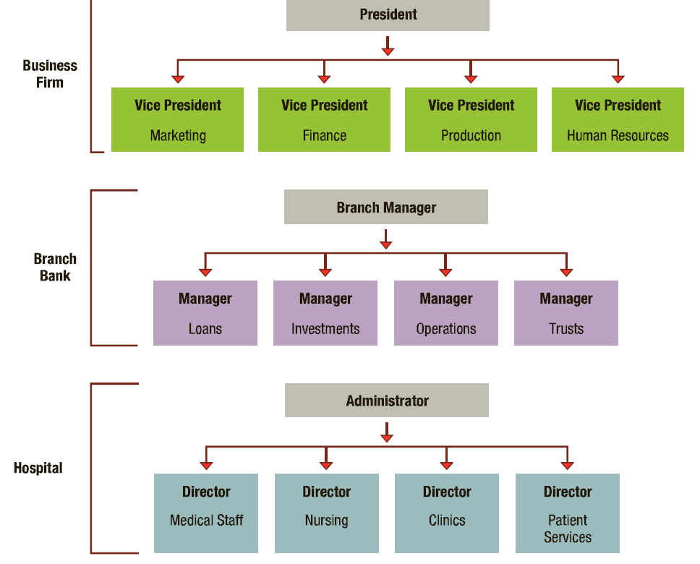

Advantages of functional structures
- Supports in depth training’
- Allows assignments to be consistent with technical training
- Economies of scale (because there are many people, budgeting)
- Clearer career path

Disadvantages of functional structures
- Difficulties in pinpointing responsibilities for cost containment, product or service quality, timeliness, and innovation
- Too many decisions referred upward in the organizational hierarchy
- .
- .

Divisional (organizational) structure
Groups together people who work on the same product or process, serve similar customers, or work in the same area or geographic region
Divisional structures based on product, geography, customer, and process
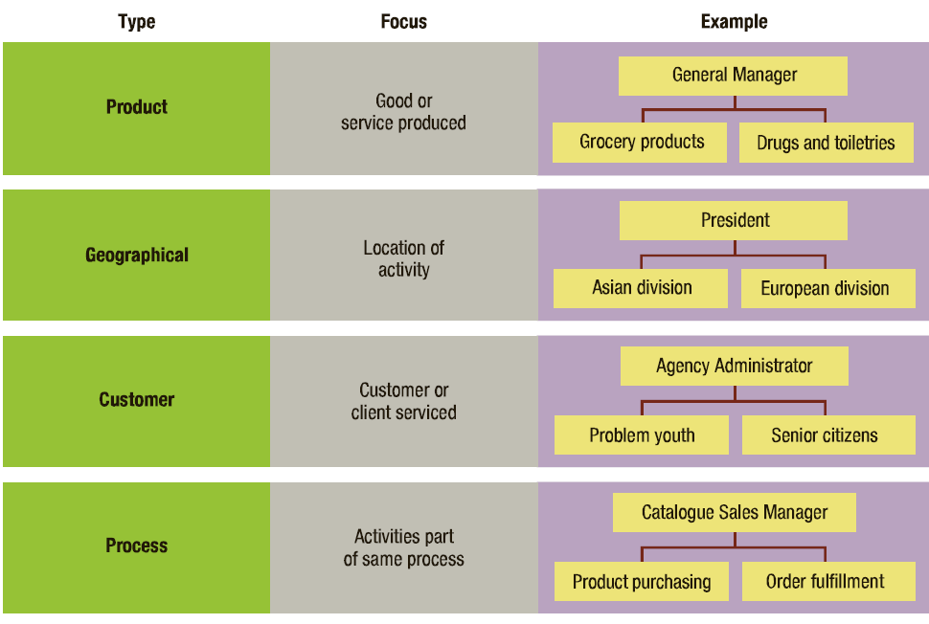

Advantages of divisional structure
- More flexibility in responding to environmental changes
- Establishes clear points of responsibility for product of service delivery
- Expertise is focused on specific customers, products, in regions
- Greater ease in changing size by adding or deleting divisions

Disadvantages of divisional structure
- Increasing costs due to duplication of resources and efforts across divisions
- Creating unhealthy rivalries as divisions complete for available resources
- Reducing economies of scale
- Emphasizing divisional needs and goals to the detriment of organizational goals

Matrix (organizational) structure
- Combines the functional and divisional structures in an attempt to gain the advantages and minimize the disadvantages of each
Matrix structure in a small, multi-project business firm
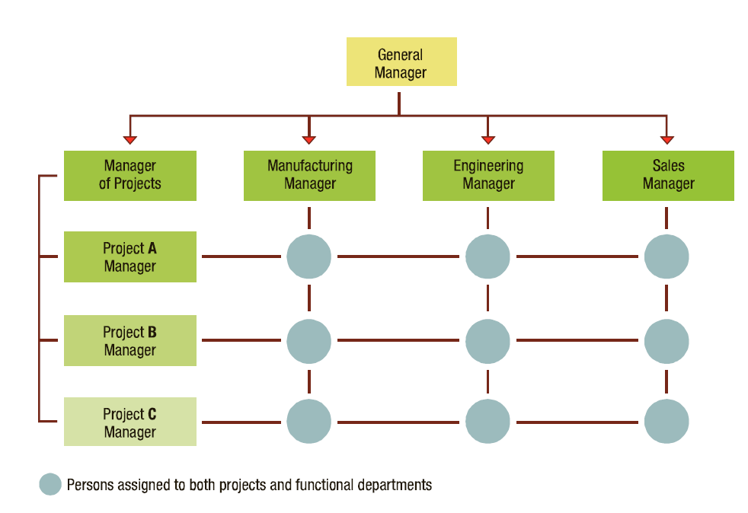

Advantages of a matrix structure
- The matrix structure allows for better interventional cooperation in operations and problem solving
- The matric structure makes it easier to ass, remove, or change operations to meet changing demands
- The matrix structure improves performance accountability
- Matrix structure improves strategic management since to managers are freed from unnecessary problems solving

Disadvantages of matrix structure
- Adding team leaders increase costs
- “Groupitis”
- Power struggles between functional and program managers
- Confusion of team members regarding task direction

Network structure

Definitions
Adaptive organization – operates with minimum bureaucratic features and encourages worker empowerment and teamwork
Boundaryless organization – eliminates internal boundaries among subsystems and external boundaries with the external environment
Bureaucracy – rational and efficient form of organization founded on logic, order, and legitimate authority
Centralization – the concentration of authority for most decisions at the top level of an organization
Chain of command – links all persons with successively higher levels of authority
Cross-functional team – brings together members from different functional departments
Customer structure – groups together people and jobs that serve the same customers or clients
Decentralization – the dispersion of authority to make decisions through out all organization levels
Delegation – the process of distributing and entrusting work to other persons
Departmentalization – the process of grouping people and jobs into work units
Functional chimneys problem – a lack of communication and coordination across functions
Geographical structure –
Mechanic design – centralized, with many rules and procedures, a clear cut division of labour, narrow spans of control, and formal coordination
Network structure – uses IT to link with networks of outside suppliers ad service contractors
Organic design – decentralized , with fewer rules and procedures, open divisions of labour, wide spans of control, and more personal coordination
Organization chart – describes arrangement of work positions within an organization
Organization design – process of creating structures that accomplish mission and objectives
Process structure – groups jobs and activities that are part of the same processes
Product structure –
Project teams – are convened for a particular task or project and disband once it is completed
Social network analysis – identifies the informal structures and their embedded social relationships that are active in an organization
Span of control – the number of subordinates directly reporting to a manager
Staff positions – provide technical expertise for other parts of the organization
Subsystem – smaller component of a larger system
Virtual organization –uses IT and the internet to engage a shifting network of strategic alliances
Work process – group of related tasks that collectively creates a valuable work product

