independent Samples t-test

You need to conduct an independent-samples t-test on SWLS composite and your new Shoes2G variable
Write up the answer to the question (with evidence): Are students that have lots of shoes happier? Provide statistical evidence in APA format and a plain language interpretation. 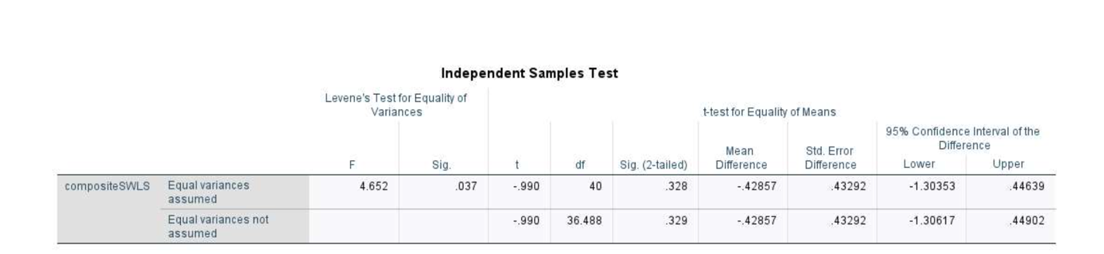
To test whether individuals with more shoes were happier, an independent sample t-test was done. On average, individuals who owned more shoes reported higher levels of happiness (M = 4.27, SD = 1.16), compared to individuals who owned fewer shoes (M = 3.84, SD = 1.61). This difference, 0.43, 95% CI [-1.31, 0.45], was not significant t(40) = −0.99, p = .39, d = 0.31. This finding suggests that owning more shoes, and possibly other material goods, does not lead to increased happiness.

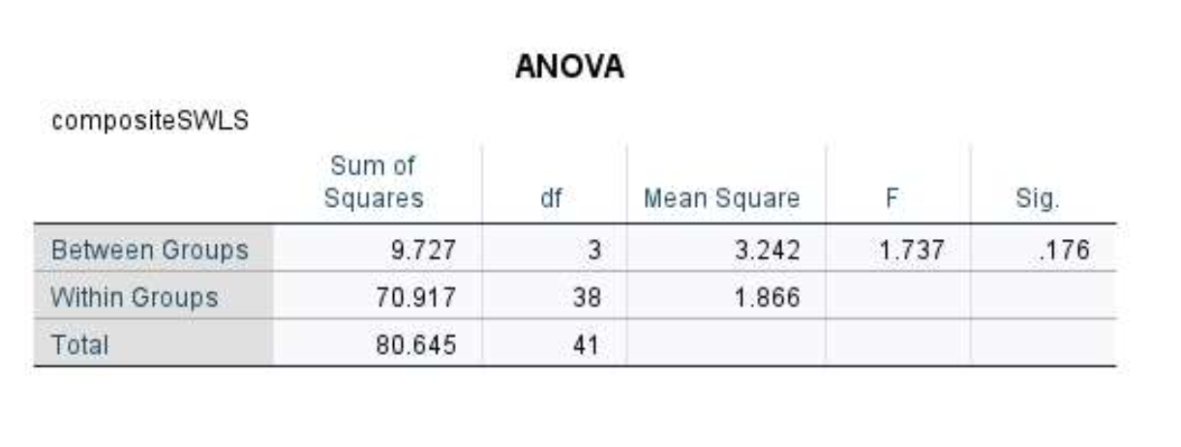
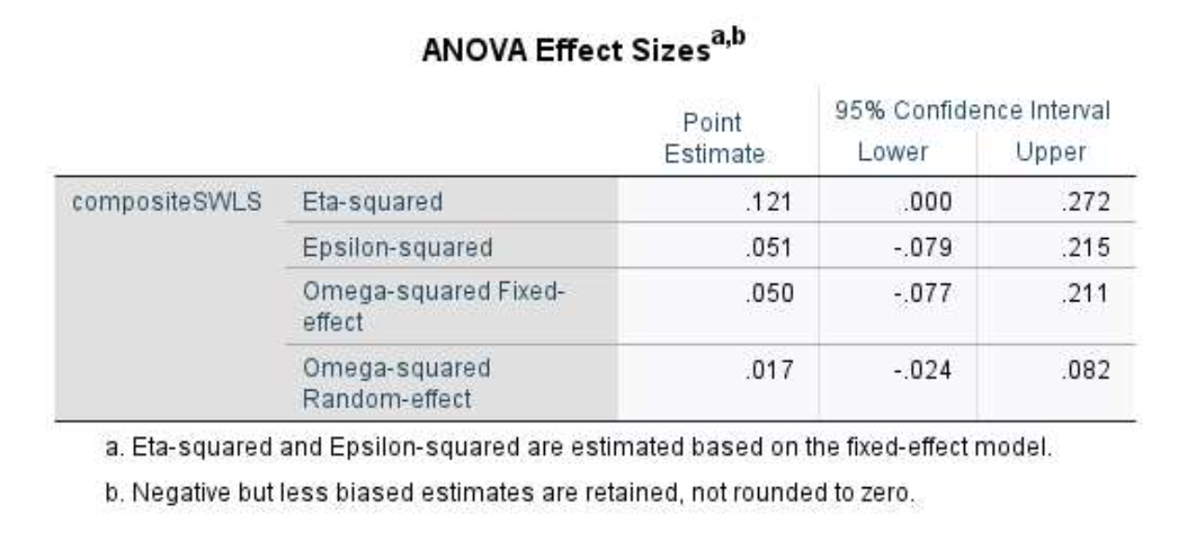

Conduct an independent/one-way ANOVA examining SWLS composite and the Animals variable. Report and interpret the omnibus result using statistical language in APA format.
The independent samples one-way ANOVA was not significant, F(3, 38) = 1.74, p =.18, η2 = .12. This result suggests that there are no differences between happiness scores based on group preferences for animals. Follow-up tests would not be necessary.

Week 2

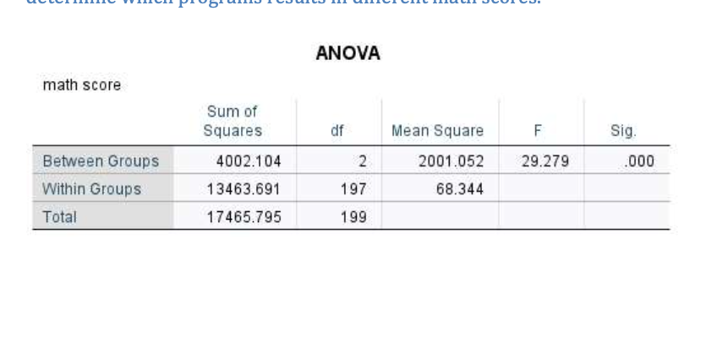
exploratory research study: we use post-hoc tests
prior research study: we use contrast u expect something in advance
Planned contrasts revealed that having 30 minutes of puppy therapy significantly increased happiness compared to having a control, t(26) = −2.77, p = .01, r = .48, but not compared to having 15 minutes, t(26) = −0.54, p = .59, r = .11.

contrast test: contrast 1 for married compared to everything else is significantly different and higherthan all other groups
Run a one-way independent samples ANOVA. Report the results of the omnibus test in APA format. Include a one-sentence interpretation (i.e., can you proceed on to post-hoc tests?).
Write a hypothesis for this type of analysis.
H0: Type of program has no effect on math scores.
H1: Type of program does have an effect on math scores.
A one-way independent samples ANOVA was run to test the effect of program type on math scores., F(2, 197) = 29.78, p < .001, η2 = 0.23. Since the omnibus test was significant, post-hoc tests are appropriate to use to determine which programs results in different math scores.
Assumptions:

Normality:Using p<0.001, the assumption of normality is met for all the variables using both the KS test and Shapiro-Wilk.

Independence: The assumption of independence is met since the observations between the groups are independent

Linearity:

The dependent variable: is WeightLOST
independent variable: is the type of Diet (3 groups).
covariates : gender (2 groups) and Height

Variables | Statistical tool | Objective | evidence | Decision/Impact
WeightLost & Height | correlation | The DV and Cov need to be significantly related to each other | r = -.12, p = .31 | Variables are not related making height not appropriate as a covariate.
WeightLost & Gender | One-way ANOVA (the more parsimonious test would be a t- test) | The DV and Cov need to be significantly related to each other | F(1,74) = .044, p=.84 | Variables are not related making gender not appropriate as a covariate.
Diet & Gender | Chi-Squared | The IV and COV need to be independent (not related) | X2(2, N=76) =.045, p=.98 | Variables are not related making gender appropriate as a covariate.
Diet & Height | One-way ANOVA | The IV and COV need to be independent (not related) | F(2,75) = 3.28, p=.043 | Variables are related making height not appropriate as a covariate.
Height & Gender | One-way ANOVA (the more parsimonious test would be a t- test) | The covariates need to be independent (not related) | F(1,74) = .9.99, p=.002 | Variables are related meaning you cannot use both as covariates
Any categorical covariates need to be added to the Fixed Factors box. Continuous variables can be added to covariate box.

Slopes Assumption | Slopes One-way Assumption ANOVA (add | All interactions need to be not significant | All ps > .05 | Assumption of homogeneity of slopes is met for all variables.
When an independent t test is done to detect the relashionship between the dp and the covariant we have to check if its significant.
If NOT significant we stop because he covariant variable is not significantly related to the dependent variable and it does not explain any of the variance. We don’t have to donduct an ancova

