Describing the shape of distribution
- Data can be described by its center, spread (variation), and overall shape
- Shape of distribution can be determined by its peaks and by its possession of symmetry, its skewness (have more points plotted on one side of the shape than on the other) or its uniformity
- Peaks and symmetry
  - Distribution shapes often have peaks, or local maximums
  - One single peak is called unimodal distribution
    - Two peaks is bimodal distribution
  - Single peak at the center of the distribution’s shape is called bell shaped (symmetric) distribution
- Skewness
  - Distributions with fewer observations on the right (toward higher values) are said to be skewed right
    - Skewed left if there are fewer observations on the left
- Uniformity
  - When observations in a set of data are equally spread across the range of distribution.
    - No clear peaks
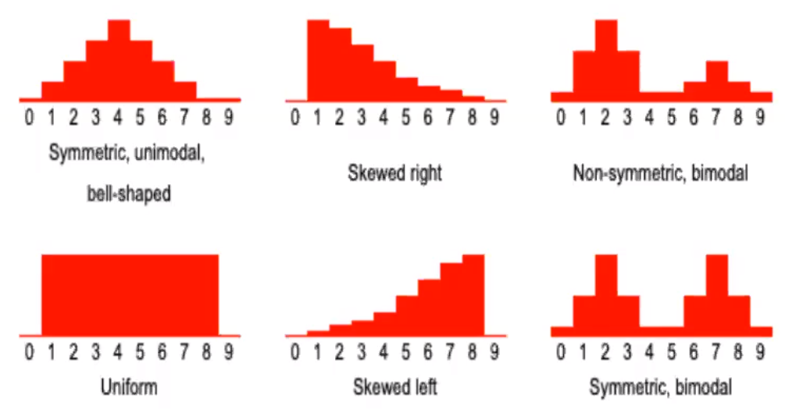
- With qualitative data, names identify the different categories
- Data can be summarized using frequency distribution
  - Frequency distribution
    - A table that summarizes the number of items in each of several non overlapping classes
      - E.g. listing frequency of favourite pizza chains
        - Find relative frequency by dividing by total entries

Graphically summarizing qualitative data
- Bar chart
  - A vertical or horizontal rectangle can represent frequency of each category
- Pie chart
  - A circle divided into slices, represents 100% of whole

- Pareto chart
  - A bar chart with different kinds of defects listed on horizontal scale
    - Bar height is frequency
    - Bars are arranged in decreasing height from left to right
    - Sometimes augmented by plotting cumulative percentage point for each bar
- Often need to summarize and describe the shape of distribution
  - One way is to group the measurements into classes of a frequency distribution
  - After grouping them, we can display the data in the form of a histogram
- Frequency distribution
  - A list of data classes with the count of values that belong to each class
    - Classify and count
    - The frequency distribution is a table
  - Show the frequency distribution in a histogram
    - A picture of a freq distribution

Constructing a frequency distribution
- Find the number of classes
- Find the class length
- Form non overlapping classes of equal width
- Tally and count
- Graph the histogram

Finding number of classes
- Group all of the n data into K number of classes
  - K is the smallest number for which 2^K is greater or equal to n
- E.g. n = 65
  - K = 7 since 2^7 = 128
    - If k=6, 2^6 = 64, which is too little

Finding class length
- Largest measurement - smallest measurement
  - Divided by number of classes

Form non overlapping classes of equal width
- Classes start at smallest value - lower limit of the first class
  - Upper limit of the first class is smallest value + class length
- Next class starts at this upper limit and goes up by class length (and so on)
Graph the histogram
- Rectangles represent the classes
- Base represents the class length
- The height represented the frequency in a frequency histogram, or relative frequency in a relative frequency histogram

Frequency polygons
- Plot a point above each class midpoint at a height equal to frequency
  - Useful for comparing two or more distributions

Cumulative distributions
- Different way to summarize distribution
  - Use same number of classes, class lengths, and class boundaries
- Rather than a count, we record number of measurements that are less than the upper boundary of that class
  - A running total

Ogive
- Visualization of a cumulative distribution
- Plot a point above each upper class boundary at a height of the cumulative frequency
  - Can be drawn with relative or percent frequencies

Dot plots
- Each data item is shown as a dot above a number line
  - A cluster shows where a group of data points fall
- A gap is an interval where there are no data items
- How to create
  - Order numbers from least to greatest
  - Draw a number line with the least and greatest numbers and everything in between
  - Put a dot above each number on the number line for each entry in set
    - Don't forget title and labels

Stem and leaf displays - good for small/moderate data distributions
- See the overall pattern of data, by grouping it into classes
  - See variation from class to class
    - The amount of data in each class
    - The distribution of data within each class
- How to create
  - Each number in data set is broken into two pieces, stem + leaf
  - Stem is the first part of the number and consists of beginning digits
    - Leaf is last part, consists the final digits

Measures of central tendency
- Represents the center of the middle of the data
  - Population mean (u) is average of the population measurements
- Recall
  - Population parameter
    - A number calculated from all the population measurements that describes some aspect of the population
  - Sample statistic
    - A number calculated using the sample measurements that describes some aspect of the sample

