LING 2005 – IPA Review
January 23, 2020

Why do we need IPA?

- No one-to one correspondence between letters and sounds of English
- Often more pronunciation for a letter. Ex. “c” Pacific “
- Multiple spellings of a given sound. Ex. Ruff and Rough
The IPA is the standard used by linguists around the world for sharing data.

English Consonants and Vowels

Describing Consonant articulation

Three Dimensions of Articulation:
Voicing:
- Vocal folds are closed and vibrating in voiced sounds ex. [z,b,d,g]
- Bus vs buzz
- Vocal folds are spread and let air pass through in voiceless sounds ex. [s,p,t,k]

Place of articulation:
- Where in the Vocal Tract two articulators come together

Manner of articulation:
- How closely or far apart the two articulators come together

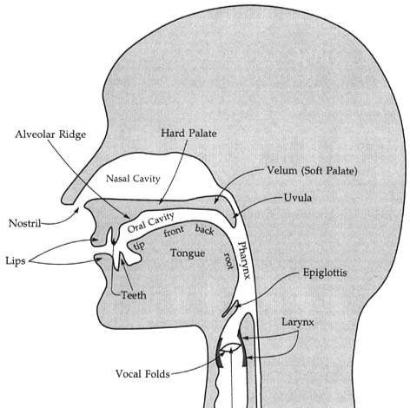

Places of Articulation

English consona
Place of Articulation | Where articulators come together | Speech Sounds Made
Bilabial: | Two lips together | [p], [b], [m]
Labiodental: | Upper teeth to lower lip | [f], [v]
Dental: | tongue to upper teeth | [θ] , [ð]
Alveolar: | Front part of tongue to alveolar ridge | [t], [d], [s], [z], [n], [l]
Postalveolar: | tongue just in front of the hard palate (also called “alveo-palatal”) | [ʃ], [ʒ], [t͡ʃ], [d͡ʒ], [ɹ]
Retroflex: | tip of tongue curled back to area just behind alveolar ridge (also called “alveolar retroflex”) | [ɻ ]
Palatal: | body of tongue to hard palate | [j]
Velar: | back of tongue to soft palate (velum) | [k], [g], [ŋ]
Labiovelar: | back of tongue to soft palate (velum), lips rounded | [w]
Glottal: | uses vocal folds/glottis (in the larynx) | [h], [ʔ]

Manners of articulation
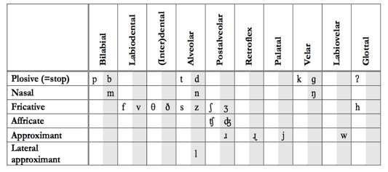

North American English also has some consonants that show up only in particular environments:
[ɾ]: voiced alveolar flap. Shows up between a stressed vowel and an unstressed vowel (in that order)
(atom [æɾm ] vs. atomic [ətɑmɪk])
[ɫ]: velarized voiced lateral approximant. Shows up at the end of syllables.
(cool [kueɫ] vs. cooling [kulɱ])

Three-part descriptions of consanant sounds
State of the larynx (voicing) + place + manner
- Voiced bilabial stop [b]
- Voiceless post-alveolar affricate [t͡ʃ]
- Voiced velar nasal [ŋ]

Characterizing vowels
Vowel quality is defined by four parameters:
Tongue height (high, mid, low)
Tongue backness (front, central, back)
Lip rounding (rounded, unrounded) Tenseness (tense, lax)
Monophthongs have a single quality (i.e., position on vowel chart);
diphthongs start with one quality/position and move to another.

Vowel Height
Vowel height has to do with how high or low in the mouth the tongue is when pronouncing the vowel
High vowels: tongue raised [i], [ɪ], [u], [ʊ]
Mid vowels: tongue neither raised nor lowered [ɛ], [ə], [ʌ], [ɔ]
Low vowels: tongue lowered [æ], [ɑ]

Vowel Backness
Vowel backness has to do with which part of the tongue is used to pronounce the vowel
Front vowels: front of tongue [i], [ɪ], [ɛ], [æ]
Central vowels: middle part of tongue [ə], [ʌ]
Back vowels: back of tongue [u], [ʊ], [ɔ], [ɑ]

Lip Rounding
The lips may be either rounded or unrounded when pronouncing a vowel.
Lips rounded: [u], [ʊ], [ɔ]
Lips unrounded: [i], [ɪ], [ɛ], [æ], [ə], [ʌ], [ɑ]

Vowel Tenses tenseness
Tenseness has to do with how far the tongue reaches to pronounce a vowel
Tense vowels: greater constriction in vocal tract, tongue muscles tenser [i], [u], [ɑ]
Lax vowels: less constriction in vocal tract, tongue muscles less tense [ɪ], [ʊ], [ɛ], [ə], [ʌ], [ɔ], [æ]
Tense vowels tend to have a longer duration than lax vowels
Only tense vowels can occur at the end of a word without a consonant following it (e.g., see [si], do [du], saw [sɑ])

Natural Classes

Groups of shared features = natural classes

Any single feature gives natural class
- ex. Bilabial, nasal, front, low, etc.

Natural classes can be com binations of features
- High, front”, “voiceless stops”, etc.

Some natural classes group together certain places or manners of articulation that share certain properties.
Some manner categorizations:
- Obstruent: obstruction of airflow (causes turbulent airflow); stops, fricatives, affricates
- Sonorant: no obstruction of airflow (no turbulent airflow) – non-obstruents; vowels, nasals, approximants
- Continuant: continuous airflow through the oral cavity; fricatives, approximants, vowels
Some place categorizations:
- Coronal: uses front part of tongue; interdental, alveolar, postalveolar, retroflex, palatal
- Dorsal: uses back part of tongue; velar, labiovelar, glottal
- Labial: uses lips; bilabial, labiodental, labiovelar

Consonants beyond english
English has only four fricatives, at two places of articulation (alveolar and post-alveolar); other languages use other places as well for fricatives
German has voiceless velar and palatal fricatives:
- Voiceless velar fricative: Bach [bax]
- Voiceless palatal fricative: ich [Iç]
Spanish has voiced bilabial and velar fricatives:
- Voiced bilabial fricative: Cuba [kuBa]
- Voiced velar fricative: amigo [amiGo]
Japanese has a voiceless bilabial fricative:
- Voiceless bilabial fricative: futon [FUton]
Many languages pronounce [r] as a trill, manner of articulation lacks in English. Many have ulvur consonants, this place of articulation is lacking in English.
- Inuktitut has a voiceless uvular stop: kayak [qajaq]

