-Chapter 1
What is Architecture?
Encompasses both the blueprint for a building and general underlying principles

Defined: Architecture is the fundamental organization of a system embodied in its components, their relationships to each other, and to the environment, and the principle guiding its design and evolution.

// a structure with a vision

An architecture provides an integrated view of the system being designed or studied.

Architecture is therefore helpful in guarding the essentials of the business, while still allowing for maximal flexibility and adaptivity. Without good architecture, it is difficult to achieve business success.

What is meant by the word Enterprise?
Defined: Any collection of organizations that has a common set of goals and/or a single bottom line

What is Enterprise Architecture?
Defined: a coherent whole of principles, methods, and models that are used in the design and realization of an enterprise’s organizational structure, business processes, information systems, and infrastructure
- Captures essentials of business, IT and its evolution
- Provides a holistic view of the enterprise

Why do architectures change?
- Because environment changes & new technological opportunities arise, new insights as to what is essential to the business
- Relation between architectural decisions - business objectives of enterprise

- Bringing together information from formerly unrelated domains necessitates an approach that is understood by all those involved from these different domains

- current IT architecture missing same shared language & culture

For example, a highly optimized technical infrastructure that offers great performance at low cost might turn out to be too rigid and inflexible if it needs to support highly agile and rapidly changing business processes. A good enterprise architecture provides the insight needed to
balance these requirements and facilitates the translation from corporate strategy to daily operations

-In constructing and maintaining an architecture, choices should therefore be related to the business objectives, i.e., they should be rational.

- The insights provided by an enterprise architecture are needed on the one hand in determining the needs and priorities for change from a business perspective, and on the other hand in assessing how the company may benefit from technological innovations.

-important to have an understanding of external factors - suppliers, customers and other partners, outsourcing - important to have insight on activities and responses of all partners involved

What are the stakeholders? What are their needs and interests?
Defined: an individual team, or organization (or classes thereof) with interests in or concerns relative to a system.

Not interested in the architecture but rather the impact of it on their concerns. Architects need to be aware of stakeholder needs & concerns (varying needs and concerns)

Remember stakeholder concerns = interests

What is meant by “a holistic view”?
“The most important characteristic of an enterprise architecture is that it provides a holistic view of the enterprise. Within individual domains local optimization will take place and from a reductionist point of view, the architectures within this domain may be optimal. However, this need not lead to a desired situation for the company as a whole. For example, a highly optimized technical infrastructure that offers great performance at a low cost might turn out to be too rigid and inflexible if it needs to support highly agile and rapidly changing business processes. A good enterprise architecture provides the insight needed to balance these requirements and facilitates the translation from corporate strategy to daily operations.”

How do you communicate Enterprise Architecture to stakeholders? Draw a diagram

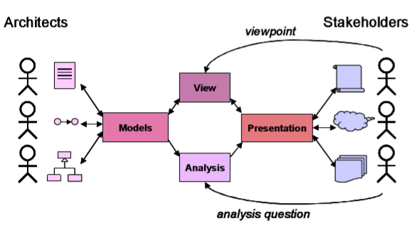
-Different types of stakeholders will have their own viewpoints on the architecture.

-Often enterprises rely on existing methods and techniques

-Requires an integrated set of methods and techniques for the specification, analysis and communication of enterprise architectures that fulfills the needs of the different types of stakeholders involved

-Architecture models, views, presentations, and analyses all help to bridge the ‘communication gap’ between architects and stakeholder

What are the drivers for EA?
Drivers for establishing an enterprise architecture

Internal Drivers:
Clear understanding of its structure, products, operations, technology and the web of relations tying these together and connecting the organization to its surroundings.

Effectiveness is driven by the relationships between components rather than by detailed specification of each individual component.

Alignment, underlining the significance of both ‘soft’ and ‘hard’ components of an organization

External Drivers
External pressures that push organizations towards adopting enterprise architecture practice. That regulatory framework increasingly demands that companies and governmental institutions can prove that they have a clear insight into their operations and that they comply with the applicable laws on, say, financial transactions.

E.g. acts, primarily in the government sector - ensuring people are aware of their responsibilities

Draw the architecture life cycle
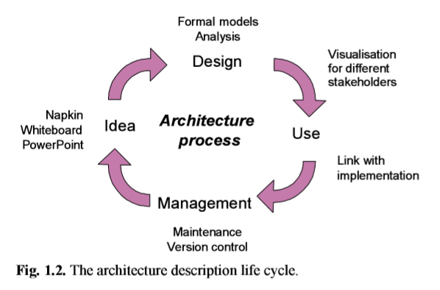
The architecture descriptions undergo a life cycle that corresponds to this design process (Fig. 1.2). The different architecture products in this life cycle are discussed with stakeholders, approved, revised, etc., and play a central role in establishing a common frame of reference for all those involved.

What is the relationship between Business Strategy and IT Strategy?
Business strategy includes the business scope, core competency, and business governance. IT strategy includes technology scope, distinctive competence, and the IT governance. One can take the business strategy of an enterprise as the starting point and derive its IT infrastructure either via an IT strategy or through the organizational infrastructure; conversely one can focus on IT as an enabler and start from the IT strategy, deriving the organizational infrastructure via a business strategy or based on the IT infrastructure.
In any of these perspectives, an enterprise architecture can be valuable help in executing the business or IT strategy.

What is functional integration?

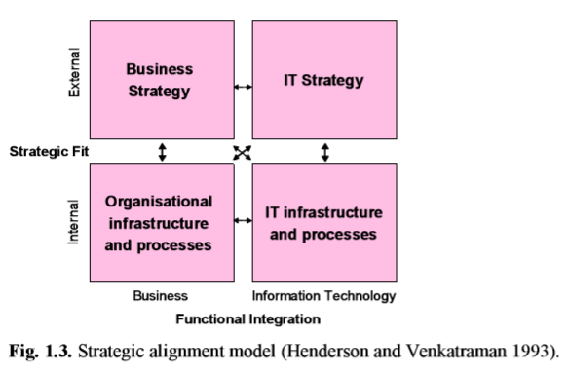
Figure 1.3 distinguishes between the aspects of business strategy and organizational infrastructure on the one hand, and IT strategy and IT infrastructure on the other hand. The model provides four dominant perspectives that are used to tackle the alignment between these aspects. One can take the business strategy of an enterprise as the starting point, and derive its IT infrastructure either via an IT strategy or through the organisational infrastructure; conversely, one can focus on IT as an enabler and start from the IT strategy, deriving the organisational infrastructure via a business strategy or based on the IT infrastructure. In any of these perspectives, an enterprise architecture can be a valuable help in executing the business or IT strategy.

What is Strategic Fit?
Strategic fit is the degree to which an organization is able to match its resources (both tangible and intangible) and capabilities with the opportunities. This matching takes place through strategy and so it is vital that the organization has all the resources and capabilities to support that strategy. It is the degree to which different parts of business working together complement each other to achieve a competitive advantage. We can say that something is a strategic fit when it is appropriate with respect to the organization's overall objectives.

What are the TOP three layers of the model “Enterprise architecture as a management instrument”?
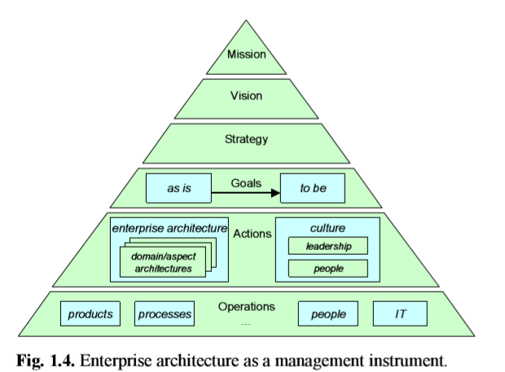
The top three layers:
Mission: Why does it exist and what do we plan to achieve?
Vision: states its ‘image of the future’ & the values the enterprise holds
Strategy: states the route the enterprise will take in achieving this mission and vision

What are the four elements of the Operating Model by Ross et al? How do they relate to each other?
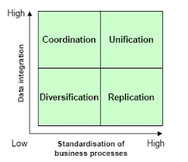
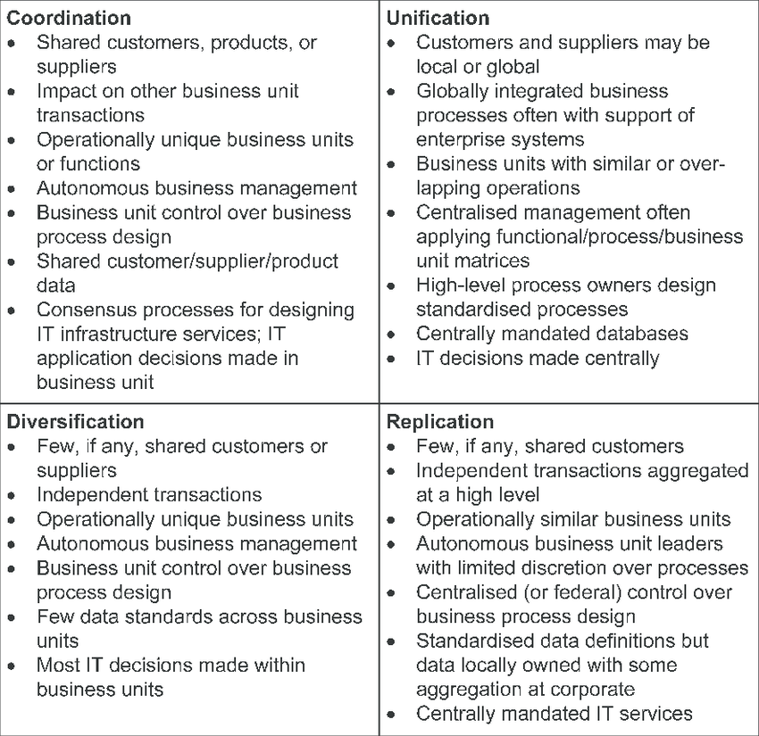

Chapter 2

Governance Instrument: A framework or set of methodologies to manage the governance of an organization.

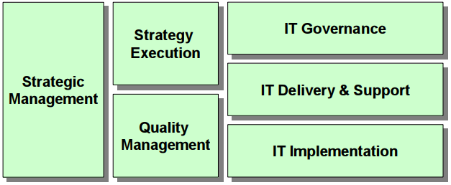

Management Area Governance Instrument
Strategic Management BSC
Strategy Execution EFQM
Quality Management ISO 9001
IT Governance COBIT
IT Delivery and Support ITIL
IT Implementation CMM and CMMI

Balanced Scorecard (BSC)
Strategic Management

BSC: A management system to clarify and implement vision and strategy. // Performance measurement and management by fact are central to the BSC approach.

- first define its mission, objectives, and measures for each perspective, and then translate these into a number of appropriate targets and initiatives to achieve these goals

-double-loop feedback: measure the outputs of internal business processes and not only fix defects in these outputs but also identify and remedy the causes of these defects

BSC Four Perspectives
- Customer: How the enterprise should appear to its customers.
- Financial: Business value created by the enterprise.
- Internal Business: Effectiveness and efficiency of a company’s internal operations, paying special attention to mission-oriented processes.
- Learning and Growth: Addresses corporate and individual ability to change and improve.

Three-layered structure for each perspective
- Mission: what is the goal
- Objectives: how will the goal be achieved
- Measures: how is success measured

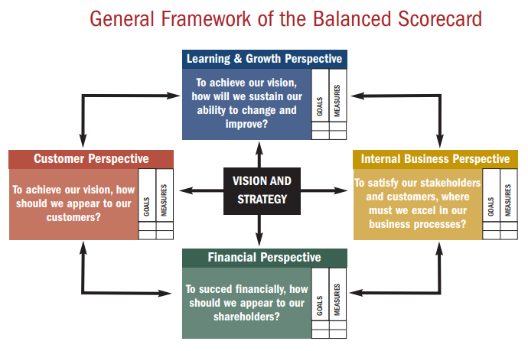
EFQM Excellence Model
Strategy Execution

Provides a management framework for performance excellence of the entire organization. The EFQM model provides principles, measures, and indicators for assessing the performance of an enterprise in all of these aspects, and these measurements are the basis for continuous learning, innovation, and improvement.

Enablers
- Establish direction and focus:
- Leadership
- Policy & Strategy
- Operations support direction and focus:
- People
- Partnerships & Resources
- Processes
Results
- Stakeholders of operations:
- People results
- Customer results
- Society results
- Analysis of stakeholder results:
- Key Performance Results

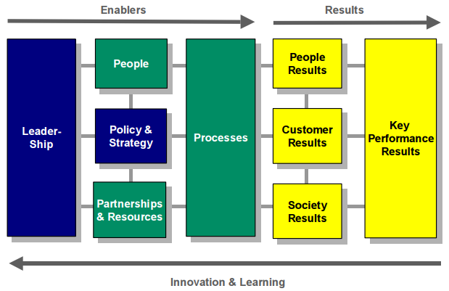
Main differences of BSC and EFQM
BSC:
- Focuses on developing effective strategic management.
- Assists in strategic decisions.
EFQM:
- Focuses on measuring and benchmarking the performance of an organization with respect to best practices.
- Assists in continuous improvement necessary to execute this strategy.

Policy & Strategies:
- Based on its mission and vision, an organisation will determine the policies and strategies needed to meet the present and future needs and expectations of its stakeholders
  - Bird’s eye view of organisational structure, business processes, information systems and infrastructure
- enterprise architecture helps in developing, managing, and communicating company-wide standards of operation, needed to ensure that company policies are indeed implemented

ISO 9001
Quality Management

ISO 9001 outlines criteria for a good quality management system (QMS).

Quality Management System: Based on a quality policy and quality goals, a company designs and documents a QMS to control how processes are planned, performed, measured and improved

ISO Requirements
Product realization processes are the core of ISO. Document heavy. Required from certain suppliers.

- Responsibilities of management for the QMS

- Requirements for resources including personnel, training, facilities, and work environment.

- Key Processes (processes that affect product or service quality) must be identified with the following details:
- Planning
- Design
- Purchasing
- Process control
- Processes put on Measurement, Analysis, Improvement

Once the QMS is installed, a company can request an audit from a registrar. If it conforms to all the criteria, the company will become ISO 9001 registered.

In this way, quality management and enterprise architecture form a natural combination: the former is concerned with what needs to be designed, documented, controlled, measured, and improved, and the latter determines how these high-quality processes and resources are organized and realized.

COBIT
IT Governance

COBIT 2000: Standard for IT governance
- IT control framework that provides organizations with ‘good practices’ that help in implementing an IT governance structure
- Aims to bridge the gaps between business risks, control needs, and technical issues.
- IT resources need to be managed by naturally grounded processes.

Core of COBIT framework: Control Objectives and management guidelines for 34 identified IT processes, which are grouped into four domains:
- Planning and organization
- Acquisition and implementation
- Delivery and Support
- Monitoring

COBIT Provides
Critical Success Factors: Factors for achieving optimal control over IT processes.
Key Goal Indicators: Measures whether an IT process has met its business requirements.
Key Performance Indicators: Measures of how well the IT process is performing towards achieving its goals.

COBIT Maturity Model
- Ad Hoc: There are no standardised processes.
- Repeatable: Management is aware of the issues. Performance indicators are being developed, basic measurements have been identified as have assessment methods.
- Defined: The need to act is understood and accepted. Procedures have been standardised, documented and implemented. BSC ideas are being adopted by the organization.
- Managed: Full understanding of issues on all levels have been reached. Process excellence is built on a formal training curriculum. IT is fully aligned with the business strategy.
- Optimized: Continuous improvement is the defining characteristic. Processes have been refined to the level of external best practices based on results of continuous improvement with other organizations.

COBIT 5 PRINCIPLES (5)
- Meet stake holders needs
  - Enterprise exist to create value for their stakeholders
  - Enterprise have many stakeholders and creating value means different things to each of them
  - Governance is about negotiating and deciding different stakeholder value interests
  - Who receives benefits? Who bears the risk? What resources are required?
- Covering the enterprise end to end
  - Cobit 5 addresses the governance and management of information and related tech from an enterprise wide, end to end perspective
- Applying a single integrated network
  - Enterprise: cosco, cosco erm, iso/iec 9000, iso/iec 31000
  - It related : iso/iec 38500, itil, iso/iec 27000 series, TOGAF, PMBOK, prince 2, cmni
  - Allows enterprise to use cobit 5 as the overarching governance and management framework integrator
  - Isaca plans a capability to facilitate cobit user mapping of practices and activities to third party references
- Enabling a holistic approach
  - Factors that influence whether something will work, in the case of COBIT, governance and management over enterprise IT
  - Driven by the goals cascade, eg. Higher level it related goals define what the different enablers should achieve
  - Described by cobit 5 framework in seven categories
- Separating governance from management
  - Governance; responsibility of the board of directors under the leadership of the chairperson
  - Management – most enterprises, management is the responsibility of the executive management under the leadership of the CEO

COBIT 5 enablers
    - Principles, policies and frameworks
    - Processes
    - Organizational structures
    - Cultures, ethics, and behaviours
    - Information
    - Services, infrastructure, and applications
    - People, skills, and competencies

The processes that are responsible for assessment of process performance and conformance: M​onitor, Evaluate and Access (MEA).
The following is concerned with identification of how IT can best contribute to achievement of business objectives: A​lign, Plan and Organize (APO).
The following makes IT concrete by identifying requirements for IT: B​uild, Acquire and Implement (BAI).
Delivery of IT Services to meet strategical and tactical plans: D​eliver, Service and Support (DSS).
Separating Governance from Management
Governance: In most enterprises, governance is the responsibility of the board of directors under the leadership of the chairperson.
Management: In most enterprises, management is the responsibility of the executive management under the leadership of the CEO.
Governance ​ensures that stakeholders needs, conditions and options are e​valuated​ to determine balanced, agreed on enterprise objectives to be achieved; setting d​irection through prioritisation and decision making; and m​onitoring ​performance and compliance against agreed on direction and objectives (EDM). (EDM = Evaluate, Direct, Monitor)
Management plans, builds, runs and monitors a​ctivities in alignment with the direction set by the governance body to achieve the enterprise objectives. (PBRM). (PBRM = Plan, Build, Run, Monitor)

ITIL
IT Delivery and Support

ITIL: IT Infrastructure Library
- The most widely accepted standard for IT service management.
- It provides codes of practice that help organisations to establish quality management of their IT services and infrastructure, where ‘quality’ is defined as ‘matched to business needs and user requirements as these evolve.’ It does this by providing guidance on the design and implementation of the various processes within the IT organisation
- Comprises a series of documents giving guidance on the provision of good IT services, and on the facilities needed to support IT
- Process-oriented approach to service management.

COBIT’s control objectives tell what to do and ITIL explains how to do it, i.e., what the best-practice processes are to realize these objectives.

Management of the IT assets of an organisation is central to ITIL

This is where a well-developed enterprise architecture is very valuable. It provides IT managers with a clear understanding of the IT applications and infrastructure, the related business processes, and the various dependencies between these domains. Nearly all of the core processes identified by ITIL will benefit from this.

- Stages of ITIL Lifecycle:
- Service Strategy: Designing, developing and implementing IT service management and strategies. Determine target markets, costs, and risks, and differentiate from competitors.
- Service Design: Design and develop services and IT service management processes to support the service strategies.
- Service Transition: Manage changes in a productive manner, transition new and changed services into operations without disruption.
- Service Operation: Practical aspects of day-to-day operations, ensure operations are smooth, reliable, efficient, and cost-effective.
- Continual Service Improvement: Development, and improvement of IT services with continual assessments.

CMM and CMMI
IT Implementation

CMM: Capability Maturity Model - a model for judging the maturity of an organization’s software engineering processes + provides organisations with key practices required to help them increase the maturity of these processes.

Upgraded from CMM → to CMMI

CMMI: Capability Maturity Model Integration - addresses the integration of software development with other engineering activities and expands the scope to encompass the entire product life cycle.

CMMI Maturity Levels / Processes:
- Initial: Processes are usually ad-hoc and chaotic. Success depends on the people in the organization and not on the use of proven processes.
- Managed: The projects of the organization have ensured that requirements are managed and processes are planned, performed, measured and controlled. However, processes may be quite different in each specific instance.
- Defined: Processes are well characterized and understood, and are described in standards, procedures, tools and methods. Projects establish their processes by tailoring the organization’s set of standard processes.
- Quantitatively Managed: Quantitative objectives for quality and process performance are established and used as criteria in managing processes. Objectives are based on the needs of the customer, end users, organization and process implementers.
- Optimizing: Process performance is continually improved through both incremental and innovative technological improvements. Quantitative process-improvement objectives are established, continually revised, and used as criteria in managing process improvement.

What is an EA Method: structured collection of techniques and process steps for creating and maintaining an enterprise architecture.

EA Methods detail the following:
- Phases of architecture lifecycle
- Deliverables at each stage
- Verification and testing of deliverables

Conceptual Model of Architecture Description: An artifact describing the architecture for a business including products and services and software-intensive systems.
Zachman Framework

A logical structure for classifying and organising the representations of an enterprise that are significant to management.

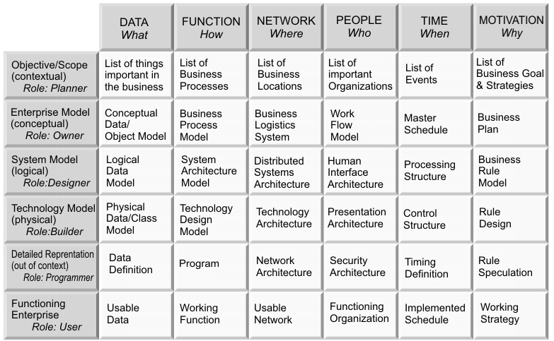

Columns: Role
- Objective / scope (contextual) Planner
- Enterprise model (conceptual) Owner
- System model (logical) Designer
- Technology model (physical) Builder
- Detailed representation (out of context) Programmer
- Functioning Enterprise User

Communication Interrogatives (rows):
- What (material)
- How (process)
- Where (geometry)
- Who (does what work)
- When (do things happen)
- Why (are various choices made)

Advantages of Zachman Framework:
- Easy to understand
- Addresses the enterprise as a whole
- Defined independently of tools or methodologies
- Any issues can be mapped against it to understand where they fit.

TOGAF
The Open Group Architecture Framework

4 Main Components of TOGAF:
- Target Architectures
- Architecture Development Method (ADM)
- Enterprise Continuum
- TOGAF Resource Base

Architecture Development Method (ADM):
- The core of TOGAF
- High level framework
- Considers EA as composed of four closely interrelated architectures:
  - Business architecture
  - Data/information architecture
  - Application architecture
  - Technology architecture

Phases A to D: Architecture Deliverables
Phases E to H: Architecture Implementation

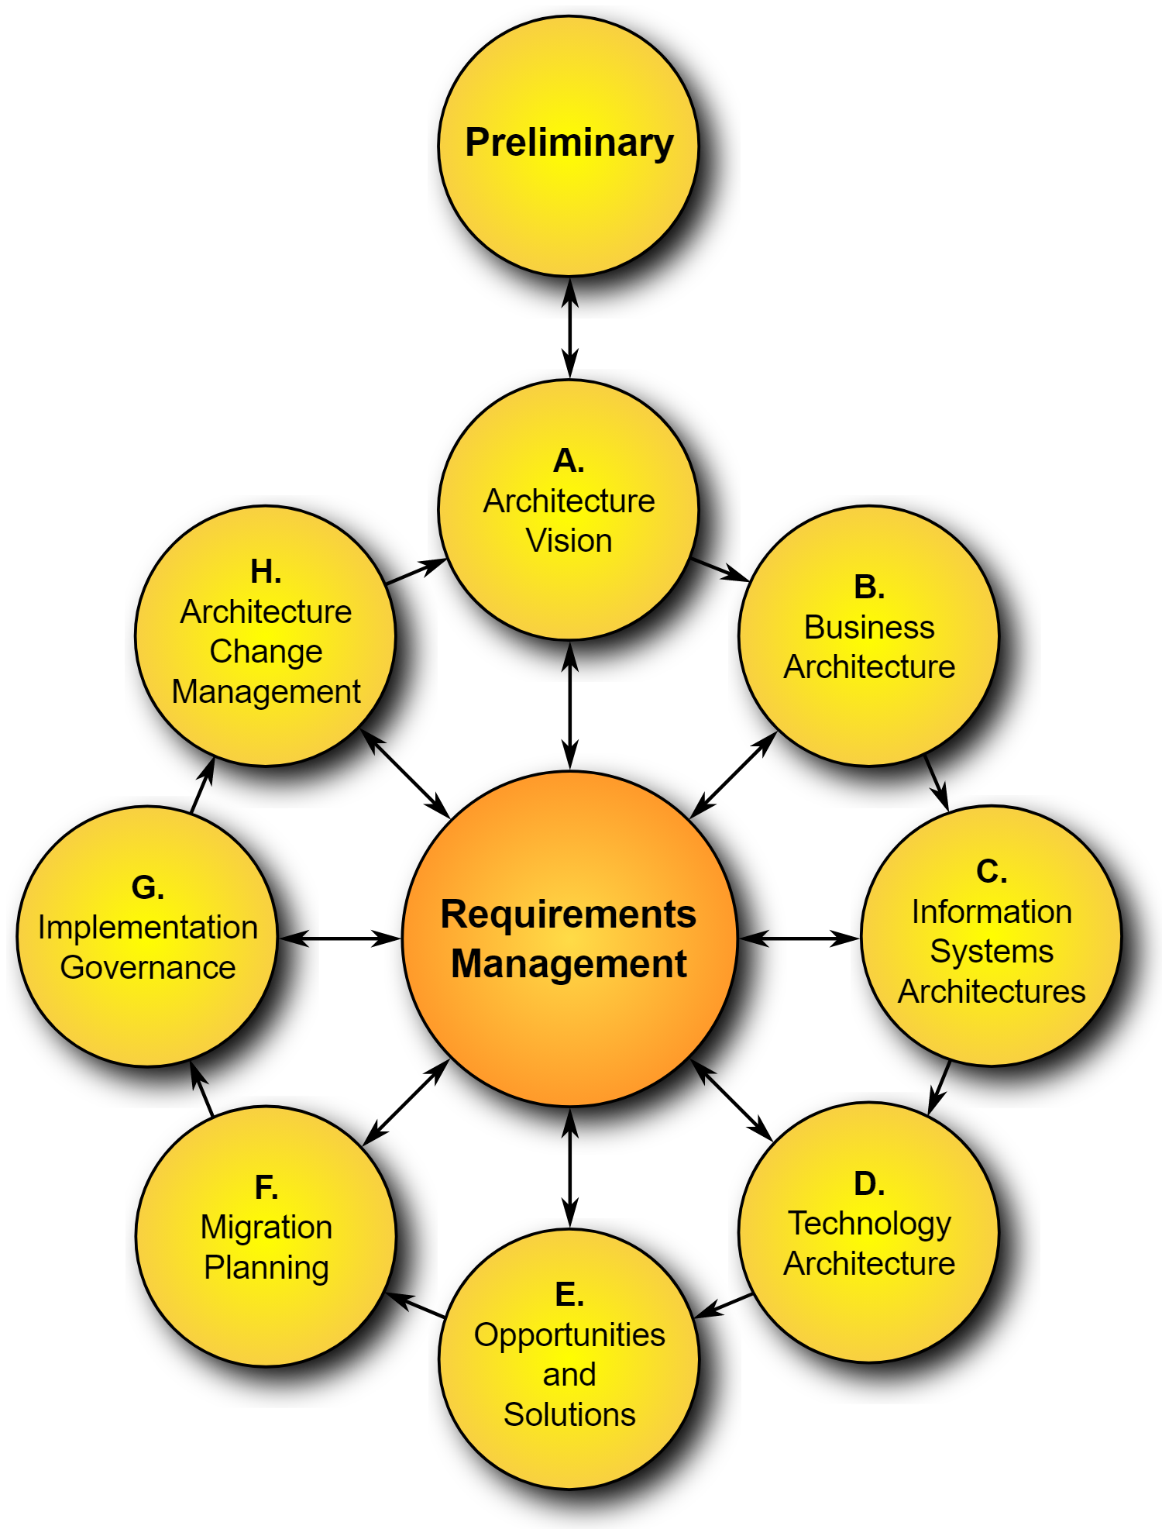

TOGAF PHASE A – H
PHASE A: ARCHITECTURE VISION
The objective of this phase is to garner support for the execution of the latest iteration of
Enterprise Architecture development and establish its objectives. The architecture vision is
Intended to scope and shape subsequent phases.
PHASE B: BUSINESS ARCHITECTURE
The objective of this phase is to describe the current business architecture of the organisation and subsequently also define a target architecture
PHASE C: INFORMATION SYSTEMS ARCHITECTURE
The goal of this phase is to develop target information and application architectures to support the business architecture
PHASE D: TECHNICAL ARCHITECTURE
The goal of this phase is to develop a target technical architecture to support information systems and application architecture
PHASE E: OPPORTUNITY AND SOLUTIONS
During this phase, implementations identified in the development of target architecture are evaluated and selected. A strategic means of implementing the changes is also identified
PHASE F: MIGRATION PLANNING
Migration planning is the detailed specification of what architecture components will be implemented and the scheduling of supporting tasks.
PHASE G: IMPLEMETNATION GOVERNANCE
Implementation governance is concerned with the monitoring of architecture change in order to ensure that the target architecture is implemented and specified
PHASE H: ARCHITECTURE CHANGE MANAGEMENT
This phase is responsible for determining if further architectural change is required and when the cycle should begin afresh

Business Process Modelling Notation (BPMN)
- A standard for graphical notation that is to serve as a common basis for a variety of business process modelling and execution languages
- Restricted to process modelling

EA Domains Zachman Framework
Business Architecture C1 (objective/scope) and C2 (enterprise model)
Information Architecture What
Application Architecture How
Security Architecture Who - C5 (detailed representation)
Privacy Architecture All columns/rows
Chapter 3
Chapter 3 Foundations
What is a key element when designing architectures?

Design -
- utilize common, well defined language to avoid misunderstandings & promote clear designs
- Allow for integration of different architectural domains
- Provide methodical support, general and organisation specific guidelines, best practices, drawing standards, and other means that promote the quality of the architectures
- Design process is iterative & requires changes and updates to architecture support for tracking architectural decisions and changes is desirable

Communication
- Visualize relevant aspects to certain stakeholders (management, system designers, outsourcing partners)
- Important to bring successful communication on relations among different domains described by diff. Architectures (.e.g processes vs applications) since it will often involved multiple groups of stakeholders
- Clear communication important as architect often not available to explain meaning of a design, to architecture should speak for itself

Realisation
- To facilitate realisation of architectures and provide feedback from this realisation to the original architectures
- Companies using different concepts and tools for activities (business process design, information modelling, software development) should be defined

Change
- An architecture often covers a large part of an organisation and may be related to several other architectures
- Therefore, changes to an architecture may have a profound impact
- Assess consequences of changes beforehand + carefully planning evolution of architecture is very important
What is the compositional approach? What does compositionality mean and why is it important?

The standard approach to dealing with the complexity of systems is to use a compositional approach, which distinguishes between parts of a system, and the relations between these parts

Ex. car functions we first describe the parts of the car such as the engine, the wheels, the air conditioning system, and then we describe the relationship among these parts

Likewise, we understand the information system of a company as a set of systems and their relations, and we understand a company as a set of business processes and their relations.

Compositionality plays a central role in the architectural approach - as the fundamental organisation of a system embodied in its components, their relationships to each other and to the environment also plays a role when varying viewpoints on a system are defined. The latter type of decompositions are usually functional, in the sense that the functionality of an architecture is decomposed in the functionality of its parts and their relations.

How would the integration of architectural domains work?
- take a pragmatic approach, and reuse elements from other languages, approaches, and techniques whenever possible
  - Top-down approach
  - Utilize language familiar by all stakeholders
BA, IA, AA, TA, SA

What is your understanding of alignment?
Relating architectures means relating the ideas of these stakeholders, most of which remain implicit. A consequence is that we often cannot assume to have complete one-to-one mappings, and the best we can ask for is that views are in some sense consistent with each other. This is often called a problem of alignment, and the UML–BPMN example is called a business–IT alignment problem

What is a service?
A service is an ‘external’ reflection of the ‘internal’ behaviour that realises it, analogous to the way in which an interface is an ‘external’ reflection of the ‘internal’ structure behind it

What is a model and how does it help describe enterprise architecture?
A model is an abstract and unambiguous conception of something (in the real world) that focuses on specific aspects or elements and abstracts from other elements, based on the purpose for which the model is created - textual graphical

Precise definitions and constraints will help us to create insight into the complexity of the enterprise architecture and to evade conflicts and inconsistencies between the different domains. For this, we use models.

What is a concern?
Stakeholder’s concerns i.e. their particular interest in the observed enterprise
Maybe be regarded at an aggregated as well as at an individual level - i.e. single business manager conceiving an information system is a stakeholder, the collective business management however can also be seen as a stakeholder of the information system
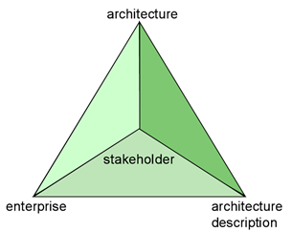
Figure 3.2 Relationship between enterprise, stakeholder, architecture and architecture description

Abraham Maslow said: “If the only tool you have is a
hammer; you tend to see every problem as a nail.” Do
you agree? Why and why not?
More specifically, in the context of system development, architects will approach a domain with the aim of expressing the domain in terms of some set of concepts, such as classes, activities, constraints, etc. The concepts an architect is used to using (or trained to use) when modelling some (part of a) domain, will strongly influence the conception of that architect. As Abraham Maslow said: ‘If the only tool you have is a hammer, you tend to see every problem as a nail.’ We therefore presume that when architects model a domain, they do so from a certain perspective.

What is a domain?
any subset of a conception (being a set of elements) of the universe that is conceived of as being some ‘part’ or ‘aspect’ of the universe.

What is modelling?
the act of purposely abstracting a model from (what is conceived to be) a part of the universe.

Distinguish between view and viewpoints?
View: a representation of a system from the perspective of a related set of concerns.

Viewpoint: a specification of the conventions for constructing and using a view; a pattern or template from which to develop individual views by establishing the purposes and audience for a view and the techniques for its creation and analysis.

What is content?
Concepts involved in architectures

What is visualization?
Forms in which these are presented

symbolic model expresses properties of architectures of systems by means of symbols that refer to reality.

Core of every symbolic model is its signature

-It comprises those parts of an architecture that can be modelled mathematically, as opposed to the more pragmatic aspects of an architecture that are concerned with characteristic notions like rationale, goals, and plans.

semantic model is an interpretation of a symbolic model, expressing the meaning of the symbols in that model

The formalized meaning of a symbolic model is given by a semantic model, an interpretation of the symbolic model

Figure 3.3 p 53
Know relationship between the enterprise, its architecture, symbolic and semantic models
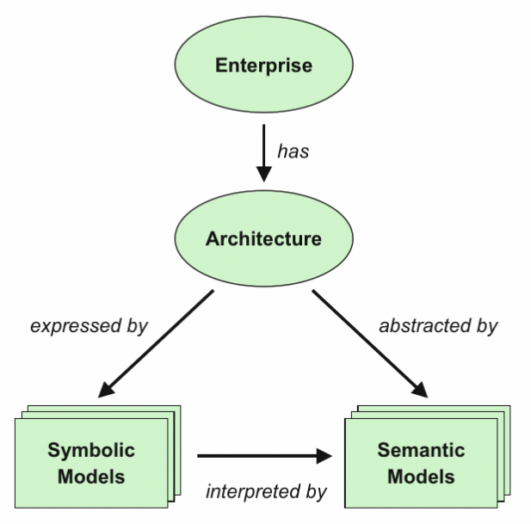
Domain- any subset of a conception (being a set of elements) of the universe that is conceived of as being some ‘part’ or ‘aspect’ of the universe. In the context of system development there is a particular interest in unambiguous abstractions from domains referred to as a model.
Model-An abstract unambiguous conception of something in the real world. Usually represented using a graphical or textual language.
-Both the domain and its model are conceptions from the same viewer
Modelling-the act of purposely abstracting a model from (what is conceived to be) a part of the universe

Phases of the Architectural Life Cycle
Design-should use a common well-defined vocabulary to avoid misunderstandings. To support an iterative design process tracking architectural decisions and changes is desirable.
Communication- Stakeholders, designers and outsourcing partners should be visualized to bring successful communications among different domains. Architecture should explain itself without the presence of the original architect
Realisation-To facilitate the realisation of architectures and to provide feedback from this realisation to the original architectures, links should be established with design activities on a more detailed level.
Change-Changes to an architecture may have a large impact, consequences of a change should be assessed before implemented and carefully planned to follow the evaluation of an architect.

Integration of architectural domains
-needed to deal with complexity of architecture and provide insight to anyone needing to deal with architecture and alignment of business and IT
-some integration problems can be solved by using an existing standard

Ex. An integration problem that houses several architectures which can be expressed in UML or Zachman cell modes can make it unclear if the views are compatible with each other. The models are made from different viewpoints of multiple stakeholders this can cause problems with alignment. An integrated language is necessary for facilitating the analysis of architectures across all domains and should be decided on before linking different tools.
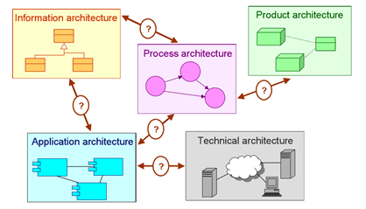

Chapter 4
Describing Architectures is all about communication. Do you
agree? Why and Why not?
Yes, Whatever the role of an architecture description is, it always involves some communicative aspect

What is an architecture description?
Architecture descriptions are used to communicate the architecture of a planned or pre-existing system. This could be a system that is part of an enterprise, an organisation, a business, an information system, a software system, or the hardware infrastructure. The communication about the system and its architecture is likely to take place between different stakeholders of that system.

Who are the actors in the System Development Community?
System development community: a group of objects, such as actors and representations, which are involved in the development of a system.

These actors are likely to have some stake with regards to the system being developed. Examples of such actors are problem owners, prospective actors in the future system (such as the future ‘users’ of the system), domain experts, sponsors, architects, engineers, business analysts, etc.

Another important class of objects are the many different documents, models, forms, etc., that represent bits and pieces of knowledge pertaining to the system that is being developed

What are the interests of stakeholders with respect to enterprise
Architecture?
Concern: an interest of a stakeholder with regards to the architecture description of some system, resulting from the stakeholder’s goals, and the present or future role(s) played by the system in relation to these goals.

EX.
− The current situation with regards to the computerised support of a business process. − The requirements of a specific stakeholder with regards to the desired situation.
− The improvements, which a new system may bring, to a pre-existing situation in relation to the costs of acquiring the system.
− The potential impact of a new system on the activities of a prospective user.
− The potential impact of a new system on the work of the system administrators that are to maintain the new system.

What are the different types of knowledge?
− Perspective: Artefacts, such as systems, can be considered from different perspectives. Some examples are:
• business, application, and infrastructure aspects of an (computerised) information system
• social, symbolical, and physical aspects of a system
• process, information, actors, and technology featuring in a system.

− Scope: Given a domain, such as a system or a development project, we can identify several scopes when approaching the domain: enterprise wide, department-specific, task-specific, etc.

− Design chain: When considering the design of some artefact, a distinction can be made between:
• Purpose: to what purpose the artefact is needed.
• Functionality: what functionality the artefact should provide to its environment.
• Design: how it should realise this functionality.
• Quality: how well it should do so.
• Costs: at what cost it may do so and may be constructed.

Based on the above distinction, knowledge topics can be characterised in terms of their focus on, for example, functionality or quality in isolation, or their focus on bridging the gaps between purpose, functionality, and design in terms of design rationale.

− Historical perspective: Given an artefact with a design, one may consider different versions of this artefact’s design over time. In the case of a system, one may consider the current version, the version that will be in existence after the development project has finished, and the (sketchy) version of the ‘future’ system that serves as a navigational beacon in a sea of possibilities to guide future development. In the case of a development process, one may consider the execution plan/strategy that is being used at the moment, or the plan/strategy that was used before.

− Abstraction level: When considering a domain, one may do so at several levels of abstraction. Various forms of abstraction can be distinguished: for example, type-instance, generalisation/is-a, encapsulation, and hiding of implementation details.

Based on Franckson and Verhoef, what are the dimensions of
explicitness for representations of system development knowledge?
Explicit knowledge refers to knowledge that can be externalised in terms of some representation. With representation of knowledge, we refer to the process of encoding knowledge in terms of some language on some medium, e.g., creating an architecture model

− Formality: The degree of formality indicates the type of language used to represent the knowledge. Such a language could be formal, in other words a language with an underlying well-defined semantics in some mathematical domain, or it could be informal – not mathematically underpinned, typically natural language, graphical illustrations, animations, etc.

− Quantifiability: Different aspects of the designed artefact, be it (part of) the target or the project domain, may be quantified. Quantification may be expressed in terms of volume, capacity, workload, effort, resource, usage, time, duration, frequency, etc.

− Executability: The represented knowledge may, where it concerns artefacts with operational behaviour, be explicit enough so as to allow for execution. This execution may take the form of a simulation, a prototype, generated animations, or even fully operational behaviour based on executable specifications.

− Comprehensibility: The knowledge representation may not be comprehensible to the intended audience. Tuning the required level of comprehensibility of the representation, in particular the representation language used, is crucial for effective communication. The representation language may offer special constructs to increase comprehension, such as stepwise refinements, grouping/clustering of topically related items/statements, etc.

− Completeness: The knowledge representation may be complete, incomplete, or overcomplete with regards to the knowledge topic (see previous subsection) it intends to cover.

What are the three major stages involved in the sharing of knowledge?
− Aware: An actor may become aware of (possible) knowledge by way of the sharing by
another actor.

− Agreed: Once knowledge is shared, an actor can make up his or her own mind about it, and decides whether or not to agree to the knowledge shared.

− Committed: Actors who agree to a specific knowledge topic may decide actually to commit to this knowledge. In other words, they may decide to adapt their future behaviour in accordance with this knowledge.

Describe some of the conversation techniques?
Each conversation is presumed to have some knowledge goal: a knowledge state which the conversation aims to achieve (or to maintain). In achieving this goal, a conversation will follow a conversation strategy

− Brown-paper session: ive group process, structured and categorised. This may involve adding, deleting, merging, or changing items. Usually, a mediator or facilitator is involved.

− Elicitation interview: An interview where an analyst puts informative questions to the informants. The aim is to gather knowledge from the informants. Interviews can be more or less ‘open’: they can be strictly focused or guided, but the conversation can also be left open to go where the interest of the interviewer or informants leads it.

− Workshop: Involves one to, say, fifteen people, working on a model or view interactively, mediated by an architect or analyst. This class also encompasses so-called joint modelling sessions. A popular, effective, and realistic technique is to project a view or model and have a facilitator adapt it in full view of the participants, thus generating immediate feedback. With a few participants, a workshop can of course simply take place behind a screen and keyboard.

− Validation interview: An interview where an analyst will aim to find out if the view or model matches the views and expectations of an informant. This could be a view or model that has been communicated to the informants beforehand, or during the interview. A validation interview will typically be much more ‘closed’ than an elicitation interview: there will have to be some systematic approach by which validity of the view or model is checked.

− Committing review: A group of stakeholders are presented with a number of alternative models or views and their impact. They are requested to select one alternative and commit to this alternative based on their insights into the potential impact. This typically involves a formal decision-making process (Franckson and Verhoef 1999).

− Presentation: Involves one to three people presenting a model or view to a group of, say, up to a hundred people. One may decide to elicit feedback, but this is usually gathered afterwards, in a more personal way, or at least 1:1 (e.g., through a feedback round).

− Mailing: A form of ‘mass’ communication, where a model or view is presented or handed over to a large number of people. Feedback may or may not be encouraged (feedback round).

Chapter 5
What is ArchiMate?
ArchiMate is The Open Group‘s open and independent modelling language for enterprise architecture, supported by different tool vendors and consulting firms. ArchiMate provides instruments to support enterprise architects in describing, analyzing and visualizing the relationships among different architecture domains in an unambiguous way, similar to those well-established disciplines like civil engineering or building and construction using internationally accepted standards for describing their designs.

What is a service?
In the enterprise modelling language that we propose, the service concept plays a central role. A service is defined as a unit of functionality that some entity (e.g., a system, organisation, or department) makes available to its environment, and which has some value for certain entities in the environment (typically the ‘service users’). Service orientation supports current trends ranging from the service-based network economy to ICT integration with Web services.

What are the three layers within ArchiMate?
1. The business layer offers products and services to external customers, which are realised in the organisation by business processes (performed by business actors or roles).

2. The application layer supports the business layer with application services which are realised by (software) application components.

3. The technology layer offers infrastructural services (e.g., processing, storage, and communication services) needed to run applications, realised by computer and communication devices and system software.

What are the three dimensions of modelling?
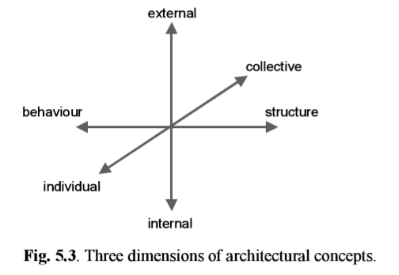
Define the following: Passive structure, Behaviour, and Active structure?
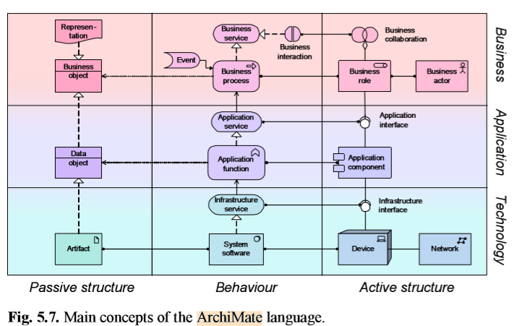
- Passive structure revolves around the objects of the business, application, or technology.
- Behavior structure is about the system processes and functions of the business, application, and technology
- Active structure is about active components of the business (actors), application (components), and technology (networks/devices)

What is a business actor?
Business actor: an active entity that performs behaviour (i.e., the ‘subject’ of behaviour).

What is a business role?
Business role: states which business behaviour is performed by a business actor that fulfils this role.

What is business collaboration?
Business collaboration: a (possibly temporary) collective of roles within an organisation which perform collaborative behaviour (interactions). -does not have an official (permanent) status within the organisation: it is specifically aimed at a specific interaction or set of interactions between roles.

What is a business interface?
Business interfaces: the (logical or physical) locations where the services that a role offers to the environment can be accessed. - The same service may be offered on a number of different interfaces, e.g., by mail, by telephone or through the Internet. This example suggests that different ‘channels’ for offering products or services are typically modelled as business interfaces.

What is a business object?
Business objects: the passive entities such as business processes or functions that are manipulated by behaviour.

Useful specializations of the business object concept are Message, i.e., an object intended to exchange information between parties

What is a business service?
Business services are used to expose business functionality to the environment.

Business service: a coherent piece of functionality that offers added value to the environment, independent of the way this functionality is realised internally.

What is a business process?
Business process: a ‘flow’ of activities, with one or more clear starting points and leading to a clearly defined result.

What is a business function?
Business function: offers functionality that may be useful for one or more business processes.

A business function groups behaviour based on, for example, required skills, capabilities, resources, or (application) support. Typically, the business processes of an organisation are defined based on the products and services that the organisation offers, while the business functions are the basis for the assignment of resources to tasks and the application support.
Handle

What is a business interaction?
Business interaction: behaviour performed in a collaboration of two or more business roles.

What is a Business Capability?
A business capability, a key component of business architecture, is an expression of what a business does and can do. A business capability denotes the “What” a business can do, whereas a business process outlines how a particular activity gets done. (google)
Capabilities are distinct from business functions (Sect. 5.8.2 ). Capabilities represent the current or desired abilities of an enterprise, realised by its people, processes, information and technology, but defined independently from the structure of the organisation (textbook)
What is Core and non-core capability?
Core capability is the strategic capabilities of the business and non-core capability is the capability to do the day-to-day tasks that have little impact on the business.
What is a Business Service?
Business service: a coherent piece of functionality that offers added value to the environment, independent of the way this functionality is realised internally.

What is a Business Interaction?
A business interaction is a unit of behaviour similar to a business process or function, but which is performed in a collaboration of two or more roles within the organisation.

What is a Business Event?
Business event: something that happens (externally) and may influence business processes, functions, or interactions.

A business event is most commonly used to model something that triggers behaviour, but other types of events are also conceivable, e.g., an event that interrupts a process. Unlike business behaviour, a business event is instantaneous: it does not have duration. Events may originate from the environment of the organisation (e.g., from a customer), but also internal events may occur, generated by other processes within the organisation.

What is a product?
Product: a collection of services together with a contract that specifies the characteristics, rights, and requirements for their use. Coherent collection of services accompanied by a contract/set of agreements, which is offered as a whole to (internal or external) customers.

What is value?
The value of a product or service is that which makes some party appreciate it.

What is an application component?
The main structural concept for the application layer is the application component.

Application component: self-contained part of a system that encapsulates its contents and exposes its functionality through a set of interfaces.

What is application collaboration?
Application collaboration: a collective of application components, which perform application interactions.

The interrelationships of components are also an essential ingredient in application architecture.

What is an application interface?

Application interface: defines the set of operations and events that are provided by the component, or those that are required from the environment.

What is a data object?
Also at the application layer, we distinguish the passive counterpart of the component, which we call a data object.

Data object: a coherent, self-contained piece of information suitable for automated processing.

What is an application service?
Application service: an externally visible unit of functionality, provided by one or more components, exposed through well-defined interfaces, and meaningful to the environment.
What is an application function?
A business function groups behaviour based on, for example, required skills, capabilities, resources, or (application) support. Typically, the business processes of an organisation are defined based on the products and services that the organisation offers, while the business functions are the basis for the assignment of resources to tasks and the application support.

What is an application interaction?
A business interaction is a unit of behaviour similar to a business process or function, but which is performed in a collaboration of two or more roles within the organisation.

What is the importance of a Business – Application Alignment?
It is important because it allows for integration, which means there is support relation between the application and business layers. It is also important as it allows for implementation between application and business layers
What is the main structural concept for the application layer? Describe it?
The application layer supports the business layer with applications services which are realized by (software) application components. The main structural concept for the application layer is the node which is a computational or physical resource that hosts, manipulates or interacts with other computational or physical resources.

What is a communication path?
Communication path: the relation between two or more nodes, through which these nodes can exchange information.

What is an artifact?

Artifacts are used to model the representation, in the form of, for example, a file, of a data object or an application component, and can be assigned to (i.e., deployed on) a node.

Artifact: a physical piece of information that is used or produced in a software development process, or by deployment and operation of a system.

What is the importance of Application - Technology Alignment?
The technology layer and the application layer can also be linked very easily. Similar to business–application alignment, two types of relations provide this link:
1. Infrastructure services can be used by application functions and infrastructure interfaces are used by application components, i.e., there is a support relation between the technology and application layers (Fig. 5.19). 2. Artifacts can realise data objects and application components, i.e., there is an implementation relation between the technology and application layers (Fig. 5.20).
Artifacts play a central role in showing how ‘logical’ application components are realised by ‘physical’ components (modelled as artifacts). A single physical component may realise multiple logical components and, conversely, multiple physical components may be used to realise a single logical component.

What is a requirement?
A statement of need that must be realized by a system
What is a constraint?
A restriction on the way in which a system is realized.
What is a principle?
A normative property of all systems in a given context, or the way in which they are realized.
What is a deliverable?
A precisely-defined outcome of a work package

Chapter 6
What is the Business Motivation Model?
If an enterprise prescribes a certain approach for its business activity, it ought to be able to say why and what result(s) is the approach meant to achieve. The Business Motivation Model (BMM) is an OMG modeling notation for support of business decisions about how to react to a changing world. An enterprise would use it by acquiring a BMM modeling tool and then creating its own BMM - populating the model with business information specific to the enterprise. There are two broad purposes:
- To capture decisions about reaction to change and the rationale for making them, with the intent of making them shareable, increasing clarity and improving decision-making by learning from experience.
- To reference the outcomes of the decisions to their effect on the operational business (e.g. changes made to business processes and organization responsibilities), providing traceability from influencer to operational change.
What is BSC? Balance Scorecard
Identify the 9 segments of the Business Model Canvas
- Customer Segments – The target audiences that you plan to offer value with your products or services.
- Value Propositions – This value proposition is built to explain how your customer segments will get value from your unique offer and differentiate it from the competition.
- Channels – What channels will your value proposition be delivered through?
- Customer Relationships – How do you plan on keeping solid relationships with your consumer segments?
- Revenue Streams – How will your value propositions bring in revenues from each target audience?
- Key Resources – These are the assets available to the business that allows you to run your operations effectively.
- Key Activities – What operations are essential to the success of your business?
- Key Partnerships – These partnerships are obtained through networking with the people that can help with your business success.
- Cost Structure – All of the costs associated with a business.

What is the Value Map?

- A visual depiction of how an organization achieves value for stakeholders within the context of a given set of business activities
- Benefits include:
  - Provide common baseline for envisioning how to deliver high visibility value
  - Provide clear focal points for prioritizing how to achieve stakeholder value
  - Enable delivery of near-term, mid-term, and long-term value to stakeholders
  - Provide new and unique ways to envision stakeholder engagement
  - Enable prioritization and managed deployment of business capabilities

What is a Roadmap?
- Roadmap is a graphical representation that is used to illustrate the milestones and deliverables required to transition to a future state from a current state over a specific period of time.
- enterprise roadmap is a type of roadmap that illustrates current and planned strategic change (business outcomes, business capabilities) at a contextual level and over a specified time.
- Benefits Include:
  - It can help earn stakeholder buy-in
  - A roadmap is a versatile tool that lets you share the right details with each audience
  - It can help your team be strategically on track and working on the right priorities

What is a Customer Journey Map?
- A customer journey map is a very simple idea: a diagram that illustrates the steps your customer(s) go through when engaging with your company, whether it be a product or an online experience, retail experience, a service, or any combination
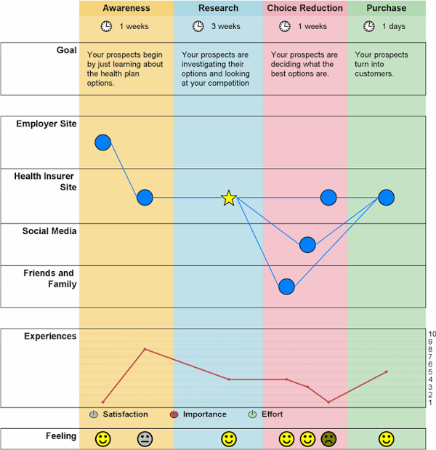

UML – Complete a tutorial in UML if you have not already done so as part of CITM 305:
- The Unified Modeling Language (UML) is a general-purpose, developmental, modeling language in the field of software engineering that is intended to provide a standard way to visualize the design of a system.
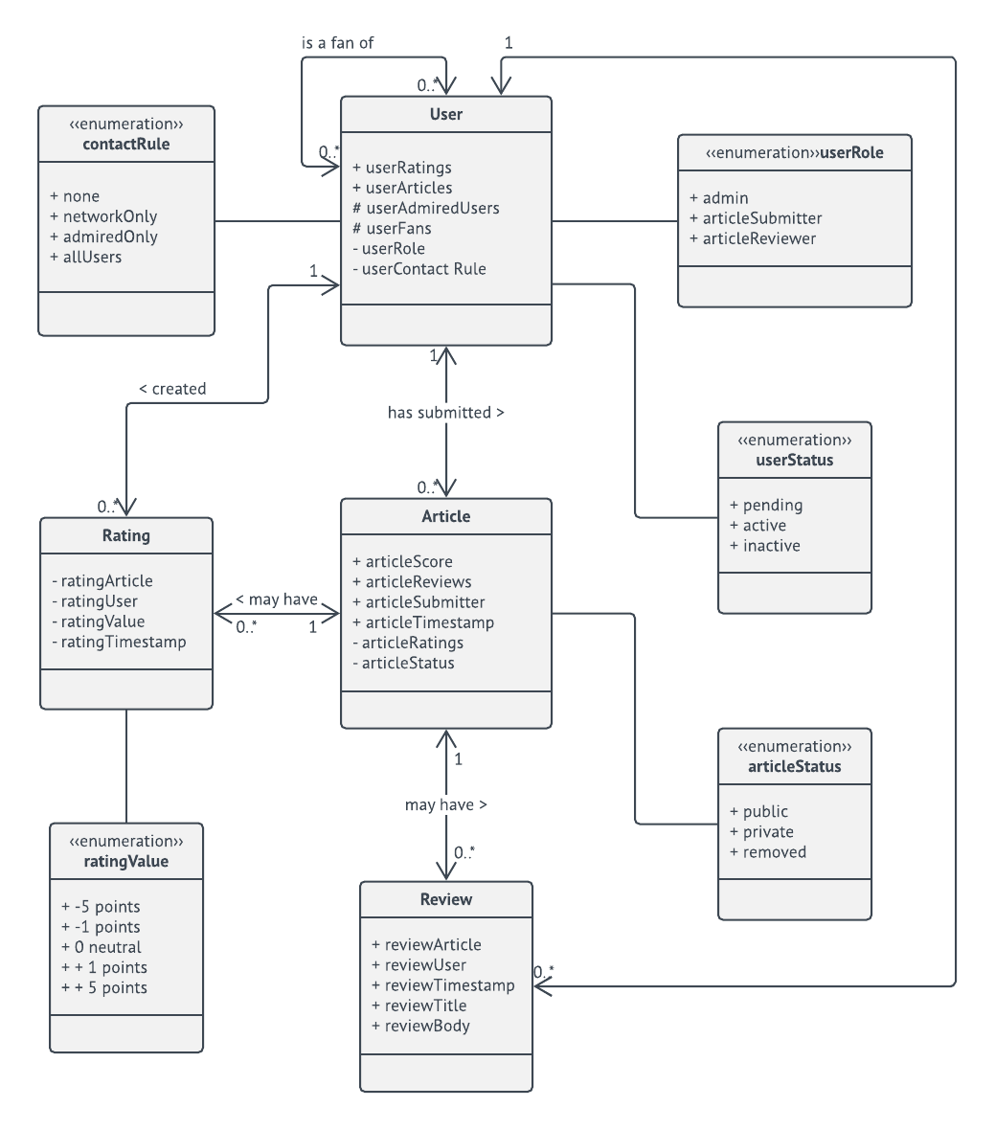

Review your ERD Model:
- Entity Relationship Diagram, also known as ERD, ER Diagram or ER model, is a type of structural diagram for use in database design. An ERD contains different symbols and connectors that visualize two important pieces of information: The major entities within the system scope, and the inter-relationships among these entities
- ERD notations guide
  - An ER Diagram contains entities, attributes, and relationships. In this section, we will go through the ERD symbols in detail.
- Entity Attributes
  - Also known as a column, an attribute is a property or characteristic of the entity that holds it.
  - An attribute has a name that describes the property and a type that describes the kind of attribute it is, such as varchar for a string, and int for integer.
- Primary Key
  - Also known as PK, a primary key is a special kind of entity attribute that uniquely defines a record in a database table.
- Foreign Key
  - Also known as FK, a foreign key is a reference to a primary key in a table. It is used to identify the relationships between entities.

- Cardinality
  - defines the possible number of occurrences in one entity which is associated with the number of occurrences in another.

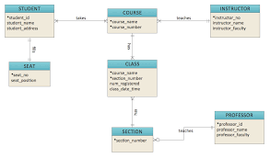

Review your TOGAF presentation:
- TOGAF is an acronym for The Open Group Architecture Framework
- The TOGAF® Standard, is a standard of The Open Group, is a proven Enterprise Architecture methodology and framework used by the world’s leading organizations to improve business efficiency.
- It is the most prominent and reliable Enterprise Architecture standard, ensuring consistent standards, methods, and communication among Enterprise Architecture professionals.
- Those professionals who are fluent in the TOGAF approach enjoy greater industry credibility, job effectiveness, and career opportunities. This approach helps practitioners avoid being locked into proprietary methods, utilize resources more efficiently and effectively, and realize a greater return on investment

- The New TOGAF 9.2 Standard
  - PART I:(Introduction) –a high-level introduction to key concepts
  - PART II:(Architecture Development Method) -a step-by-step approach to developing an enterprise architecture.
  - PART III:(ADM Guidelines and Techniques) -a collection of guidelines and techniques to apply ADM
  - PART IV:(Architecture Content Framework) -includes a structured metamodel for architectural artifacts, the use of reusable architecture building blocks, etc.
  - PART V: (Enterprise Continuum & Tools) -taxonomies and tools to categorize and store the outputs of architecture.
  - PART VI: (Architecture Capability Framework) This part discusses the organization, processes, skills, roles, and responsibilities required to establish and operate an architecture function within an enterprise

- The TOGAF 9.2 Library:
  - Section 1:(Foundation Documents)
    - Broadly applicable information relating to the subject of the TOGAF framework or Enterprise Architecture
  - Section 2:(Generic Guidelines and Techniques)
    - information describing architecture styles and how then TOGAF framework and Enterprise Architecture can be adapted to exploit the characteristics of a more specific cont
  - Section 3:(Industry-Specific Guidelines and Techniques)
    - information describing how the TOGAF framework and Enterprise Architecture can be applied to meet the specific needs of a vertical industry segment
  - Section 4:(Organization-Specific Guidelines and Techniques
    - information describing how the TOGAF framework and Enterprise Architecture have been applied to meet the needs of specific enterprises

Chapter 7:

1. What is the modelling process? (Page 143)
The process where architecture models are created in order to communicate something, either to the people reading the model or between people making the model. Communication also has an underlying goal, which is to get participants to introduce, agree on, and commit to some knowledge representation. This means that the model that is the result of a modelling process is not the ultimate goal, and not even the only product of that process. Transformations in the knowledge, agreements, and commitments in the minds of the people involved are as important, if not more important than the representations (models). The three main goals of the modelling process are essentially knowledge goals, models, and the creation of models that are directly aimed at fulfilling those knowledge goals.

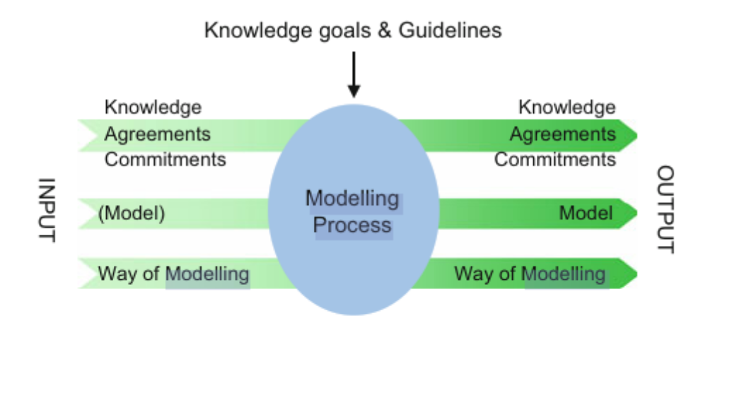

2. What are the input and output of the modelling process? (Page 143)
The inputs of the modelling process include flow of data and materials (models) that go into the process from the outside(from outside the organization). The processing step includes all the tasks required to effect the transformation of the inputs. The outputs are data and materials that flow out as a result of the transformation process (completed models, knowledge, etc.).

3. What is the importance of communication in the modelling process? (Page 143)
Communication is at the core of the modelling process. The modelling process occurs in order to create architecture models that communicate something, either to the people reading the model or between people making the model. Communication also has an underlying goal, which is to get participants to introduce, agree on, and commit to some knowledge representation.

4. What are the basic modelling activities? (Page 144)
The basic modelling activities include:
- Establishing the purpose, scope, and focus
- Selecting one or more viewpoints to create the model
- Creating and structuring the model
- Visualizing the model
- Using the model
- Maintaining the model

5. What are the types of modelling actions?
- Introduce: The act of placing a fresh term for a concept or relation within the model. It may not even be linked(related) to anything, it just seems ‘somehow relevant’. It may be changed or even deleted later on.

- Refine:
This corresponds to adding detail to the element. Refining an element can take two main forms. The 1st form is to classify the newly introduced (candidate) element. Classifications are selected based on the modelling context. The 2nd form is to provide a description. A description can be done by adding internal detail to an element, writing a definition or gloss kept outside the model, and nesting models(using multiple levels in your model)

- Abandon: This action is harder and more complex than it looks. Certain concepts and relations may be a simple matter to delete if they turn out to be wrong. However, if a model has been around for a while, it may be a good idea to make an explicit(even communal) decision to abandon a concept or relation, in order to avoid the concept ‘lingering around’. A record of this potential but rejected element might be kept somewhere such as a ‘lesson learned’.

- Abstract: Abstraction is different from abandoning a concept or scrapping some detail. Abstraction is the opposite of refinement and takes place at two levels. These levels are to ‘abstract the whole concept or relation’ or ‘abstract some internal detail’. In either case you must make the decision that some information that is available to you is to be left out of the model. If you cannot part with some information because it’s not ‘wrong’ as such, you can hide the detail by keeping the information somewhere else.

- Translate: Finding a fitting alternative for an interesting element in another model. There is no crucial difference between introduction or refinement. Translation may need to be documented in order to keep track of the existing relationship between models/contexts.

- Document Modelling Actions: Documentation and administration of all or some modelling actions may be useful. There are several reasons to document a model. These include:
- To be able to undo a decision and backtrack to a previous state
- To revisit rejected alternatives
- To record modelling rationales related to traceability, accountability, etc. of the modelling process
- To add conceptual meta-data. It may be interesting to keep track of who did what with a model element, and where it occurs

6. What are the guidelines for modelling?
Guidelines for modelling include the following:
- A model has to provide answers to questions: Modelling itself is not an objective. The purpose of modelling is to answer some particular questions. Making questions explicit will help you find the appropriate scope and focus while creating a model
- Make a clear distinction between a model and its visualisations: Follow Grice’s Four Maxims.
- Model iteratively: When modelling an EA, use several iterations to discuss intermediate stable models with the stakeholders. Use their feedback to improve the model and determine parts of the model that do not yet have the appropriate level of detail
- Model for dynamics: Models often include real-life aspects that are likely to change over time, such as a company’s product portfolio. Models are dynamic. If certain changes can be foreseen, architects should add a description of how the model can change.
- Be economical in models: Model only those concepts and relations that are relevant given the purpose of the model and the type of stakeholders it is intended for
- Be economical in views: When communicating with a specific stakeholder, use a view of that model that only includes the concepts and relations that are relevant for that stakeholder.
- Make concepts recognisable: Indicate concepts in a model by the same names the stakeholders apply to those concepts.
- Make structures recognisable: Use the same type of structuring that the stakeholders apply: if the stakeholders for instance describe their business in terms of a process with various steps, make sure this process and the individual steps are clearly present in the model
- Make a model consistent: Apply the same type of concepts to denote the same types of elements from the real world in a model. Model similar relations in a similar manner and use the same terms to denote the same concepts in related models as well.
- Keep related models consistent: Architects will create a series of related models to model different aspects of the same enterprise. Coherence between these models is very important. Avoid conflicts between related models by using uniform terminology.
- Make models as correct and complete as needed: A model should be a correct representation of something in the real world, focusing on specific aspects. In many cases you do not want to create a 100% complete or correct model.
- Treat different concerns orthogonally: Different concerns should be addressed in different parts of the model, or in different, related models.

7. What are the four maxims related to modelling?
The four maxims are heuristics created by Grice, that are used to help optimize communication. Keep in mind that the goal of EA is to communicate information about an enterprise. The 4 maxims aid in that and include the following;

1. Maxim of quantity:
- Make your model as informative as necessary
- Do not make your model more informative than necessary

2. Maxim of quality:
- Do not model what you believe to be false
- Do not model that for which you lack adequate evidence

3. Maxim of relevance:
- Be relevant (i.e. model things related to the modelling goal).

4. Maxim of manner:
- Avoid obscurity of expression
- Avoid ambiguity
- Be brief (avoid unnecessary concepts and relations).
- Be orderly

8. Structuring Models and Visualizations:
When a model consists of many concepts and relations, structuring a model helps to reduce the visual complexity of the model, which makes it easier for your stakeholders to recognise and understand your model. Structuring a model may also help to discover recurring structures, patterns, or inconsistencies. Different structures will be dominant in different parts of the EA. Architecture models may contain different types of structure. Commonly used structural dimensions include:
- Functionality: Functional decomposition
- Time: Temporal structure, data flow, control flow
- Usage: Dependencies, call graphs
- Location: Physical distribution
- Data structure: Type/class hierarchies
- Work: Units of implementation, module structure

Widely used structuring principles include:
- Make a model as self-explanatory as possible
- Separate internal and external behaviour
- Use layers
- Group by phase
- Group by product or service
- Group by information used
- Group by physical distribution
- Separate independent parts

9. How do you check for Readability of models? (Page 160)
Readability breakdowns occur when communicating models are visualised in an inappropriate manner, given your stakeholders and the modelling goals. Having your stakeholders understand the model is of the utmost importance, independent of whether your model is meant for designing, deciding, or informing. The following are readability breakdowns accompanied with their respective solutions:
1) The model is not understood
Solution: Analyse the stakeholder and use his/her language, terms, and concepts. It can be useful to build a model using the terms of the stakeholder or to explain newly introduced vocabulary

2) The model is understood the wrong way:
Solution: Analyse the stakeholder and use his/her language, terms, and concepts. It can be useful to build a model in terms of the receiver or to explain newly introduced vocabulary

3) The model has no intuitive structure for the receiver (The receiver finds it difficult to recall all of the elements of the model and thinks of it as a bag full of propositions)
Solution: Copy the structure used by the stakeholder or analyse it to find out about its underlying logic. Use that underlying logic in the new model.

4) The model has an unclear structure or notation
Solution: Explain the structure of the model or use structures the receiver is used to. Introduce new kinds of diagrams describing a well-known situation to explain the diagram constructs

5) The visualisation of the model distracts from the original message(Diagram and colours are so awful or beautiful that nobody takes any notice of the contents. The form of the model is the only thing that people remember, not its contents)
Solution: Adjust the visualisation of the model: first give the message as text, or as a story. Secondly, apologise for the ugly models.

10. What are the issues related to communications with respect to created models? (Page 161)
These include the following:
- The model or architect lacks status(The receiver is not willing to listen. He or she is always busy and cannot make time for you)
Solution: This is a relational breakdown, which needs to be solved before continuing the process.

- The model has a true but unwanted message(There is no room to negotiate. The model is forgotten and deliberately misunderstood. Some sort of delaying tactics is used)
Solution: This too is a relational breakdown, which needs to be solved before continuing the process.

- The model is irrelevant(The model is true, it is a good representation of the modelled situation, but it has no relation with the problem)
Solution: See ‘the model contains superfluous elements’

- The model contains superfluous elements(The model is true, it is a good representation of the modelled situation, and there is a relation with the problem, but not everything is relevant. The real message is hidden somewhere in the larger message)
Solution: Construct and get commitment for a problem description. For every line and every drawing, you should ask yourself ‘Do I miss something if I leave this thing out?’. If you are convinced that the model should include some elements that should be left out considering the problem description, re-evaluate the problem description together with the stakeholders.

- The model is too complex(The model contains relevant information, but there is just too much of it)
Solution: Use abstraction levels to allow the stakeholder to zoom in on or out of parts of the model

- The model is too vague(The model is true but not very specific. It does not provide the stakeholder with the desired knowledge)
Solution: Iterate and create a more concrete model, focusing on the objective of the stakeholder.

- The model is not sufficiently complete(Not all required information is included in the model)
Solution: Iterate and create a more complete model, focusing on the objective of the stakeholder. An architect needs to find a balance between a model being sufficiently complete while simultaneously not being too complex.

- The model is not true(The model contains incorrect arguments, or inaccurate or untrue reasoning)
Solution: Gather the required information and check it for correctness

11. State GESTALT principles (Page 164-166)
Principles taken from the Gestalt theory of human perception that assists in the representation of relationships that exist between different entities in architectural models. These include:
- Proximity: Related objects should be placed near to each other in a model. This rule also applies for colours. The colour of objects in a model should be applied to indicate relations between objects

- Continuity: People have a tendency to perceive a line as continuing its established direction. Therefore, right angles should not be positioned next to each other in a model.

- Closure: In general, symmetry and regularity of models increases the readability of models and reduces the perceived complexity

- Similarity: As a specialisation of this principle, people have a tendency to perceive objects with similar size as being of equal importance: When shown a larger object and a small object, people have a tendency to perceive the larger object as being more important

- Common fate: Consider a group of four similar objects that are perceived as a group: if two objects are rotated, the group of objects is no longer perceived as one group, but rather as two pairs.

12. What are the model representation conventions?
Model representation conventions can be applied to increase the ease of understanding models. They provide useful clues for the meaning of a model. There are three model representation conventions. These are:
1. Use of Layout: One of the most important visual attributes of a model. Use of layout principles include;
- Use white space
- Distinguish between normal and exceptional cases
- Use symmetry to stress similarities
- Model time dependence from left to right
- Avoid crossing lines

2. Use of Symbols: The shapes of objects usually match the intrinsic properties of the objects. Use of Symbols principles include:
- Use similar shapes for similar concepts
- Use line width to stress important relations

3. Use of Colour: It is a visual attribute that is strongly influenced by ‘prior knowledge’, like cultural values, fashion colours, or company colours. Additional meanings can be easily (temporarily) attached to a certain colour. Use of Colour principles include:
- Use colour for emphasis
- Use colour for similarity
- Use colour to convey emotions
- Limit the number of colours

4. Use of Text: Most modelling languages combine the power of text and graphics. Text can be very strong in suggesting the proper interpretations and associations and in stimulating thinking. Use of text principles include:
- Use domain-specific terminology
- Use naming conventions

13. Comment on the use of Symbols and Colour
- Use of Symbols: The shapes of objects usually match the intrinsic properties of the objects. Use of Symbols principles include:
- Use similar shapes for similar concepts
- Use line width to stress important relations

- Use of Colour: It is a visual attribute that is strongly influenced by ‘prior knowledge’, like cultural values, fashion colours, or company colours. Additional meanings can be easily (temporarily) attached to a certain colour. Use of Colour principles include:
- Use colour for emphasis
- Use colour for similarity
- Use colour to convey emotions
- Limit the number of colours

Principles of Information Security
- Information security is integral to enterprise strategy
  - Key support to business objectives of enterprise strategy by both reducing risk and enabling trust to be maintained in new generations of services. Info security must have endorsement and support from executive management and board
  - Mission vs strategy
    - Mission describes the long-term goal of the organisation. Purpose for the organisation being in business. It is an ongoing guide without time frame
    - Strategy outlines progressive direction the organisation intends to take in order to achieve the mission. Strategic objectives provide short term guide for planning
  - Protects physical and financial resources, rep, legal position, employees and tangible/intangible assets.

- Information security impacts on the entire organisation (USED IN PROJECT)
  - Holistic approach to implementing enterprise information security is the most effective. Involves considering people, technology, processes throughout all areas of the business. To maximize return on security investment, info security must be designed into information systems and processes from the outset
  - Return on security investment
    - Benefits to the organisation as a result of spending on security initiatives. Replies on the simple yet powerful concept of return on investment
      - Can be used to…
        - Compare alternative security investment strategies
        - Justify security investment
  - Holistic approach ensures that info security achieves
    - Whole organisation acceptance and cooperation
    - Information security implementations that are practical, well integrated and address business needs; and
    - The cost-effective inclusion of appropriate controls
- Enterprise risk management defines information security requirements
  - Organisations need to assess, protect against and report on information security risk
  - Risk management
    - Possible reduction in business value from any source. The activity which seeks to understand these risks and subsequently accept, mitigate, eliminate or transfer them
  - Driving information security risk management from the enterprise risk management function allows:
    - Information security function to be aware of the business impact of information security ;
    - Information security function to be aware of risk management regulatory requirements;
    - Enterprise risk management to be aware of technical controls in the management of information security risk
- Information security accountabilities should be defined and acknowledged
  - Responsibilities should be developed and implemented within the enterprise.
  - Accountability vs responsibility
    - Responsibility defines obligation and expected behaviour. It implies a proactive stance on the part of the responsible party and a causal relationship between the responsible party and given outcome
    - Accountability refers to the ability to hold people responsible for their actions. Therefore people could be responsible for their actions but not held accountable.
    - Least privilege: the concept that every user of a system should operate using the least set of privileges necessary to complete the task allocated to them
  - Effectively enforce responsibilities for info security, organisations should;
    - Include assessment against info security objectives in performance reviews with corresponding recognition
    - Cleary document and enforce an acceptable usage and user responsibility policy
    - Make info on security issues available to users
- Information security must consider internal and external stakeholders
  - Stakeholders
    - Refers to any person or group – including investors, employees, customers, suppliers and in some cases the community at large – who are impacted by a given decision. The competitiveness and ultimate success of an organisation requires the support and commitment of all key stakeholders
      - Interest of stakeholders must be protected in order to retain long-term cooperation
  - By considering internal and external stakeholders an organisation can ensure that it
    - Protects customer (upstream user) interests
    - Ensures consistency in data protection throughout the chain of suppliers involved in delivering a product or service
    - Ensure the maintenance of trust between the organisation and community at large
- Information security requires understanding and commitment
  - A high level of awareness within the organisation supports the development of a “culture of security” and can reduce the frequency and impact of information security incidents
  - Threat vs vulnerability (The three concepts of security)
    - Threat is defined as any potential circumstances, capability, action or event which could breach security or cause harm to an asset
    - Vulnerability: a flaw or weakness in an information system design, implementation or operation and management that could be exploited to violate the system’s security policy
    - Risk is an expectation of loss expressed as the probability that particular threat will exploit a particular vulnerability with a particular harmful result.
Information security awareness directly assists an organisation to:
• Develop a “culture of security” within the organizations’ staff
• Provide early detection for information security threats
• Improve acceptance and use of the information security policy
• Improve information security communication within the organisation
• Effectively coordinate responses to information security incidents

- Information security requires continual improvement
  - Risk exposure is dynamic, information security review and improvement must be a part of business as usual. Good security governance will enable an organisation to manage gap created by tech adoption outpacing controls adoption
  - Continual improvement allows the organisation to
    - Maintain capabilities to assess security risk and implement effective controls
    - Provide assurance that information security risks are identified and managed consistently
    - Satisfy legal and regulatory requirements consistently
    - Ensure security considerations that are included in the selection and adoption of the new technology
    - Audit the organizations performance over time.

CIA (Confidentiality, Integrity, Availability)
- Confidentiality: (pertains to the notion that there must be control over who has authority to see a particular document and the document will be protected accordingly) FOR YOUR EYES ONLY. (top secret is highest level of authority). (High level of sensitivity) (NIST)
- Integrity: About ensuring the authenticity of the document. (The document has not been altered by unauthorized parties). Birth certificate, your marks need to have high level of integrity.
- Availability: Authorized users are not permitted to access a system they are authorized to access. (Messaging a professor at the wrong time midnight). (They must be allowed access when/if they are allowed). Vice versa for unauthorized users.
(Know each one and show examples, know the difference).

TRA = Threat Risk Assessment PIA = Privacy Impact Assessment
MATA = Mitigate (reducing the risk), Avoidance (risk avoidance, you ensure that the risk or threat will not pause), Transfer (risk transfer, share the risk) and Accept (risk acceptance).
EA Program achieves: (GOP), Outcomes, EA Principles, Services and results of service output.
Governance → Corporate → IT Governance & Enterprise Architecture Governance Business Governance → Enterprise Architecture Governance
This is governed by Architecture Review Body.
CIA = Confidentiality, Integrity, Availability
IAA = Identification, Authentication, Authorization RAA = Responsibility, Accountability, Authority
Authentication → Something you know (Password), Something you have (Token, pin two factor authentication), Something you are (biometrics), Somewhere you are (Location).
Standards = IT Standards, EA Standards.
PMO is also related to Enterprise Architecture, IT Architecture. CAPSA = Controllership, Architecture, Privacy, Security, Accessibility.
Business Strategy drives IT Strategy and Enterprise Strategy = Alignment

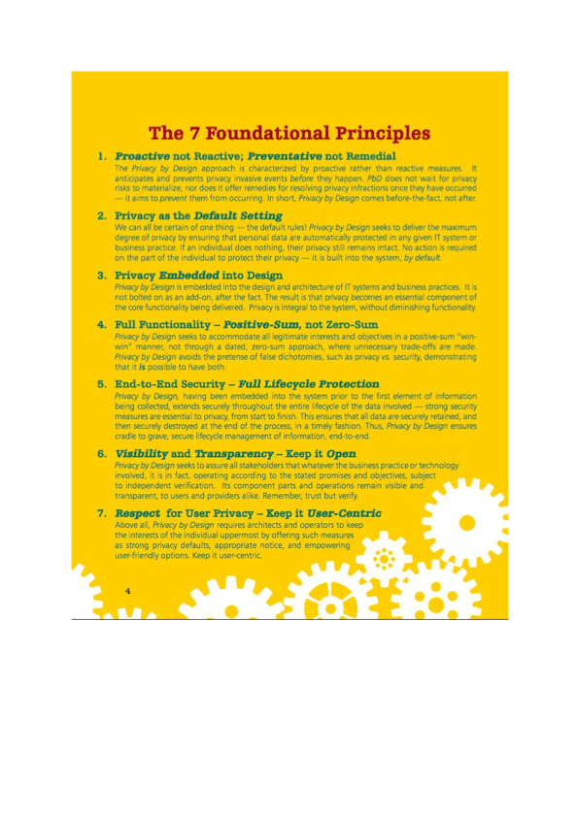
Final Exam Practice Questions

      - What is the concept in the ITIL 4 that defines “a result for a stakeholder”?
- Output
- Utility
- Warranty
- Outcome (Answer)

      - What is the concept in ITIL 4 that defines “how the service performs”?
- Output
- Utility
- Warranty (Answer)
- Outcome

      - What is the concept in ITIL 4 that defines the “what the service does”?
- Output
- Utility (Answer)
- Warranty
- Outcome

      - In the ITIL 4 roles and definitions the ____ is a person responsible for the requirements of a service?
- Customer (Answer)
- User
- Sponsor
- Business analyst

      - Which of the following is NOT one of the five components of SVS?
- Governance
- Practices
- Opportunity/demand (Answer)
- Guiding principles

      - Which of the following is NOT one of the four dimensions of the ITIL 4 service management?

- Organizations and People
- Partners and Suppliers
- Information and Technology
- Guiding principles (Answer)

      - The structure of the ITIL 4 is based on 2 frameworks. Which of the following is correct?

- SVS and SVC
- SVS and 4 dimensions (Answer)
- SVC and 4 dimensions
- Practices and Governance

      - Put the following in the right sequence.

- Identification-Authorization-Authentication
- Identification-Authentication-Authorization (Answer)
- Authentication-Identification-Authorization
- Authentication-Authorization-Identification

      - Cristall wishes to digitally sign a document and send it to Talmud. Which key will be used to encrypt the signature related data?

- Cristall’s public key
- Cristall’s private key (Answer)
- Talmud’s public key
- Talmud’s private key

      - Put the following in the right sequence.

- Identification-Authorization-Authentication
- Identification-Authentication-Authorization (Answer)
- Authentication-Identification-Authorization
- Authentication-Authorization-Identification

      - What do you call a one-way hash function?

- Cryptoanalysis
- Cryptovariables
- Message digest (Answer)
- Message encrypt

      - Which of the following risk treatments has the GREATEST risk profile?

- Mitigation
- Transfer
- Acceptance (Answer)
- Avoidance

      - Which of the following is an example of MFA?

- Numerical and pattern password
- An RSA and soft token
- Passphrase and hand geometry (Answer)
- Iris scan and fingerprint

      - Which one of the following statements is INCORRECT?

- Symmetric keys are fast
- Asymmetric keys are easy to manage
- Asymmetric keys uses different keys
- You need two pairs of keys for symmetric keys (Answer)

      - Cole needs to send an important document to all his students in the Enterprise Architecture class. Which key must Cole use?

- Cole’s Public Key
- Cole’s Private Key (Answer)
- Either key will work
- No key will work

      - Digital Signature is to ensure _____?

- Confidentiality
- Integrity (Answer)
- Availability
- Confidentiality and Integrity

      - Ali needs to send an important document to Bisha. Ali wishes to ensure that only Bisha can decrypt the encrypted message. Which key must Ali use?

- Bisha’s Public Key (Answer)
- Bisha’s Private Key
- Ali’s Public Key
- Ali’s Private key

      - What is the term used to describe a weakness in a system?

- A Threat
- A risk
- A fault
- A vulnerability (Answer)

      - Which of the following refers to the actual delivery of the IT services required to meet strategic and tactical plans?

- Align, Plan, and Organize (APO)
- Build, Acquire, and Implement (BAI)
- Monitor, Evaluate, and Access (MEA)
- Deliver, Service, and Support (DSS) (Answer)

      - What is the term used to describe an encrypted message?

- Cipher text (Answer)
- Clear text
- Plain text
- Coded text

      - Amir has identified few risks with the new implemented system. What is the term used to refer to the activities planned to reduce risk?

- Risk minimization
- Risk monitoring
- Risk treatment (Answer)
- Risk plan

      - One of the COBIT 5 principles talks about the difference between two concepts. They are:

- Governance and Responsibility
- Governance and Management (Answer)
- Management and Accountability
- Accountability and Responsibility

      - Dr. Ann Cavoukian, then privacy commissioner created a concept to address the ever-growing and systemic effects of Information and Communications Technologies. What is the name of this concept?

- Privacy principle
- Privacy by design (Answer)
- Privacy by architecture
- Privacy system

      - Which of the following include processes that are responsible for the assessment of process performance and conformance?

- Align, Plan, and Organize (APO)
- Build, Acquire, and Implement (BAI)
- Monitor, Evaluate, and Access (MEA) (Answer)
- Deliver, Service, and Support (DSS)

      - Prakash is the privacy analyst of Babylon Enterprise. His colleague, Prem is a security analyst in the same company. Prem believes that you cannot have privacy without compromising security. Which one of the following principles could Prakash cite to Prem?

- Privacy as the default setting
- Privacy embedded into design
- Positive-Sum, not zero-sum (Answer)
- Keep it open

      - Yusuf has been working hard in enduring that privacy is included in his coding structure and not bolted in. Which one of the following principles is Yusuf following?

- Privacy as the default setting
- Privacy embedded into design (Answer)
- Positive-Sum, not zero-sum
- Keep it open.

      - Which of the following is concerned with the identification of how IT can best contribute to the achievement of the business objectives?

- Align, Plan, and Organize (APO) (Answer)
- Build, Acquire, and Implement (BAI)
- Monitor, Evaluate, and Implement (MEA)
- Deliver, Service, and Support (DSS)

      - Sabina has been hired as web master for Best Graphics Enterprise. She has been asked to ensure that the web design would allow people with hearing impairment to navigate the site without much difficulty. Which principle is Sabina following?

- Architecture
- Accessibility (Answer)
- Privacy
- Security

      - Suleiman has been hired as web master for Best Graphics Enterprise. He has been asked to configure the firewall to prevent illegal access to company resources. Which principal is Suleiman following?

- Architecture
- Accessibility
- Privacy
- Security (Answer)

      - The last two principles talk about requirement for Understanding, Commitment, and what?

- Architectural Improvement
- Continual Improvement (Answer)
- Accessibility
- Privacy

      - Martina is reading about the first principle in Security and was told that Information Security is an integral part of what?

- Mission and Vision of the Enterprise
- Architecture Strategy
- Privacy and Security Strategy
- Enterprise Strategy (Answer)

      - Talking about Security, the article suggests that _____ is a subset of _____ ?

- IT Security, Information Security (Answer)
- Information Security, IT Security
- Enterprise Security, Privacy Security
- Privacy Security, Enterprise Security

      - Jackie was told that she does not have rights to view the document. Which principle does this represent?

- Confidentiality (Answer)
- Integrity
- Accessibility
- Availability

      - Zuber wishes to ensure that the file he received from his boss has not been tampered with. Which principle does this represent?

- Confidentiality
- Integrity (Answer)
- Accessibility
- Availability

      - Which of the following represents the Strategic Intent?

- Goals
- Purpose (Answer)
- Objectives
- Principles

      - How many principles are there in COBIT 5?

- 4
- 5 (Answer)
- 7
- 8

      - How many enablers are there in COBIT 5?

- 4
- 5
- 7 (Answer)
- 8

