Project Phase 1: Claim Management System

Linying (Lin) Dong, Ph.D.
June 10, 2020

Table of Contents
1.0 Use Case Diagram………………………………………………………………………………………………………………..3
2.0 Use Case Descriptions………………………………………………………………………………………………………….4
2.1 Create Account………………………………………………………………………………………………………………4
2.2 Submit Claim…………………………………………………………………………………………………………………5
2.3 Process Claim………………………………………………………………………………………………………………..6
3.0 Activity Diagrams………………………………………………………………………………………………………………..7
3.1 Create Account……………………………………………………………………………………………………………..7
3.2 Submit Claim………………………………………………………………………………………………………………..8
3.3 Process Claim……………………………………………………………………………………………………………….9
4.0 Domain Class Diagram………………………………………………………………………………………………………10

1.0 Use Case Diagram
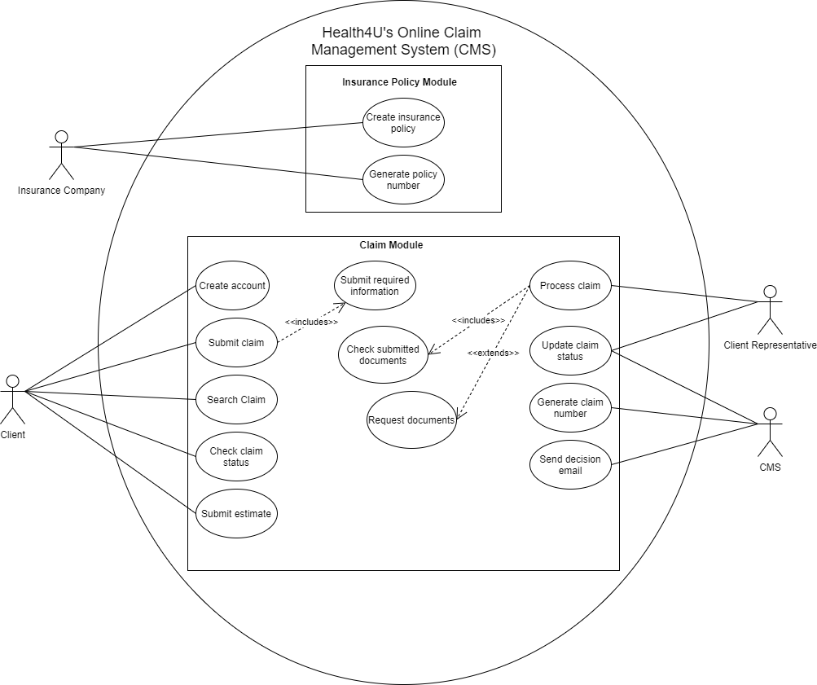

2.0 Use Case Descriptions
2.1 Create Account
Use case name | Create Account
Scenario | Create an account
Triggering event | Client wants to create an account
Brief description | Client creates an account by providing personal information (e.g., name, address, phone number, email address, gender, date of birth) and insurance policy or group policy number. The system enters the information into the database and generates an account for the client.
Actors | Client
Related use cases | None
Stakeholders | Client  Insurance company
Preconditions | Client must be insured to their needed service types.
Post conditions | Client must be able to submit claim.  Client must be able to search claim history.  Client must be able submit an estimate.  Client must be able to upload documents and receipts.  Client must be able to check claim status
Flow of activities | Client  1. Clients wants to create account.  2. Client provides personal information (e.g., name, address, phone  number, email address, gender, date of birth).  3. Client provides insurance policy number or group policy number. | System  1.1 Create account.  2.1 Enter client details into database.  3.1 Verify policy number.  3.2 Create account for client
Exception conditions | 3.1 Insurance policy number does not exist.

2.2 Submit Claim
Use case name | Submit claim
Scenario | Submit a claim
Triggering event | Client wants to submit a claim
Brief description | Client wants to submit a claim through CMS by specifying the service type (e.g., dental, medical, physio), provide the date and the time of the services provided, total amount paid, the name of the client for whom the service was provided, receipt(s) from the service provider and all other required documents and, the information of the service provider such as name, address, and phone number. The system will then generate a claim number for the client to use to track their claim status.
Actors | Client  CMS
Related use cases | Submit required information
Stakeholders | Client  Insurance company  Service provider
Preconditions | Client is insured.  Client has an account.  Client must have used a service.  Client must have all required documents.
Postconditions | Client must be able to check claim status  Client must still be able to upload any required documents
Flow of activities | Client  1. Client wants to submit a claim.  2. Client signs into their account.  For every claim submission  3. Provide name of the client the service was provided to.  4. Specify the service type  5. Provide date and time the service was provided.  6. Provide total amount paid for the service.  7. Provide receipts and other documents from the service provider.  8. Provide information of the service provider (e.g. provider’s name, address, and phone number).  9.Submit claim. | System  1.1 Create claim  8.1 Enter all information into client profile and database.  9.1 Generate claim number.  9.2 Upload claim into claims list
Exception conditions | 7. Required documents are not submitted.

2.3 Process Claim
Use case name | Process claim
Scenario | Processing a claim.
Triggering event | Client representative wants to process a new claim.
Brief description | Client representative will choose a new claim from the claims list to process. The representative will check all submitted documents for correctness and make sure all receipts and documents are received from the client. The representative will also archive rejected claims and the system will send the client an email with a rejection letter.
Actors | Client representative  Customer
Related use cases | Check submitted documents  Request documents
Stakeholders | Client representative  Insurance company
Preconditions | There should be a claim to process.
Postconditions | Decision email should be sent to client after the process.
Flow of events | Client Representative  1. Select claim from claim list.  2. Check documents for correctness and completeness.  3. Request missing documents from client if needed.  3. Update the status of the claim to “Approve” or “Reject” when it is done being processed. | System  1.1 Display list of new claims  2.1 Record documents into database  2.2 Notify client representative of any new submission of documents from client.  3.1 Send email notification to client about the decision made on their claim.  3.2 Enter rejected claims in archives
Exception conditions | 1.1 There are no claims to be displayed.  3.1 Client does not submit any documents.

3.0 Activity Diagrams
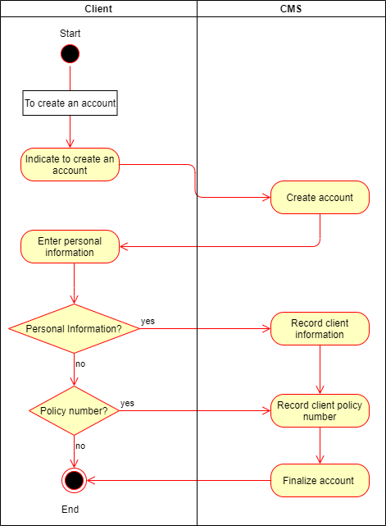
3.1 Create Account

3.2 Submit Claim
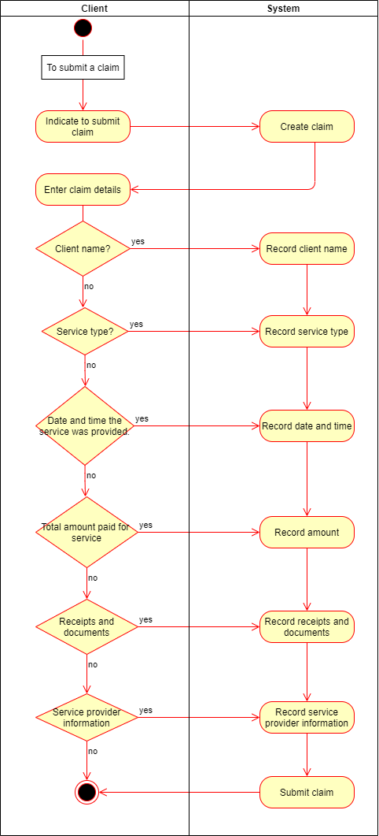

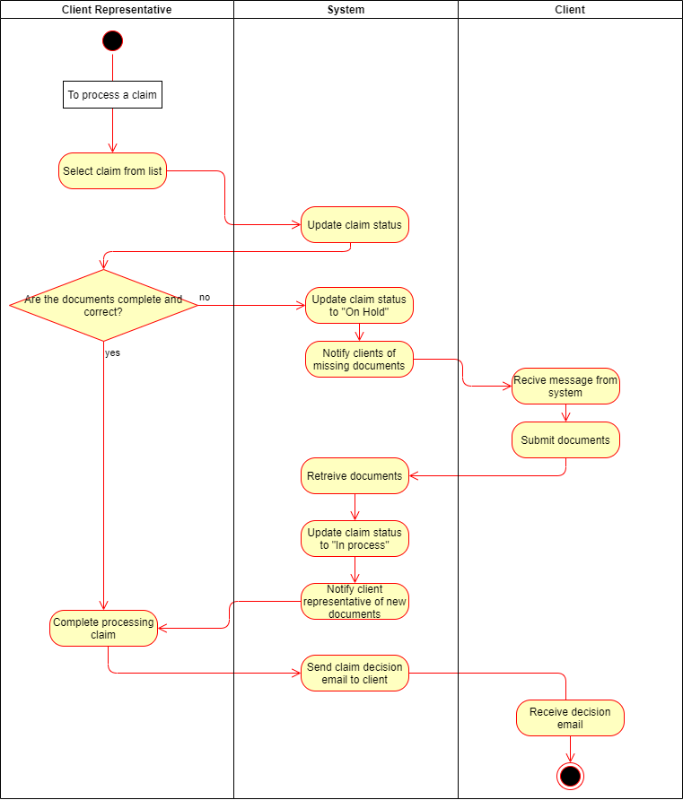
3.3 Process Claim

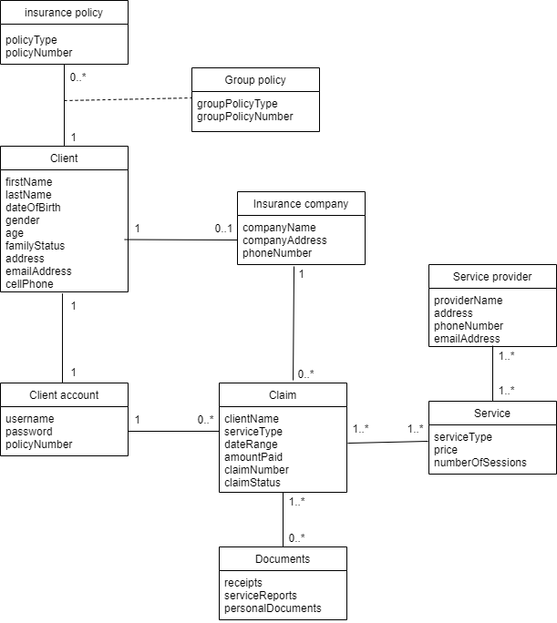
4.0 Domain Class Diagram

