LECTURE 6.1
The Beginning
- Wilheim Wundt used introspection to investigate the human mind (“first real psychologist”)
- Introspection - means ‘looking into’ in Latin
  - Participants were asked to reflect on their own cognitive processes and describe them
  - Another experiment - metronome clicking at different speeds (faster meant energetic thoughts while slower meant deep or sad thoughts) - affected their conscious (conscious experience)
- A precursor to psychology was psychophysics - relating how physics was about “outside world” while psychophysics is more about “inside world”
- Psychology wasn’t believed to be a proper form of science - was not studied much until cognitive revolution in 70s-90s
- Conscious definitions
  - State or condition of being conscious - if they are wake or alert (medical term but also altered states)
  - A sense of one’s personal or collective identity (self awareness)
  - The state of being conscious, awareness of one’s own feelings, what is happening around us (subjective experience)
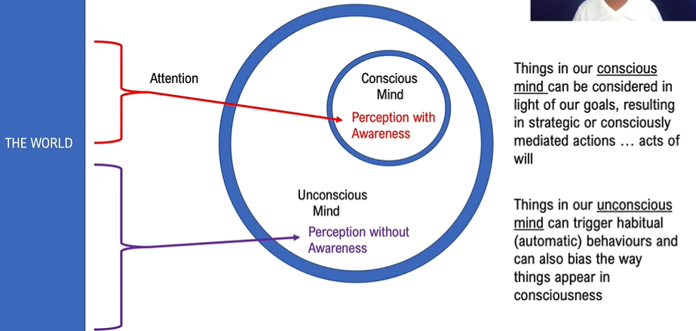
- A lot of our actions become habitual (ex. driving an already known route and forgetting how long you’ve been driving for because you are thinking about something else)
- It is believed consciousness is only there for events that we do not have habits for and to help us build these habits
- Subject of experience is in conscious mind (thoughts and processes are those that we feel and experience)

You are Two Video
- Each brain sees the opposite eye’s field of view
- Left brain is responsible for speech (right brain is “mute”)
- Split brain patients can draw images with both hands at same time

LECTURE 6.2
- Biology, chemistry, and physics are considered hard sciences (can be measured mathematically) unlike psychology which is considered a soft science
  - Psychology is harder to understand - more complex
  - More difficult to directly see what we are studying - consciousness
- The Two-Colour Variant

LECTURE 6.3
- The Role of Critical Thought in Science
  - Peer review of articles
  - Academic “Sparring” During Talks
- Gallup’s Mirror test
  - Mirrors are hung in the cages of animals while they are elsewhere (less and less animals make it past each stage)
    - Stage 1 - the animals react as though a new member of their species was there
    - Stage 2 - the animals ignore the reflection because it has no information value (habituation - ignore the stimuli/reflection)
    - Stage 3 - some animals re-engage and start “using the mirror” - self aware
      - chimpanzees used mirror to inspect themselves - checked themselves out
  - Mirror Test of Rouge Test of Self-Awareness
    - Expose an animal to a mirror and let them reach whatever stage they reach
    - Sometime when you have to anesthetize them anyway (dental) place odorless arks on one eye ridge and the other ear lobe
    - Let the animal recover from surgery
    - Show them their reflection, including the marks - what did they do and what does that imply?

LECTURE 6.4
- Passive Attention
  - Sudden onsets of light, sound, touch or other stimulation can automatically pull our attention to that simulation
  - “Salient” stimuli can also do the same, like hearing our name said across the room
  - Active Attention doesn’t always win (on purpose looking for something)
- Saccade = eye movement
  - Prosaccade - natural eye movement drawn to an object we may see
  - Antisaccade - avoiding looking at an object (done in studies)
    - takes longer to overcome shift
    - “battle for conscious mind” - can only deal with one thing at a time
- Selective attention - towards what intrigues us
- Things in our conscious mind can be considered in light of our goals, resulting in strategic or consciously mediated actions… acts of will
- Things in our unconscious mind can trigger habitual (automatic) behaviours and can also bias the way things appear in consciousness

LECTURE 6.5
- Steve believes there is perception without awareness ex. non-verbal body language but textbook contrasts this
  - Subliminal perception enhanced behaviour does not work (as mentioned in textbook) but subliminal perception does
- Freudian Unconscious has its own goals, like keeping certain things out of your consciousness - it’s like another entity or consciousness in your mind
  - not believed by many psychologists
- Cognitive Unconscious can be described in one word - habits
  - like a programmer is needed to make and revise algorithms which then just work on their own given certain input

LECTURE 6.6
- Attention Span - the relevance of person and simulation
- Patients with visual neglect - attention/consciousness is not pulled to the left side so they do not draw it

