Lab 1
Problem 1
Equipotential graph:
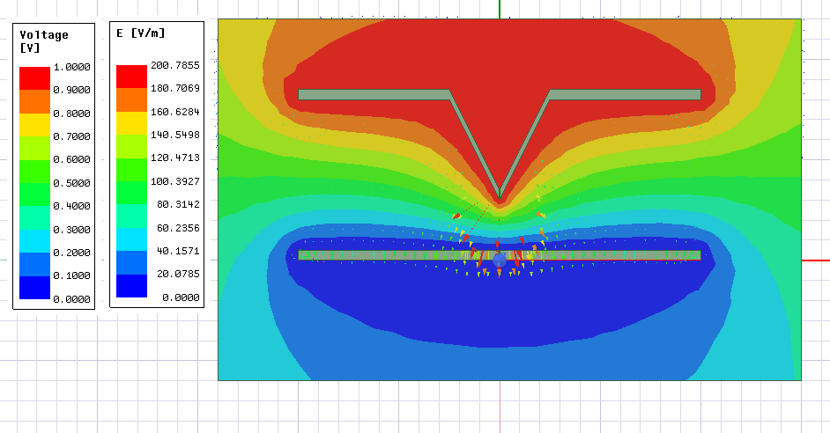
Electric field line graph:
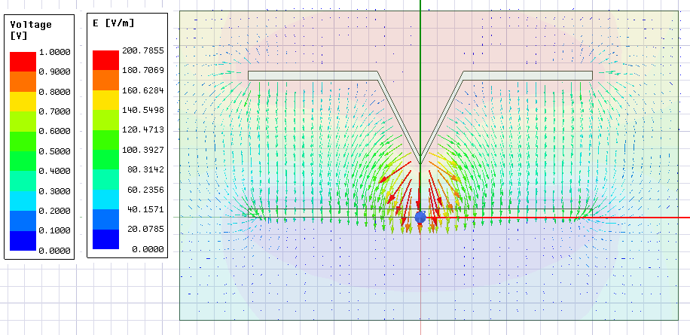
(b) The point where electric field is the biggest is just below the sunken point, the maximum field strength is 200.7855 V/M.
(c) 3*10⁶ v/m = V / 0.001m, V=3000V
Problem 2:
Equipotential graph:
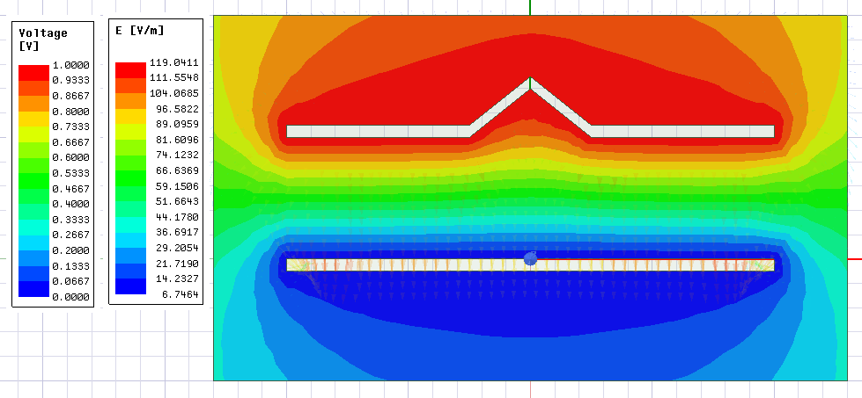
Electric field graph:
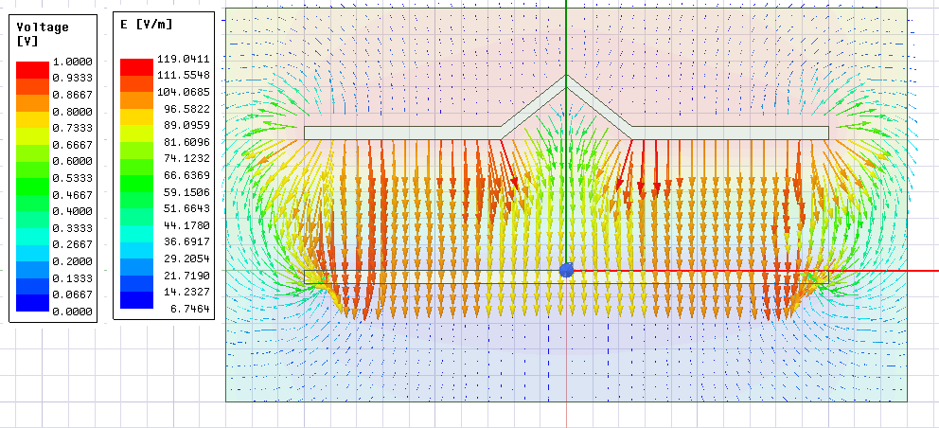

(b) The electric field is different because of the dent at the top plate

Problem 3
Equipotential graph:
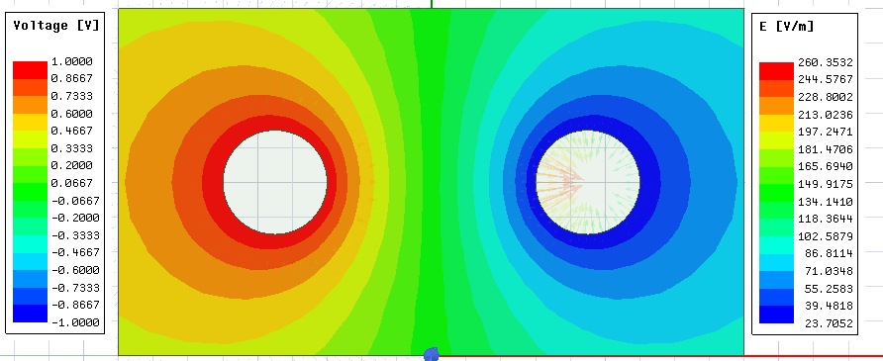
Electric field graph:
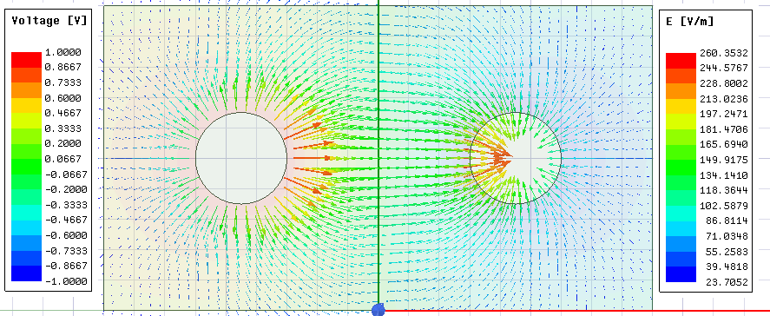
(b) The direction of the Electric field vector is perpendicular to the equipotential lines.
(c) The maximum electric field happens at when it leave the positive charge and enters the negative charge, the maximum electric field is 260.3532 v/m.
(d) Estimated capacitance table:
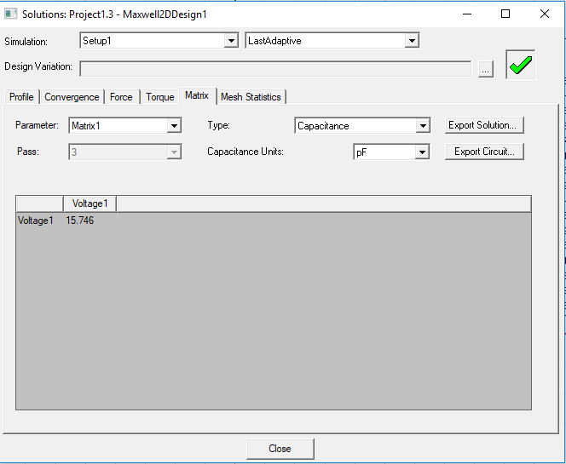
And 15.746 pF divide by 4 is 3.9365 pF
(e) The calculated capacitance is 1.18*10⁻¹¹ F.

Problem 4:
Equipotential graph:
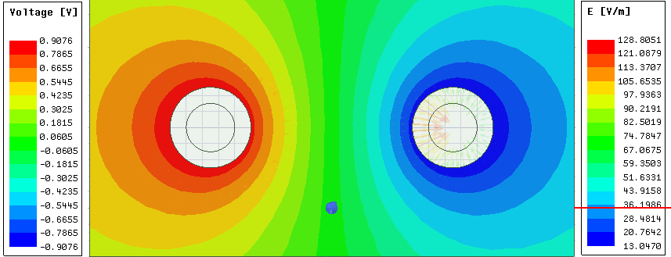
Electric field graph:
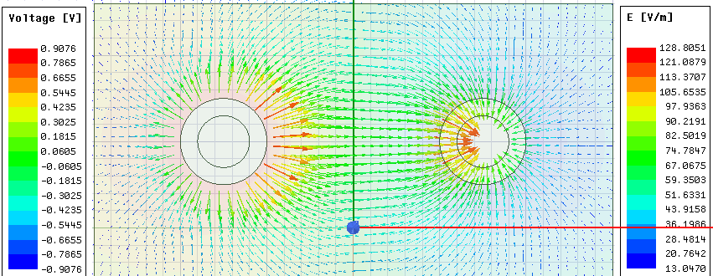
(b) The maximum electric field is 128.8051 v/m, this value less than problem 3 because the distance between two charges is bigger.
(c) Estimated capacitance table:
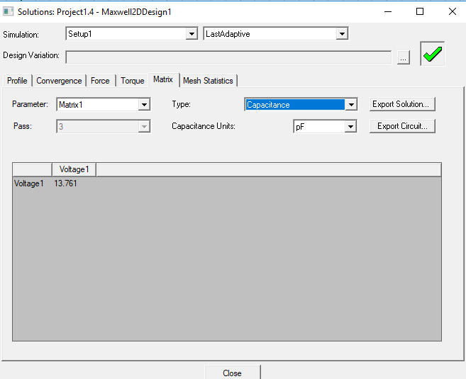
And 13.761 pF divide by 4 is 3.44025 pF.
(d) the capacitance is smaller because the delta D is bigger in the problem 4 and the wire is surrounded by non conducted material.

Problem 5:
Equipotential graph:
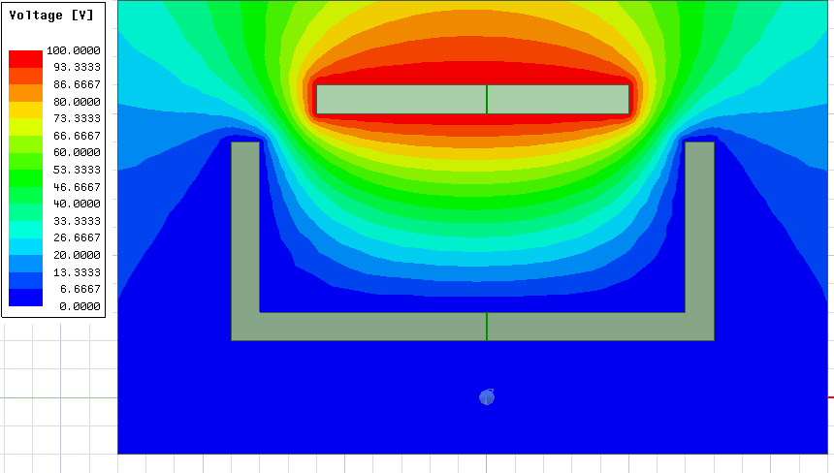Electric field graph:
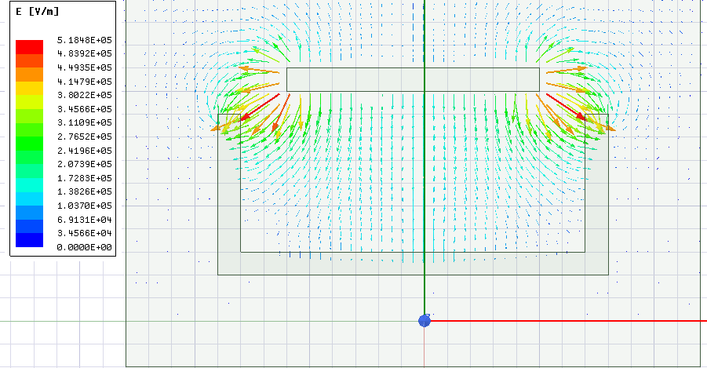

(b) the result is the same compare to the pre lab.
Prelab

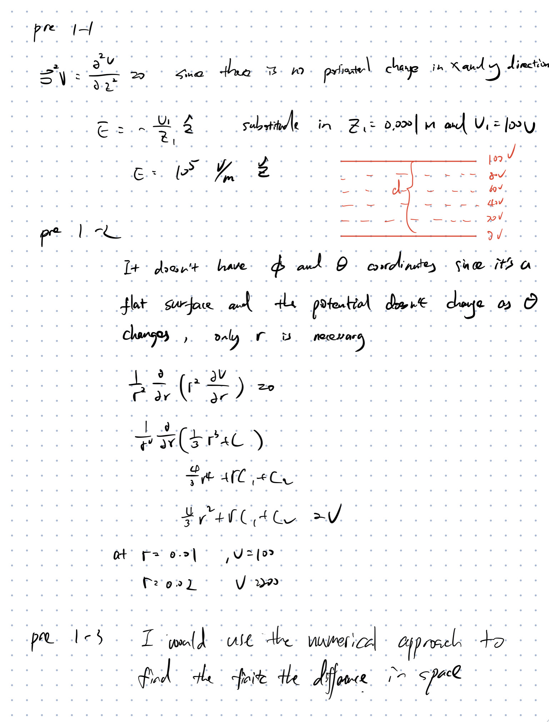

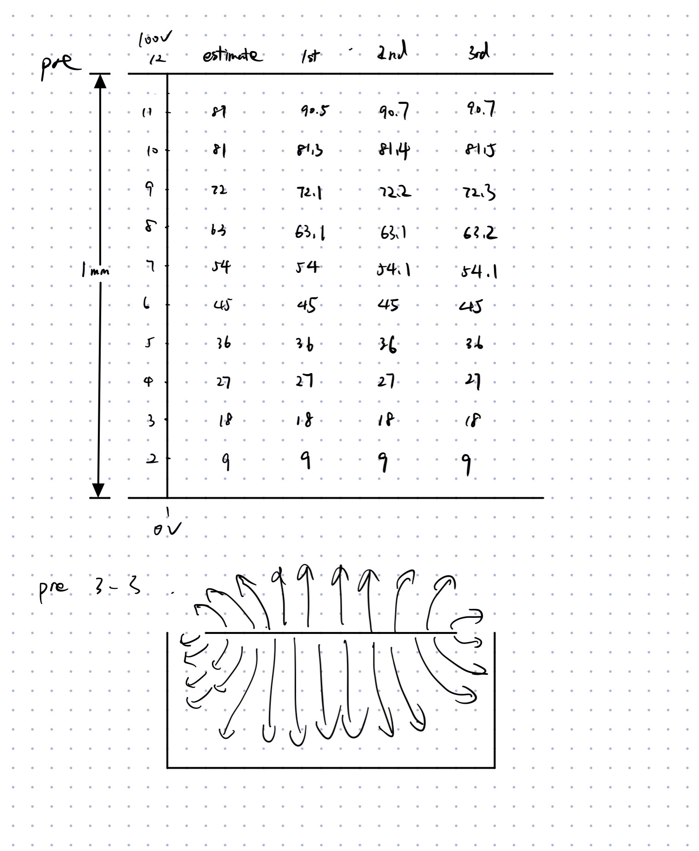

5 decimal places+A20:L124
point | estimate | 1st | 2nd
1 | 100.00000 | 100 | 100
2 | 99.00990 | 99.00990
3 | 98.01980 | 98.01980
4 | 97.02970 | 97.02970
5 | 96.03960 | 96.03960
6 | 95.04950 | 95.04950
7 | 94.05941 | 94.05941
8 | 93.06931 | 93.06931
9 | 92.07921 | 92.07921
10 | 91.08911 | 91.08911
11 | 90.09901 | 90.09901
12 | 89.10891 | 89.10891
13 | 88.11881 | 88.11881
14 | 87.12871 | 87.12871
15 | 86.13861 | 86.13861
16 | 85.14851 | 85.14851
17 | 84.15842 | 84.15842
18 | 83.16832 | 83.16832
19 | 82.17822 | 82.17822
20 | 81.18812 | 81.18812
21 | 80.19802 | 80.19802
22 | 79.20792 | 79.20792
23 | 78.21782 | 78.21782
24 | 77.22772 | 77.22772
25 | 76.23762 | 76.23762
26 | 75.24752 | 75.24752
27 | 74.25743 | 74.25743
28 | 73.26733 | 73.26733
29 | 72.27723 | 72.27723
30 | 71.28713 | 71.28713
31 | 70.29703 | 70.29703
32 | 69.30693 | 69.30693
33 | 68.31683 | 68.31683
34 | 67.32673 | 67.32673
35 | 66.33663 | 66.33663
36 | 65.34653 | 65.34653
37 | 64.35644 | 64.35644
38 | 63.36634 | 63.36634
39 | 62.37624 | 62.37624
40 | 61.38614 | 61.38614
41 | 60.39604 | 60.39604
42 | 59.40594 | 59.40594
43 | 58.41584 | 58.41584
44 | 57.42574 | 57.42574
45 | 56.43564 | 56.43564
46 | 55.44554 | 55.44554
47 | 54.45545 | 54.45545
48 | 53.46535 | 53.46535
49 | 52.47525 | 52.47525
50 | 51.48515 | 51.48515
51 | 50.49505 | 50.49505
52 | 49.50495 | 49.50495
53 | 48.51485 | 48.51485
54 | 47.52475 | 47.52475
55 | 46.53465 | 46.53465
56 | 45.54455 | 45.54455
57 | 44.55446 | 44.55446
58 | 43.56436 | 43.56436
59 | 42.57426 | 42.57426
60 | 41.58416 | 41.58416
61 | 40.59406 | 40.59406
62 | 39.60396 | 39.60396
63 | 38.61386 | 38.61386
64 | 37.62376 | 37.62376
65 | 36.63366 | 36.63366
66 | 35.64356 | 35.64356
67 | 34.65347 | 34.65347
68 | 33.66337 | 33.66337
69 | 32.67327 | 32.67327
70 | 31.68317 | 31.68317
71 | 30.69307 | 30.69307
72 | 29.70297 | 29.70297
73 | 28.71287 | 28.71287
74 | 27.72277 | 27.72277
75 | 26.73267 | 26.73267
76 | 25.74257 | 25.74257
77 | 24.75248 | 24.75248
78 | 23.76238 | 23.76238
79 | 22.77228 | 22.77228
80 | 21.78218 | 21.78218
81 | 20.79208 | 20.79208
82 | 19.80198 | 19.80198
83 | 18.81188 | 18.81188
84 | 17.82178 | 17.82178
85 | 16.83168 | 16.83168
86 | 15.84158 | 15.84158
87 | 14.85149 | 14.85149
88 | 13.86139 | 13.86139
89 | 12.87129 | 12.87129
90 | 11.88119 | 11.88119
91 | 10.89109 | 10.89109
92 | 9.90099 | 9.90099
93 | 8.91089 | 8.91089
94 | 7.92079 | 7.92079
95 | 6.93069 | 6.93069
96 | 5.94059 | 5.94059
97 | 4.95050 | 4.95050
98 | 3.96040 | 3.96040
99 | 2.97030 | 2.97030
100 | 1.98020 | 1.98020
101 | 0.99010 | 0.99010
102 | 0 | 0 | 0

potiential well electrode
0 | 100 | 100 | 100 | 100 | 100 | 100 | 100 | 100 | 100 | 100 | 0
0 | 66.7 | 83.3 | 87.5 | 88.5 | 88.5 | 88.5 | 88.5 | 88.5 | 87.5 | 83.3 | 0
0 | 52.7 | 70.1 | 75.5 | 77.1 | 77.1 | 77.1 | 77.1 | 77.1 | 75.5 | 70.1 | 0
0 | 43.8 | 59.1 | 64.2 | 65.9 | 65.9 | 65.9 | 65.9 | 65.9 | 64.2 | 59.1 | 0
0 | 35.9 | 48.8 | 53.3 | 54.8 | 54.8 | 54.8 | 54.8 | 54.8 | 53.3 | 48.8 | 0
0 | 28.4 | 38.7 | 42.4 | 43.7 | 43.7 | 43.7 | 43.7 | 43.7 | 42.4 | 38.7 | 0
0 | 21.0 | 28.8 | 31.7 | 32.7 | 32.7 | 32.7 | 32.7 | 32.7 | 31.7 | 28.8 | 0
0 | 13.6 | 18.9 | 21.0 | 22.2 | 22.2 | 22.2 | 22.2 | 22.2 | 21.0 | 18.9 | 0
0 | 6.2 | 9.1 | 10.3 | 14.5 | 14.5 | 14.5 | 14.5 | 14.5 | 10.3 | 9.1 | 0
0 | 0 | 0 | 0 | 0 | 0 | 0 | 0 | 0 | 0 | 0 | 0

