Chapter 1- What is Business Strategy? Who is Responsible for Business Strategy?

What does it mean to have a strategy?

Markets: : What markets (industries and geographic markets) the company will pursue in search of a high return on invested capital

Unique Value (why we win with customers): : What unique value to offer the customer in those markets (the firm’s value proposition : cost or differentiation

Resources and Capabilities (how we deliver unique value): What resources (e.g., assets, brands, etc.) and capabilities (e.g., processes) will allow the firm to deliver a superior value proposition to customer

Barriers to Imitation: How the company will prevent imitation of its strategy by competitors.

business strategy: A plan to achieve competitive advantage that involves making four interrelated strategic choices: (1) markets to compete in; (2) unique value the firm will offer in those markets; (3) the resources and capabilities required to offer that unique value better than competitors; and (4) ways to sustain the advantage by preventing imitation.

Strategies are more likely to be successful when the plan explicitly takes into account four factors:
- Where to compete, or the attractiveness of a market or customer segment in the targeted markets
- How to offer unique value relative to the competition in the targeted markets
- What resources or capabilities are necessary to deliver that unique value
- How to sustain a competitive advantage once it has been achieved?

Case: Apple Example
Apply these questions to Apple’s development of the iPod:

- Where do we compete?
Apple competes in the high-priced computer and music industry/ music player industry. Apple competes on a worldwide basis, which allows it to spread heavy research and development costs across its many geographic markets.
- What unique value do we bring?
Apple’s unique value is offering iPods (music players), iPhones (smartphones), and iPads (tablets) that are well designed, innovative, easy to use, and have features that competing products don’t have (“there’s an App for that”).
- What resources and capabilities do we utilize?
Apple worked with the music companies to sell songs that had been digitized using software that prevented customers from copying the songs to more than a few computers. iTunes was designed to be easy to use with the iPod. Customers now could easily and legally access songs simply by connecting their iPods to their computers and letting the software do the rest. Even a technology-challenged grandparent could do it.
- How do we sustain our value?
By being the first to offer music downloads through its easy-to-use iTunes software, Apple encouraged its customers to store their entire music libraries on iTunes. Designing iTunes so that it wouldn’t easily download songs to other music players helped Apple to prevent competing MP3 players from taking market share from iPod. Of course, Apple’s brand image and its Apple Stores also prevent competitors from easily imitating its products and services. These actions helped Apple capture and sustain the value it created.

What is the key to success?

Strategic Management Process- The process by which organizations formulate a plan and allocate resources to achieve competitive advantage that involves making four strategic choices: (1) markets to compete in; (2) unique value the firm will offer in those markets; (3) the resources and capabilities required to offer that unique value better than competitors; and (4) ways to sustain the advantage by preventing imitation
External Analysis- Examining the forces that influence industry attractiveness, including opportunities and threats that exist in the environment
Internal Analysis- The analysis of a firm’s resources and capabilities, its strengths and weaknesses, to assess how effectively the firm is able to deliver the unique value (value proposition) that it hopes to provide to customer

The focus of the strategic management process should be to make four key strategic choices:
- Which markets will the company pursue? A company’s markets include the high-level industry and specific customer segments in which it competes and its geographic markets.

- What unique value does the company offer customers in those markets? This is the firm’s value proposition, the reason the company wins with a set of customers.
- What resources and capabilities are required? What does the company need to have and know how to do so that it can deliver its unique value better than competitors, and exactly how will the company deliver its unique value through an implementation plan?
- How will the company capture value and sustain a competitive advantage over time? Firms need to create barriers to imitation to keep other companies from delivering the same value.

How can you evaluate a “good” or “bad” strategy
Good Strategies Have Barriers to Imitation
If competitors can quickly and easily imitate, then it raises all rival’s costs without creating advantage.

Unique Value
Two Generic Strategies for Offering Unique Value: Cost and Differentiation
Cost Advantage- An advantage that a firm has over its competitors in the activities associated with producing a product or service, thereby allowing it to produce the same product at lower cost

Differentiation Advantage- An advantage a firm has over its competitors by making a product more attractive by offering unique qualities in the form of features, reliability, and convenience that distinguishes it from competing produce

Example: Generic Firm-Level Strategies to Deliver Unique Value
- Low Cost (Efficiency)
  - Providing similar product at lower cost
  - Questrade, Walmart, Tata Nano (car in India), Flair Airline (Canana)
- Differentiation (Premium Value)
  - Providing unique product with attributes buyers will pay for
  - Apple, NIKE, Starbuck
- Value (Best Value for the Price)
  - Providing a combination of features and price between low priced and premium value offerings
  - Costco, IKEA?, Lexus?

What Guides Strategy Formulation?

Mission- A company’s primary purpose that often specifies the business or businesses in which the firm intends to compete—or the customers it intends to serve

SWOT Analysis- Strategic planning method used to evaluate the strengths, weaknesses, opportunities, and threats involved in a business

External analysis involves: (1) an examination of the competition and the forces that shape industry competition and profitability; and (2) customer analysis to understand what customers really want

Internal Analysis involves an analysis of the company’s set of resources and capabilities that can be deployed—or should be developed—to deliver unique value to customers

How Are Strategies Formulated?
A company will also need to formulate, and then implement, strategy at three different levels of the organization: corporate, business unit (product), and functional.

Corporate Strategy- Decisions about what markets to compete in, made by executives at the corporate level of an organization.

Business Unit Strategy- Decisions about how to gain and sustain advantage, made at the manager level for each standalone business unit within a company.

Functional Strategy- Decisions about how to effectively implement the business unit strategy within functional areas like finance, product development, operations, information technology, sales and marketing, and customer service.

Strategy Vehicles- Activities and strategic choices—such as make versus buy, acquisitions, and strategic alliances—that influence a firm’s ability to enter particular markets, deliver unique value to customers, or create barriers to imitating its product.

Strategy Implementation
The translation of a chosen strategy into organizational action so as to effectively implement the activities required to achieve strategic goals and objectives.

Effective implementation typically requires the following:
- The functional strategies within the company—research and development, operations, sales and marketing, human resource management—are well aligned with delivering the unique value identified in the overall strategy. Implementation is generally more successful when a company can measure how effectively functional activities are being performed to support the overall strategy
- The organization’s structure, systems, staff , skills, style (culture), and shared values are designed to facilitate the execution of the strategy.

Who is Responsible for Business Strategy?
Strategic Leaders- Organizational leaders charged with formulating and implementing a strategy with the objective of ensuring the survival and success of an organization
- Deliberate Strategy- A plan or pattern of action that is formulated through a deliberate planning process that is then carried out to achieve the mission or goals of an organization
- Emergent Strategy- A plan or pattern of action that develops and emerges over time in an organization despite a mission or goals

How is Strategy Made?
Intended versus Emergence
Intended Strategy – conceived by top management

Emergent Strategy –the decisions that emerge by adapting to changing circumstances; learning from continuous interaction between strategy formulation and strategy implementation in which strategy is constantly being adjusted and revised in light of experience.

Realized Strategy – actual strategy that gets implemented (only 10 -30% of intended is realized according to Henry Mintzberg (strategic management guru)

Chapter 2- Analysis of the External Environment: Opportunities and Threats

Determining the Right Landscape: Defining a Firm’s Industry
Rather than identifying the industry based on the product or service they produce, firms should think carefully about the job that products do for customer
The landscape is typically defined by:
(1) the industry (or industries) in which a firm competes, and
(2) the product and geographic markets within that industry that the firm targets.

Five Forces that Shape Average Profitability Within Industries
(1) rivalry, (2) buyer power, (3) supplier power, (4) threat of new entrants, and (5) threat of substitute products. The strength of each of these five forces (known as Porter’s five forces)

How do you know a company is more “attractive?”
MORE PROFITABILITY MEANS MORE ATTRACTIVE TO STAY OR ENTER INDUSTRY
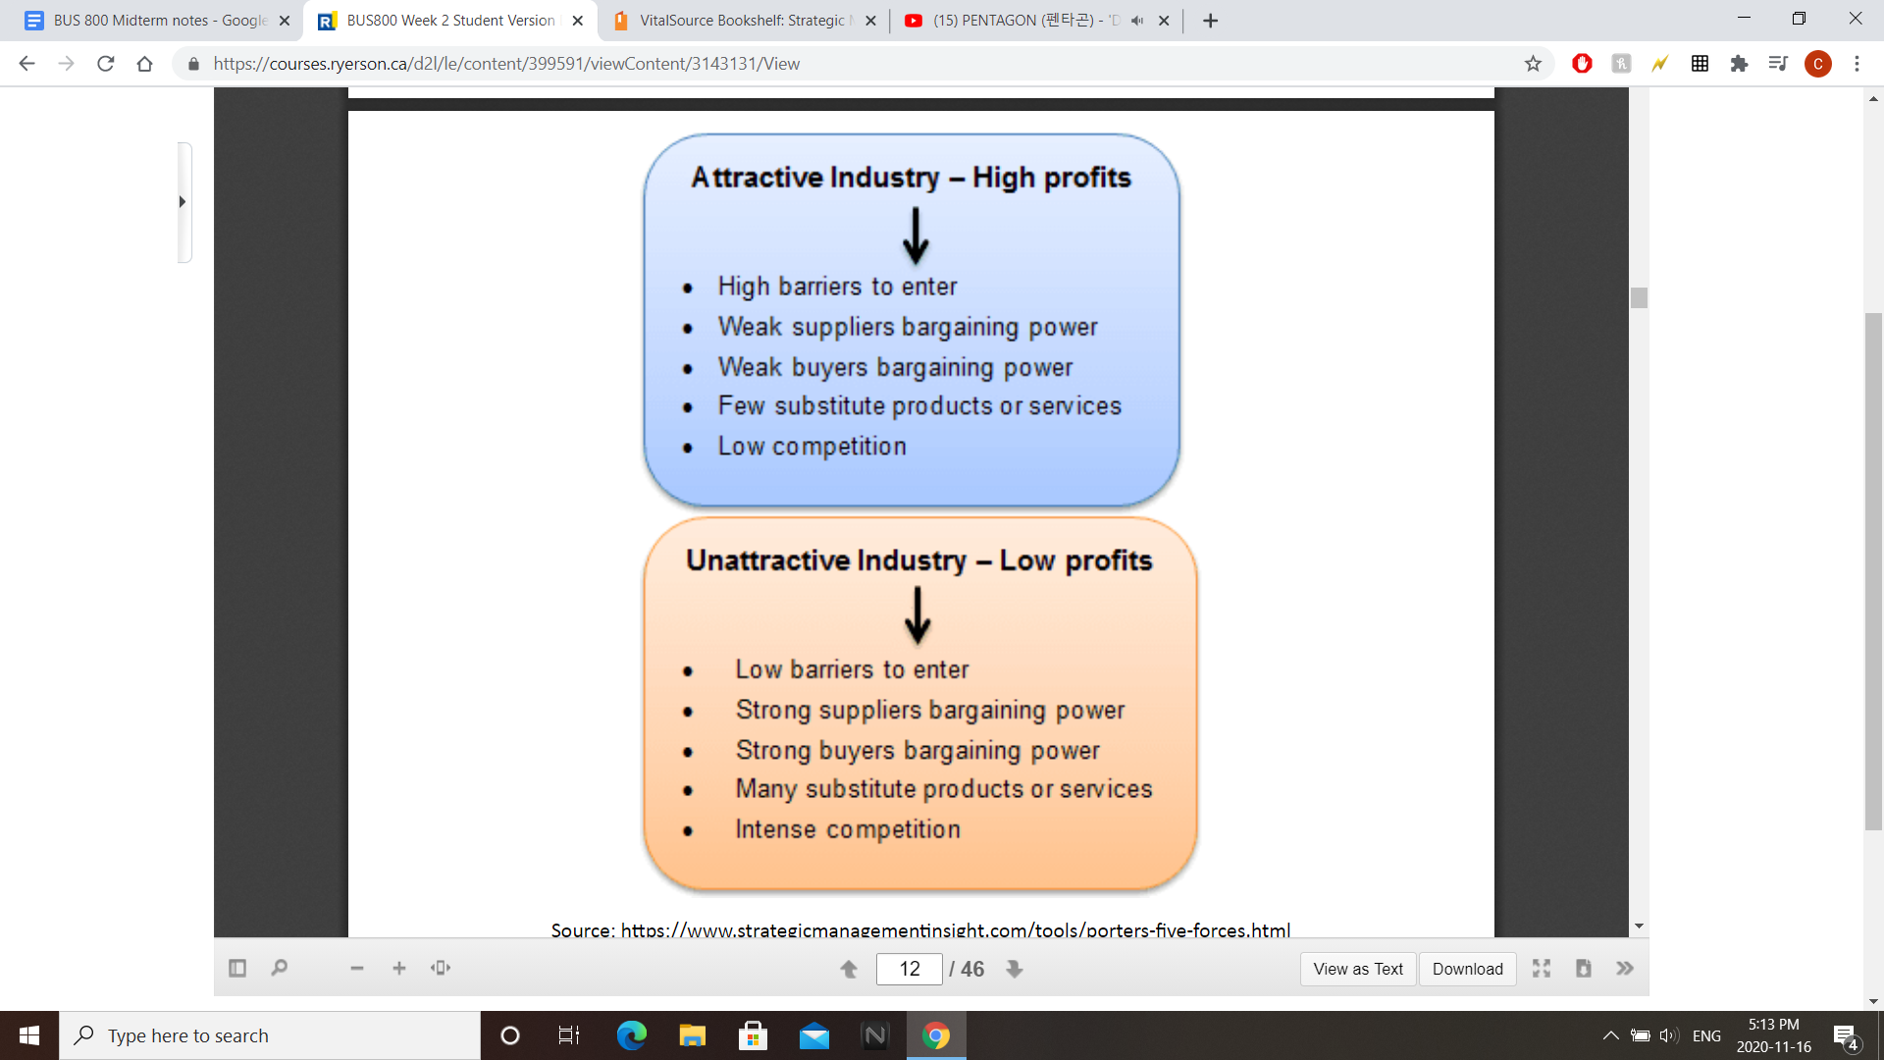
Rivalry: Competition Among Established Companies
The following seven factors are critical to understanding the intensity of rivalry in an industry:
- The number and size of competitors
  - industry with a lot of competitors is a fragmented industry
  - The large number of firms responding to one another tend to create intense rivalry.
  - If they are the same size they tend to be able to respond, or retaliate, strongly to moves by rival firms.
  - Small amounts of competitors are called concentrated, and tend to be dominated by a few large firms. In these industries, rivalry is typically much less intense.

- Standardization of products
  - When products are standardized, or commodity-like, buyers are less loyal to a particular brand and it is easier to convince them to switch brands
- Low Switching Costs for Buyers
  - switching costs Barriers that help keep buyers using the same supplier by imposing extra costs for switching suppliers.

- Slow Growth in Demand for Products or Services
- High Levels of Unused Production Capacity
- High Fixed Costs, Highly Perishable Products, High Storage Costs
- High Exit Barriers

Buyer Power: Bargaining Power and Price Sensitivity
When buyers have sufficient power, they can demand either lower prices or better products from their suppliers, thereby hurting average profitability of firms in the supplier industry. The two primary situations in which buyers have high power are when buyers hold a stronger bargaining position than sellers and when buyers are price-sensitive.

- Buyer Bargaining Power
concentration and size of buyers and the threat that buyers can backward integrate:
- Number, or concentration, and size of buyers:
  - Law of Supply and Demand
- Credible threat of backward integration:
  - a buyer can exert pressure over suppliers by threatening them with backward integration, meaning they will make the product themselves. For example, one way Walmart keeps prices low for consumers is by threatening to expand its Sam’s Choice store brand products into additional categories if manufacturers of other branded products don’t meet Walmart’s pricing demands.
  - backward integration: A firm purchases one or more of its suppliers in order to make a product itself rather than buying it from another firm.
- Buyer Price Sensitivity
Buyers exert pressure not just through price negotiation but also through more comparison shopping and a greater willingness to switch suppliers. Buyer price sensitivity tends to increase in the following situations:
- Buyers are struggling financially
- Product is significant proportion of buyer’s costs
- Buyers purchase in large volumes
- Products doesn’t affect buyers performance very much
- Products doesn’t save buyer money

Supplier Bargaining Power
When supplier industries have strong bargaining power, they can charge higher prices, which tends to decrease average profitability in a buyer’s industry. As firms understand the factors that give suppliers power, they may be able to make decisions that decrease that power.

- Number, or Concentration, and Size of Suppliers
- Credible Threat of Forward Integration
Forward integration: Suppliers going to business with a buyer instead of selling to them

Threats of New Entrants
Barriers to Entry: The way organizations make it more difficult for potential entrants to get a foothold in the industry.
- Economies of scales, experience, or learning
- Other cost advantage not related to scale
- Capital requirements
- Network effects
- Government policy restriction
Threats of substitute products
1. Awareness and Availability
2. Price and Performance

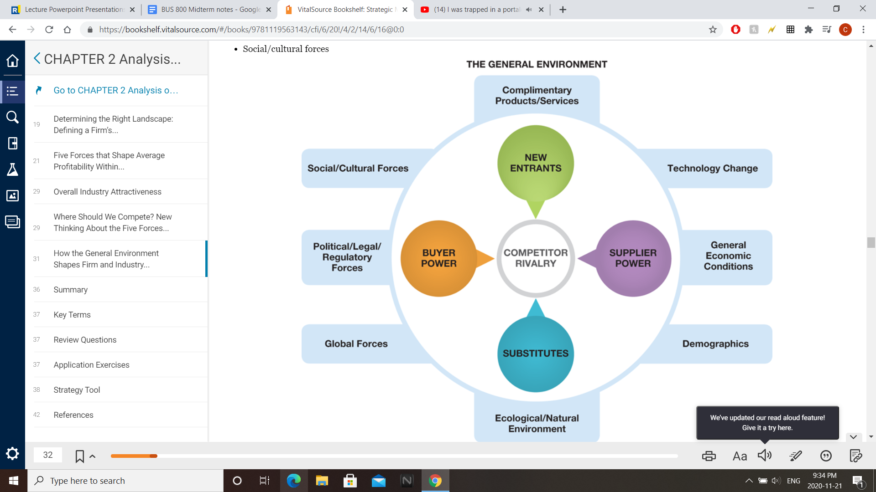
Chapter 3- Internal Analysis: Strengths, Weaknesses, and Competitive Advantage

Chapter 4- Cost Advantage

Chapter 5- Differentiation Advantage

Financial Analysis

Chapter 6- Corporate StrategyCreating Value through Diversification

Chapter 10- Innovation Strategies that Change the Nature of Competition

Types of Innovation
- Incremental Innovation
- Better offerings that generate better profits from current customers
- New features
- Important for success but they don’t create growth because they are replacements of existing product
- Radical (Disruptive) Innovations
Categories of Innovative Strategies:Radical or Disruptive
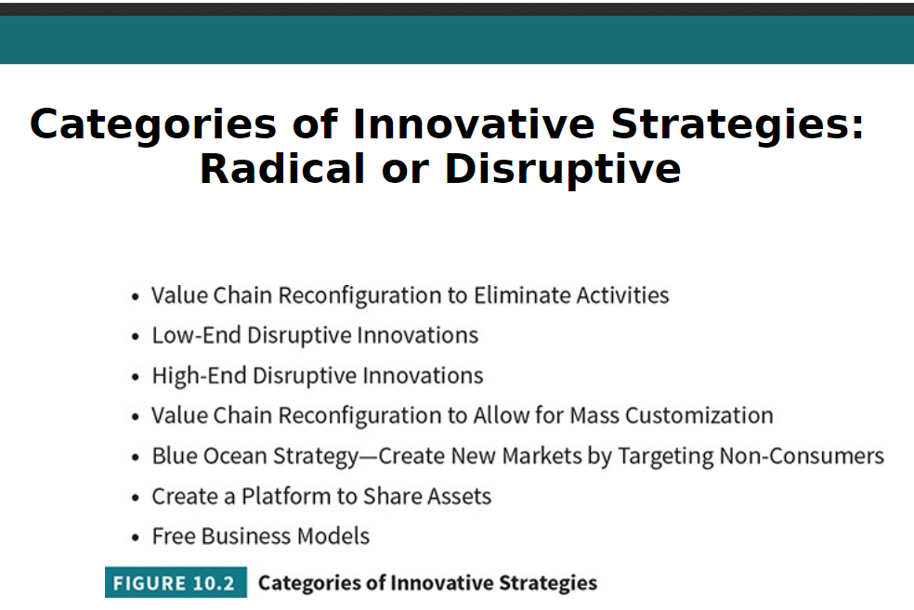

Reconfigure Value Chain Activitiesor eliminate them entirely!
Process innovations that typically create an efficient new business model; allow companies to create, deliver, sell, or service a product more efficiently

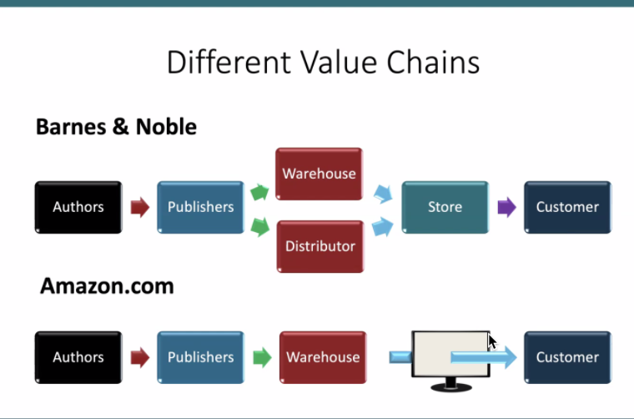

Low-End Disruptive Innovations
- Target customers whose needs are over-served in the mainstream market
  - Price is far more important than feature
- Product performance is “good enough” on basic features to attract low-end customers of the mainstream market
- Entrant uses a new low-cost business model; performs different activities which allows the firm to earn profits even at deeply discounted price

Categories of Disruptive Innovation
Low End Disruption: Low cost business model based on new technology that improve
- Nucor vs. U.S. Steel
- Skype vs. AT&T
- Honda vs. Harley Davidson or Mercedes Benz
High End Disruption: Leapfrog technology with premium price comes from top-down.
- Apple iPod vs. Sony Discman
- Flash drives vs. floppy disks
- PCs vs. typewriters
- Cell phones vs. landline

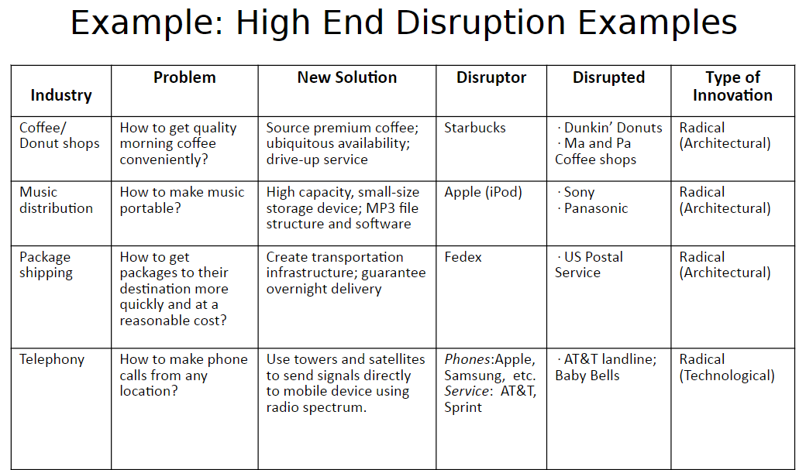

Why High End Disruptions Are Difficult For Incumbents To Imitate?

Radical (Architectural) Innovation
- A product’s architecture reflects the way in which a set of components are integrated into a “system” (product). Architectural innovations change the architecture of a product (the way they are linked together or adding new components) without fundamentally introducing changing the technology underlying its components (e.g., iPod, Starbucks, FedEx) Leapfrog
Radical (Technological) Innovation
- Innovations based on a different set of engineering and scientific principles and technologies. Compared to established products, a radical technological innovation establishes a new dominant design for the product and a new set of core technologies and design concepts embodied in components that are linked together in a new product architecture (e.g., Mobile phones, PCs, Electronic Fuel Injection)

Reconfigure the Value Chain to allow for “Mass Customization”—the mass production of customized goods
- Build-A-Bear (mass produce components of stuffed animals and customize them at store)
- NIKEID
- Timbuk2 (customize/design your own handbag)
- DELL (custom computer)
Conflicts In Mass Customization
Conflicts in Name:
Mass – Aggregation
Customization – one-of-a-kind
Conflicts in Operability:
Customers’ demands are diverse and irregular which calls for leads to high component variety, large numbers of suppliers, and high administrative complexity

The Blue Ocean Strategy
- The aim is not to out-perform the competition in the existing industry, but to create new market space or ‘Blue Ocean”, thereby making the competition irrelevant.
- Reorient your focus from competitors to alternatives, and from original customers to non-traditional customers of the industry.
- Blue Ocean Strategy: create new demand in an uncontested market space
  - Federal express (met uncontested demand for secure overnight delivery)
  - ChotuKool ($49 refrigerator that runs on a battery and uses solid state thermoelectric cooling)
  - Cirque du Soleil (combination of circus, acrobatic troupe, music, Broadway)

Cirque du Soleil example: How was value innovated i.e. new value created?
•Shifting the target group from _____________________
•Drawing on the distinctive strengths of alternative industries, such as ______________ •Offering a totally new ___________ to more mature and higher spending customer

Create a platform to coordinate and share private asset
P.186

FREE BUSINESS/REVENUE MODEL
- Free Up-Sell Strategy (“Freemium”):
Offer a free version to gain attention and widespread use; then offer a premium product with advanced features for customers willing to pay.

Example: Youtube, Spotify, up-sale businesses.

Requirements: A high percentage of users willing to pay for the premium version, or, A free product that appeals to a very large user base so that even a low conversion rate of free users to paying customers will generate substantial revenue

- Free Cross-Sell Strategy:
Offer a free version to gain attention and widespread use; then offer other products for which customers are willing to pay

Example:

Requirement
A broad product line (preferably products that complement the free product)ORThe ability through partnerships to sell a broad line of products to users of the free product

- Free Third Party Pay (Advertising) Strate
Make the product/service free to generate a community (network externality) for which you get paid by a third party company who desires access to that community

Examples:

Requirements:
A free offering that attracts either many users who can be segmented for advertisers or a targeted group that comprises a customer segment AND Third parties willing to pay to reach these customer

- Free Bundling Strategy (Direct cross subsidy):
Bundle the free product with non-free products and derive revenues from non-free products; can’t get the one without the other

Example?

Requirements:
Products or services that can be bundled with the free offering OR A free product that needs regular maintenance or complementary products (e.g., free printer but costly ink)

Hypercompetition:The Accelerating Pace of Innovation

Hypercompetition- A term coined by Professor Rich D’Aveni to refer to his argument that competitive intensity has increased and that periods of competitive advantage have decreased

Innovation And The Product/Business/Industry Life Cycle(S-CURVE)

Introduction – Early adopters
Growth – Early majority
Maturity – Late majority
Decline – Falling demand

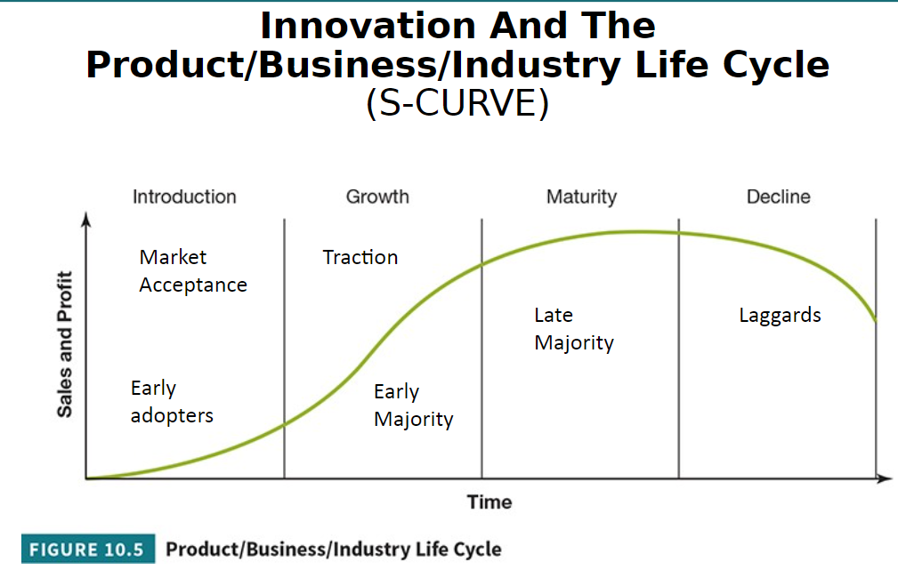
The industry life cycle
Introduction: wide variety of products or service type
Growth: as demand grows a dominant design usually emerges
Maturity Phase: competitive advantage is increasingly a quest for efficiency
The Decline Phase: Shrinking market demand gives rise to acute strategic issue

