It is most beneficial to you to write this mock midterm UNDER EXAM CONDITIONS. This means:
- • Complete the midterm in 3 hours.
- • Work on your own and attempt every question.
- • Keep your notes and textbook closed.
After the time limit, go back over your work with a different colour or on a separate piece of paper and try to do the questions you are unsure of. Record your ideas in the margins to remind yourself of what you were thinking when you take it up at PASS.
The purpose of this mock exam is to give you practice answering questions in a timed setting and to help you to gauge which aspects of the course content you know well and which are in need of further development and review. Use this mock exam as a learning tool in preparing for the actual exam.
Please note:
- Complete the mock exam before attending the take-up session. During the session you can work with other students to review your work.

- Often, there is not enough time to review the entire exam in the PASS workshop. Decide which questions you most want to review – the Facilitator may ask students to vote on which questions they want to discuss in detail.

- Facilitators will not distribute an answer key for mock exams. The Facilitator’s role is to help students work together to compare and assess the answers they have. If you are not able to attend the PASS workshop, you can work alone or with others in the class.

- PASS worksheets are designed as a study aid only for use in PASS workshops. Worksheets may contain errors, intentional or otherwise. It is up to the student to verify the information contained within by attending the PASS workshop.
Good Luck writing the Mock Exam!!
Take-up Session #1: Monday November 2nd, 3-5pm

Take-up Session #2: Tuesday November 3^{rd,} 10am-12pm

Office Hour: Wednesday November 4th, 6-7pm

Zoom Meeting Information:
Will be available on cuLearn and emails. Please check your inbox prior to the take-sessions
Contact Information: laurenpesce@cmail.carleton.ca

Multiple Choice (60 questions)
- Which of the following is not one of the 10 Principles of Economics?
  - A country’s standard of living depends on its productivity
  - Trade can make everyone better off
  - Governments can always improve market outcomes
  - Markets are a good way to organize economic activity
- Which of the following is an example of a cause of market failure?
  - A tire manufacturer just acquired its main competitor and edged out all other smaller business in the industry
  - The government just levied a large tax on the industry and buyers subsequently purchase less of the good
  - A chemical manufacturer’s toxic waste leaks into the local water supply, poisoning locals
  - A and C
  - All of the above
- What best explains equity in economics?
  - Distributing economic prosperity fairly among members of society
  - Employment Insurance
  - Giving every member of society the same income
  - Society extracting the most benefits out of its scarce resources
- The short run trade-off between inflation and unemployment can be explained as:
  - Decreasing the amount of money in the economy means people spend less, producers hire more people to try to make people spend more, employment rises
  - Increasing the amount of money in the economy means people spend more, increasing their demand for goods/services, producers hire more people to deal with higher demand, unemployment decreases
  - Increasing the amount of money in the economy means people save more money, their demand for goods/services decreases, producers have to let employees go (fire them), unemployment rises
  - People speculate that the stock market will crash, employers fire their employees, and prices of goods increases

- Which of the following is a normative statement?
  - Taxes should be raised on the wealthy class
  - The deadweight loss caused by a tax is lower when the demand is inelastic than if it were elastic
  - The US should export wheat because they produce more than they consume
  - The US has a lower opportunity cost than Canada for the production of wheat
  - B and D
  - A and C
  - None of the above
- Label the missing pieces from the Circular Flow Diagram below:
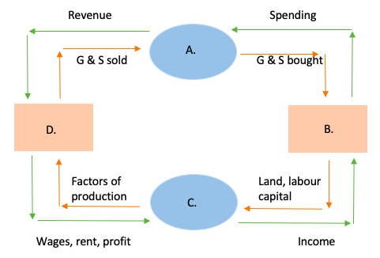
  - A. firms, B. households, C. Markets for goods and services, D. Markets for factors of production
  - A. Markets for factors of production, B. households, C. Markets for goods and services, D. firms
  - A. Markets for goods and services, B. households, C. Markets for factors of production, D. firms
  - A. Markets for goods and services, B. firms, C. Markets for factors of production, D. households
- Why might the PPF be bow-shaped?
  - As the economy shifts resources from one good to another, the opportunity cost of an extra unit increases
  - As the economy shifts resources from one good to another, the input costs decrease
  - Demand for one good is far greater than the demand for the other
  - The PPF is never bow-shaped

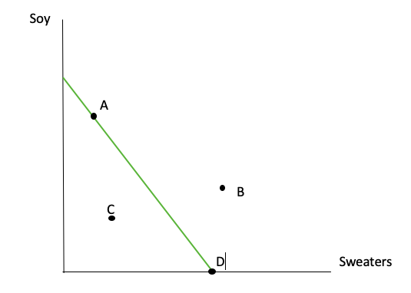
- Consider the PPF below. Which point is the least efficient?

  - A
  - B
  - C
  - D
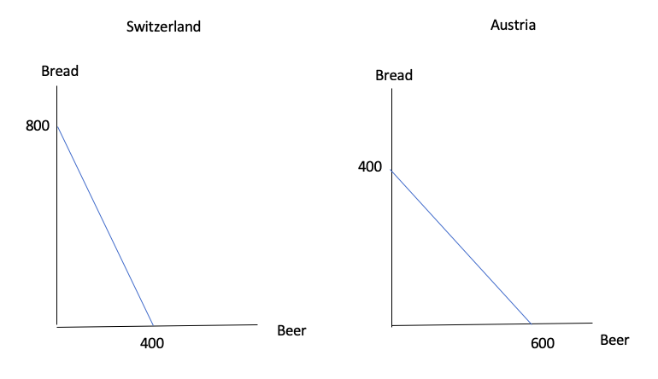
- Consider the PPF’s below. Who has the comparative advantage in either good?
  - Switzerland has comparative advantage in both goods
  - Switzerland has comparative advantage in bread, Austria has comparative advantage in beer
  - Switzerland has comparative advantage in beer, Austria has comparative advantage in bread
  - Austria has comparative advantage in both
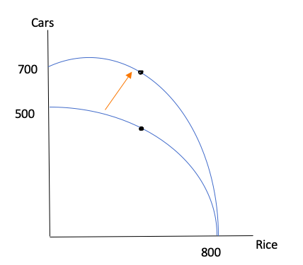
- Consider the PPF below. What statement best describes the change seen here?

  - The demand for cars increased
  - The technology required to produce cars improved
  - The technology required to produce rice improved
  - A large number of car producers left the market
- Which of the following is not a demand curve shifter?
  - Tastes
  - Expectations
  - Price of related goods
  - Technology
- What happens to a nations consumption when they open to trade?
  - Their consumption moves right along the PPF
  - Their consumption moves left along the PPF
  - Their consumption is outside of their PPF
  - Their consumption is inside their PPF
- Mexico and Brazil both produce mangoes and coffee. A Mexican worker takes 10 hours to harvest one tonne of mangoes, and 20 hours to harvest a tonne of coffee beans. A Brazilian worker takes 15 hours to harvest a tonne of coffee beans and 15 hours to harvest a tonne of mangoes. If the two countries trade, which good will they export?
  - Mexico will export both mangoes and coffee beans
  - Brazil will export both mangoes and coffee beans
  - Mexico will export mangoes and Brazil will export coffee beans
  - Mexico will export coffee beans and Brazil will export coffee beans

- China and India both produce computer chips and motorcycles. Chinese workers can produce a computer chip in 10 hours, and a motorcycle in 25 hours. An Indian worker can produce a computer chip in 15 hours and a motorcycle in 20 hours. For both countries to benefit from trade, what must the price of computer chips be, in terms of motorcycles?
  - Between 0.4 motorcycles and 0.75 motorcycles
  - Between 1.3 motorcycles and 2.5 motorcycles
  - Between 2.5 motorcycles and 3 motorcycles
  - Between 0.5 motorcycles and 1.5 motorcycles
- Which of the following is the best example of absolute advantage?
  - Canada produces maple syrup faster than they produce hockey sticks
  - Canada has more maple trees and production facilities, so they are able to produce the most maple syrup
  - Canada exports 50% of their maple syrup because they produce so much
  - Canada imports the most maple syrup in the world, so they have the largest amount of syrup
- A competitive market is best described as:
  - Suppliers racing to sell their products first
  - A large amount of bother buyers and sellers who, individually, do not have any effect on the market
  - A small number of suppliers who compete for consumers
  - A market in which the government allocates all production and consumption
- If the price of hot dog buns decreases, what effect is there on hot dogs?
  - Demand for hot dogs increases
  - Demand for hot dogs decreases
  - Quantity demanded for hot dogs increases
  - Quantity demanded for hot dogs decreases
  - No change
- Suppose Bicrosoft, global technology manufacturer, develops new technology that makes the production of tablets much more efficient. What effect would there be on the supply of tablets?
  - The price would increase, because they want to earn more profit
  - The supply curve would shift left, because they do not want to oversaturate the market with tablets
  - The supply curve would shift right, because they are able to produce more tablets with the same resources
  - They would push all other competitors out immediately and take over the market

- Due to incorrect/incomplete information, Phord Motors has not produced enough trucks to meet demand at its current price. This has resulted in a truck shortage. What can Phord do to reduce the shortage?
  - They should raise the price to the maximum consumer WTP
  - They should slowly raise the price until quantity demanded is equal to the quantity supplied
  - They should lower the price to increase quantity demanded
  - They should wait for government intervention
- Which of the following do not shift the supply curve?
  - Number of sellers
  - Input prices
  - Government taxes
  - Expectations
- Using the midpoint-method, find the elasticity of the graph below.
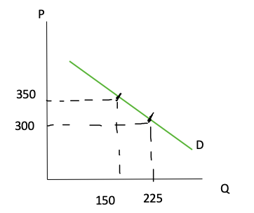

  - 2.6
  - 1.6
  - 3
  - 3.6
- “The extent to which close substitutes are available” as a determinant of price elasticity is best defined as:
  - The number of suppliers there are in a market
  - How often there is a shortage of goods in a market
  - The availability of similar products that are of similar price
  - Commodity goods that are all homogenous
- Consider the demand curve below. What elasticity does this curve show?
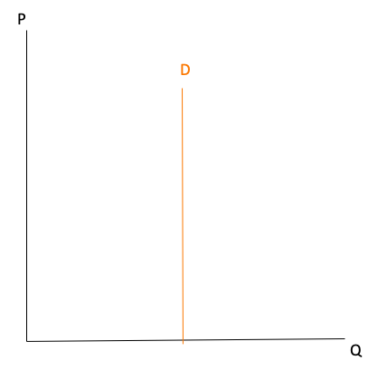

  - Perfectly elastic
  - Elastic
  - Inelastic
  - Perfectly Inelastic
- The graph below shows a change in price in a good. Calculate total revenue and decide whether the line is elastic or inelastic.
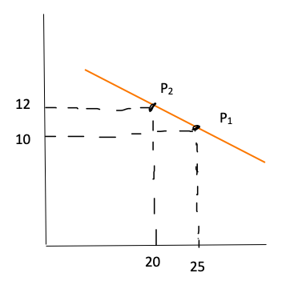
  - TR decreases, demand is elastic
  - TR decreases, demand is inelastic
  - TR increases, demand is elastic
  - TR increases, demand is inelastic
- Research has shown that when P=700, the quantity demanded for refrigerators is 1000 and when P=800, quantity demanded is 800. The research also shows that when price of refrigerators is 700, the quantity demanded for freezers is 500, and when the price of refrigerators increases to 800, the quantity demanded for freezers is 400. Are freezers a substitute or a complement to refrigerators?
  - Cross-price elasticity is 0.6, they are substitutes
  - Cross price elasticity is 0.6, they are complements
  - Cross price elasticity is -0.6, they are substitutes
  - Cross price elasticity is -0.6, they are complements
- The government implementing rent control is an example of:
  - Price ceiling
  - Price floor
  - Economic well-being
  - Tariff
- Currently the price of gas is 80 cents per liter. At this price, the quantity demanded is 10,000 liters. The government believes this is too cheap and wants to create a price control on this good, to discourage consumption and be more sustainable. What kind of price control should they implement, and what should the new price be?
  - They should implement a price floor at any price less than 80 cents
  - They should implement a price ceiling at any price less than 80 cents
  - They should implement a price ceiling at any price above 80 cents
  - None of the above
- Assume that in the market of eyeglasses, the supply curve is inelastic, and the demand curve is elastic. A tax is placed on eyeglasses and is distributed between the buyers and sellers. In this situation, how is the incidence of the tax distributed?
  - Evenly between buyers and sellers
  - Incidence of the tax falls more heavily on buyers
  - Incidence of the tax falls more heavily on sellers
  - We do not have enough information to make a decision
- Recently, the government decided to tax basketballs, in an effort to raise money in order to build public basketball courts. Research shows the demand curve is inelastic, and the supply curve is elastic. Should the government levy the tax on the suppliers, or buyers, and why?
  - Buyers, because their inelastic demand will increase total revenue
  - Sellers, because they make more money than buyers
  - It doesn’t matter, as the economic result stays the same
  - Both, that way they maximize their total tax revenue

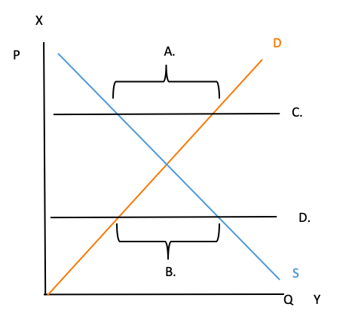
- Label the graph below.
  - A: Shortage, B: Surplus, C: Price ceiling, D: Price floor
  - A: Shortage, B: Surplus, C: Price floor, D: Price ceiling
  - A: Surplus, B: Shortage, C: Price ceiling, D: Price floor
  - A: Surplus, B: Shortage, C: Price floor, D: Price ceiling
- Which of the following does not describe allocation of resources?
  - Where resources come from that are used to produce goods
  - The amount of each good produced
  - Which consumers consume the good
  - Which producers produce the good
- Which situation is best for society?
  - PS = 400 CS = 1000
  - PS = 700 CS = 700
  - PS = 900 CS = 500
  - All of the above
  - None of the above
- 5 buyers’ willingness to pay for backpacks is shown below. Suppose P=50. What is consumer surplus?
Name | WTP
Beyoncé | 100
Madonna | 80
Cher | 68
Grimes | 24
Sia | 40
  - 50
  - 98
  - 64
  - 80
- Consider the supply schedule for the market of bikes below. Who is the marginal supplier when P=60?
Name | Cost
Earl | 70
Rex | 60
Frank | 61
Jay | 59
Mac | 38
  - Frank
  - Jay
  - Rex
  - Mac
- How do you measure total surplus?
  - (value to buyers) – (amount paid to suppliers)
  - (amount paid to sellers) – (cost to sellers)
  - (value to buyers) + (cost to sellers)
  - (value to buyers) – (cost to sellers)
Refer to the graph below for the following questions.
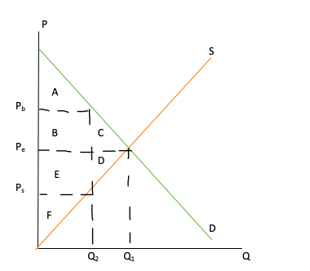
- Which area(s) define the total surplus, before a tax?
  - A, B, C
  - A, B, C, D, E, F
  - D, E, F
  - A, B, E, F
- Which area(s) define the deadweight loss, once the tax is imposed?
  - C
  - D
  - C, D
  - B, C, D, E
- Which area(s) define the total loss of well-being to society?
  - C, D
  - B, C, D, E
  - A, B, C
  - C
- Consider the two markets for oat milk and cows’ milk. The supply and demand curve for cows’ milk is relatively more elastic than the supply and demand curve for oat milk. If a tax of $0.50 is levied on both goods, is one market affected more than the other?
  - The oat milk market faces a greater loss of welfare
  - The cow milk market faces a greater loss of welfare
  - The demand for cow milk increases far more than for oat milk
  - Both markets are affected the same amount
- The Laffer curve is a graphical representation of what?
  - The increasing rate of the DWL as taxes increase
  - The decreasing rate of the DWL as taxes increase
  - The relationship between tax rates and tax revenues
  - The relationship between tax rates and DWL
- Germany produces and sells steel at $100, and the world sells and produces steel at $120. What will Germany do in this situation?
  - Open to trade and export steel to the rest of the world, where they can get a higher price
  - Close their markets to trade to preserve their low prices
  - Raise their prices to match the world prices, in order to maximize total revenue
  - Open to trade and import steel from the rest of the world, where they can get a lower price
- Which of the following is not a benefit to international trade?
  - An increased variety of goods
  - Reduces unemployment
  - Foreign suppliers enter marketplace, lowering market power, increasing total welfare
  - Facilitates the spread of technology around the world

- Imagine a country produces lumber and has never been open to trade. Their domestic price is $150/unit, and at P_{D} quantity demanded is 400. In the world market, lumber goes for $175/unit. With the information provided in the graph below, what is the net gain if they open to trade?
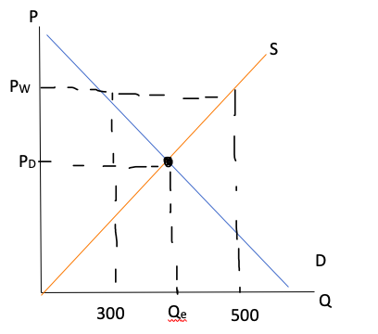
  - 1250
  - 2500
  - 1750
  - 1500
- Costa Rica produces coffee, and charges $15/kg of coffee beans. Other countries in the world produce coffee, but they all charge $18/kg of coffee beans. If Costa Rica opens up to trade will it import or export? What will the effect be on their consumer surplus, producer surplus, and total surplus?
  - Costa Rica will export, consumer surplus will rise, producer surplus will rise, and total surplus will rise
  - Costa Rica will import, consumer surplus will rise, producer surplus will fall, total surplus will rise
  - Costa Rica will import, consumer surplus will fall, producer surplus will fall, total surplus will fall
  - Costa Rica will export, consumer surplus will fall, producer surplus will rise, total surplus will rise
- Many people believe trade should be restricted, claiming that trade destroys jobs in the domestic market. What would an economist say about this argument against trade?
  - Imports and exports have no effect on total unemployment, this is a misconception
  - The jobs that are lost in the importing industry are made up for in the exporting industry
  - Imported goods are typically taxed, and the tariffs from these goods are used by giving the recently unemployed welfare
  - Unemployment may increase overall, but this means that inflation subsequently decreases, making cost of living cheaper
- Which of the following statements describe an import quota?
  - A quantitative limit on imports of a good
  - Creates a deadweight loss
  - Raises revenue for the government
  - All of the above
  - None of the above
- What is an example of a positive externality?
  - Pollution from a company causes cancer in the local population
  - Methane from dairy farms contributes to climate change
  - A higher rate of education increases standard of living
  - You do not wash your recycling and it cannot be processed, resulting in it being thrown out anyways (adding to the local landfill)
- Which of the following is an example of the social cost of an externality?
  - A student doesn’t study for a test and gets a bad grade
  - The resources it takes to produce one tonne of coal
  - The children of smokers inhale second-hand smoke and are more likely to develop early-onset lung cancer
  - The cost it takes to clean oil spills, plus the cost of oil
- Public vaccination has lots of positive externalities. What is an effective incentive to encourage more citizens to participate in vaccination to increase total possible benefits?
  - Subsidize vaccinations for the public
  - Tax vaccinations to raise government revenue
  - Rely on the publics good nature to get vaccinated
  - Create a charity with the goal to eradicate the disease
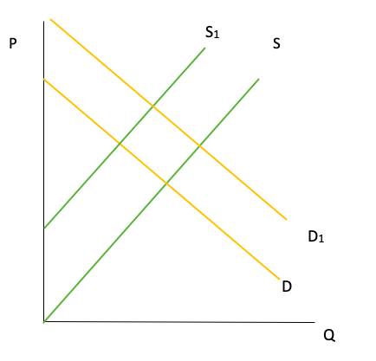
- Consider the externalities that occur with an educated population. Do these externalities create social value or social costs? Which line are the represented with in the graph below?

  - Social cost: S₁
  - Social cost: D₁
  - Social value: S₁
  - Social value: D₁
Short Answer (3 questions)
- Peru has 40,000 labour hours available for production per month. It takes 20 hours to produce a pound of Alpaca wool, and 40 hours to produce a metric tonne of wine. Chile has 60,000 labour hours available for production per month. It takes Chile 30 hours to produce a pound of Alpaca wool, and 30 hours to produce a metric tonne of wine.
  - Draw the PPF for Peru and Chile
  - What is the opportunity cost for both countries?
  - Who has comparative advantage in either good? Does one country have absolute advantage in either good?
- The market for cheese has the following demand and supply curves:
D: y = -1/2x + 100
S: y = x
- What is the Equilibrium Price and Quantity in the market for cheese?
- When the market is in equilibrium, what is producer surplus, consumer surplus, and total surplus?
- If P=75, what is producer surplus, consumer surplus, and total surplus?
- A new concert venue wants to open in Ottawa’s Byward Market. While considering their proposal, the city determines there will be several effects on the community.
  - The city believes that it is a great location to encourage more tourism in the city; after concerts the venue is next door to Ottawa’s largest bars and pubs. They city estimates that every ticket sold will generate an extra $20 in foot traffic to local food and drink establishments. What kind of externality is this and why? Graph the market for concert tickets and include the social cost/social value curve, market equilibrium, and the efficient level of output.
  - The city also worries that an increase in partiers in the downtown area may create dangerous, or disorderly conduct in the neighbourhood. For every ticket sold, the city estimates there will be $10 of damage to the area. What kind of externality is this and why? How does this change your original graph?
  - What can be done to create the most efficient outcome to all parties involved? Suggest two possible programs that could do this.

