CHAPTER 8
THE COSTS OF TAXATION

- A tax is a wedge between the price buyers pay and the price sellers receive.
- A tax raises the price buyers pay and lowers the price sellers receive.
- A tax reduces the quantity bought & sold.
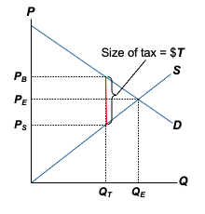
- These effects are the same whether the tax is imposed on buyers or sellers, so we do not make this distinction in this chapter.

The Effects of a Tax
With no tax, eq’m price is P_{E} and quantity is Q_{E} .
Gov’t imposes a tax of $T per unit.
The price buyers pay is P_{B} ,
the price sellers receive is P_{S} ,
and quantity is Q_{T} .

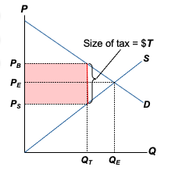
The tax generates revenue equal to
$T x Q_{T} .

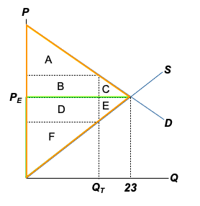
Without a tax,
CS = A + B + C
PS = D + E + F
Tax revenue = 0
Total surplus
= CS + PS
= A + B + C
+ D + E + F

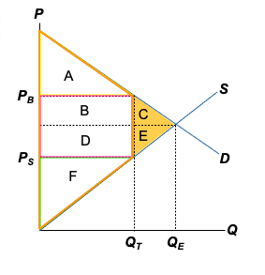
With the tax,
CS=A
PS=F
Tax Revenue
= B+D
Total Surplus
= A+B
+D+F
The tax causes total surplus to fall by C+E

C + E is called the deadweight loss (DWL) of the tax, the fall in total surplus that results from a market distortion, such as a tax.
The losses to buyers and sellers exceed the revenue raised by government.

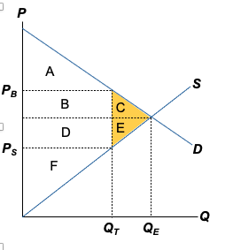

About the Deadweight Loss
- Because of the tax, the units between Q_{T} and Q_{E} are not sold.
- The value of these units to buyers is greater than the cost of producing them,
- so the tax has prevented some mutually beneficial trades

The Size of the DWL
- Government needs tax revenue to finance roads, schools, police, etc., so it must tax some goods and services.
- Question: which goods should the government tax?
- Government should tax goods or services with the smallest DWL.
When is the DWL small vs. large? - it depends on the elasticities of supply and demand

DWL and the Elasticity of Supply
When supply is inelastic, the DWL of a tax is small 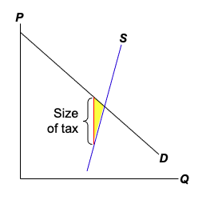

The more elastic is supply, the larger the DWL is

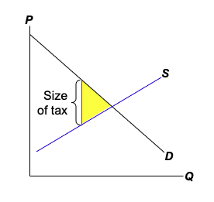
Why Elasticity Affects the Size of DWL
- A tax distorts the market outcome: consumers buy less and producers sell less,
so eq’m Q is below the surplus-maximizing quantity.
- Elasticity measures how much buyers and sellers respond to changes in price, and therefore determines how much the tax distorts the market outcome.

How big should the government be?
- A bigger government provides more services,
but requires higher taxes, which cause DWL.
- The larger the DWL from taxation, the greater the argument for smaller government.
- The tax on labour income is especially important; it’s the biggest source of gov’t revenue.
- For many workers, the marginal tax rate (the tax on the last dollar of earnings) is almost 50%.
- How big is the DWL from this tax? It depends on elasticity….
- If labour supply is inelastic, then this DWL is small.
- Some economists claim that labour supply is inelastic, arguing that most workers work full time regardless of the wage.
- Other economists believe labour taxes are highly distorting because some groups of workers have elastic supply and can respond to incentives: e.g. adjusting their hours by working overtime; retiring when the tax rate is too high; and choosing to work in the “underground economy” to evade high taxes.
The Effects of Changing the Size of Tax
- Policymakers often change taxes, raising some and lowering others.
- What happens to DWL and tax revenue when taxes change?
DWL and the Size of the Tax

Initially, the tax is T per unit. Doubling the tax causes the DWL to more than double.

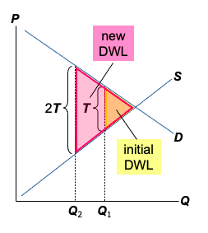
Tripling the tax causes the DWL to more than triple
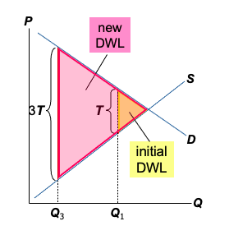
DWL and the Size of the Tax
Implication:
- When the tax rates are low raising them doesn’t cause much harm and lowering them doesn’t bring much benefit.
- When the tax rates are high raising them is very harmful and lowering them is very beneficial.
- When a tax increases, DWL increases at an increasing rate

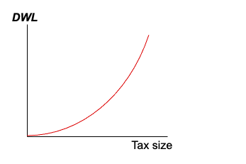
Revenue and the Size of the Tax
When the tax is small, increasing it causes tax revenue to rise.
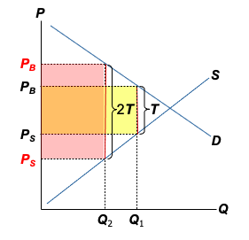

When the tax is larger, increasing it causes tax revenue to fall.
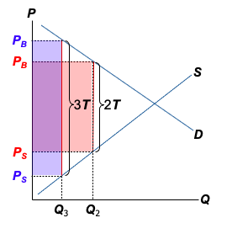
Revenue and the Size of the Tax
Laffer curve: shows the relationship between the size of the tax and tax revenue.
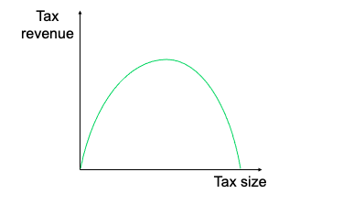
Summary
- A tax on a good reduces the welfare of buyers and sellers – the welfare loss usually exceeds the revenue the tax raises for the govt.
- The fall in total surplus (consumer surplus, producer surplus, and tax revenue) is called the deadweight loss (DWL) of the tax.
- A tax has a DWL because it causes consumers to buy less and producers to sell less, thus shrinking the market below the level that maximizes total surplus

CHAPTER 9
INTERNATIONAL TRADE

Recall:
- A country has a comparative advantage in a good if it produces the good at lower opportunity cost than other countries.
- Countries can gain from trade if each exports the goods in which it has a comparative advantage.
- Now we apply the tools of welfare economics
to see where these gains come from and
who gets them.
World Price and Comparative Advantage
- P_{W} = the world price of a good,
the price that prevails in world markets
- P_{D} = domestic price without trade
- If P_{D} < P_{W},
  - country has comparative advantage in the good
  - under free trade, country exports the good
- If P_{D} > P_{W},
  - country does not have comparative advantage
  - under free trade, country imports the good
The Small Economy Assumption
- A small economy is a price taker in world markets: Its actions have no affect on P_{W}.
- Not always true – especially for the U.S. – but simplifies the analysis without changing its lessons.
- When a small economy engages in free trade,
P_{W} is the only relevant price:
  - No seller would accept less than P_{W}, because
she could sell the good for P_{W} in world markets.
  - No buyer would pay more than P_{W}, because
he could buy the good for P_{W} in world markets.
The Country That Exports Soybeans
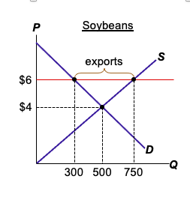
Without trade,
P_{D} = $4
Q = 500
P_{W} = $6
Under free trade,
  - domestic
consumers
demand 300
  - domestic producers
supply 750
  - exports = 450
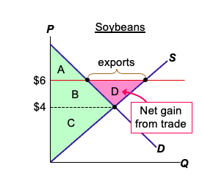

Without trade,
CS = A + B
PS = C
Total surplus
= A + B + C
With trade,
CS = A
PS = B + C + D
Total surplus
= A + B + C + D

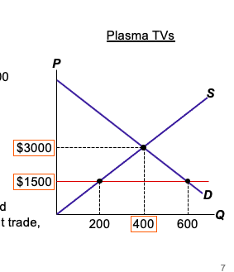
EXAMPLE
Without trade,
P_{D} = $3000, Q = 400
In world markets,
P_{W} = $1500
Under free trade,
how many TVs
will the country
import or export?
Identify CS, PS, and
total surplus without trade, and with trade.

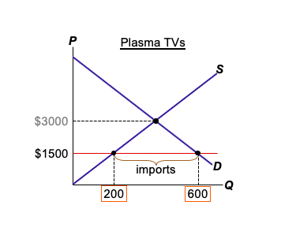
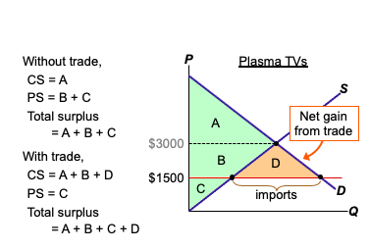
Summary: The Welfare Effect of Trade

 | P_{D} < P_{W} | P_{D} > P_{W}
Direction of trade | Exports | Imports
Consumer surplus | Falls | Rises
Producer surplus | rises | Falls
Total surplus | rises | Rises
Whether a good is imported or exported, trade creates winners and losers. But the gains exceed the losses.

Other Benefits of International Trade
- Consumers enjoy increased variety of goods.
- Producers sell to a larger market and may achieve lower costs through economies of scale.
- Competition from abroad may reduce market power of some firms, which would increase total welfare.
- Trade enhances the flow of ideas, facilitates the spread of technology around the world.

Why Some Oppose Trade
- Recall: Trade can make everyone better off.
- The winners from trade could compensate the losers and still be better off.
- However, compensation rarely occurs.
- The losses are often highly concentrated among a small group of people, who feel them acutely. The gains are often spread thinly over many people, who may not see how trade benefits them.
- Hence, the losers have more incentive to organize and lobby for restrictions on trade.

Tariff: An Example of a Trade Restriction
- Tariff: a tax on imports
- Example: Cotton shirts
  - P_{W} = $20
  - Tariff: T = $10/shirt
  - Consumers must pay $30 for an imported shirt.
  - So, domestic producers can charge $30 per shirt.
- In general, the price facing domestic buyers & sellers equals (P_{W} + T ).

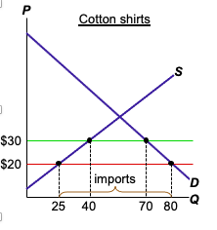
Analysis of a Tariff on Cotton Shirts
P_{W} = $20
free trade:
buyers demand 80
sellers supply 25
imports = 55
T = $10/shirt
price rises to $30
buyers demand 70
sellers supply 40
imports = 30

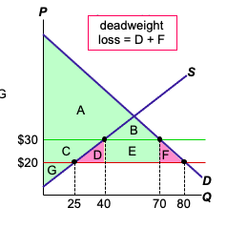
free trade
CS = A + B + C
+ D + E + F
PS = G
Total surplus = A + B
+ C + D + E + F + G
tariff
CS = A + B
PS = C + G
Revenue = E
Total surplus = A + B
+ C + E + G

D = deadweight loss from the
overproduction
of shirts
F = deadweight loss from the under-consumption
of shirts

Import Quotas: also restricts Trade
- An import quota is a quantitative limit on imports of a good.
- Mostly, has the same effects as a tariff:
  - raise the domestic price of the good
  - reduce the quantity of imports
  - reduces buyers’ welfare
  - increases sellers’ welfare
  - cause a deadweight losses
- A tariff creates revenue for the govt. A quota creates profits the holder of the import license who sells the good at domestic price which is higher than the world price.
- If the government charges a fee for the import license the import quota works exactly like a tariff.
Arguments for Restricting Trade
1. The jobs argument
Trade destroys jobs in the industries that compete against imports.
Economists’ response:
Total unemployment does not rise as imports rise, because job losses from imports are offset by
job gains in export industries.
Even if all goods could be produced more cheaply abroad, the country need only have a comparative advantage to have a viable export industry and to gain from trade.

2. The national security argument
An industry vital to national security should be protected from foreign competition, to prevent dependence on imports that could be disrupted during wartime.
Economists’ response:
This is acceptable as long as the policy is based on true security needs. But producers often exaggerate their importance to national security to obtain protection from foreign competition.

3. The infant-industry argument
A new industry argues for temporary protection until it is mature and can compete with foreign firms.
Economists’ response:
Difficult for government to determine which industries
will eventually be able to compete, and whether benefits of establishing these industries exceed cost to consumers of restricting imports. Besides, if a firm will be profitable in the long run, it should be willing to incur temporary losses.

4. The unfair-competition argument
Producers argue their competitors in another country have an unfair advantage, e.g. due to government subsidies.
Economists’ response:
We can import extra-cheap products subsidized by the other country’s taxpayers. The gains to our consumers will exceed the losses to our producers.

5. The protection-as-bargaining-chip argument
Example: In the mid- to late 90s, Canada threatened to limit the import of certain Australian products (e.g, fruits, wine, lamb, and beef) in retaliation of Australia’s prohibition of imports of fresh salmon from Canada.
Economists’ response:
Suppose Australia refuses. Then Canada must choose between two bad options:
A) Restrict imports from Australia - reduces welfare in Canada.
B) Don’t restrict imports - lose face and suffer a loss of credibility.

Trade Agreements
- A country can liberalize trade with
  - unilateral reductions in trade restrictions
  - multilateral agreements with other nations
- Examples of trade agreements:
  - North American Free Trade Agreement (NAFTA), 1993
  - General Agreement on Tariffs and Trade (GATT), ongoing
- World Trade Organization (WTO) est. 1995, enforces trade agreements, resolves disputes

