Carleton University

PHYS-1004 Lab Section: A1
Electrostatics Lab

Devan Langdon, 101153252

Wednesday, July 22, 2020
Introduction:

The goal of this experiment is to explore and understand the behaviours of static charges and how they change with varying environments / materials. The instruments in this experiment are the electroscope and the electronic charge sensor. These instruments detect and measure the charge on the desired object. The phenomena being studied is the accumulation of static electricity. Static electricity is a very common physics phenomena, seen everyday. Fur on cloth, and lightning are both examples of static electricity, except on drastically different scales. The transfer of charges is caused by the frictional contact between 2 objects. This is known as the triboelectric effect which describes the electrons either leaving or entering the object, leaving the object positively or negatively charged respectfully. The electroscope consists of a pair of lightweight “leaves” metallic plates that hang vertically when uncharged (equilibrium). When a charge is induced, the leaves will be charged with identical charges of the same sign, thus causing repulsion, pushing them apart. The charge induced on the leaves can be calculated, using the distance between the leaves, as well as including the gravitational force pushing the leaves downwards.

Equations:
- Coulomb’s Law: $F= \frac{1}{4πε_{0}}\frac{q_{1}q_{2}}{r^{2}}$
- where: $ε_{0}=8.85E-12 \frac{C^{2}}{Nm^{2}}$
q = point charge ( C )
r = radius (m)
F = force between charges (N)
Coulomb’s Law calculates the force between 2 point charges, separated by a distance, r. This equation includes the constant “$ε_{0}$” which represents the permittivity of free space. This is a necessary aspect of nature which allows electric fields to exist in free spaces.
- Angle of Separation: $θ=2\sin^{-1}(\frac{d}{2L})$
where: $θ$ = angle of separation
d = distance between leaves
L = length of leaves
Angle of separation uses basic trigonometry to solve for the angle between both leaves.
- Charge on each leaf: $Q=\sqrt{2πε_{0}d^{2}mg*tan⁡(\frac{θ}{2})}$
where: $ε_{0}=8.85E-12 \frac{C^{2}}{Nm^{2}}$
d = distance between leaves (m)
m = mass of leaves (Kg)
g = acceleration of gravity (m/s^2)
The equation calculates the total charge on each leaf in Coulombs. Because this equation is only for a single leaf, it only counts for half of the total charge on the plastic rod in contact. The charge on the rod will be equal to 2Q

- Error propagation for $σ_{Q_{e}}$: GE = 0.1 * Q_{e}
- Error propagation: $σ_{f}= \sqrt{{(\frac{ϑf}{ϑx})}^{2}σ_{x}^{2}+{(\frac{ϑf}{ϑy})}^{2}σ_{y}^{2}+{(\frac{ϑf}{ϑz})}^{2}σ_{z}^{2}}$
Where: $\frac{ϑf}{ϑx}$ is a partial derivative of x, continuing with f(x,y,z)
Data Analysis Methods:
The data analysis method used was statistical analysis. This involves taking multiple samples of data taken and creating a representation of information from the total collection, with more precise data. This involves collecting, organizing and analysing data, then interpreting the data to create a transparent presentation of information learned. In this experiment, the distances between the leaves were recorded and put into a chart. Information from the experiments were then put into Logger Pro and a table was created.

Experimental Setup:
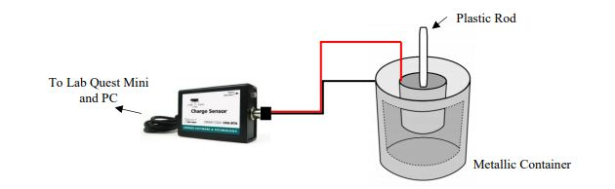
In this experiment, a plastic rod is charged with a piece of fur. Using an electroscope, and an electronic charge sensor, data is collected and inputted into Logger Pro with the Lab Quest MINI interface. Initially the electroscope is discharged by touching it to the top of the experiment performer’s hand. The negatively charged rod is then brought close to the electroscope, inducing separation of the metallic leaves. The distance between the leaves is recorded. This is repeated 5 separate times with all trials being recorded. The plastic rod is left in the metallic container for 10 seconds before the data collection is stopped.
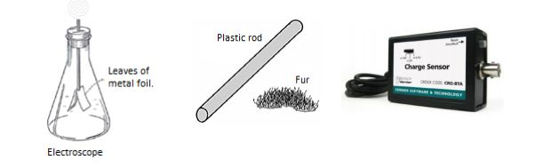
Fig. 1: Instruments

Fig. 2: Apparatus Setup

Fig. 3: Neutral, Induced Charge, Transferred Charge, Electroscope Visualization
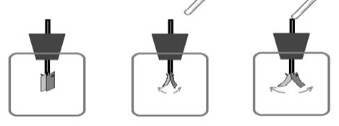

Observations:
The data and observations were acquired by the lab supervisors. Trial & Distance data set shows the distance between the metallic leaves, for 5 separate trials. Time vs. Charge data set shows the change in charge of the rod over time.

Table 1: Time vs. Charge Data Set

Table 2: Trial & Distance Data Set:

Data Analysis:
Average distance between leaves: d = $\frac{sum of distances}{\# of trials}$
= $\frac{2.21+2.23+2.2+2.18+2.25}{5}$= 2.21 +/-0.05 cm

Angle between leaves: $θ=2\sin^{-1}\left(\frac{d}{2L}\right)$= $2\sin^{-1}\left(\frac{2.21+/-0.05}{2(3.00+/-0.05cm}\right)$ = 0.754 +/- 0.05 rad

Charge on Leaf (Qleaf): $Qleaf=\sqrt{2πε_{0}d^{2}mg*tan⁡(\frac{θ}{2})}$
$Qleaf=\sqrt{2π(8.85e-12)({0.0221)}^{2}(1e-4)(9.81)*tan⁡(\frac{0.754}{2})}$
= -4.19 x ${10}^{-10}$ +/- 0.42 C

Charge on Rod (Qrod): Qrod = 2Qleaf = 2(-4.19e-10 C) = -8.83 x ${10}^{-10}$ C +/- 0.84 C

Statistical Error (SE): std.dev: 0.09203
# of samples: 20 samples
$SE= \frac{std. dev}{\sqrt{\# of samples}}$ = $\frac{0.09203}{\sqrt{20}}$ = +/- 0.0206 C

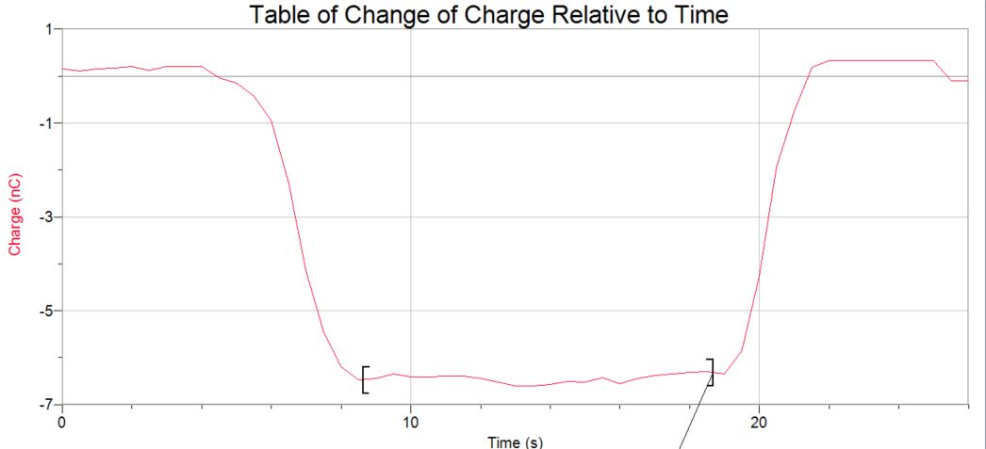
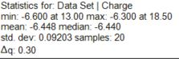

Results:
Following the procedure and completing the experiment, calculations were completed to determine; distance between metallic leaves, the angle between leaves, the charge on each individual leaf, as well as the total charge on the plastic rod itself.
d = ( 2.21 +/- 0.05 )cm
θ = ( 0.754 +/- 0.05 )rad

Qleaf = ( -4.19E-10 +/- 0.42 )C

Qrod = ( -8.38E-10 +/- 0.84 )C
From the LoggerPro Software, the charge on the rod was determined to be
-6.448 E-10 C.

Discussion:
The experiment was completed with all data being recorded and calculations being performed for precise and necessary data. The calculated charge of the rod (Qrod) was calculated to be (-8.38E-10 +/- 0.84 C) while the electroscope and LoggerPro software determined the charge to be ( -6.448E-10 +/- 0.0206 C). The difference between the two calculations is a 29.96 % Error. This can be reduced to significant figures, rounding, total population of data taken, as well as different methods of analysing the data. The results are consistent as all values in the calculations are plausible and reasonable for the experiment performed. The data collected from LoggerPro is more accurate, more efficient and a better visualization than hand calculations. The overall experiment is simple but is open to many errors, such as; exact and identical distance between rod and electroscope for multiple trials, time of rod in metallic container staying consistent, etc. The calculation error only applies if each trial is consistent and exact as the trial before it. Sources of error can be minimized with more trials, as well as less human error performing it (ie. Have experiment performed with more mechanical components to reduce discrepancies in human movement such as shaky hands, fatigue.) The lab successfully demonstrates the effect of charged objects / electron transfers and the visualization of charged objects and their behaviour. For Environmental Engineering, it is important to understand the behaviour of electrons and charged objects, as Chemistry is a fundamental science for this field of engineering and a visualization is easier to comprehend than work performed on atoms and molecules.

