Week 1
System defined as: A computer system that converts inputs to outputs, A manual system that helps accomplish objectives, An organized sequence of tasks
Connected part that forms a whole. Set of procedures to complete an activity. An organized scheme
Computers are not necessary, but they do help!
Information systems are any computer-based tool that people use to work with information that supports information and info processing

Disruptions: Cloud computing, Big data, AI
Hospitality examples: smart rooms, Ipad check-in, reviews and bookings (trip advisor), robots in hotels

Using IT for advantage:
Competitive advantage – a product or service that an organization’s customers place a greater value on than similar offerings from a competitor
First-mover advantage – occurs when an organization can significantly impact its market share by being first to market with a competitive advantage

Business analyst role:
New ways of doing things within the company
New ways of serving customers
New technological products
Changes to keep up with the competition
Mandatory changes to satisfy regulations

Week 2 - Ethics
Plagiarism is unethical
the principles and standards that guide our behavior toward other people and their property
Accessibility is a ethical issue when using designs from the internet
Examples: Eye mannequin, gene editing, autonomous cars, the trolley problem (kill 1 to save 100), fake news, deepfakes, CCTV, Facial recognition
Selling client information is a privacy ethical issue related to IT
Data aggregators collect a digital dossier based on your actions online and sells this data

Week 3 – ERP
For decision making, data with context = information and wisdom/experience turns it into knowledge

Granularity of data
Transactions = are a collection of very detailed (fine) data; Cannot see the big picture
Information = Transactions are put together to make sense; Coarse data = BIG PICTURE
Examples of fine data: Sales transactions & Payments
Examples of coarse data: Occupancy for the week & Revenue for the year

TPS Transaction Processing Systems
Processes for: Accuracy of data, Ability to cancel, Audit trail
Database must be secure and no overlapping updates; protection from failures
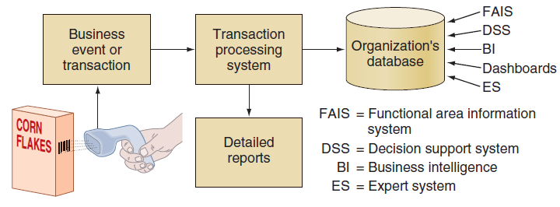
Who uses coarse data to see the big picture: Housekeeping manager planning staffing levels for next week

ERP
Contains modules for FIN, HR, CRM, PMS, POS, E-biz
Enterprise resource planning that uses a single database with integrated components that work together as a system

Legacy systems – before ERP
Separate databases resulted in Difficult to exchange information, satisfying departmental needs, entering data multiple times, different definitions of data, home grown systems, working in silos

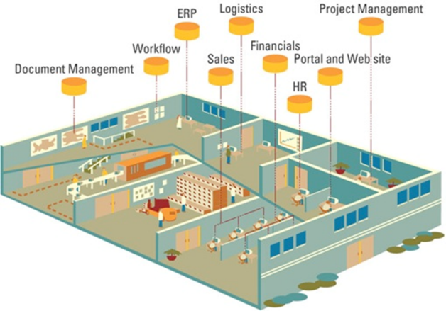
Advantages of ERP
- Single vendor
- No worries about interfaces
- Consistent look and feel
- Consistent data definitions
- Overall performance
Core component of ERP: Finance
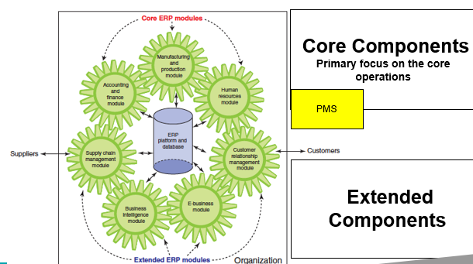
Major hotel systems have a central DB
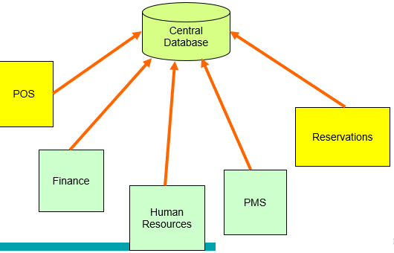

Core:
- PMS
- HR
- Finance

Extended:
- Reservations
- B2C: website
- B2B: procurement
- Supply Chain
- Sales
- CRM
- POS
- Business Intelligence
Mobile check-in is transforming the hospitality industry
On-premise ERP implementation
Vanilla approach: use the standard ERP package
Custom approach: modifications
Best of Breed: integrated with other software (AKA Point Solutions)

Running ERP systems
In-house
- Running computer centre in-house
- ERP implemented and supported in-house
SaaS ERP:
- Lease ERP software
- Run in the cloud
- Typically, vanilla approach

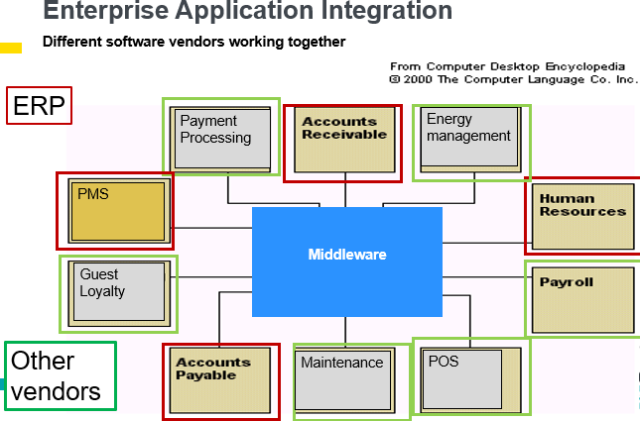
Week 4 – Acquiring Software

Processing transactions
OLTP (OnLine Transaction Processing)
- Transactions are processed immediately
- Examples: CC auth verification
  - Updating inventory upon receipt of merchandise
  - Adding loyalty points to a guest’s account during the reservation
  - Changing the availability of a room upon a booking
Batch
- Transactions are collected together (in a batch)
- At certain times they are processed
- Examples: Receiving merchandise, Cheque processing, Payroll
Purpose of the IT Steering Committee - To prioritize how best to use the IT resources of the company
Focus on where to spend IT budget
Limited resources: Money, systems analysts, organizational time
Multiple requirements across the organization
Composition: Department heads of functional areas, IT

Applications required
Company strategy, choices and alignment of business and IT needs
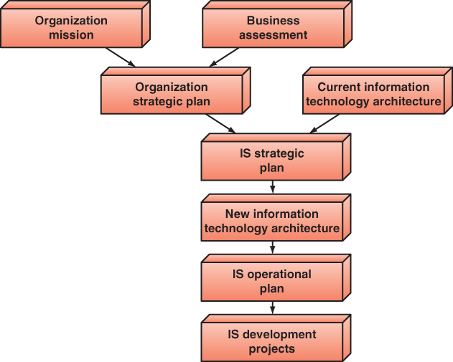

Cost-Benefit Analysis
System Costs – Development, Running, and Maintenance costs
Tangible Benefits - Cost savings
Intangible Benefits - Guest satisfaction
IT infrastructure - Changes
ROI - Difficult to measure, Competitive pressures
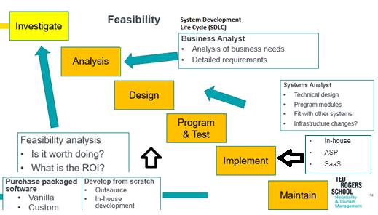

Systems development – options
Buy
- Purchase an existing application
- Purchase a prewritten application
- Customize the application
Build
- Build from scratch
- Use own team
- Use outsourcing.
Lease/rent
- Existing software
- Use application service providers (ASP)
- Software-as-a-service vendors (SaaS)

Transactions
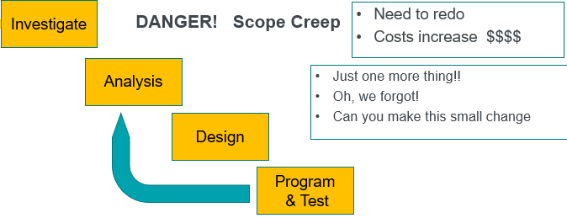
Scope creep - Addition of new requirements in the Programming stage

ASP
- Computer services provided by an agent or vendor
- Each company has its own software
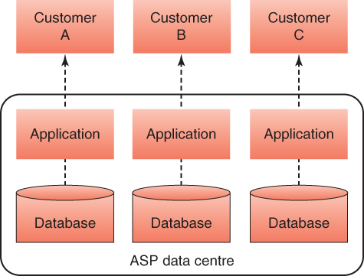

Saas
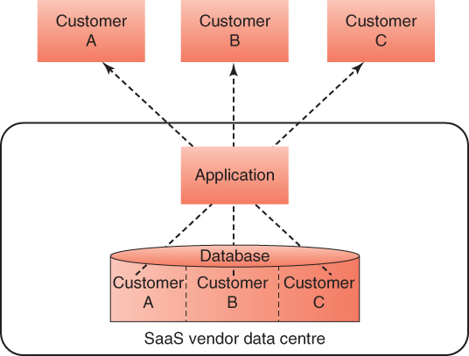
Implementation or deployment
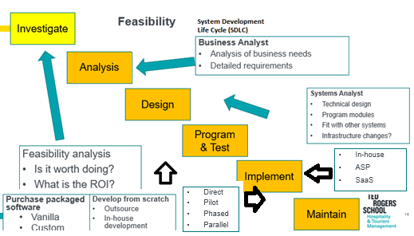

Implementation
Direct
- New system ON, old system OFF (‘Big Bang’)
Pilot
- New system first installed in one part of the organization
- When it is working satisfactory, it is rolled out
Phased
- System is installed in stages.
Parallel
- New system and old system are run at the same time
Maintenance: Debug, mandatory changes, added functions (Final step)

Beauty Apps - Sephora virtual artists makeup application
- Help you shop beauty products from app (bonus: earn rewards).
- Try on makeup and discover the best in beauty shopping, skincare, fragrance & more from your favourite brands.
- Lets you find the perfect foundation, palettes, lipstick and more for your personal style.
- Get makeup tips from our cosmetics experts and seriously glow this season!

Week 5 – Security and Controls

Protection of intellectual property
Piracy
  - copying a software program without making payment to the owner.
Trade secret
  - E.g. Coca Cola’s formula
Patent
  - grants the holder exclusive rights on an invention or process for 20 years.
Copyright
  - provides creators of intellectual property with ownership of the property for life of the creator plus 50 years.
Ransomware = holds your data hostage

Organizational vulnerability
Connected computers
- Internet
- Wireless
- Interdependence
- Data storage
- Networked
Hardware capabilities
  - Smaller, faster, cheaper computers and storage devices;
More tools available for the hacker
  - It’s easier to be a computer hacker;
International organized crime taking over cybercrime;
Lack of management support.
Greatest threats: internal = HR, IT External = Attackers

Human Errors
- Poor password selection and use
- Opening questionable e-mails
- Careless Internet surfing
- Careless monitoring of environmental hazards
- Carelessness with laptops and other computing devices
- Carelessness with one’s office
- Carelessness using unmanaged devices
- Carelessness with discarded equipment

Theft of equipment
Lack of encryption and USB usage

DDOS using a botnet to attack a router for a server to overflow requests

Social engineering
Phishing
  - Sending e-mails from a supposed reliable source
Impersonation
  - pretending to be a company manager of an information systems employee
Tailgating
  - following behind an employee to enter restricted areas
Shoulder surfing
  - watching over someone’s shoulder to view data or passwords

Identity theft
- stealing physical mail
- dumpster diving: finding sensitive trash
- stealing personal information in computer databases
- infiltrating organizations that store large amounts of personal information (e.g., data aggregators such as Acxiom)
- impersonating a trusted organization in an electronic communication (phishing).

Types of software attacks
Remote attacks requiring user action
- virus, worm, phishing attack, spear phishing attack
Remote attacks needing no user action
- denial-of-service attack, distributed denial-of-service attack
Attacks by a programmer developing a system
- Trojan horse, back door, logic bomb

Defense mechanisms – firewalls (comm controls), ID systems (Access controls) [External]
Internal = physical controls, access controls

Authentication
- Something the user is (“biometrics”)
- Something the user has
- Something the user does
- Something the user knows

Digital certificates
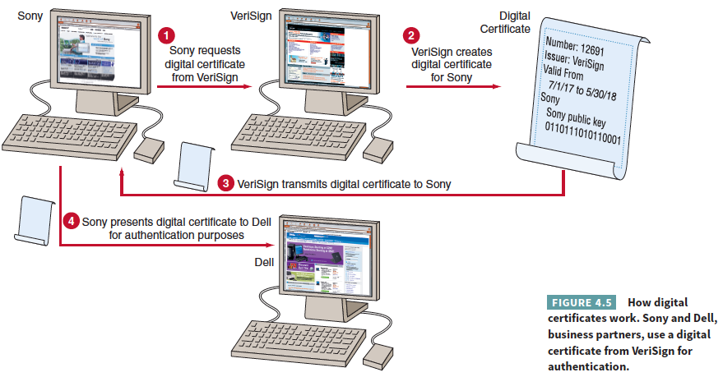
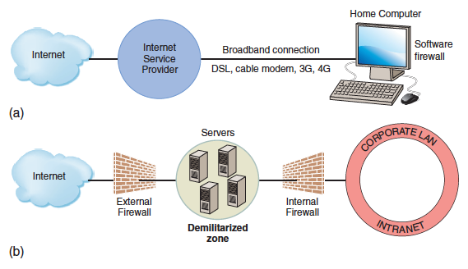

VPN
- VPNs have several advantages:
- allow remote users to access the company network
- provide flexibility to access the network remotely
- organizations can impose their security policies through VPNs
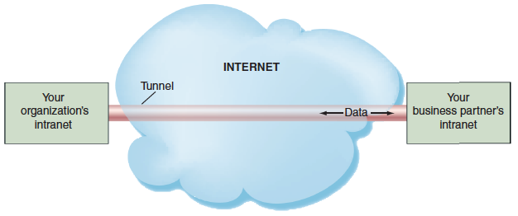
Purpose of a firewall – to keep unauthorized users out

Encryption
- Messages are encrypted
- End to end
- Transport layer security
  - Replaced Secure socket layer SSL
- TLS = Transport Layer Security; https = ‘secure’
HTTPS:// = provides tunnel for secure communication

SCADA Attacks
- Supervisory Control And Data Acquisition
Monitoring and control systems for:
- Oil refineries
- Water and sewage treatments
- Electrical generation
- Nuclear power plants
- Baby monitors

