CHAPTER 1: Management Today
Working Today

Talent
- Intellectual capital is the combined brainpower and shared knowledge of an organization’s employees
- A knowledge worker’s mind is a critical asset to employers and adds to the intellectual capital of an organization

Commitment x Competency = Intellectual Capital

Technology
- Tech IQ is a person’s ability to use current tech at work and in personal life:
  - Checking inventory, making a sales transaction, ordering supplies
  - Telecommuting
  - Virtual teams

Globalization
- The worldwide interdependence of resource flows, product markets, and business competition that characterize our economy
- Job migration: occurs when firms shift jobs from one country to another
- Reshoring: is the shifting of manufacturing and jobs back home from overseas

Ethics: Code of moral principles that set standards of conduct of what is “good” and “right,'' as well as “bad” and “wrong”
  - An individual behaviour
  - In business practices

Corporate Governance
- Board of directors hold top management responsible for organizational performance
  - Financial performance
  - Ethical performance
  - Sustainability
Diversity
- Workforce diversity reflects differences with respect to gender, age, race, ethnicity, religion, sexual orientation, and able-bodiedness
- A diverse and multicultural workforce both challenges and offers opportunities to employers

How diversity bias can occur in the workplace:
- Prejudice: the display of negative, irrational opinions and attitudes
- Discrimination: unfairly treating members of some groups
- Glass ceiling effect: an invisible barrier or ceiling

Careers and Connections
- Organizations consist of 3 types of workers (aka shamrock organization) :
  - Permanents full time workers
  - Temporary part-time workers
  - Freelance or contract workers
- Free-agent economy
  - People change jobs more often and work on flexible contracts
- Self-management
  - Ability to assess oneself realistically, recognize strengths and weaknesses, make constructive changes, manage personal development

Organizations
Organizations
- A collection of people working together to achieve a common purpose
- Organizations provide goods and services of value to customers and clients, and seek to serve society

Organizations (chart)
The environment supplies
- Resources inputs
  - People
  - Money
  - Materials
  - Technology
  - Information
The organization creates value
- Work activities turn resources into outputs (transformation process)(consumer feedback)
The environment consumes
- Product output
  - Finished goods and services
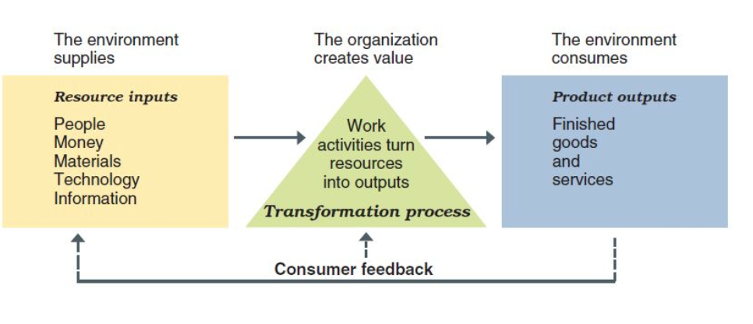
*Organizations as open systems interact with their environments

Organizational performance
- “Value creation” is a very important notion for organizations
- Value is created when an organization’s operations add value to the original cost of resource inputs
- When value creation occurs:
  - Business earn a profit
  - Non-profit organizations add wealth to society
- Productivity: an overall measure of the quantity and quality of work performance with resource utilization taken into account
- Performance effectiveness: an output measure of task or goal accomplishment
- Performance efficiency: an input measure of resource costs associated with goal accomplishment

Workplace changes that provide a context for studying management
- Focusing on valuing human capital
- Demise of :command-and-control”
- Emphasis on teamwork
- Pre-eminence of tech
- Importance of networking
- New workforce expectations
- Concern for sustainability

Managers

Importance of human resources and managers
- People are not ‘costs to be controlled’
- High performing organizations treat people as valuable strategic assets

Managers
- Directly supports, supervises, and helps activate the work efforts of others
- The people who managers help are the ones whose contributions represent the real work of the organization

Levels of management
- Board of directors: makes sure the organization is run well
- Top managers: are responsible for the performance of an organization as a whole or for one of its major parts
- Middle managers: oversee large departments or divisions
- Team leaders: supervise non-managerial workers
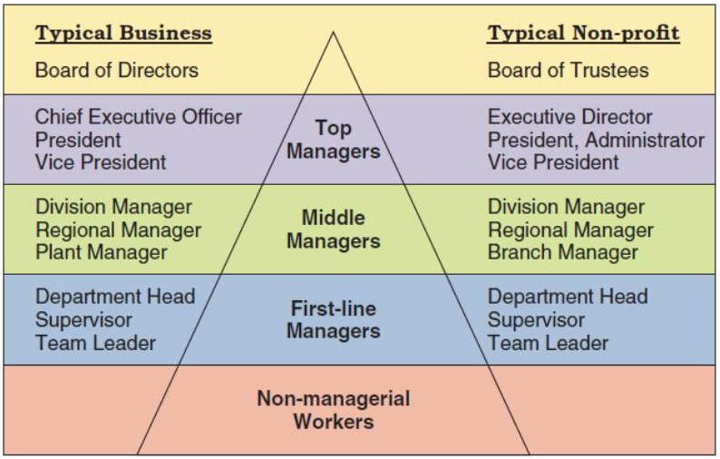
Types of managers
- Line managers: are responsible for work activities that directly affect organization’s outputs
- Staff managers: use technical expertise to advise and support the efforts of line workers
- Functional managers: are responsible for a single area of activity
- General managers: are responsible for more complex units that include many functional areas
- Administrators: work in public and non-profit organizations

Managerial performance accountability: is the requirement to show performance results to a supervisor
- Effective managers help others achieve high performance and satisfaction at work

Quality of Work Life (QWL)
- An indicator of the overall quality of human experiences in the workplace
  - QWL Indicators:
    - Respect
    - Fair play
    - Safe working conditions
    - Opportunities to learn and use new skills
    - Room to grow and progress in a career
    - Protection of individual rights

The organization as an upside-down pyramid
- A manager’s job is to support workers’ efforts
- The best managers are known for helping and supporting
- Customers at the top served by workers who are supported by managers
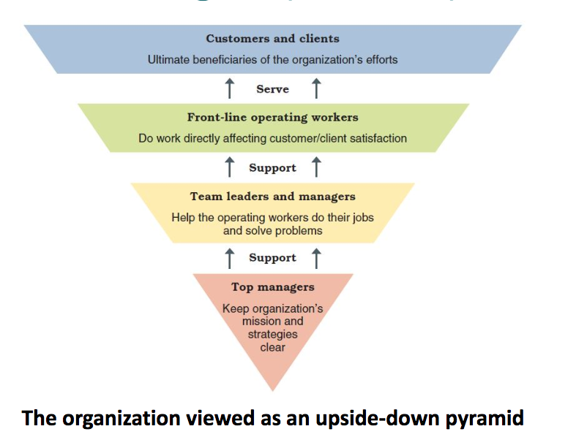
The Management Process

The Management Process
- Managers achieve high performance for their organizations by best utilizing its human and material resources
- Management is the process of planning, organizing, leading, and controlling the use of resources to accomplish performance goals
- All managers are responsible for the four functions
- The functions are carried on continually
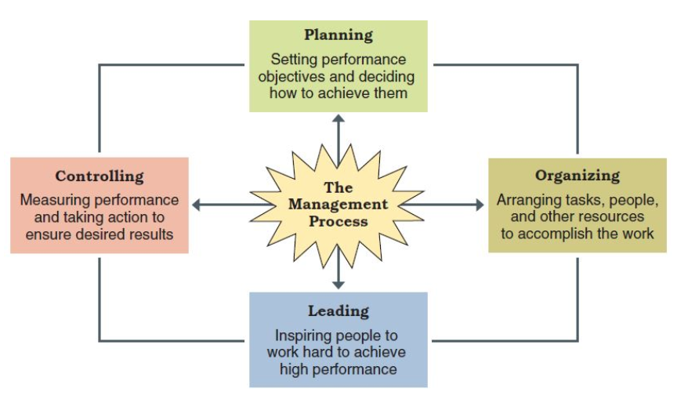
Functions of Management
- Planning
- The process of setting objectives and determining what actions should be taken to accomplish them
- Organizing
- The process of assigning tasks, allocating resources, and coordinating work activities
- Leading
- The process of arousing peoples’ enthusiasm and inspiring them to work hard to achieve goals
- Controlling
- The process of measuring work performance, comparing results, and takinf corrective action

Mintzberg’s 10 managerial roles
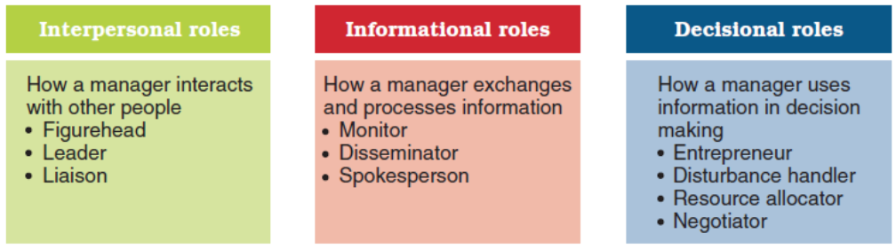
Characteristics of managerial work
- Long hours
- Intense pace
- Fragmented and varied tasks
- Many communication media
- Filled with interpersonal relationships

Managerial agendas and networks
- Agenda setting
  - Developes actions priorities for accomplishing goals and plans
- Networking
  - Process of building and maintaining positive relationships with people who can help advance agendas
- Social capital
  - Capacity to attract support and help from others

Learning how to manage
- Learning
  - The change in a behavior that results from experience
- Lifelong learning
  - The process of continuously learning from daily experiences and opportunities

Katz’ Essential Managerial Skills
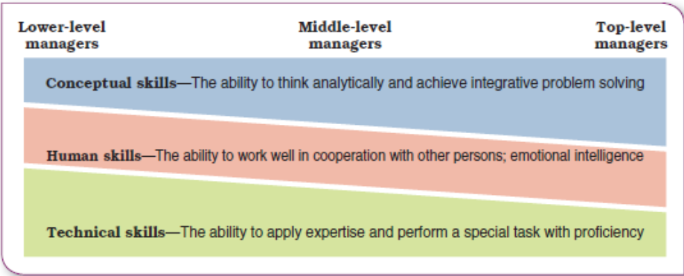
Which of the following constitute intellectual capital?
- Knowledge
- Skills
- Savings in the bank
- Experiences
- Diploma

How would you reconcile ethics and business profitability?
- There is conflict between ethics and business
- Short run: conflict
- Long run: no conflict

