Deryk Jamgotchian
Avery Larose
Philosophy of Communications
December 9th 2019

Field trip to the World Press Photo Expo:
‘Akashinga - The Brave Ones’

After going to the World Press Photo Expo, I was most inspired by the ‘Akashinga – The Brave Ones’ collection of photos by photographer, Brent Stirton. I found the intensity of the photo intriguing; I found the photo grabbed your attention much quicker than I was struck by other photos at the Expo. The photo is about Akashinga, (titled the ‘The Brave Ones’) who is a ranger force and presented as an alternative conservation model. Before going in depth on the story about his photo, I would like to give a little information about Brent Stirton who captured this moment. Based in South African, Brent Stirton has teamed with Getty images and corresponded for this organization for a while. Also he has had many of his shots included in National Geographic magazine. Brent has won many awards and captured many inspiring moments around the world. His genre of photography is documentary work, focusing on the correspondence of the human species and environment. The photo of the ranger and her force’s goal is to collaborate and work together than neglect or conflict. This creates a space of conversation other than violence allowing using the benefits given from collaboration with other communities. Akashinga, The Brave One’s, have helped many women deal with coming from negative experiences in their past and allow them to grow and evolve using preservation of the environment. This means they offer these woman jobs and ways to earn from hunting. This groups origin begins in 2017, the International Anti-Poaching Foundation is what created the Akashinga conservation rangers, it lead to an all women force watch over a nature reserve in Zimbabwe. These women come from the most dark backgrounds, for example; victims of rape and abuse. This program allows them to uplift themselves and be an example for other women in Africa.

After reading sources I found three that I value most not only for their informative review but as well their insight on the positions of the story. The first source I found was a Facebook post by the South China Morning Post. They also wrote a lot in the caption mostly explaining the story about the Photo and the Akashinga. In their caption they wrote “Predominately male forces are hampered by ongoing corruption, nepotism, drunkenness, aggressiveness towards local communities and a sense of entitlement. The International Anti-Poaching Foundation, led by former Australian Special Forces soldier Damien Mander, was created as a direct action conservation organisation to be used as a surgical instrument in targeting wildlife crime.” As I read this paragraph I was informed on why the photographer was drawn to creating his photo collection on this subject.

The second source I found was on a site called bjp-online.com and it has an article called ‘World Press Photo of the Year nominee Brent Stirton’ written by Marigold Warner. It states many facts about this collection; the only negative aspect I have to reveal about this site is that the article is very long. It is filled with information about the story and the photographer but not so much on the audience’s point of view and critiques.

Lastly the third source I found is an article on artsy.net that highlights the nominees and winners of the expo. Brent was in this list and his gallery of the Akashinga was presented in this news piece. It was brief and simple it stated that the work received 1st place and receive outstanding reviews. Although it states the audience’s opinion on the story and photos, it does not give any in depth insightful facts about who these rangers are and what they stand for.

In conclusion, the expo influenced my perception on creating an idea towards anything; the environment, political matters or even international issues and being able to present it is incredible to me. After introducing you my sources, The South China Morning Post and two articles on the internet, I was able to process and analyse how there are many conversations and perceptions towards one work of art. I read many sites that had bias opinions, but the ones I chose were well informative but again had their negative traits. This assignment showed me a physical and virtual experience of analysing art which I found very interesting. I got to choose a work of art I enjoyed and wanted to learn more about and was able to find all sorts of different perceptions towards this subject. I believe that information is losing its true value; although we are humans that seek answers again we are quick to trust the first source of information. Thus giving the impression that are humans losing their sense of wonder for the truth or are we cherishing opinions more than reality.

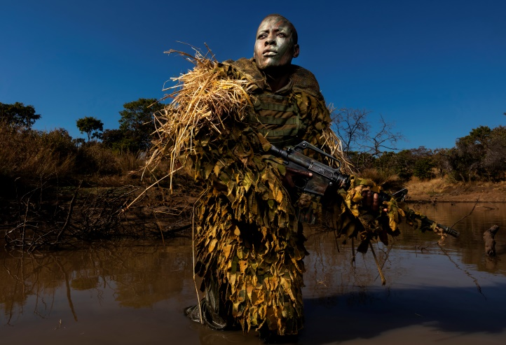

Sources

**The Facebook post was not able to be cited as it Facebook is an independent and private site. **

- British Journal of Photography. (2019). World Press Photo of the Year nominee Brent Stirton. [online] Available at: https://www.bjp-online.com/2019/04/world-press-photo-of-the-year-nominee-brent-stirton/

- Palumbo, J. (2019). See the Best Pictures of 2018, According to World Press Photo. [online] Artsy. Available at: https://www.artsy.net/article/artsy-editorial-press-photo-reveals-top-photojournalism-images-2018

