Final Exam Workshop
ORGANIZATIONAL BEHAVIOUR
BUSI 2121
FALL 2018

- Why effective communication in the work environment has become a key to success, to manage Human Resources in the organizations in Canada?
- Unprecedented changes and economic uncertainty
- Political changes and high expectations
- Unprecedented changes and levels of anxiety
- The need to increase competitiveness and productivity

- According to the information given during all the term, what are the major issues that companies are facing with Millennials?
- Performance Evaluation and Training
- Recruitment and Retention
- Work-life balance and Happiness
- Compensation and Health & Safety

- Technology has improved the quality of the communications in the workplace and is becoming strategic for organizations because of its direct impact in:
- Competitiveness and wellbeing of the employees
- Performance, profitability and efficiency
- Quality of life and work-life balance
- Facilitating change and grapevine communication

- The following Power base is influenced by the expertise, special skills or knowledge of one person’s:
- Referent Power
- Information Power
- Expert Power
- Legitimate Power

- Please explain in the following spaces the six elements of the interpersonal communication and what are their function in the communication process model:
1)___________________________________________________________________________________________________________________________________________________________________________
2) ____________________________________________________________________________________
______________________________________________________________________________________
3)___________________________________________________________________________________________________________________________________________________________________________
4) ____________________________________________________________________________________
______________________________________________________________________________________
5)___________________________________________________________________________________________________________________________________________________________________________
6)___________________________________________________________________________________________________________________________________________________________________________
Please refer to the following exhibit to answer questions 6 and 7
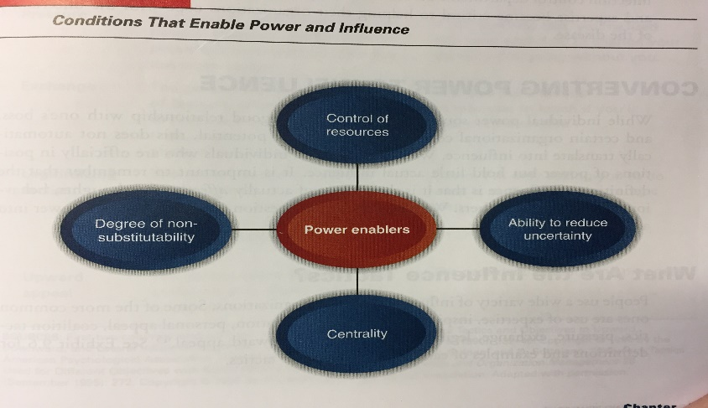

- The above image is an illustration of the conditions that ….
  - Provide organizational authority
  - Determine employee empowerment
  - Enable access to power
  - Define the relationship between influence and outcomes

- The oval with the letter X represents which condition?
  - Proximity to authority
  - Level of specialization
  - Social network
  - Control of resources
- Two common reactions to power and influence attempts are…
  - Follower compliance and Follower commitment
  - Follower compliance and Follower resistance
  - Follower engagement and Follower commitment
  - Follower engagement and follower disengagement

- Jack Welch, former head of General Electric (GE), provided the leadership that made GE the most valuable company in America. He also ruthlessly preached firing the lowest-performing 10 percent of the company’s employees every year. What behavioural leadership theory applies to Jack Welch leadership style?
- Managerial Grid Leadership Theory
- University of Michigan Leadership Theory
- Ohio State Leadership Theory
- Life Situational Theory

- This type of Organizational Structure is based on core processes where work focuses on the customer and on the entire sequence of activities rather than on one activity:
- Vertical Structure
- Hybrid Structure
- Horizontal Structure
- Functional Structure

- Boundary-less Structures are all the following ones, except:
- Network Structure
- Virtual Structure
- Front-back Structure
- Modular Structure
- These are the characteristics of a Type A personalilty, except:
- Seldom impatient
- Time urgency
- Work steadily
- Hyper alert
- Which of the following costs of employee stress can have the highest impact for the organization?
- Decrease productivity
- Increased benefit costs
- Increased absenteeism
- Dissatisfied workforce

- The process of deciding how to divide workload in an organization also referred to as division of labour is:
- Organizational differentiation
- Organizational Integration
- Organizational Design
- Organizational Structure

- The constructive use of power and influence is critical for organisational …
  - Profitability
  - Longevity
  - Competitiveness
  - Effectiveness

- Former IBM chair Lou Gerstner oversaw the re-emergence of IBM as powerhouse in the computer industry. He was not however easy to work for him. He believed in never relaxing or in letting others enjoy life. What type of transactional leadership style he had?
- Paternalistic
- Participative
- Authoritarian
- Laissez-Faire

- Leadership is most important when the environment is…
  - Dynamic
  - Competitive
  - Stable
  - Flexible

- According to ___________ theory, leaders are born with certain personal qualities.
  - Charismatic
  - Fiedler’s
  - Contingency
  - Trait

- The way in which organizations are helping their employees to cope with the different stressors in their personal lives is by:
  - Employee Assistance Programs (EAP)
  - Reducing Work load
  - Using rotations in the positions
  - Increasing the benefits the employee receive

- The degree of vertical differentiation through reporting relationships and the span of control within the structure of the organization is:
- Hierarchy of Authority
- Vertical differentiation
- Organizational Design
- Organizational Structure

- In a Flat organization, the span of control is:
- Narrow
- Wide
- Horizontal
- Vertical

- This type of grouping in the Organizational Structure brings together employees based upon the organization’s main outputs or geography or both:
- Functional Grouping
- Divisional Grouping
- Hybrid Grouping
- Skills Grouping

- According to the leadership Grid Model, this style of leadership is possible through balancing the necessity to get work done in the organization, while maintainin morale of people at a satisfactory level:
- Country Club leadership
- Team leadership
- Middle-of the Road leadership
- Authority-Compliance leadership

- This leadership theory is not part of the contingency theories of Leadership:
- Leadership Substitutes Theory
- Fiedler’s Leadership Theory
- Path Goal Leadership Theory
- Transformational Leadership Theory

- According to the contingency theory of leadership, good leadership….
  - Means having a back-up plan
  - Has specific characteristics
  - Depends on the circumstances
  - Is fixed
- The biggest cause of workplace stress in Canada is:
  - The excess of work
  - Hierarchical pressure
  - Relationships at work
  - Organizational Climate
- The following illustration is a representation of …
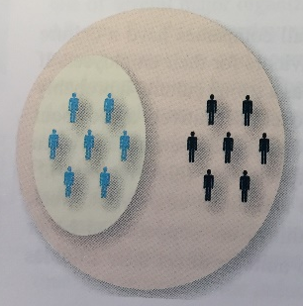
  - Organizational subcultures
  - Differentiated cultures
  - Fragmented cultures
  - Countercultures
- Small companies that are experiencing rapid growth will benefit from a _________________ organizational structure.
  - Bureaucratic
  - Product
  - Functional
  - Simple
- A survey of nearly 10,000 people in Quebec found that in the previous 12 months, __________ had been subjected to violence or harassment of some kind in their workplace.
  - 15%
  - 20%
  - 25%
  - 30%
- These are the key characteristics of a Transformational Leader, except:
  - Charisma
  - The ability to inspire loyalty
  - Clarification of performance
  - Individualized Consideration
- These are the characteristics of Transformational Leaders that help employees reach the organizational goals, except:
  - Articulates Vision
  - Builds Commitment to the mission
  - Demonstrates Integrity
  - Places the interest of the followers before the self-interests
- In this type of Organizational Structure, the ‘knowledge management’ positions are given to the heads of the projects:
  - Functional Structure
  - Divisional Structure
  - Matrix Structure
  - Organic Structure

- This is the set of internal and external variables that influence the organizational design processes:
  - Contextual variables
  - Environmental variables
  - Complex variables
  - Unpredictable variables

- This type of organizational strategy is used by ‘Apple’ and ‘Google’:
  - Differentiation Strategy
  - Low Cost Strategy
  - Innovation Strategy
  - Market share Strategy
- The most significant medical illnesses produced by stress are:
  - Heart disease
  - Strokes
  - Backaches
  - Muscle pain
- The main cause of stress in Canada is:
  - Job
  - Finances
  - Children
  - Health
- These are some of the recommended things to do to manage life stress, except:
  - Recognize the Symptoms
  - Use Relaxation Techniques
  - Get enough sleep
  - Talk to your boss
- Dr Jane Goodall, has dedicated all her life to research Chimpanzees and Gorillas. According to the picture showed during session 8 what stage is showing of the communication model with the Chimpanzee?
  - Decoding a message
  - Dealing with noise in the message
  - Sending a message
  - Encoding a message
- Bulling in High Schools is an excellent example for what type of communication noise?
  - Physiological Noise
  - Psychological Noise
  - Physical Noise
  - Semantic Noise

