PSY Lecture 10: Brain Tour (Part 1) 27th Sep 2019
Difference between human and animal brain?
- Outside of the brain, that surround the midbrain, cerebellum, corpus callosum is different including: cortex, cortical tissue, is where high level perception happens.

- Midbrain keeps individual alive, sexual thoughts occur, etc.
- The cerebral cortex is the place where high level perception of the world occurs and is also the place where controlled motor activities originate. In a simpler way, it is the place where all our controlled interactions with the external world occur.
- This contrasts with a number of more basic brain regions:
- which are more devoted to monitoring and controlling internal
- behaviours and automatic responses to external stimuli.

THE CORTEX:
- 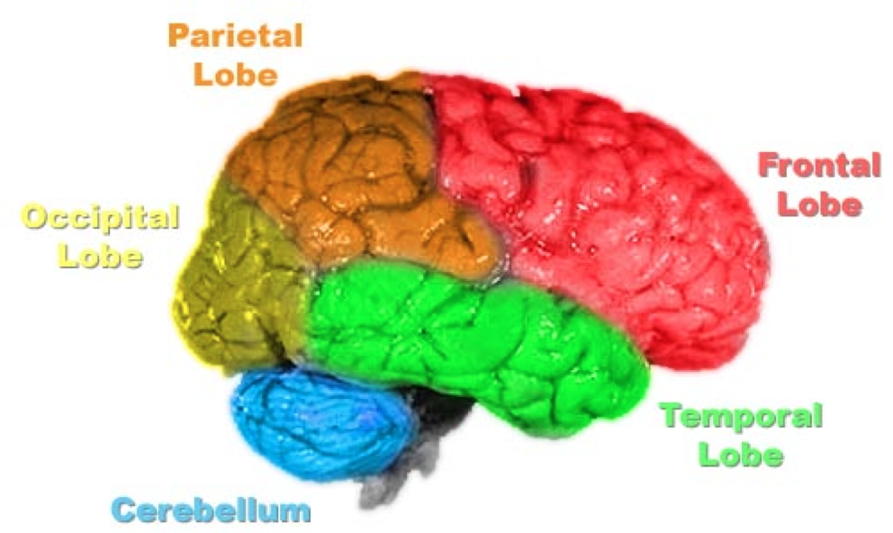
- Brains are relatively consistent. Brains among individuals are not identical, there would be some minor differences.
- different lobes of brain are responsible for specific duty and when the duties combine in outside world then where the two lobes connect, that part comes in action to do the job.
- Broka (brain region) is important for production of speech.
- vocalization of function: various specific function seem to be mapped onto a very specific brain region.
- Cleaning up stimuli (brain is good at it).
- Brain uses memory and previous experiences to interpret the input.
=> Primary Vs. Association cortex:
- Primary cortex: tends to deal with raw input, just what’s coming from world at that moment.
- Association cortex: is where memory comes in and helps to analyze the input.
=> Contralateral Organization: Brain often in many cases, is cross wired from the body. Parts that take in information from body and control the body. For example: brain regions on left of the body tend to control right side of body and right regions control left side of the body.

=> Lateralization of Function: Lateralization refers to the notion that the brain is composed of separate hemispheres creating left and right sides of all cortical tissue, and sometimes the left and right have different priorities.
- 2 distinct sides of brain, and in-between these 2 sides, there’s a corpus collosum (Thick tangle of nerve fibres that connect the 2 sides of the brain and makes it 1 brain).
- Epilepsy is a signal that goes back and forth. Epilepsy seizures.
- To immediately treat this epilepsy seizure, you cut the corpus because that’s the highway of signals to go to one brain to other. But after that is cut, there are other consequences such as: no feedback loop; split consciousness happens and seems like there are 2 independent people in the head and in 1 body. The left brain works independently and so do the right brain.
- lateralization is a notion where brain tissue on 1 half of the brain does different than that tissue is doing on the other half of the brain. Eg: language.
- most of your language capabilities is on left sides of the brain, only few is on the right side. Also, people who get strokes on the left side of the brain, tend to lose their language ability and get paralysed on the right side of the brain.
Right-handed people are very lateralized

=> Occipital Lobe: The occipital (and lower part of the temporal) lobes are devoted to vision.
- left and right occipital (back of the brain). Is farthest from the eyes.
- Primary visual cortex Is directly related to sight, and damage to it produces a hole in a person’s visual field … a scitoma.
- Association cortex in this area perform the function of providing an interface between visual input and memory, allowing one to categorize visual images. Damage can lead to agnosia, the inability to name common objects.
- Agnosia: lack of knowledge about visual stimulus. Can look at things but cannot recognize it. Cannot connect visual input to memory.
=> Temporal Lobe: Most of the temporal lobe is devoted to audition (hearing sound, sensing sound). Is about producing stuff.
- Primary auditory cortex is mostly hidden from view, lying on the inside to the upper temporal lobe. Damage to this leads to hearing problems.
- Auditory association cortex is located on the lateral surface of the upper temporal lobe:
- Damage to left leads to severe language deficits … patients losing the ability to comprehend or produce meaningful speech.
- Damage to the right affects the patient’s ability to properly perceive non-speech sounds, like the rhythm in music.

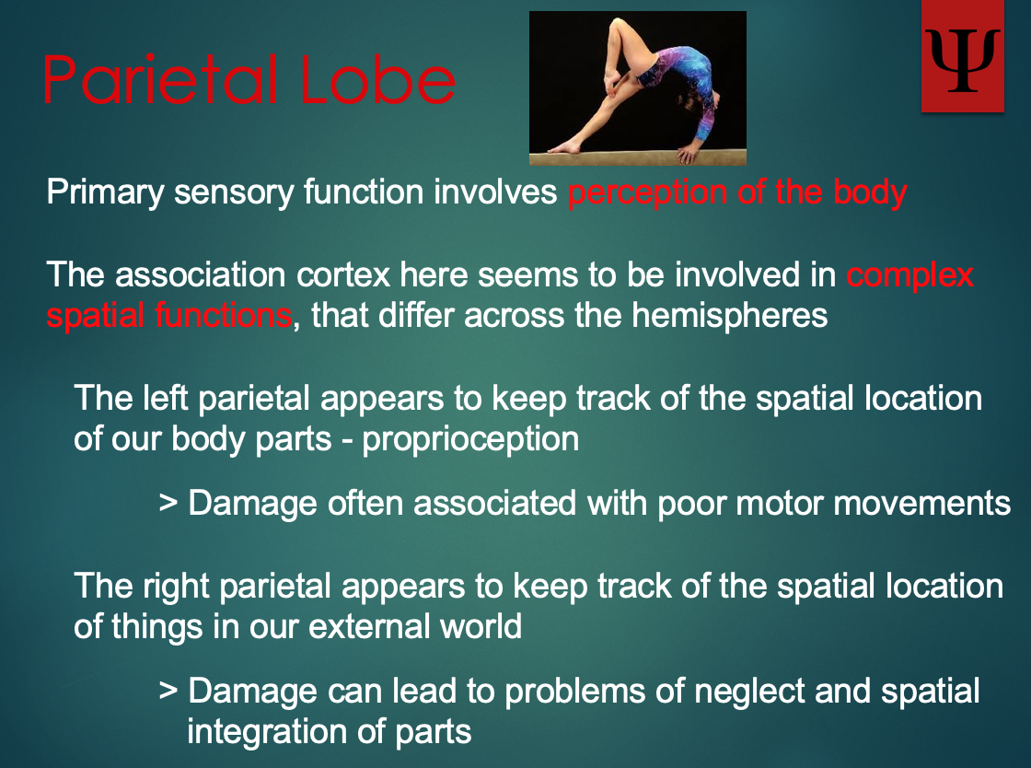
- we use language to code things. Left part Is where we deal with logics and all. Right part is more creativity.
- right side is used for non-speech sounds. Does like rhythm and more auditory things.
- primary cortex involves perception.
- pro-perception gives input to your mind.
- left part- worried about where your body parts are.
- right part- where world is
- Patients neglect the left side.

