Managerial Accounting Defined
Managerial accounting:
- An internal accounting system
- Not bound by GAAP (General accounting principles) or IFRS
- Designed to support managers’ information needs
Three Broad Objectives
- Planning, Controlling, Decision Making
Differences between managerial and financial accounting
 | Financial Accounting | Management Accounting
Target Users | External users | Internal Users
Restrictions | Must follow externally imposed guidelines | Not required to follow any guidelines
Type of information | Produces objective and verifiable financial information | Includes historical events, but focuses on future events
Degree of aggregation | Overall firm performance | Performance of entities, product lines, departments, and managers
Breadth | Self-contained | Multiple disciplines: managerial economics, industrial engineering, management science, etc.
Time Orientation | Reports on historical events | Includes historical event, but also focuses on future events
So, financial accounting is made for external stakeholders (e.g. shareholders, banks) and must follow strict guidelines and records only factual historic events. Management accounting is made for internal stakeholders (e.g. managers) and does not follow any strict guidelines and can include future predictions.
Accounting System
- Needs to be flexible enough to provide both financial and managerial accounting information
- The key point here is flexibility – the system should be able to supply different information for different purposes
Current Focus on Managerial Accounting
- Developments in technology, transportation and communication have created the need for better information
- In response to the need for better information, activity-based management accounting systems were developed
Indirect cost allocation
First stage allocation
Second stage allocation
Cost objects
Activity-Based Costing
- More detailed approach to determining cost of goods and services
- Emphasizes cost of many activities or tasks that must be done to produce a product

Customer Orientation
- Companies get an advantage when they can create better customer value
- Customer Value = What Customer Receive – What Customer Gives Up
Increasing Customer Value
Two Strategies: 1) Cost Leadership, 2) Superior products through differentiation

Cross-functional perspective
- Allows management to see the big picture, increase quality, reduce time, improve efficiency, etc.
- Cost benefit analysis
- Decisions that affects one function can affect others
- Managerial accountants must understand the different functions of the business to manage the value chain
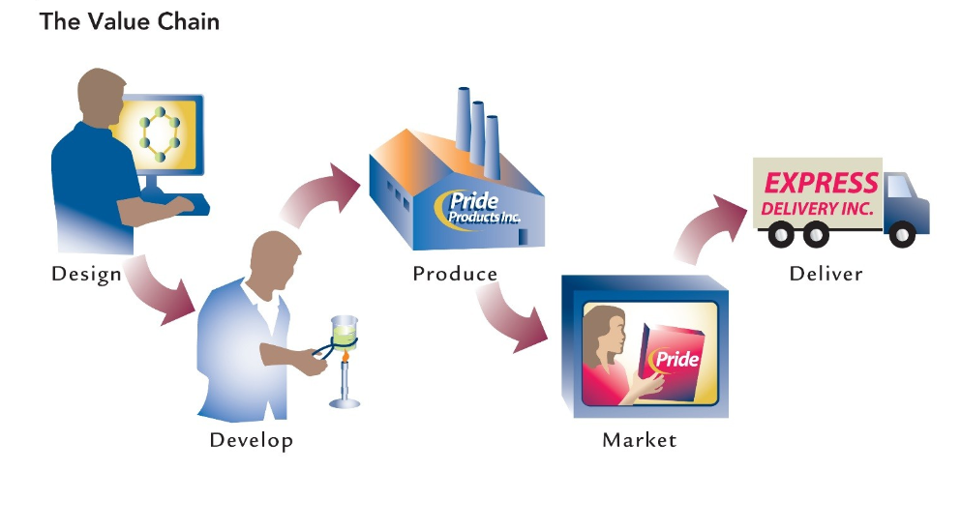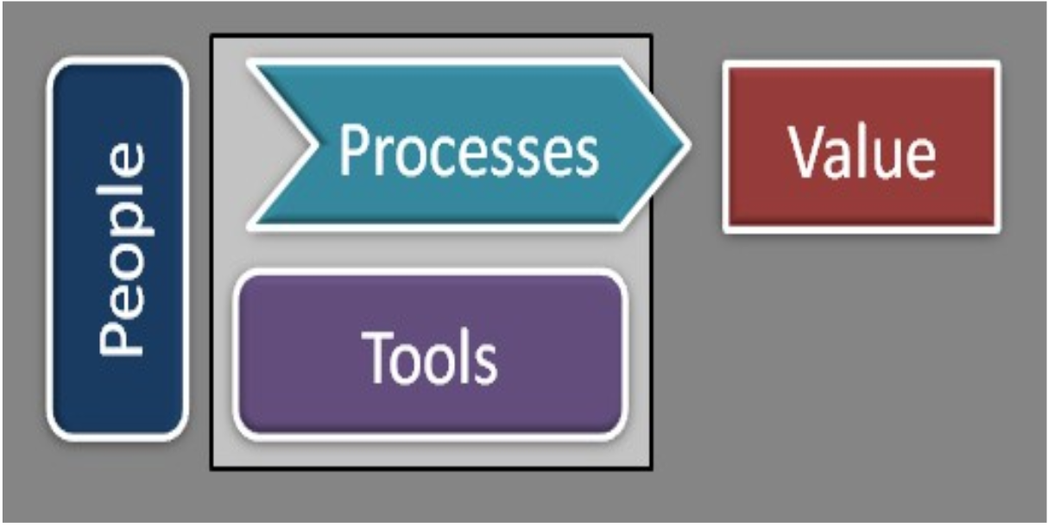
Total Quality Management
- “Acceptable quality” attitude is unacceptable
- Philosophy of perfect products (zero defects)
- Management accounting must provide both financial and nonfinancial information about quality
- Continuous improvement is fundamental
Time is of the upmost important
- Time is crucial in all phases of the value chain
- Companies try to eliminate non-value-added time
- Managers must respond quickly and decisively to changing market conditions
Efficiency
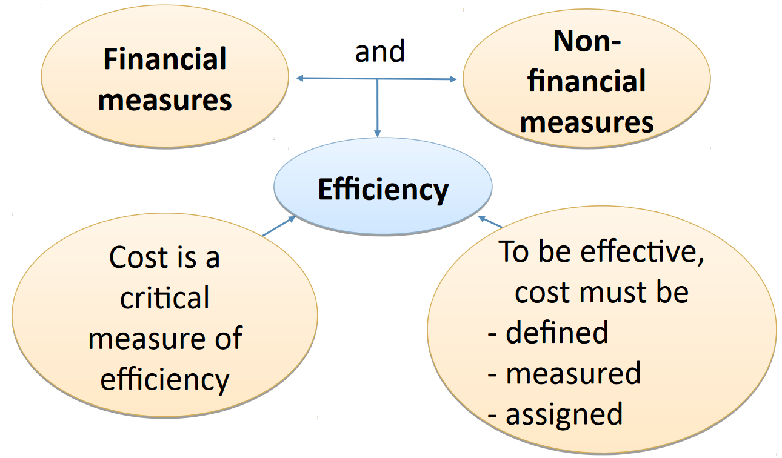

Structure off Company PG 16
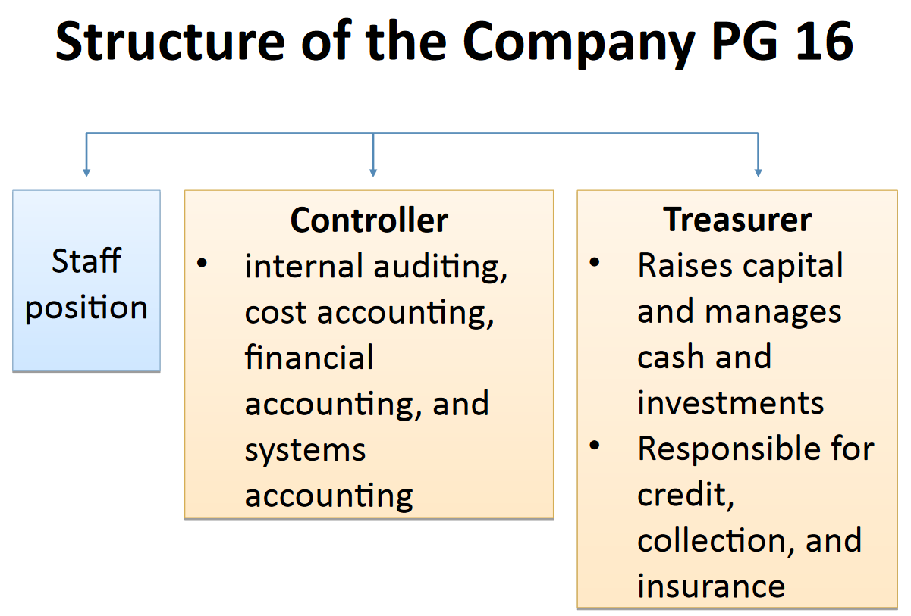
Explain the importance of ethical behaviour for managers and managerial accountants
Sarbanes-Oxley Act of 2002 was passed by the U.S. Congress in response to corporate securities fraud and corporate misconduct
Identify three accounting designations available in Canada
- Certified Management Accountant (CMA)
- Chartered Accountant (CA)
- Certified General Accountant (CGA)
Recently however, these three have merged into Certified Professional Accountant (CPA)

