BIOL2002 Fall 2012 Assignment 5. (2.5% of total mark)

Q1. Below is an image of a flowering plant that can be found in Ontario (Monotropa uniflora). It contains no functional chlorophyll, how does it obtain carbohydrate (2 marks)?
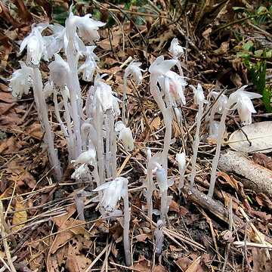
This plant is heterotrophic and monotropes are parasitic on fungi. These fungi are mycorrhizal with photosynthetic trees, and thus the energy ultimately comes from photosynthesis of the tree, passing through the mycorrhizal fungus on the way to the Monotropa.

Q2. In the lecture on growth responses and timing there were many examples of tropisms (e.g. geotropism), two examples of nastic movement (e.g. the seismonastic/touch/contact response of Mimosa pudica), and I mentioned circumnutation of a growing Arabidopsis inflorescence stem. Provide definitions of these 3 types of plant movement: Tropisms, Nastic movements, Nutation (No more than 1-2 sentences per definition, 3 marks total).
Tropism is a biological phenomenon, indicating growth or turning movement of a biological organism, usually a plant, in response to an environmental stimulus. The direction of tropic responses depends on the direction of the stimulus
Nastic movements are non-directional responses to stimuli (e.g. temperature, humidity, light irradiance). The direction of nastic movements is independent of the stimulus.
Nutation is the successive bowing or bending in different directions of the growing tip of the stem of many plants, especially seen in climbing plants.

Q3. In the lecture on growth responses and timing I talked about phototropism in terms of the growth of a plant organ toward or away from light. However, plants can also respond rapidly to excessive fluences of light (too much light) with movements at the sub-cellular level. Describe these responses and how they help the plant (3 marks).
The disc-shaped chloroplasts move from a diagonal position in "higher light" and reorient themselves to a more horizontal position to capture more PAR in lesser intensities. The chloroplasts are no longer stacked up like plates, but become spread-out. Leaves therefore can become longer and thinner. If the red to far-red ratio is off, the plant becomes stretched ("internode elongation").

Q4. One of the ‘optional extras’ I have provided was a time lapse video of the flowering of the Titan Lily/Arum (Amorphophallus titanium), which is the largest “unbranched inflorescence”. What angiosperm species produces the heaviest “single” flower, and how is it pollinated (2 marks)?

Rafflesia arnoldii, the heaviest and largest single flower in the world. This plant is pollinated by its foul odor of rotten meat, which attracts flies and beetles that must visit both the male and female plants, in that order to successfully pollinate.

