Biology 1010 Lecture #2 Review

Mitochondria
- Site of cellular respiration and ATP production
- Most cells contain many mitochondria but the amount depends on the function of the cell (for ex muscle cells that move and contract have more)
- Double membrane, each a lipid bilayer
- Matrix contains many enzymes, ribosomes that are free in the matrix, and circular DNA
- The highly folded cristae increases SA and thus enhances the productivity of cellular respiration (more ATP synthase and ETC can exist, more ATP)
- Mitochondrial DNA: all maternal (from mom) because the sperm only has a few mitochondria that are degraded anyhow by lysosomes during fertilization
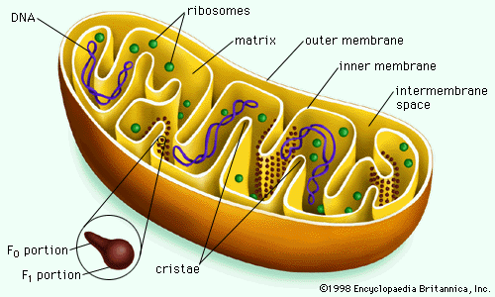

Endosymbiont Theory:
- Said to have happened over 2 billion years ago
- An early ancestor of eukaryotic cells engulfed an oxygen-using non-photosynthetic prokaryotic cell (Bacteria that produced ATP)
- Eventually the engulfed cell formed a relationship with the host cell
- At least one of these cells must have taken up a photosynthetic prokaryote, becoming the ancestor of eukaryotic cells that contain chloroplasts
EVIDENCE: 1) Bacterial DNA is also circular
2) Ribosomes in mitochondria are the same size as the ones found in bacteria
3) Roughly the same size as bacteria
4) Double membrane like bacteria

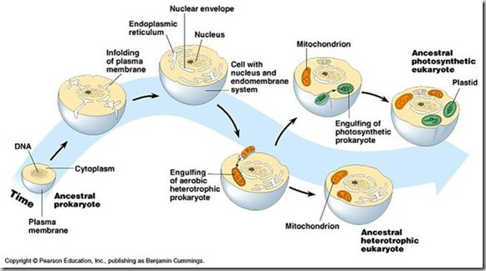

Cytoskeleton
- A network of fibres extending through the cytoplasm that provide the cell with structure (like bones), and allow certain activities
1) Mechanical Support
2) Movement/Motility
- Cell motility requires the interaction of the cytoskeleton with motor proteins. The cytoskeleton elements and motor proteins work together with plasma membrane molecules to allow whole cells to move along fibres outside of the cell
- Inside the cell, vesicles and other organelles use motor protein “feet” to “walk” along tracks provided by the cytoskeleton

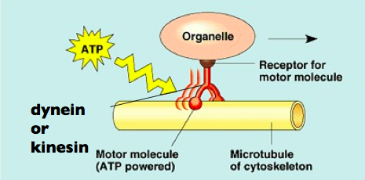

3 Main Types
1) Microtubules: thickest, long hollow pipes
2) Microfilaments: thinnest
3) Intermediate Filaments: fibres with diameters in a middle range

Microtubules (compression resisting)
STRUCTURE:
- Hollow cylinders constructed from a globular protein called tubulin
- Each tubulin is a dimer–composed of two subunits α-tubulin and β- tubulin
- Microtubules grow in length by adding tubulin dimers; they can also be disassembled and their tubulin used to build microtubules elsewhere in the cell
- Because of the orientation of the tubulin dimers, each end of a microtubule is slightly different
- This makes microtubules POLAR – pos end and neg end
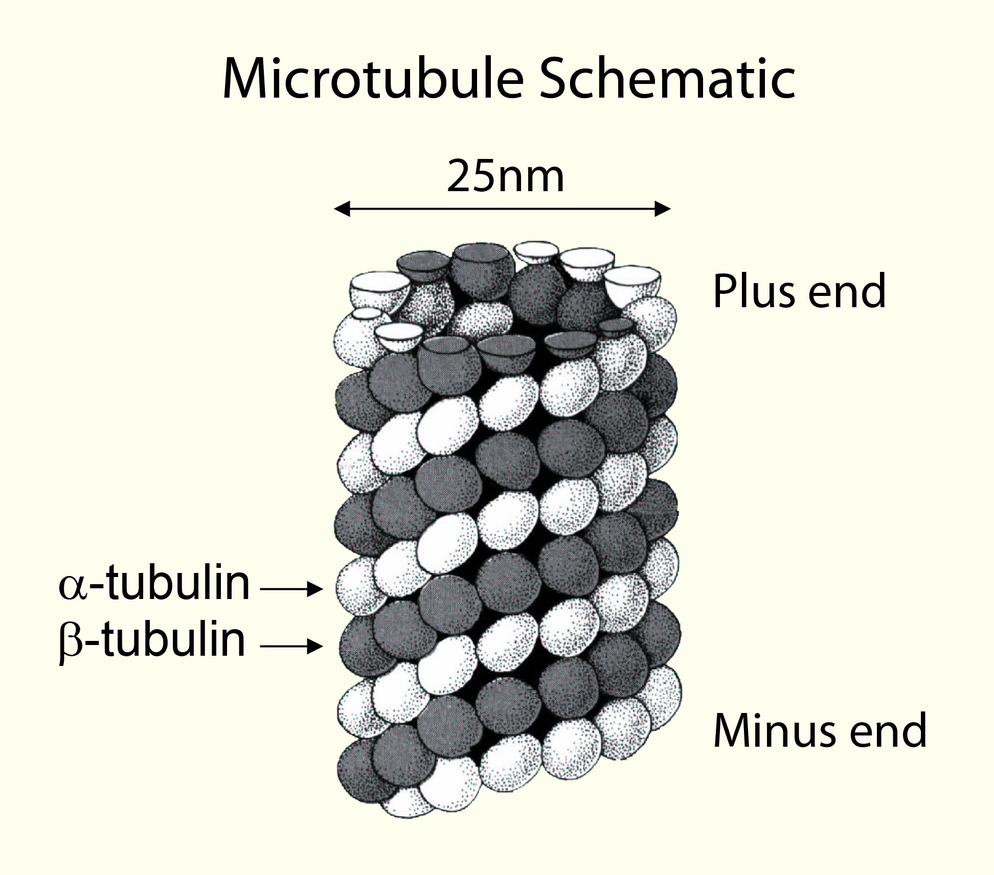
FUNCTION:
- Maintenance of cell shape
- Chromosome movement in cell division
- Cell motility (cilia and flagella)
- Organelle movement
…

- Microtubules serve as tracks along which organelles equipped with motor proteins can move
- They guide vesicles from the ER to the Golgi apparatus and from the Golgi to the plasma membrane.

Molecular Motors (protein subunit)
1) Kinesin: Moves towards the outside of the cell in the POSITIVE direction
2) Dynein: Moves towards the inside of the cell in the NEGATIVE direction

Centrosomes and Centrioles:
- Microtubules grow out from a centrosome, which contains two centrioles within, at right angles to each other.
- Each centriole is composed of nine sets of triplet microtubules arranged in a ring
- This is where microtubules are assembled/ organized
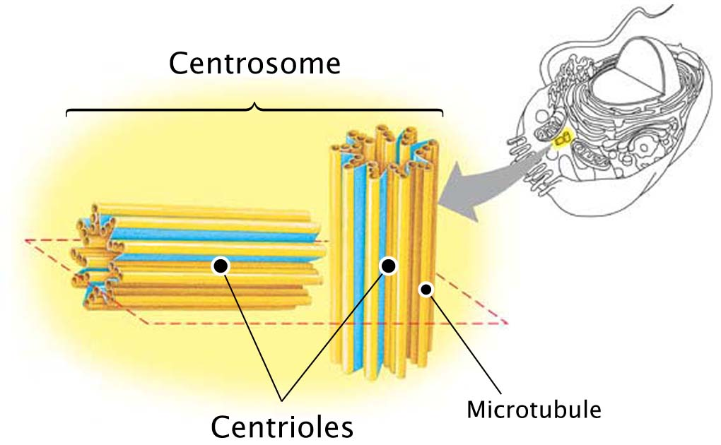
Cilia and Flagella
- Share the same structure
- Cilia and flagella both have a group of microtubules sheathed in an extension of the plasma membrane
- Nine doublets of microtubules are arranged in a ring and in the centre are two single microtubules (9+2 pattern)
- The microtubule assembly of cilium or flagellum is anchored in the cell by a basal body (9+0 pattern, nothing in centre unlike cilium/flagellum)

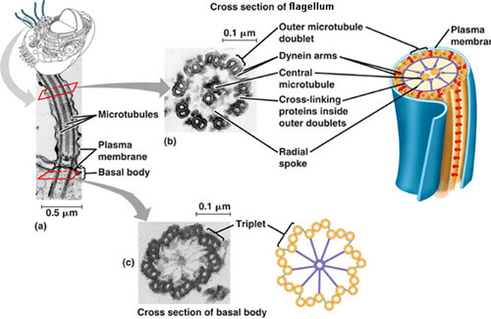

Bending
- Large motor proteins called dyneins (move towards neg) are attached along each outer microtubule doublet
- The movement of the dynein protein (like feet that walk) along the microtubule of the adjacent microtubule doublet, use ATP for energy – this movement causes the microtubules- and the organelle as a whole- to bend.

Microfilaments also called Actin Filaments (pulling forces)
STRUCTURE:
- Three dimensional network of actin filaments form just inside the plasma membrane to help support the cells shape
- Made of stacks of actin protein (globular protein) – making it a polymer of actin subunits
- Often works with motor protein myosin
- When ATP is available, actin can polymerase
- The stacks of actin that make up microfilaments have polarity which provides orientation for the material they move (which way to go depends on the charge)
FUNCTION:
- Maintenance of cell shape
- Changes in cell shape
- Muscle contraction
- Cell motility (amoeboid movement)
- Division of animal cells (cytokinesis)

Muscle Contraction
- Myosin: a fibrous protein that forms (together with actin) the contractile filaments of muscle cells and is also involved in motion in other types of cells.
- The “walking” of myosin drives the parallel myosin and actin filaments past each other so that the muscle cell shortens and causes a contraction when many muscle cells preform this

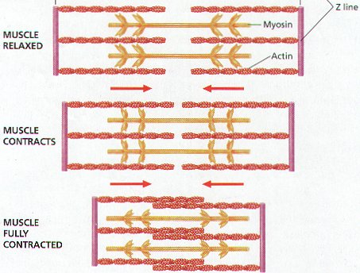

Amoeboid Movement
- Interaction of actin filaments with myosin causes contraction of the cell, pulling the cells trailing end forward
- Allows unicellular eukaryotes and white blood cells to “crawl” and extend pseudopodia and move toward them.
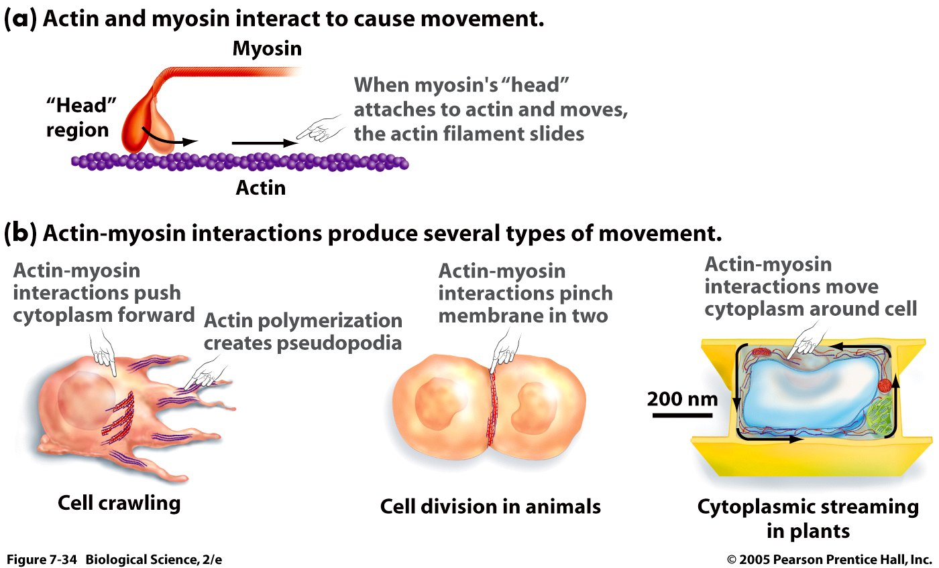

Intermediate Filaments
STRUCTURE:
- No motor molecules- no motility
- Protein subunit: one of several different proteins (such as keratins), depending on cell type
- No polarity – no motor proteins so there does not need to be a pos or neg end for orientation
- Fibrous proteins that are relatively small
FUNCTION:
- Maintenance of cell shape (resist tension, very strong)
- Anchorage of nucleus and certain other organelles
- Make up the nuclear lamina, which lines the interior of the nuclear envelope

Extracellular Matrix
- Mainly composed of glycoproteins and other carbohydrate containing molecules secreted by the cell
- The most abundant glycoprotein found in the ECM is collagen which forms strong fibres outside the cell (accounts for 40% of the human body protein)
- Collagen fibres are embedded in a network woven out of proteoglycans secreted by cells
- A proteoglycan consists of a small protein core with many carbohydrate chains covalently bonded (up to 95% carbohydrate)
- Some cells are attached to the ECM by glycoproteins called fibronectin. Fibronectin and other ECM proteins bind to membrane receptor proteins called integrins that are built into the plasma membrane
- Integrins span the membrane and bind on their cytoplasmic side to associated proteins attached to microfilaments of the cytoskeleton. This linkage can transmit signals between the cell’s external environment and its interior and can result in changes in cell behavior.

FUNCTIONS:
- Cell Migration
- Coordinate Cell behavior

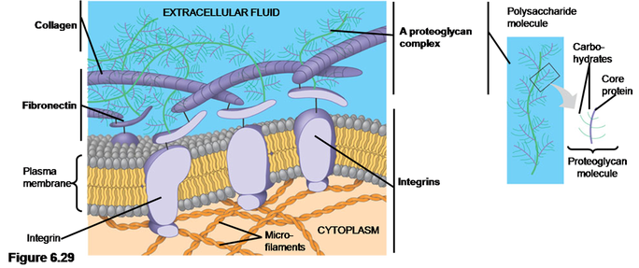

Cell Junctions In Animal Tissues
Especially common in epithelial tissue which lines the internal and external surfaces of the body

1) Tight Junctions
- The plasma membranes of neighboring cells are very tightly pressed against each other, bound together by specific proteins.
- Form continuous seals around cells which forms a barrier that prevents leakage of extracellular fluid
- Ex. Tight junction across skin cells make us watertight

2) Desmosomes (also called anchoring junctions)
- Fasten cells together in strong sheets
- Intermediate filaments made of keratin proteins anchor desmosomes in the cytoplasm

3) Gap Junctions (also called communicating junctions)
- Provide cytoplasmic channels from one cell to an adjacent cell
- Consists of small holes so tiny signaling molecules can move between the two cells
- Necessary for communication between cells on many type of tissue, such as heart muscle, and in animal embryos.


